

Programme: BSc Health and Social Care
Module code: BMHP5015
Module: Changemakers: Building your Personal Brand for Sustainable Employment
Lecturer: Olufemi Oluranti
Presented by: Saima Khan (2407142)

Contents
Task 1 – Personal Brand 2
Task 2 - Network Map and Rationale 3
Network Map Rationale 4
Task 3- Blog 5
The Growing Mental Health Crisis Among Young People in the UK 5
Task 4- NHS Equality, Diversity and Inclusion Quiz 6
Task 5- A Letter to Yourself 8
Task 6- GANTT Chart (200 words equivalent) 9
Task 7- Making Changes- Report 10
Introduction 11
Planning the Change 11
Skills Required 11
Barriers and Solutions 11
Conclusion 12
Reference List 12

Task 1 – Personal Brand
Personal branding refers to the way individuals present their skills, values, and personality to employers and professional networks (Gorbatov, Karpova and Lysova, 2018).
According to Calvo-Lorenzo, M. (2016), who you are and how you present yourself are important for becoming successful. A personal brand helps students and professionals remain relevant in their field, create opportunities, and make a lasting impression on employers. In today’s digital world, social media and professional platforms also play an important role in helping individuals communicate their skills, knowledge, and career goals. My personal brand is based on being hardworking, adaptable, and committed to continuous learning. These qualities are important in today’s competitive market because employers value individuals who can collaborate effectively, solve problems, and respond positively to change (Vallas and Christin, 2018). I also consider myself reliable and motivated to achieve both personal and professional goals.
To further develop my personal brand, I need to improve my professional communication skills and strengthen my online presence. Creating and maintaining a professional LinkedIn profile would allow me to showcase my qualifications, achievements, and experiences while connecting with potential employers. Research shows that online professional profiles play a significant role in shaping employability and career opportunities (Scolere, Pruchniewska and Duffy, 2018).
In addition, gaining work experience, volunteering, and attending networking events would help me build confidence and demonstrate transferable skills such as teamwork, leadership, and time management. Continuous professional development through training and learning new skills is also essential for career success.

Task 2 - Network Map and Rationale

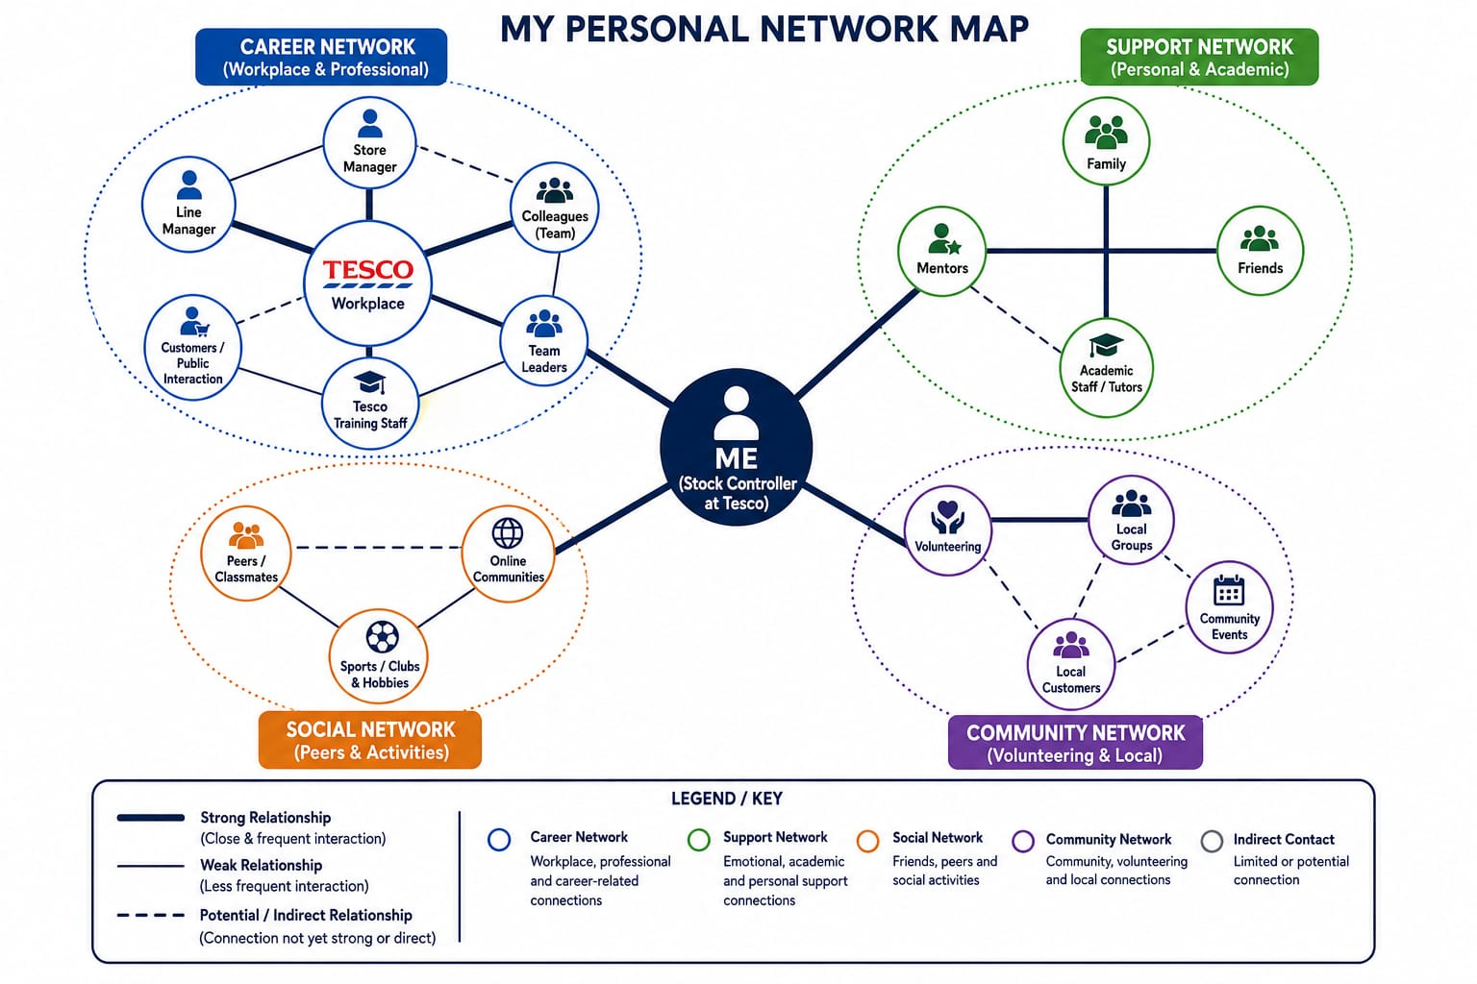

Network Map Rationale
My personal network can be described as a hybrid network because it includes both strong close relationships and wider professional and community connections. My network consists of career, support, social, and community dimensions which all contribute to my personal development and future career goals in Health and Social Care.
My support network is one of the strongest parts of my network. Family, friends, mentors, and academic staff provide emotional support, motivation, and guidance throughout my studies and personal life. I also have a growing professional network through my current role as a Stock Controller in Retail job. Through this job, I regularly interact with managers, supervisors, colleagues, and customers, which helps me develop communication, teamwork, leadership, and problem-solving skills. These relationships strengthen my career network and provide workplace experience that can support my future progression into Health and Social Care.
My social and community networks are also important because they help me build confidence, social interaction, and community awareness through peers, online communities, volunteering, and local engagement.
However, there are still areas where my social capital could improve. My bridging social capital is limited because most of my connections are within familiar academic, workplace, or social environments. Expanding my professional relationships outside these areas would help expose me to new opportunities and perspectives. My linking social capital also needs development because I have limited connections with professionals in senior healthcare positions or organisations. To improve this, I plan to attend networking events, gain healthcare-related work experience, volunteer within the community, and actively build professional connections through LinkedIn and workplace opportunities.

Task 3- Blog

The Growing Mental Health Crisis Among Young People in the UK
Mental health among young people has become one of the most pressing issues facing the UK health and social care sector today. Increasing numbers of children and teenagers are experiencing anxiety, depression, stress, and other mental health conditions. This rise has placed significant pressure on schools, families, the NHS, and social care services. Understanding the causes and impact of this crisis is important for everyone involved in supporting young people, (NHS England ,2024).
One major factor contributing to poor mental health is social media. While platforms such as Instagram, TikTok, and Snapchat help young people stay connected, they can also create pressure to look perfect, gain approval, and compare themselves to others. Cyberbullying has also become more common, affecting self-esteem and emotional wellbeing. Many young people report feeling isolated despite being constantly online, (Mental Health Foundation, 2023).
The COVID-19 pandemic also had a lasting effect on mental health. Lockdowns, school closures, and reduced social interaction caused loneliness and uncertainty for many children and teenagers. Some young people struggled with grief, financial worries at home, or fear about the future. Even after restrictions ended, many continued to experience anxiety and emotional difficulties, (Department of Health and Social Care, 2021)
The NHS has seen a sharp increase in referrals to Child and Adolescent Mental Health Services (CAMHS). Unfortunately, long waiting times mean that many young people do not receive help quickly enough. In some areas, families wait months for appointments, which can worsen mental health problems. This highlights the growing need for investment in mental health services and trained professionals.
Schools are now playing a larger role in supporting mental wellbeing. Many schools have introduced wellbeing programmes, counselling services, and mental health awareness campaigns. Teachers are increasingly expected to recognise signs of emotional distress and guide students towards support services. However, schools alone cannot solve the problem without stronger support from healthcare and social care systems.
Parents and carers also have an important role. Open conversations about emotions and must continue to promote understanding and acceptance of mental health conditions.
In conclusion, the mental health crisis among young people is a serious issue affecting the UK mental health can help reduce stigma and encourage young people to seek support. Society health and social care sector. Greater funding, earlier intervention, and stronger collaboration between schools, families, and healthcare professionals are essential to improve outcomes for young people and ensure they receive the support they need, (Department for Education, 2023).

Task 4- NHS Equality, Diversity and Inclusion Quiz
- What is the primary goal of the NHS Equality, Diversity, and Inclusion Improvement Plan?
The Plan is to create a fair, inclusive, and respectful workplace where all staff have equal opportunities to succeed. It aims to reduce discrimination and inequalities while improving staff experience, wellbeing, and patient care (Ross et al., 2020, Harvey et al., 2026).
- How does the NHS EDI Improvement Plan propose to tackle the gender pay gap?
It aims to tackle by improving equal access to career progression, leadership opportunities, and flexible working arrangements. It also promotes fair recruitment, promotion, and pay practices to reduce inequalities (Brown, Rickard, and Broughton, 2017).
- What is meant by the term ‘intersectionality’ as used in the NHS EDI Improvement Plan?
Intersectionality means that a person can face different types of discrimination at the same time, such as their gender, race, disability, or age.
- Why is it important for the NHS to create a psychologically safe work environment?
So that the staff feel comfortable speaking up, sharing ideas, and reporting concerns without fear of blame or discrimination. This helps improve staff wellbeing, teamwork, and patient safety.

- How does the NHS EDI Improvement Plan suggest improving the experience of internationally recruited staff?
It suggests improving the experience of internationally recruited staff by providing better support, fair treatment, and equal opportunities for career development. It also aims to reduce discrimination and help overseas staff feel welcomed and included in the workplace.

- What role does leadership play in advancing EDI objectives according to the NHS Improvement Plan?
Leadership plays an important role in promoting equality, inclusion, and fair treatment for all staff. Leaders should set a positive example and make sure EDI goals are achieved across the NHS.
- Identify one way the NHS EDI Improvement Plan aims to reduce health inequalities within the workforce.
One way to reduce health inequalities within the workforce is by ensuring all staff have fair access to health, wellbeing, and support services, regardless of their background or personal characteristics.

- Why does the NHS EDI Improvement Plan emphasise the importance of collecting and analysing data on protected characteristics?
It collects data on protected characteristics to identify inequalities and improve fairness.

- Explain how flexible working policies can contribute to equality and inclusion in the NHS workforce.
Flexible working helps all staff balance work and personal responsibilities, promoting equality and inclusion.
- What is one strategy mentioned in the NHS EDI Improvement Plan to combat bullying and harassment in the workplace?
The NHS tackles bullying and harassment by encouraging staff to speak up and about concerns and ensuring that reports are taken seriously and dealt with fairly. This helps create a safer and more respectful workplace for everyone.

Task 5- A Letter to Yourself
Dear Me,
I know that there was a time when you were facing many challenges and felt unsure about yourself and your future. You often worried about making mistakes and sometimes felt overwhelmed by the pressure of work, study, and personal responsibilities. Looking back now, I can see how important emotional intelligence and resilience would have been during that difficult period.
Emotional intelligence is the ability to understand and manage emotions, both your own and those of others. At that time, you were often very hard on yourself when things did not go as planned. If you had been more aware of your emotions, you may have been able to manage stress better and avoid feeling discouraged. It would also have helped you communicate your feelings more effectively and build stronger relationships with the people around you.
Resilience is the ability to recover from setbacks and keep moving forward. During difficult times, you sometimes focus too much on problems instead of possible solutions. Developing resilience would have helped you stay positive and see challenges as opportunities to learn and grow. It would have reminded you that setbacks are a normal part of life and do not define your abilities or future success.
The most important thing I want you to remember is that every challenge teaches a valuable lesson. Be patient with yourself, believe in your strengths, and do not be afraid to ask for support when needed. The difficult experiences you face today will help you become stronger, more confident, and better prepared for the future.
Keep going and trust the process.
Yours sincerely,
Your Future Self

Task 6- GANTT Chart (200 words equivalent)

The aim of this Gantt chart is to plan and monitor the key stages required to achieve my future employment goal of becoming a registered Occupational Therapist. It outlines the qualifications, skills, professional development, and milestones needed to progress from my current studies to securing employment in the profession.
3.2 Explained: Although I am still developing professionally, I have already gained valuable communication, customer service, time management, and task management skills through my current employment. Working with customers, lecturers, and colleagues has helped me build confidence, teamwork, and interpersonal skills, which will support my future role as an Occupational Therapist.

Task 7- Making Changes- Report
Implementing a Dementia-Friendly Environment Enhancement Programme to Improve Safety, Orientation and Wellbeing in a Care Home as the Manager of the Care Home.

Introduction
As the manager of a care home, I propose implementing a Dementia-Friendly Environment Enhancement Programme to improve the safety, independence and wellbeing of residents living with dementia. The programme will introduce dementia-friendly signage to improve orientation and create a calm sensory environment through improved lighting, reduced unnecessary noise and personalised music based on residents' life histories. These changes support person-centred care and aim to reduce anxiety while promoting familiarity and independence (Lee, Lee and Kim, 2022).

Planning the Change
The programme will be implemented using Lewin's Change Management Model of unfreezing, changing, and refreezing (Burnes, 2020). During the unfreezing stage, staff and families will be consulted to explain the purpose of the change and identify residents' individual preferences. During the change stage, clear picture-based signage will be installed, environmental improvements introduced, and personalised music playlists developed with support from relatives. Staff will receive training to ensure consistent implementation. During the refreezing stage, regular audits and feedback from residents, families and staff will evaluate the programme and embed it into routine practice (Harrison et al., 2021). Although implementation requires staff training, additional planning and some financial investment, the programme is expected to improve orientation, emotional wellbeing and quality of life

Skills Required
Successful implementation requires effective leadership, communication, teamwork, organisation, time management, and problem-solving skills. I will ensure that staff receive adequate training, sufficient time and the necessary resources to develop the confidence and skills required to implement the programme successfully. This supportive approach is likely to reduce resistance to change, increase staff engagement and help embed the programme into everyday practice

Barriers and Solutions
Potential barriers include staff resistance, limited resources, and identifying appropriate music for each resident. These barriers can be addressed through staff involvement, practical training, and phased implementation. Families will be encouraged to contribute residents' life histories and preferred music, ensuring a personalised approach. Continuous monitoring and feedback will help evaluate the programme and encourage long-term staff engagement while maintaining high-quality dementia care (Wang and Lu, 2022).

Conclusion
Implementing this change will create a safer, calmer, and more supportive environment for residents living with dementia. By applying Lewin's Change Management Model and promoting person-centred care, the programme is expected to enhance residents' wellbeing, independence and quality of life while supporting staff to deliver effective dementia care

Reference List
- Calvo-Lorenzo, M. (2016) ‘0195 Personal branding’, Journal of Animal Science, 94(suppl_5), pp. 93–93. Available at: https://doi.org/10.2527/jam2016-0195.(Accessed: 20 May 2026).
- Gorbatov, S., Khapova, S.N. and Lysova, E.I. (2018) ‘Personal Branding: Interdisciplinary Systematic Review and Research Agenda’, Frontiers in Psychology, 9(9), pp. 1–17. Available at: https://doi.org/10.3389/fpsyg.2018.02238. (Accessed: 23 May 2026).
- Scolere, L., Pruchniewska, U. and Duffy, B.E. (2018) ‘Constructing the Platform-Specific Self-Brand: The Labor of Social Media Promotion’, Social Media + Society, 4(3), p. 205630511878476. Available at: https://doi.org/10.1177/2056305118784768. (Accessed: 28 May 2026).
- NHS England (2024) Children and Young People’s Mental Health Services. Available at: https://www.england.nhs.uk/mental-health/children-and-young-people/ (Accessed: 26 May 2026).
- Mental Health Foundation (2023) Children and Young People’s Mental Health. Available at: https://www.mentalhealth.org.uk/explore-mental-health/a-z-topics/children-and-young-people (Accessed: 23 May 2026).
- Department of Health and Social Care (2021) COVID-19 Mental Health and Wellbeing Recovery Action Plan, GOV.UK. Available at: https://www.gov.uk/government/publications/covid-19-mental-health-and-wellbeing-recovery-action-plan/covid-19-mental-health-and-wellbeing-recovery-action-plan (Accessed: 28 May 2026).
- YoungMinds (2024) Impact of Social Media on Young People’s Mental Health. Available at: https://www.youngminds.org.uk/ (Accessed: 21 May 2026).
- Department for Education (2023) Promoting Children and Young People’s Emotional Health and Wellbeing, GOV.UK. Available at: https://www.gov.uk/government/publications/promoting-children-and-young-peoples-emotional-health-and-wellbeing (Accessed: 27 May 2026).
- Brown, D., Rickard, C. and Broughton, A. (2017) Tackling gender, Equality and Human Rights Commission Research report 110 | Pay gaps research. Available at: https://www.equalityhumanrights.com/sites/default/files/research-report-110-tackling-gender-disability-ethnicity-pay-gaps.pdf.
- Ross, S. et al. (2020) Workforce race inequalities and inclusion in NHS providers. Available at: https://collections.nlm.nih.gov/master/borndig/101769651/workforce-race-inequalities-inclusion-nhs-providers-july2020.pdf (Accessed: 2 June 2026).
- Harvey, C. et al. (2026) ‘Steps to embedding equality, diversity, and inclusion principles into research settings’, Research Involvement and Engagement, 11(1). Available at: https://doi.org/10.1186/s40900-025-00778-0.
- People, S., off Signature, E.S. and under Freedom, D., Equality, Inclusion and Human Rights Policy. Policy, 3, p.3.
- Kelly, C. et al. (2022) ‘Intersectionality, health equity, and EDI: What’s the difference for health researchers?’, International Journal for Equity in Health, 21(1). Available at: https://doi.org/10.1186/s12939-022-01795-1.
- Burnes, B. (2020) 'The origins of Lewin's three-step model of change', The Journal of Applied Behavioral Science, 56(1), pp. 32–59. https://doi.org/10.1177/0021886319892685
- Harrison, R., Fischer, S., Walpola, R.L., Chauhan, A., Babalola, T., Mears, S. and Le-Dao, H. (2021) 'Where do models for change management, improvement and implementation meet? A systematic review of the applications of change management models in healthcare', Journal of Healthcare Leadership, 13, pp. 85–108. https://doi.org/10.2147/JHL.S289176⁠. 9 (Accessed: 17 June 2026).
- Lee, K.H., Lee, J.Y. and Kim, B. (2022) 'Person-centered care in persons living with dementia: A systematic review and meta-analysis', The Gerontologist, 62(4), pp. e253–e264. https://doi.org/10.1093/geront/gnaa207⁠.
- Wang, W. and Lu, Z. (2022) 'Influences of physical environmental cues on people with dementia: A scoping review', Journal of Applied Gerontology, 41(4), pp. 1209–1221. https://doi.org/10.1177/07334648211050376⁠.
- NICE (2018) Dementia: assessment, Management and Support for People Living with Dementia and Their Carers | Guidance | NICE, Nice.org.uk. NICE. Available at: https://www.nice.org.uk/guidance/ng97 (Accessed: 21 June 2026).
- TeamGantt (2019) Online Gantt Chart Software | TeamGantt, Teamgantt.com. TeamGantt. Available at: https://www.teamgantt.com/ (Accessed: 24 June 2026).

