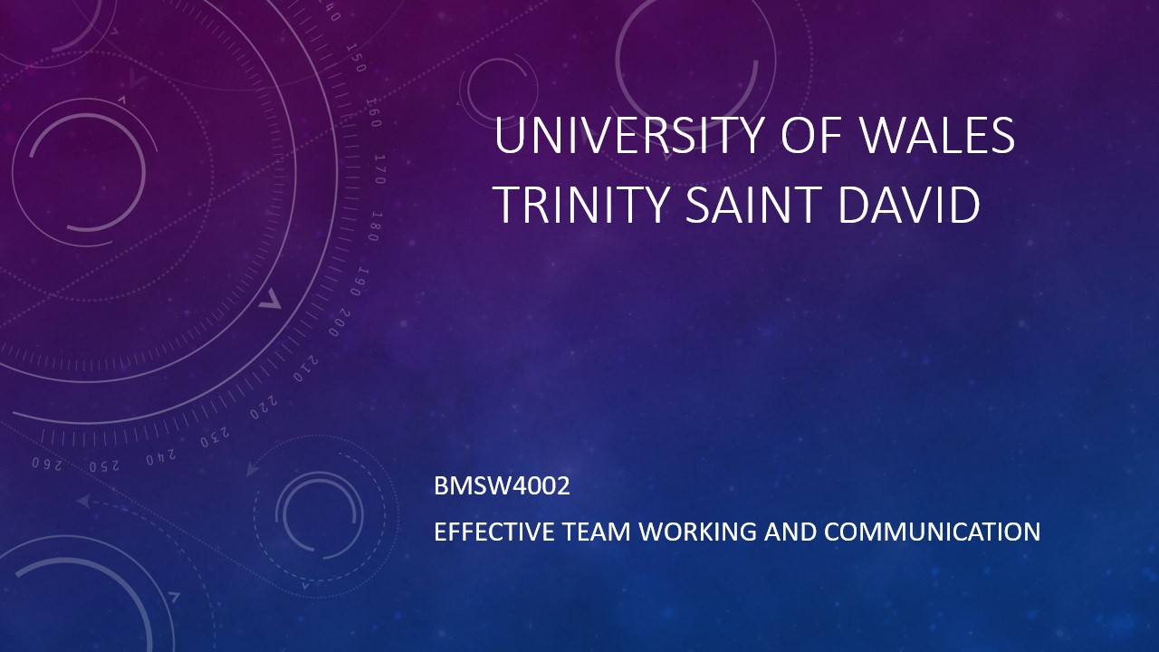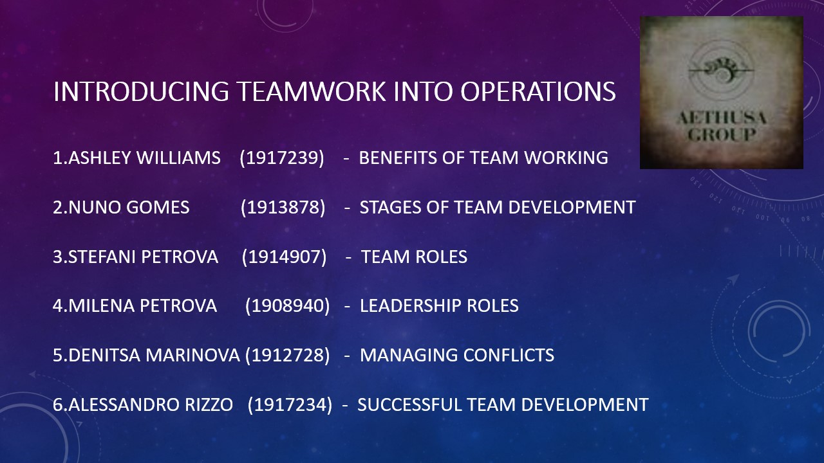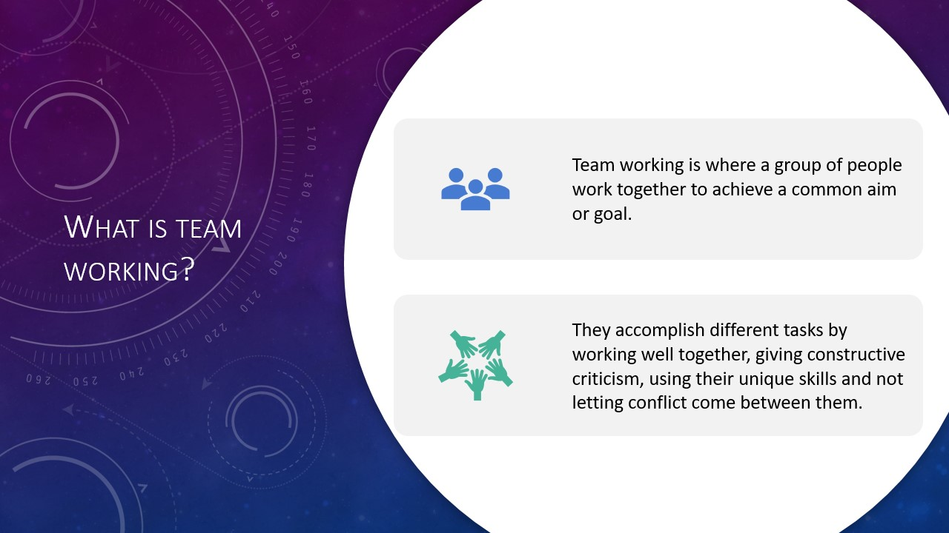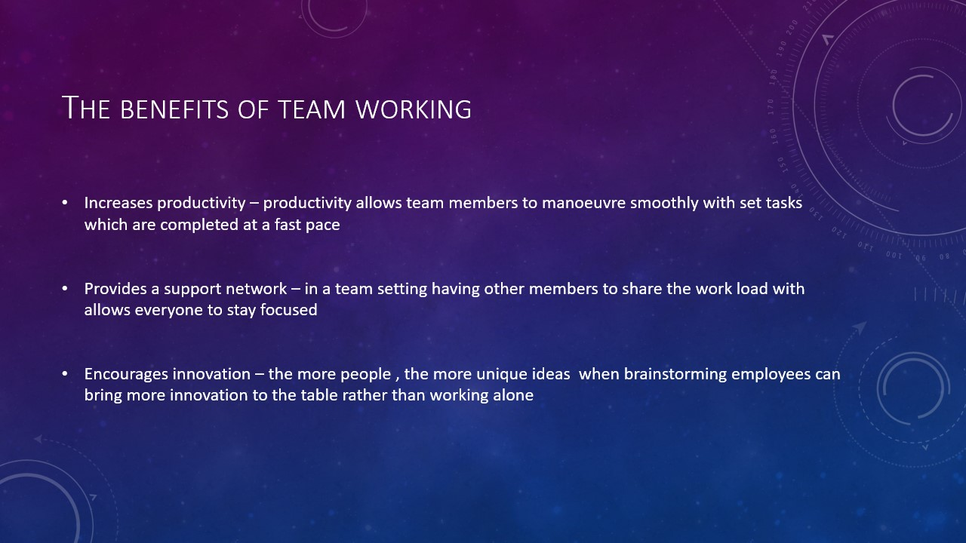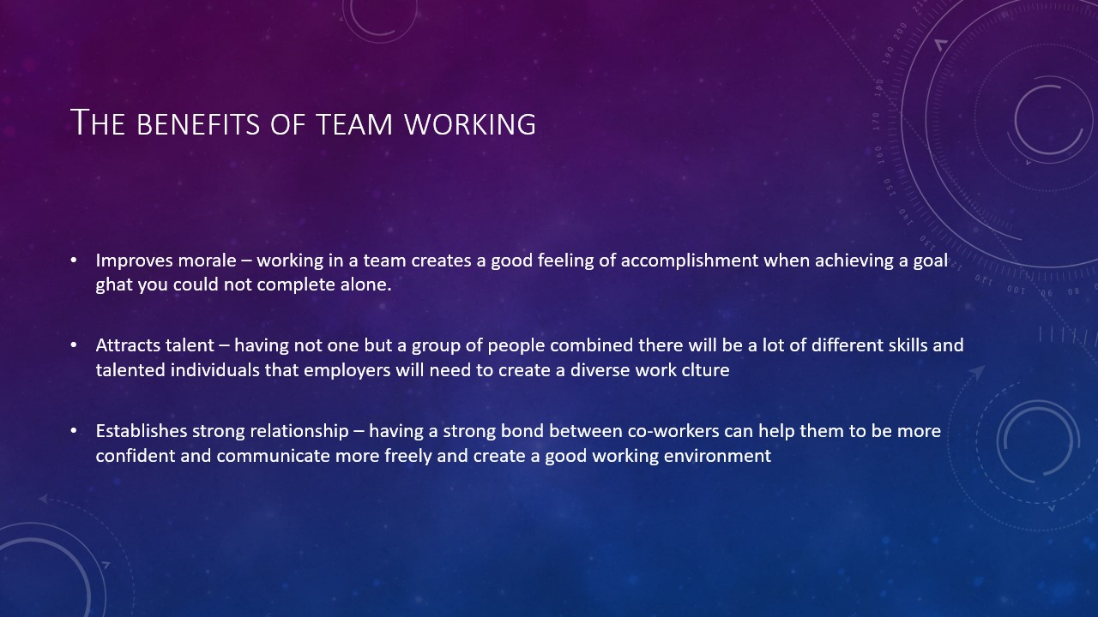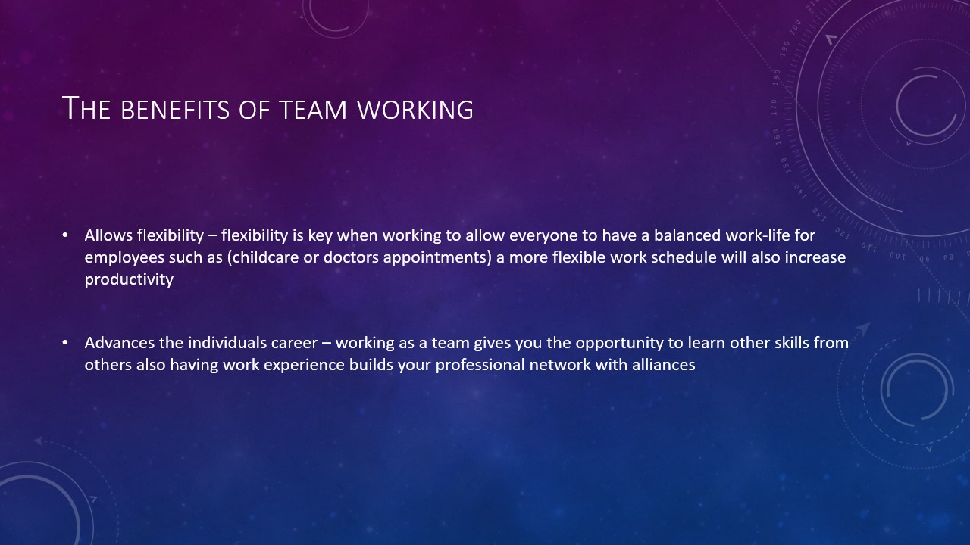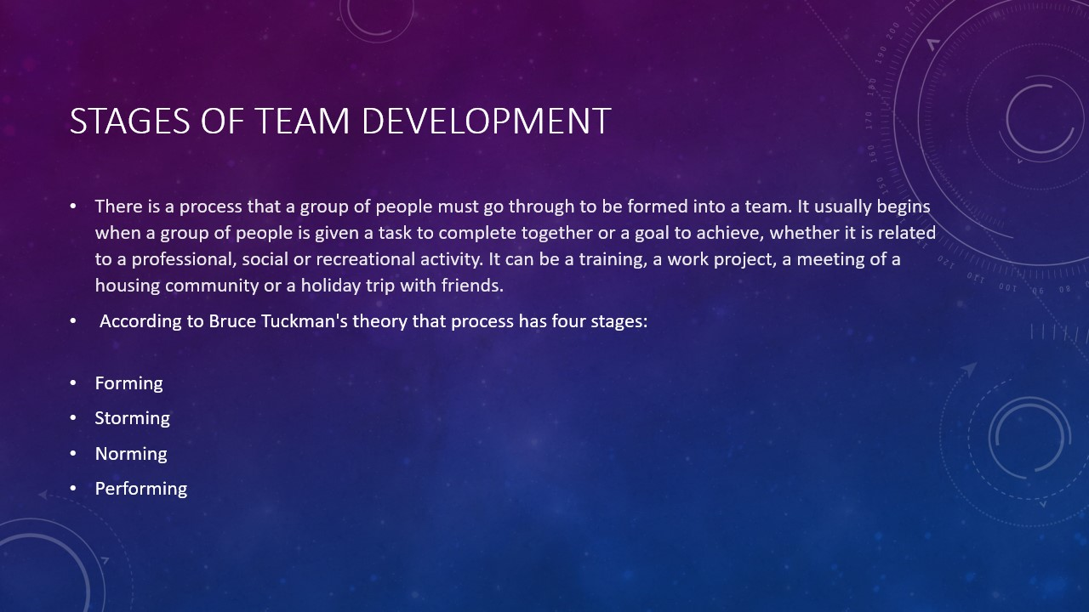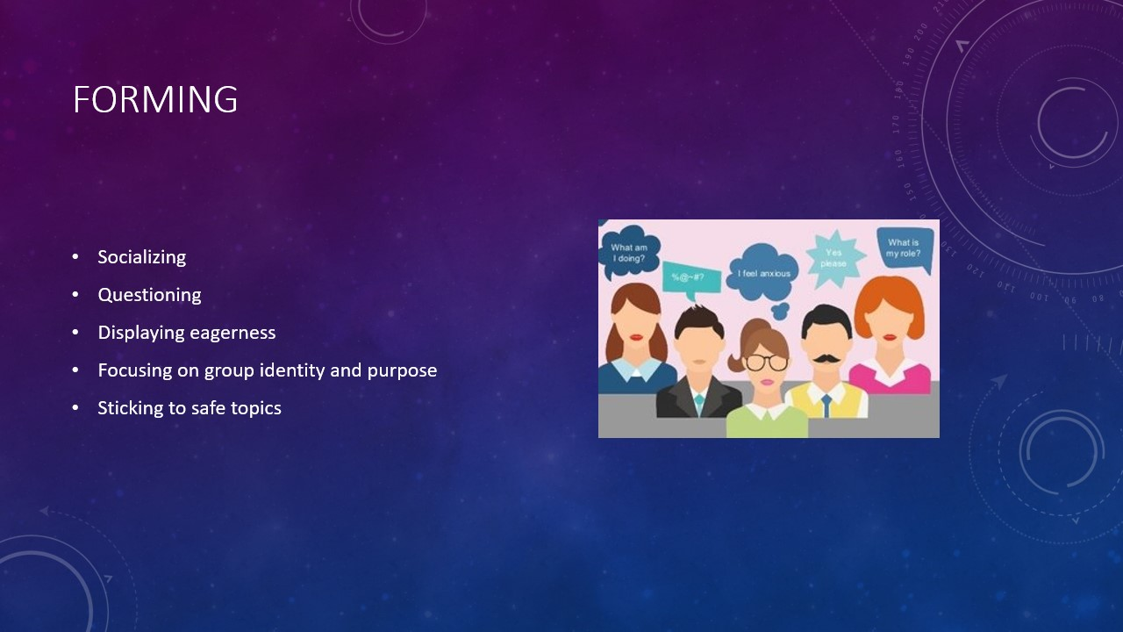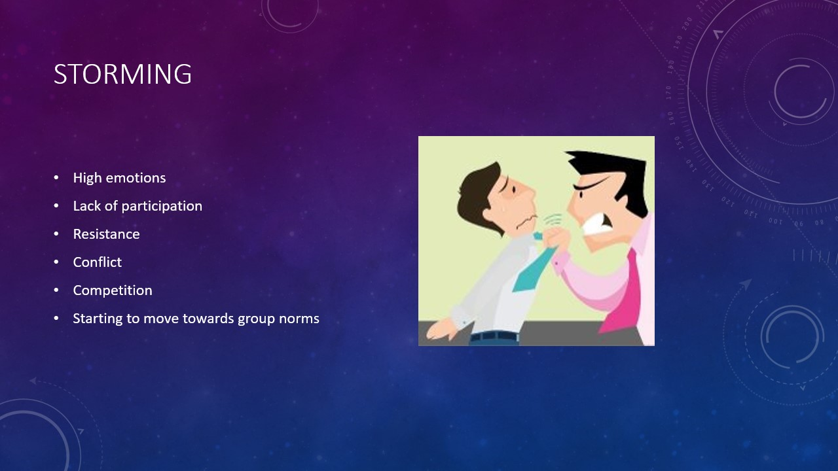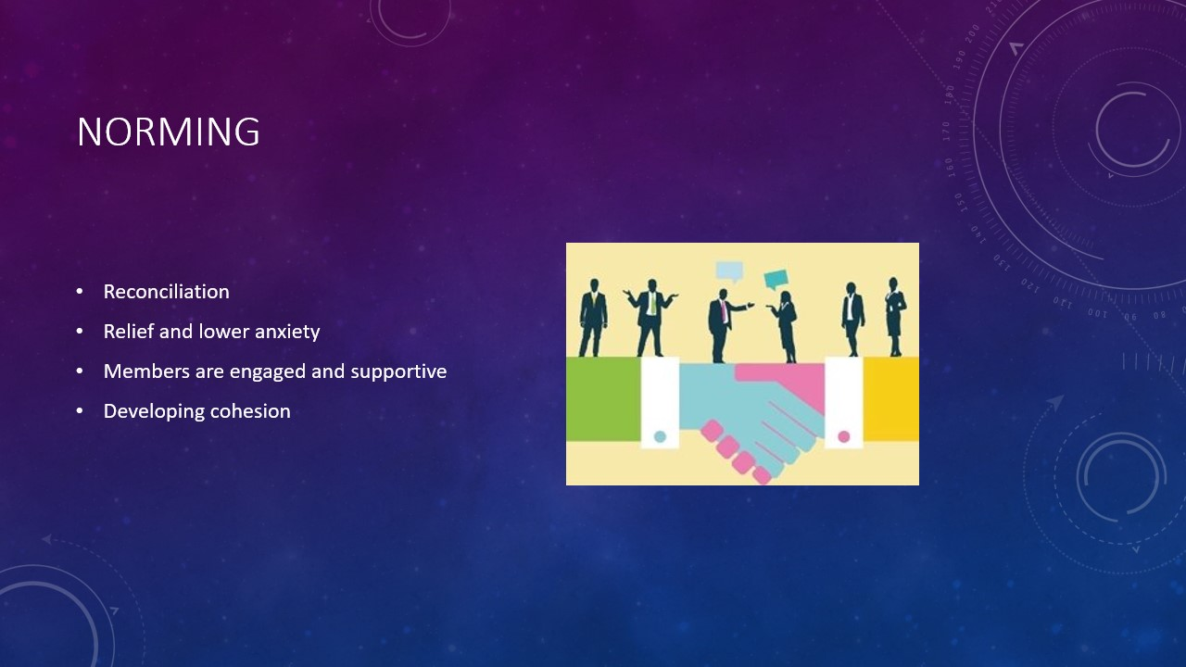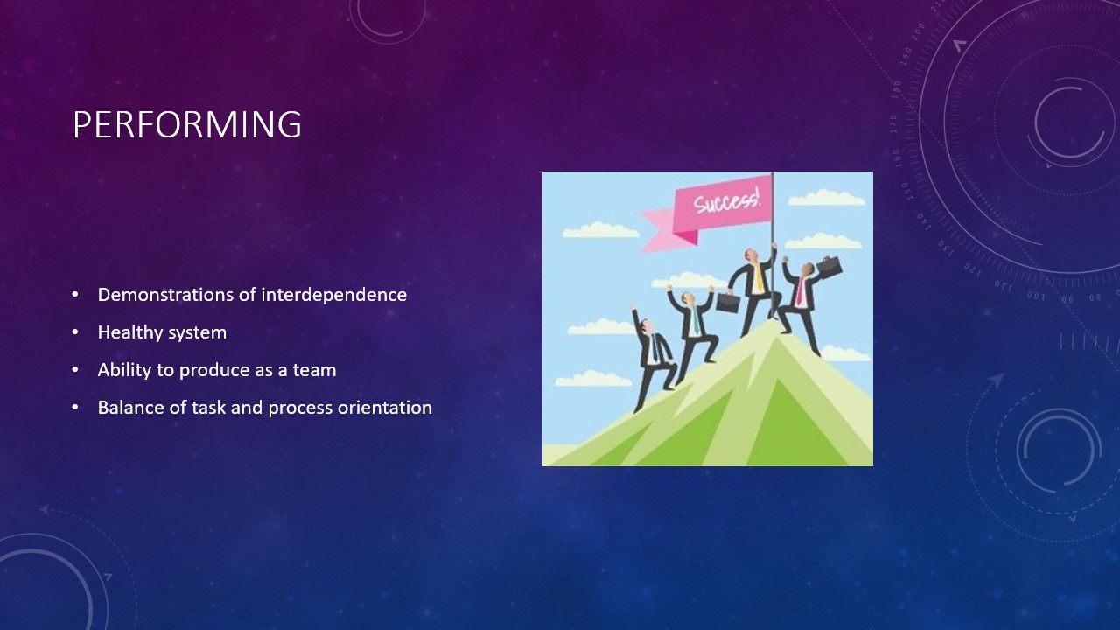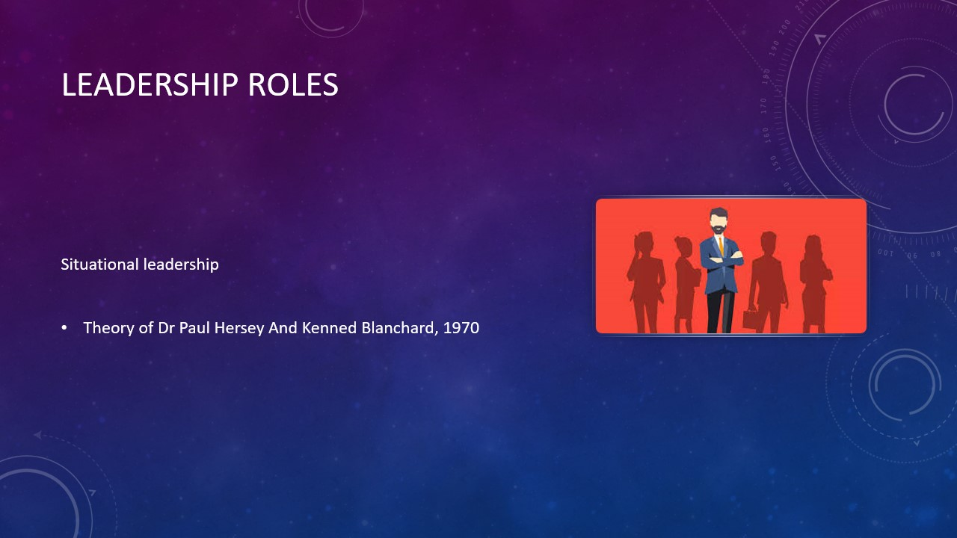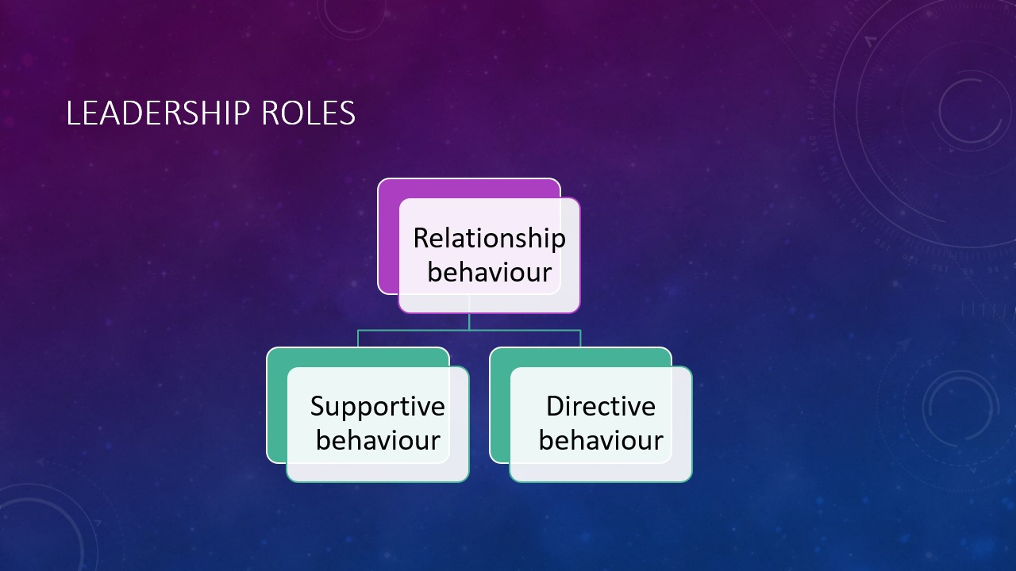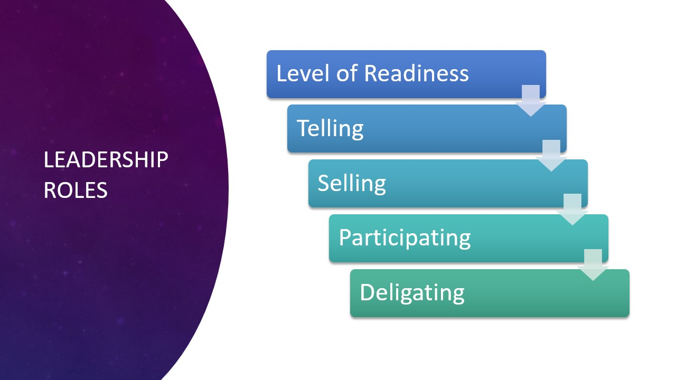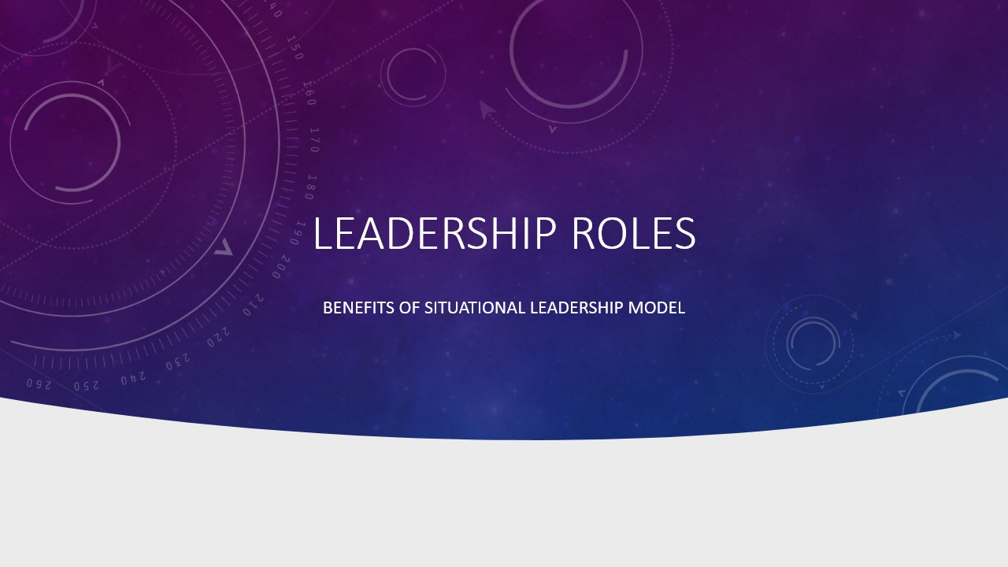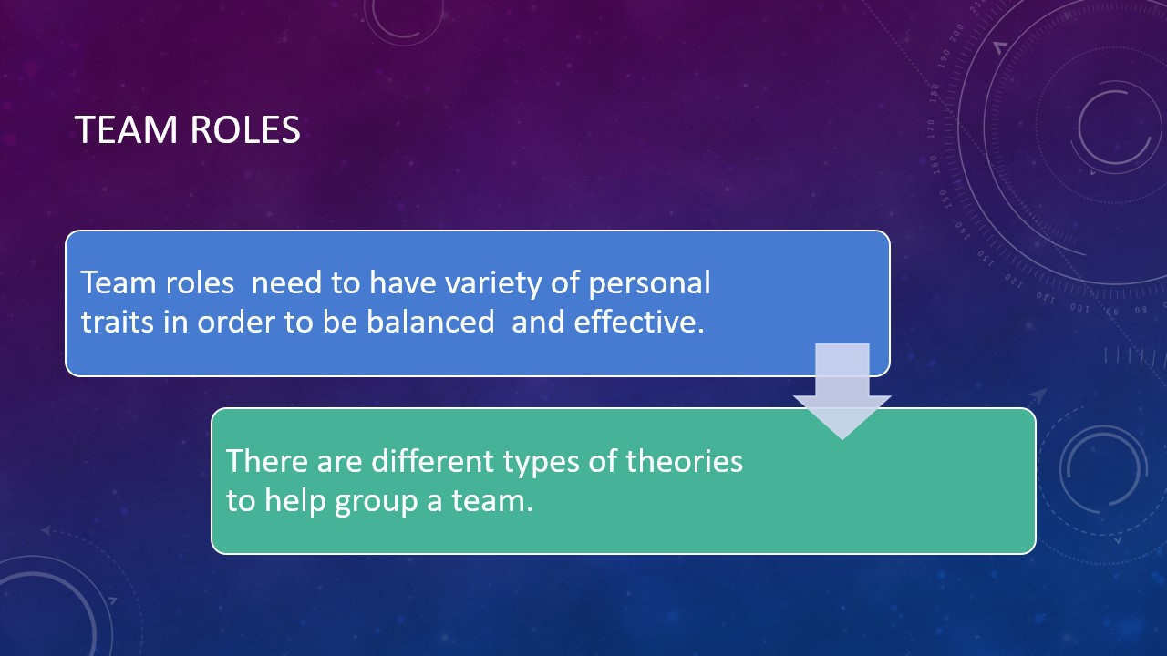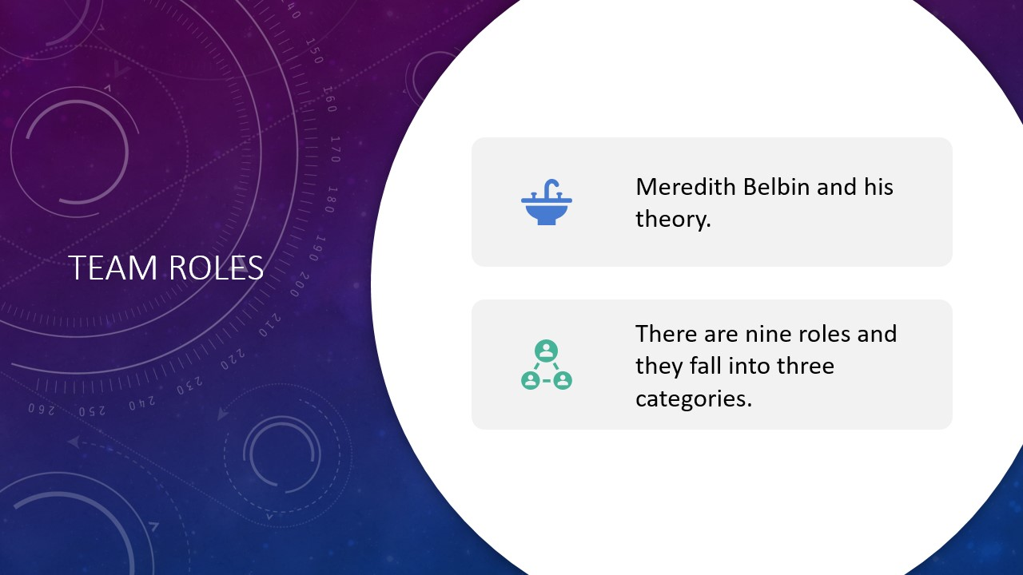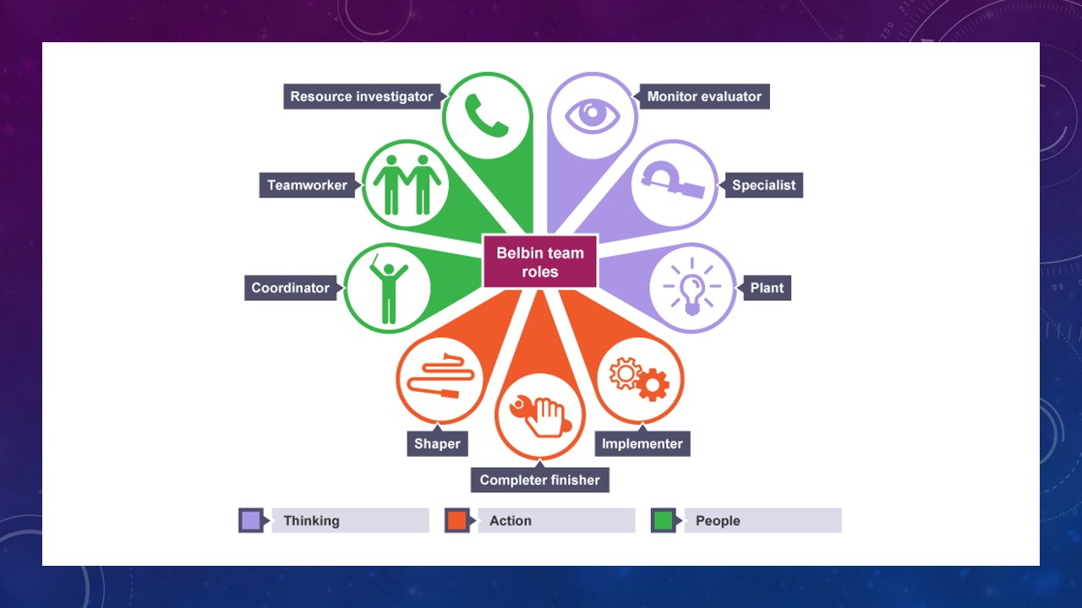
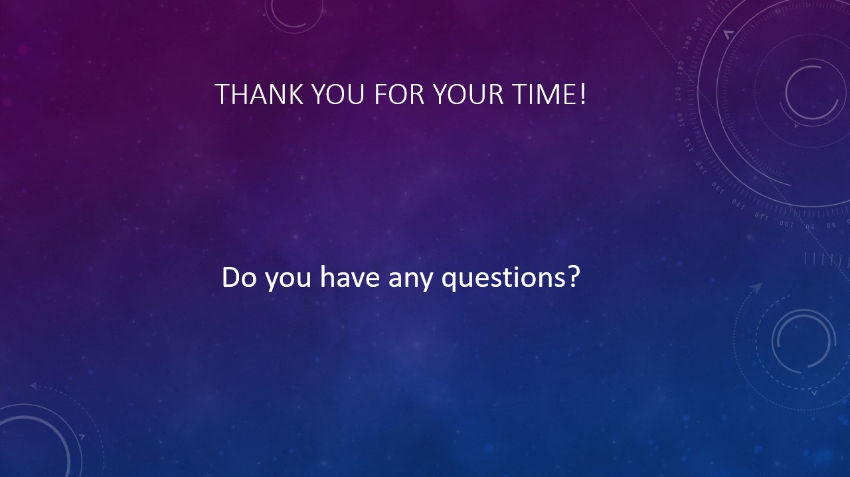

Leadership roles
Every job we perform as humans have specific responsibilities and skills that come with it. And as we all know, each of us takes part in various positions.
The theory created by Dr Paul Hersey and Kenneth Blanchard "Situational Leadership Theory" (1970) gives an idea for leaders to match their behaviours with the presentation needs of the individual or team that they are managing. "If you are looking for a formula… there is no magic solution for leaders". (Dr Paul Hersey 1931-2012)
Situational Leadership model benefit to leaders to develop difficult situations as a cause of extensive research. This theory built on the capacity of Leadership. Task behaviour and the amount of support. Relationship behaviour a leader should give the situation and the level of Readiness of the supporter or company. The best leaders take the time to weigh the many variable situations and select leadership approach. (R. K. Hambeton, R. Gumpert 1982)
Task Behaviour and Relationship Behaviour
The acknowledgement of task and relationship as two critical of a leader's behaviours has been an essential part of management research from a long time. These two elements have provided different descriptions, "autocratic" and "democratic" to "employee oriented" and "production-oriented". Those called these two elements "Initiating Structure" and "Consideration". They can define in the following approach: Task behaviour and Relationship behaviour.
Task behaviour is when the leader communicate and explain what the employer must follow and accomplish.
Relationship behaviour is when the leader is providing the second way to communicate, emotional support "psychological stroke". (Englewood Cliffs, NJ: Prentice-Hall, 1988)
Leadership can provide you with an original idea of your skills as a business leader, no matter where you are in your career path. It could help you to develop your strengths and what you need to learn more about yourself and be able to build your leadership success in the future. Managers need to ensure that the work required to provide the vision handled correctly. Enterprises should prepare their leaders with the tools and reserves they need to pass through the workers global marketplace competently. Still, other leaders had styles characterized by both high-task and high relationship behaviour.

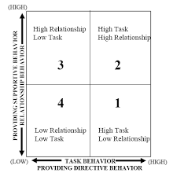Figure 1 (Englewood Cliffs, NJ: Prentice-Hall, 1988)

- Amount of directions and task behaviour leaders gives.
- Emotional support and relationship behaviour leaders provide.
- Specific task or activities that employers must accomplish "Readiness".
- "Separated" is the relationship when there is no trust and detachment between employers and leaders.

Level of Readiness
Situational Leadership model describes Readiness, and maybe the most important is when the person is willing to take responsibilities to control his behaviour and the task, they been given to him. This is sometimes called Maturity or Development level. People are different, and they tend to have a level or Readiness depending on the specific job that leaders are trying to finish through their hard work. The entire model starts with the third variable Follower readiness. Sensually is how ready the person to perform a task is, for example, if I was work in a club as a bartender. You are my supervisor, I might have a lot of skills but to make a cocktail is not one of them, so I must ask myself how ready I am. Readiness is made of two variables Competence and Confidence. When you combine these two variables, you came up with these four combinations:

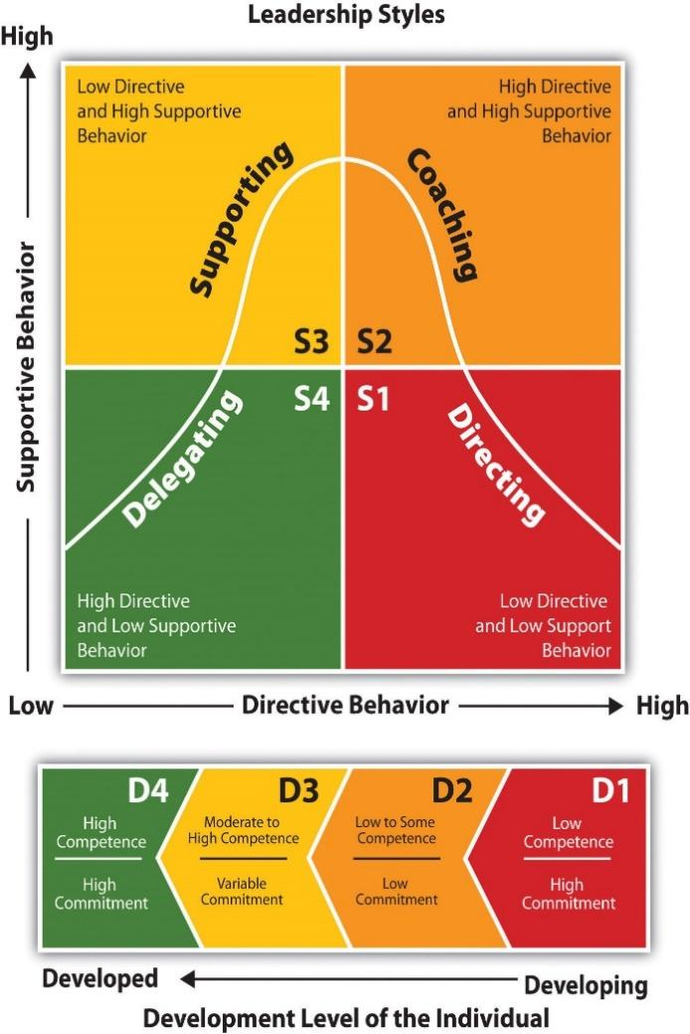
Figure 2. SLII - Development Level of the Individual (Situational Leadership Model, 2013)
Telling - Directive behaviour is when people need a leader to support and provide information about, specific task, when the have low confidence for the new employee.
Selling - Low to several competent and confidence which make the employers feel better in their job.
Participating - Supporting Leadership is when the leader offers less direction and allow members of the staff to take more active roles and coming up with ideas. Directive behaviour is when people need a leader to support and provide information about, specific task, when the have low confidence for the new employee.
Delegating - Leadership this characterize by less involved, hands of approach to Leadership. Group members make most of the decisions and take more responsibility and Employers are highly competent and confident, no need for any direction in their job.

Expert estimate that it can take one and two years for the employee to be fully productive. Vital elements to the Situational Leadership Model are to identify employer readiness (Competence + Confidence), match your leadership style to the employer based on this Readiness, and last no two employers or situation are alike.

Reference

- Paul Hersey and Kenneth H. Blanchard, Management of Organization behaviour: Utilizing Human Resources, (Englewood Cliffs, NJ: Prentice-Hall, 1988).

- Development Level of the Individual [Chart]. (2013, September 29). In Self Awareness. Retrieved March 18, 2018, from
3.http://www.selfawareness.org.uk/news/situational-leadership-and-developing-great-teams.

Successful team development
Every successful team is supported always by some factors like different skills, management support, and clear goals that are helping every team to be stronger and competitive. (Twomey 1996)
Leadership is one of the most important keys of success for any team the leader must be a person with a strong personality, with excellent knowledge of every skill required and must have good communication to transmit to the team the right way to follow to achieve the success. (Fletcher 1999)
Every workplace must trainee every team member often to help the team to be productive always and to build excellent teamwork. (Brown 2009)
Another way to build a strong team is to trainee them together to be ready to work hard since they will start. If the team leader will be able to encourage every team member and make them feel happy and important like they are enjoying the work, the team will grow up strong and very productive. (Swanson 1997)

Successful team management is imperative in every company that wants to be a leader in the global market excellent management is important for the team because they need to be lead and focus on their goals. (Levi 1995)
Effective communication has extremely important in every successful team because the ways to give a message or information to another colleague is important because will affect his work. If he will receive information clearly and with a good stimulus to make it perfect there will be an excellent job done. (Lindelow 1989)
The basic of every entrepreneur of success his how strong is his teams because it is very important to make success to have collaborative people around. In fact collaboration in a workplace is the principal way to make a success with the excellent communication and trust of every colleague. A lack of one of these can be a big issue for an organization and can make an unsuccessful team. Good relationships in the workplace are very
important because everyone will work happy and feel important to reach the goal of the organization. ( Yang 2014)
If the team will reach its goals, every team member will have done a great job and this means that will have got a development individually and like a team. There are some characteristics that every member must have to be part of the group like to be open mind to others' ideas and able to avoid any kind of conflict. (Aritzeta 2005)

References:
Flechter M., August 1999. The effects of internal communication, leadership and team performance on successful service quality implementation: A South African prospective.Team performance management.
Q.Brown, F.Lee, S.Alejandre. April 2009. Emphasizing soft skills and team development in an educational digital game design course. Proceedings of the 4th International Conference on Foundations of Digital Games. PP 240-247.
Swanson J. May 1997. Building a successful team through collaboration. Scholarly Journals.
Levi D., Slem C. July 1995. Team work in research and development organizations: The characteristics of successful teams. International Journal of Industrial Ergonomics. Vol.16 PP.29-42
Lindelow J., Bentley S. 1989. Team management. ERIC Publications.
Yang I. December 2014. What makes an effective team ? The role of trust (dis)confirmation in team development. European Management Journal. Vol.32 PP.858-869.
Aritzeta A., Ayestaran S. 2005. Team role preference and conflict management styles. The International Journal of conflict Management. Vol.16 PP.157-182

What is the management conflict?

Management Conflict is a purposeful activity of the subject of management, which is carried out for prevention, as well as at all stages from the emergence and development of the conflict to its completion.
Conflict management involves the following processes:
1. Diagnosis of the environment and the organization (periodic scanning; scanning for changes). Disclosure of individual elements (symptoms) of a pre-conflict situation
2. Planning
3. Organizing and coordinating.
4. Impacts on the pre-conflict situation (conflict).

5. Control of the results (consequences) of the conflict management and conclusions for subsequent impacts.

Team roles
Teams are made up of different types of people possessing different types of skills and qualities working towards achieving goals and objectives. Some people are better at some things than others. Teams need to have variety of personal traits in order to be balanced and effective. There are number of different theories to help group people based on their core strengths. Two of the most popular approaches are the Belbin test and the Myers-Briggs Indicator. The primary difference is that Myers-Briggs is a psychometric test which tries to identify your personality whereas Belbin is a behavioural test which tries to identify the traits you can display out of 9 possible roles.
Meredith Belbin came up with his Belbin Team Inventory test during his time at Henley Management College. His goal was to try to determine the ideal roles that an individual can assume within a team and what sort of work they are better suited for. Participants perform the test – evaluating their own behaviours and comparing their results with that of an outside observer. There are 9 roles and individuals typically are strongest in some and weakest in others. Using this approach, the idea is that for a team to be their best and most effective it should be made up of individuals which, between them, can fill in all the 9 roles. They are known as thought oriented, action oriented and people oriented.
1. The Monitor Evaluator (thought), they make decisions based on facts and normally are able to take criticism. They have strategic planning and are able to look at all angles of a situation and give a solution. They tend to be lonely. They perform best when there is a challenge as their ability to solve problems is elevated; these personages usually hold managerial positions due to their sufficient ability to consistently make effective decisions.

2. The Specialist – (thought), is expert who has in-depth knowledge about a subject. Just like the Monitor Evaluators they tend to be loners and when working as part of a team it usually does not come naturally to them. They are extremely useful as they provide technical knowledge that very few can and senior management create proposals and projects based on their expertise. Although they find it challenging when working in a team, they become very engaging when it comes to their field of knowledge and will share it with others who want to learn.

3. The Plant – (thought), is independent and creative. They will be the ones who produce original ideas and suggesting new ways of doing things. Plants are team members that prefer to work alone as that is their strength, usually leading to ground-breaking concepts. They are all about progress and bring progression to the team.

4. The Shaper – (action), is a confident asset who pushes themselves and others to achieve goals and objectives in a team. Shapers are driven and inspire and motivate team members even when a challenge arises. They manage to stay positive because they enjoy working under pressure and that allows them to create strategies to help the team achieve their mission.

5. The Implementer – (action), is a practical person and highly disciplined. They are best at organizing and they like to structure their environment and maintain order. They usually prefer to do things in already established ways, however they can change that disregard of their self interest, in order to achieve positive results. They are flexible and negotiable, implementing strategies for quick and efficient task completion for everyone in the team.
6. The Completer/ Finisher (action), They are individuals who involve in key stages of a project assuring quality. They are able to spot fine details and this allows them to easily review tasks or products for any errors. The completer is precise and strictly follows deadlines and expects the same from others.

7. The Coordinator (people) – they have excellent interpersonal and communication skills. They focus on helping team members accomplish their individual objectives. They are excellent on identifying individuals talents. Coordinators are very calm and trusting individuals who are able to utilize each member’s strengths appropriately.

8. The Team Worker (people) - they are good listeners, flexible and highly adaptable. They establish harmony within the team. If they notice someone is not coping with their work, they are likely to step in and help. They are excellent at solving personal issues and usually rise to senior positions.

9. The Resource Investigator (people) - they are talented in networking. They are positive individuals who like exploring new opportunities hence that is why they are excellent at making new business contacts and carrying out negotiations. They find new ideas opportunities and investigate new developments. Resource investigators come up with new ideas themselves however they are very good at picking up ideas from others too.

STAGES OF TEAM DEVELOPMENT.

Team development process are the stages a group of people go through to be formed into a team. According to Bruce Tuckman's theory, 4 stages can be identified in the team building process: forming, storming, norming, performing. This process begins when a group of people meet to complete a task together, achieve a goal. It can be a training, a project, work to be done in a team, as well as a holiday trip of friends or a meeting of a housing community. The goal is efficient cooperation in a group, effective learning during training or an effective decision-making process.
The first step is team formation (forming). At this stage, group members explore their boundaries and the boundaries of the group. It is not known what the norms in the group are, what is its structure and role division, what are the goals of individual members of the group and what guide it as a team. It is also unknown who the leader of the group is. And this knowledge is important for team members to find their place in it.
The next stage is called storming. At this stage, there is an internal conflict in the team. The word conflict suggests that it is a group quarrel. It does not have to be like that - it can be an exchange of views, a misunderstanding, a perceptible tension. Conflict does not have to take place between all members of the group - depending on the size of the group, it usually occurs between 2-4 members of the team. Often the conflict is triggered by some behaviour which, during the formation stage, goes beyond the group boundaries, is not accepted, or rejected by most participants. In this phase, potential leaders stand in opposition to each other and defend opposing interest groups, opinions, and goals. At this stage, stress, aggression, frustration, anger, anger can emerge at the emotional level.
Norming is the stage of normalizing, creating rules. In the normalization phase, the process of defining the team structure that started in the conflict phase continues. The division of team roles is established, the role of a leader is established, the group establishes a set of behaviour norms and rules of functioning. The group's goal and vision of its operation emerges. The team starts working together, it becomes cohesive. Team members create relationships with each other. It is a stage of stabilization, so emotions of satisfaction with the developed solutions, satisfaction and willingness to act appear.
The next stage is performing. It is the stage of action and effective cooperation. The performing stage comes when the group knows how it works, where it is going and who is leading it. And team members know their roles and know what contribution they are making to the group. Then the team can work effectively, cooperation between individual members is good. Then it is possible to efficiently implement the common goal of the group. It is a stage of action, so it is accompanied by feelings of realization, fulfilment, and happiness / contentment.
Sometimes there is mention of one additional phase of the group's functioning - the adjourning stage. Tuckman placed it at the end of the process, after the performing phase. The Adjourning phase is the final stage of team development. It is the closing phase. The team is wrapping things up and members are being recognized for their contribution to the group.

Benefits of Team Working

What is team working
Team working is where a group of people work together to achieve a common aim or goal. They accomplish different tasks by working well together, giving constructive criticism, using their unique skills and not letting conflict come between them.
Here are some benefits that go hand in hand with team working;
Productivity
Productivity allows team members to manoeuvre smoothly with set tasks which are completed at a fast pace. With more people involved and workload being distributed equally thereby creates
Provides a Support Network
Team members will help and rely on each other for support and guidance. In a team setting having other members to share the work load with allows everyone to stay focused on their goals and complete projects more efficiently.
Encourages innovation
The more people, the more unique ideas when brainstorming employees can bring more innovation to the table rather than working alone.
Improves morale
Working in a team creates a good feeling of accomplishment when achieving a goal that you could not complete alone. This combined with a sense of belonging, appreciation and recognition can drastically improve an employee’s self esteem and morale.
Attracts talent
Having not one but a group of people combined there will be a lot of different skills and talented individuals that employers will need to create a diverse work culture.
Establishes strong relationships
Having a strong bond between co-workers can help them to be more confident and communicate more freely and create a good working environment as well as to encourage and motivate each other to work to their best ability , which is
key to the success of any business.
Allows flexibility
Flexibility is key when working to allow everyone to have a balanced work-life for employees such as (childcare or doctor’s appointments) a more flexible work schedule will also increase productivity also members are generally cross-trained to cover for each other’s skills and strengths.
Advances the individual’s Career
Working as a team gives you the opportunity to learn other skills from others. By collaborating with others at work, it exposes you to other skill sets, and you can take on board new skills to expand your own knowledge also having work experience builds your professional network with alliances.

