In September 2019, the local Council in London conducted a survey into the public’s perception of County Lines (London Council). It was established that London was the main source of county lines across the UK. County lines is a policing term used to describe the distribution of illegal drugs from urban to rural areas. This is conducted effectively by ‘branded’ mobile phone lines. The criminal exploitation of children via county lines is a key priority in the Serious Youth Violence Strategy (HM Government, 2018). In 2019 the Home Secretary stated that £20million worth of funding would go towards tackling county lines through the County Lines Coordination Centre (Guardian,2019). Many researchers found that there was a significant disregard towards the harm inflicted on the young people involved in county lines, and that these youths were labelled as criminals rather than victims (Turner, Belcher and Pona, 2019). The National Crime Agency (2019) stated that 11% of county lines involved local ‘juveniles’, 13% involved the exploitation of out of local police force’s young people, and 2% stated that there was some form of child sexual exploitation or abuse in their reports. These figures are reported to the media and reflect on members of the public’s perceptions and understandings of county lines, and people’s ignorance towards the vulnerabilities surrounding county lines. The Guardian (2019) found that “Child welfare and media narratives construct a binary picture of evil county lines gangs and helpless victims”. However, there is no evidence of professionals acknowledging that some ‘evil’ gang members may be victims themselves of exploitation or poverty and may have experienced numerous adverse childhood experiences early in life, giving them no option but to commit crime to survive (McClean et al, 2020). McClean (2020) insists that the victim of exploitation is often the exploiter too. Some believed that children steer towards drug supply as the lifestyle is an appealing one (Coomber and Moyle, 2018). Whilst others believe that youths follow that lifestyle due to agency involvement and rational choice of involvement (Irwin-Roger, 2019). Child criminal exploitation is now recognised as a form of child abuse, therefore a multiagency and partnership approach in required to safeguard children (HM Government, 2018). There are various strategies and approaches that have been adopted by local governments and councils across the UK to address these matters, some youths are relocated to youth justice services across the UK due to the lack of national strategies for safeguarding young people from harm outside of their families (Maxwell et al, 2019; Child Safeguarding Practice Review Panel, 2020).

The Child Safeguarding Practice Review Panel (Annual Report, 2020)
The Child Safeguarding Practice Review Panel (Annual Report, 2020) is an evidence-based source which investigates serious incidents involving children and young persons. It is an annual review from the Children Safeguarding Practice Review Panel. Its analysis and reflects on England’s safeguarding practices in the last year, although, it must be noted that this review was reported following the coronavirus pandemic, therefore there was a large amount of pressure on families and agencies to safeguard and protect youths (Gov, 2020). This panel seeks to establish a contemporary framework of how best to safeguard and protect children nationally and across local authorities, stability and clear guidance would help prevent children being involved in county lines and serious crimes, as they would be dealt with in a consistent manner (Maxwell et al, 2019).
This report is consisted of quantitative analysis of local child safeguarding practice reviewers, and 25% of rapid reviews received during the year. It also consists of analysis of safeguarding partners yearly reports. The panel has an external organisation to gather research and intelligence with safeguarding partners and stakeholders for a more qualitative approach. All of the most serious incidents and reports are discussed and investigated on the panel, and the date was placed into numerous charts to identify patterns and trends of how best to safeguard children. The below chart demonstrates how many cases of non-fatal physical abuse have been investigated on the panel:
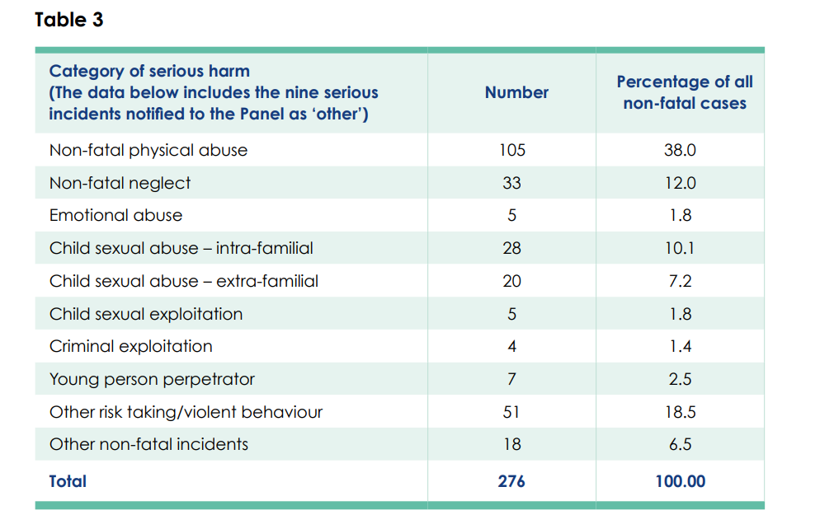
Figure 1 - • The Child Safeguarding Practice Review Panel (2017). Available at: The Child Safeguarding Annual Report 2020 (publishing.service.gov.uk)

Table 3 shows that the Child Safeguarding Practice Review Panel found that non-fatal physical abuse was the most common form of serious harm inflicted on children at 22%, shortly followed by 10% being that of child sexual abuse. Young persons being involved in violent behaviour or other risk taking, perpetrators of violence were at 11%. The Child Safeguarding Practice Review Panel found on another report that neglect was the primary cause of all cases reported, they acknowledge that this is the route cause for many youths being involved in criminal exploitation.
51 incidents reported that young people were involved in risk taking or violent behaviour. 37 (75%) of which were involved in gang violence or county lines. 15 of the 51 were involved in self-harm, and 4 of which were involved in criminal exploitation of drug supply. Seven of the 51 were the perpetrators of serious violence to another person. Child criminal exploitation was made the panel’s annual priority of the 2020 review following these statistics. Beckett, Holmes and Walker (2017) argues that interconnected conditions must be understood in order to address child exploitation. This included the source of why they have made these decisions, such as neglect from childhood, the young person’s vulnerabilities, and their protective structures (Beckett et al. 2017).

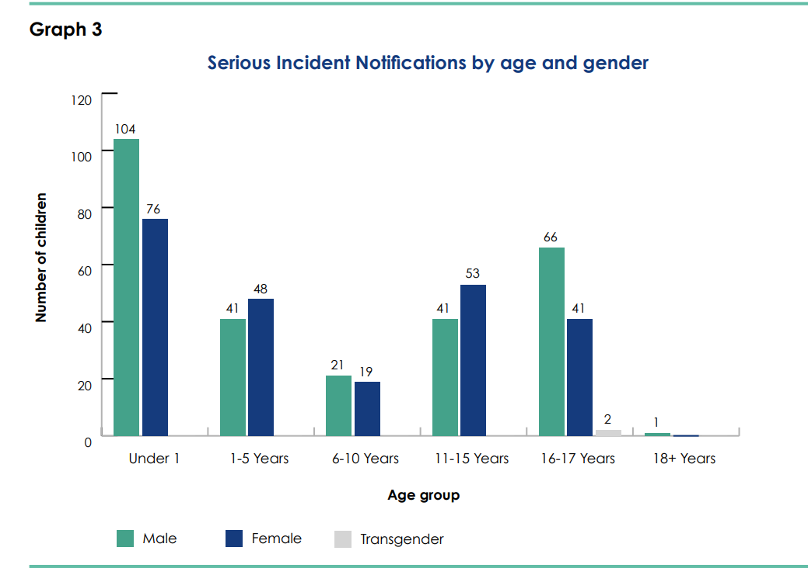
Figure 2- Graph 3 - • The Child Safeguarding Practice Review Panel (2017). Available at: The Child Safeguarding Annual Report 2020 (publishing.service.gov.uk)
Graph 3 shows that the majority of serious incidents reported to the Child Safeguarding Practice Review Panel were those aged under one year old, however 30% were involving youths aged 15-17 years of age, the majority male.
The Child Safeguarding Practice Review Panel concluded that known risks, such as adverse childhood experiences (ACESs) do not always result in youths becoming violent criminals. They identified that those who demonstrate risks of becoming criminalised should not be excluded from schools, as this is encouraging these persons to look for social status and conform to another group for approval (Maxwell et al. 2019). The Child Safeguarding Practice Review Panel also found that moving youths away from their current location is not an effective way to prevent them from involving themselves with gangs as Maxwell et all (2019) previously stated.
Whilst the Child Safeguarding Practice Review Panel demonstrated the percentages of serious violent crimes being committed by children and their correlation with gang crime, it does not demonstrate any strategies in preventing child criminal exploitation and recognising further trends across all ACEs. The only ACE initially addressed was neglect, showing that 35% of all cases were as a result of neglect. A 2019 Home Affairs Select Committee on ‘Serious Youth Violence’ (Home Affairs Select Committee, 2019) stated that there is no strategic approach and response to young people impacted by county lines. It argues that the responsibility falls upon the youth justice system and child protection agencies, combined with the voluntary sector as they can build the best rapport and trust with youths. It is vital that young people are safeguarded from harm, however, the number of young people involved in county lines and committing serious crimes is on the increase according to the statistics of young people being convicted of drug offences (McCulloch and Furlong, 2019). Setter and Baker (2019) argue that mechanisms such as youth referrals and strategies to support victims are underutilised. It is also possible that young people have been labelled too much as ‘victims’ in this report, and there has been a disregard towards any real victims of the crimes in which these youths are committing in their communities, causing community tensions.

The Child Safeguarding Practice Review Panel had no mention of any police involvement, whereas the National Crime Agency Report: County Lines Violence, Exploitation and Drug Supply 2017 is a national overview report looking at the threat of county lines drug supply, violence, and exploitation across the UK.

National Crime Agency Report: County Lines Violence, Exploitation and Drug Supply 2017:
This report is supported by the Home Office and NPCC. Information and intelligence are also gathered by civilian agencies such as Ending Gang Violence and Exploitation, and Gangs Inter-Ministerial Group meaning this report takes a more qualitative approach. The information in this report is dependant and gathered from 43 Territorial Forces across England and Wales, including British Transport Police, however their findings were not included in the report as they are not located in a particular area. A child in this report is considered anyone under the age of 18 years. The report aims to support the response to county line drug supply and address the violent gang related violence in the UK by providing insight to the world of County Lines. There in a combination of national overviews of crime, and local/reginal overviews allowing a more wholistic and realist approach to the research. This encourages a clear way of addressing county lines, as advised by Maxwell et al (2019). The findings of this research looked at various persons involved in the county lines the use of vulnerable people and children involved in county lines.

Statistics:
The National Crime Agency Report 2017 found that the most supplied drug from gang members in the UK was class A drugs, namely crack, cocaine and heroin. The report established that 88% of police forces have a problem with county lines in their area. It is believed that there are now 720 county lines run across England and Wales. However, these statistics are gathered by police forces, therefore the reliability of this figure is likely to be incorrect.
10 forces reported that gangs are steering away from cuckooing and are now looking for other ways to set up base in rural areas, such as staying in hotels. It is possible that this is due to police disruption. 26% of forces found that the cunty lines ‘deadline’ mobile numbers change frequently, meaning that it is more challenging for police to track down and gather solid evidence on any gang leaders. 18% of forces report that the gang members are beginning to try hide their identity by having inconsistent travel methods, eating out, phone lines and locations to stay, hiding the identity of the county lines runners. Traditionally, drugs would be stored in one main location, and children or vulnerable people would rotate staying at the property and distributing drugs from the ‘stash house’ in various sized batches. This rotation of individuals located in the ‘stash house’ has been reported by 12% of police forces.

Vulnerabilities and Youths:
Hiding the identity of the county line runner is reinforced by their use of exploiting young persons and vulnerable persons. 30% of forces reported ‘plugging’ whereby children’s bodies in particular would be used to store drugs and transport them from one location to another without the drugs being taken. ‘Plugging’ drugs hold severe health risks and leaves the person carrying the drugs at risk of being subject to violence and intimidation. Children are preyed upon and targeted to carry drugs and money from urban areas to rural areas. Children known as ‘clean skins’; children with no criminal record, are targeted as they are less likely to be stopped by police. Children who have little possessions, parents who are less protective, children who go regularly missing, those in care or exposed to broader vulnerable issues are most likely to have an involvement in criminal drug activity and county lines.
Forces also reported that those who have existing drugs misuse problems, mental health issues, physical health issues and are at a point of crisis are easily targeted by gang members.

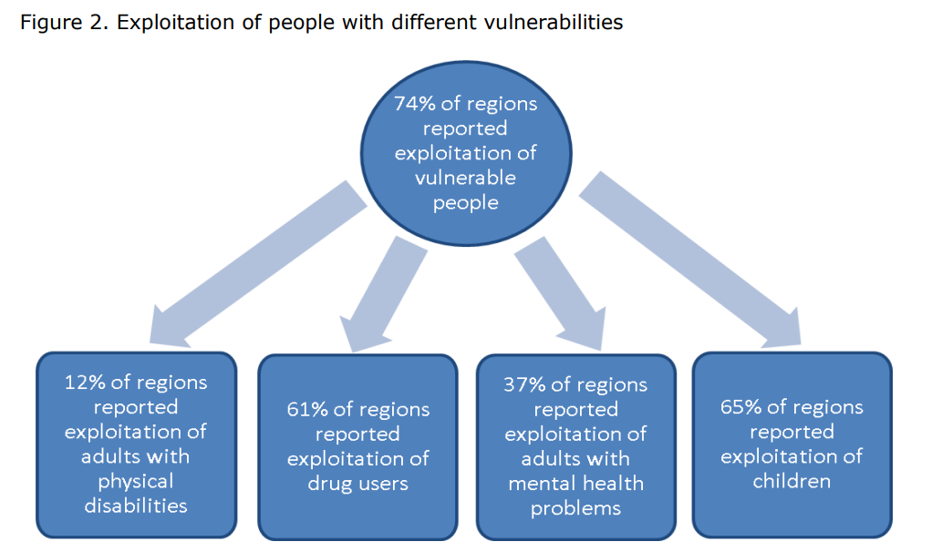
Figure 3 - figure 2 - • National Crime Agency Report: County Lines Violence, Exploitation and Drug Supply 2017. Available on: (nationalcrimeagency.gov.uk)

Figure 2 shows that 74% of police forces reported exploitation of vulnerable people, 65% of forces noted exploitation of children regarding county lines. The NPCC (2017) stated “Children assessed as vulnerable due to missing episodes do appear to be more regularly linked directly or through association to drug networks operating in the areas they reside”. Following this remark, this may be why prior to the Child Safeguarding Practice Review Panel, children involved in county lines were often moved from their area of residency, so that any networks and links with gang crime could be broken. However, it would be argued by The Home Affairs Select Committee (2019) that should this be all a child knows, if they wish to resort to it, they shall.
The National Crime Agency Report 2017 found that 58% of forces reported that vulnerable people saw county lines initially as a business investment and an opportunity to get themselves out of a financially poor situation. Victims then often being coerced into running errands for the dealers such as arranging deals, and are then too scared to report the problem or involve police. These victims are then coerced through debt bondage and fear of repercussions. However, whilst this is a qualitative piece of information, it leaves questions as to which victims have been spoken to, because those involved in county lines will not be involved in these findings, questioning reliability of data.
Young people are often approached and recruited by the promises of valuable assets. Young females will often be used to recruit other young females, and deliberately target children with evidential vulnerabilities such as ACEs. One force reported a gang member attending at a youth drug rehabilitation centre with the purpose to recruit potential drug users to network and use to run the lines. 42% of forces reported children specifically ‘running’ and ‘plugging’ for the drug lines. The average age of child involvement was 14 years old, however one force reported a 12-year-old being involved. The NPCC (2017) further states “Vulnerable young people aged between 13 to 18 years are being recruited to be drug runners/dealers. Most of these young people have accrued drug debts and the networks are using fear tactics, threatening them with violence to force them into working for the line.”
County lines groups use young members to recruit children through personal or social media links. Children who are particularly vulnerable, at crisis, have boarder line mental health conditions or complex difficulties at home. These children are groomed and enticed by gang members to work with them in the drug distribution network. It was found that young males are often used as ‘watchers’ and sometimes given small amounts of drugs to supply. Children are used in county lines because they are less likely to be known by the police, and more likely to be given lenient sentences.
Almost half of police forces stated that children from care homes were involved in county lines, and 15% stated that children in care were specifically targeted by gangs. 35% of forces stated some form of involvement of child sexual exploitation in regard to county lines.

The National Crime Agency Report is a good source of qualitative data research, it evidences facts and findings from police forces, who are the people that are involved front line in detecting and disturbing criminal activity (College of Policing, 2016). Whereas The Child Safeguarding Practice Review Panel takes a more quantitative approach and notes that neglect from a young age may be the route cause to youths becoming involved in violent crimes and drug networking. The child safeguarding review panel states that 58% of their cases they had not yet decided on, therefore making these results unreliable, and leaving questions for how well their victims are being safeguarded. There are significant gaps in findings of child drug exploitation. Both research projects have labelled the child as a victim in this case, it is possible that this is due to them being classified as a child under the age of 18. The police and partner agencies face difficulties when trying to address and tackle children being groomed into county lines as safeguarding opportunism rely on the child being stop searched, or present when warrants or safeguarding visits are conducted. Different elements of the picture will be held on various partner agencies systems, which is why communication is vital and the sharing of information and intelligence is improved (National Crime Agency, 2017). Bourdieu, Mason (2019) developed a ‘Social Harm Theory’ lens (Dorling et al, 1995) and stated that police forces need to utilise statutory interventions rather than criminalising youths and labelling them as ‘evil gang members’.

Words - 2655

- Beckett, H. Holmes, D. and Walker, J. (2017), Child sexual exploitation: Definition and guide for professionals. Accessed on 20.07.2022
- Bourdieu, P. (1986), The Forms of Capital, Handbook of Theory and research for the sociology of education, Greenwood Press, pp. 46-58.
- Coomber, R. and Moyle, L. (2018) The changing shape of street level heroin and crack supply in England: commuting, holidaying and cuckooing drug dealers across “county lines”, The British Journal of Criminology, Vol. 58No. 6, pp. 1323-1340.
- County Lines: Public Attitude Survey by YouGov Commissioner by London Councils. Accessed at: County Lines Research.pdf Accessed on 23.07.2022
- Guardian (2019), We’re coming after you: Priti patel unveils £20m county lines crackdown. Available at: www.theguardian.com/uk-news/2019/oct/01/priti-patel-unveils-county-lines-crackdown. Accessed 01.07.2022
- Home Affairs Select Committee (2019), Serious youth violence, available at: https://publications.parliament.uk/pa/cm201719/cmselect/1016/101602.htm. Accessed on 01.07.2022
- McClean, R. Robinson, G and Densley, J. A. (2020), County Lines Criminal Networks and Evolving Drug Markets in Britain, Springer Briefs and Criminology.
- National Crime Agency Report: County Lines Violence, Exploitation and Drug Supply 2017. Available on: file (nationalcrimeagency.gov.uk) Accessed on 23.07.2022
- Maxwell, N. Wallace, C. Cummings, A (2019) A systematic Map and Synthesis review of child criminal exploitation, What works for children’s social care.
- The Child Safeguarding Practice Review Panel (2017). Available at: The Child Safeguarding Annual Report 2020 (publishing.service.gov.uk) Accessed on 23.07.2022
- Turner, A. Belcher, L. and Pona, I (2019), “Counting lives: responding to children who are criminally exploited”, available at: www.childrenssociety.org.uk/sites/default/file/counting-lives-report.pdf Accessed 20.07.2022

