Edna Davyes Martins (2219393)

Group Dynamics

Definition

Group dynamics are the process that occur between group members, they behaviours as a team or individual. These dynamics are affected by each members internal facts and feelings they express in verbal communication and relationship with each other.
Having the right group dynamic can improve the chances of a team's success, so understanding the concept can be helpful. Group dynamics examine how different personalities, behaviours, and attitudes interact with one another.

Another essential factor in group dynamics is the concept of cohesiveness, which represents the bond and unity amongst members. More cohesion may encourage people to collaborate more with the group and make it easier to accomplish tasks. To gain cohesiveness, the group may establish where they find common interests and values, along with an agreement on their goals and the processes to achieve them. Groups can also increase cohesion when members spend significant time together or must compete against another team.

The term Group Dynamics

A social psychologist named Kurt Lewin coined the term group dynamics in the 1940s. He noticed that individuals take on distinct roles and behaviours when working in a group. Group dynamics describe the effects these roles and behaviours have on the group as a whole, and on individual group members. A positive group dynamic is one where a team can trust one another, hold each other accountable, and collaborate effectively to complete tasks and achieve certain goals.

Types of group dynamics

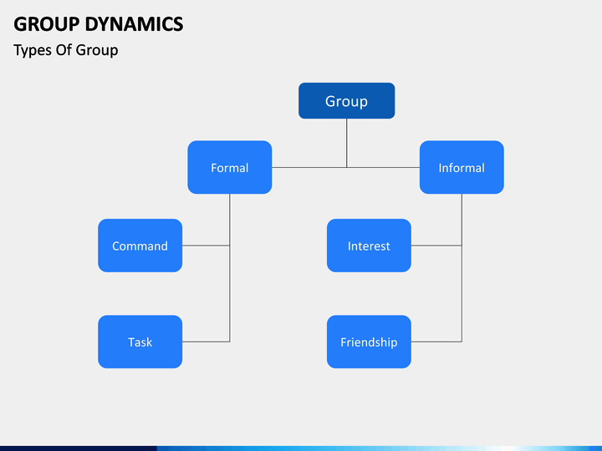

There are two main types of groups: formal and informal. Businesses typically form formal groups to achieve their goals, while individuals with shared interests or values create informal groups. Within these two categories, there are more specific types of groups, such as the following:

- Command

Organizations typically create a command group to implement company policies and guide employees to success. The command group may include supervisors or managers and the employees who report to them. For example, a project manager and the software developers that work under them are a command group.

- Functional

Functional groups work together to achieve a company's short-term or long-term objectives. Each group member has a specific role, and they collaborate effectively to complete one project or many, typically without a specific timeline. Departments, such as a marketing department within a company, are examples of functional groups as they typically work towards the same goals.

- Task

Like a functional group, a task group works together to achieve a specific goal, but they do so within a certain timeframe. Task groups are typically temporary, meaning they disband once they collectively reach their goal. For example, a business may form a task group to create and implement a new employee handbook.

- Interest

An interest group is another type of informal group consisting of individuals from different formal business groups who still have shared interests, such as the well-being of the company. These interests may not align with organizational goals, but members typically want to work together to improve the conditions of the workplace for everyone. For example, a union at a company is an interest group, as they want to create a safe and inclusive workplace for all employees.

- Reference

The final type of informal group is a reference group that acts as a reference point for other individuals. These groups demonstrate what actions or attitudes are appropriate to help positively influence other peoples' behaviours. This gives individuals outside of the group something to evaluate themselves against. For example, an accounting department may evaluate its performance by comparing itself against a competitor's accounting department.

Group dynamic stages
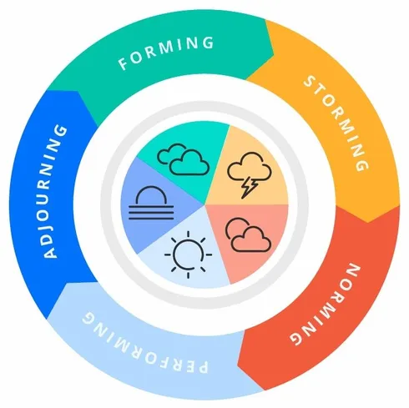

The five group dynamic stages created in 1965 by Tuckman’s.
Helped us understand every stage we’ve been true in this process.

- Forming — a group is created.
- Storming — group members seek out others in the group who share similar interests.
- Norming — group norms are created.
- Performing — group tasks are begun, carried out, and completed.
- Adjourning — a group is disbanded after its goals have been met.

Ever since this group was created, we didn’t stablish trust and enough confidence to get along with one another affecting our process and blocking us for a long time on the storming process.
Going true all the stages at the end helped our team grow, finding solutions to solve the problems we faced, improving the group performance and communication.
Starting with the forming stage we struggled choosing the Team Leader and the tasks in discussion. We didn’t use the time in the right way to know and learn more about each other, causing a crash into the team.
We emerge into the storm stage with a few goals and tasks to accomplish and we’ve got stuck because we didn’t manage how to face the challenge of having other tasks to do at the same time, we are preparing the presentation, finding excuses to look for solutions to deliver better results.

For example: the fact that some team members didn’t understand the questions and tasks provided, claiming a need of prioritizing other tasks in their lives, and not having any kind of resources to work with in the meetings we all agreed to do making all the work harder.
The number of hours to meet was small, and the struggle and pressure higher.

On that stage we behaved as individuals which in a group view was not the best, as we haven’t focus enough I the common goal.
I’ve been chosen as a team leader, and so I used my Team worker an Implementer potential described in Belbin’s Theory to help managing the team into the hard work way showing them my relevant and efficient ways of work.
Supporting everyone, concerning how the work was going, what was done or not.
We used our weaknesses and strengths to pass to the Norming stage which we had some work done.
On the Performing stage following the common goal, we carried out the work, completing the tasks successfully to deliver a good presentation.
On the final the Adjourning stage where the goal its completed and delivered.

Belbin

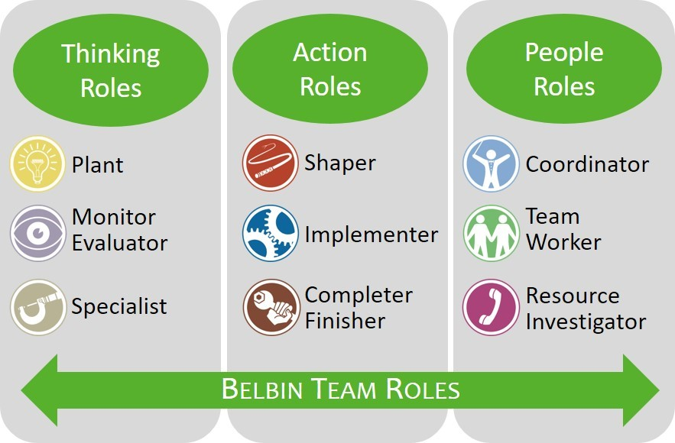

Belbin Team Roles to help you build high-performing teams, maximise working relationships, and to enable people to learn about themselves.

Thomas Kilmann

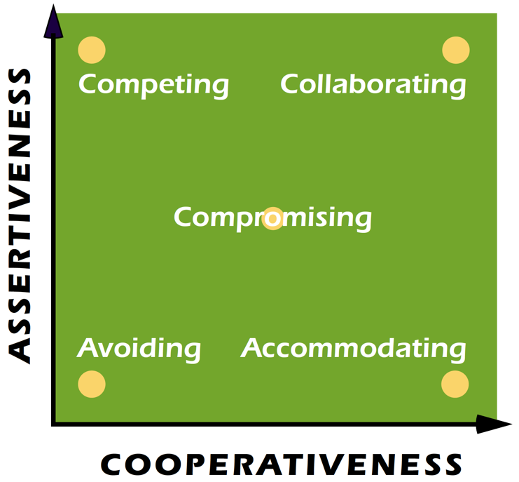

The Thomas Kilmann model identifies two dimensions when choosing a course of action in a conflict situation, these are assertiveness and cooperativeness. Assertiveness is the degree to which you try to satisfy your own needs. Cooperativeness is the degree to which you try to satisfy the other person’s concerns. From this come five conflict handling modes:
- Avoiding - sidestepping the conflict
- Accommodating - trying to satisfy the other person’s concerns at expense of your own.
- Compromising - trying to find an acceptable settlement that only partially satisfies both people’s concerns.
- Competing - trying to satisfy your concerns at the expense of others.
- Collaborating - trying to find a win-win solution which completely satisfies both people’s concerns.

Conclusion

Concluding we end up showing our potential, giving the effort to deliver the presentation in a good way. Knowing how to interact as a group make the leading easier, knowing how to clarify ideas and how the decisions need to be made, how the group respond to a change, and how they interact with each other.

We’ve learned about the team members, attending to meetings, sharing information with the team, not to commit the same mistakes in further presentations, understanding how groups work, improving our performance on finding solutions for the problems we might face and believe more in ourselves.

Reference list

- Forsyth, D.R. (2018). Group Dynamics. [online] Google Books. Cengage Learning. Available at: https://books.google.co.uk/books?hl=en&lr=&id=vg9EDwAAQBAJ&oi=fnd&pg=PP1&dq=group+dynamics+are&ots=t8ssaNKtb3&sig=tnFd-mJXp-x8S-bba7tgk07zTAg#v=onepage&q=group%20dynamics%20are&f=false [Accessed 25 Feb. 2023].
- Litmos Heroes (2019). Belbin’s Theory on Team Dynamics. YouTube. Available at: https://www.youtube.com/watch?v=hMesDq_rNOw.
- ‌ https://www.sagepub.com/sites/default/files/upm-binaries/27380_Chapter3.pdf

- www.sketchbubble.com. (n.d.). Group Dynamics. [online] Available at: https://www.sketchbubble.com/en/presentation-group-dynamics.html.

- https://ca.indeed.com/career-advice/career-development/what-are-group-dynamics

- https://www.jaga.com.au/tuckman-stages-of-team-development

- https://challengingcoaching.co.uk/conflict-and-challenge/

