Course: BA Business Management

Module name: Marketing Fundamentals

Module code: LCBB4004

Lecture name: Afzal Munna

Title of report: Marketing fundamentals analysis and evaluation of Tesco

Student name: Daniela Krasteva

Student number: 2124368

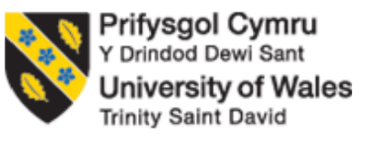
Table of Contents
Introduction 3
Brief of Tesco 3
Marketing Process 3
Marketing Stages 5
Role of Marketing Environment 5
Internal Analysis of Tesco 6
SWOT Analysis 6
External Analysis 7
PESTEL Analysis 7
Impact of COVID-19 on Tesco 8
Motivation Theory adopted by Tesco 9
“Maslow’s Hierarchy of needs” 9
Examples of Industries 10
STP of Tesco 10
Segmentation 10
Targeting 10
Positioning 11
Conclusion 11
References 12

Introduction
Marketing refers to the promotional activity for products and services. Certain activities are required in marketing which involve “advertising, selling and delivery of products” to consumers or other businesses. The awareness regarding the product can be increased by making different market-related strategies where the basic elements are “product, place, promotion, price, people, processes and physical evidence”. These elements are proved to be helpful in attracting potential consumers. This report gives emphasis on the COVID pandemics' impact on the global market. There are certain challenges faced by the businesses due to a shortage of money in consumers which is a hurdle for project-related operations. The external and internal environment is also defined in the report through “SWOT Analysis” and “PESTLE Analysis” of “Tesco”. The process of marketing is also required to understand to grab the opportunities which are available in the global market. The main aim of the marketing process is to opt for the “target market” in order to create an effective “marketing strategy”.

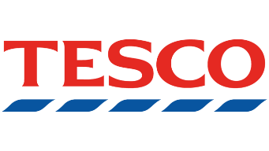
Brief of Tesco

Tesco is a multinational retail industry which comes under the list of a public limited company. Tesco’s headquarter is in “Welwyn Garden City, England”. This company mainly offers products and services which include “retailing of books, clothing, electronics, furniture, toys, petrol, software, financial services, telecoms and internet services, etc.” Tesco sells its products using a variety of stores which are “multi-format stores” while there are certain consumers who prefer online shopping and this became a trend during COVID. Tesco created its website named “Tesco.com” to offer their consumers quality products by steeping into the stores. The number of stores that are owned by Tesco is 2300 with 326,000 employees employed in it (Morgan et al., 2019).

Marketing Process
The market process is used for the proper analysis of upcoming opportunities which will be accessible for the organisations in the domestic or international market. The main aim of the marketing process is to opt for the “target market” in order to create an effective “marketing strategy”. These strategies are good for the better management of the activities involved in marketing. There are certain steps required in the process of marketing to determine the various issues that a consumer faces, and analyze the opportunities available in the market. This helps the company to produce goods according to the requirement of the consumers. In this marketing process, there are five main steps which are required to fulfil the objective of the marketing process (Agzamov, Rakhmatullaeva and Giyazova, 2021, June).
The steps are as follows:
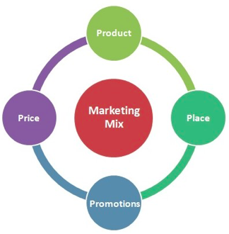
- Expand the knowledge of consumers’ behaviour and their requirements.
- Develop Marketing Strategies.
- A marketing Plan required offering superior values.
- Maintain profitable relationships.
- Extract values from the potential consumers.

The knowledge of consumers’ needs and their behaviour is important to maintain valuable relationships with their targeted audience. The improved relationship can help in retaining consumers and make them repeat customers of the organisation. This can be done by providing the consumers with a better customer service experience and selling them quality products. Another step focuses on the creation of better marketing strategies to divide the audience on the basis of the same characteristics. This division means dividing the market into smaller segments to make the organisation what to produce to achieve more profits and revenue generation (Ferrell, Hartline and Hochstein, 2021). The company can achieve a reputed image on the basis of the treatment, they offer to their customers. For the creation of a better image in the market, the company needs to think about their marketing strategies. After planning for marketing strategies, the next step is to execute the set plan otherwise the planning will be of no use. The execution requires some tools like the introduction of various programs which are helpful in promoting the relationship with consumers using effective communication techniques and offering them the expected value. The next step is to set up profitable relationships with consumers as the ultimate goal of any organisation is to maximize profits. The interaction with consumers can be improved by providing the consumers with superior values and fulfilment. This not only increases the sales but also increases the number of repeat consumers which leads to an increase in loyal consumers. The final step includes the development of “Customer Equity” where the rise in loyal consumers gives rise to consumer equity which is the best method of measuring the performance of the company in the global market (Teoli, Sanvictores and An, 2019).

Marketing Stages
- “Production Orientation” is the first stage of marketing where the organisation focus on increasing the level of production by reducing the production cost. The increase in the level of production offers increasing output which leads to maximum profit generation. A firm like Tesco focuses on sustaining efficiency in the process of production by offering proper consideration to the consumers’ requirements. Also, it is considered that the quality of products is not reduced or compromised (Çitilci and Akbalık, 2020).
- “Product Orientation” is the stage which presents the efforts of Tesco for selling or providing the consumers with quality products. It is said that the products of good quality are able to “sell themselves” in the market as consumers mainly get attracted to quality products. These products have the potential to increase profits (Monte, 2021).
- “Sales Orientation” aims to increase the potential of marketers to promote the products as this will help in increasing the sales along with clearing the stock. Here the marketer's approach is not to fulfil the needs of the consumers but to simply sell the products (Acquah et al., 2021).
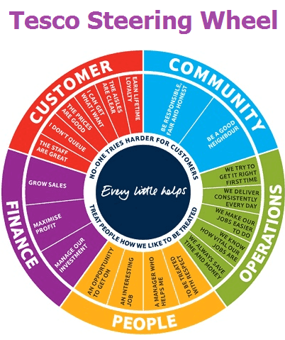
- “Market Orientation” is the final stage in marketing where the organisation focus on the targeted audience before making any kind of activities related to sales and production. This orientation is based on a “customer-first approach” as the products and services are offered without considering the consumer’s needs in mind. Tesco focuses on fulfilling the requirements of the consumers which makes it the “third largest retailer in the world” (Navy, 2020).

Role of Marketing Environment
The combination of internal and external factors makes the “marketing environment” which affects the relationship of consumers with the company. “A company’s marketing environment consists of the factor and forces outside of marketing that affect marketing management's ability to build and maintain successful relationships with target customers”. Businesses can control the “internal marketing environment” but cannot change or control the “external marketing environment” (Goede and Boshuizen‐van Burken, 2019).

Internal Analysis of Tesco

SWOT Analysis
Strengths
Tesco is the largest grocery retailer in the United Kingdom having high sales and excellent revenue when a comparison is done with other supermarkets. It has supermarkets with leading market share. In 14 countries, Tesco has opened its stores and thus achieve great market share in the “Asian markets”. Tesco increased its business operations by opening new stores named “Tesco Homeplus”, “Tesco Motors”, “Tesco Extra”, “Tesco Express”, “One Stop”, and “Tesco Superstores”. The international awards are also achieved by Tesco for the successful performance of the company at the global level (Agzamov, Rakhmatullaeva and Giyazova, 2021, June).
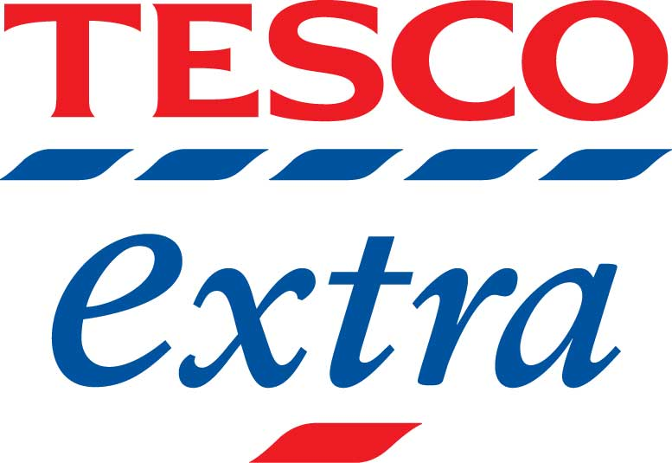


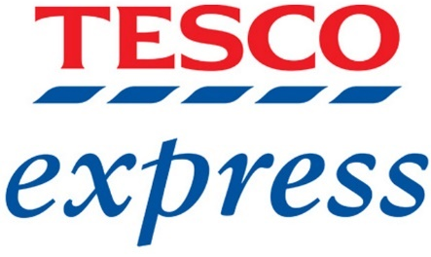

Weaknesses
Tesco had some weaknesses which slow down its progress of Tesco. There were certain “export-related operations” in which Tesco failed and thus leads to the shutdown of Tesco stores in the markets of “America and Japan”. Tesco was also fined as it presented misleading accounting information including profit statements. The allegations like selling expiry-dated food were also imposed on Tesco. The food includes “Pizza, Flavoured milk, Soup, etc.” With a lack of sufficient market research, Tesco fails to survive in some markets which make Tesco shut down its stores in those locations (Romppanen, 2021).
Opportunities
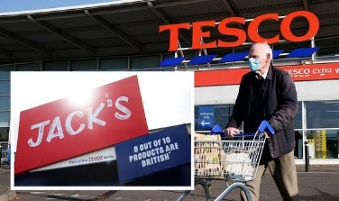
Tesco launched its discount store named “Jacks” which is considered to be an opportunity as it can attract consumers if the organisation effectively manages the operations. Tesco’s partnership with reputed brands can prove to be a better choice for business expansion even if the company is not performing well in some areas. The decision of Tesco for business expansion in certain creative and innovative countries like “South Korea, Turkey and Indonesia” can prove to be a gainful opportunity. For making the consumers more comfortable and make their shopping experience excellent, Tesco has launched a Cashless and Cardless method for its Clubcard members which is named “Tesco Clubcard Pay+” (Rosnizam et al., 2020).
Threats
The Brexit Agreement was the reason behind the great disturbance in the financial conditions of the industries. According to this agreement, Britain is no longer considered to be a part of the European Union. This agreement impacts the trading system of not just Tesco but also of other businesses. Tesco also has a threat from its competitors “Walmart, Carrefour, and Aldi” as these competitors are growing frequently. COVID-19 gave birth to an “economic crisis” which impacted the performance of the business and thus decline the position of Tesco. Tesco also faced issues in the supply chain which impacted its performance of Tesco (Mohapatra and MV, 2021).
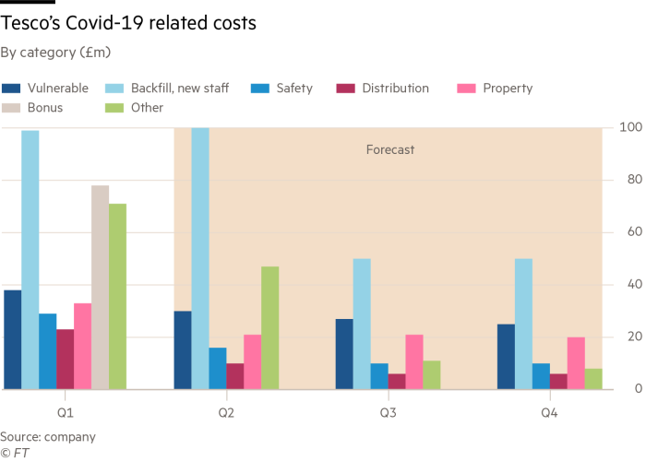

External Analysis

PESTEL Analysis
Political Factors
The operations of Tesco run at an international level which means the political factors of other countries will impact the performance of Tesco. The political factors include “tax rates, acts of legislation, and the stability of the country where the company is operating”. The increasing instability in the finances of the world makes it important for the organisation to promote job opportunities. Tesco is also supporting the government to provide employment to the citizens of the country (Koch, Frommeyer and Schewe, 2020).
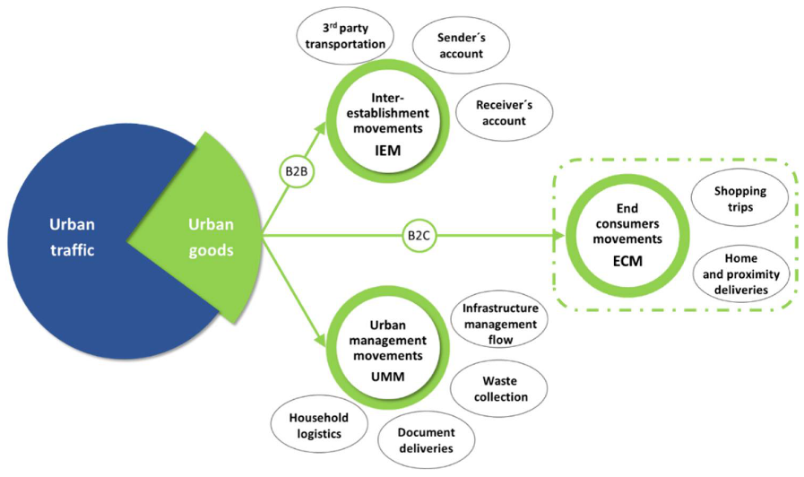

Economic Factors
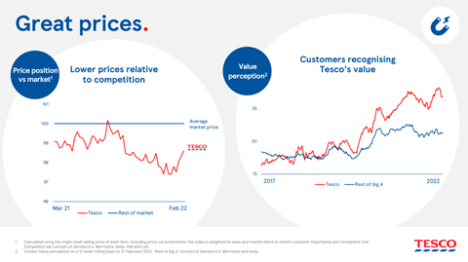
Factors that focus on “leverage costs, demand, profits and prices” come under Economic factors. Tesco gets encouragement with this factor as it makes it important for the companies to be responsive in respect of any changes that come in the taxation policies or finances. The dependency of Tesco is still on the markets of the United Kingdom even if its operations are running at the global level (Agzamov, Rakhmatullaeva and Giyazova, 2021, June).

Social Factors
The consumers of the United Kingdom are bending toward the trend of “bulk shopping” which made it important for Tesco to increase the sale of non-food items. Consumers’ demand differs according to their beliefs which are influenced by “social conditioning”. The shifting of consumers toward healthy products made Tesco work more on producing healthy items. Tesco is adopting these changes to increase the demand for its organic products (Morgan et al., 2019).
Technological Factors
Frequent improvement in technologies offers various opportunities to Tesco. There are mainly two improvements in which the first one is to introduce the facilities supporting the trend of “online shopping”. Facilities like home delivery, exchange, etc. are important to make this trend work. The second improvement can be self-service checkout points which make the consumers comfortable and this is also helpful in reducing the labour cost. Tesco also invested its efforts in long-term objective projects (Ferrell, Hartline and Hochstein, 2021).
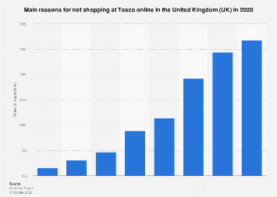

Environmental Factors
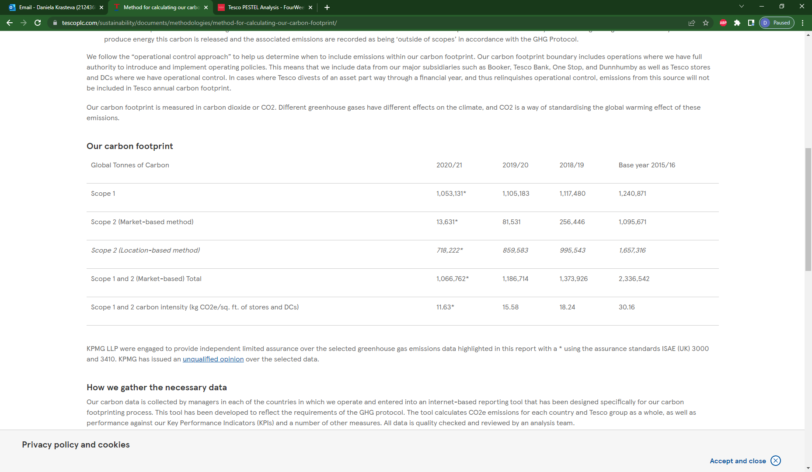
Companies are responsible to promote the welfare of society and work on environmental issues. Tesco is also working on reducing the “carbon footprint” and minimizing the wastage of business. In the process of operating businesses and running multiple stores, a vast range of material gets wasted which needs to be managed by the company. These issues come under the concept of “corporate social responsibility” which promotes the ideas of “social ethics” (Camilleri, 2018).

Legislative Factors
The business operations run by Tesco have a great impact on changing “government policies” and “legislations”. There a body named “Food Retailing Commission” launched a “Code of Practice” which regulates the changing prices of products. According to this Code, any change made by the enterprises without informing suppliers will be banned. Tesco adopted this policy and reduced the prices of fuel against the spending on grocery stores (Teoli, Sanvictores and An, 2019).

Impact of COVID-19 on Tesco
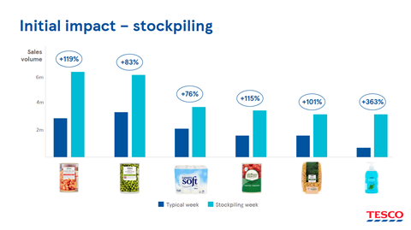
Every industry faced certain challenges with the outbreak of pandemics and the introduction of the Brexit agreement made it more challenging. According to this agreement, Britain is no longer considered to be a part of the European Union. This agreement impacts the trading system of not just Tesco but also of other businesses. This agreement made it difficult for Tesco to deliver the goods to “Northern Ireland” (Çitilci and Akbalık, 2020). In European Union, Tesco is free to trade which increases the rate of development in the United Kingdom. Tesco is the biggest supermarket in Britain and during a pandemic, the requirement of staff gets increased with the growing sales. According to the data offered by Tesco, they recruited 50000 workers on a temporary basis and 20000 workers for the permanent retailing purpose. Safety measures were also taken by Tesco to make their stores safe. In the initial stage of the pandemic, the businesses of the United Kingdom get hit badly and so the government provided financial support to them. The business enterprise that comes under the retail sector gives special assistance. Tesco gets benefitted from the lockdown as the working habits of the consumers changed and more meals are required in every home. Tesco states that the sales increased by 7% and online sales increased by 77% in the United Nations. This growth in sales shows the effort of Tesco during the pandemic as Tesco doubled its supplies because of the increasing demands of consumers (Monte, 2021).

Motivation Theory adopted by Tesco
“Motivation Theory” refers to the learning of how to shift an individual’s behaviour towards achieving a specific goal. This theory is applicable everywhere but has great importance in business enterprises. It is significant in encouraging the workers to become productive and consistent as these two elements provide profitable results (Škare, Soriano and Porada-Rochoń, 2021).

“Maslow’s Hierarchy of needs”
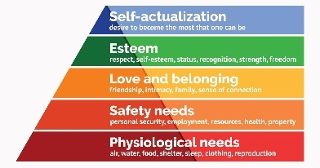
This is a theory of motivation that highlights the behaviour of an individual using five categories of human requirements. The requirements include physiological needs, safety needs, love and belonging needs, esteem needs and self-actualization needs. Tesco too fulfils these requirements of its worker to make them motivated (Acquah et al., 2021). Tesco offers good workplace conditions to its workers, offers them fair monthly payments, and other faculties like restaurants and private lockers to secure their personal belongings. The official contract related to employment and health insurance is also provided by Tesco to its employees. Teamwork inside the organization is also encouraged which is good for maintaining coordination and reducing conflicts among the workers. The achievements of the employees are also appreciated and celebrated which boosts their self-esteem. Proper personality development is also given importance to enhance the skills of the employees (Navy, 2020).

Examples of Industries
Pandemic impacted the business operations of not just Tesco or the retail industry but also impacted other industries. The tourism industry gets badly impacted due to the continuous lockdowns. 10 per cent of “Global Domestic Product” comes from the tourism industry and various job opportunities are also offered by this sector before the pandemic but during Corona, the demand for tourism declined and thus increases the rate of unemployment (Romppanen, 2021). The industry gets affected because of global lockdowns which blocked the transportation of goods and services. The decline in the movement of goods made the labours move back to their domestic countries and also the survival of the labour become difficult in the situation of lockdown. The reduced affordability of consumers was also the reason behind the decline in the industry. The hotels and resorts face huge losses too. Huge relaxation was offered by the banks to the companies for the repayment of loans. The tourists’ visits get lowered by 70% because of the increasing financial crisis at the international level (Rosnizam et al., 2020).

STP of Tesco

Segmentation
Market division on the basis of similar characteristics is termed segmentation. The aim of segmentation is to fulfil the requirements of the consumers of a particular group. The “market segmentation of Tesco” provides huge profits on increased production as the segmentation makes it clear to produce what type of product (Goede and Boshuizen‐van Burken, 2019).

Targeting
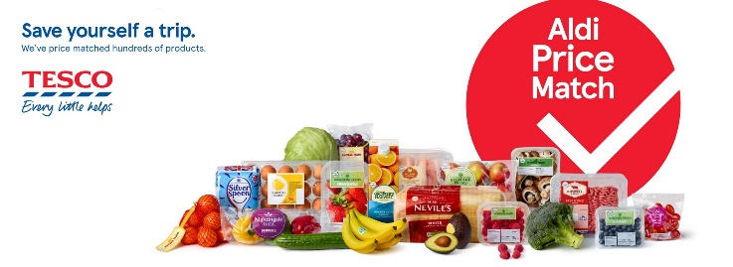
In targeting, a particular segment is targeted by proper analysis. The most profitable segment is opted in targeting to achieve high profits. Tesco targeted the “cost-conscious audience” who prefer bargaining and needs varieties of choice to opt for. There are several other supermarket chains in the UK that focus on targeting other customer segments. This stage offers support to the organisation in reducing the cost of production and producing products of effective quality (Mohapatra and MV, 2021).

Positioning
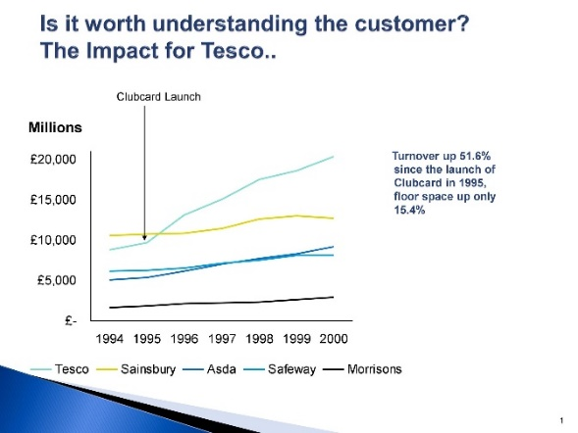
In this stage, the company is offered a position and considers a specific area to be a targeted market. A company always aims to increase its potential benefits by lowering the prices as this attracts consumers. Tesco lowered its prices to make the products available to everyone and thus can target other market segments too. The different methods are also used by Tesco to promote the products which include advertisements, etc. Tesco also created a reputed image in the market by offering consumers food items even in the worst conditions during pandemics. The offerings of loyalty programs also motivate the consumers and make them repeat consumers (Koch, Frommeyer and Schewe, 2020).

Conclusion
The report concludes the stages of marketing which considers four orientations. The process of marketing is also required to understand to grab the opportunities which are available in the global market. The main aim of the marketing process is to opt for the “target market” in order to create an effective “marketing strategy”. The importance of the market environment defines how the external and internal environment affects the relationship of consumers with the company. The external and internal environment is also defined in the report through “SWOT Analysis” and “PESTLE Analysis” of “Tesco”. The report focuses on the aim of Tesco to improve its business operations for satisfying the consumers. The motivational theory used by Tesco encourages the workers to perform with consistency. The report highlighted the impact of the COVID-19 pandemic on the tourism industry as the pandemic not just impacted the business operations of Tesco or a retail industry but also impacted other industries. The tourism industry gets affected because of global lockdowns which blocked the transportation of goods and services. There are certain challenges faced by the businesses due to a shortage of money in consumers which is a hurdle for project-related operations. Thus, it can be concluded that the proper marketing strategies and social ethics are important to follow.

References
- Acquah, A., Nsiah, T.K., Antie, E.N.A. and Otoo, B., 2021. Literature Review on Theories of Motivation. EPRA International Journal of Economic and Business Review, 9(5), pp.25-29.
- Agzamov, A.T., Rakhmatullaeva, F.M. and Giyazova, N.B., 2021, June. Marketing strategy for the competitiveness of modern enterprises. In E-Conference Globe (pp. 1-3).
- Camilleri, M.A., 2018. The marketing environment. In Travel marketing, tourism economics and the airline product (pp. 51-68). Springer, Cham.
- Çitilci, T. and Akbalık, M., 2020. The importance of PESTEL analysis for environmental scanning process. In Handbook of Research on Decision-Making Techniques in Financial Marketing (pp. 336-357). IGI Global.
- Ferrell, O.C., Hartline, M. and Hochstein, B.W., 2021. Marketing strategy. Cengage Learning.
- Goede, R. and Boshuizen‐van Burken, C., 2019. A critical systems thinking approach to empower refugees based on Maslow's theory of human motivation. Systems Research and Behavioral Science, 36(5), pp.715-726.
- Koch, J., Frommeyer, B. and Schewe, G., 2020. Online shopping motives during the COVID-19 pandemic—lessons from the crisis. Sustainability, 12(24), p.10247.
- Mohapatra, P. and MV, N.K., 2021. Accounting Scandal at Tesco. IUP Journal of Accounting Research & Audit Practices, 20(4).
- Monte, A., 2021. A study of value chain reconfiguration processes under Covid-19 pressures: the case of Tesco PLC in the United Kingdom.
- Morgan, N.A., Whitler, K.A., Feng, H. and Chari, S., 2019. Research in marketing strategy. Journal of the Academy of Marketing Science, 47(1), pp.4-29.
- Navy, S.L., 2020. Theory of human motivation—Abraham Maslow. In Science Education in Theory and Practice (pp. 17-28). Springer, Cham.
- Romppanen, J.M., 2021. Segmentation, Targeting & Positioning (STP).
- Rosnizam, M.R.A.B., Kee, D.M.H., Akhir, M.E.H.B.M., Shahqira, M., Yusoff, M.A.H.B.M., Budiman, R.S. and Alajmi, A.M., 2020. Market opportunities and challenges: A case study of Tesco. Journal of the Community Development in Asia (JCDA), 3(2), pp.18-27.
- Škare, M., Soriano, D.R. and Porada-Rochoń, M., 2021. Impact of COVID-19 on the travel and tourism industry. Technological Forecasting and Social Change, 163, p.120469.
- Teoli, D., Sanvictores, T. and An, J., 2019. SWOT analysis.

