
Application of Computer Aided Engineering Processes
Computer Aided Engineering
ACDB5007
Stan Collins
2022429

29/4/2024

Contents
1. Contents 2
2. Introduction 3
3. Computer Aided Design 3
4. Simulation Set-up 4
4.1. SolidWorks 4
4.1.1. Limitations of SolidWorks Simulations 5
4.2. ANSYS Workbench 6
4.2.1. Comparison to SolidWorks 6
5. Hypothesis 6
5.1. Effect of Mesh Size 7
5.2. Effect of Deck Thickness 8
5.3. Effect of Deck Material 9
6. Results 10
6.1. Effect of Mesh Size 10
6.2. Effect of Deck Thickness 12
6.3. Effect of Deck Material 13
7. Validation 14
7.1. First-principal calculations 14
7.2. Issues with first-principal validation 15
7.3. Literature Review 15
7.4. Comparison with obtained results 17
8. Discussion 17
8.1. Limitations of static structural modelling 17
9. Conclusion 18
10. References 18

Introduction
This report will discuss the how the application of computer aided engineering design techniques can improve a design process. An example component will be designed using SolidWorks design software, then will undergo structural analysis using SolidWorks and ANSYS Workbench. A number of separate hypotheses are investigated.
Once analysis has been completed, the results will be compared to a validation example, to test the authenticity of the results, and the importance of validation will be explored through the assumptions and simplifications made during the modelling.

Computer Aided Design
Computer Aided Design (CAD) is a broad term for the multitude of softwares and processes aimed to assist design activities. CAD software provides a number of benefits over traditional hand-drawn documents, such as reducing the time involved, improving the accuracy and quality of designs, easing the sharing of documents and the ability to share models and parts with others [1]. Arguably the largest benefit to CAD is the ease with which it can enable iterative design processes, such as in Figure 1, whereby the design is altered and adjusted with analysis and feedback.
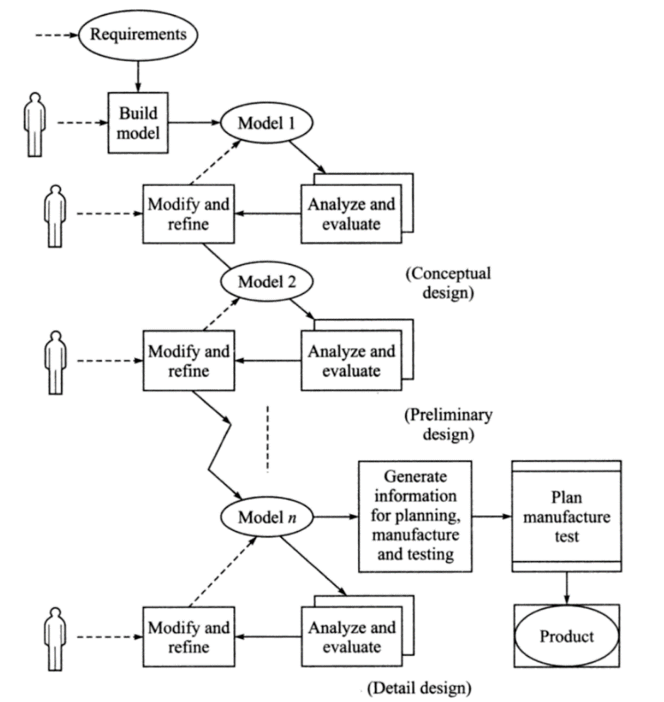
Figure 1: An iterative design process [1].
Modern software can go far beyond the generation of engineering drawings and are able to simulate complex interactions and loading scenarios. Two such softwares will be used in this report, SolidWorks and ANSYS workbench. The main analysis conducted in the report will be using Finite Element Analysis, a method of breaking up geometries into discrete finite elements to solve for deformation and similar calculations more easily [2]. This meshing of the bodies is one of the key factors in establishing how well the simulation with replicate the real-life responses.

Simulation Set-up
This report will fully model a skateboard, based on disassembly of real skateboards and technical drawings. The model stuck as close to real designs as possible, as can be seen in the exploded view of the design in Figure 2.
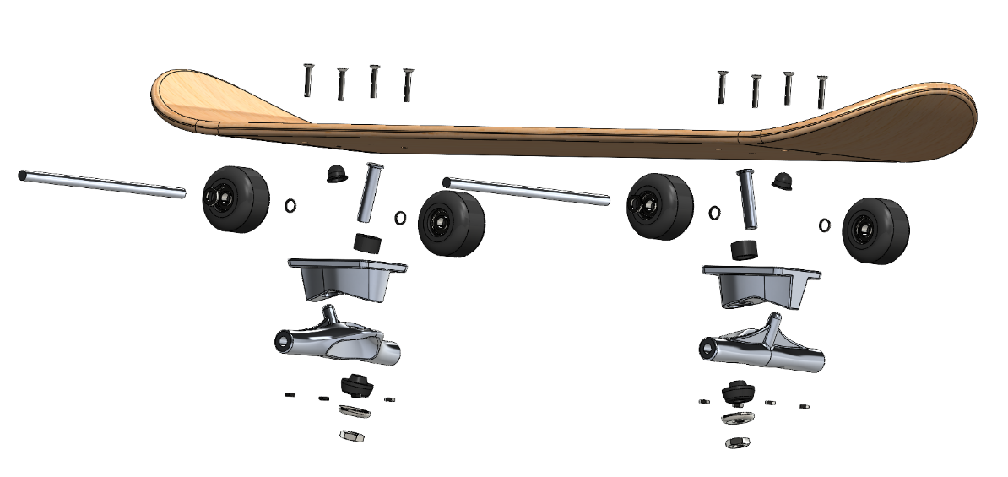
Figure 2: The exploded view of the skateboard assembly in SolidWorks.
The focus of the structural analysis will be on the deformation of the deck of the skateboard, and so three variations were made, changing the thickness of the board each time. 10mm, 6mm and 3mm deck thicknesses were produced, changing none of the other dimensions to best compare results. The dimensions and technical drawing of the 10mm board can be seen in Figure 3.
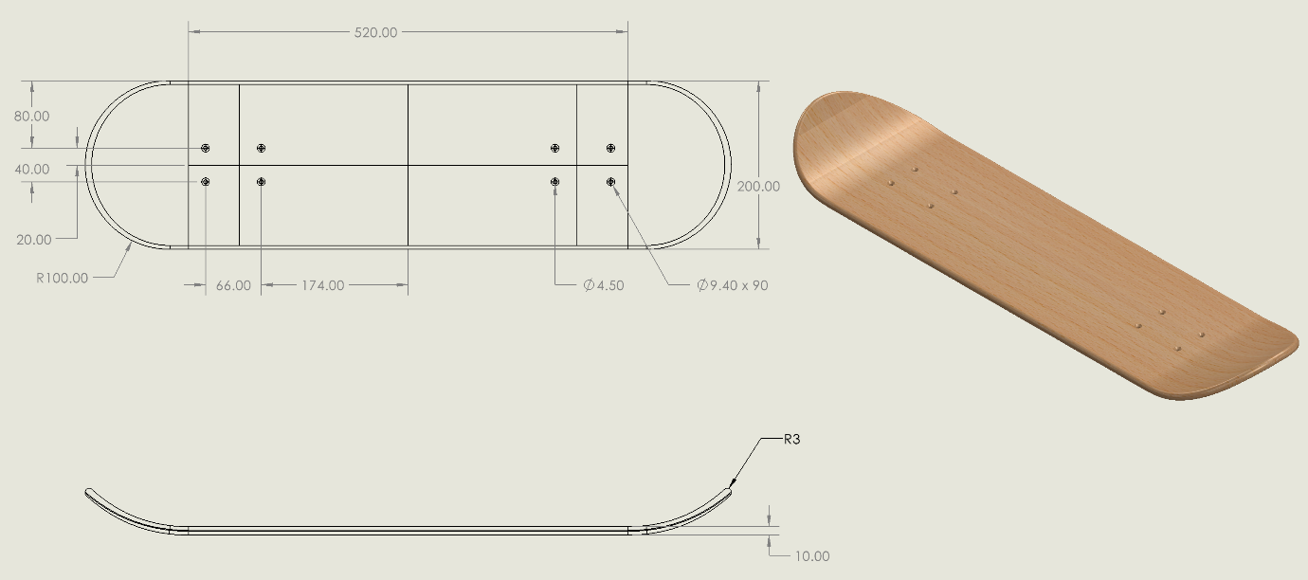
Figure 3: Technical drawing of the 10mm deck.

SolidWorks
As the premier geometry modeler available, the model was designed using SolidWorks, a 3D CAD software specialising in assembly generation. As seen in figure 2, the model consisted of over 60 components. Each component was modelled and assigned one of three materials: oak for the deck, plastic for the wheels and steel for everything else. A full table of material properties can be seen in Table 1.
Table 1: Material properties of skateboard materials
Properties | Oak Hardwood | Structural steel | ABS Plastic
Density ($kg/m^{3}$) | 935.7 | 7850 | 1030
Young’s Modulus ($GPa$) | 22.78 | 210 | 1.62
Poisson’s Ratio | 0.37 | 0.3 | 0.4
Tensile Yield Strength ($MPa$) | 47.76 | 237 | 27.44
Ultimate Tensile Strength ($MPa)$ | 146.7 | 422 | 36.26

Once the model was fully built, the model would then be used in simulations both in SolidWorks itself, and ANSYS Workbench.

Limitations of SolidWorks Simulations
While this report is simulating a fairly simple problem in comparison to other potential problem sets, there are important limitations of the software to have in mind when considering results. As laid out in Figure 4, SolidWorks assumes all materials are linear, that stress is proportional to strain [3]. While there are values for wood to input into the system (in fact SolidWorks provides multiple inbuilt wood materials to choose from), wood often behaves in a non-linear fashion.

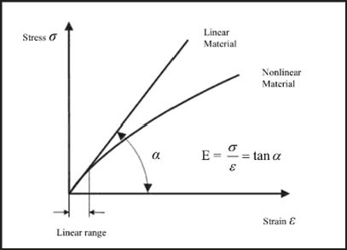
Figure 4: The linear material model assumed in SolidWorks Simulations [3]
Wood is generally considered as an orthotropic material [4] having unique mechanical properties in each axis. Values for most mechanical properties can be obtained for each direction, but this assumes total knowledge and uniformity of the material. Factors including (but not limited to) moisture content, knots, imperfections, and the length of the beam all can cause variations in performance. Walley and Rogers [5] posit that much of the literature on the topic has "assumed that wood's properties can be described using concepts developed for materials that are effectively homogeneous and continuous", pointing to significant discrepancies between these theories and real data. It goes as far as to suggest wood cannot be adequately modelled using standard material models. Further outlining the non-linear behaviour of wood is the difference in response to compression and tension, as in figure 5, an effect further pronounced by the presence of knots.

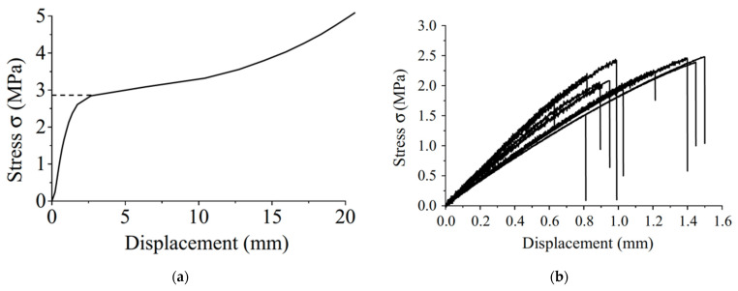
Figure 5: Stress-displacement plots of Korean pine under (a) compression and (b) tension [6].

The United States Department of Agriculture would agree with this assessment, outlining adapted equations for deformation and other loading scenarios [7], such as:
$$δ= \frac{k_{b}WL^{3}}{EI}+ \frac{k_{s}WL}{GA'}$$

Where $k_{b}$ & $k_{s}$ are constants depending on loading and support type, W is the load applied, L is the length of the beam, I is the moment of inertia, G is the shear modulus and A' is the modified beam area:
$$A^{'}= \frac{5}{6}bh$$

All of this is to say that SolidWorks can account for none of the nuances of modelling the non-linear behaviours of wood, or any other non-linear material.

ANSYS Workbench
The secondary simulations will be conducted using ANSYS Workbench, in particular the static-structural module. Much like the SolidWorks simulation, static-structural solves for the deformation, stress and strains of linear forces [8]. The simulation only requires young’s modulus, Poisson’s Ratio and mass density for linear structural analyses. Simulations will be repeated in ANSYS to provide points of comparison to SolidWorks and to test the consistency of the model simulations.

Comparison to SolidWorks
ANSYS differentiates itself in a number of technical ways from SolidWorks. It provides a number of different contact types which must be applied to all surface interactions, as well as more robust options for support and load types. Using the various modules of extra software available through Workbench, ANSYS operates as the ‘preferred choice’ for many complex modelling problems, such as aerodynamic studies [9], and simpler tasks like the modal analysis of a cantilever beam [10]. Most often in the literature review, it was observed that SolidWorks was used to generate the models, and then the geometries were used in other more complex software packages, such as ANSYS [11].

Hypothesis
This report will outline three separate design tests conducted in CAE software.
- Effect of Mesh Size
- Effect of Deck Thickness
- Effect of Deck Material
The first test will take the model generated and compare results when simulated as close as possible in both Solidworks and Ansys modelling packages, while changing the size of mesh. Due to the inherent difference between the simulation softwares there will be unavoidable differences, but any variables that can be controlled between simulations will be.
The second test will seek to explore the effects of deck thickness on the maximum deflection, von-mises stress and strain observed in the simulations. Similar work has previously been conducted in published journals [12], so this report will seek to compare results with that study.
Finally, the last test will compare the results of two different woods for the deck material. The previously used material will be compared to a wood more readily used in skateboard manufacture, with the differences between the two materials examined in the context of an overarching design process of a skateboard.

Effect of Mesh Size
Before comparing simulations, a few constants must be established. The geometry for the skateboard will remain the same between simulations and use the 10mm thick board. The materials will remain the same for this test, and are outlined in Table 1.
For both models, boundary conditions have been applied to the wheels, acting as fixed supports as in Figure 6, as this this where each model would touch the ground. In ANSYS further relationships and body interactions had to be established. For simplicity, and as the action being analysed was not motion, all joints are taken as bonded contacts. In all simulations, a standard weight of 80kg, or 784N, is placed in the centre of the board.
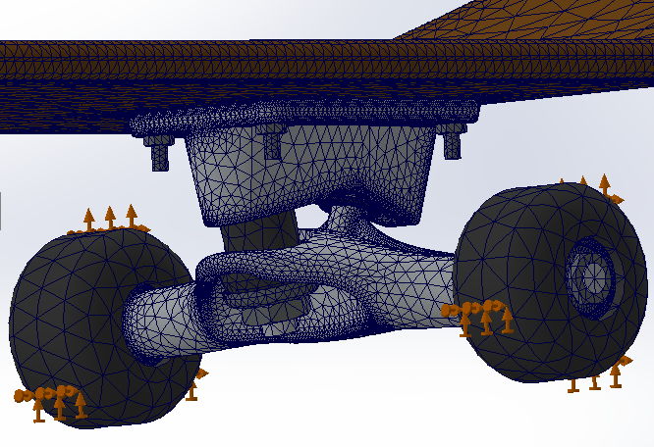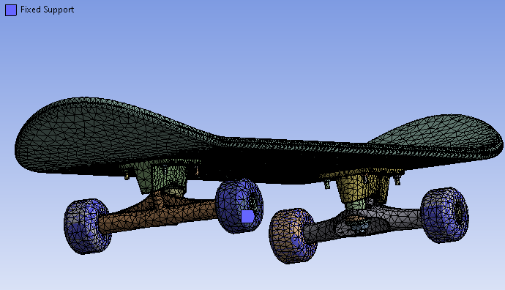
Figure 6: The boundary conditions for the SolidWorks simulation (left) and the ANSYS simulation (right)
A critical component of the simulations is the mesh shape and size. As much as is possible, the mesh type and sizing has been kept constant between softwares, however there were some uncontrollable elements to the meshing process. SolidWorks can alter mesh type, the differences of which are illustrated in figure 7. The standard mesh produced mesh distortions on some of the curved bodies in particular elements of the trucks, as in figure 8. No distortion was found on the deck however, so the effect on deformation in that area is estimated to be minimal.
Linked to the size of the mesh is the number of nodes in the simulation. The smaller the mesh, the more nodes are required to cover the geometry. Previous studies have shown the relationship between number of nodes and deformation is not linear [12], but the effect of changing the number of nodes will be evaluated in both softwares to investigate.
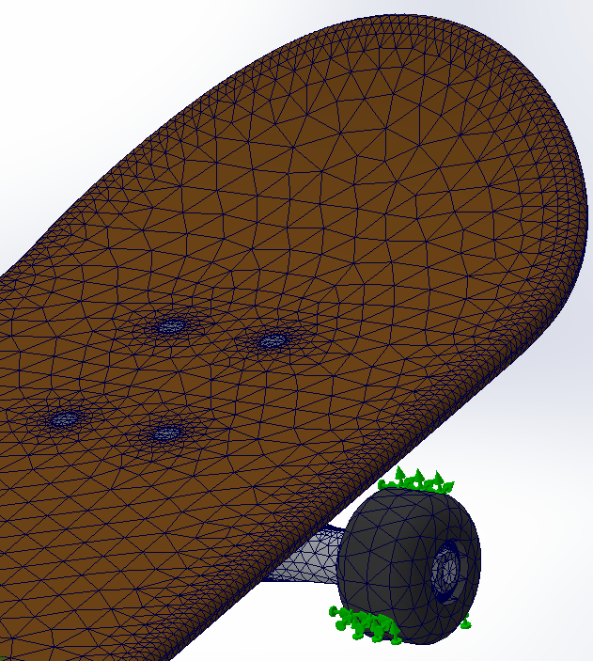
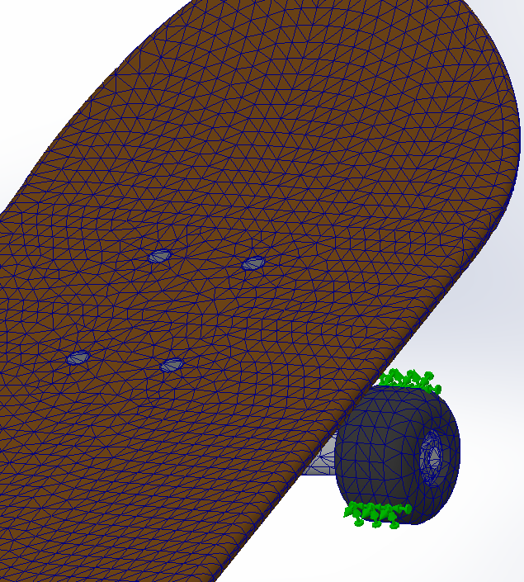
Figure 7: Examples of the curved mesh (left) and standard mesh (right) with differing mesh sizes.
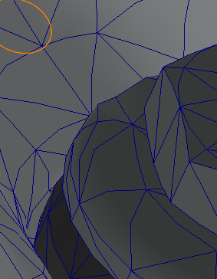
Figure 8: an example of the mesh distortion of the initial geometry on the truck.

Effect of Deck Thickness
For the second set of tests, the thickness of the skateboard deck is changed. Three thicknesses were chosen; 3mm, 6mm and 10mm. For consistency the same oak material was used as the previous set of tests, and the same 784N was applied at the centre. Only the decks were modelled, removing all other components. As such, the mesh sizes for these simulations are much smaller than in the previous tests, but are kept consistent between thicknesses. Figure 9 shows the meshing on the boards, with a much finer mesh being visible.
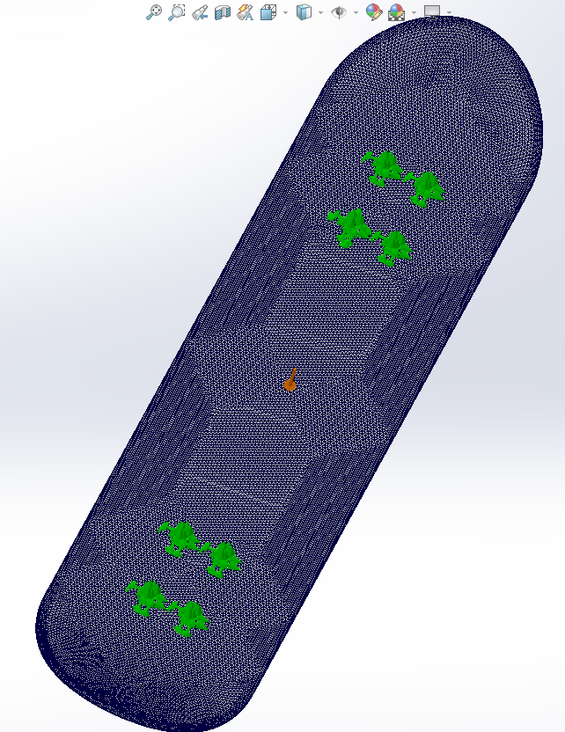
Figure 9: Meshed 6mm thick deck model in SolidWorks.
In both simulation softwares, the model is held in place with fixed supports in the holes where the deck would be screwed into the trucks. The mesh used for the SolidWorks simulations was the default blended curvature-based mesher, which caused no surface deformation in the previous testing.
Testing just the deck provides an interesting point of comparison between the simulations with and without the rest of the skateboard, illustrating the effect of the rest of the geometry on the results, and providing a better comparison to the theoretical calculations in the verification section.

Effect of Deck Material
Across all previously discussed simulations, the deck material has been oak. This was decided as it could be easily compared to existing data, and the material properties were easily available. However, typically skateboard decks are made from a less hard wood like Birch, composite materials like plywood, or even plastics [13]. Following a review of typical skateboard deck materials, American Maple was chosen to provide comparison to the already simulated Oak. Values for the material properties were taken from Granta EduPack 2022, and are seen in Table 2. Both materials would be simulated in ANSYS, using the 10mm thick board and full assembly, with a 3mm element size.

Table 2: American Maple material properties
Density (kg/m3) | Poisson’s Ratio | Young’s Modulus (Pa) | Tensile Yield Strength (Pa) | Ultimate Tensile Strength (Pa)
601.498 | 0.374166 | 12387100000 | 46764400 | 85505600

Results

Effect of Mesh Size
Tabel 3 outlines the various results from each simulation conducted across the two softwares, alongside various notes on the variables changed between runs which are addressed below.
Table 3: Results from the comparison testing.
Software | Mesh Parameters |  |  | Nodes | Output
Software | Max size | Min Size | Type | Nodes | Deformation | Stress | Strain⁽³⁾
SW | 30mm | 1.5mm | B.C.M | 271126 | 2.723mm | 5.915e7 Pa | 2.734
SW | 15mm | 0.75mm | B.C.M | 560843 | 2.765mm | 6.234e7 Pa | 3.578
SW | 13.4mm | 0.67mm | B.C.M | 596557 | 2.783mm | 6.268e7 Pa | 3.504
SW | 6.7mm ⁽¹⁾ | - | S.M | 127203 | 2.679mm | 6.876e7 Pa | 2.428
SW | 2.68mm | 0.13mm | B.C.M | 2025159 | 3.037mm | 1.679e8 Pa | 4.652
ANSYS | 5mm | - ⁽²⁾ | S.M | -⁽²⁾ | 0.538mm | 7.5313e7 Pa | 0.006
ANSYS | 3mm | -⁽²⁾ | S.M | -⁽²⁾ | 0.55mm | 1.9826e8 Pa | 0.0194

Firstly, note (1) refers to the fact that no parameter data for minimum size of mesh was available when using the standard mesh (S.M) in SolidWorks. A tolerance of 0.335mm was given in the mesh details, but no further details were provided. As mentioned in the previous section, some of the mesh elements were distorted in the meshing of the skateboard, but this only amounted to 0.0551% of elements, so will be assumed to have a negligible effect. Similarly, note (2) signifies the lack of available information from the ANSYS software.
Note (3) refers to the large discrepancy between the results of the maximum strain between the two softwares. SolidWorks output Strain only in ESTRN values (Equivalent Strain), whereas ANSYS uses the standard non-dimensional mm/mm. The formula for calculating ESTRN is:
$$ESTRN= {2\left[\left(ε_{1}+ ε_{2}\right)/3\right]}^{(1/2)}$$
Where $ε_{1}$ and $ε_{2}$ are further calculations based on normal and shear strain in the X, Y & Z directions [14]. As such, these Strain values are not really comparable between softwares, rather should be used to compare results altering other variables within the same software.
As expected, all results had their maximum deformation at the centre of the boards, at the point of loading, as in Figure 10. The SolidWorks simulations all experienced maximum stress at elements where the axle met the fixed wheel elements, as illustrated in figure 11. In contrast, the ANSYS simulations had the max stress at the pin where the deck is joined to the truck.
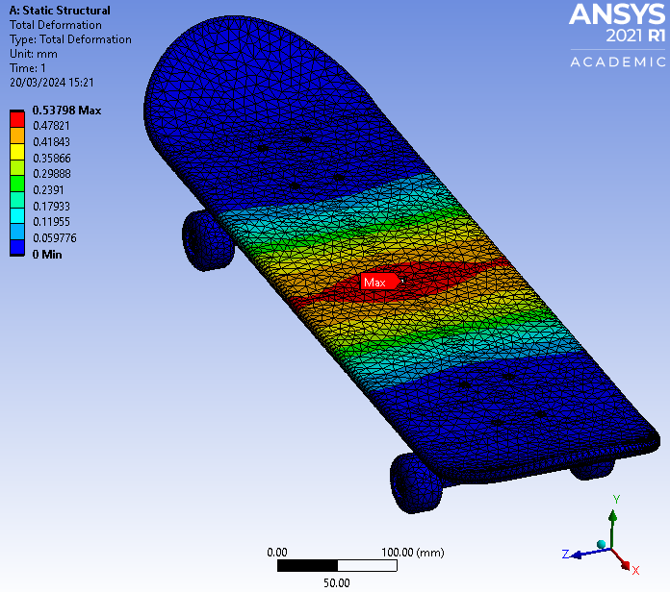
Figure 10: 1:1 scale deformation on the ANSYS simulation.
As seen in Table 3, the SolidWorks simulations produced deformations between 5.5 and 4.95 times the largest deformation seen in the ANSYS modelling. The stresses produced were much more comparable, with the ANSYS results aligning closer to the SolidWorks results. The change in SolidWorks mesh type did not appear to produce results out of line with those produced using the default mesh.
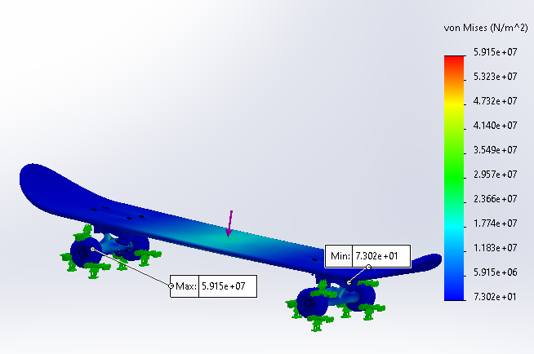
Figure 11: Points of Max and Min stress on the SolidWorks simulation.
When looking at the effect of mesh size on the results, the two softwares must be viewed in isolation, as the deformation results prove that there is a discrepancy between the two models. When plotted in Figure 12, the SolidWorks data suggests that as the mesh size increases, stress and deformation decrease. Comparing the two ANSYS simulations also shows a negative correlation between mesh size and deformation/stress.

Figure 12: SolidWorks output with changing mesh size.

Effect of Deck Thickness
The data from the second batch of simulations can be seen in Table 4. The experiment was repeated in SolidWorks and ANSYS. The default mesh type was used for each software. Both softwares used a maximum mesh size of 3mm.
Table 4: Results for the deck response when changing the thickness.
Software | Deck Thickness | Deformation | Stress | Strain
SW | 10mm | 4.214e-2 mm | 1.295e7 Pa | 2.722e4
SW | 6mm | 2.346mm | 1.79e8 Pa | 4.452
SW | 3mm | 17.97mm | 3.777e8 Pa | 1.252e2
ANSYS | 10mm | 0.54377mm | 1.984e8 Pa | 0.019418
ANSYS | 6mm | 2.3231mm | 6.8223e7 Pa | 0.0099271
ANSYS | 3mm | 17.879mm | 2.769e8 Pa | 0.01289

As expected, the thinner the deck became, the more it deformed, with the maximum deformation at 3mm deck thickness seen in Figure 13. Stress and strain did not show a similar proportional change as thickness increased. The ANSYS simulation for the 10mm thick deck showed deformation consistent with the ANSYS results in the previous section, suggesting that the presence of the rest of the skateboard geometry had a minimal effect on the maximum deformation in that software. The SolidWorks simulation at 10mm thickness deformed much less than the previous simulations, suggesting either that the rest of the geometry had a large effect (but only at this thickness), or there was an issue with this simulation.
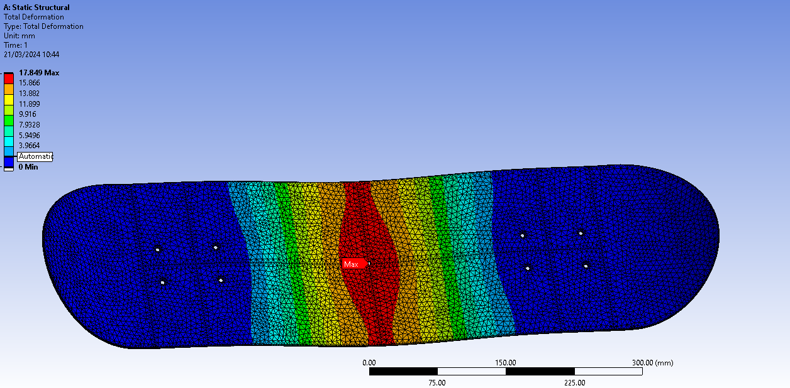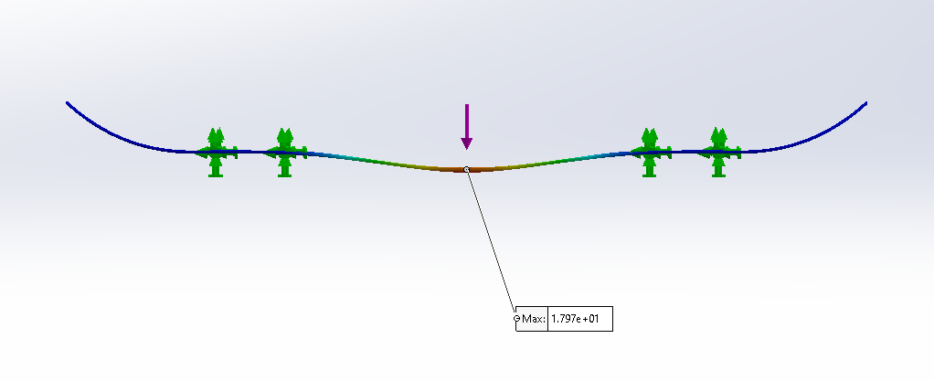
Figure 13: Maximum deformations of the 3mm thick board in (top) SolidWorks and (bottom) ANSYS simulations.
The deformations match fairly well at 3mm and 6mm thickness across the two simulations, further pointing to the issue being a problem with the SolidWorks 10mm simulation. However, repeats of this simulation produced identical results across two separate computers, suggesting an as-yet unidentified issue with the model.
As these simulations are just the deck, the results should align closer to the results predicted by the theoretical calculations of beam deformation, which will be explored more fully in the next section.

Effect of Deck Material
Table 5 shows the deformation, stress and strain results of the two simulations. The maple wood deck had almost twice the deformation as the oak, but a near identical maximum stress result.
Table 5: Results from the ANSYS simulations when changing deck material.
Deck Material | Deformation | Stress | Strain
Oak | 0.54798mm | 198.28 MPa | 0.019416
Maple | 0.97773mm | 197.86 Mpa | 0.035591

This result is in line with the expectations of this experiment, as maple is much less strong wood. It has a lower density and young’s modulus so deforms more at the same loading.

Validation
The validation stage of the analysis is arguably the most pivotal of the entire process. The validation defines if the results from the analysis are correct or completely incorrect. Without this, any future results will not be worth the time spend to obtain them. Using an existing data source, the simulation is compared to a known result. Ideally, the results are identical, indicating that the model and simulation have successfully reproduced a real-world event. However, as the model or event being simulated get more complex, more and more assumptions are made in the simulation process, akin to how air resistance is assumed negligible in physics, until it isn’t.
For the validation of this simulation, there are two separate validation techniques, one derived from first-principal calculations, and another derived from existing simulation results.

First-principal calculations
An easier way of conceptualising the problem being modelled is to think of the deck not as a skateboard, but as a beam on two supports, as illustrated in Figure 14. This is a large simplification of the physics of the skateboard but is close enough to provide an estimation of the simulation’s accuracy.
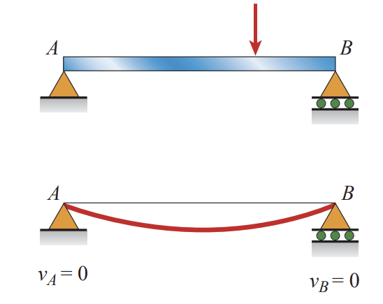
Figure 14: Visualisation of the skateboard as a beam supported by a fixed and a roller support, with boundary conditions [15].
From first principal calculations, when the force is applied to the direct mid-point between the support (as is the case in the simulations run), the maximum deflect at that point is defined by [15]:
$$δ_{max}=\frac{PL^{3}}{48EI}$$
Where δ = Deflection, P = Force, L = Length between supports, E = Modulus of elasticity and I = Area moment of inertia of a cross section.
In theory, all four variables should be reproducible between the calculation and the simulation, as L and I are geometric properties, E is a material property definable in the simulation, and P is a force defined by the simulation. As such, the results should be very similar.
For the first run of simulations (Section 4.1), L = 400mm or 0.4m, P = 784N, E = 22.78GPa & I = 16666.6mm⁴ or 0.0000000167m⁴ .Therefore, δ = 1.10mm. A full table of predicted deformations for all of the various simulations run in this paper is seen in Table 6.

Table 6: Theoretical calculations for displacement of the various simulations
Material | Deck Thickness | E | I | δ
Oak | 10mm | 22.78 GPa | 1.67e-8 m⁴ | 2.74 mm
Oak | 6mm | 22.78 GPa | 3.6e-9 m⁴ | 12.7 mm
Oak | 3mm | 22.78 GPa | 4.5e-10m⁴ | 102 mm
Maple | 10mm | 12.39 GPa | 1.67e-8 m⁴ | 5.05 mm

Issues with first-principal validation
As previously mentioned, modelling the skateboard deck as a beam between supports is a simplification, involving a couple major assumptions. The largest of these assumptions is in relation to the ‘two supports’ of the visualisation, as seen in Figure 15. The deck is technically supported by the two trucks, the centres of which are 400mm apart, but they cannot be assumed to have exactly zero deformation. This is because is the model they are deformable objects with their own interactions. In the simulations, the wheels are the only fixed objects, and so the trucks are free to deform at will, changing the boundary condition of the calculation.
In addition, there are slight geometrical differences between the rectangular beam assumed in the calculation, and the filleted, curving deck in the simulation. Also not taken into account is the support provided by the screws connecting the deck to the truck, or any effects cause by the geometry of the wheel base.
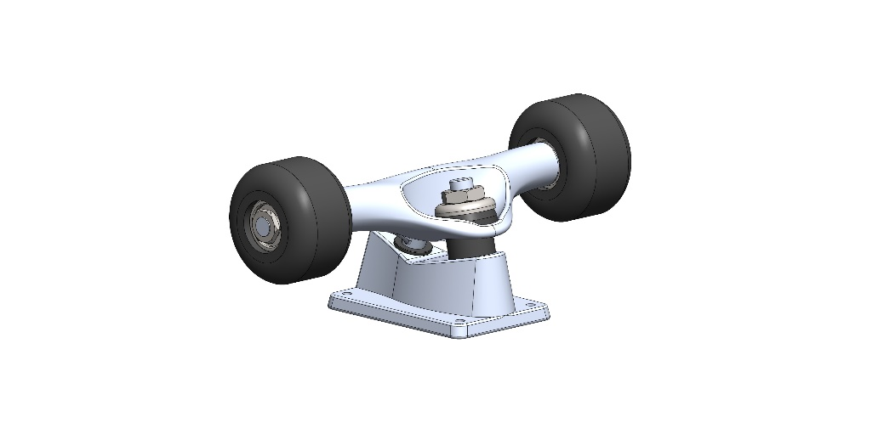
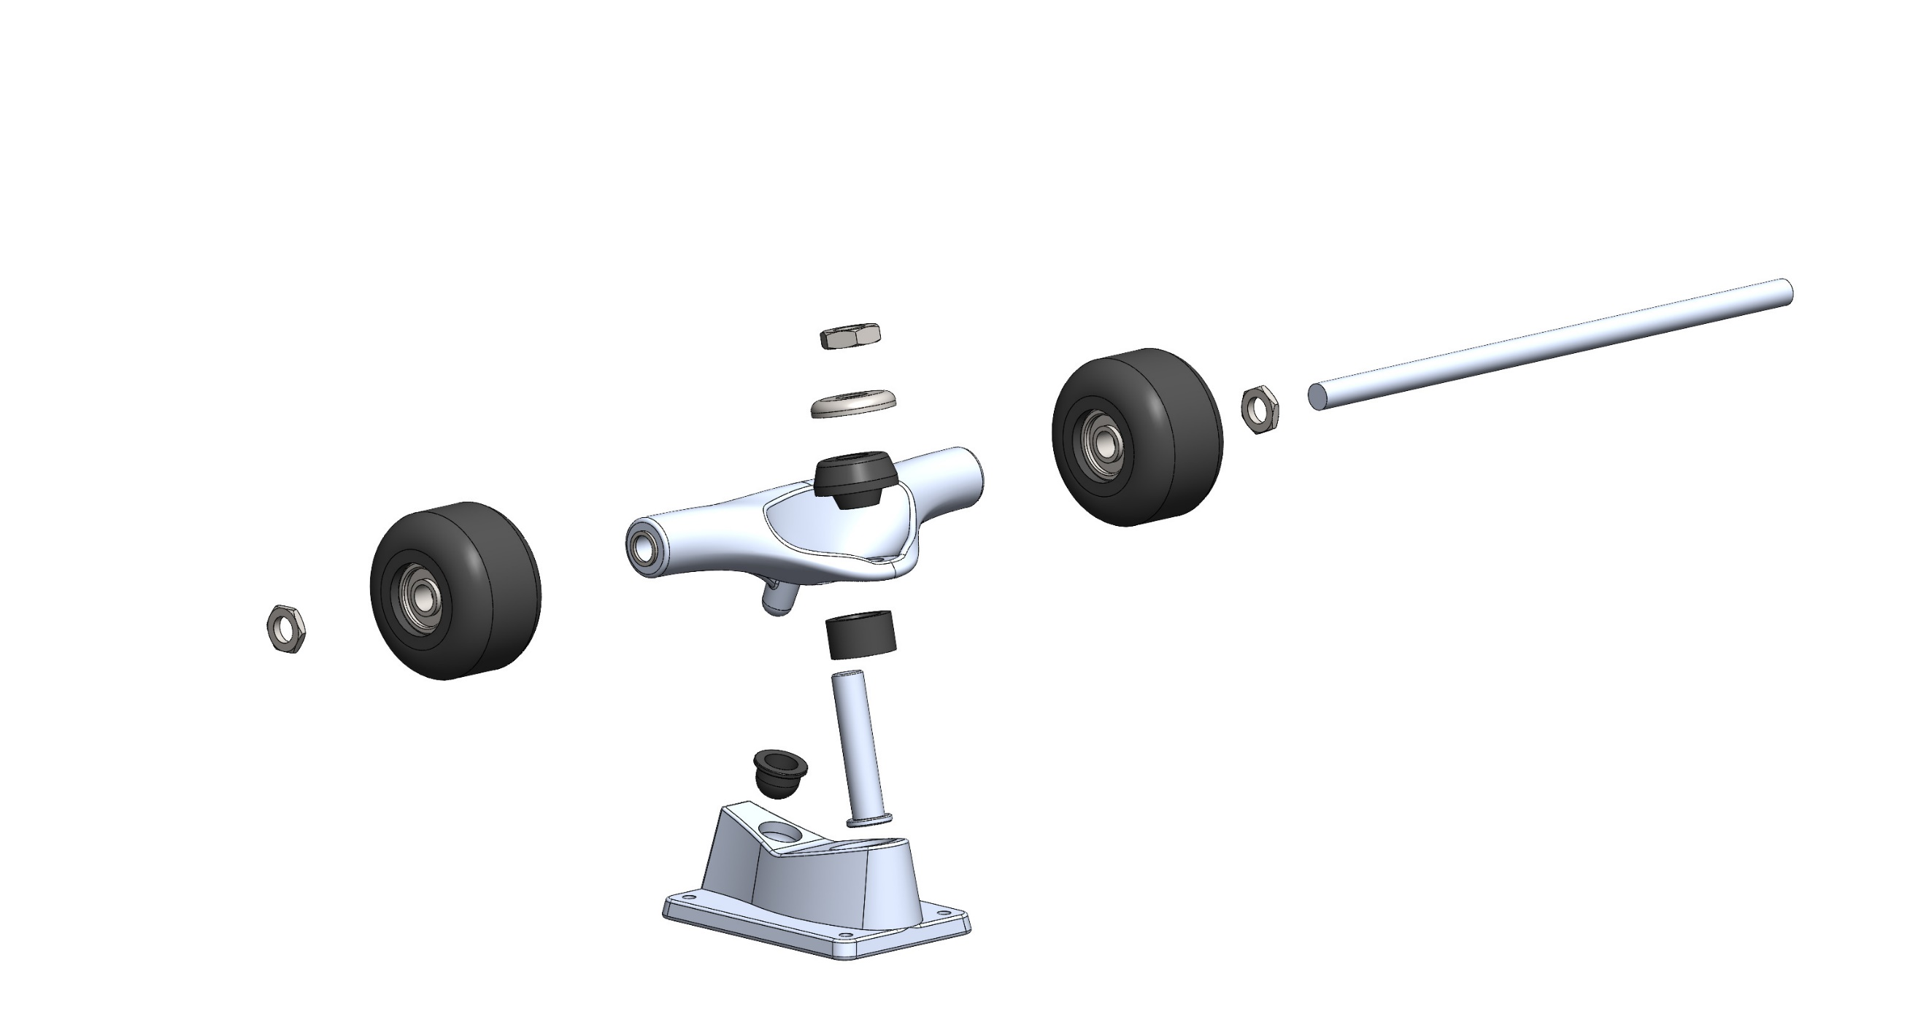
Figure 15: The wheelbase assembly. As modelled (left) and exploded (right)

Literature Review
A secondary method of validation is cross-referencing data from existing studies and simulations run by others. This method of validation is inherently less reliable than calculations from first principles or real life data, as there is no way of knowing the assumptions or changes made in producing the results. As such, this data is only viewed as a support for the first principal calculations. In Abid & Bhuiyan’s paper on static structural impact on a skateboard [12], they model three skateboard prototypes with varying thicknesses to determine maximum deflection, as in Figure 16.
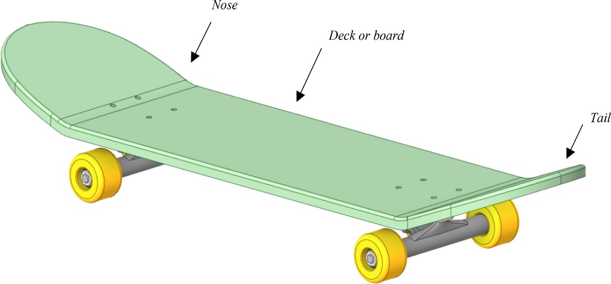
Figure 16: CAD model of the skateboard.
The paper modelled the whole skateboard, and so there is some discrepancy expected between this paper’s results and those of the calculations, for the same reasons as mentioned in the previous section. Table 7 shows the mechanical properties of the working materials, as every component had to be modelled with a material. The material of the skateboard deck matches that used in the first principal calculations.
Table 7: Mechanical properties of the work materials
Properties | Oak Hardwood | Structural steel | ABS Plastic
Density ($kg/m^{3}$) | 935.7 | 7850 | 1030
Young’s Modulus ($GPa$) | 22.78 | 210 | 1.62
Poisson’s Ratio | 0.37 | 0.3 | 0.4
Tensile Yield Strength ($MPa$) | 47.76 | 237 | 27.44
Ultimate Tensile Strength ($MPa)$ | 146.7 | 422 | 36.26

When comparing the results of the 10mm thick model, the deformation peaked at 0.116mm. However, the study does not specify the point of loading on the deck, only providing Figure 17, which clearly does not show the force acting through the centre of the deck. It also does not detail the geometry of model beyond the thickness of the board, so the length between supports cannot be confirmed. As a last point of conflict between this model and this report’s, the skateboard trucks have differing geometry.
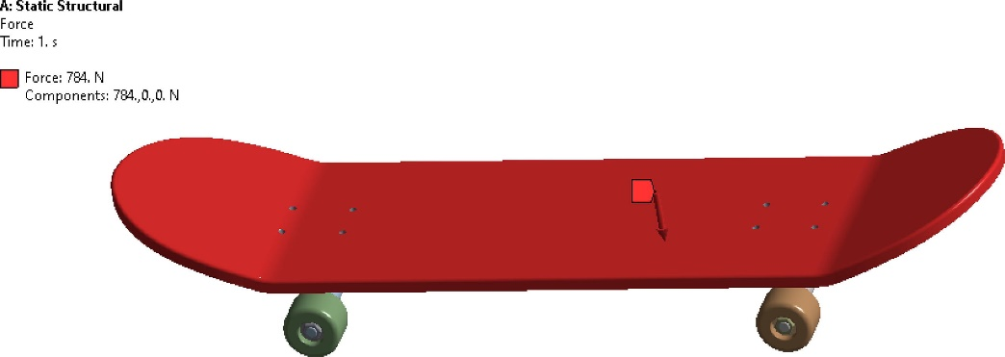
Figure 17: The loading point on the skateboard.
For all the reasons listed, this paper would not make for a good validation. As it stands, it is at best a rough guide for expected results, but it provides a decent example of the checks needed before comparing results with those found online.

Comparison with obtained results
When comparing the results of this report with that of the validation, it can be observed that almost none of the results matched the calculated deformations. The potential causes for these discrepancies are myriad, ranging from calculation errors and geometric issues with the models to material property selections and meshing mistakes. Aside from the 10mm thick deck, the SolidWorks and ANSYS simulations both produced similar results for deformation and stress, suggesting that the issue is not one of meshing or model, as the two softwares used separate meshing and boundary interaction parameters.
Another potential difference could be that when applying 784N to the 3mm oak board, it would simply fail. Neither the simulation or the theory can account for failure, and so the board may have been held together by the remaining geometry, causing the difference between the results.
The previously discussed differences between the ideal beam in the theory and the curved, filleted skateboard deck likely also cause differences in the responses. Given the opportunity, a more thorough examination could be made to fully and exhaustively determine the root cause of the difference by changing parameters until consistency was found. As it stands however, the only steadfast conclusion to be drawn from the attempt at validating the simulations in this report is that they remain unvalidated.

Discussion
When viewing the results in isolation from the validation, there are interesting points to observe. Figure 12 suggests that as the mesh size increases, the maximum deformation decreases. However, the number of data points is miniscule, and further reading into the topic suggests no such direct proportionality, with the exact relationship seemingly dependent on the geometry of the model, or plateauing after an initial change [12] [16] [17] [18] [19].
Removing all of the geometry apart for the deck, as in the second set of simulations, provides an opportunity to investigate the effect that geometry had on the deformation of the deck. The ANSYS had very similar results with and without the trucks and wheels, whereas the SolidWorks simulation produced markedly different results. The SolidWorks simulation may have had issues, as discussed in section 6.2. Ignoring that result, it would suggest that the rest of geometry had little effect on the deck deformation. This set of simulations should have theoretically been closer to the calculated results as well, but this was not the case.
Section 6.2 also provided expected results on the effect of reducing the thickness of the board. An increase in deformation was predicted and collaborated with testing. Further testing with failure parameters would be useful in assessing if the deck would actually deform that far, or simply break, a circumstance unavailable in these simulations.
The results in Table 5 were also reassuring, in that the oak board deformed less than the maple board. The ‘better’ material properties produced a lesser response, indicating that the model at least was accurate in that regard.

Limitations of static structural modelling
While these results would suggest that a thicker board is desirable, with the strongest wood available as the material of choice, it is important to contextualise these results. The performance of a skateboard is more than its ability to withstand weight between supports, otherwise the deck would be made of steel. This is the largest issue with viewing the results of a static structural study in a vacuum. It negates any other design considerations, and the vital fact that the skateboard is used in motion. While a thicker board might better take the weight of a user, the aerodynamics of the situation might point to another conclusion.
As the dynamics of skateboarding [20] illustrates, control of the skateboard is determined through the displacement and turning of the user’s body. The ergonomics of this user control method need to be considered, and material choices that will not hurt the user need to be applied [13]. The board can also not be so heavy as to not be controlled by the user. This is why it is much more common to find a maple wood skateboard deck than an oak one.
It is for these reasons that analysis such as the type done in this report is only one part of a design process. As illustrated in the validation section, a model is only as good as the assumptions and perspective that went into it’s construction, which were evidently lacking in the case of these simulations.

Conclusion
This report aimed to investigate a number of hypotheses which would impact the performance of a skateboard undergoing static loading. The results indicated that a thicker board made of strong materials such as oak would be the best at withstanding such loading. However, through a validation process, it was found that the results could not be completely supported by either first-principal calculations or a wider literature review.
Furthermore, the report evaluated the adequacy of extrapolating conclusions from static-structural analysis, pointing out that skateboarding is a dynamic process with more considerations than just withstanding a static load.

References

[1] | M. Sarcar, K. Mallikarjuna and K. Lalitnarayan, Computer Aided Design and Manufacturing, New Delhi: PHI Learning Pvt. Ltd., 2008.
[2] | B. Szabo and I. Babuska, Finite Element Analysis: Method, verification and Validation, Wiley, 2021.
[3] | P. Kurowski, Engineering Analysis with SolidWorks Simulation 2013, SDC Publications, 2013.
[4] | D. Kretschmann, “Mechanical Properties of Wood,” in Wood Handbook, Wood as an engineering material, Wisconsin, United States Department of Agriculture, 2010.
[5] | S. Walley and S. Rogers, “Is Wood a Material? Taking the Size Effect Seriously,” Materials, vol. 15, no. 15, 2022.
[6] | N. Yang and L. Zhang, “Investigation of elastic constants and ultimate strengths of Korean pine from compression and tension tests,” Journal of Wood Science , vol. 64, pp. 85-96, 2017.
[7] | D. Rammer, “Structural Analysis Equations,” in Wood Handbook, Wood as an engineering material, Wisconsin, United States Department of Agriculture, 2010.
[8] | ANSYS, “Workbench - Mechanical Introduction. Chapter 4 Static Structural Analysis,” 5 May 2009. [Online]. Available: http://mguler.etu.edu.tr/WB-Mech_120_Ch04_Static.pdf. [Accessed 29 April 2024].
[9] | I. Ramlan and N. Darlis, “Comparison between Solidworks and Ansys Flow Simulation on Aerodynamic Studies,” Journal of Design for Sustainable and Environment, vol. 2, no. 2, 2019.
[10] | P. Lengvarsky, J. Bocko and M. Hagara, “Modal Analysis of Titan Cantilever Beam Using ANSYS and SolidWorks,” American Journal of Mechanical Engineering, vol. 1, no. 7, pp. 271-275, 2013.
[11] | I. Magomedov and Z. Sebaeva, “Comparative study of finite element analysis software packages,” in Journal of Physics: Conference Series 1515, 2020.
[12] | A. Abid and A. Bhuiyan, “A finite element analysis approach to design and optimize the static structural impact on a skateboard,” Materials Today: Proceedings, vol. 60, no. 3, pp. 2171-2187, 2022.
[13] | H. Liu, T. Coote and C. Aiolos, “Skateboard deck materials selection,” in IOP Conference Series: Earth and Environmental Science, 2018.
[14] | Dassault Systems, “Strain Components,” 2021. [Online]. Available: https://help.solidworks.com/2021/english/SolidWorks/cworks/c_Strain_Components.htm?format=P&value=. [Accessed 1 April 2024].
[15] | J. Gere and B. Goodno, Mechanics of Materials, Cengage Learning, 2012.
[16] | F. Koslan, A. Zaidi, M. Othman, S. Abdullah and S. Thanakodi, “The Effect of Mesh Sizing Toward Deformation Result in Computational Dynamic Simulation for Blast Loading Application,” Modern Applied Science, vol. 7, no. 7, 2013.
[17] | P. He, Q. Qian, Y. Wang, H. Liu, E. Guo and H. Wang, “Influence of finite element mesh size on the carrying capacity analysis of single-row ball slewing bearing,” Advances in Mechanical Engineering, vol. 13, no. 4, 2021.
[18] | H. Abioghli, “Effect of Changes of Mesh Size on the Numerical Analysis of Reinforced Soil Walls,” Australian Journal of Basic and Applied Sciences, vol. 5, no. 12, pp. 1693-1696, 2011.
[19] | G. D'Emilia, A. Di Ilio, A. Gaspari, E. Natale and A. Stamopoulos, “Uncertainty assessment for measurement and simulation in selective laser melting: a case study of an aerospace part,” ACTA IMEKO, vol. 9, no. 4, pp. 96-105, 2020.
[20] | Y. Ispolov and B. Smolnikov, “Skateboard Dynamics,” Computer Methods in Applied Mechanics and Engineering, vol. 131, no. 3, pp. 327-333, 1996.

