Strategic Development and Implementation for SMEs

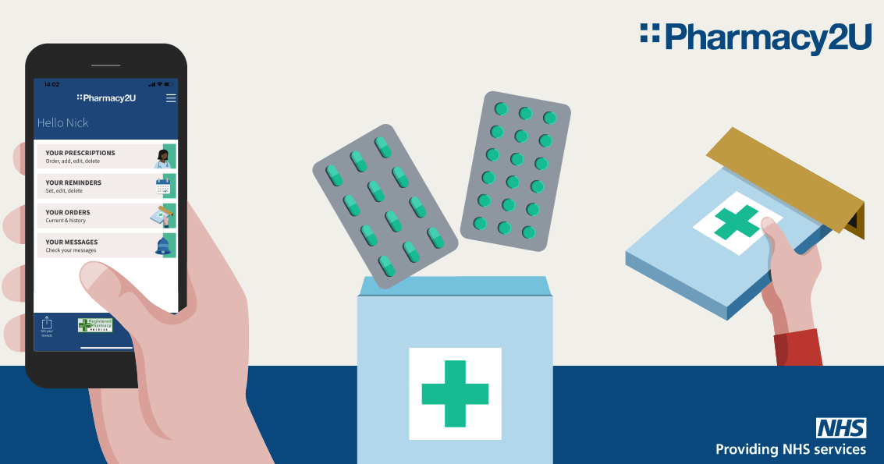
UNIVERSITY OF WALES TRINITY SAINTS DAVID
Student Name: Kazi Shaila Sultana Sonia
Student ID: 2013422
Module Code: BMSW 6104
Lecture’s Name: Hoang Dang Nguyen
Unit Name: Strategic Management for SMEs
Programme Name: BA(Hons) Leadership and Management Skills for the Workplace

Executive Summary

This report aims to demonstrate an understanding of organisational strategy management and to offer important strategic recommendations and implementation within the organisation for future developments, considering the challenges SMEs encounter to implement strategic approach. The UK’s first online pharmacy Pharmacy2U has been selected who is apprised a profitable SME and offer pharmaceutical products and services though online and during and after the Covid-19 crisis, this sector was severely impacted by government restrictions, Brexit, inflation, the living cost crisis, and other factors.

The internal environment has been critically evaluated using VRIO model and Value Chain Model; resulting that it has an organized strategic management with efficient human and material capital. The results of the analysis of the external environment using the PESTEL planform, Industry Life Cycle, and Strategic Group Mapping show that Pharmacy2U has a solid market position thanks to their value proposition and value discipline, as well as a broad client base. Porter's Five Forces, which was used to examine the competitive power in the market, also revealed that these forces must contend with the threats of substitution and new entry. Hereafter, using SWOT analysis, identified the strengths and weaknesses they have within organization; and opportunities and threat they face from the external environment. After that Porter’s Generic strategy has been recommended, specifically focused on cost effectiveness and diversification options as well as they have been waited by SFA Matrix to justify suitability, feasibility of the options, and Mendelow’s stakeholder matrix to justify the proposed strategy and its acceptability. Additionally, a Stakeholder Communication Plan, an Implementation Plan, and a potentially negative consequence if the suggestions are not adopted by the organisation have been prepared to implement the proposed Growth Strategy.

It is expected that, Pharmacy2U would be able to attain a sustainable competitive advantage and overcome any potential hurdles by implementing the growth strategy recommended in the report.

Table of Contents

Introduction 4
Section 1. Strategic Analysis 5
1.1. SME & Background Pharmacy2U 5
1.2 External Analysis. 6

1.2.1. PESTEL analysis…………………………………………………………………………….7

1.2.2. Industrial Life Cycle………………………………………………………………………..9

1.2.3. Strategic Group Mapping …………………………………………………………………10
1.3. Internal Analysis 11

1.3.1. VRIO Model……………………………………………………………………………….11

1.3.2. Value Chain Model………………………………………………………………………..13
1.4. Industrial Analysis 14

1.4.1. Porter’s Five Forces……………………………………………………………………….14
1.5. SWOT Analysis 16
Section 2. Strategic Growth Choices 19
2.1. Porter’s Generic Strategies 19
2.2. Ansoff Matrix 20
2.3. Identification of Sutable Growth Strategy 22
2.4. SFA Matrix 23
2.5 Mendelow’s Stakeholder Matrix. 24
3. Strategic Growth Action Implementation Plan ……………………………………………...26
4. Evaluation and Monitoring 29
5. Recommendation…………………………..…………………………………………………...30
6. Conclusion 31
7. References 32

INTRODUCTION

Strategic management (SM) refers to the review procedure, planning, and implementation strategy to maintain or improve competitive advantages (Lynch, 2018). There are two basic strategic management processes: a dynamic approach with a risk component refers to an emergent view of SM, and a prescriptive approach relates to the goals of the company and the plans and actions to attain the goal (Trott, 2017). For SMEs (small and medium-sized firms) to survive in this competitive climate, it is essential to understand Strategic Management and how to apply it in connection to environmental change. 0.7% of all businesses in the UK have 50 to 249 employees, or 35,900 SMEs (GOV.UK, 2022). This sector suffered greatly both during and after the COVID-19 crisis, and the UK government put in place a number of substantial measures to boost SME liquidity during the crisis (Bank of England, 2021).

The first online pharmacy in the UK, Pharmacy2u, has been chosen as an example of Strategic Management understanding and implementation. Their strategic approach and capacity for adaptation to an uncertain and challenging external and internal company environment have been examined. The internal environment is being critically evaluated using VRIO model and Value Chain Model and the PESTEL planform, Industry Life Cycle and Strategic Groupe Mapping are being used to analysed external environment. Furthermore, Porter’s Five Forces is also used to examine the market's competitive power. Hereafter, to identify the strengths and weaknesses within organization; and opportunities and threat of external environment is used SWOT analysis platform. Furthermore, Porter’s Generic strategy and Ansoff Matrix are being analysed in section 2, in order to recommend a suitable strategic approach for Pharmacy2U. Finally, Porter’s Generic strategy is recommended, specifically cost effectiveness and diversification strategy, as well as SFA Mrategic atrix is used to justify suitability, feasibility of the options, and Mendelow’s stakeholder matrix to justify its acceptability. In addition, A Stakeholder Communication Plan and an Implementation Plan are also being created to put the suggested Growth Strategy into practise.

It is expected that, With the help of the report's recommendations for strategic growth, Pharmacy2U will be able to leverage its weaknesses into strengths, adapt to the external threat, and develop durable competitive advantages that will help it face and overcome any upcoming obstacles.

Section 1. Strategic analysis

1.1. Background of Pharmacy2U & SME

Daniel Lee, a chemist, launched Pharmacy2U, the first internet pharmacy in the UK, in November 1999, with cutting-edge dispensing facilities, industry-leading clinical care, and accolade-winning customer service (BBC, 1999). Through its 200 committed employees, Pharmacy2U has been offering the NHS electronic repeat prescriptions service in the UK and is recognised as a successful SME in UK. Any company with fewer than 250 workers, a revenue of less than €50 million, or a balance sheet total of less than €43 million is considered a Small to Medium-sized Enterprise (SME) (Gov.UK, 2022).

. 

Pharmacy2U is a well-known name in the UK's online pharmacy market, with a solid reputation for offering trustworthy and reasonably priced healthcare products and services, such as NHS prescription and online services (Armstrong, et al., 2018). They serve as a SME that fills NHS repeat prescriptions for more than 700,000 individuals. These patients make benefit of their free prescription delivery service to the home and their award-winning knowledge. By prioritising the requirements of its clients, the organisation has maintained its quality of service since its inception. Free Covid-19 vaccinations, flu injections, blood pressure checks, and door-to-door prescription delivery are just a few of their well-liked offerings. Pharmacy2U and ChemistDirect.co.uk merged in 2016 to offer over-the-counter medicines in the UK and around the world. In 2021, MarketLine 350000 EPS patients were included in Pharmacy2U's customer base as of the end of 2019. By the end of 2019, clients in the UK had received 621,128 prescription products. While 5.3 million NHS prescriptions have been distributed in the UK, Pharmacy2U has added more than 330,000 NHS patients to its customer list as of today (pharmacy2u, 2020).
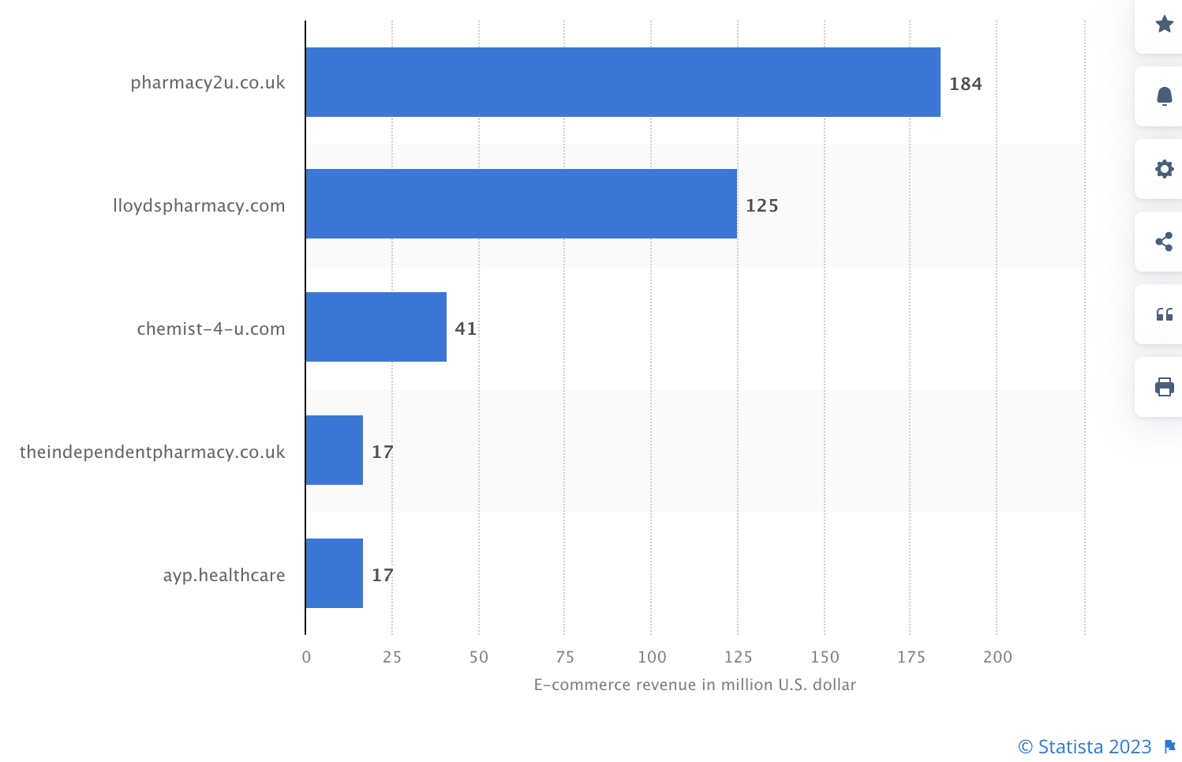

The online store Pharmacy2u.co.uk, which sells products in the UK's pharmacy e-commerce industry, has the biggest eCommerce net sales, with revenue expected to reach US$184 million in 2021. Pharmacy2u.co.uk, which generated US$184 million in revenue in 2021, was the online store with the greatest eCommerce net sales, followed by lloydspharma-cy.com with US$125 million. Chemist-4-u.com comes in third with US$41 million. With sales of $17 million in 2021 (Peters, 2022) theindependentpharmacy.co.uk ranked fourth among internet pharmacies in the UK.

1.2. External Environmental Analysis

The external environment refers to the variables outside of an organisation that might have an impact on how it operates by influencing its decisions and actions as well as identifying its opportunities and hazards (Aguilar, 1967). The following analysis is being done on Pharmact2U's external environment:

1.2.1. PESTEL analysis

PESTEL analysis is a framework for analysing external elements that is utilised in the strategic management process of environmental scanning (Aguilar, 1967). Political, Economic, Social, Technological, Environmental, and Legal, or PESTEL, is an acronym for these terms. To assess an organization's external environment, it is a useful technique. Both positive and negative effects of the Covid-19 pandemic have been felt by Pharmacy2U on its business operations. For example, due to a government sanction, Pharmacy2U reported a loss of £16 million in the 2018/2019 fiscal year (Andalo, 2020), but during the pandemic, the world's largest online pharmacy made a profit of £2.9 million (Kennedy, 2023). This is Pharmacy2U's PESTEL analysis:

Political: Through regulatory agencies like the Medicines and Healthcare Products Regulatory Agency (MHRA), the UK government has a considerable impact on the pharmaceutical sector. The UK government has prioritised healthcare during the pandemic and made large expenditures in the industry. This has given Pharmacy2U the chance to expand its offerings and grow its market share. However, the company's operations have been damaged by post-Covid-19, current political issues, supply chain disruption brought on by Brexit and the war in Russia and Ukraine, as well as tax and minimum wage laws.

Economic: People tried to avoid in-person doctor appointments and pharmacy lines during the epidemic, which increased demand for Pharmacy2U's online goods and services. Patients, especially those who need repeat medicines, could benefit from affordable options provided by online pharmacies like Pharmacy2U. Following Covid, the rise of SMS is slowing down as a result of a variety of causes, including an increasing inflation rate of 10.4%, increases in gas and electricity prices of 129% and 65%, respectively the cost-of-living crisis, and unpredictability in the world economy (Bank of England, 2023).

Socio: The epidemic has had a big impact on people's behaviours and way of life. Online purchasing and telemedicine have become more commonplace due to remote job, social isolation, and other factors. Pharmacy2U has the opportunity to benefit from this development and grow its clientele. The pandemic has also raised people's awareness of medical issues and the significance of treating chronic diseases. However, as people returned to regular shopping after Covid-19 and were more social and engaged, consumer behaviour shifted as a result of the tumultuous and unclear circumstances.

Technological factors: Pharmacy2U operates their operations largely through technology. However, the business can encounter issues with cybersecurity and data privacy. The deployment of technology in healthcare has accelerated because of the pandemic. Pharmacy2U may have an advantage over conventional brick-and-mortar pharmacies due to the growing importance of its online platform and telemedicine services. Technological developments could, however, also bring in new rivals to the market.

Environmental factors: The pandemic has made people more conscious of how human activity affects the environment. To lessen its carbon footprint, Pharmacy2U might want to think about introducing more eco-friendly strategies, such cutting back on packaging materials and improving delivery routes. To lessen its carbon impact, Pharmacy2U may need to think about embracing sustainable practises.

Legal factors: Regulations pertaining to healthcare have changed throughout the epidemic, including the loosening of restrictions on remote consultations. The company's activities, however, might be impacted by changes to the law governing data protection and the sale and distribution of prescription drugs. The sale and distribution of prescription drugs is subject to several laws, all of which Pharmacy2U must abide by. The business must also abide by data privacy laws, such as the General Data Protection Regulation (GDPR). The company's operations and revenue may be impacted by changes to these regulations.

Overall, Pharmacy2U has the ability to benefit from COVID-19-related trends like the rise in telemedicine and online buying. However, the business must also negotiate the difficulties brought on by unstable economic conditions and shifting legislation. Pharmacy2U may need to adjust to new market circumstances and shifting consumer behaviour after COVID-19. Pharmacy2U operates in a dynamic sector that is changing quickly, and the business must negotiate a number of challenges to stay competitive.

1.2.2. Industrial Life Cycle

The industrial life cycle is a stage-based diagram that shows how an industry develops through time. There are five stages in the industrial life cycle. The start-up stage of an industry's life cycle is made possible by the expansion stage, where more profit leads to increased competition. An industry enters the shakeout stage once it has seen expansion. The maturity stage follows the shakeout stage, which is characterised by slow growth and increased competition. Following then, the sector ultimately starts to erode (Mowery and Nelson, 1999).
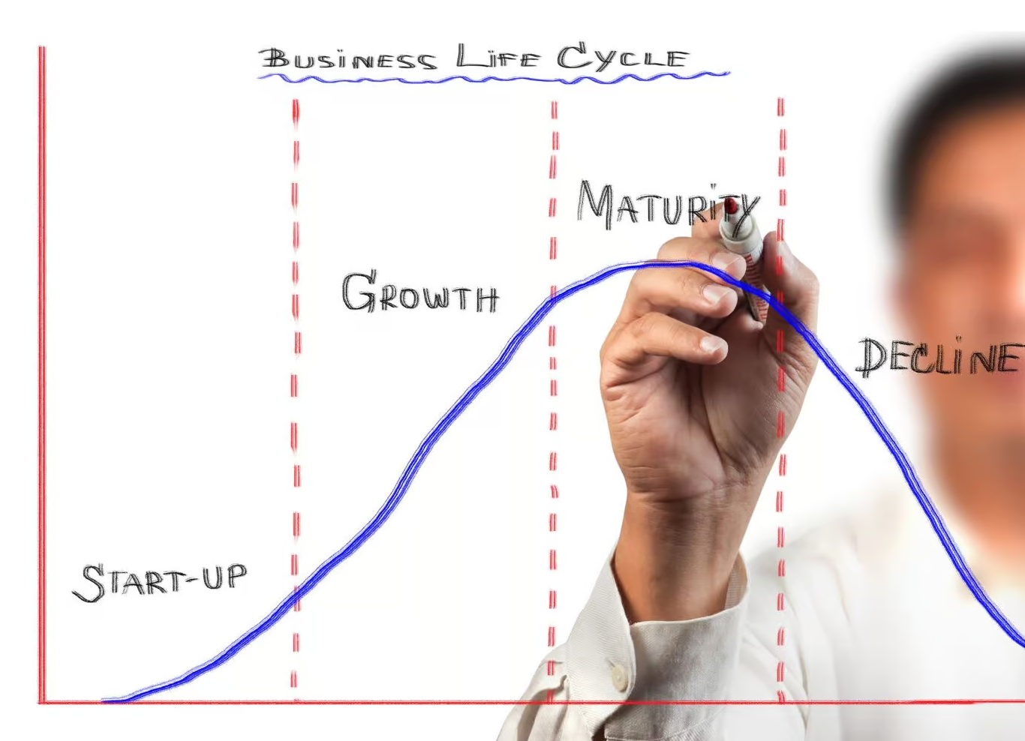
Every stage of the industry's life cycle offers details on the opportunities and factors that will affect its growth. This model, which examines the development of an industry through five stages, aids in predicting its future. Additionally, understanding where the sector is now and where it is going might assist policymakers make decisions going forward (Mowery and Nelson, 1999). This platform makes it easier for interested parties to learn about an industry's present state. Knowing what stage, the sector is in will give businesses a competitive edge, aid in decision-making, future planning, and when to depart.

It can be said that Pharmacy2u is in the growth stage and generated a profit of £2.9 million (Kennedy 2023) in Covid-19. Pharmacy2u still has room to grow because the online pharmaceutical market has comparatively little competition, there are plenty of resources at home, and there are tonnes of opportunities for research and development.

1.2.3. Strategic Group Mapping

To study the competitive structure of an industry, strategy group mapping is crucial. A strategic group is a collection of companies with comparable business models and market positions. An organisation uses strategic group mapping to learn vital information about its competitors in the market and to pinpoint opportunities to enhance its own systems. The best technique for examining their market positions is strategy group mapping (Meilich, 2019).

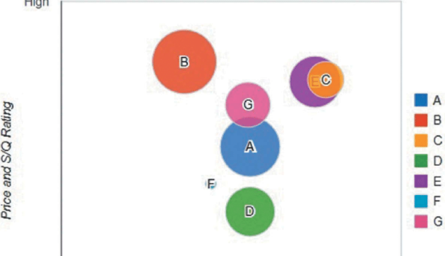

Pharmacy2u.co.uk, which generated US$184 million in revenue in 2021, is the online store with the greatest eCommerce net sales, followed by Lloyds Pharmacy, which generated US$125 million. Chemist-4-u.com, with US$41 million, takes third place (Peters, 2022). In the strategic group mapping, Pharmacy2U has a good position in relation to their competition, allowing them to enhance their own system and obtain an advantage over their rivals.

1.3. Internal Environmental Analysis

The term "internal environment" refers the factors that the company can control but that may have an impact on its strategic management. (Schein, 1990) such as an organization's culture, goal, and vision as well as its technology, operational procedures, human resource management, and overall strategic planning. Porter’s value chain and VRIN model is being discussed to analyse Pharmacy2U’s internal factors.

1.3.1. VRIO Model

In 1991, Professor James Barney published a study titled "Firm Resources and Persistent Competitive Advantage," in which he first introduced the VRIO Model (Alderdi, 2023). To develop a persistent competitive edge, this method is used to assess an organization's internal resources. He suggests that in order for organisations to properly pursue long-term competitive advantage, they must analyse their own internal resources, such as physical capital, organisational capital, and human capital. Companies must fulfil the four criteria of the VRIO Framework in order to convert these resources into a long-term competitive advantage.

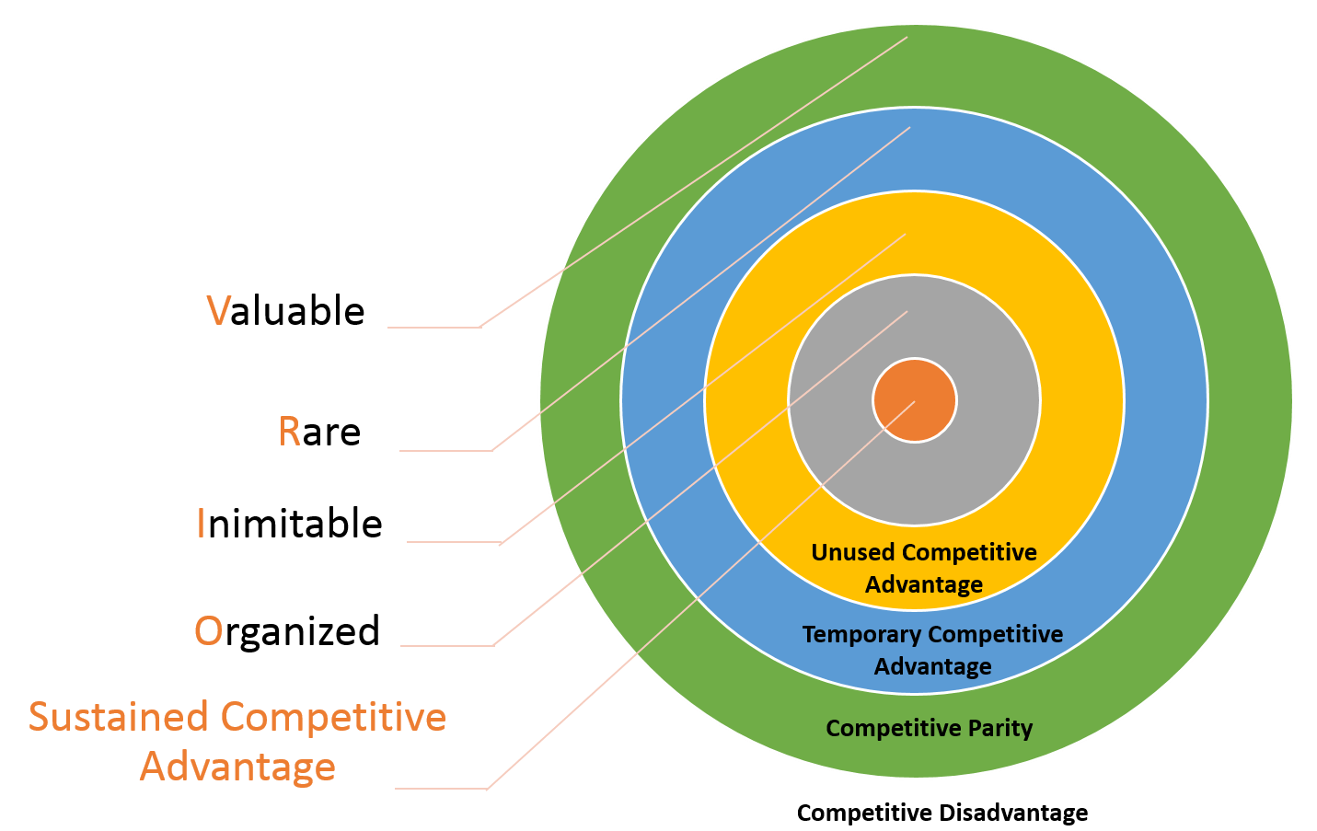

Valuable: A resource is deemed valuable if it aids a company in putting initiatives into practise that boost productivity or effectiveness.

Rare: Rare resources can give businesses a considerable advantage over their rivals. They can use them to deploy tactics for creating value that are unavailable to rivals.

Inimitable: resources give a company a competitive edge if they are expensive or impossible for rivals to duplicate.

Organization: In order to maintain a competitive advantage, it takes more than just having the resources. To make that happen, the company needs a solid organisational structure. If not, the asset turns into a lost competitive advantage (Alderdi, 2023).

As a SME, Pharmacy2U's knowledge and information about its customers are a significant resource. In contrast to other rivals, they are governed by the Medicines and Healthcare Products Regulatory Agency. Their regulatory position and 20 years of experience can be challenging for other companies to match. Pharmacy2U benefits from a solid corporate culture and procedures that aid in achieving their goals and objectives. Pharmacy2U, as a SME, has a competitive advantage according to the VRIO model, because of its customer-centric approach, expertise, regulatory status, and organisational structure.

1.3.2. Porter’s Value Chain Model

Professor Michael E. Porter of the Harvard Business School first introduced the value chain model in his book Competitive Advantage. The value chain examines the whole series of processes necessary to transform basic materials into a consumer-facing product and reveals how and where value might be added along that chain (Michael, 1998).

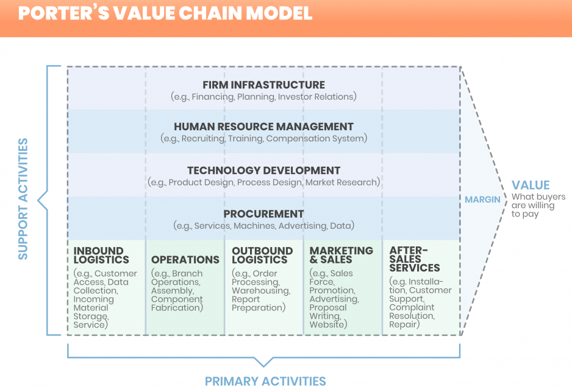

The following major actions make up Pharmacy2U's value chain, including purchasing medications and medical supplies from manufacturers and distributors. It guarantees that the pharmaceuticals are of the highest calibre and adhere to all legal standards. Consumers can submit Pharmacy2U their prescriptions, which are subsequently filled and shipped out. Pharmacy2U also monitors for drug interactions and offers guidance on how to utilise medications properly. Customers can choose from a variety of services, such as managing repeat prescriptions, online medical consultations, and drug delivery right to their doorstep. Through its website and customer service lines, the business additionally offers advice on health-related subjects. Pharmacy2U spends money on marketing and branding to advertise its products and raise brand recognition. This covers marketing, public affairs, social media, and other platforms. Ultimately, Pharmacy2U's value chain is concentrated on employing technology and a customer-centric strategy to deliver convenient and high-quality pharmacy services to customers.

1.4. Industrial Analysis

Industrial analysis is the evaluation of microenvironmental aspects that affect an organization's competitiveness, such as suppliers, consumers, competitors, and stakeholders (Hitesh, 2020). Porter's Five Forces model is being used to assess Pharmacy2U's microenvironment.

1.4.1. Porter’s Five Forces

Poter's Five Forces provides an organisation with a framework for analysing the level of competition in a certain market and its macroenvironment. An organisation must evaluate the factors that have a direct impact on performance and profit margin and shape them to achieve organisational goals and a sustainable competitive advantage. (Lars, 2018).

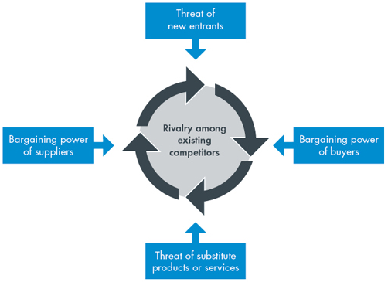

Porter's Five Forces are composed of five elements below:
New entry: When new competitors enter a market, that company's influence also declines. The majority of businesses want to compete in competitive markets or sectors.
Supplier power: This factor examines how suppliers can use their influence to raise the cost of goods and services; the market's power increases as the number of suppliers decreases.
Buyer power: Consumers may be able to lower prices for goods and services when they have more negotiating power.
The threat of substitutes: Competitor goods and services that are simple to replace pose a risk to a company's profitability.

Rivalry among existing competitors: The power of competing businesses declines as competition increases. When there is little competition, businesses can take any action necessary to boost their profits.

Porter's Five Forces analysis within Pharmacy2U context.

Five forces | Status of Pharmacy2U | Power
Threat of New Entrants | highly regulated, strong staff and infrastructure (require significant investment for new entry) | Low
Bargaining Power of Suppliers | Variety of suppliers source (reduce power of supplier & offer competitive price) | Low
Bargaining Power of Buyers | Pharmacy2U established reputation and regulatory status, but market is highly competitive | Medium to low
Threat of Substitutes | Online service preferable than traditional brick-and-mortar pharmacies but there is different online service provider in the market | Medium to low
Rivalry Among Existing Competitors | reputation, expertise, and regulatory status give them a competitive advantage | Low

Due to the high entry barriers, established reputation and regulatory status, and diminished negotiating power of suppliers and buyers, Pharmacy2U enjoys a relatively strong market position. They are still up against opposition from both newcomers and other well-established firms in the online pharmacy market.

1.4. SWOT Analysis of PharmacyU2

The SWOT Matrix was initially presented by Albert Humphrey in 1960 at the Stanford Research Institute. The four elements are strengths, weaknesses, opportunities, and threats, or SWOT. It is a strategic management tool that entails determining the organization's internal strengths and weaknesses as well as the possibilities and challenges given by the external environment. (Gurel, 2017).

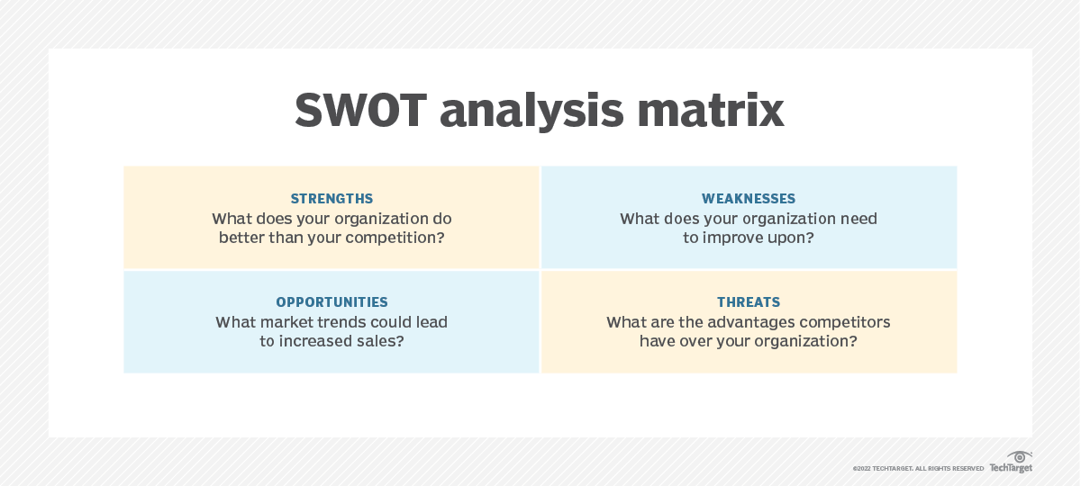

Based on the findings of the internal and external environmental analysis in section 1 of this report, Pharmacy2U's strengths, weaknesses, opportunities, and threats are being identified and analysed using the SWOT matrix:

Strengths: Pharmacy2U is a well-known company with a solid reputation for offering trustworthy and reasonably priced healthcare products and services, including online and NHS prescription services (Armstrong et al., 2018). Additionally, their distribution hubs are well-connected. Thirdly, they also offer parcel delivery services. Fourthly, the business engages with its clients and customers through social networking sites to learn about their feedback, preferences, convictions, likes, and other viewpoints in order to improve their manufacturing division. Fifthly, one of Pharmacy2U's advantages is the suppliers' weak bargaining position.

Weaknesses: Online pharmacies compete intensely with Pharmacy2U since many of them provide comparable goods and services. Pharmacy2U's company is hampered by the limited global presence of the digital marketing sector. Many nations place constraints on their ability to conduct business there (Baltes, 2017). Second, any regulatory problems can have an effect on how well it can function. Pharmacy2U's ability to assist consumers may be constrained by the fact that it is largely an internet pharmacy.

Opportunities: The COVID-19 epidemic has hastened the shift to online healthcare, which presents Pharmacy2U with a chance to broaden its clientele and develop its clientele. In order to assist the brand, realise its full potential, Pharmacy2U has the option to expand its business into other industries or nations (Chaffey & Ellis-Chadwick, 2019). Second, more clients are creating online marketing structures in the current environment, which helps the organization's operations. The internet market chain could assist the business in establishing and accelerating growth.

Threats: Pharmacy2U faces a serious challenge from the other businesses' or shops' pricing competition. Second, the government frequently modifies the market policies that must be adopted by the corporation, overturning previous regulations and altering the entire corporate structure. Pharmacy2U may have difficulties complying with evolving rules because the pharmaceutical industry is heavily regulated.

SWOT Analysis of Pharmacy2U

Strengths  - Established Brand  - Affordable products  - Efficient Services  - Human Capital  - Digital marketing  - Strong organization Structure | Weaknesses  - Limited Product Differentiation  - Absence of physical presence  - Highly regulated by regulatory agency  - Reputation factors  - Lack of global presence
Opportunities  - Increased Online demand.  - Chance to differentiate.  - Expansion into new markets  - Advance technology  - Demographic change | Threats  - Intense Competition  - Regulatory Challenges  - Economic Uncertainty  - Brexit  - Activists
It can be said that Pharmacy2U has some noteworthy strengths to adopt the threats of the external environment, such as intense competition, regulatory challenges, and turn the weaknesses into opportunities, like deferrization, physical presence, in order to achieve competitive advantages in this unstable and ambiguous business environment.

2. Strategic Growth Action

Strategic growth action refers to a company's strategy for overcoming present and upcoming obstacles in order to achieve long-term growth. By utilising its strengths, identifying, and minimising risks, and seizing opportunities in a thoughtful and strategic manner, this strategy seeks to assist the organisation in achieving sustainable, long-term growth. (Sun, 2019)
In this section, Porter's Generic Strategies and the Ansoff Matrix model are evaluated rigorously in order to pick the best strategy for the chosen SME "Pharmacy2U."

2.1. Porter’s Generic Strategy

Michael Porter created the concept known as Porter's Generic Strategy in 1985 for his book Competitive Advantages: Creating and Sustaining Superior Performance. Cost leadership, distinctiveness, and focus are the three general techniques that the framework suggests a company might employ to get a competitive edge. (Cambridge University, 2018).

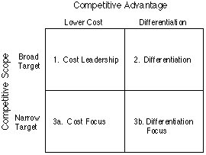

Cost Leadership: Companies that employ a cost leadership approach strive to make items or provide services for less money than their rivals, allowing them to charge less for those goods or services.

Differentiation: Developing distinctive and differentiating goods or services is a component of this strategy. This strategy is used by businesses to differentiate themselves from their rivals by developing a distinctive Value Proposition and Value Discipline.

Focus Strategy: With this strategy, the company focuses on a small market niche or sector and develops products or services that are tailored to the demands of that group.

A business can give their operations a defined direction and develop a long-lasting competitive advantage in their industry by selecting one of these three strategies. It's crucial to remember that each approach comes with its own risks and difficulties, and that businesses must carefully assess their unique advantages and disadvantages before determining which plan to pursue.

2.2. Ansoff Matrix Model

H. Igor Ansoff created the Ansoff Matrix, which was initially published in the Harvard Business Review in 1957. A tool for strategic planning called the Ansoff Matrix aids businesses in choosing their approach to expanding their product and market portfolios. (1957 Ansoff). There are four distinct growth tactics in it:

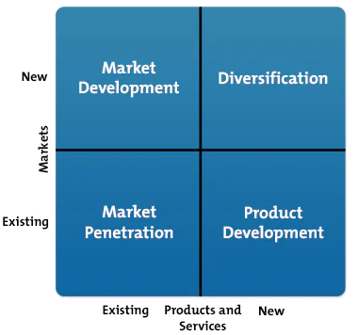

Market Penetration: This strategy involves boosting the sales of current products in current markets. By attracting new clients, boosting purchase frequency, and improving product promotion, it aims to increase market share.

Product Development: This tactic entails introducing fresh goods into already-established marketplaces. The emphasis is on growing the product line and giving current consumers more value.

Market Development: This strategy entails bringing current products into new markets. Its main goal is to find new markets, locations, or client groups where the product can be sold.

Diversification: New items are being introduced into new markets as part of this strategy. In order to reduce risk and diversify the company's revenue streams, it concentrates on entering new enterprises or industries.

Businesses may choose which growth strategy is best for their current circumstances and create a clear plan to attain their growth targets by using the Ansoff Matrix. However, it's crucial to remember that every strategy has its own unique set of risks and obstacles, and businesses must carefully assess their resources and skills before following any specific approach.

2.3. Identification of Suitable Growth Strategy

A UK-based online pharmacy called Pharmacy2U provides a variety of medical services, such as the delivery of prescription drugs, online doctor consultations, and health information. Pharmacy2U may think about implementing Porter's Generic Strategy in order to maintain growth and expand its market share. Every industry has its unique set of values and cultures, and no growth strategy is adequately suited to guarantee that growth strategy. However, when comparing Ansoff Martix and Porter's Generic models in section 2, it can be concluded that Porter's Generic strategy is most suited to help Pharmacy2U achieve its goals of overcoming present and upcoming obstacles to long-term growth.

In accordance with the business environment analysis in section 1, Pharmacy2U has a strong human and capital resource base, an effective organisational structure, favourable market positioning, a strong brand and reputation, and a variety of market segments. In order to attain competitive advantages, Porter's Generic Strategy would be a useful framework for promoting cost-effective products and services and diversifying product lines.

2.4. SFA Matrix

The SFA matrix, created by Gerry Johnson and Kevan Scholes, is a framework for evaluating the appropriateness, viability, and acceptability of a company's strategic direction (Johnson and Scholes, 1997). It is a terrific tool for quickly and fairly weighing all of the possibilities available and making decisions.
Suitability: This refers to how well the business is suited to the strategic opportunity.  Feasibility: Taking into account the strengths and limitations of an internal study, this is the extent to which the strategic alternative is evaluated to determine its viability. | 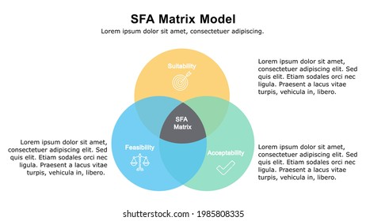
Acceptability: It is crucial to gauge how a specific strategy affects stakeholders, risk, and return; and how they are convinced and engage with the proposal.

Using the SFA framework to assess the appropriateness, viability, and acceptability of its strategic direction, a company can decide on its future course and modify its strategy as necessary to meet its objectives. The Porter generic matrix, which emphasises cost leadership, differentiators, and focus strategy; recommended for future development of Pharmacy2U.

The table is created to compare the option of strategic growth action and select the suitable option for Pharmacy2U.

Angles Of Approach | Option 1:  Cost Leadership | Option 2: Differentiation | Option 3:  Focus
Suitability | 8 | 8 | 6
Feasibility | 8 | 8 | 7
Acceptability | 8 | 7 | 5
Total | 24 | 23 | 18

(Weighted out of 10 where 0 is minimum value & 10 is maximum value)

According to result Pharmacy2U should emphasise on option -1 with total weight 24 and option -2 with 23 weight to gain competitive advantages following cost leadership and differentiation.

2.5. Mandelow’s Stakeholder Matrix

In 1999, Ian Mendelow developed the Mende-low Stakeholder Matrix, a strategic management tool that assists organisations in classifying stakeholders according to their level of interest and influence (Oxford, 2023).According to their level of influence and interest, stakeholders are divided into four groups: low power/low interest (stakeholders need to monitor primarily), low power/high interest (keep stakeholders informed), high power/low interest (keep stakeholders satisfied), and high power/high interest (stakeholders must manage closely).
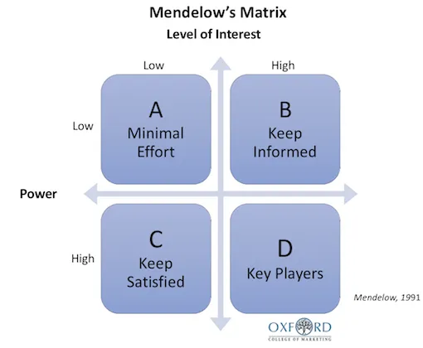

Organisations may prioritise their engagement activities and gain a better understanding of their stakeholders by using Mendelow's Stakeholder Matrix. In order to identify and rank the stakeholders of Pharmacy2U and determine whether or not the "option 1" and "option 2" examined in section 2.4 for Porter's Generic Strategy in section 2.1 are acceptable. a stakeholder analysis of selected SME is conducted below.

Customers (High power/high interest): are the main means of support and survival. They will be motivated to purchase Pharmacy2U goods and services in the current unstable climate where the cost-of-living crisis persists by diversification and cost leadership possibilities.
Shareholders (High power/low interest): Although they have a sizable investment and are not directly involved in the company's daily operations, more customers and profits will secure their future growth and allow them to purchase additional stock.
Employees (High power/high interest): who operate the company will be highly supportive of the expansion strategy because it will give them greater options for juggling work and personal life as well as opportunities to advance their careers.
Regulators (High power/high interest): It is possible to have their acceptability by managing them closely.
Suppliers (Low power/high interest): More supply leads to more demand, thus they will benefit from the proposed Growth Strategic choice.

To build enduring relationships with stakeholders, Pharmacy2U is advised to effectively engage and communicate with these stakeholders about any future changes, risks, and successes, to preserve their support, and to make sure their requirements are addressed.

3. Strategic Growth Action Implementation Plan

A strategic growth action plan's implementation entails carrying out the suggested strategies and techniques. The success or failure of the strategy will depend on this stage of the plan, which is the most important one. Following are some crucial actions for putting into practise a strategic growth action plan for a particular SME Pharmacy2U:

Develop an Implementation Plan: Create a strategy that details how the plan will be implemented at the strategic, tactical, and operational levels of the organisation. The main players in charge of each work, as well as the deadlines and milestones, should be identified in this plan. The growth approach in the near future, Pharmacy2U's process will incorporate Porter's Strategic Growth model. In order to provide outstanding customer experiences at reasonable costs, the strategy calls for offering a variety of goods and services to both current and potential customers. It also calls for developing a distinctive value proposition and market positioning.

Organizational Chart: To prevent misunderstandings, overlapping tasks, and project creep, everyone will be involved and informed about their roles and duties in accordance with the organisational chart. (Pharmacy2U.com, 2022).

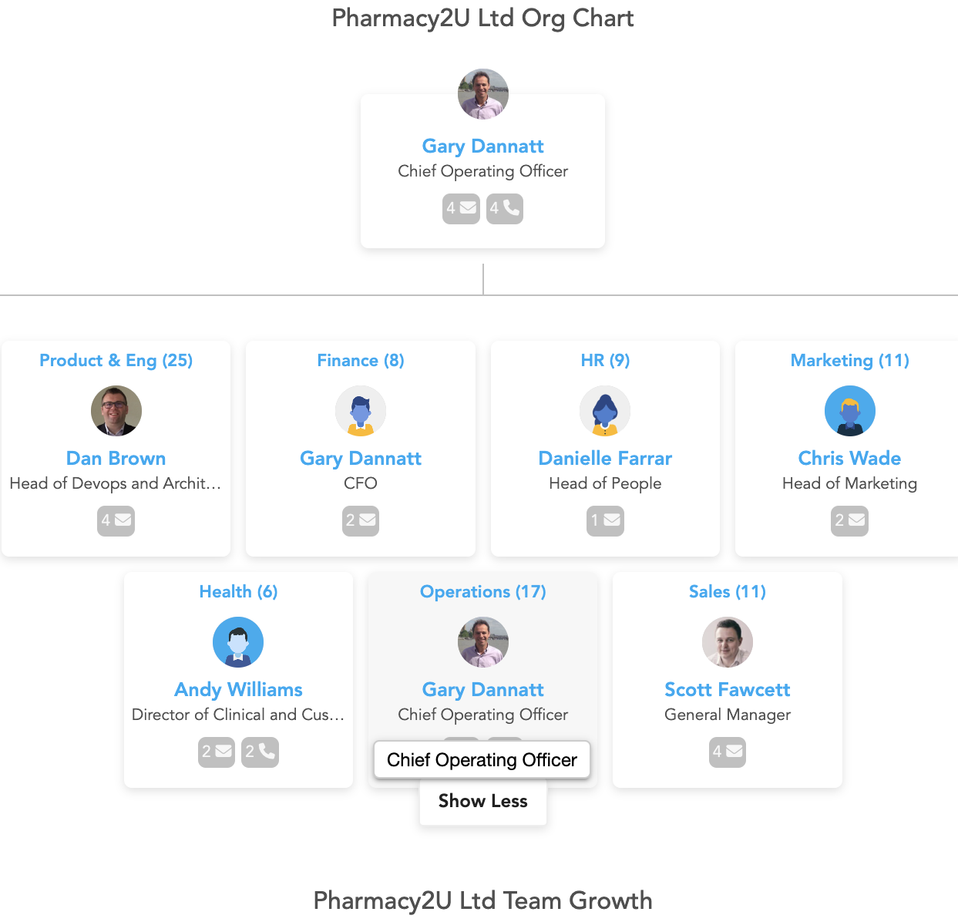
Source: Pharmacy2U.com

Resource Allocation: To guarantee that the Growth Strategy actions are being implemented and completed within the timebound and budgets and to be able to assess any probable, necessary resources such as money, persons, technology, and equipment will be specifically identified and allocated.

Stakeholder Management: The strategic growth action taken will have an impact on a number of internal and external stakeholders, including workers, clients, shareholders, suppliers, delivery drivers, regulators, local governments, and the community. Mendelow's Stakeholder Matrix is used to improve the communication plan based on the power and interest of the stakeholders:

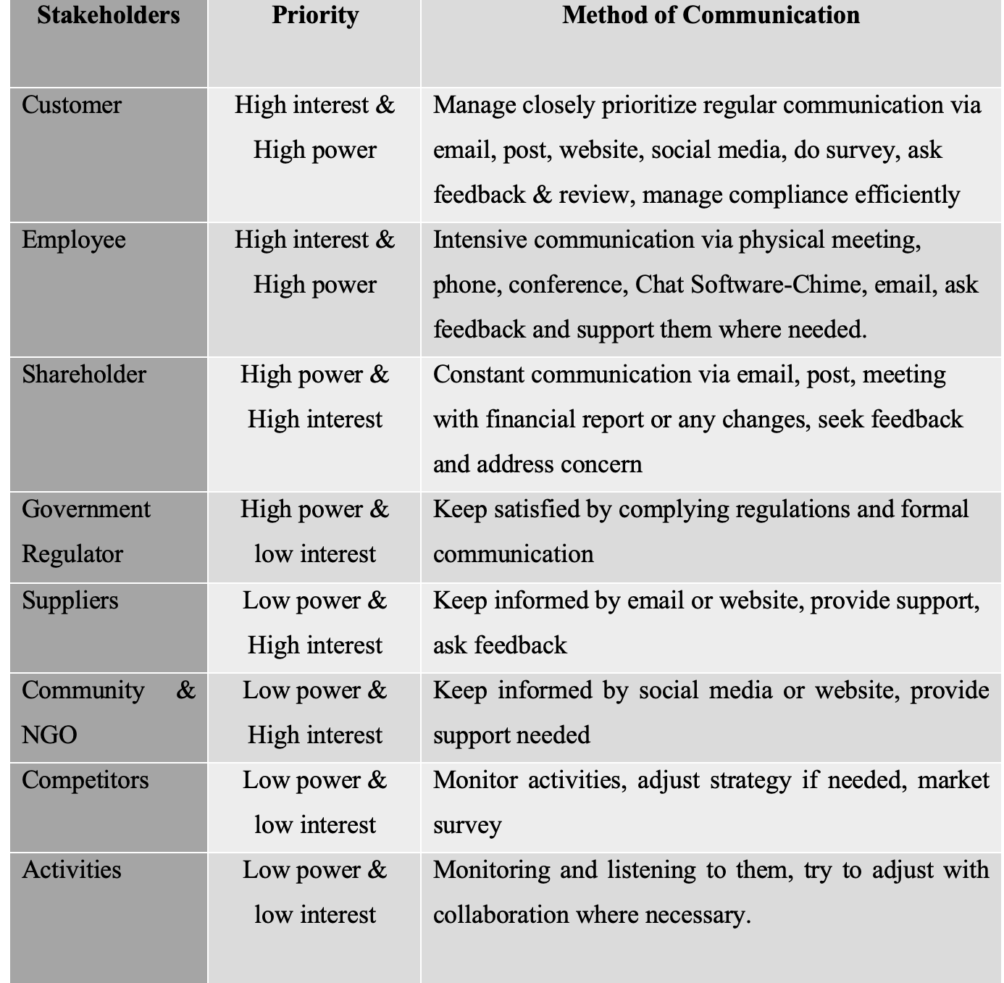

4. Monitoring and Evaluation

It is an essential phase of a growth plan that involves assessing whether the desired outcomes have been realised, identifying any unexpected outcomes, and researching the development strategy's effects on the firm. This evaluation will help determine whether the method was successful and whether any further adjustments are required (Barratt et al., 2018). Some strategies are being used to monitor and assess the Strategic Growth implementation and its outcome of ‘Pharmacy2U’.

- Enhance engagement with stakeholders
- Review meeting
- Set Key Performance Indicators (KPIs) to evaluate implementation plan
- Compilation of questionnaires
- Observation engagement of stakeholders
- Benchmarking the growth progress
- Customer feedback and review
- Conduct a survey
- Collection of data before and after implementation
- Conduct a SWOT analysis frequently to identify weaknesses and threats
- Assess effectiveness and modify the strategy following the outcomes

5. Recommendation

In this report, the strategic management of Pharmacy2U has been discussed and critically evaluated its internal environment using VRIO model and Value Chain Model to understand the strength and weakness within the organization, and external factors applying the PESTEL planform, Industry Life Cycle and Strategic Groupe Mapping. Furthermore, Porter’s Five Forces platform is used to analyse the rivalry power in the market. It can be said with the outcomes of business environment analysis that Pharmacy 2U have a great brand value and they have a strong position in the pharmaceutical market for their reputation and unique value proposition. They have organised structure with human and material capital along with advance technology system within organization.

Pharmacy2u is recommended to follow Porter’s Generic Strategic and focus on Cost effective option and Diversification option: both options are weighted through SFA Matrix and assess the acceptancy throw Mendelow's Stakeholder Matrix. In order to combat the threat of substitutes in the market, it is crucial to draw in the trendy client and segment the market by offering affordable goods and services. Pharmacy2u should move quickly in order to take advantage of sustainable competitive advantages over the long term and prepare for unforeseen obstacles in this uncertain and volatile economic environment.

6. Conclusion

By evaluating small and medium-sized enterprises (SME) and offering strategic recommendations for their future development and equipping them to meet new challenges and achieve competitive advantages, this study demonstrates the understanding of strategic management. The reason Pharmacy 2U was chosen as the first online pharmacy in the UK is that it is a profitable SME that offers pharmaceutical products and services online. During and after the Covid-19 crisis, this sector was severely impacted by government restrictions, Brexit, inflation, the living cost crisis, and other factors. Using the VRIO model, Value Chain Model, PESTEL planform, Industry Life Cycle, and Strategic Group Mapping, this SME's business environment has been examined and critically analysed. Porter's Five Forces is also used to study market competition. Then, utilising a SWOT analysis, the strengths, weaknesses, opportunities, and threat were determined. Following that, Porter's Generic strategy—which emphasised cost effectiveness and diversification has recommended. Additionally, Mendelow's stakeholder matrix and the SFA Matrix have been used to support the two possibilities to determine the applicability, feasibility, and acceptability of the suggested plan. They are also given an organisational chart, a stakeholder communication plan, an implementation plan, and details on the possible adverse effects if the recommendations are not adopted into the organisation immediately. By adopting the strategic growth plan recommended in the report into practise, it is anticipated that Pharmacy2U would be able to attain its sustained competitive advantages and overcome any potential hurdles.

7.REFERENCES

- Aguilar, F.J. (1967) Scanning the Business Environment. Johannesburg: Macmillan Press.
- Alderdi, R. (2023) VRIO Analysis: The Four-Question Framework in Competitive Advantage [Online]. Available at https://www.thepowermba.com/en/blog/vrio-analysis (Accessed: 10 April 2023).

Andalo, D. (2020) Pharmacy2U reports £16m loss in 2018/2019 [Online]. Available at: https://pharmaceutical-journal.com/article/news/pharmacy2u-reports-16m-loss-in-2018-2019 (Accessed: 6 April 2023).
- Ansoff, H. (1957). Strategies for Diversification. Harvard Business Review. 35 (5): 10–25
- Armstrong, G. M., Kotler, P., Harker, M. J. & Brennan, R., 2018. Pharmacy2U digital marketing Marketing: an introduction. s.l.:Pearson UK.
- Baltes, L. P., 2017. Marketing technology (Martech)–the most important dimension of online marketing. Bulletin of the Transilvania University of Brasov. Economic Sciences. Series V, 10(2), pp. 43-48.
- Bank of England (2021) Impacts of the Covid-19 crisis: evidence from 2 million UK SMEs [Online]. Available at: https://www.bankofengland.co.uk/-/media/boe/files/working-paper/2021/impacts-of-the-covid-19-crisis-evidence-from-2-million-uk-smes.pdf (Accessed: 6 April 2023).
- Bank of England (2023) Monitory Policy Report- February 2023. [Online] Available at:https://www.bankofengland.co.uk/monetary-policy-report/2023/february-2023#:~:text=The%20Bank%20of%20England's%20Monetary,percentage%20p04%25 (Accessed: 30 April 2023).

Barratt, M., Debbie, V., Wills, H., and Metcalfe, C., 2018. Knowhow.ncvo.org.uk [Online] Available at: https://knowhow.ncvo.org.uk/how-to/how-to-develop-a-monitoring-and-evaluation-framework [Accessed: 30 April 2023].
- BBC (1999) UK’s first online pharmacy opens: the nation’s largest online Pharmacy [Online]. Available at: http://news.bbc.co.uk/1/hi/health/537928.stm (Accessed: 5 April)
- GOVT. UK. (2022) Small to medium sized enterprise (SME) action plan [Online]. Available at: https://www.gov.uk/government/publications/fcdo-small-to-medium-sized-enterprise-sme-action-plan/small-to-medium-sized-enterprise-sme-action-plan# (Accessed: 6 April 2023).
- Gurel, E. (2017) SWOT Analysis: A theoretical review, Journal of International Social Research, 10 (51), pp. 994-1006.
- Hitesh, B. (2020) Marketing91.com [Online] https://www.marketing91.com/internal-environment/ [Accessed 13 April 2023].

Kennedy, B. (2023) Pharmacy2U 2021/22 financial results reveal 'dramatic' yearly increase [Online]. Available at: https://www.chemistanddruggist.co.uk/CD136665/Pharmacy2U-202122-financial-results-reveal-dramatic-yearly-increase (Accessed: 6 April 2023).
- Lars, D., B. (2018) Business-to-you [Online]. Available at: https://www.business-to-you.com/porters-five-forces/ (Accessed: 12 April 2023).
- Lynch, R. (2015) Strategic Management. 7 ed. Harlow: Pearson Education Limited.
- Lynch, R.L. (2018) Strategic management. 8th ed. Harlow: Pearson Education Limited.
- Mahoney, Joseph T. and J. R. Pandian (1992), "The Resource-Based View Within the Conversation of Strategic Management." Strategic Management Journal, 13 (5), pp. 363-380.

MarketLine (2021) Sustainable Growth in the Pharmaceutical Market: Companies embracing ESG objectives will thrive [Online]. Available at: https://advantage-marketline-com.ezproxy.uwtsd.ac.uk/Analysis/ViewasPDF/sustainable-growth-in-the-pharmaceutical-market-9(Accessed: 9 April 2023).
- Meilich, O. (2019), "Strategic groups maps: review, synthesis, and guidelines", Journal of Strategy and Management, 12 (4), pp. 447-463.

Michael, E. R. (1998) Competitive Advantage: Creating and Sustaining Superior Performance. Cambridge: Free Press.
- Mowery, D. & Nelson, R.R. (1999) The sources of industrial leadership. Cambridge: Cambridge University Press.

Oxford College of Marketing (2023) What Is Mendelow’s Matrix And How Is It Useful?[Online]https://blog.oxfordcollegeofmarketing.com/2018/04/23/what-is-mendelows-matrix-and-how-is-it-useful/ [Accessed 13 April 2023].
- Peters, L. (2022) Top online stores in the Pharmacy segment in the UK in 2021, by e-commerce net sales [Online]. Available at: https://www.statista.com/forecasts/1218277/top-online-stores-pharmacies-united-kingdom-ecommercedb (Accessed: 10 April 2023).

Pharmacy2U (2017) Pharmacy2U: Who are Pharmacy2U [Online]. Available at: https://www.pharmacy2u.co.uk/whoarepharmacy2u.html (Accessed: 6 April 2023).
- Schein, E. H. (1990). Organizational Culture. American Psychologist. 45 (2), pp. 109–119
- Sun, W. (2019) Growth Strategy Explained. [Online] Available at: https://strategyforexecs.com/growth-strategy/ (Accessed: 3 May 2023).
- Trott, P. (2017) Innovation management and new product development. 6th ed. Harlow: Pearson.
- University of Cambridge (2018) Porter's Generic Competitive Strategies (ways of competing). [Online] Available at: https://www.ifm.eng.cam.ac.uk/research/dstools/porters-generic-competitive-strategies/ (Accessed: 28 April 2023).

