Activity 2
The CIPD HR Profession Map is made up of 4 areas. This map aims to help the organisation and personal career progression and can be applied in day-to-day work. The CIPD HR Profession Map can help make better decisions and implement these with confidence, drive the organisation within their changes and help individuals perform at their peak (CIPD, Profession 2020).
The first of the four areas is the purpose and values. The purpose is essential to help individuals and the organisation understand what is important and what the company is trying to achieve. The map's purpose area breaks down into three smaller professional values (CIPD, Purpose 2020). Principles-led, Evidence-based and Outcomes-driven. Suppose businesses and individuals apply all 3 of these professional values. It will help them through a challenging or uncertain future and help ensure all decisions have a long-term, positive impact.
The second area is known as Core Knowledge. It comprises six core areas of knowledge that help drive change and positively impact the working environment (CIPD, Core Knowledge 2020). The six core areas are people practice, culture and behaviour, business acumen, analytics, creating value, digital working and change. The Core Knowledge area is designed to help individuals gain the knowledge and understanding that they need to be an expert in the people profession and applies to all individuals regardless of their profession.
The third area is Specialist Knowledge; this shows and helps individuals organise their expertise to make a positive impact. Specialist Knowledge contains nine smaller subcategories: employee experience, employee relations, diversity and inclusion, learning and development, organisation development and design, people analytics, resourcing, reward and talent management. With all these considered, specialist knowledge is relevant for any individual within the people profession ( CIPD, Specialist Knowledge 2020).
The final area is known as Core Behaviours. It is the most significant part of the CIPD HR Profession Map. The core behaviours were developed to help individuals understand the actions they need to comply with the CIPD three professional values: including principles-lead, evidence-based and outcomes-driven. This area is critical for individuals within an organisation. It helps them understand how to apply their knowledge and expertise to ensure that the most positive impact occurs. Core Behaviours are not only designed for professional individuals; they can be used in all professions. (CIPD, Core Behaviours 2020). To ensure that decisions are made with the most effective outcome, the Core Behaviours contains eight values to help create value for people, organisations, society and profession.
The first value is Ethical practice. It is about building trust and ensuring ethical behaviour when making decisions and applying that decision to the organisation's principles and values to ensure consistency in the decision-making process (CIPD, Ethical-practice 2020). It is of extreme importance when deciding for the organisation what is the correct decision, factoring in all the ethical behaviours as the wrong decision can have a significant impact on people’s lives and even the organisation's reputation. Not only does this include poor choices, but can also include decisions that have been poorly implemented. When making a decision, be sure to factor in good principles and good values.
The next value is Professional Courage and influence. It helps individuals gain personal and professional courage to speak up regardless of the opposition's resistance, ensuring it is the right thing to do. When professional courage and influence are teamed with communication skills and others' influence, it can be significantly essential in a range of situations such as making a case for change, challenging others' behaviours, and merely taking responsibility for mistakes. To ensure that professional courage, influence and communication is done effectively, professional relationships need to be built on understanding other individuals' views, concerns and needs. This will be the most effective way to communicate with others to achieve positive outcomes (CIPD, Professional Courage 2020).
Valuing people is the next element which is a critical aspect. People professionals must ensure that they value individuals and are always at the centre of the approach by providing support, compassion and fairness (CIPD, Valuing People 2020). Whilst working alongside managers and leaders, people professionals aim to create a team of trust, people development and support all individuals to be their best at work ensuring they give them a meaningful voice on matters that may affect their working lives.
Working Inclusively is another element. How individuals work together is increasingly becoming more import due to its impact on how the outcomes in the changing world of work are delivered (CIPD, Working Inclusively 2020). Due to expansion from organisations across geographies and cultures, it is of extreme importance that people are included and allowed to work together. Following this guidance will result in positive outcomes for the organisation.
Commercial Drive is the next element implemented to apply a business and customer-focused approach, showing the commitment to create value for organisations (CIPD, Commercial Drive 2020). The responsibility of this element is to make the most value for people and the business. It identifies any issues, opportunities, and risks that will harm the individuals and the organisation's performance and success.
Passion for learning is a core element for professionalism and is critical for all people professionals. Individuals need workplace learning and development, but they also need to connect and contribute to the broader people profession, including external practices and improving their understanding (CIPD, Passion for learning 2020). Alongside this, individuals and businesses need to seek new ways to improve and innovate in the work environment.
The next element is Insights focused, which means individuals need to adopt a disciplined procedure to understand and diagnose problems. From this, a range of evidence can be produced to help develop peoples insights and solutions (CIPD, Insights focused 2020). There are three main evidence-based practice steps: asking questions, acquiring evidence, critically assessing evidence, and understanding the whole issue and its broader implications. Following these steps will result in decisions being most effective.
Situational decision-making is the final element to complete the Core Behaviours. This element is about how to make decisions effectively (CIPD, Situational decision making 2020). It considers the benefits and risks associated with making decisions and how they align to the professional principles and values. All decisions that are made will need to be flexible to ensure they can be adapted if a change of circumstance occurs.

Bibliography
CIPD. (2020) ‘Profession Map’ [online]. Available at https://peopleprofession.cipd.org/profession-map?gclid=CjwKCAiAirb_BRBNEiwALHlnD3Q7ct0iT2RJSWdSiaMme7sufDU2FLAOZY-hAHzbY8Kb-QpRsNcUfxoCsWYQAvD_BwE [accessed 12.2020]
CIPD. (2020) ‘Core Purpose’ [online]. Available at https://peopleprofession.cipd.org/profession-map/core-purpose [accessed 12.2020]
CIPD. (2020) ‘Core Knowledge’ [online]. Available at https://peopleprofession.cipd.org/profession-map/core-knowledge [accessed 12.2020]
CIPD. (2020) ‘Specialist Knowledge’ [online]. Available at https://peopleprofession.cipd.org/profession-map/specialist-knowledge [accessed 12.2020]
CIPD. (2020) ‘Core Behaviours’ [online]. Available at https://peopleprofession.cipd.org/profession-map/core-behaviours [accessed 12.2020]
CIPD. (2020) ‘Ethical Practice’ [online]. Available at https://peopleprofession.cipd.org/profession-map/core-behaviours/ethical-practice [accessed 12.2020]
CIPD. (2020) ‘Professional courage’ [online]. Available at https://peopleprofession.cipd.org/profession-map/core-behaviours/professional-courage-influence [accessed 12.2020]
CIPD. (2020) ‘Valuing People’ [online]. Available at https://peopleprofession.cipd.org/profession-map/core-behaviours/valuing-people [accessed 12.2020]
CIPD. (2020) ‘Working Inclusively’ [online]. Available at https://peopleprofession.cipd.org/profession-map/core-behaviours/working-inclusively [accessed 12.2020]
CIPD. (2020) ‘Commerical Drive’ [online]. Available at https://peopleprofession.cipd.org/profession-map/core-behaviours/commercial-drive [accessed 12.2020]
CIPD. (2020) ‘Passion for learning’ [online]. Available at https://peopleprofession.cipd.org/profession-map/core-behaviours/passion-for-learning [accessed 12.2020]
CIPD. (2020) ‘Insights focused’ [online]. Available at https://peopleprofession.cipd.org/profession-map/core-behaviours/insights-focused [accessed 12.2020]
CIPD. (2020) ‘Situational decision making’ [online]. Available at https://peopleprofession.cipd.org/profession-map/core-behaviours/situational-decision-making [accessed 12.2020]

Activity 4
For an organisation to be successful, a significant aspect of that success is to ensure positive team dynamics (Deakinco, 2017). Team dynamics is when two or more people are working together to reach a goal or purpose. The team can be put together for a long term project or just come together for a few hours (ateb). Team dynamics help the business reach its full potential whilst helping the employees' potential also to use their skills and experience and progress these further. Although Team dynamics are positive, there are no two teams that are the same. To help the team improve, you must first start with formulating a tailored strategy for them and identify and minimise any issues (ateb). Alongside team dynamics, you also have group dynamics, and this is where each team members' role and behaviour will impact each other and the group as a whole. Team dynamics are the psychological factors that influence the team's performance (Notredame, 2020). Group dynamics are still of importance because they impact areas such as creativity, productivity, and effectiveness. Group work is seen as an integral part of organisations as it can result in better work outcomes and improved customer satisfaction. When a team has a positive group of dynamics, the team can trust one another (ateb). Due to this positivity, the results are constructive and productive. Although this is not always the case, poor group dynamics will result in poor decision-making and disruptive.
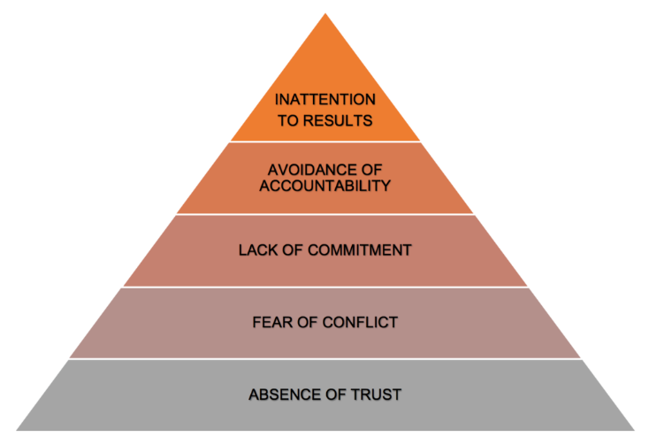
A range of models has been created for organisations to apply them throughout their work team optimise performance. Firstly there is the Lencioni model, and this was created by P.Lencioni in his 2005 book and outlines five common problems that teams experience that will have an impact on their effectiveness. The first step is lack of trust; if team members do not trust one another, they are less likely to ask for help. Fear of conflict, this is a normal part of teamwork which can be productive if performed correctly as a team. Lack of commitment, if team members do not commit or follow through with their work, will affect the project's success. Avoidance of accountability and finally inattention to results; this is where team members focus on their personal goals rather than the project goals. This model is to be followed from the bottom up. Once you have trust as the crucial first step from this, you will manage conflict, achieve commitment, create accountability and focus on the end goal (Lencioni, P 2002).
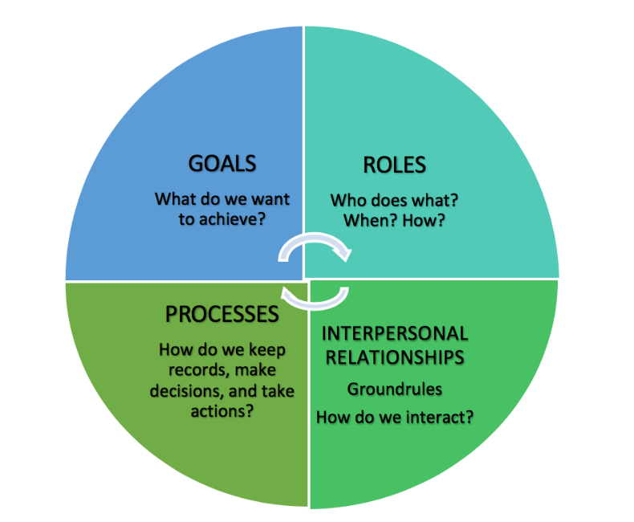
Another model is the GRPI model created by Richard Beckhard in 1972. This model has been widely adopted throughout organisations as it outlines four areas that result in highly effective teamwork. Goals are where each member must fully understand and be committed to their primary goal for the team and the organisation. Roles, each team member must understand what part they play within the team and what is expected of them. Interpersonal, communication is key to building trust among the other team members and finally process how the decisions will be made (Beckhard, R 1972).
All models that have been produced for organisations to understand the team and group dynamics contain similar if not the same areas and certainly have the same outcome.

When politics are implied effectively, it can help an organisation meet its strategic goals and objectives and live up to its values (HBR, 2017). Organisational politics is not only beneficial to the organisation but individuals within that organisation also. Organisational politics refer to a variety of activities that will help improve personal or organisational interests. Political behaviour is always likely to be present but not always explicit. Still, it is essential to understand that the cause of political activities is often due to scarce resources, including time pressure, individual personal motivations, and social and structural inequalities (ateb). The first step for the organisation and the individuals within it to feel comfortable with politics requires that they are equipped with a reliable map of the political landscape and fully understand the sources of political capital (ateb). Bauer & Erdogan (2018) outline “Organisational politics can be seen as informal, unofficial, an increase in power, and influence” (Iedunote, 2020). This can be seen as both advantageous and disadvantageous within the organisation. Organisational politics is natural, but unhealthy politics can lack employee commitment and performance and cause higher stress levels, anxiety, and depression (Iqbal, I 2018). When it comes down to the organisational objectives, political behaviour on achieving these can lead to healthy or unhealthy competition. There are many positive political behaviour results in an organisation. It can include, single-minded focus, mental toughness, positive mindset and overcome hardship. However, when there are positives, there are always negatives. The negatives for political behaviour within an organisation is wasted time, loss of productivity, increased stress and stunted business growth (ateb). If an organisation factors in both the positives and negatives of political behaviour within its team, it will give the organisation and the individuals the strength and confidence to grow. If a company can minimise the negative impacts that political behaviour will have, they would create an enjoyable work environment and focus on the organisational objectives ensuring these will be met and creating new goals for the business and its employees.

Bibliography
Beckhard, R (1972). “Optimising team-building efforts,” Journal of Contemporary Business, 1972, pp. 23-27.
Deakinco. (2017) ‘Strategies for managing team dynamics’ [online]. Available at https://www.deakinco.com/media-centre/news/6-strategies-for-managing-and-improving-team-dynamics#:~:text=Group%20dynamics%20can%20be%20understood,a%20team's%20behaviour%20and%20performance [accessed 12.2020]
HBR. (2017) ‘Types of organisational politics’ [online]. Available at https://hbr.org/2017/04/the-4-types-of-organizational-politics [accessed 12.2020]
Iedunote. (2020) ‘Politics’ [online]. Available at: https://www.iedunote.com/politics [accessed 12.2020]
Iqbal, I (2018). “Political behaviours in organisations,” Relfections of a learning & development professional.
Lencioni, P (2002). “Five Dysfunctions of a Team, New York, NY: John Wiley and Sons Inc., 2002
Notredame. (2020) ‘Understanding the importance of team dynamics’ [online]. Available at https://www.notredameonline.com/resources/leadership-and-management/understanding-the-importance-of-team-dynamics/ [accessed 12.2020}

