BMIH6007

International Meetings Management for the Hotel Industry (PPT)

Student Name: Raducu – Viorel Ciolpan
Lecturer`s Name: Kathryn Flynn
Student ID: 2221478
Date of Submission: 10/06/2025

Table of Contents
Executive Summary 3
Introduction 4
Event Content and Context 5
Market Analysis 6
Operational Feasibility 7
Financial Feasibility 8
Strategic Importance and Impact 10
Risk Assessment Mitigation 11
Conclusion & recommendations 12
References 13

I acknowledge the use of Grammarly (https://www.grammarly.com/) on 20.May 2025 to check my work using the prompt(s):
- Please check the following text for readability, grammar and syntax.

I confirm that I have not presented any AI generated text as my own work. I confirm I have copies of my drafts, notes, and other resources I used before, and after the use of AI tools which I may be asked to provide in evidence.

I acknowledge the use of Google Scholar on 20.May 2025 to check my work using the prompt(s):
- Please check the following text for readability, grammar and syntax.

I confirm that I have not presented any AI generated text as my own work. I confirm I have copies of my drafts, notes, and other resources I used before, and after the use of AI tools which I may be asked to provide in evidence.

Executive Summary
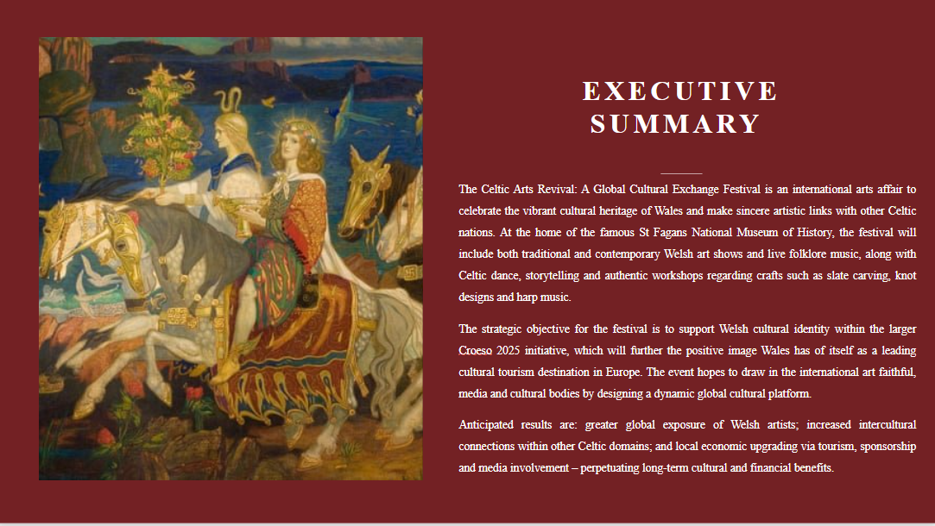
The Celtic Arts Revival: A Global Cultural Exchange Festival is an international arts affair to celebrate the vibrant cultural heritage of Wales and make sincere artistic links with other Celtic nations. At the home of the famous St Fagans National Museum of History, the festival will include both traditional and contemporary Welsh art shows and live folklore music, along with Celtic dance, storytelling and authentic workshops regarding crafts such as slate carving, knot designs and harp music.
The strategic objective for the festival is to support Welsh cultural identity within the larger Croeso 2025 initiative, which will further the positive image Wales has of itself as a leading cultural tourism destination in Europe. The event hopes to draw in the international art faithful, media and cultural bodies by designing a dynamic global cultural platform.
Anticipated results are: greater global exposure of Welsh artists; increased intercultural connections within other Celtic domains; and local economic upgrading via tourism, sponsorship and media involvement – perpetuating long-term cultural and financial benefits.

Introduction
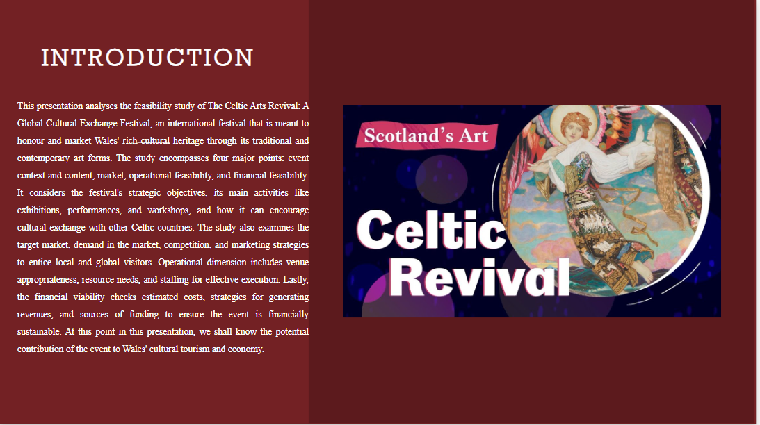
This presentation analyses the feasibility study of The Celtic Arts Revival: A Global Cultural Exchange Festival, an international festival that is meant to honour and market Wales' rich cultural heritage through its traditional and contemporary art forms. The study encompasses four major points: event context and content, market, operational feasibility, and financial feasibility. It considers the festival's strategic objectives, its main activities like exhibitions, performances, and workshops, and how it can encourage cultural exchange with other Celtic countries. The study also examines the target market, demand in the market, competition, and marketing strategies to entice local and global visitors. Operational dimension includes venue appropriateness, resource needs, and staffing for effective execution. Lastly, the financial viability checks estimated costs, strategies for generating revenues, and sources of funding to ensure the event is financially sustainable. At this point in this presentation, we shall know the potential contribution of the event to Wales' cultural tourism and economy.

Event Content and Context
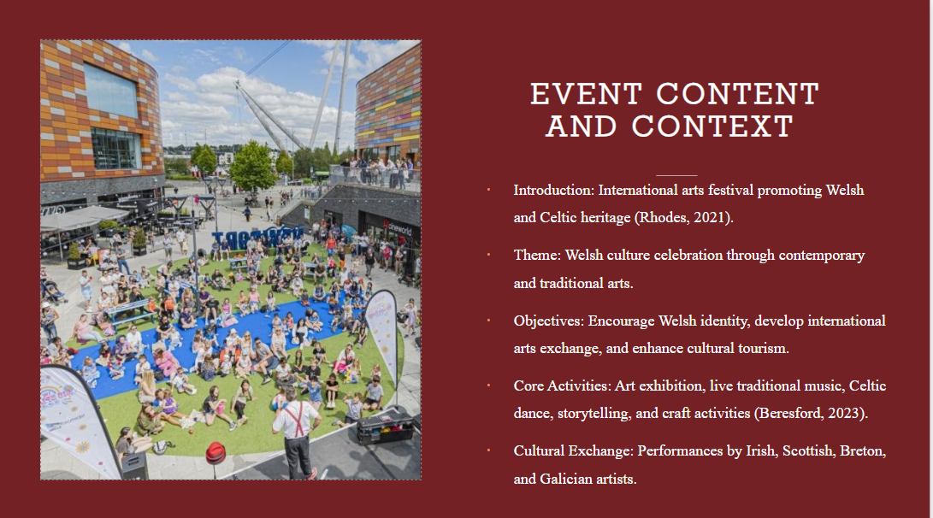
- Introduction: International arts festival promoting Welsh and Celtic heritage (Rhodes, 2021).
- Theme: Welsh culture celebration through contemporary and traditional arts.
- Objectives: Encourage Welsh identity, develop international arts exchange, and enhance cultural tourism.
- Core Activities: Art exhibition, live traditional music, Celtic dance, storytelling, and craft activities (Beresford, 2023).
- Cultural Exchange: Performances by Irish, Scottish, Breton, and Galician artists.
Notes:
The Celtic Arts Revival: Global Cultural Exchange Festival is a worldwide celebration of Welsh and wider Celtic heritage in the form of traditional and modern art forms. Based on the concept of cultural pride and exchange, the festival is designed to advance Welsh identity as well as establish global links. Major goals include the promotion of the richness of Welsh arts, the development of cultural tourism, and collaboration between Celtic nations. Main activities will comprise displays of traditional and contemporary Welsh art, live shows of folklore dance and music, storytelling, and practical workshops in ancient crafts. The festival also focuses on global cultural exchange through artists from Ireland, Scotland, Brittany, and Galicia.

Market Analysis
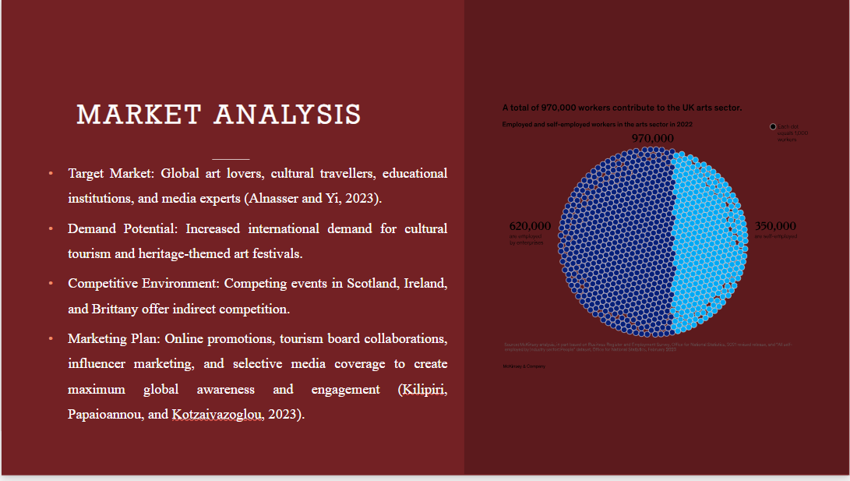
- Target Market: Global art lovers, cultural travellers, educational institutions, and media experts (Alnasser and Yi, 2023).
- Demand Potential: Increased international demand for cultural tourism and heritage-themed art festivals.
- Competitive Environment: Competing events in Scotland, Ireland, and Brittany offer indirect competition.
- Marketing Plan: Online promotions, tourism board collaborations, influencer marketing, and selective media coverage to create maximum global awareness and engagement (Kilipiri, Papaioannou, and Kotzaivazoglou, 2023).
Notes:
The Celtic Arts Revival festival aims to reach a broad audience that includes foreign art lovers, culture tourists, educational institutions, and members of the media. The increasing demand for cultural tourism and true heritage-based experiences around the globe makes the festival extremely relevant and timely. Although such events are found in other Celtic nations like Scotland, Ireland, and Brittany, the festival stands out in its exclusive focus on Wales and cross-Celtic cooperation. To achieve maximum outreach, marketing will involve electronic promotions, social media efforts, coalition building with the cultural tourism boards, influencer involvement, and strategic media alliances designed to gain worldwide attention and increased attendance.

Operational Feasibility
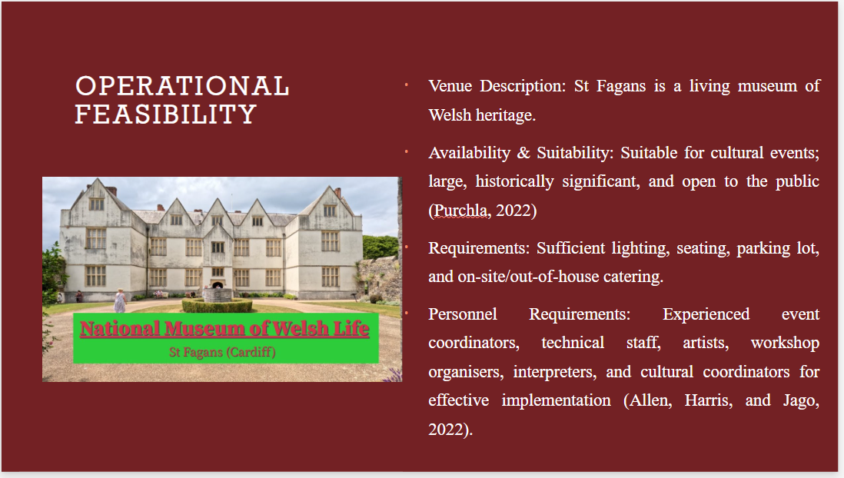
- Venue Description: St Fagans is a living museum of Welsh heritage.
- Availability & Suitability: Suitable for cultural events; large, historically significant, and open to the public (Purchla, 2022)
- Requirements: Sufficient lighting, seating, parking lot, and on-site/out-of-house catering.
- Personnel Requirements: Experienced event coordinators, technical staff, artists, workshop organisers, interpreters, and cultural coordinators for effective implementation (Allen, Harris, and Jago, 2022).
Notes:
St Fagans National Museum of History is a very appropriate location for the Celtic Arts Revival Festival, providing a realistic and engaging environment that is in tandem with the event's cultural theme. The location is large, historically important, and publicly accessible. It is capable of accommodating the festival's logistical requirements, such as lighting, seating, parking, and catering facilities. Operational success will demand an efficient team, such as qualified event managers, technical support staff, artists, workshop facilitators, and interpreters to communicate with international participants. The availability and infrastructure of the venue render it a perfect site to hold a large-scale, culturally oriented international arts festival.

Financial Feasibility
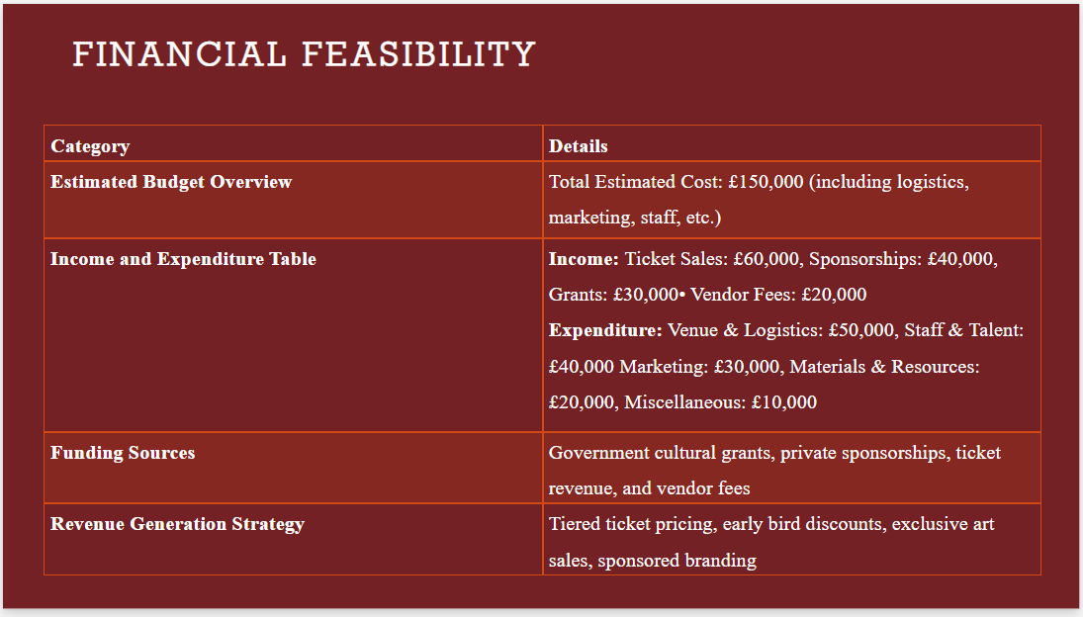
Category | Details
Estimated Budget Overview | Total Estimated Cost: £150,000 (including logistics, marketing, staff, etc.)
Income and Expenditure Table | Income: Ticket Sales: £60,000, Sponsorships: £40,000, Grants: £30,000• Vendor Fees: £20,000  Expenditure: Venue & Logistics: £50,000, Staff & Talent: £40,000 Marketing: £30,000, Materials & Resources: £20,000, Miscellaneous: £10,000
Funding Sources | Government cultural grants, private sponsorships, ticket revenue, and vendor fees
Revenue Generation Strategy | Tiered ticket pricing, early bird discounts, exclusive art sales, sponsored branding

Notes:
The economic viability of the Celtic Arts Revival Festival is assured through a balanced budget and varied revenue streams. The projected total expense is £150,000, allocated to venue arrangements, personnel, advertising, and supplies. Foreseen revenue comprises £60,000 in ticket sales, £40,000 in sponsorship, £30,000 in grants from government cultural funds, and £20,000 in fees from vendors. The festival is intended to stay in the black through strategic revenue streams, including tiered ticket prices, early bird discounts, and sponsored brand exposure. Through proper financial management and robust funding streams, the festival will either break even or be in surplus, providing both economic viability and cultural relevance.

Strategic Importance and Impact
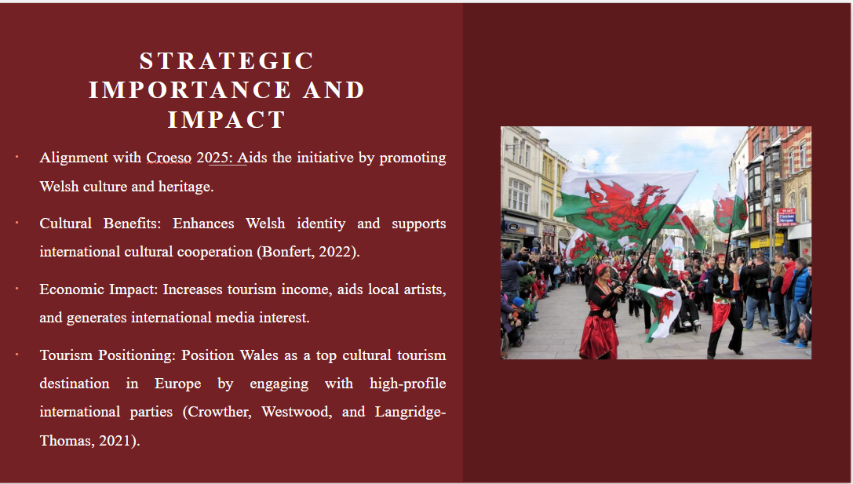
- Alignment with Croeso 2025: Aids the initiative by promoting Welsh culture and heritage.
- Cultural Benefits: Enhances Welsh identity and supports international cultural cooperation (Bonfert, 2022).
- Economic Impact: Increases tourism income, aids local artists, and generates international media interest.
- Tourism Positioning: Position Wales as a top cultural tourism destination in Europe by engaging with high-profile international parties (Crowther, Westwood, and Langridge-Thomas, 2021).
Notes:
The Celtic Arts Revival Festival has great strategic importance by being highly aligned with the objectives of the Croeso 2025 campaign, which will celebrate and enhance Welsh culture on a global platform. The festival promotes Welsh identity while creating cultural exchange with the other Celtic countries. It provides long-term cultural advantages by bringing more exposure for local artists and promoting international co-operation. Economically, the event will be expected to stimulate cultural tourism, attract media attention, and drive local expenditure. By hosting an international high-profile festival, Wales enhances its reputation as a major cultural tourism destination in Europe, attracting future events, visitors, and investment.

Risk Assessment Mitigation
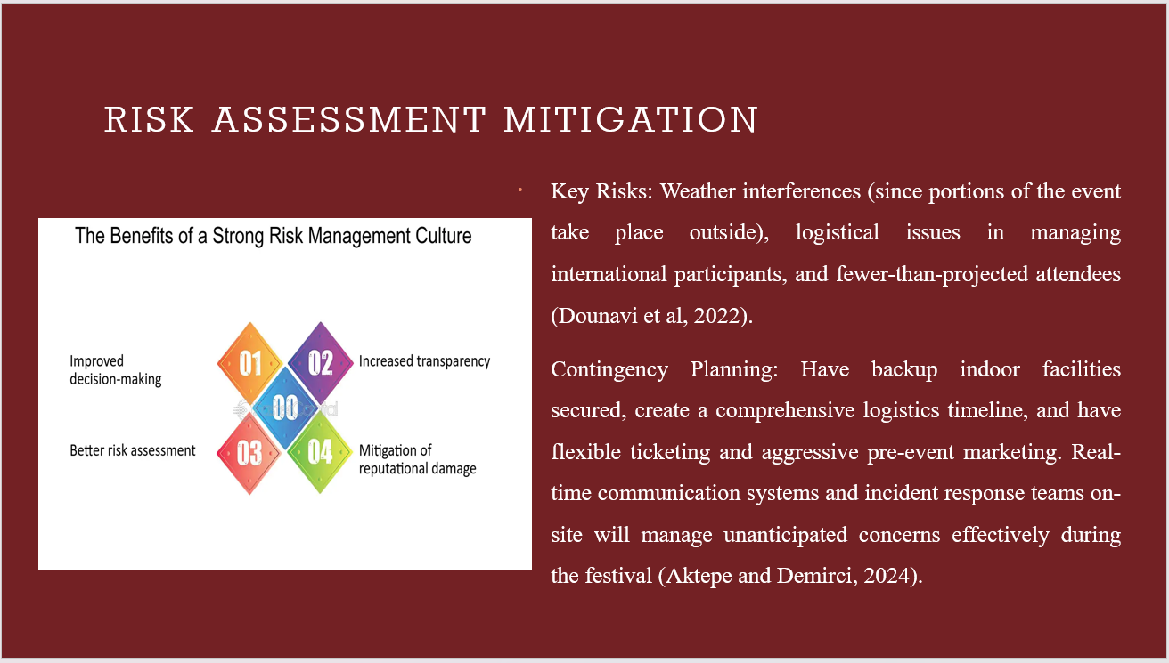
- Key Risks: Weather interferences (since portions of the event take place outside), logistical issues in managing international participants, and fewer-than-projected attendees (Dounavi et al, 2022).
- Contingency Planning: Have backup indoor facilities secured, create a comprehensive logistics timeline, and have flexible ticketing and aggressive pre-event marketing. Real-time communication systems and incident response teams on-site will manage unanticipated concerns effectively during the festival (Aktepe and Demirci, 2024).
Notes:
The Celtic Arts Revival Festival is threatened by several critical risks that can affect its success. Inclement weather interruption, especially to outdoor events, is a potential threat, as are logistical complications in arranging foreign artists and attendees. Furthermore, turnout may lag behind expectations if promotional activities fail to engage the desired market segments. To counter these risks, contingency plans involve making indoor areas backup weather options, having a solid logistics plan in place, and providing flexible tickets. Pre-event promotion will be increased to drive high turnout, and real-time communication systems and on-site crisis management teams will be available to handle any issues that may develop.

Conclusion & recommendations
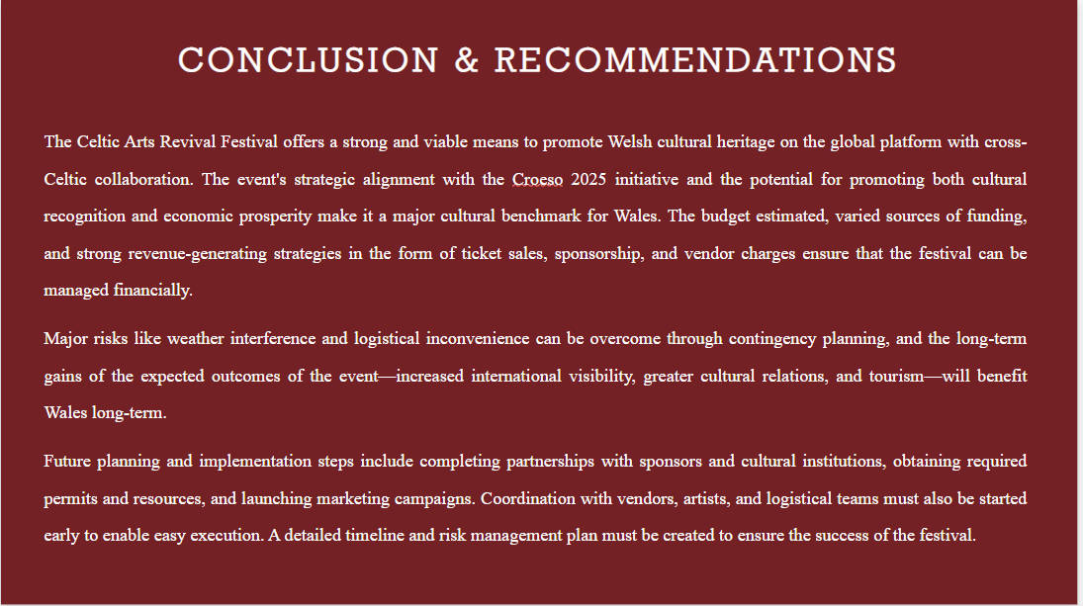
The Celtic Arts Revival Festival offers a strong and viable means to promote Welsh cultural heritage on the global platform with cross-Celtic collaboration. The event's strategic alignment with the Croeso 2025 initiative and the potential for promoting both cultural recognition and economic prosperity make it a major cultural benchmark for Wales. The budget estimated, varied sources of funding, and strong revenue-generating strategies in the form of ticket sales, sponsorship, and vendor charges ensure that the festival can be managed financially.
Major risks like weather interference and logistical inconvenience can be overcome through contingency planning, and the long-term gains of the expected outcomes of the event—increased international visibility, greater cultural relations, and tourism—will benefit Wales long-term.
Future planning and implementation steps include completing partnerships with sponsors and cultural institutions, obtaining required permits and resources, and launching marketing campaigns. Coordination with vendors, artists, and logistical teams must also be started early to enable easy execution. A detailed timeline and risk management plan must be created to ensure the success of the festival.

References
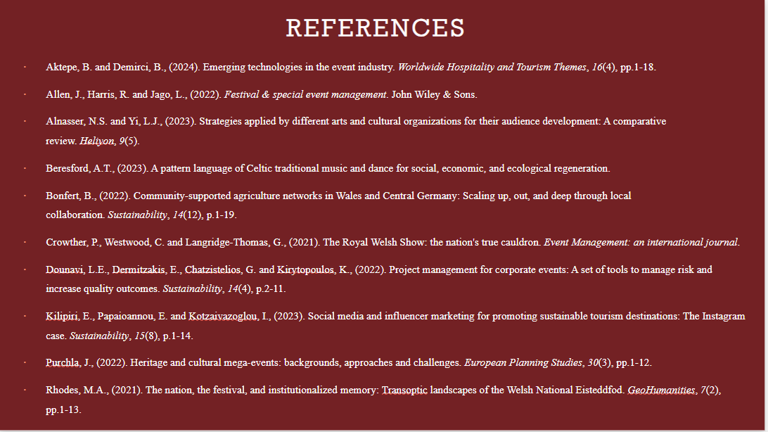
Aktepe, B. and Demirci, B., (2024). Emerging technologies in the event industry. Worldwide Hospitality and Tourism Themes, 16(4), pp.1-18.
Allen, J., Harris, R. and Jago, L., (2022). Festival & special event management. John Wiley & Sons.
Alnasser, N.S. and Yi, L.J., (2023). Strategies applied by different arts and cultural organizations for their audience development: A comparative review. Heliyon, 9(5).
Beresford, A.T., (2023). A pattern language of Celtic traditional music and dance for social, economic, and ecological regeneration.
Bonfert, B., (2022). Community-supported agriculture networks in Wales and Central Germany: Scaling up, out, and deep through local collaboration. Sustainability, 14(12), p.1-19.
Crowther, P., Westwood, C. and Langridge-Thomas, G., (2021). The Royal Welsh Show: the nation's true cauldron. Event Management: an international journal.
Dounavi, L.E., Dermitzakis, E., Chatzistelios, G. and Kirytopoulos, K., (2022). Project management for corporate events: A set of tools to manage risk and increase quality outcomes. Sustainability, 14(4), p.2-11.
Kilipiri, E., Papaioannou, E. and Kotzaivazoglou, I., (2023). Social media and influencer marketing for promoting sustainable tourism destinations: The Instagram case. Sustainability, 15(8), p.1-14.
Purchla, J., (20220. Heritage and cultural mega-events: backgrounds, approaches and challenges. European Planning Studies, 30(3), pp.1-12.
Rhodes, M.A., (2021). The nation, the festival, and institutionalized memory: Transoptic landscapes of the Welsh National Eisteddfod. GeoHumanities, 7(2), pp.1-13.

