Manufacturing Systems and Simulation
Applying Lean Techniques - ACEA 6002
Iestyn Thomas – 1809101
Cas-Ob Spraying and Drying Observations

Introduction
Historically the lives of the CAS OB Polo at Port Talbot have fluctuated a great deal (Composition Adjustment by Sealed argon bubbling, Oxygen Blowing). At present the operating lives of the units are considered stable, following several improvements driven by the Cost Of Liquid Steel Snorkel VIU project. However, there are still areas that can be improved on to further increase Value In Use.

The CAS snorkel unit at Port Talbot has a target life of >53 heats, to achieve this service life the snorkel will be subjected to numerous intermediate repairs during it campaign. Each snorkel will be subjected to treatments ranging from 3-10 heats dependant of the type of treatment (reheat) or level of skull adhesion. Once a repair is required the snorkel will be removed from service, cleaned and then gun repaired before being returned to service. Once damage to the Polo (bottom section) is considered too severe, it will be removed from service, split from the upper part (wine glass) and disposed off. The wine glass, if redeemable will then be attached to a new Polo and used again. This report will show the process of spraying and drying process and current issues and what can be improved to gain more value in use.

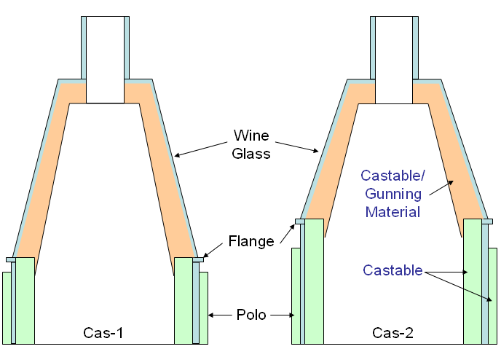

Summary
The handling of the CAS Snorkel units observed would not be considered favourable towards the refractory. Tipping the units over prior to spraying with the graddall will cause elements of damage to the Refractories by shock, impact or stress. Gunning operations showed good levels of control through operator experience, however materials were sprayed in areas that would be considered as a waste (newly installed cast polo for example) The thickness of the material is applied would also be considered as over compensation when comparing to the recommended practices and dry out procedures, outlined by Robert Lickley. This over compensation would also be excessive when considering the lack of anchorage for the gunned material.
Air setting time for the material once applied contravened the supplier’s recommendation as does the dry out profile, although following the dry out profile recommended would be impossible as the flare system demonstrated a complete lack of control.
The CASGM material used to repair the CASOB Snorkel showed lower than desired refractoriness levels, it would be considered that this material would show high levels of wear and would not be suitable for this application. If all these can be adhered and adapted to within the process then there is a potential saving of 20-30% which also will make a leaner more efficient process providing new standards can be met.

Gunning and Handling
During the observations Cas-1 Bell 69 was observed moving through the various gunning and drying operations. Prior to gunning the bell was inspected for general condition can be seen in images below.
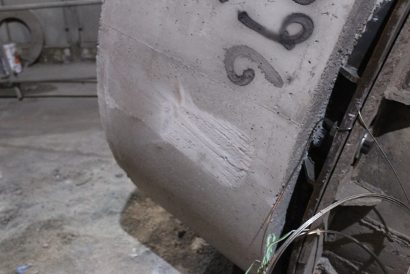
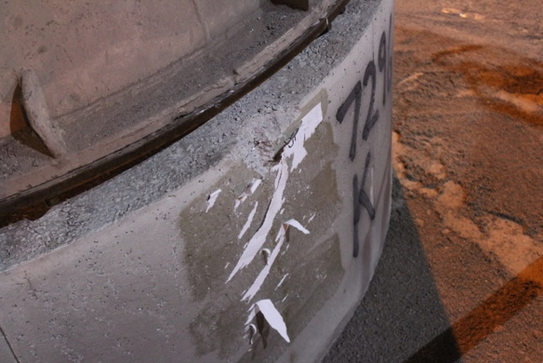

Picture 1: Showing the impact damage sustained to the top of the polo
Picture 2: Showing graze damage sustained when the neighboring Cas bell was up righted

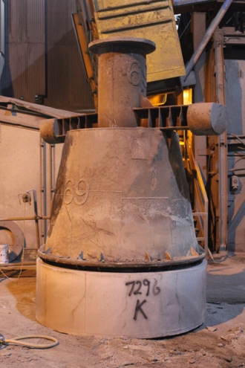

Handling in preparation for gunning
Cas 69 was placed in the gunning area stood upright, prior to gunning the unit was tipped onto its side using the wrecking machine. The machine placed the pecker tip into the top of the bell and pulled the unit over. During this motion force is applied to the bottom side of the polo castable, and once past its fulcrum position enters into free fall. The Pecker driver tries to control the fall during the movement in an attempt to prevent damage. The unit is then laid on its side ready for gunning.

Gunning
On inspection it could be seen that the wine glass had been used and that the original castable was still evident. No records existed for how many campaigns the wine glass had covered prior to this use. It was estimated that approximately 50mm of the original castable was still in position. Looking at Picture 5, you can see that 70 mm of the polo castable was standing proud of the wine glass.

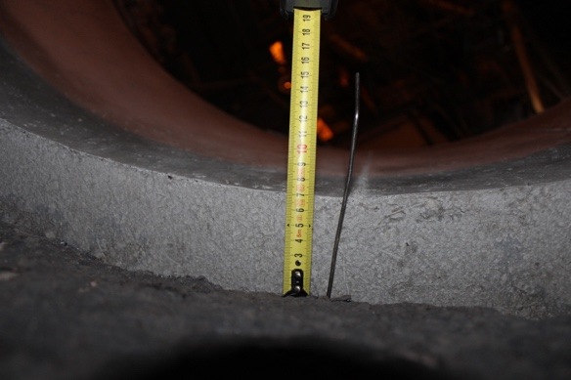

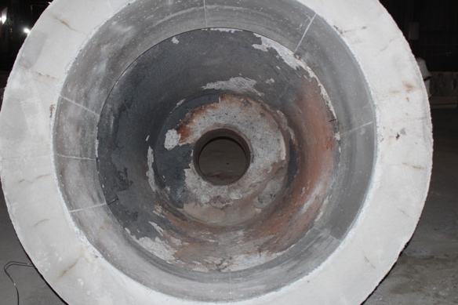

Picture 5: Showing the polo/wineglass interface

Gunning of the wine glass and polo was carried out using CASGM material, applied by operators through a Piccola system. CASGM is an Alumina based repair material. Overall the operation was well carried out with all standards being met.

Material Usage
Prior to the start of the operation a one tonne bag of CASGM was placed into a dispensing hopper, before filling the hopper wasn’t completely empty. This caused some spillage of material, approximately 200Kgs (estimated). Showing the bell before and after spraying, note the material applied to the castable in the internal polo and the underside.
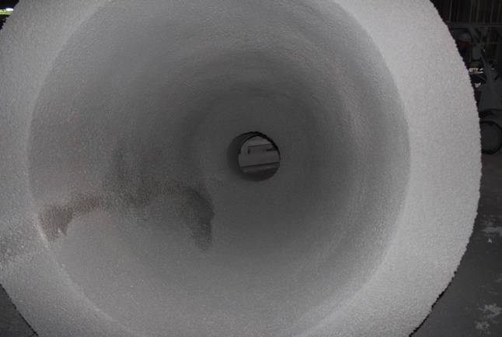
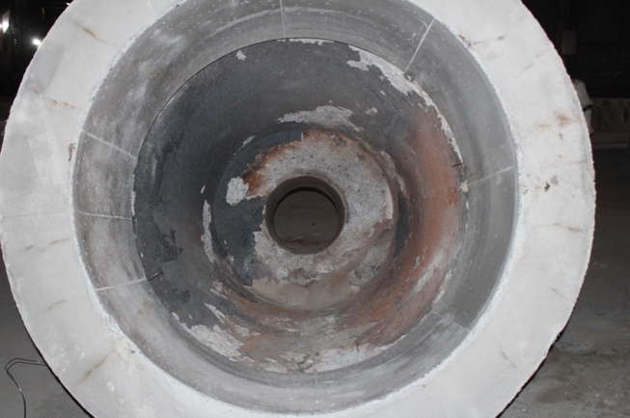
Picture 6a and b

Handling after gunning
Once the bell unit was ready for flare the wrecking machine that was used for tipping the bell over was again used to upright the unit. During the operation it is expected that shock damage will be apparent to the green state refractory.

Handling and gunning comments/recommendations
- Use of the wrecking machine to tip the Bell for spraying would not be considered a good practice. Both shock damage and stresses placed on the Refractories could result in damage to the units. When the refractory is in its green state it is expected that material thickness will be lost during the tipping after gunning.
- CASGM was applied to a brand new Polo. This would not be considered beneficial as the new castable will make adhesion difficult for this material. It would be recommended not to gun this area with a repair material. A parting agent (a Magnesia based sacrificial spray material) would be more advisable to apply at the start of a Polo campaign. This will reduce the sintering effect on the Polo castable material and reduce the risk of damage during deskulling. As the polo proceeds through its life, applying a repair material would be advisable.
- On a refurbished wine glass (castable re-used from previous campaign) it would not be recommended to spray the material to a depth of more than 100mm, the main reasons being.
  - The material does not have any anchoring system to aid security,
  - Excessive material weight/thickness may result in a material more prone to shock damage,
  - Above a thickness of 100mm will result in longer drying times required to ensure the cold face of the material has fully cured.
- Anchoring system, if any areas of the castable are missing and the steel shell is exposed, it would be recommended to employ an anchoring system to aid security of the applied material, expansion (coating of the anchors) should also be considered
- Weep holes – the wine glass showed no evidence of weep hole to allow steam gasses) to pass and easily exit the material during drying. It would be recommended to introduce weep holes.
- Water pressure - if fluctuating water pressure or pressure lower than the air pressure is experienced, then a water pressure booster should be considered.
- Operators should not be allowing material to be spilled and wasted so easily; standards are in place and should be followed rigorously.

To implement some of these highlighted there would not be many problems to face as a majority are operator error and can be easily improved with simple adjustments and standards being re put out. With the highlights around weep holes this is an expensive task to not gain much reward as a new wine glass would need creating and they cost around £12’000 to purchase to create a new one but with significant changes and being a test it would cost significantly more to meet the needs. A new way to move the snorkels because of the graddall is also a very expensive tasks due to buying new moving machinery that can only be used for one task where the graddall has multiple purposes on plant and is utilised to its main potential.

Drying
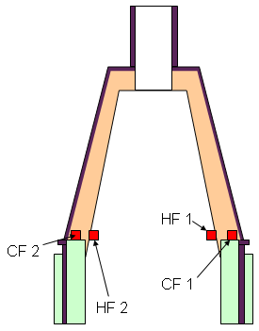
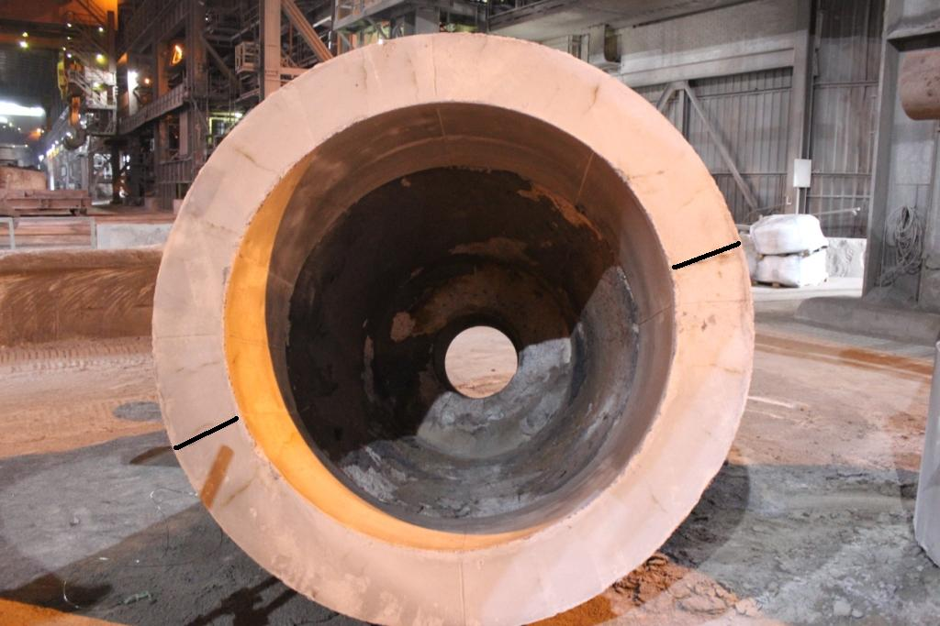

Robert Lickley CASGM material was applied to the bell, which is issued with guide lines (see appendix 1) on how to dry and treat the material. Following the application the bell was allowed to stand for 8 hours to air dry. This is contrary to the 12 hours recommended but much improved on previous standard of 2 hours. The bell was then transported to the flare table for an 18-hour flare cycle. At the start of the flare a data logger was used to log the profile of the dry out operation.

The graph below demonstrates the measured temperature profile and compares against the recommended procedure form Robert Lickley. It must be noted at this point that the procedure recommended is based on a material thickness of 100mm. From the gunning observation it was estimated that an average of 150 millimetres of material were applied.

Looking at the graph you will note that erratic internal hot face temperatures. These can be explained by the positioning of the bell. Looking at the photograph below you will not large gaps around the bottom of the bell.
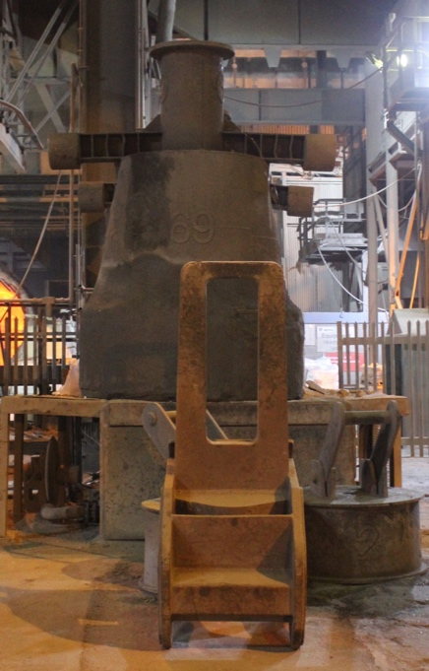

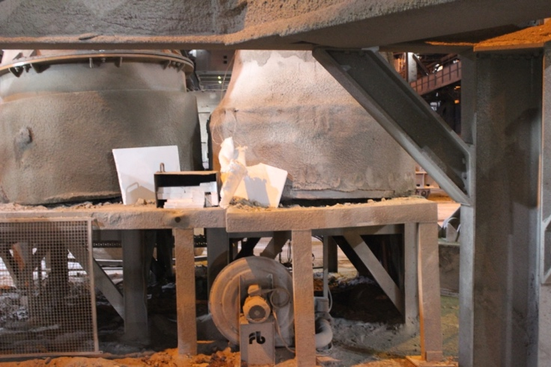
Picture 8&9; showing the gaps around the bottom of the bell allowing air flow

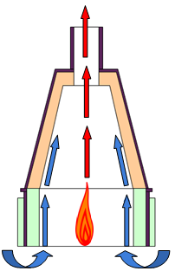
These gaps are generated by debris on top of the flare table and the general unevenness of the table itself. After the 18-hour flare the areas around these gaps were very low in temperature (around 60ºC) and relatively cool to touch. The airflow around these gaps could be felt in a ‘sucking’ motion into the bell. The effect can be explained in the following:

- Hot air from the burner rising through the throat at a high rate
- Hot air movement creating Ventura, or chimney effect sucking the cold air from the bottom of the bell
- Cold air mixing with the burner, reducing the effectiveness of the dry out or ‘cooling the sidewall as it passes’
- To ensure burner effectiveness a positive atmosphere should be created
- Major issue with creating a positive atmosphere will be the lack of control on the flare temperature; care will be needed to ensure that the heating rate does not rise too quickly.

Looking at the graph above from the 18 hour dry out you can see that the hot face temperature instantly rises (the start of the trend) to 250ºC minimum and doesn’t increase much above this for H/face1, where as the opposite side is approximately 75ºC - 150ºC higher. Looking at photograph 8 and 9, the gaps around the bottom of the bell were considerable larger on the H/Face 1 side than H/Face 2. It may also be possible that the bell its self was not positioned centrally to the burner, exposing one side of the bell to higher temperatures.
When drying out Refractories from their green state it is important to control the heating rate. The suppliers recommend certain profiles to stop rapid over heating and control the rate at which the water turns gaseous. During dry out steam is generated within the material, which has to move through the pores of the material structure before it can escape into the atmosphere. If excess steam is generated in a short space of time then pressure within the material builds as the level of steam increases. Once this pressure exceeds the strength of the material it will cause the structure to ‘pop’ or in extreme cases ‘explode’ resulting in damage to the lining. Earlier in the report weep holes were mentioned for the wine glass steel shell. These weep holes will also help reduce the level of pressure build up as they allow a path for the steam to pass through to atmosphere from the cold face of the gunning/castable.

The thermo couples located on the cold face of the material indicate that the temperature increased to 100ºC in 8 hours. For approximately 5 hours the profile remained at 100ºC and then started to rise again at the 12-hour mark. The holding period at 100ºC indicates steam generation around the thermocouple, which keeps the constant temperature. Once all the free water is removed (and no more steam) the temperature then starts to increase, at this point we could conclude that the material is clear (dry) of all free water.

Drying Comments/recommendations
When placing the bell on flare the following should be considered.
- The initial temperature increase is too high and should be controlled in line with the supplier’s recommendations to reduce to the potential for material ‘popping’ or worse ‘explosions’.
- Consideration for the introduction of weep holes should made.
- Condition of the flare station table should be improved to ensure a seal on the bottom of the bell. Sealing of air gaps should generate a positive atmosphere and improve efficiency.
- Bell location should be considered; it is essential that the bell be placed centrally to the flare.
- Control of the flare will be critical in improving the drying procedure. Controlling the internal temperature may also lead to energy savings on gas. Once controllable the top hat (lid) maybe usable again (in the past the lid has caused the temperature to increase rapidly, a controllable flame should be able to compensate for this insulation improvement, leading to gas usage improvements)

Cost can be kept to a minimum implementing these as we can control and adjust the flame in house. We can also in house manufacture a top hat which would keep the flame inside the snorkel warming throughout keeping a better through temperature through the entire process. Location is a difficult but can be changed but a new space will need to be allocated and other movements in the bay which can prove difficult at times.

Overall Benefit
Should the vast majority of the recommendations stated be put into place, and providing Plant Operating Conditions do not alter significantly i.e. reheating does not increase significantly, deskulling is still undertaken hot etc., then a 20-30% reduction in spraying costs is a realistic target, combined with an increase in Polo lives leading to an increase in VIU of the CASOB Snorkel.

Cas-GM Testing/suitability
The CASGM material was sampled on plant during gunning. A mould was placed at the side of a bell during gunning and filled by the gunning operator during application. The sample was then placed in the bell during flare to simulate plant conditions. Figures can be seen in table figure 1.

Looking at the results you will see that the tested chemical results fall in line with the supplier’s product definition (appendix 2). Bulk density, PLC and cold crushing have only been compared after treatment at 1400C, the product definition shows this as supplementary information and not as a critical property. These comparisons have been made as the material was dried at Port Talbot in the flare unit and was exposed to temperatures above the 110C stated on the critical property. Looking at the cold crushing strength you will note that the result shows to be considerably lower than the defined limit. Due to the nature of how the sample was prepared this result should be discarded, as water content, material compaction could not be quantified.

Looking at the graphs above you will note that the CAS GM material shows a softening in the refractoriness under load test at a low 1230ºC and then ultimately fails at 1307ºC, coupled with the dilatation test showing high shrinkage due to collapse it can be concluded that the service temperature of this material is too low for the application in which it is used.

From the results it can be concluded that the material showed comparable results as outlined in the Product Definition. However the refractoriness under load and dilatation result indicate that the material will soften and possibly melt when used in the CAS Snorkel as the exposure temperature would be higher than the service temperature of the material (1300ºC). It would be considered that rather than catastrophically failing in service, the material would instead show high wear characteristics. The issue here is cost to go and look for new material where only now and then the material fails there is currently not enough evidence against to force the change. We do have alternatives on site that we do alternate between but budgets must be kept to ensure profit is made for the business.
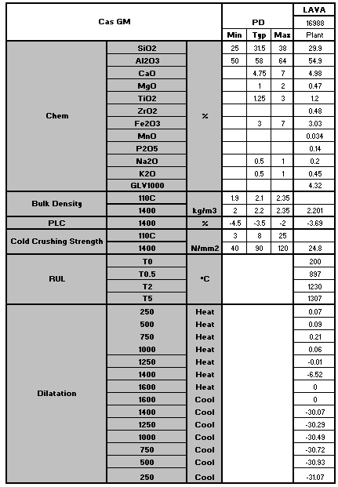
Figure 1

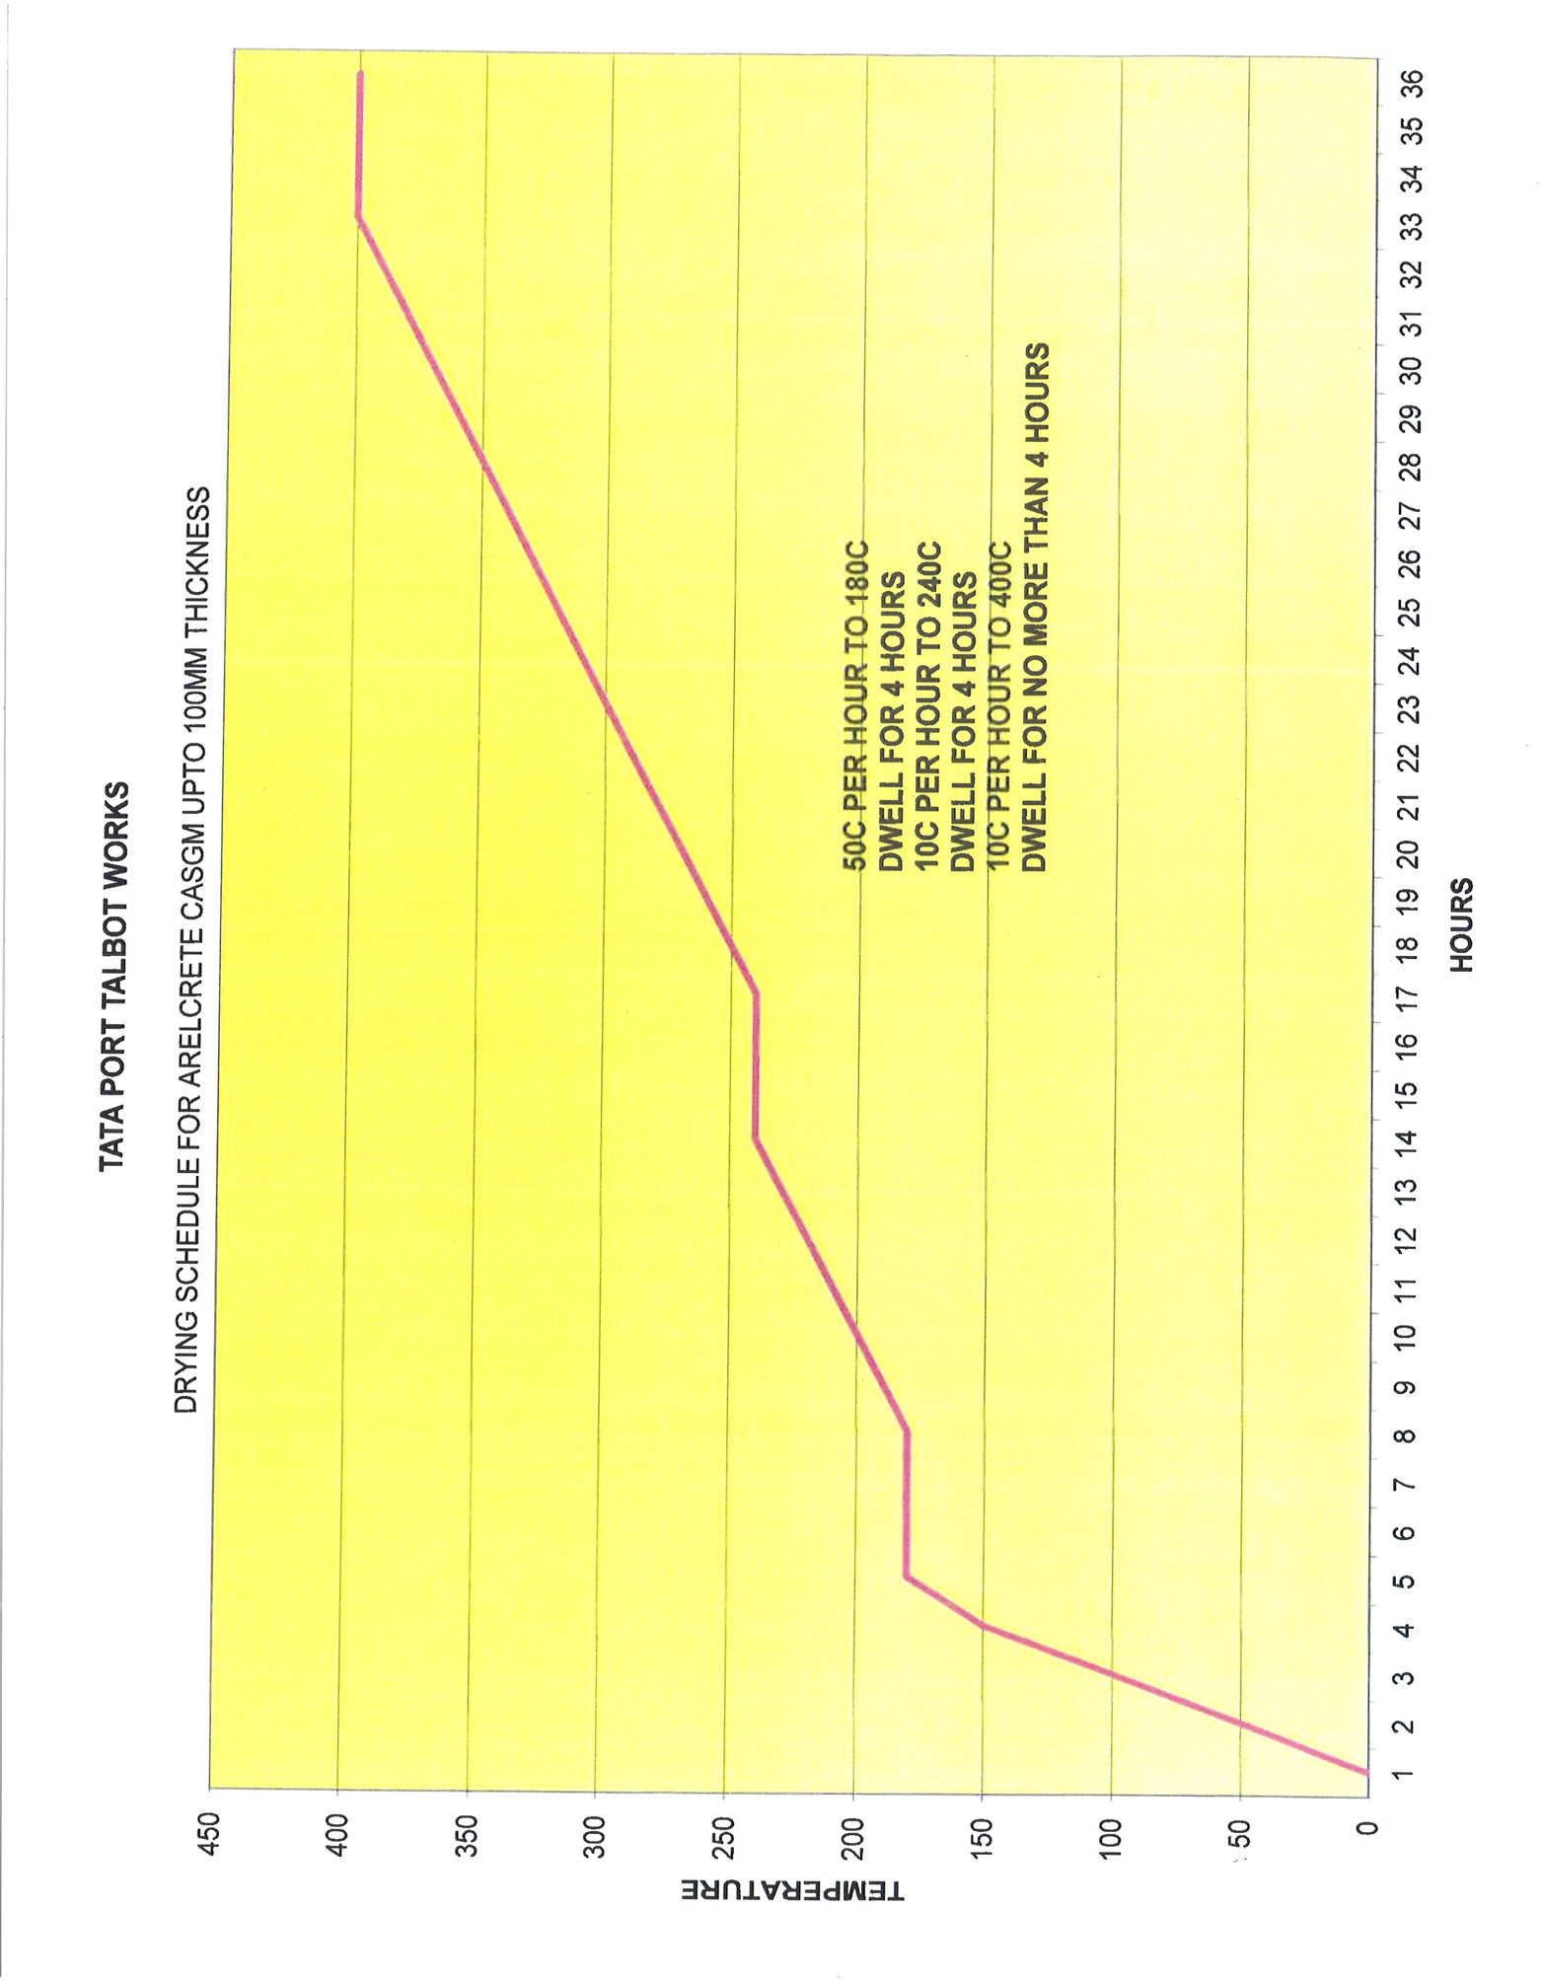
Figure 2

