

ACCB6017
Usability Engineering

Full Interface & Testing
Lecturer: Dr Nassir Ibrahim

Student Name: Gheorghe Luca Atanasiu
Student ID: 2224316
Table of Contents
Introduction 3
Full-Colour Storyboard Designs and Justifications 4
Usability Testing and Feedback Collection 12
Testing Methodology 12
Usability Testing Activity and Results 12
Positive Feedback 13
Negative Feedback and Improvements 14
Data Collection Strategy 15
Reflecting: Usability vs User Experience 18
References 19
Appendix: 21
Appendix A: Navigation Flow Diagram 21
Appendix B: Full Storyboard Diagram 22
Appendix D: MoSCoW table 22

Table of Figures
Figure 1. Splash Screen 3
Figure 2. Login/Signup Screen 4
Figure 3. Main Dashboard 5
Figure 4. Character Selection Screen 6
Figure 5. Game Board Screen 7
Figure 6. Clue Screen 8
Figure 7. Results/End Screen 9

Introduction
The UWTSD Cluedo Game project aims to create an interactive, accessible, and inclusive digital board game targeting students and staff. Component 1 (Phase 1) involved the development of detailed user personas, user requirements, and low-fidelity wireframes to illustrate the layout and functionality of the interface. Based on these, Component 2 will seek to bring the wireframe concepts to the next level, resulting in fully formed, high-fidelity, full-colour storyboard designs that capture not only the principles of usability but also the principles of user experience.
The main goal of this element is to make sure that the end interface design will follow the actual user requirements by means of usability testing and organised feedback gathering. Accessibility, simplicity, and an intuitive navigation are also important to serve the various users with some of whom are visually impaired, colour blind and language barrier. This report describes the complete colour interface graphics, usability test methodology, data collection method, and sharp thoughts concerning the design procedure, which included the necessity of considering the equilibrium between ease of use and the general user experience.

Full-Colour Storyboard Designs and Justifications
The design of the final interface of the UWTSD Cluedo Game was aimed at developing a clean, accessible, and visually appealing user experience. The interface was created based on the rules of user-centred design and accessibility, and, as a result, all personas found in Component 1 will be able to deal with the game. Every storyboard screen has been executed with a uniform palette of colours, easy fonts, and user-friendly navigation to decongest the cognition workload and facilitate easy navigation.
The last storyboard will be composed of eight major screens that will embody major steps of the user journey: Splash Screen, Login/Sign-Up, Dashboard, Character Selection, Game Board, Clue Screen, Results Screen, and Settings. The interface design has contrast ratios, icon-based objects, and text scaling features to assist users with visual or cognitive disabilities. The explanation and justification of each screen are given below.
1. Splash Screen
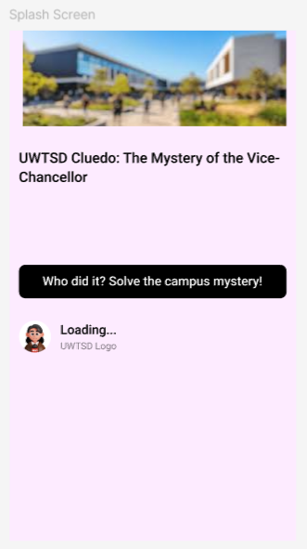
Figure 1. Splash Screen
(Source: Author, 2025)
Purpose: The entry point of the game, with the logo, the name of the game, and the loading animation.
Design features: The Background is of high contrast. The logo is in the centre and has a clear progress indicator [3].
Justification:
- Gives an instant visual welcome experience.
- Simplified design allows the users who are visually impaired or colour blind to identify the entry point.
- Short loading animations can be used to add expectations and decrease frustration.
2. Login / Sign-Up Screen
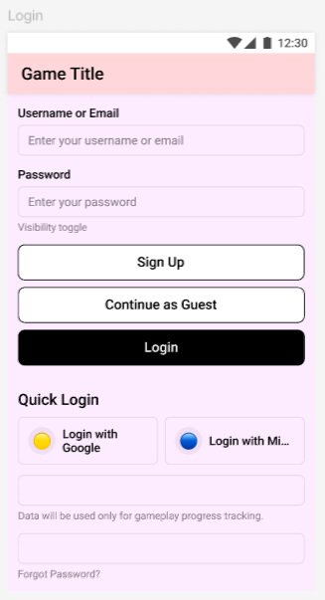
Figure 2. Login/Signup Screen
(Source: Author, 2025)
- Purpose: Allows new customers to sign up and returning customers to log in.
- Elements of design: large text fields, icon-assisted input labels, show password toggle, language option and accessibility help icon.
- Justification:
  - Unfussy, plain, and simple design aids users with few technical aptitudes.
  - The language choice and the proper labelling of fields can help overseas students.
  - Password revealing and highlighting errors make usability and recovery of errors better.
3. Main Dashboard
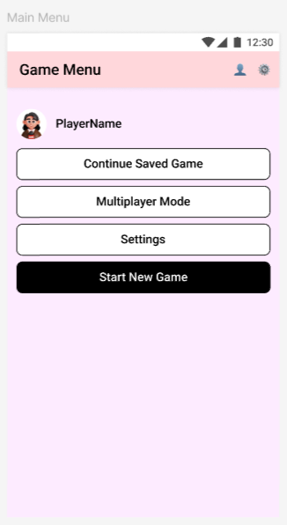
Figure 3. Main Dashboard
(Source: Author, 2025)
- Purpose: The key point through which users can go to select the gameplay, tutorials, and settings.
- Design: Intrusive start game button, tutorial option, user profile, and well-defined navigation bar.
- Justification:
  - Limited layout minimises decision fatigue.
  - Available navigation icons assist those users who have visual and cognitive impairments.
  - Strong conformity to the heuristic principles of visibility and recognition as opposed to recall.
4. Character Selection Screen
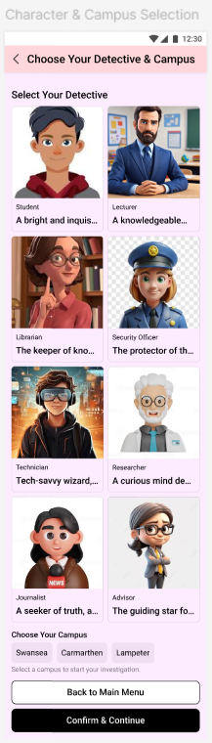
Figure 4. Character Selection Screen
(Source: Author, 2025)
- Purpose: The players can select their in-game character or avatar.
- Design features: grid design, big character cards, visual or tap highlighting, and visual labels.
- Justification:
  - Big clickable fields are helpful for motor-challenged users.
  - Icons and names assist users who have a language barrier.
  - When there is visual feedback on the selection, it is better to be clear and confident in the decision [9].
5. Game Board Screen
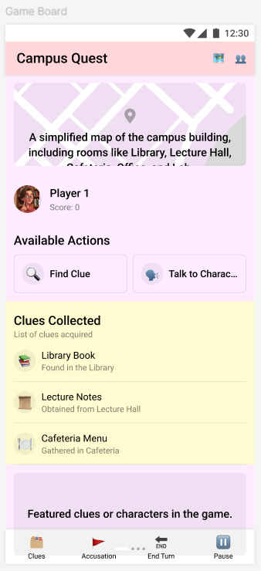
Figure 5. Game Board Screen
(Source: Author, 2025)
- Purpose: This is the main part of the game where the user plays the game, picks up the pieces on the board, and collects clues.
- Design items: Interactive board, zoom-adjustable, move buttons, clue tracker board and chat icon [2].
- Justification:
  - Huge contrast board and adaptable text size satisfy the standards of WCAG.
  - Simple controls permit participation equal to all personas.
  - Real-time feedback provides the player with information about actions.
6. Clue Screen
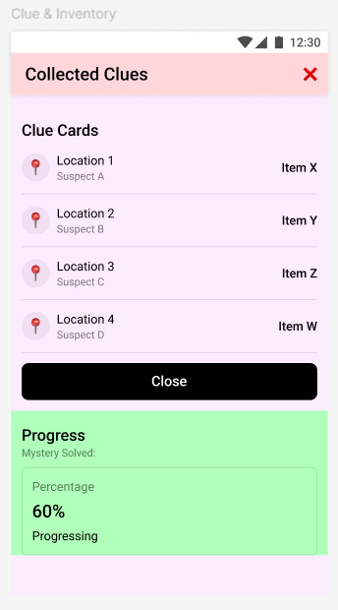
Figure 6. Clue Screen
(Source: Author, 2025)
- Purpose: Shows hints, evidence, and advances in the gameplay.
- Design: modal in the form of a pop-up with distinct headings, hint cards and filters.
- Justification:
  - Enhanced Space and visual hierarchy respond to Component 1 feedback that the wireframe was crowded.
  - There is support for fast learning through icons and colour coding.
  - Both mobile and desktop friendly.
7. Results / End Screen
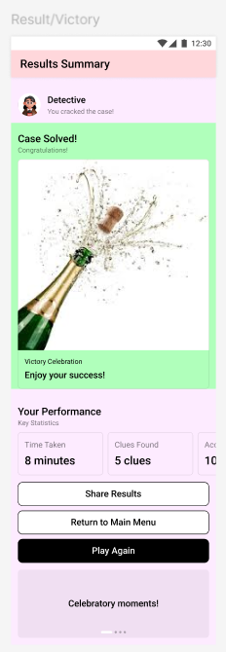
Figure 7. Results/End Screen
(Source: Author, 2025)
- Purpose: Overviews the game result, displaying the information about the winner and the last hints.
- Design: Huge text, festive icons, play again button, Exit button, and a table with the leaderboard [6].
- Justification:
  - Visual feedback, positive reinforcement increase emotional involvement.
  - The next steps are intuitive as they have large buttons and a clear structure.
  - Encourages replayability.
8. Settings / Tutorial Screen
- Purpose: Enables users to change their settings concerning sound, languages, accessibility, tutorials, etc.
- Design: Toggle switches that can be used to disable audio/visual options, language choice, and Help.
- Justification:
  - Favours personalisation, which is necessary to be accessible.
  - The tutorial enhances the experience of new players.
  - Compliant with heuristic rules of flexibility and efficiency of usability [10].
9. Design Principles Applied
- Convenience: High contrast ratios, big touch targets, language choices, text scaling.
- Consistency: All the screens should have the same colour palette, layout, and navigation.
- Visibility & Feedback: real-time response, pop-ups, and progress status.
- Prevention of errors: Instructions, validation messages, and undo.
- Ease: A less complicated interface with minimal and iconic navigation.

Usability Testing and Feedback Collection
The usability test on the UWTSD Cluedo Game interface was carried out to determine the capability of users to interact with the ultimate storyboard designs. The main goals were to evaluate the readability of the interface, the availability of the most important functions, the convenience of navigation, and the general experience when using it. The task-based evaluation method was used to test them, and it enabled the participants to perform usual in-game tasks with their interactions observed and documented.

Testing Methodology
Participants:
The participants chosen to fit the personas created in Component 1 were the same four that previously tested the wire frames.
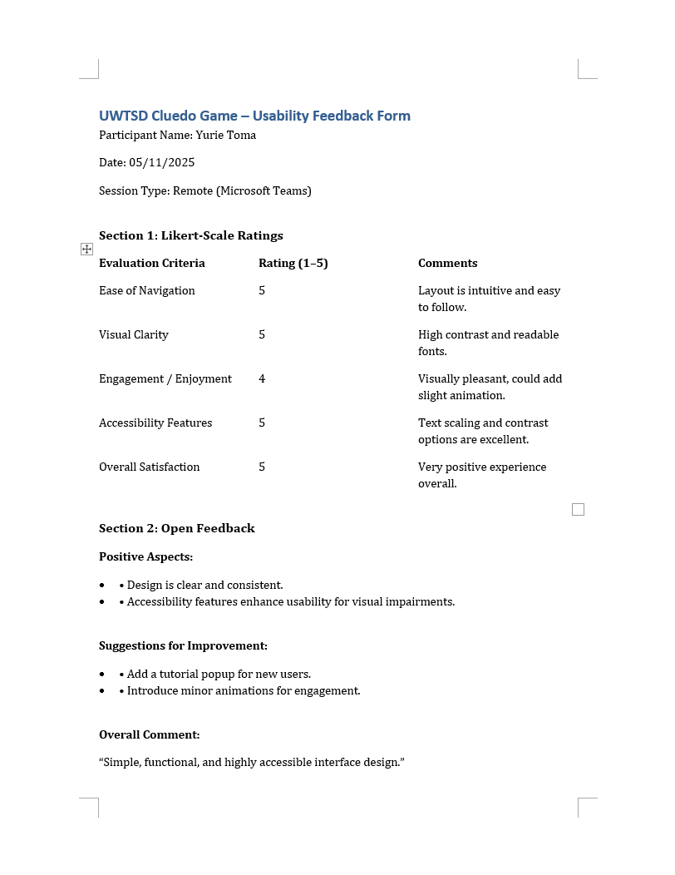
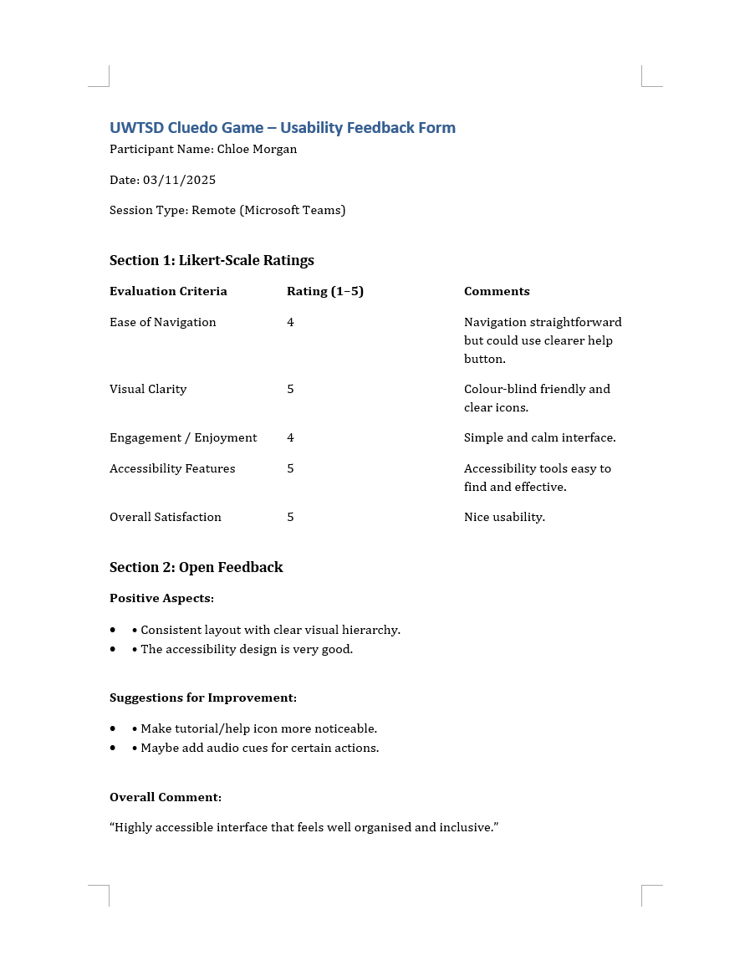
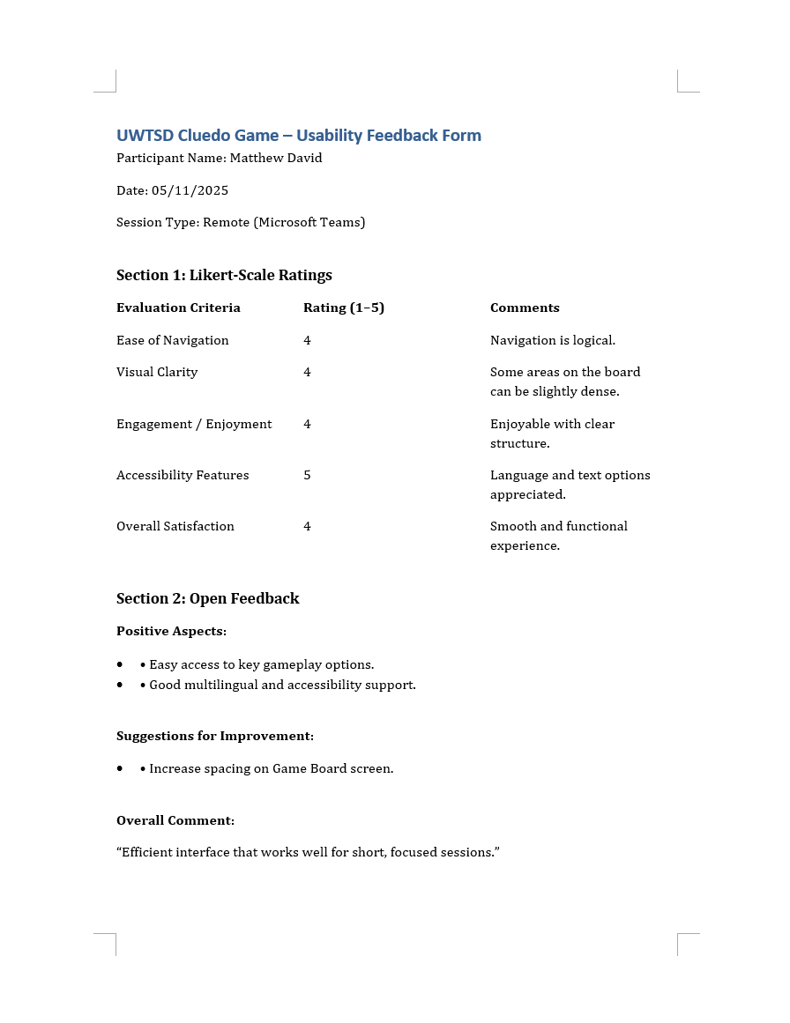

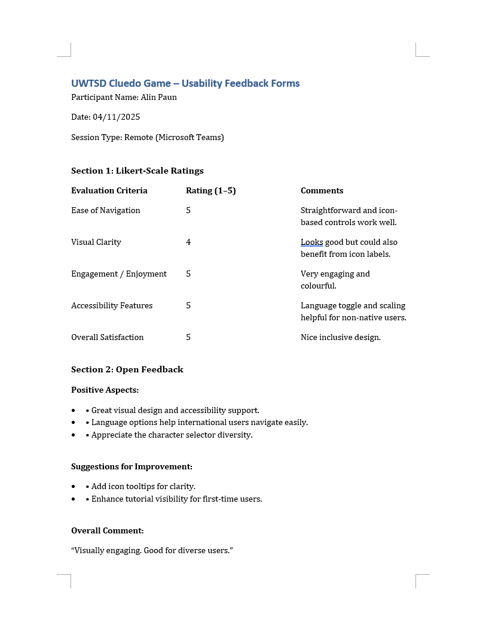

Method:
The remote testing sessions were conducted via Microsoft Teams. The subjects were provided with five central tasks:
- Review the Login/Sign-Up storyboard screen and comment on layout, clarity, and visible options (e.g., language selector, show password toggle
- Choose a character and start another game.
- Examine the Game Board storyboard and indicate whether the layout, controls, and clue tracker are visually clear.
- Inspect the Settings storyboard and state whether the presented accessibility options (text size, language choice) appear discoverable and sufficient.
- Complete the game story boards and see the results [8].
Data Collection Tools:
- Observation checklists
- Likert scale survey (1 =Very Difficult, 5 =Very Easy).
- Short (5-minute) post-test interviews.

Usability Testing Activity and Results

Task | Perceived Ease (1–5) | What Was Observed | Participant Feedback
Login / Sign-Up Screen | 4.5 | Participants clearly recognised form fields and support options. | Noted that the password toggle and language selector were easy to notice in the screen design.
Character Selection Screen | 4.3 | Characters and selection highlights were easily identified. | Participants felt large character cards and clear labels supported decision-making.
Game Board Screen | 3.8 | Core game elements were visible, but some smaller elements needed clarity. | Some participants suggested clearer labelling for the clue tracker and controls.
Settings Screen | 4.7 | Accessibility controls (text size, language) were quickly noticed. | Participants appreciated seeing customisation options and stated these would likely support accessibility well.
Results Screen | 4.6 | The screen flow and leaderboard were easily understood. | Participants described the end screen as celebratory and well-structured for result review.

Positive Feedback
- The interface design was simple and uniform in its various screens, making it easy to use.
- High contrast colour and big touch targets were also in place, which was favourable to accessibility.
- Respondents liked language choices and customisation in environments.
- Easy navigation among the principal screens enhanced confidence and minimised errors.

Negative Feedback and Improvements
Observation | Mentioned By | Suggested Design Action
The clue tracker area appeared less noticeable | 2 participants | Add clearer visual labels or highlighting near the clue tracker section
The game board appeared slightly visually dense | 1 participant | Increase spacing and padding around interactive elements
Tutorial/help entry point not immediately visible | 1 participant | Introduce a more prominent Help icon on primary screens

Data Collection Strategy
The UWTSD Cluedo Game requires an effective data collection strategy to enhance the game after its initial implementation. By gathering and evaluating quantitative and qualitative data, one will be able to detect the problems with usability, learn the habits of the players, and optimise the user experience.
1. Data Collection Objectives
- Determine what characteristics are most utilised or disregarded.
- Identify usability problems according to drop-off and navigation.
- Assess the interaction of various user groups (according to personas) with the game.
- Test the level of user satisfaction and emotional involvement to improve it.
- Favour iterative design and feature improvement [5].
2. Types of Data to Be Collected
Type of Information | Example Details | Why It’s Collected | How It’s Collected
Activity of Users | Login counts | Information about the functionality usage | System counts
Performance | Loading Speed | To remove errors and issues [7] | Analysis from reports
Success | Steps and time needed to finish | Check the mode of the game, if easy or not | Recorded within the system
Experience | Short ratings and quick comments | To hear what people feel after playing | Gathered with short forms
Accessibility Use | Font size, language, sound settings | To know how people use the support features | Taken from system notes and forms

3. Data Collection Methods
a) Automated Analytics
- The tools of event tracking can track user activity in real-time (e.g., button-clicks, time spent on each screen, navigation path).
- These analytics can be used to detect drop-off points at which users might have problems.
b) System Monitoring Tools
- Gather information regarding page loading time, etc.
- Critical in enhancing the performance and facilitating accessibility in a cross-platform environment.
c) In-App Surveys & Feedback Prompts
- Pop-up, short, and optional surveys following a game round.
- Likert scale (15) ease of use, clarity, and enjoyment.
- Free text suggestion boxes.
d) SUS and Heuristic Evaluation.
- Occasional gathering of SUS scores by users in the measurement of usability.
- Expert heuristic assessment (optional) to gain more knowledge.
4. Ethical and Privacy
- As well, all data collected will be anonymous and will be utilised to better the system.
- Consent messages will be shown clearly before the commencement of data collection.
- Customers have the choice of not taking part in surveys on the feedback.
- No sensitive personal information (e.g. login credentials) will be stored, and no access to it will be provided to the outside world [4].
5. Continuous Improvement Use of Data
- Optional Feature Optimisation: Find the features that are not used enough and make them more visible or usable.
- Accessibility Improvements: Examine accessibility settings utilisation frequency and make them even more optimised.
- Performance Tuning: Error logs, response time statistics: Optimise technical stability.
- User experience enhancements: Respond to the survey and make the interface more usable, entertaining, and welcoming.
- Future Testing: Notify the subsequent cycles of the usability testing with specific scenarios according to the gathered information.

Reflecting: Usability vs User Experience
The natural tension of the design and development process of the UWTSD Cluedo Game was the need to design the interface that is as usable as possible and as well as provide the user with an enjoyable and engaging experience. As usability is concerned with functionality, accessibility and efficiency, user experience is concerned with the emotional and aesthetic influence of the design on the user.
At the initial wireframe stage (Component 1), the focus was on making sure that the basic usability principles, such as ensuring straightforward navigation, having large touch areas, a high contrast ratio, and supporting a variety of users with the help of language, were identified. The persona feedback had been useful to inform many of the initial decisions (e.g., Emily and Daniel). The above considerations ensured that the design is of the ISO 9241-11 usability standards and compliant with principles such as error prevention, system status visibility, and consistency.
On the stage when the project was brought to the stage of full-colour interface, the elements of user experience - visual attractiveness of the project, the effects of transition between the elements of the navigation, the festive images in the results screen and personalisation options were given more consideration. These developments improved the amount of emotional attachment of the users to the game and made it more intriguing and enjoyable, particularly to the younger users and the first-time users of the game. Among the design choices, a trade-off between usability and UX existed on several occasions.
To illustrate, due to the high attractiveness of animation, excessive animation would be a risk of irritating the users with eye fatigue. The animations were thus brought down to a minimum and made optional. The quantitative data (e.g. completion rates of assigned tasks, ease of navigation scores) also showed where the usability may be refined, and the qualitative feedback (e.g. emotional reaction to the interface) also showed where UX can be reinforced. The combination of these data-driven details and design intuition enabled the interface to become a product that is easy to access and pleasant to use.
Ultimately, this project reinforced the idea that usability and UX are interdependent rather than separate. A usable product ensures functionality and efficiency, but UX transforms it into a meaningful, engaging experience. The final design of the UWTSD Cluedo Game reflects this balance, offering a user-friendly, inclusive, and enjoyable environment that can adapt to diverse user needs.

References
[1] N. A. N. Ahmad and M. Hussaini, “A usability testing of a higher education mobile application among postgraduate and undergraduate students,” Int. J. Interact. Mobile Technol., vol. 15, no. 9, 2021. [Online]. Available: https://pdfs.semanticscholar.org/4e40/8ffb23211b974e0a64d585e7c198fbb0cecf.pdf
[2] J. M. Ferreira, F. D. Rodríguez, A. Santos, O. Dieste, S. T. Acuña, and N. Juristo, “Impact of usability mechanisms: A family of experiments on efficiency, effectiveness and user satisfaction,” IEEE Trans. Softw. Eng., vol. 49, no. 1, pp. 251–267, 2022. [Online]. Available: https://ieeexplore.ieee.org/iel7/32/10008953/09707667.pdf
[3] C. J. Hellín et al., “Enhancing student motivation and engagement through a gamified learning environment,” Sustainability, vol. 15, no. 19, p. 14119, 2023. [Online]. Available: https://www.mdpi.com/2071-1050/15/19/14119/pdf
[4] M. J. Parker, C. Anderson, C. Stone, and Y. Oh, “A large language model approach to educational survey feedback analysis,” Int. J. Artif. Intell. Educ., vol. 35, no. 2, pp. 444–481, 2025. [Online]. Available: https://link.springer.com/content/pdf/10.1007/s40593-024-00414-0.pdf
[5] J. T. Meyer, R. Gassert, and O. Lambercy, “An analysis of usability evaluation practices and contexts of use in wearable robotics,” J. NeuroEng. Rehabil., vol. 18, no. 1, p. 170, 2021. [Online]. Available: https://link.springer.com/content/pdf/10.1186/s12984-021-00963-8.pdf
[6] R. Pushpakumar et al., “Human–computer interaction: Enhancing user experience in interactive systems,” in E3S Web Conf., vol. 399, p. 04037, 2023. [Online]. Available: https://www.e3s-conferences.org/articles/e3sconf/pdf/2023/36/e3sconf_iconnect2023_04037.pdf
[7] Section508.gov, “Guide to accessible web design & development,” Section508.gov, 2023. [Online]. Available: https://www.section508.gov/develop/guide-accessible-web-design-development/. [Accessed: Oct. 10, 2025].
[8] A. Subiyakto et al., “Investigating quality of institutional repository website design using usability testing framework,” in AIP Conf. Proc., vol. 2331, no. 1, p. 060016, Apr. 2021. [Online]. Available: https://arxiv.org/pdf/2101.04880
[9] W3.org, “Web Content Accessibility Guidelines (WCAG) 2.1,” W3C, 2025. [Online]. Available: https://www.w3.org/TR/WCAG21/. [Accessed: Oct. 10, 2025].
[10] C. Wallwey and R. L. Kajfez, “Quantitative research artifacts as qualitative data collection techniques in a mixed methods research study,” Methods Psychol., vol. 8, p. 100115, 2023. [Online]. Available: https://www.sciencedirect.com/science/article/pii/S2590260123000061

Appendix:

Appendix A: Navigation Flow Diagram

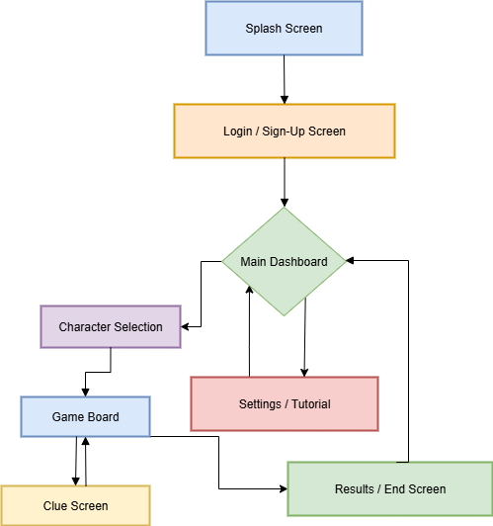

Appendix B: Full Storyboard Diagram

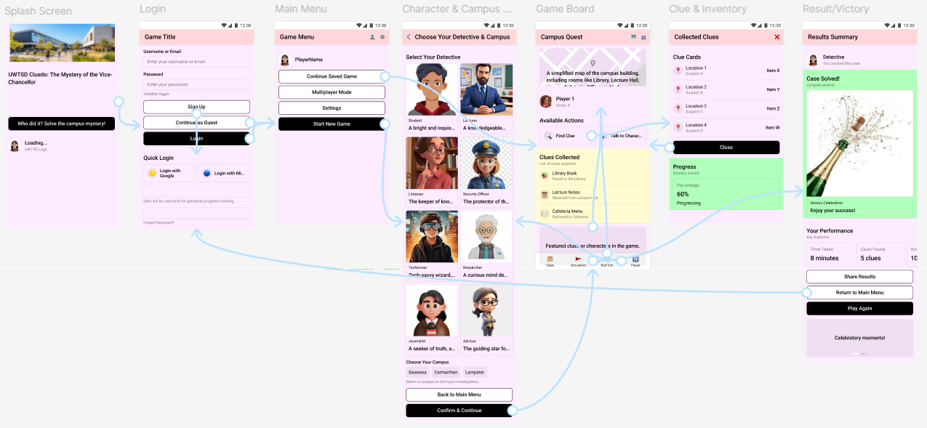

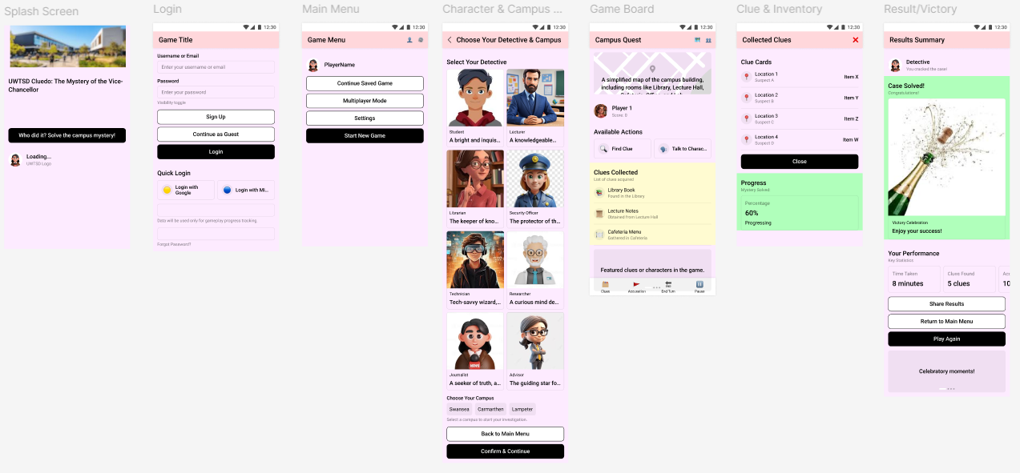

Appendix C: MoSCoW table

Persona / Feature | Requirement Description | MoSCoW Priority | Justification
Persona 1 – Emily (Undergraduate Student) | Adjustable text size and contrast settings | Must Have | Emily has mild visual impairment, so accessibility features are essential for usability and inclusivity.
 | Easy navigation bar | Must Have | Core gameplay and menu access rely on intuitive navigation for all users.
 | Tutorial tips for new players | Should Have | Supports onboarding of less experienced users, but not strictly essential to gameplay.
 | Offline single-player mode | Could Have | Enhances flexibility but not critical to core game functionality.
Persona 2 – Dr. John (Lecturer) | Quick loading and smooth game flow | Must Have | Important for users with limited time availability.
 | Game session restart functionality | Must Have | Ensures continuity and supports short play sessions during breaks.
 | Short game mode | Should Have | Improves experience for time-constrained players, but not essential.
 | Limited animations and simple UI | Should Have | Helps reduce cognitive load but is secondary to core gameplay.
Persona 3 – Megan (Admin Staff) | Colour-blind friendly design (patterns, symbols) | Must Have | Accessibility requirement for colour-blind users.
 | Tap-based controls and guided tutorial | Must Have | Low technical expertise requires intuitive and simple interactions.
 | Sound cues for clarity | Should Have | Improves clarity but not critical if visual cues exist.
 | No fast reflex/time-limited challenges | Should Have | Enhances enjoyment but is not essential to play.
Persona 4 – Daniel (International Student) | Simplified English / multilingual interface | Must Have | Crucial for non-native speakers to understand the game clearly.
 | Easy multiplayer connection and chat | Must Have | Core gameplay feature for Daniel’s preferred game mode.
 | Icon-based instructions | Should Have | Enhances comprehension but not strictly required.
 | Avoid text-heavy tutorials | Should Have | Improves accessibility but not core functionality.

