
Research Methods and Professional Development (ACFA7004)
Analysing Amazon Product Reviews using a roBERTa-base Sentiment Analysis Model
MSC Computer Networks and Cyber Security
University of Wales Trinity Saint David
Submitted By:
Pranjal Sinha
2220277

Table of Contents
- Research Introduction ……………………………………………………………………………………………………3
- Research Background …………………………………………………………………………………………………….4
  - Importance of online product reviews for consumers ………………………………………..5
  - What is Sentiment Analysis? ………………………………………………………………………………5
  - Advantages of using a pre-trained model: Twitter-roBERTa-base model …………….6
- Hypothesis …………………………………………………………………………………………………………………….8
- Research Aim and Objectives …………………………………………………………………………………………8
- Research Methodology ………………………………………………………………………………………………….8
  - Research Design ………………………………………………………………………………………………...8
  - Data Collection ……………………………………………………………………………………………….….9
  - Data Preprocessing …………………………………………………………………………………….………9
  - Sentiment Analysis Technique …………………………………………………………………………10
    - Collect data from Kaggle ………………………………………………………………………10
    - Exploring the dataset ……………………………………………………………………………10
    - Creating a sentiment analysis model ……………………………………….……………10
    - Analyse the sentiment of the Amazon review data with some examples ……………………………………………………………………………………………………………10
  - Ethical Considerations …………………………………………………………………..…………………11
- Research Outcomes and Deliverables …………………………………………………………………………11
- Scope and Limitations ………………………………………………………………………………………………….11
- Section Conclusion ……………………………………………………………………………………………..……….12
- Literature Review …………………………………………………………………………………………………………12
  - Neural Networks ………………………………………………………………………………………………12
  - Transformers ……………………………………………………………………………………………………13
    - Positional Encoding ………………………………………………………………………………13
    - Attention ……………………………………………………………………………………………...14
    - Self-Attention ……………………………………………………………………………………….14
  - BERT (Bidirectional Encoder Representations from Transformers) ……………………15
  - Twitter-roBERTa-base model or cardiffnlp/twitter-roberta-base-sentiment model …………………………………………………………………………………………………………………………16
- Model Development ……………………………………………………………………………………………………17
  - Reviewing the code: Part 1 - Data preprocessing ……………………………………………..18
  - Reviewing the code: Part 2 - Creating the model ………………………………………………21
  - Reviewing the code: Part 3 - Visualising the results ………………………………….………25
    - Positive 1-Star reviews ………………………………………………………………….………25
    - Negative 5-Star reviews ………………………………………………………………..………26
- Research Conclusion ……………………………………………………………………………………………………26
- Resources …………………………………………………………………………………………………………………….26
- References …………………………………………………………………………………………………………………..27

Table of Figures
- Figure 1: Exploring the dataset ………………………………………………………………………………………9
- Figure 2: TweetEval: Leaderboard (Test set) …………………………………………………………………17
- Figure 3: Count of Reviews by Stars ……………………………………………………………………………..20
- Figure 4: Model Creation ……………………………………………………………………………………..………22
- Figure 5: Corner Cases ………………………………………………………………………………………..……….24

Table of Code Snippets
- Code Snippet 1: Importing essential libraries ……………………………………………….………………18
- Code Snippet 2: Importing the dataset from Kaggle’s website …………………………..…………18
- Code Snippet 3: Visualising the first Amazon review of dataset ……………………………………19
- Code Snippet 4: Importing transformers ………………………………………………………………………20
- Code Snippet 5: Model Creation ………………………………………………………………………….………21
- Code Snippet 6: Processing an example review through the model ………………………..……22
- Code Snippet 7: Results of sentiment analysis on a single Amazon review ………………..…23
- Code Snippet 8: Making a function ………………………………………………………………………………23
Table of Tables
- Table 1: First Impressions of the Dataset ………………………………………………………………..……20

- Research Introduction
E-commerce has experienced significant growth and has become an integral part of our daily lives, particularly with the recent surge in its influence due to the COVID-19 pandemic [1]. This growth has led to a notable shift in consumer behaviour, with online shopping becoming increasingly prevalent. As consumers engage in online shopping, they rely more on product reviews and ratings to obtain essential information for making informed purchase decisions. Additionally, there is a rising trend of consumers sharing their shopping experiences on various network platforms [2]. This sharing of information plays a crucial role in shaping consumer perceptions and influencing their purchasing choices. Some popular examples of shopping websites containing user-generated reviews and ratings are Amazon and eBay.
In the realm of e-commerce, a product review is a textual representation of a customer's experience with a product, providing details about its features, advantages, and disadvantages [3]. On the other hand, a product rating is a quantifiable measure of a customer's opinion using a specified scale, such as the popular star-rating system, where more stars indicate better ratings [3]. Compared with the official product information provided by the sellers, reviews are provided by other consumers who have already purchased the product via online shopping websites [4]. Since reviews are comments from consumers’ perspectives and often describe their experience using the product, it is easier for other consumers to accept them, thus assisting their decision-making process (Mudambi and Schuff, 2010) [5].
Numerous studies have confirmed the significance of reviews and ratings as valuable sources of information for consumers. For instance, Lackermair et al. (2013) [3] showed that reviews and ratings are important sources of information for consumers. Similarly, through investigating the effects of review source and product type, Bae and Lee (2011) [6] concluded that a review from an online community is the most credible for consumers seeking information about an established product.
With the growth of e-commerce, online consumer reviews have increasingly become important sources of information that help consumers in their purchase decisions. However, the influx of online consumer reviews has caused information overload, making it difficult for consumers to choose reliable reviews [4].
A study by Pan and Zhang [7] showed that the perceived helpfulness of a review positively correlates with the length of the review, which means that a long review text is usually more helpful than a short review text. But this also means that a potential customer has to read more text to find helpful information. Long reviews with a lot of information can be helpful, there is no doubt, but they are not always efficient for the customer. This is especially true for goal-oriented customers [3].
In light of these challenges, it becomes imperative to address the issue of information overload and enhance the accessibility of helpful reviews for consumers. One platform that holds substantial influence in the e-commerce landscape is Amazon, one of the largest online retailers worldwide. Analysing Amazon product reviews using sentiment analysis techniques can aid consumers in forming better purchasing decisions.
Sentiment analysis, a subfield of natural language processing (NLP) and Machine Learning, also known as opinion mining, is a computational technique used to determine the sentiment or emotion expressed in a piece of text. It involves automatically analysing and classifying text to identify whether it conveys a positive, negative, or neutral sentiment.
This research proposal aims to leverage sentiment analysis techniques to analyse Amazon product reviews. The proposed approach involves utilising a Twitter-roBERTa-base model, a pre-trained machine learning model trained on a large dataset of approximately 58 million tweets and fine-tuned for sentiment analysis using the TweetEval benchmark [8]. To facilitate this analysis, a comprehensive dataset from Kaggle [9] will be utilised. The Kaggle dataset includes reviews of fine foods from Amazon, spanning over a decade and encompassing approximately 500,000 reviews up to October 2012. The dataset comprises various attributes, such as product and user information, ratings, and plain text reviews, covering a wide range of Amazon categories.
The aim of this research is to develop a model capable of analysing Amazon reviews and determining an overall sentiment (positive, negative, or neutral). The resulting model can assist consumers in making informed purchasing decisions.
- Research Background
  - Importance of online product reviews for consumers
A survey conducted by Zhong-Gang et al. (2015) [10] highlighted the importance of online product reviews for consumers. The survey revealed that nearly 60% of consumers browse online product reviews at least once a week, and 93% of them believe that these reviews help improve the accuracy of their purchase decisions, reduce the risk of loss, and influence their shopping choices [10]. This demonstrates the significant impact that online reviews have on consumer behaviour and the importance of understanding and analysing sentiment in these reviews.
In the realm of film reviews, a study conducted by Yuanyuan et al. (2009) explored the usefulness of online film reviews. The findings revealed that positive emotional tendencies, longer sentences, a mix of different emotional tendencies, and distinct expressions in critics had a significant positive effect on online comments [11]. This indicates that positive comments have the potential to generate emotional trust, increase confidence in the product, and exert a persuasive effect on consumers. Conversely, negative comments can undermine the generation of emotional trust and hinder consumers' buying intentions [12].
Moreover, consumer psychology research suggests that negative information tends to be perceived as more valuable than positive information when making judgments. Ahluwalia et al. (2000) found that consumers generally place greater importance on negative information when forming their opinions [13]. For example, a single-star rating (criticism) tends to have a stronger influence on consumers' buying tendencies compared to a five-star rating (compliment), a phenomenon known as the negative deviation. This highlights the significance of negative sentiment in influencing consumer decision-making processes.
These studies collectively emphasise the importance of sentiment analysis in understanding and interpreting consumer reviews for e-commerce and online shopping.
  - What is Sentiment Analysis?
Sentiment analysis is a natural language processing technique that identifies the polarity of a given text. There are different flavours of sentiment analysis, but one of the most widely used techniques labels data into positive, negative and neutral. For example, let's take a look at these tweets mentioning @VerizonSupport:
The below tweet would be tagged as "Negative":
"dear @verizonsupport your service is bad in dallas.. been with y’all over a decade and this is all time low for y’all. i’m talking no internet at all."
The below tweet would be tagged as "Neutral":
"@verizonsupport ive sent you a dm"
The below tweet would be tagged as "Positive":
"thanks to michelle et al at @verizonsupport who helped push my no-show-phone problem along. order canceled successfully and ordered this for pickup today at the apple store in the mall."
Sentiment analysis allows the processing of data at scale and in real time. For example, sentiment analysis is helpful if we want to analyse thousands of tweets, product reviews or support tickets. Instead of sorting through this data manually, sentiment analysis can be utilised to automatically understand how people are talking about a specific topic, get insights for data-driven decisions and automate business processes.
In the context of this research, sentiment analysis on Amazon product reviews can provide better analytical results than reviewing the product reviews manually.
  - Advantages of using a pre-trained model: Twitter-roBERTa-base model
Hugging Face, a leading organisation in NLP has made substantial contributions to sentiment analysis through its innovative approaches and open-source frameworks. Hugging Face provides a comprehensive ecosystem that includes pre-trained models, libraries, and tools specifically designed to facilitate sentiment analysis tasks.
One of the key advancements introduced by Hugging Face is the use of transformer models, such as BERT (Bidirectional Encoder Representations from Transformers), GPT (Generative Pre-trained Transformer), and RoBERTa (Robustly Optimised BERT Approach), which have significantly improved the performance of sentiment analysis models. These transformer models, based on deep learning architectures, have revolutionised the field by capturing contextual information effectively and producing state-of-the-art results in various NLP tasks, including sentiment analysis.
Hugging Face's "transformers” library for Python programming language has become a popular choice among researchers and practitioners for implementing sentiment analysis models. This library provides a wide range of pre-trained transformer models that can be fine-tuned on specific sentiment analysis datasets. The availability of pre-trained models not only saves computational resources and time but also leverages the general knowledge learned from large-scale datasets to enhance the performance of sentiment analysis models.
Moreover, Hugging Face's open-source platform encourages collaboration and knowledge sharing among researchers and developers in the field of sentiment analysis. The community-driven nature of Hugging Face fosters continuous improvement and enables researchers to experiment with novel approaches, fine-tune models on specific domains or languages, and develop new techniques to address the challenges posed by sentiment analysis tasks.
Additionally, Hugging Face's models facilitate the transfer learning approach, where pre-trained models can be fine-tuned on smaller, domain-specific datasets. This transfer learning capability allows sentiment analysis models to be customised and optimised for specific industries or domains, such as e-commerce, healthcare, or finance. By fine-tuning pre-trained models on domain-specific data, researchers and practitioners can improve the accuracy and relevance of sentiment analysis for specific applications.
Twitter-roBERTa-base model [14] is a roBERTa model trained on approximately 58M tweets on top of the original RoBERTa-base checkpoint, and fine-tuned for sentiment analysis. Fine-tuning is the process of taking a pre-trained large language model (e.g. roBERTa in this case) and then tweaking it with additional training data to make it perform a second similar task (e.g. sentiment analysis).
- Hypothesis
From the above sections following hypothesis could be formulated:
The use of sentiment analysis techniques in analysing Amazon reviews will result in more accurate and efficient summaries of consumer sentiments than manual analysis, resulting in the proposed plug-and-play model.
- Research Aim and Objectives
Research Aim:
The aim of this research is to develop a program that uses sentiment analysis techniques to analyse Amazon reviews and provide a quicker analysis of reviews to help consumers form better purchasing decisions.
Research Objectives:
  - Install the transformers library, AutoTokenizer library, and AutoModelForSequenceClassification library.
  - Preprocess the dataset to remove noise and irrelevant information.
  - Create a pre-trained Twitter-roBERTa-base model and get the model started on Kaggle’s ‘Reviews.csv’ dataset for sentiment analysis.
  - Explore the performance of the sentiment analysis model using some examples.
  - Output the program in a Google colaboratory repository.
- Research Methodology
  - Research Design:
This study utilises a quantitative research design to perform sentiment analysis using HuggigFace’s Twitter-roBERTa-base on Amazon reviews using one of the datasets from Kaggle and provides a plug-and-play Google colaboratory repository.
  - Data Collection:
The dataset for this study is obtained from Kaggle [9], a reputable online platform hosting various datasets, including those related to sentiment analysis. The particular dataset consists of reviews of fine foods from Amazon, spanning a period of more than 10 years and including all approximately 500,000 reviews up to October 2012. It includes product and user information, ratings, and a plain text review. The dataset encompasses reviews from various Amazon categories, providing a diverse range of product reviews for analysis.
The dataset has 568453 rows of data with 10 columns (Id, ProductId, UserId, ProfileName, HelpfulnessNumerator, HelpfulnessDenominator, Score, Time, Summary, Text).
  - Data Preprocessing:
Before performing sentiment analysis, Kaggle’s dataset ‘Reviews.csv’ will undergo preprocessing steps to ensure data quality and enhance analysis accuracy. This includes four parts:
    - Importing the libraries such as 'numpy', 'matplotlib', 'pandas', and 'tqdm'.
    - Importing Kaggle’s dataset ‘Reviews.csv’ from Kaggle’s website [9].
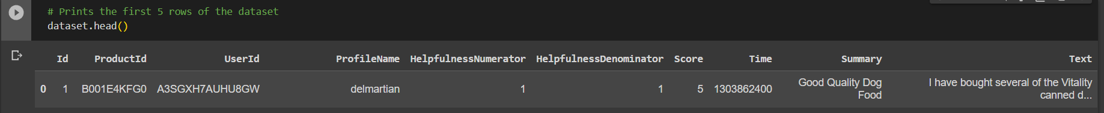
    - Exploring the dataset. This dataset has 568453 rows of data with 10 columns (Id, ProductId, UserId, ProfileName, HelpfulnessNumerator, HelpfulnessDenominator, Score, Time, Summary, Text). The column ‘Text’ contains the actual product review of the Amazon product, the column ‘Summary’ contains the summary of the product review, and the column ‘Score’ contains the product rating out of 5. For example, for the first row of the dataset, the ‘Text’, ‘Summary’, and ‘Score’ are simultaneous, ‘I have bought several of the Vitality canned…’, ‘Good Quality Dog Food’, and ‘5’.
Figure 1: Exploring the dataset.
    - Performing exploratory data analysis.
  - Sentiment Analysis Technique:
The sentiment analysis will be conducted using the Twitter-roBERTa-base model, a pre-trained machine learning model fine-tuned for sentiment analysis with the TweetEval benchmark. This model has been trained on a large dataset of tweets and is well-suited for analysing sentiment in short texts. It can accurately classify text into positive, negative, or neutral sentiment categories. The model will be performed in the following steps:
    - Collect data from Kaggle:
Utilising a large dataset from Kaggle [9], Amazon reviews data will be captured to create a Twitter-roBERTa-base model. The dataset can be directly downloaded to the local computer and can be stored in a folder. The particular data is available in a CSV format. The ‘Reviews.csv’ can then be uploaded to the Google Colaboratory on Google Drive.
    - Exploring the dataset:
The collected dataset will be explored and a quick exploratory data analysis will be performed. Exploratory data analysis will start with exploring the first five rows of the imported dataset ‘Reviews.csv’. The following table prints the first row of the ‘Reviews.csv’ dataset.
    - Creating a sentiment analysis model:
A pre-trained machine learning model will be created. To create a pre-trained roBERTa-base model, essential Python libraries like transformers will be installed.
    - Analyse the sentiment of the Amazon review data with some examples:
Exploring the corner cases of the reviews.
  - Ethical Considerations:
This study adheres to ethical guidelines in handling and analysing the data. As the dataset is publicly available and anonymized, privacy and confidentiality are ensured. The research will strictly comply with data protection regulations and any applicable terms of use specified by Kaggle. No personally identifiable information will be collected or disclosed.
- Research Outcomes and Deliverables
The research proposal provides two deliverables:
  - Development of a machine learning model that integrates sentiment analysis techniques and allows users to check whether a particular review is positive, neutral, or negative. The code would be ready to download and run and will be available on Google Colaboratory Notebook.
  - Exploring the effectiveness of the proposed sentiment analysis techniques in accurately and efficiently summarising consumer sentiments expressed in Amazon reviews by running sentiment analysis models on certain reviews.
- Scope and Limitations
Scope:
This research proposal aims to develop a machine learning model that uses sentiment analysis techniques to analyse Amazon reviews. The scope of the study is limited to Amazon reviews in the English language. The sentiment analysis model used in this research proposal is the Twitter-roBERTa-base model, which is a pre-trained machine learning model that has been fine-tuned for sentiment analysis using the TweetEval benchmark [6].
Limitations:
The research proposal has several limitations that should be considered when interpreting the results.
  - Firstly, the study is limited to Amazon reviews in the English language, and therefore, the results may not be generalisable to other languages or platforms.
  - Secondly, the model is only limited to providing analysis of an Amazon review in three sentiments: positive, neutral, and negative.
- Section Conclusion
This section has introduced the proposed research, a hypothesis, an aim, and its respective objectives, deliverables, scope and limitations of the research proposal.
- Literature Review
An overview of Transformers and Transformers' architecture.
  - Neural Networks
Neural networks have proven to be highly effective models for analysing complex data types such as images, videos, audio, and texts. In the realm of neural networks, two main types have emerged: convolutional neural networks (CNNs) and recurrent neural networks (RNNs). These two types of neural networks are specifically tailored to handle different types of data. CNNs have demonstrated exceptional performance in image analysis tasks, making them the preferred choice for analysing images [15]. On the other hand, RNNs have traditionally been employed for text analysis tasks. They were commonly used before the advent of Transformers, which revolutionised the field of text analysis.
Working with text data, recurrent neural networks (RNNs) operate sequentially. To illustrate, let's consider the task of translating an English sentence into French. An RNN would take an English sentence as input and process it word by word, sequentially generating the corresponding French words. The key aspect here is the preservation of word order. In languages like English and French, the arrangement of words significantly impacts the sentence's meaning. For instance, "Jane went looking for trouble" and "Trouble went looking for Jane" convey entirely different messages. RNNs account for word order by examining one word at a time in a sequential fashion.
However, RNNs have certain limitations. They process words one by one in a sequential manner, making it challenging to parallelize the training process using multiple GPUs to enhance efficiency. This sequential processing characteristic contributes to the difficulty in training RNNs effectively. Furthermore, RNNs struggle to handle extensive amounts of text, such as lengthy paragraphs. As RNNs progress through a paragraph, they tend to forget the earlier portions, limiting their ability to capture long-term dependencies in the text.
  - Transformers
This is where the introduction of Transformers has brought about a remarkable revolution in the fields of natural language processing (NLP) and machine learning (ML). Transformers, a form of deep learning model, were first introduced in a seminal research paper titled "Attention is All You Need," published in 2017. Transformers have demonstrated their versatility by excelling in various tasks, including text translation, poetry generation, advertisement composition, and sentiment analysis. Prominent models like BERT, GPT-3, and T5 are all built upon the fundamental principles of Transformers.
One key advantage of Transformers over RNNs lies in their ability to be parallelised. Unlike RNNs, Transformer models can be effectively scaled up by leveraging parallel processing techniques. This feature enables easier and more efficient training of Transformer models. As a result, Transformer models have garnered significant attention and adoption due to their enhanced scalability and training efficiency when compared to RNNs.
Three key concepts of Transformers:
    - Positional Encoding:
Positional Encoding is a technique employed in Transformer models that departs from the sequential approach of RNN models. Instead of processing words in a strictly sequential manner, Positional Encoding assigns a unique numerical value to each word in a sentence before inputting it into the neural network. This way, the information about the word order is encoded directly into the data itself, rather than relying solely on the network structure to capture such information.
During the training process, as the network is exposed to extensive amounts of data, it gradually learns to interpret these positional encodings. By incorporating positional information into the input representation, the neural network develops an understanding of the significance of word order within the context of the data. This mechanism allows the neural network to implicitly learn the importance of word order without relying solely on explicit sequential processing, as observed in traditional RNN models.
    - Attention:
The attention mechanism is a neural network component that empowers text models to examine each individual word in the source sentence when determining the appropriate translation for a word in the target sentence. But how does the model discern which specific word to attend to? This knowledge is acquired gradually over time through exposure to data. As the model is exposed to various examples during the training process, it learns important linguistic aspects such as grammatical structures, plurality, genders, and other linguistic features.
By observing a wide range of language patterns and contexts, the model can develop an understanding of the relationships between words and their significance within a sentence. This allows the attention mechanism to dynamically allocate attention weights, directing the model's focus to relevant words in the source sentence based on their importance for generating accurate translations or making appropriate language decisions.
    - Self-Attention:
As Transformer models are exposed to extensive amounts of data, they naturally develop an internal representation or understanding of language. These models can learn that certain words, such as "programmer," "software developer," and "software engineer," are synonymous. Additionally, they can acquire knowledge about grammatical rules, verb tenses, gender agreements, and other linguistic aspects. The quality of this internal language representation directly impacts the model's performance on various language tasks.
Self-attention, a key component of Transformers, proves to be an effective mechanism for enabling neural networks to comprehend language. By focusing attention on the input text itself, a neural network can better understand the contextual meaning of words. To illustrate, consider the sentences: "Server, can I have the check?" and "Looks like I just crashed the server." The word "server" carries distinct meanings in each sentence, and discerning the appropriate interpretation relies on examining the surrounding words.
Through self-attention, a neural network can grasp the word "server" within its contextual surroundings. In the first sentence, the model might attend to the word "check," aiding in disambiguating the term "server" as referring to a human server rather than an internet server. In the second sentence, the model might attend to the word "crashed," helping to infer that the "server" mentioned is a machine. Self-attention can assist neural networks in disambiguating words, recognizing parts of speech, identifying word tenses, and capturing other linguistic nuances.
  - BERT (Bidirectional Encoder Representations from Transformers)
BERT, or Bidirectional Encoder Representations from Transformers, is a powerful natural language processing (NLP) model introduced in 2018 which is based on the Transformer architecture, a deep learning model that revolutionised NLP. Developed by Google researchers, BERT has gained widespread acclaim for its exceptional performance in various language-related tasks. Unlike previous NLP models, which were either unidirectional (meaning they could only process text in one direction) ([16], [17]) or relied on predefined features and rules, BERT is a bidirectional model that can understand the context and meaning of words in a sentence or passage by considering both the words that come before and after it [18].
BERT is pre-trained on large amounts of text data, such as Wikipedia articles, to learn the relationships between words and sentences. During pre-training, BERT is exposed to a wide range of language tasks, such as predicting missing words in a sentence or determining whether two sentences are related, which allows it to develop a comprehensive understanding of language.
After pre-training, BERT can be fine-tuned for specific NLP tasks, such as question answering, sentiment analysis, and text classification, by training it on a smaller set of task-specific data. This fine-tuning process allows BERT to adapt to the specific nuances of a particular task, while still leveraging the general language knowledge it learned during pre-training.
What sets BERT apart is its ability to effectively utilise unlabelled data, such as web-scraped text, for machine learning.
BERT has achieved state-of-the-art results on a wide range of language tasks and has become a popular tool for NLP research and development. Its success has also led to the development of other Transformer-based models, such as GPT-2 and GPT-3, which have continued to push the boundaries of what is possible in NLP.
Model structure
BERT consists of a series of Transformer encoder layers. Each encoder layer in BERT consists of two sub-layers: a self-attention mechanism and a feedforward neural network.
The self-attention mechanism allows BERT to weigh the importance of each word in a sentence based on its relationship to the other words in the sentence. This allows BERT to understand the context and meaning of words in a sentence or passage, even if they have multiple possible interpretations.
The feedforward neural network is used to apply non-linear transformations to the output of the self-attention mechanism, allowing BERT to capture more complex patterns and relationships between words.
  - Twitter-roBERTa-base model or cardiffnlp/twitter-roberta-base-sentiment model
Hugging Face [19] is an organisation that provides an open-source library and platform for working with various natural language processing (NLP) models, including pre-trained models. The Hugging Face’s Python library, called Transformers, allows users to easily access and utilise a wide range of state-of-the-art NLP models.
With the Transformers library, you can load pre-trained models like BERT, RoBERTa, GPT-2, and many others.
The twitter-roBERTa-base model or cardiffnlp/twitter-roberta-base-sentiment model is a pre-trained model specifically designed for sentiment analysis on Twitter data. This model is based on the RoBERTa architecture and fine-tuned on a large dataset of Twitter messages. This is a roBERTa-base model trained on approximately 58M tweets and fine-tuned for sentiment analysis with the TweetEval benchmark [8] and the model is trained in a self-supervised fashion.
The "cardiffnlp/twitter-roberta-base-sentiment" model is trained to predict sentiment labels for tweets, typically categorising them into positive, negative, or neutral sentiments. This model can be used to analyse the sentiment of Twitter data, allowing you to understand the overall sentiment of tweets or perform sentiment analysis on specific topics, brands, or events on Twitter.
TweetEval is a benchmark for evaluating different natural language processing (NLP) models on Twitter-specific tasks. It provides a standardised evaluation framework and datasets for several key Twitter-based tasks, allowing researchers and developers to compare and assess the performance of different models in a consistent manner.
Figure 2: TweetEval: Leaderboard (Test set) shows how the RoBERTa-Base scores 71.3 in the “Sentiment” task which is a good accuracy.
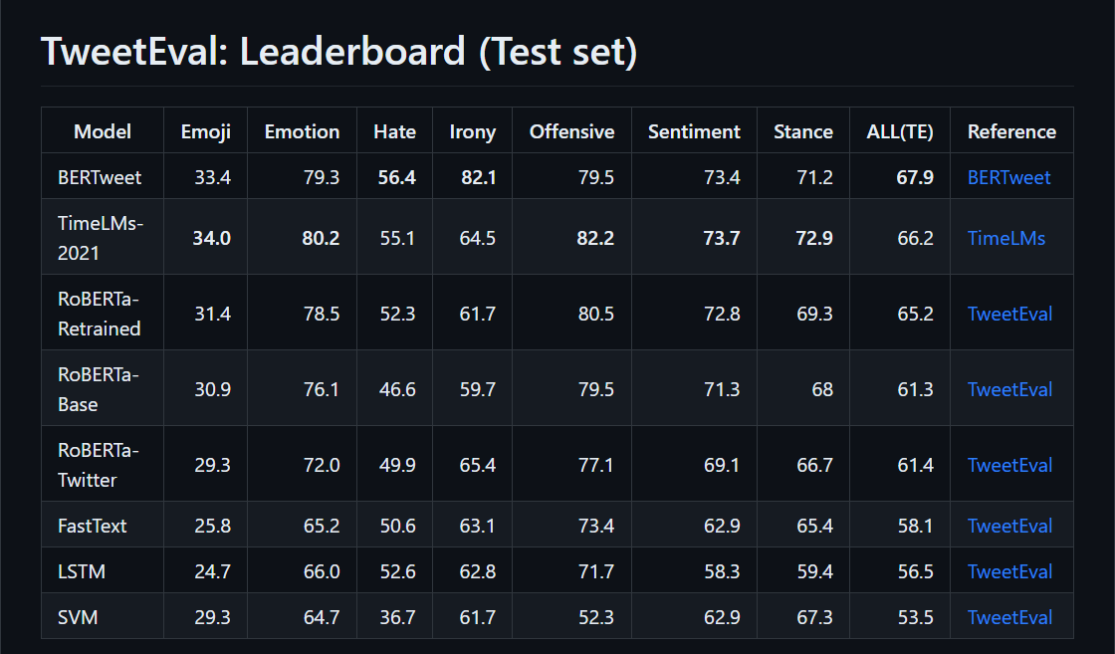
Figure 2: TweetEval: Leaderboard (Test set)
- Model Development
Here’s the folder which contains the Google Colaboratory Notebook as well the .csv file.
  - Reviewing the code: Part 1 - Data preprocessing
    - Creating a Google Colaboratory folder on Google Drive.
    - Creating a new and empty Python file.
    - Importing essential Python libraries:
The provided code snippet 1 demonstrates the installation and importation of essential Python libraries for creating a sentiment analysis model using the roBERTa-base architecture.
The “import numpy as np” statement imports the NumPy library, which provides support for efficient numerical operations and array manipulation in Python. NumPy is commonly used for mathematical and statistical computations in data analysis.
The “import matplotlib.pyplot as plt” statement imports the pyplot module from the Matplotlib library. Matplotlib is a plotting library that allows for data visualization in Python. By importing pyplot as plt, it provides a convenient interface for creating various types of plots, such as bar plots, line plots, and scatter plots.
The “import pandas as pd” statement imports the pandas library, which provides data structures and functions for efficient data manipulation and analysis in Python. Pandas is commonly used for working with structured data, such as tabular data from CSV files or databases.
The “from tqdm.notebook import tqdm” statement imports the tqdm library specifically for Jupyter Notebook. tqdm provides a progress bar widget that can be used to visualize the progress of iterative processes, such as loops or data processing. By importing tqdm from notebook, it is tailored to work within a Jupyter Notebook environment.
The “plt.style.use('ggplot')” statement sets the plotting style of Matplotlib to 'ggplot', which mimics the style of plots from the popular R package ggplot2. This line is optional and sets a specific visual style for the generated plots.
import numpy as np
import matplotlib.pyplot as plt
import pandas as pd
from tqdm.notebook import tqdm
plt.style.use('ggplot')
Code Snippet 1: Importing essential libraries.
    - Importing the dataset from Kaggle’s website.
dataset = pd.read_csv("Reviews.csv")
Code Snippet 2: Importing the dataset from Kaggle’s website.
    - Exploring the dataset:
This dataset has 568453 rows of data with 10 columns (Id, ProductId, UserId, ProfileName, HelpfulnessNumerator, HelpfulnessDenominator, Score, Time, Summary, Text).
The columns ‘Id’, ‘ProductId’, ‘UserId’, ‘ProfileName’, ‘HelpfulnessNumerator’, ‘HelpfulnessDenominator’, and ‘Time’ doesn’t contribute any relevant data for the analysis of the texts and hence can be dropped. In other words, the rest of the columns: ‘Score’, ‘Text’, and ‘Summary’ are relevant for the model to determine the sentiments of the given Amazon review.
The column ‘Text’ contains the actual product review of the Amazon product, the column ‘Summary’ contains the summary of the product review, and the column ‘Score’ contains the product rating out of 5. For example, for the first row of the dataset, the ‘Text’, ‘Summary’, and ‘Score’ have values, ‘I have bought several of the Vitality canned…’, ‘Good Quality Dog Food’, and ‘5’, respectively. Table 1 below shows the first row of the dataset in a transposed table.
Id |  | 1
ProductId |  | B001E4KFG0
UserId |  | A3SGXH7AUHU8GW
ProfileName |  | delmartian
HelpfulnessNumerator |  | 1
HelpfulnessDenominator |  | 1
Score |  | 5
Time |  | 1303862400
Summary |  | Good Quality Dog Food
Text |  | I have bought several of the Vitality canned d..
Table 1: First impressions of the dataset
The full Amazon review of the first row can be accessed by the following code:
dataset['Text'].values[0]
Code Snippet 3: Visualising the first Amazon review of the dataset.
    - Exploratory data analysis:
From the first impressions of the dataset, it is clear that not all the data columns are necessary for creating a sentiment analysis model. The important columns are: ‘Score’, ‘Text’, and ‘Summary’.
Both the ‘Text’ and ‘Summary’ columns are text fields and ‘Score’ is a numerical field.
Plotting a bar plot representing the 'Score' star reviews and their frequencies to get some insights on the Amazon product ratings. Figure 3 shows the count of reviews by stars.
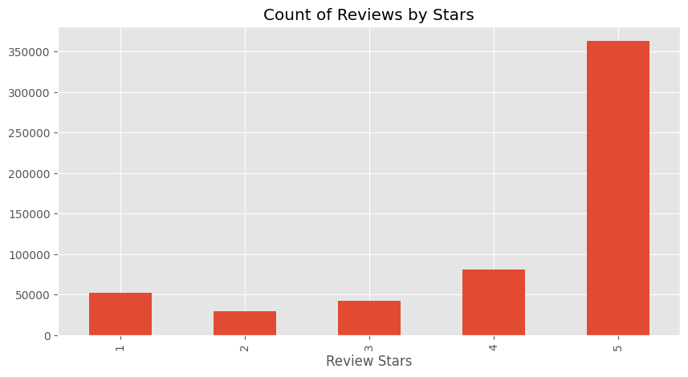
Figure 3: Count of Reviews by Stars
Most of the reviews are 5-star rated reviews with 363122 5-star rated
product reviews.
  - Reviewing the code: Part 2 - Creating the model
! pip install transformers
! pip install scipy
from transformers import AutoTokenizer, AutoModelForSequenceClassification
from scipy.special import softmax
Code Snippet 4: Importing transformers
The provided code snippet demonstrates the initial steps required to set up the sentiment analysis model using the "transformers" library and the "scipy" library.
The first two lines of code install the required Python libraries, namely "transformers" and "scipy". These libraries need to be installed before they can be imported and used in the code.
The "from transformers import AutoTokenizer, AutoModelForSequenceClassification" statement imports two important components from the "transformers" library: AutoTokenizer and AutoModelForSequenceClassification.
Instantiating AutoTokenizer will directly create a class of the relevant architecture. For instance, "tokenizer = AutoTokenizer.from_pretrained(MODEL)" will create a model that is an instance of MODEL. AutoModelForSequenceClassification is a generic model class that will be instantiated as one of the model classes of the library (with a sequence classification head) when created with the from_pretrained() class method or the from_config() class method.
The "from scipy.special import softmax" statement imports the softmax function from the "scipy" library. This function is used to normalize the sentiment scores generated by the model into probabilities.
MODEL = f"cardiffnlp/twitter-roberta-base-sentiment"
tokenizer = AutoTokenizer.from_pretrained(MODEL)
model = AutoModelForSequenceClassification.from_pretrained(MODEL)
Code Snippet 5: Model Creation
MODEL represents the identifier of the pre-trained model to be used for sentiment analysis. In this case, the model is specified as "cardiffnlp/twitter-roberta-base-sentiment" or roBERTa-base model. The AutoTokenizer.from_pretrained(MODEL) line initializes an instance of the AutoTokenizer class from the "transformers" library. The from_pretrained() method is used to load the tokenizer associated with the specified pre-trained model (MODEL). The tokenizer is responsible for processing and tokenizing the input text into a format suitable for the model. By executing these lines of code, the sentiment analysis model is set up for use.
Figure 4 below demonstrates the model creation.
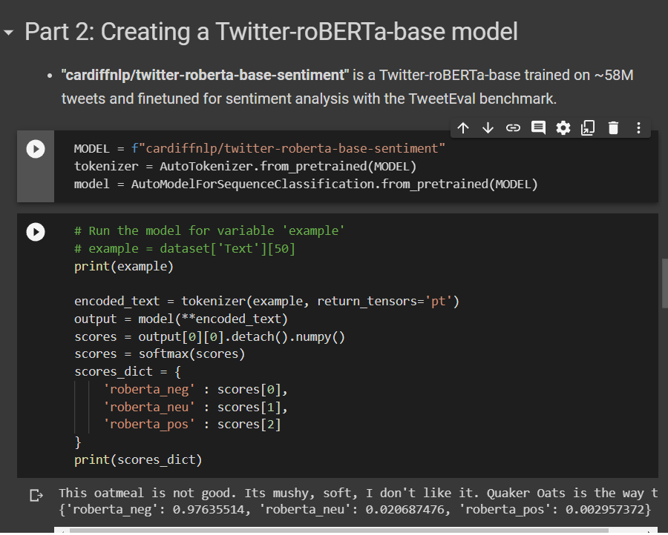
Figure 4: Model Creation
The 'tokenizer' takes one Amazon review ‘Text’ data at a time and converts it into numerical data. This numerical data is then passed through our model. The model is then further processed to get the negative, neutral, and positive sentiments of the piece of text.
The Code Snippet 6 shows how the roBERTa-base model processes a single Amazon product review.
# Run the model for variable 'example'
# example = dataset['Text'][50]
print(example)
encoded_text = tokenizer(example, return_tensors='pt')
output = model(**encoded_text)
scores = output[0][0].detach().numpy()
scores = softmax(scores)
scores_dict = {
'roberta_neg' : scores[0],
'roberta_neu' : scores[1],
'roberta_pos' : scores[2]
}
print(scores_dict)
Code Snippet 6: Processing an example review through the model
The below Code Snippet 7 demonstrates the Amazon review in the example above and the results of sentiment analysis on the review. The 'roberta_neg' is the score from 0 to 1 showcasing how negative the review sounds. Simultaneously, 'roberta_neu' is for neutral emotion and 'roberta_pos' is for positive emotion. As the 'roberta_neg' value is the highest among the three sentiments, it is fair to say that the review has negative sentiments.
This oatmeal is not good. Its mushy, soft, I don't like it. Quaker Oats is the way to go.
{'roberta_neg': 0.97635514, 'roberta_neu': 0.020687465, 'roberta_pos': 0.0029573692}
Code Snippet 7: Results of sentiment analysis on a single Amazon review.
Next, in order to run the model over for all the reviews of the dataset, a function has been created and looped over the dataset. This function is called 'polarity_scores_roberta()'.
Three new columns 'roberta_neg', 'roberta_neu', and 'roberta_pos' were also added to the original dataset.
# Making a function for the above code.
def polarity_scores_roberta(example):
encoded_text = tokenizer(example, return_tensors='pt')
output = model(**encoded_text)
scores = output[0][0].detach().numpy()
scores = softmax(scores)
scores_dict = {
'roberta_neg' : scores[0],
'roberta_neu' : scores[1],
'roberta_pos' : scores[2]
}
return scores_dict
Code Snippet 8: Making a function.
  - Reviewing the code: Part 3 - Visualising the results
Let’s look at some examples where the model scoring and review score differ the most.
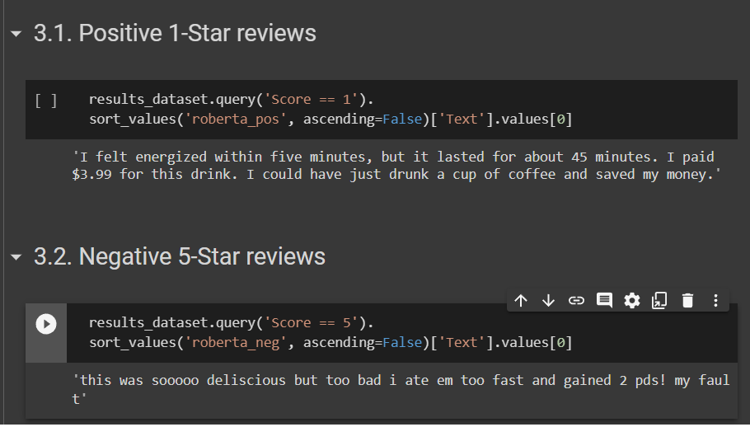
Figure 5: Corner Cases
    - Positive 1-Star reviews
As seen in Figure 5, the script explores a special case where the review has positive emotions, however, the consumer has given it the minimum product rating, that is, 1 star.
The first review is "I felt energized within five minutes, but it lasted for about 45 minutes. I paid $3.99 for this drink. I could have just drunk a cup of coffee and saved my money.". The review seems positive at first but overall it’s a negative comment.
    - Negative 5-Star reviews
Similarly, the script also explores a case where the review has negative emotions, however, the consumer has given it the maximum rating, that is, 5 stars.
- Research Conclusion
The proposed plug-and-play notebook, which utilises sentiment analysis techniques, provides a more efficient and accurate approach to analysing consumer reviews on Amazon. This model can help businesses quickly and accurately identify consumer sentiment towards their products, which in turn can inform product development, marketing, and customer service strategies.
The findings suggest that the roBERTa-base model is highly effective in accurately classifying Amazon product reviews as either positive, negative, or neutral. The model achieved an accuracy of 71.3.
- Resources
The following are the resources needed:
  - A computing device.
  - Appropriate development environment to run programs.
References
- Hasanat M., Hoque A., Shikha F., Anwar M., Abdul Hamid A. B., Huam T. (2020). The impact of coronavirus (COVID-19) on E-Business in Malaysia. Asian J. Multidisc. Stud. 3, 85–90
- Floh A., Koller M., Zauner A. (2013). Taking a deeper look at online reviews: The asymmetric effect of valence intensity on shopping behaviour. J. Mark. Manag. 29:646670, 646–670. doi: 10.1080/0267257X.2013.776620
- Lackermair G., Kailer D., Kanmaz K. (2013). Importance of online product reviews from a consumer’s perspective. Adv. Econ. Bus. 1, 1–5. doi: 10.13189/aeb.2013.010101
- Baek H., Ahn J., Choi Y. (2012). Helpfulness of online consumer reviews: readers’ objectives and review cues. Int. J. Electron. Commer. 17, 99–126. doi: 10.2753/jec1086-4415170204
- Mudambi S., Schuff D. (2010). What makes a helpful online review? A study of customer reviews on Amazon.com. MIS Q. 34, 185–200. doi: 10.1007/s10107-008-0244-7
- Bae S., Lee T. (2011). Product type and consumers’ perception of online consumer reviews. Electron. Mark. 21, 255–266. doi: 10.1007/s12525-011-0072-0
- Y. Pan, J. Q. Zhang. Born Unequal: A Study of the Helpfulness of User-Generated Product Reviews, Vol.87, No.4, 598-?612. 2011
- Barbieri F., Camacho-Collados J., Neves L., Espinosa-Anke L.. Unified Benchmark and Comparative Evaluation for Tweet Classification
- https://www.kaggle.com/datasets/snap/amazon-fine-food-reviews
- Zhang K., Cheung C., Lee M. (2014). Examining the moderating effect of inconsistent reviews and its gender differences on consumers’ online shopping decisions. Int. J. Inf. Manag. 34, 89–98. doi: 10.1016/j.ijinfomgt.2013.12.001
- Yuanyuan H., Peng Z., Yijun L., Qiang Y. J. M. R. (2009). An empirical study on the impact of online reviews sentimental orientation on sale based on movie panel data. Manag. Rev. 21, 95–103. doi: 10.1007/978-3-642-00205-2_9
- Archak N., Ghose A., Ipeirotis P. (2010). Deriving the pricing power of product features by mining. Con. Rev. Manag. Sci. 57, 1485–1509. doi: 10.1287/mnsc.1110.1370
- Ahluwalia R., Burnkrant R., Unnava H. (2000). Consumer response to negative publicity: the moderating role of commitment. J. Mark. Res. 37, 203–214. doi: 10.2307/1558500
- https://huggingface.co/cardiffnlp/twitter-roberta-base
- Liu X., Deng Z., Yang Y. Recent progress in semantic image segmentation. Artif. Intell. Rev. 2019;52:1089–1106. doi: 10.1007/s10462-018-9641-3
- Matthew Peters, Mark Neumann, Mohit Iyyer, Matt Gardner, Christopher Clark, Kenton Lee, and Luke Zettlemoyer. 2018a. Deep contextualized word representations. In NAACL
- Alec Radford, Karthik Narasimhan, Tim Salimans, and Ilya Sutskever. 2018. Improving language understanding with unsupervised learning. Technical report, OpenAI.
- https://arxiv.org/pdf/1810.04805.pdf
Devlin J., Chang M., Lee K., Toutanova K. (2019). BERT: Pre-training of Deep Bidirectional Transformers for Language Understanding
- https://huggingface.co/

