

Student Name: Noreen Kouser
Student ID: 2433387
Module Title: Introduction to Physiology
Module Code: BMHP5023
Assignment Title: Component 1: Witten Assignment
Lecturers Name: Dr Gillian Weaver
Word Count: 1998

Table of Contents
Introduction 3
Section 1: Anatomy and Physiology 3
Blood Glucose Regulation 3
Role of the Pancreas 4
Function of Insulin and Glucagon 4
Cellular Metabolism and Energy Production 5
Relationship to Type 2 Diabetes 5
Section 2: Pathophysiology and Impact 5
Failure of Blood Glucose Regulation 5
Effect of Diet on Glucose Control 6
Impact of Physical Activity on Glucose Control 6
Impact of Smoking Affects Glucose Control 6
Section 3: Monitoring and Data Use 7
Importance of Monitoring Blood Glucose Levels 7
Use of Routine Data to guide Diabetes Management 7
Section 4: Evidence-based lifestyle Recommendations 8
Healthy Diet 8
Regular Physical Activity 8
Weight Management 8
Smoking Cessation 9
Patient Education and Self-Management 9
Conclusion 9
References 11

Introduction
Diabetes mellitus type 2 (DMT2) is a chronic metabolic disease in which blood glucose cannot be regulated (Galicia-Garcia et al., 2020). This occurs when the cells in the body turn a blind eye to insulin or when the pancreas no longer makes enough insulin to keep blood sugar levels normal. Insulin acts as a hormone which allows the glucose to cross the bloodstream into the cells to be utilised for energy production. If the action of insulin is not effective, glucose builds up in the blood and causes hyperglycaemia. Type 2 diabetes is the most prevalent type of diabetes and a significant public health problem globally (Abdul Basith Khan et al., 2020).
There are numerous risk factors for type 2 diabetes. Obesity is one of the most important risk factors as it leads to insulin resistance. Too little exercise can also increase insulin resistance as well as impair glucose utilization. Poor nutrition, in particular high sugar and saturated fat intake, are also lifestyle factors involved in the risk factor. Other risk factors are ethnicity, smoking, family history of diabetes and age (Lechner et al., 2020). These factors may combine to elevate the danger of acquiring Type 2 diabetes and the related issues.
This report is to provide a description of how blood glucose is controlled and the role of oxygen and glucose in generating energy in the body during metabolism. The report will also include why it is important to monitor blood glucose levels and the evidence that supports lifestyle changes that people with Type 2 diabetes can make to help control their blood glucose levels and minimize the risk of developing long-term diabetes complications.

Section 1: Anatomy and Physiology

Blood Glucose Regulation
Maintenance of a normal blood glucose level is critical for normal body function (Kwon, 2021). The body's main energy currency is glucose, which is derived principally from carbohydrates from the food. Once absorbed after digestion, glucose is present in the blood where it needs to be kept within normal limits to sustain cell function.
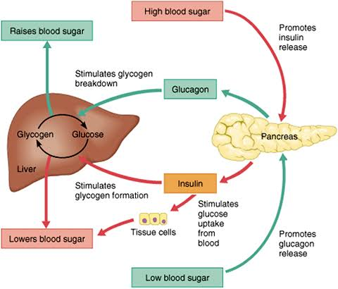
Figure 2: Regulation of blood glucose levels by insulin and glucagon
Source: ATrain Education (ATrainCEU)

Role of the Pancreas
Pancreas is a major organ that play role in regulation of blood glucose. It contains groups of cells (islets of Langerhans). These cells generate hormones which regulate the level of sugar in the blood. Insulin is made by beta cells and glucagon is made by alpha cells.

Function of Insulin and Glucagon
After eating, insulin is released because the blood glucose level is elevated. It lets glucose transfer from blood to body cells, notably fat and muscle cells. Insulin is also involved in the storage of excess glucose in the liver as glycogen. As a result, blood sugar levels drop.
Glucagon is released during periods of hypoglycaemia (Hölzen et al., 2020). This hormone is a stimulator of the liver to convert stored glycogen to glucose. Then the glucose is released into the blood stream. Insulin and Glucagon work in opposition to keep blood glucose in check.

Cellular Metabolism and Energy Production
Cells need a constant source of energy to carry out necessary functions. This energy is created in the cells as a result of cellular metabolism. Inn Aerobic Respiration: Glucose is used in the presence of oxygen for the release of energy.
The energy generated stores in a molecule named adenosine triphosphate (ATP). ATP is a source of energy for movement, growth, repair of tissues and organ functioning (Suwara et al., 2023). Carbon dioxide and water are wastes and are excreted from the body.
The entire procedure can be stated as:

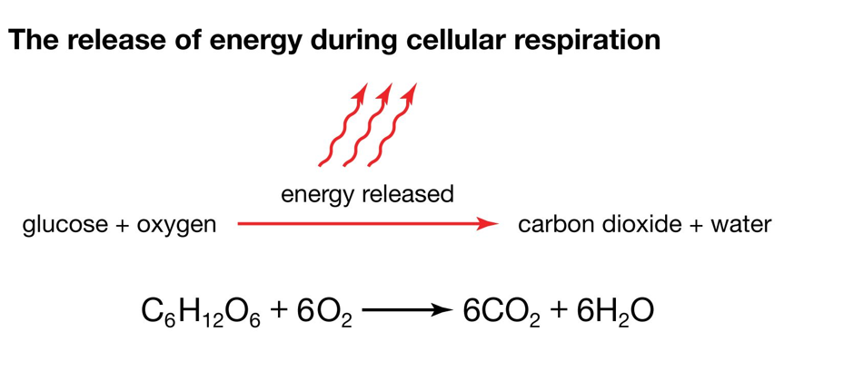
Figure 1: Release of energy during cellular respiration (glucose oxidation reaction)
Source: Encyclopaedia Britannica, Inc. (britannica.com)

Relationship to Type 2 Diabetes
People with type 2 diabetes have trouble processing insulin because their cells do not respond (Rachdaoui, 2020). So glucose doesn’t actually go into the cells. This raises blood glucose and reduces energy use by tissues.

Section 2: Pathophysiology and Impact

Failure of Blood Glucose Regulation
In Type 2 diabetes, blood glucose levels "run amok. In normal conditions, insulin helps the glucose to pass from the blood into the cells and use it for the production of energy (Rahman et al., 2021). Body cells of an individual with Type 2 diabetes become less sensitive to insulin. This is called insulin insensitivity. This makes it impossible for glucose to flow into the cells effectively, thereby giving rise to blood glucose levels. This means that glucose does not get into the cells efficiently, thus creating blood sugar levels.
In the early phases of a disease, an increase in insulin production will be a way for the pancreas to compensate (Weir and Bonner-Weir, 2021). But, with the passage of time, the pancreas may not be able to meet the body's needs for insulin. This causes the blood glucose level to increase (hyperglycaemia). When the blood glucose level is high (hyperglycaemia), this can damage blood vessels, nerves and organs in the body. When not well controlled, it can lead to heart disease, kidney disease, nerve damage and vision problems.

Effect of Diet on Glucose Control
A healthy eating plan is an important strategy for dealing with Type 2 diabetes. High-refined sugar and processed carbohydrate foods can result in a quick rise in blood sugar. Over consumption of calories can also lead to weight gain and this can further promote insulin resistance (Wali et al., 2021).
Poor nutrition can thus make it more difficult to manage blood glucose, and may promote the progression of the disease.

Impact of Physical Activity on Glucose Control
Proper use of glucose with exercise. Muscle requires additional energy and blood glucose to be utilized during exercise. Activity also helps to improve insulin sensitivity, meaning that insulin can work more efficiently in getting glucose into cells (Papakonstantinou et al., 2022). But sedentary behaviors have the opposite effect; they reduce glucose consumption, increase weight gain and impaired glycaemic control which, in turn, can worsen insulin resistance.

Impact of Smoking Affects Glucose Control
Another major lifestyle factor that impacts diabetes management is smoking (Driva et al., 2022). Tobacco chemicals lead to insulin resistance and can increase blood glucose control. Smoking can also harm blood vessels, and heightens the risk of heart and blood vessel disease. The risks to heart and circulatory health with Type 2 diabetes can be even higher if someone smokes.
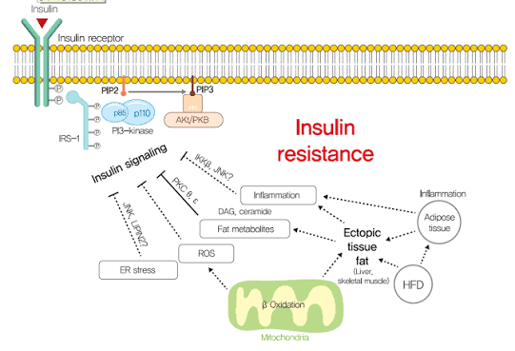
Figure 3: Mechanisms of insulin resistance in Type 2 diabetes mellitus (insulin signalling disruption pathway)
Source: Diabetes & Metabolism Journal / E-DMJ (Lee et al., 2021)

Section 3: Monitoring and Data Use

Importance of Monitoring Blood Glucose Levels
Blood sugar control is a key part of type 2 diabetes management. The regular monitoring enables individuals to gain insight into what their body is reacting to as far as food, exercise, medication, and lifestyle. It also enables the patient and health care providers to detect blood glucose fluctuations and act accordingly if required.
Finger-prick testing or continuous glucose monitoring systems (CGM) can be used to monitor blood glucose (Mathew and Zubair, 2026). Additionally, in health care, HbA1c is frequently ordered. HbA1c gives a record of your average blood sugar for the last 2-3 months. This is useful to evaluate long-term glucose control and treatment effectiveness.

Use of Routine Data to guide Diabetes Management
Health data plays an important role in diabetes management and is common almost every day. Continuous blood glucose monitoring can provide the health care providers with patterns and trends regarding blood glucose (Miller, 2020). This information can be used to assess the current effectiveness of treatment, and to consider medication changes, diet or exercise.
Monitoring data can also be used to detect peak blood glucose levels (when blood glucose is high) or low blood glucose levels (when blood glucose is low). These issues can be minimized in the potential for complications and patients' danger if identified early. In addition, frequent monitoring encourages patient involvement in their treatment. Information regarding blood glucose can be used by people to make decisions about their lifestyle and adherence to treatment.
Therefore, the importance of monitoring and review of BG is crucial in providing a better glycaemic control, preventing complications and living a healthy life in persons with Type 2 diabetes.

Section 4: Evidence-based lifestyle Recommendations

Healthy Diet
This may be one of the healthy ways to control Type 2 Diabetes and healthy eating. NICE (2024) recommends reducing high-sugar, high saturated fat and high refined carbohydrate (SHS) containing foods. However, the consumption of whole grains, fruits, vegetables, lean protein and fibre rich foods is encouraged. Fibre slows down the rate at which the glucose is taken into the blood, thus keeping the blood sugar level in check. Eating a healthy diet has been found to help to control glycaemic levels and lower the risk of complications associated with diabetes (Awuchi et al., 2020)

Regular Physical Activity
Exercise is recommended for people with Type 2 diabetes. The NICE guideline for physical activity in adults is to get at least 150 minutes of moderate intensity physical activity (MIPA) each week. Walking, biking and swimming is beneficial for overall health and blood sugar. Exercise stimulates the body to become more sensitive to insulin, which means that the body can take in the glucose more readily. It also helps to expand muscle use of glucose as fuel and thereby reduces blood glucose levels and maintains a person's health.

Weight Management
Keeping a healthy weight is a key to diabetes control. Even a small amount of weight loss (5–10% of body weight) has been seen to enhance insulin sensitivity and blood glucose control in clinical studies. Weight loss reduces the extra body fat which can be linked with insulin resistance (Kahleova et al., 2020). This helps the body react better to insulin and thus aid in the uptake of glucose by cells and lower the chances of developing long term effects.

Smoking Cessation
Quitting smoking is also important in your lifestyle. Smoking increases insulin resistance and narrowed blood vessels, making the control of diabetes more difficult. Studies have indicated that being a non-smoker reduces the risk of cardiovascular disease, one of the complications of Type 2 diabetes. Therefore, it is important to motivate people to enroll in smoking cessation programs and professional services.

Patient Education and Self-Management
Patients' knowledge may be improved and their motivation to manage their diabetes optimally through diabetes education programmes (American Association of Diabetes Educators, 2020). Routine blood glucose testing, taking prescribed medicines and attending health reviews can help with people's glycaemic control. All of these lifestyle changes can have a beneficial effect on a person's physiology, in addition to reducing the likelihood of complications, and improving general quality of life.

Conclusion
Type 2 Diabetes is a chronic metabolic disease wherein, the body does not respond well to the function of maintaining blood glucose (or sugar level). The pancreas, insulin and glucagon play a coordinated role in effective blood glucose regulation. These mechanisms keep glucose at a relatively constant level throughout the day, and provide the energy needed for proper cell function. Glucose and oxygen are also important in ATP production from cellular respiration, for sustaining physiological function.
This report has demonstrated that when controlling blood glucose is not successful, long-term hyperglycaemia can result, making the person more susceptible to serious health issues. Bad lifestyle habits like unhealthy eating, sitting for long periods of time and smoking can make diabetes harder to control and lead to insulin resistance. Thus, routine health surveillance, especially blood glucose surveillance, is important for detecting early disease problems, and effective disease management.
Evidence-based lifestyle modifications to treat glycaemic control, including maintaining a healthy lifestyle (regular exercise, weight control, smoking cessation) can be a very important factor in reducing the risk of developing complications. These changes come with health and quality of life improvements and physiological benefits. Nurses and other health care worker play an important role in patient education and support. Healthcare professionals can play a role in supporting client's with Type 2 diabetes by providing them with the information they require, and assisting them to use healthy lifestyle habits to help them manage their condition effectively and improve long-term health.

References
Abdul Basith Khan, M., Hashim, M.J., King, J.K., Govender, R.D., Mustafa, H. and Al Kaabi, J., 2020. Epidemiology of type 2 diabetes—global burden of disease and forecasted trends. Journal of epidemiology and global health, 10(1), pp.107-111.
American Association of Diabetes Educators, 2020. An effective model of diabetes care and education: revising the AADE7 Self-Care Behaviors®. The Diabetes Educator, 46(2), pp.139-160.
Awuchi, C.G., Echeta, C.K. and Igwe, V.S., 2020. Diabetes and the nutrition and diets for its prevention and treatment: a systematic review and dietetic perspective. Health Sciences Research, 6(1), pp.5-19.
Driva, S., Korkontzelou, A., Tonstad, S., Tentolouris, N. and Katsaounou, P., 2022. The effect of smoking cessation on body weight and other metabolic parameters with focus on people with type 2 diabetes mellitus. International journal of environmental research and public health, 19(20), p.13222.
Galicia-Garcia, U., Benito-Vicente, A., Jebari, S., Larrea-Sebal, A., Siddiqi, H., Uribe, K.B., Ostolaza, H. and Martín, C., 2020. Pathophysiology of type 2 diabetes mellitus. International journal of molecular sciences, 21(17), p.6275.
Hölzen, L., Schultes, B., Meyhöfer, S.M. and Meyhöfer, S., 2024. Hypoglycemia unawareness—a review on pathophysiology and clinical implications. Biomedicines, 12(2), p.391.
Kahleova, H., Petersen, K.F., Shulman, G.I., Alwarith, J., Rembert, E., Tura, A., Hill, M., Holubkov, R. and Barnard, N.D., 2020. Effect of a low-fat vegan diet on body weight, insulin sensitivity, postprandial metabolism, and intramyocellular and hepatocellular lipid levels in overweight adults: a randomized clinical trial. JAMA network open, 3(11), p.e2025454.
Kwon, O., 2021. Glucose metabolism. In Stroke revisited: diabetes in stroke (pp. 3-13). Singapore: Springer Singapore.
Lechner, K., von Schacky, C., McKenzie, A.L., Worm, N., Nixdorff, U., Lechner, B., Kränkel, N., Halle, M., Krauss, R.M. and Scherr, J., 2020. Lifestyle factors and high-risk atherosclerosis: Pathways and mechanisms beyond traditional risk factors. European journal of preventive cardiology, 27(4), pp.394-406.
Mathew, T.K. and Zubair, M., 2026. Blood glucose monitoring. In StatPearls [Internet]. StatPearls Publishing.
Miller, E.M., 2020. Using continuous glucose monitoring in clinical practice. Clinical diabetes: a publication of the American Diabetes Association, 38(5), p.429.
Papakonstantinou, E., Oikonomou, C., Nychas, G. and Dimitriadis, G.D., 2022. Effects of diet, lifestyle, chrononutrition and alternative dietary interventions on postprandial glycemia and insulin resistance. Nutrients, 14(4), p.823.
Rachdaoui, N., 2020. Insulin: the friend and the foe in the development of type 2 diabetes mellitus. International journal of molecular sciences, 21(5), p.1770.
Rahman, M.S., Hossain, K.S., Das, S., Kundu, S., Adegoke, E.O., Rahman, M.A., Hannan, M.A., Uddin, M.J. and Pang, M.G., 2021. Role of insulin in health and disease: an update. International journal of molecular sciences, 22(12), p.6403.
Suwara, J., Radzikowska-Cieciura, E., Chworos, A. and Pawlowska, R., 2023. The ATP-dependent pathways and human diseases. Current Medicinal Chemistry, 30(11), pp.1232-1255.
Wali, J.A., Solon-Biet, S.M., Freire, T. and Brandon, A.E., 2021. Macronutrient determinants of obesity, insulin resistance and metabolic health. Biology, 10(4), p.336.
Weir, G.C. and Bonner-Weir, S., 2021. Reduced glucose-induced first-phase insulin release is a danger signal that predicts diabetes. The Journal of clinical investigation, 131(12).

