IPv6
Report
Balasa Alexandru 1814696

Table of Contents
1. Introduction 4
2. Address Structure 4
3. Address Types and Scope 6
4. Advantages of IPv6 8
5. Conclusion 9
6. Reference 10
7. Lab: IP Addressing scheme 13

a.
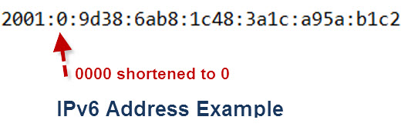
b.
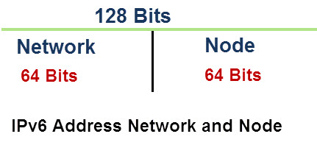
c.
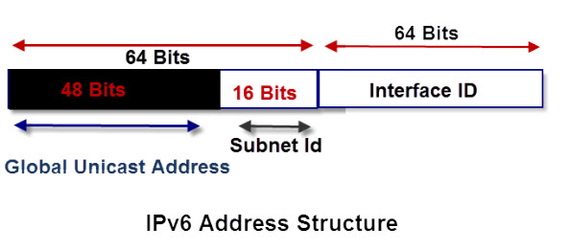

d.
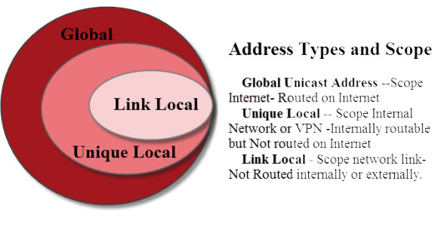

e.
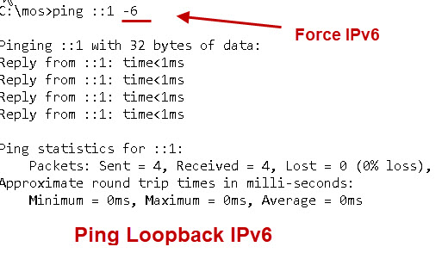
f.
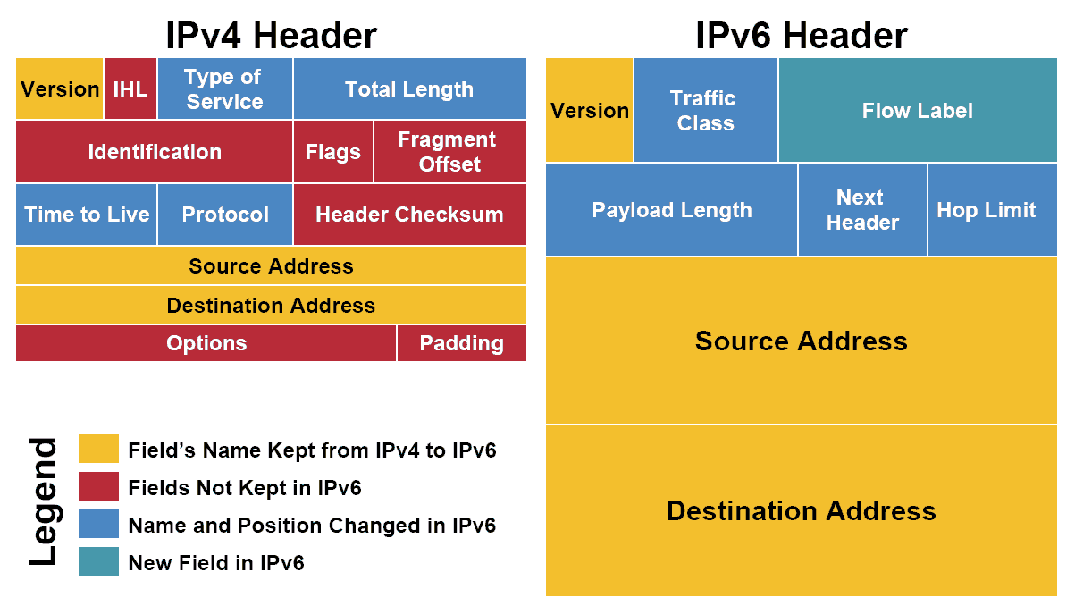

Introduction
A network has configured using Internet Protocol and addresses to identify each workstation. Therefore, IPv4 and IPv6 addresses used to provide a valid address in a network to identify the identity in a network at a worldwide level. An IPv6 address has used to identify a node in the addressing scheme of Internet Protocol version 6. It is a 128-bit alphanumeric number (Henderson, 2003).
It has arranged in eight groups, which have 16 bits in each group. Each group has four digits that are in hexadecimal numbers and they are separated using colons. As an example of IPv6, address is FE80:CD00:0000:0CDE:1257:0000:211E:729C. It can be write as FE80:CD00:0:CDE:1257:0:211E:729C (Forouzan, 2007).
This scheme has required because of running out of IPv4 addressing scheme. IPv6 can provide trillions of IP addresses to the computer devices as well as other things, such as Internet of Things (IoT) devices, people, animals, objects, and many others (Rouse, 2013).

Address Structure
IPv 6 has been created to provide better IP addresses to the different devices and it will connect many other objects as well. In addition, a number of Internet users are increasing day-by-day, which is a critical issue in front of the whole world. Therefore, IPv6 has developed to overtake IPv4 addresses. Moreover, tunneling has been used to manage both types of IP addresses. However, the adoption of IPv6 is highly increased in the last two years. There is an example of the IPv6 address of a device in the below diagram (Tanenbaum, 2014).
a.
Source: (Steve, 2019)
In addition, IPv4 uses two segments in their 32-bit address, which are network id and host id. Same as IPv6 has divided 128-bit into two groups I network part and node part, both parts have 64 bits. The upper 64 bits has used for routing purpose by admin in a network. The lower 64 bits has used for the node identity or interface in the network. In addition, the upper part has been divided into two different parts of 48 bits and 16 bits. 48 bits are used for the assignment of global network addresses and 16 bits has used for the subnets (Khalid, 2018).
b.
Source: (Steve, 2019)
c.
Source: (Steve, 2019)

Address Types and Scope
IPv6 addresses have three types:
Global Unicast Address: it has used for the Scope Interne and routed on the Internet
Unique Local: it has used for the Scope Internal Network and sometimes in VPN internally routable, but it is not routed on the Internet
Link-Local: it is used for scope network link, but it is not routed internally or externally.
d.
Source: (Steve, 2019)
The global addresses are generally started with 2001: which is known as global unicast addresses, such as a public address in the IPv4 networks. This can be used by the ISPs who in turn allocate them to their clients. There is much another purpose of global addresses in the network (Steve, 2019).
In addition, IPv6 has two types of internal addresses types, which areas:
- Link-local addresses
- Unique local addresses
Link-local meant to be used inside a network, which is not used on the internet. They are in separated from others and used as internal addresses in the network. It is like IPv4 address 172.10.5.0/ 16 that is allocated to a particular network in the absence of DHCP. It starts from FE80 and it is required in every IPv6 interface when routing is not present in the network (Sunshine, 2013).
Moreover, a unique local address can be used for an internal network. They can be used for routing I internal network but cannot use on the internet. It is like three classes private address of a network using IPv4 addressing, such as 10.0.0.0/8, 172.16.0.0/12, and class C address 192.168.0.0/16. In the case of IPv6, address space was divided into two parts, which are fc00:: /8 and fc00:: /8 for globally assigned addressing and local addressing respectively (manikumarreddy.com, 2013).
IPv6 addresses are also used for the URLs in this term HTTP: IPv6 address/webpage.
User can ping the IP address using ping:1 command from command prompt or terminal.
e.
Source: (Steve, 2019)
f.
Source: (Khalid, 2018)
Furthermore, the IPv6 header is different from the IPv4 format. The version field is used for the describe the version internet protocol format that is six and in binary is shown as 0110. A traffic class is used 8-bits, which are a device in the two parts that are 6-bits are used for the protocol and 2 bits used for ECN (Explicit Congestion Notification) (Tanenbaum, 2014).
In addition, flow label has used manage flow of packets in the network. It is the best way to reorder of a data packet in the network. Payload field is used for the upper layer data. Next header shows upper-level address. Hop limit is the same field, which is present in the IPv4 as a TTL (Time to live). It contains source and destinations addresses in each packet.

Advantages of IPv6
- Better Customer Insights
- Reliability
- Improved User Experience
- Faster Speeds
- Higher Website Conversion
- Stringer Security
- Enhanced Encryption
- Routing efficiency
- Global Reachability
For starters, an IP deal with is a unique identifier inside the discipline of networking that identifies the bodily coordinates of a tool that is related online ( Beaver, 2013). In domestic networks, the internet service issuer (ISP) gives your property region a bodily IP address that may be traced again to your modem via coordinates (Certiology, 2018). Every family that connects to the internet and all on-line websites want an IP deal with to make it unique for identity purposes ( Dosal, 2018).
We have been made use of IPv4 for many years, but subsequently, the constrained variety of IP addresses that may be issued will run dry (Dye, et al., 2007). With IPv4, most of 4.3 billion addresses are to be had used and we are speedy coming near that limit (Gapiński, 2014). That is where IPv6 comes into play because it gives, in reality, a limitless wide variety of IP deal with that may be assigned to gadgets and offerings (Hogg, 2017). With cell devices beginning to take over the arena of the era, it changed into only a count number of time before we ran out of IP addresses (Kenneth C. Mansfield & Antonakos, 2009). The sheer wide variety of devices, specifically cellular has stated to boom exponentially over the next few years on my own (Lammle, 2011).
Aside from being able to overcome the bodily obstacles of IP addresses that IPv4 has, IPv6 offers some key benefits as well (Medhi & Ramasamy, 2017). All current IPv4 devices must rely upon what is called NAT (community cope with Translation) to retrieve the IP deal with the identifier (Mitchell, 2018). The use of a NAT lets in all gadgets linked to a network to be diagnosed as the unmarried IPv4 deal with given to you via your ISP (Mitchell, 2018). Irrespective of which device you operate in your own home community, they will all show the same place because of the number one IP address with the aid of default (Paquet, 2013).
With IPv6, there will be no need to use a NAT, because of this all gadgets will be capable of being recognized with a completely unique IP address in their very own (RIPE, 2018). IPv6 additionally lets in for an extra exceptional-tuned manage over individual devices seeing that every device can be assigned with a unique IP deal with network (Yadav, 2018) (Masucci, 2016). This permits for the router or modem to engage with those devices especially, making manner for greater accurate communique between them. Protection is likewise an awful lot higher with IPv6 since the authenticity of each network packet is encrypted. Encrypting the packets being sent and acquired over the community ensures that packet spoofing will be tougher to accomplish by using a capacity attacker (Prospects, 2018).

Conclusion
It has concluded from above parts of this report that IPv6 has provided many facilities in the field of networking. It has contained a unique address style and types with a different structure. It can provide trillions of IP addresses to various computer devices and other things, such as IoT devices, animals and other objects. It can be used for identification of various objects. It will provide better addressing and management of nodes in proper way.
Finally, IPv6 has implemented in various devices. It used for networking and other purposes. It will provide better monitoring and controlling facility to the administrator.

References
Beaver, K., 2013. Top 5 Common Network Security Vulnerabilities that Are Often Overlooked. [Online]
Available at: https://www.acunetix.com/blog/articles/the-top-5-network-security-vulnerabilities/
Dosal, E., 2018. 5 Common Network Security Problems and Solutions. [Online]
Available at: https://www.compuquip.com/blog/5-common-network-security-problems-and-solutions
[Accessed 12 March 2019].
Certiology, 2018. Network Devices:. [Online]
Available at: http://www.certiology.com/computing/computer-networking/network-devices.html
[Accessed 29 08 2018].
Dye, M., McDonald, R. & Rufi, A., 2007. Network Fundamentals, CCNA Exploration Companion Guide. Indianapolis: Cisco press..
Forouzan, A. B., 2007. Data communications & networking. 8th ed. New Delhi: Tata McGraw-Hill Education.
Gapiński, A., 2014. Strategies for Computer Networks Security. Kwartalnik Nauk o Przedsiębiorstwie, Volume 3, pp. 59-65.
Henderson, T. R., 2003. Host mobility for IP networks: a comparison. IEEE network, 17(6), pp. 18-26.
Hogg, S., 2017. IPv6 Addressing for Enterprises. [Online]
Available at: https://www.networkworld.com/article/3235384/ipv6-address-enterprises-how-to-easier-than-ipv4.html
[Accessed 5 August 2019].
Kenneth C. Mansfield, J. & Antonakos, J. L., 2009. Computer Networking for LANS to WANS: Hardware, Software and Security. 1 ed. Bostan(MA): Cengage Learning.
Khalid, B., 2018. What Is IPv6 Address & Why Should I Know About It?. [Online]
Available at: https://www.purevpn.com/blog/what-is-ipv6-address-scty/
[Accessed 5 August 2019].
Lammle, T., 2011. CCNA Cisco Certified Network Associate Deluxe Study Guide. indiana: John Wiley & Sons.
manikumarreddy.com, 2013. Introduction to Network Fault Management. [Online]
Available at: https://manikumarreddy.com/2013/10/15/introduction-to-network-fault-management/
Masucci, M., 2016. 4 Ways to Ensure Network Physical Security. [Online]
Available at: https://www.belden.com/blog/smart-building/4-ways-to-ensure-network-physical-security
Medhi, D. & Ramasamy, K., 2017. Network routing: algorithms, protocols, and architectures. s.l.:Morgan Kaufmann.
Mitchell, B., 2018. What Is Computer Networking?. [Online]
Available at: https://www.lifewire.com/what-is-computer-networking-816249
[Accessed 16 January 2019].
Paquet, C., 2013. Network Security Concepts and Policies. [Online]
Available at: http://www.ciscopress.com/articles/article.asp?p=1998559&seqNum=3
[Accessed 4 June 2019].
Prospects, 2018. Network engineer. [Online]
Available at: https://www.prospects.ac.uk/job-profiles/network-engineer
[Accessed 22 08 2018].
RIPE, 2018. IPv6 Address Allocation and Assignment Policy. [Online]
Available at: https://www.ripe.net/publications/docs/ripe-707
[Accessed 5 August 2019].
Rouse, M., 2013. IPv6 address. [Online]
Available at: https://internetofthingsagenda.techtarget.com/definition/IPv6-address
[Accessed 5 August 2019].
Steve, 2019. IPv6 Explained for Beginners. [Online]
Available at: http://www.steves-internet-guide.com/ipv6-guide/
[Accessed 5 August 2019].
Sunshine, C. A., 2013. Computer network architectures and protocols. New Jersy: Springer Science & Business Media.
Tanenbaum, A. S., 2014. Computer networks. Harlow, Essex: Pearson.
Yadav, A., 2018. Network Design: Firewall, IDS/IPS. [Online]
Available at: https://resources.infosecinstitute.com/network-design-firewall-idsips/
[Accessed 14 March 2019].

Lab: IP addressing scheme
I use VLSM addressing scheme for this network because of various advantages of it instead of particular fixed addresses. There are some extra requirements of addresses, but it will be in limit. Therefore, VLSM is used for the address scheme, as it is good for best-fit scheme. There are three school with different requirements. As we have more than 2000 machine in both networks. Therefore, I choose class B address that is 172.16.0.0.
Name of schools | Total computer systems | Network address | Broadcast address | Starting address | Ending address | Subnet mask
School of Applied Computing | 439 |  | 172.16.1.255 |  | 172.16.1.254 | 255.255.254.0
  172.16.0.0
  172.16.0.1
School of Automotive Engineering | 283 | 172.16.2.0 | 172.16.3.255 | 172.16.2.1 | 172.16.3.254 | 255.255.254.0
School of Engineering | 406 | 172.16.4.0 | 172.16.4.1 | 172.16.5.254 | 172.16.5.255 | 255.255.254.0
A Test center | 22 | 172.16.6.0 | 172.16.7.255 | 172.16.6.1 | 172.16.7.254 | 255.255.254.0
Open Access lab | 250 | 172.16.8.0 | 172.16.9.255 | 172.16.8.1 | 172.16.9.254 | 255.255.254.0

For six servers we use IPv6 addresses, which areas:
IP Address: | 2001:db8:85a3::8a2e:370:7334/125
Full IP Address: | 2001:0db8:85a3:0000:0000:8a2e:0370:7334
Total IP Addresses: | 8
Network: | 2001:0db8:85a3:0000:0000:8a2e:0370:7330
IP Range: | 2001:0db8:85a3:0000:0000:8a2e:0370:7330 - 2001:0db8:85a3:0000:0000:8a2e:0370:7337

