
School of Engineering

Joseph Michael Belcher

Use of Energy Carriers; Legislation & Practicality Approach

1803210

22/12/2022

University of Wales Trinity Saint David

Automotive Materials & Sustainability
ACHA6012
Contents
1. Introduction 3
2. Literature Review 3
2.1. Energy Carriers 3
2.1.1. Electricity 3
2.1.2. Hydrogen 4
2.1.3. Bio/Synthetic Fuels 5
2.1.4. Energy Recovery Systems 6
2.2. Sustainability Currently in Motorsport 6
2.2.1 Formula E 6
2.2.2. World Rally Championship (Rally 1) 7
2.2.4. Le Man 24HR 7
2.3. World Rally Championship Legislation in Terms of Sustainability 8
2.4. Championship Travel & Event Improvements 8
2.4.1. Formula E Off-Track Improvements 8
3. Suggested Plan in Aims to Reduce the Carbon Footprint of WRC 10
3.1. Powertrain and Drivetrain Improvements 10
3.2. Infrastructure Improvements 10
4. Conclusion 11
References 12

Introduction
Global warming and climate change are terms frequently used in the 21st centaury. They describe the damage that mankind has and will continue to have on our planet if things do not change. In recent years, many industries have adopted a more environmentally friendly attitude in an attempt to reduce their carbon footprint. This includes the motorsport industry, often under fire for their fossil fuel bias championships and travel requirements, with many of them reaching multiple continents in a single season. But on top of this motorsport and its series are meant to be an opportunity for teams and manufacturers to show their advances in technology. Which is why a strong display of sustainability could benefit not just the series but the industry overall.

The aim of this report is to take a sustainable engineering standpoint surrounding the motorsport championship, World Rally Championship (Rally 1). Established in 1973 and described as “an epic battle against the elements and the clock” (WRC, 2023) the World Rally Championship has been a fan favourite of motorsport enthusiasts for decades. In its current format WRC features 12 rallies across 4 continents, from snowy forest roads to twisting mountain passes, it’s an eye watering display of man and machine working in harmony. In recent times the championship has made a step in a more environmentally friendly direction with the introduction of hybrid vehicles. However, this report will extend beyond just the vehicles on grid, looking at other alternative ways for the carbon footprint of this championship to be reduced even further. Because for a championship that takes place in the heart of nature all over the globe, it is only right a step in the direction of preserving it is taken.

Literature Review

Energy Carriers
‘Energy carrier’ refers to either a substance (fuel) or a phenomenon (energy system) that contains energy that can be converted into other forms of energy, such as mechanical or heat. The substances or phenomena classed as energy carriers that will be studied in this report are either renewable or sustainable (IMECHE, 2023).

Electricity
Electricity can be produced in a multitude of methods, many in the modern day that are either renewable or sustainable. Examples of these methods include, Solar, Wind and hydro which are all fully sustainable (Bogdanov et al., 2019).

Solar power is generated from solar radiation produced by the sun. There is a variety of ways in which this radiation can be used, the two methods that will be included in this report are heliochemical, used in the conversion of solar radiation into electricity and heliothermal, used in the conversion of solar radiation into thermal heat (Guney, 2016).

Heliochemical, also known as photovoltaic (PV) energy conversion uses PV cells to directly convert sunlight into electricity. This is achieved via direct or indirect exposure to the solar radiation causing a reaction between the radiation and a semiconductive material. The most used material in modern solar panel cells is crystalline silicon, achieving a power conversion efficiency between 15-22%. When the radiation reacts with a cell the energy knocks an electron free from its atom allowing it to flow through the material, resulting in DC electricity. From this point the DC electricity is transferred to a power inverter which converts this current to AC, the type of power used in homes and businesses (Guney, 2016).

Heliothermal on the other hand converts the solar radiation into thermal energy (heat). This conversion of radiation can fall into three categories depending on how the thermal energy is collected. The method we will focus on in this report is when it’s collected in a fluid. In this case the thermal energy can be used to heat water and other necessary fluids, useful for catering and other applications (Guney,2016).

The power produced by these systems can be used in a multitude of ways, from powering the vehicles electric powertrains to providing the infrastructure with 100% renewable energy. In terms of using this power to charge an electric powertrain the energy would need to be stored in batteries. This would allow a portable power supply which would suit the championship as it is constantly moving between rallies from country to country. However, batteries have a lifespan with them degrading over time and eventually needing to be replaced and recycled which can prove a challenge due to cost and the environmental impact this can have with the process releasing emissions contributing to greenhouse gases. Batteries also contain less energy per unit in terms of weight/volume when compared to traditional fossil fuels, yet this is a problem that can be resolved with the introduction of more advanced batteries and storage techniques (Soloveichik, 2011).

Hydrogen
Hydrogen is another energy carrier with extreme potential. As a raw material it is highly abundant and contains a large gravimetric energy density making it very ideal as a renewable source of fuel. On top of this, when burned in its gas form the only biproduct released is H20, therefore meaning this fuel would have no contribution to greenhouse gas emissions (Singh, 2015). However, to achieve this the hydrogen would have to use a fuel cell rather than an internal combustion engine.

Hydrogen fuel cells produce electricity via a chemical reaction between hydrogen and oxygen. The process begins with hydrogen stored in a high-pressure tank being emitted into the fuel cell, from here the hydrogen is separated into protons and electrons at the anonde. The electrons flow through an eternal circuit creating electrical current while the protons pass through the membrane electrode assembly to the cathode. The membrane electrode assembly consists of a proton exchange membrane and catalyst coated electrodes. This thin layer between the anode and cathode allows for ions to flow between them. At the cathode oxygen is fed into the fuel cell where it reacts with the protons and electrons that have passed through the membrane electrode assembly creating the only biproduct of this reaction, water vapour.

Bio/Synthetic Fuels
Alternative fuels (bio/synthetic) are fuels that have not been derived from crude oil such as petrol & diesel. These fuels when used in an internal combustion engine (ICE) offer many benefits including a bright as well as a sustainable future for the vehicular industry (Hwang et al., 2016). This is due to their reduced emissions in comparison to petrol and diesel when burned & offer the ability to replace depleted and costly supplies of natural gasses/oil (Probstien & Hicks, 2006).

Bio/synthetic fuels are substances that are produced via fermentation of plants, algae, or microbial culture that are chemically comparable to gasoline and diesel. The carbon in biofuels comes from carbon dioxide, which plants convert to their biomass through the process of photosynthesis (Sachdeva, 2013). As previously mentioned, they offer many properties such as sustainability, reduction in greenhouse gas emissions & security of supply due to the abundance in biomass (Demirbas, 2006). An example of a bio/synthetic fuel is ethanol, the fuel currently blended with petroleum to produce E5 & E10. In terms of octane number and latent heat of vaporization it allows for a large improvement of the engine due to these properties being like that of petroleum (Jeuland, 2006).

Currently at the pinnacle in terms of Biofuels is a product called Excellium Racing 100, quoted as a “certified 100% sustainable product according to the mass balance system applied by a voluntary certification organisation approved by the European Union” (Total Energies, 2023). This fuel is produced from agricultural waste, via 18 months of research and development the waste that was acquired from viniculture was turned into a competition fuel that meets FIA requirements. Not only was this fuel created, but it was used throughout the grid of Le Mans 24-hour race in 2022 (Total Energies, 2023), meaning the fuel has also been proven through practice. The result of using this fuel in the series also resulted in a reduction of carbon emissions of at least 65% over its life cycle (Total Energies, 2023).

Energy Recovery Systems
There are numerous options when it comes to recovering energy that can be re-used from a drivetrain or powertrain. They capture energy that would have otherwise been lost and allow it to be stored and used again in the drive process or to support powering other auxiliaries. This energy can be recovered in the form of regenerative braking & deceleration. This system is often referred to as MGU-K. Which converts the kinetic energy which is usually dissipated as heat via the brake discs and pads and captures it using an electric motor. When the brakes are applied the electric motor acts as a generator converting the wheels rotational energy into electrical energy. This is the current form of recovery systems within the WRC as well as Formula 1.

Another high-tech recovery system being used in Formula 1 is motor generator unit-heat (MGU-H). This system captures heat spent from the vehicles exhaust. It uses a turbine connected to a generator within the exhaust system to capture the energy and convert it to electricity. Once again, the system recovers a loss that otherwise would have been wasted.

Sustainability Currently in Motorsport

2.2.1 Formula E
Formula E appears to be the most prominent environmentally friendly championship with it taking measures both on the track with their all-electric vehicles and off the track using sustainable energy sources to power as much as possible. In fact, in season 6 of the championship Formula E became the first championship to achieve a net 0 carbon emissions. This was achieved by a focus on the championships freight, recycling at their events and using as much renewable energy as possible. On top of this, where carbon emissions where un-avoidable Formula E invested in certified projects to offset this contribution (Formula E, 2023).

2.2.2. World Rally Championship (Rally 1)
The 2022 season marked a new landmark for WRC with the introduction of their new generation Rally 1 vehicles, to uphold the FIA’s attempt to make motorsports more sustainable. The line up featured 3 cars from 3 manufacturers, Ford with the ‘Puma Rally 1’, Hyundai with the ‘I20 N Rally 1’ and Toyota with the ‘GR Yaris Rally 1’. These vehicles feature an 100kW electric motor combined with the “competition-proven” 1.6-litre turbocharged petrol engine. The result of this change is a package that produces over 500BHP while reduces harmful emissions emitted from the vehicles. On top of this the fuel encouraged to powering the ICE is 100% sustainable, reducing the carbon footprint of the championship even more (WRC, 2022).
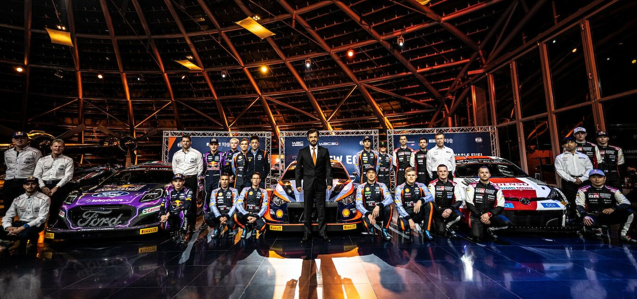
Figure1, Rally 1’s 2022 line up of hybrid vehicles (WRC,2022)

2.2.4. Le Man 24HR
Le Mans 24-hour has as previously mentioned taken a step in the direction of sustainability via the use of Excellium Racing 100 fuel, an 100% sustainable source of power for the vehicles on grid. However, in 2022 another form of fuel was used by a program between ACO and Green GT. This fuel was in the form of hydrogen, used in the vehicle Mission H24.

The vehicle did not compete directly within the championship but was more a display of what the future motorsport could possibly hold (WEC, 2022). The cars inclusion in the championship was a success completing several laps prior the start of the competition, however its lap times reflected a non-competitive vehicle in comparison to the ICE vehicles that competed in the championship. This is believed to be since this technology is new and still has a large amount of development to come. Also, a factor to consider is the weight of the of the car, a large amount more than the other cars on grid due to the thick walls of the fuel tank required to safely store the hydrogen (GreenGT, 2022).
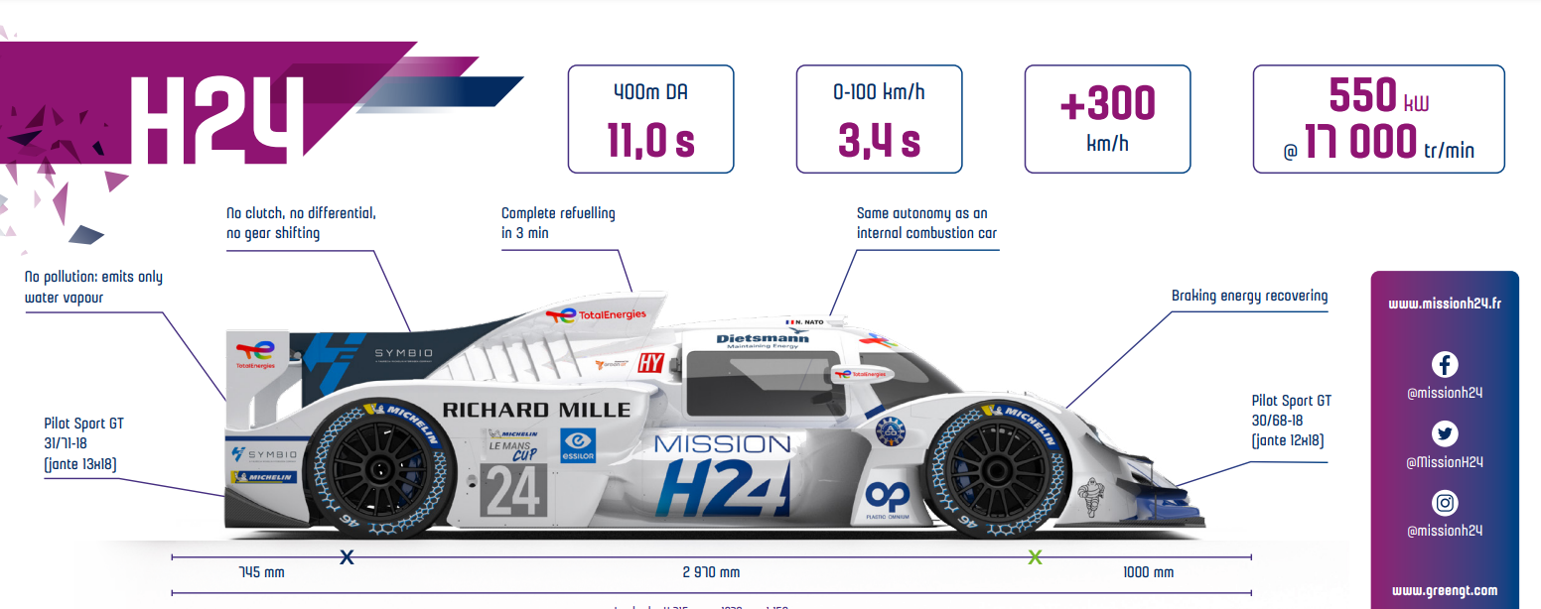
Figure 2, Mission H24 vehicle (WEC, 2022)

World Rally Championship Legislation in Terms of Sustainability
The World Rally Championship (WRC) has introduced several technical sustainability legislation measures to make the sport more sustainable. One such measure is the introduction of hybrid powertrains in the rally cars. The hybrid powertrains are designed to reduce carbon emissions and improve fuel efficiency while maintaining performance levels. Additionally, the use of biofuels is encouraged, which are produced from renewable sources and have a lower carbon footprint than traditional fuels. The WRC also mandates the use of sustainable materials in the construction of the rally cars and has set targets to reduce the carbon footprint of the sport (FIA, 2022).

Looking to the future, the WRC has set ambitious targets to achieve sustainability in the sport. The WRC is aiming to be carbon neutral by 2030, and the rally cars will be powered by 100% renewable energy sources by 2035. The use of electric and hydrogen-powered cars is also being considered to reduce carbon emissions further. Additionally, the WRC is exploring ways to minimize waste and promote circular economy practices, such as recycling and repurposing materials used in the sport. These sustainability legislation measures demonstrate the WRC's commitment to reducing the environmental impact of the sport and promoting sustainable practices (FIA, 2022).

Championship Travel & Event Improvements
With most championships travelling globally and hosting largely attended events there Is a huge opportunity to improve their carbon footprint off the track. This includes, freight, team travel, catering and other off-track activities such as maintenance of the vehicles.

Formula E Off-Track Improvements
As previously mentioned, Formula E achieved a net 0 carbon emissions championship in season 6. A lot of this was due to how they managed not only the cars on track but everything that was required to make the events happen. Figure3 shows the percentages of where these emissions stemmed from. As can be observed a massive percentage of the overall carbon emissions come from the freight sector, responsible for transportation of vehicles and other equipment between events. Other percentages include staff travel, operations, food and drink as well as spectator travel. But the most impressive thing to note is how the vehicles competing in the championship only contribute to 1% of the overall CO2 emissions, which really emphasises on how much an improvement off-track can really have on a motorsport championship.
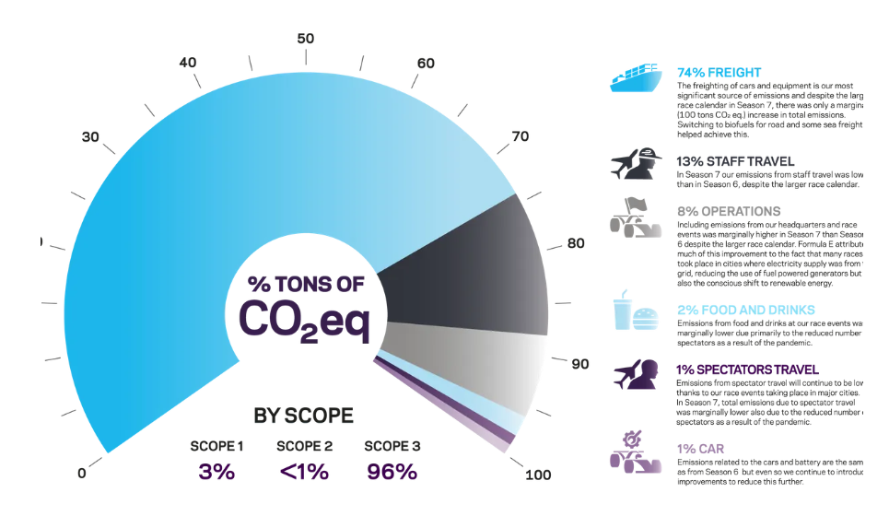
Figure3, A pie chart showing the % distribution of CO2 emitted during the championship. (Formula E, 2022)

The ways in which Formula E tackles these percentages in order to achieve a net 0 series include:
· Freight optimization, achieved via optimisation of the calendar to reduce the distance between events, use of a multi modal approach using sea, rial & road over air where possible and only freighting race critical items, sourcing other assets locally where possible.
· Suppliers are another focus in the sustainability plan, using food and beverages sourced locally and a sustainable approach in terms of construction.
· Transport is tackled in terms of spectators by not providing public car parks at the event, promoting the use of public transport in the events area. This plan doesn’t stop at spectators though and stems in to even the teams competing, with only race critical staff attending the events reducing unnecessary attendance.
· Waste is managed from the events with the removal of single use plastic bottles and the introduction reusable replacements. Hydration stations were also implemented to reduce on site waste.
(Formula E, 2022)

Suggested Plan in Aims to Reduce the Carbon Footprint of WRC
Below is suggested actions which could be implemented into the World Rally Championship to reduce the series overall carbon footprint. These suggestions consider the research gained from this report and both actions on and off the track.

Powertrain and Drivetrain Improvements
With the introduction of hybrid vehicles including recovery systems and encouraged use of sustainable fuels it appears that the WRC is taking measures to make the championship more sustainable. However, there are always improvements that can be made. The first change that could have a good return on carbon emissions with little to no disturbance in the championship is an enforced use of 100% sustainable fuels such as Excellium Racing 100. With this development teams would have no choice but to fuel their competing cars with the provided sustainable option.

Other recovery systems could also be introduced to assists the MGU-K/regenerative braking systems already in place. The MGU-H system currently used to recycle exhaust gasses in formula one may be complicated and costly but by implementing this change into the vehicles will result in more power being harvested from losses. This in turn reduces the amount of work from the ICE with more energy being supplied to the supporting electric motor system allowing it to be used more frequently. With an increased use of the sustainable power source the emissions produced by the car can once again be reduced.

Infrastructure Improvements
Demonstrated by Formula E it is clearly apparent that factors outside the races themselves have a very large contribution to a series overall carbon footprint. This is where the WRC will benefit most via changes. The plan to reduce emissions in the series should follow a similar pattern to what Formula E have implemented into their own series. Starting with an optimisation of the championships calendar. Currently the calendar doesn’t consider minimising the distance between each event, this results in larger distances being covered than necessary to complete the championship. The result of this equates to a larger carbon footprint due to the carbon emissions spent across large producers of such emissions in the series such as freight. A more optimised calendar could allow for a larger use in other modal transports such as rail, road and sea rather than air. It would also reduce distance covered by staff and spectators.

Another improvement could include the use of sustainable energy such as solar converted to electrical to power as much as possible, including the charging stations for the cars, the electric power tools used in the mechanical area, technical equipment used to track the vehicles performance, catering stands and any entertainment on site. This reduction in use of fossil fuels would only benefit the targeted reduction of emissions.

Other changes could include promoting the use of sustainable and renewable materials where possible, in terms of track Layout construction and catering equipment. The food and beverages on site could also be sourced locally reducing the carbon spent transporting them to the event whilst supporting local businesses and infrastructure. Recycling as much as possible would also help an attempt in a reduced emissions series, although the WRC has made attempts into this it should be a focus. This is because a large majority of the events take place in natural areas, these areas are largely in need of protection from such negatives as littering and poor maintenance.

Conclusion
To conclude this report, it is apparent that governing bodies such as the FIA alongside manufacturers and teams in motorsport are taking strides to become as sustainable as possible in all aspects. WRC aims to be carbon neutral by 2030, with the changes that have already been implemented into the series and the adoption from others such as Formula E I think this can be achieved. Overall, an all-hydrogen grid would be the best option but the technology in this sector doesn’t seem to be advanced enough to make the transition into mainstream motorsport with comparisons in performance statistics leaning in favour of electric and ICE vehicles.

An all-electric grid could be very possible and wouldn’t come as a surprise if the WRC chose to go in this direction, however the hybrid vehicles and introduction of sustainable fuels allows for improvements as well as keeping the ICE powertrains which the fans love so much until this layout is no longer able to meet the aims and goals of the series as well as the legislation enforced by the FIA.

References

Bogdanov, D. et al. (2019) Radical transformation pathway towards sustainable electricity via evolutionary steps, Nature News. Nature Publishing Group. Available at: https://www.nature.com/articles/s41467-019-08855-1 (Accessed: April 2, 2023).

Demirbas, A. (2006) Progress and recent trends in Biofuels, Progress in Energy and CombustionScience.Pergamon.Availableat:https://www.sciencedirect.com/science/article/pii/S0360128506000256?casa_token=o8QooROTYrAAAAAA%3ARn8pY9BzLbyovQ2GvNrZQG3vAOpPrO4t3f95y1221SYmbJ2N-K50TjXw7fF3TdcmtfzXeBPbfN8 (Accessed: January 1, 2023).

Formula E (2022) How formula E achieves net zero, The Official Home of Formula E. Formula E. Available at: https://www.fiaformulae.com/en/news/2033/how-formula-e-achieves-net-zero (Accessed: April 2, 2023).

Formula E (2023) ABB FIA Formula E World Championship, The Official Home of Formula E. Formula E. Available at: https://www.fiaformulae.com/ (Accessed: April 2, 2023).

FIA (2022) WRC Regulations, Federation Internationale de l'Automobile. FIA. Available at: https://www.fia.com/regulation/category/119 (Accessed: April 2, 2023).
GreenGT (2022) A successful 88th 24 Hours of Le Mans for missionh24! - greengt, Mission H24. Available at: http://greengt.com/wp-content/uploads/2020/12/20200920-MH24_PR_Great-Le-Mans-24-Hours-for-MissionH24-V1_EV-for-JMB.pdf (Accessed: April 2, 2023).

Guney, M.S. (2016) Solar Power and application methods, Renewable and Sustainable Energy Reviews. Pergamon. Available at: https://www.sciencedirect.com/science/article/pii/S1364032115014380?casa_token=Os7E47xgohkAAAAA%3AVQ_Mx5MSQImGIVL8fqFVAWeoP2Tff26tfR9V9SGo6s0Afw76Yi4jgLG_VU3GI3nnL69MWizJ (Accessed: April 2, 2023).

Hwang, J., Yu, J. and Reif, K. (2016) Alternative fuels for internal combustion engines, Proceedings oftheCombustionInstitute.Elsevier.Availableat:https://www.sciencedirect.com/science/article/abs/pii/S1540748916304850?fr=RR-1&ref=cra_js_challenge (Accessed: January 2, 2023).

IMECHE (2023) Renewable Power Committee, Renewable Power Committee | Institution of Mechanical Engineers. IMECHE. Available at: https://www.imeche.org/industry-sectors/power-energy/power-industries-division-how-we-are-governed/renewable-power-committee (Accessed: April 2, 2023).

Jeuland, N. (2006) Potentiality of ethanol as a fuel for dedicated engine, Oil & Gas Science andTechnology.EDPSciences.Availableat:https://ogst.ifpenergiesnouvelles.fr/articles/ogst/abs/2004/06/jeuland1_vol59n6 (Accessed: January 1, 2023).

Probstien, R.F. and Hicks, E. (2006) Synthetic fuels, Google Books. Dover Publications. Available at: https://books.google.co.uk/books?hl=en&lr=&id=7mAl_1f2XzQC&oi=fnd&pg=PP1&dq=synthetic%2Bfuels&ots=cao9JFzzSl&sig=UOBBH7ycBCFtkg3ZecgN8jchBTs&redir_esc=y#v=onepage&q=synthetic%20fuels&f=false (Accessed: January 2, 2023).

Singh, S. (2015) Hydrogen: A sustainable fuel for future of the Transport Sector, Renewable and Sustainable Energy Reviews. Pergamon. Available at: https://www.sciencedirect.com/science/article/pii/S1364032115006127 (Accessed: January 8, 2023).

Soloveichik, G.L. (2011) Battery Technologies for large-scale stationary energy storage, Annual Review of Chemical and Biomolecular Engineering. Annual Reviews. Available at: https://www.annualreviews.org/doi/abs/10.1146/annurev-chembioeng-061010-114116 (Accessed: April 2, 2023).

Total Energies (2023) Excellium racing 100: The new 100% certified* sustainable fuel, TotalEnergies Competition. Total Energies. Available at: https://competition.totalenergies.com/en/auto/endurance/wec/excellium-racing-100-new-100-certified-sustainable-fuel (Accessed: April 2, 2023).

WEC(2022)2022WECMediaGuide.WEC.Availableat:https://press.fiawec.com/assets/fileuploads/62/21/6221fc7896b74.pdf (Accessed: April 2, 2023).

WRC (2022) WRC's new hybrid era hits Top Gear, WRC. FIA World Rally Championship. Available at: https://www.wrc.com/en/news/2022/wrc/wrcs-new-hybrid-era-hits-top-gear/ (Accessed: April 2, 2023).

WRC (2023) What is the WRC?, WRC. Available at: https://www.wrc.com/en/more/about-wrc/what-is-wrc/ (Accessed: March 31, 2023).

