
Master Of Business Administration
Business Development Proposal
Student ID :2321459
Student Name : Mohmedkaif Mansuri
Supervisor :Balandran Kandasamy

SEASONAL FRUIT DRINK TO MANUFACTURED PRODUCT

Table of Contents
Chapter 1: Introduction 9
1.1 Introduction 9
1.2 Research Background and Context 9
1.3 Research Aim and Objectives 10
1.4 Research Question 10
1.5 Research Rationale 11
1.6 Research Significance 11
1.7 Research Structure 11
Chapter 2: Company Description 12
2.1 Business identity and legal structure 12
2.2 Product or service and the problem solved 12
2.3 Founding idea and brief history 12
2.4 Mission, vision and values 13
2.5 Business objectives and goals 13
2.6 Alignment with trends and opportunity 14
Chapter 3: Literature Review 15
3.1 Introduction 15
3.2 Macro-Environmental Analysis: PESTLE 15
3.3 Consumer Motivation: Jobs-to-Be-Done 15
3.4 Industry Competitiveness: Porter's Five Forces 16
3.5 Value Design: Value Proposition Canvas and Business Model Canvas 16
3.6 Chapter Synthesis 17
Chapter 4: Research Methodology 18
4.1 Methodological Approach and Opportunity Identification 18
4.2 Market Insight and Data Collection 18
4.3 Quantitative and Qualitative Evidence 18
4.4 Data-Analysis Methods 19
4.5 Application and Integration of Frameworks 19
4.6 Reliability, Validity, Limitations and Ethics 20
4.7 Summary 20
Chapter 5: Opportunity Market Analysis 20
5.1 Scope and Market Definition 20
5.2 Market Size and Growth Trends 21
5.3 Segmentation and Target Customer 22
5.4 Pain Points, Unmet Needs, and Demand 25
5.5 Economic and Geographic Conditions 27
5.6 Research Findings and Synthesis 29
Chapter 6: Competitive Environment Analysis 30
6.1 Scope, Frameworks, and Competitive Set 30
6.2 Key Success Factors 31
6.3 Main Competitors and Positioning 32
6.4 Porter's Five Forces 35
6.5 PESTLE and External Change 38
6.6 Industry Attractiveness, Gaps, and Synthesis 41
Chapter 7: Strategic Analysis and Business Strategy 42
7.1 Strategic Situation and Frameworks 42
7.2 Internal Analysis Using VRIO 44
7.3 SWOT and Strategic Issues 45
7.4 Strategic Alternatives and Choice 47
7.5 USP, Value Proposition and Positioning 49
7.6 Competitive Advantage and Success Factors 50
7.7 Strategic Synthesis 52
Chapter 8: Business Model Canvas 53
8.1 Model Overview and Alignment 53
8.2 Customer Segments and Value Proposition 53
8.3 Channels and Customer Relationships 56
8.4 Revenue Streams and Cost Structure 57
8.5 Key Resources, Activities and Partnerships 57
8.6 Integration, Assumptions and Conclusion 59
Chapter 9: Financial, Marketing and Sales, and Human Capital Management Plan 59
9.1 Integrated Plan Overview 59
9.2 Financial Plan 60
9.2.1 Financial Assumptions 60
Table 4: Financial Assumptions 60
9.2.2 Start-up Costs and Funding Requirements 61
Table 5: Start-up Costs and Funding Requirements 61
9.2.3 Operating Cost Structure 62
Table 6: Operating Cost Structure 62
9.2.4 Revenue Model and Pricing Strategy 63
Table 7: Revenue Model and Pricing Strategy 63
9.2.5 Financial Projections 64
Table 8: Five-Year Profit & Loss Forecast 64
9.2.6 Break-even Analysis 65
Table 9: Break-even Analysis 65
9.2.7 Sensitivity and Scenario Analysis 66
Table 10: Sensitivity and Scenario Analysis 66
9.3 Marketing and Sales Plan 67
9.3.1 Market Segmentation and Target Audience 67
Figure 28: Younger drinkers have seen the largest increase in Alcohol- Free/Lower Strength use since 2018 67
Figure 29: British Soft Drinks Sales 68
9.3.2 Positioning Strategy 68
9.3.3 Marketing Messaging 69
9.3.4 Marketing Mix — 7Ps 69
Figure 30: UK Search Behavior 69
9.3.5 Customer Acquisition Strategy 70
Table 11: Customer Acquisition Funnel 70
9.3.6 Digital and Offline Marketing Tactics 70
9.3.7 Sales Strategy 71
Table 12: Sales Strategy & Controls 71
9.3.8 Marketing Budget and Performance Measures 72
Table 13: Marketing Tactics & Measurement 72
9.4 Human Capital Management Plan 73
9.4.1 Organisational Structure 73
Table 14: Human Capital — Organisation & Roles 73
9.4.2 Staffing Requirements 74
Table 15: Compensation, Benefits & Compliance 74
9.4.3 Labour Costs 75
Table 16: Staffing Plan & Labour Cost 75
9.4.4 Recruitment and Selection 76
Table 17: Recruitment, Training & Development 76
9.4.5 Training and Development 77
9.4.6 Compensation, Benefits and Compliance 77
9.5 Integration and Conclusion 77
Chapter 10: Operations Plan 78
10.1 Operating Model, Scope and Frameworks 78
10.2 Operational Workflow and Capacity 79
10.2.1 End-to-End Workflow 79
Figure 31: Process Map 79
10.2.2 Customer Journey and Capacity 80
10.3 Location, Facilities, Equipment and Technology 80
10.4 Supply Chain, Procurement, Inventory and Logistics 81
10.5 Quality, Compliance and Operational Controls 81
10.6 Operational Synthesis 82
Chapter 11: Feasibility Analysis 82
11.1 Feasibility Basis and Decision Criteria 82
11.2 Ethical and Market Feasibility 82
11.2.1 Ethical and Stakeholder Acceptability 82
11.2.2 Market Demand and Competition 83
11.3 Technical/Operational Feasibility 83
11.3.1 Workflow, Technology and Capacity 83
11.3.2 Suppliers, Staffing and Compliance 83
11.4 Financial Feasibility 84
11.4.1 Revenue, Margin and Break-Even 84
11.4.2 Funding and Sensitivity 84
11.5 Strategic Fit, Risks and Mitigation 84
11.5.1 Strategic and Business-Model Fit 84
11.5.2 Material Risks and Mitigation 86
11.6 Integrated Viability Judgement 86
Chapter 12: Implementation Plan 87
12.1 Implementation Approach and Launch Phases 87
12.2 Milestones and Timeline 87
12.2.1 Key Milestones 87
12.2.2 Gantt-Style Implementation Schedule 88
Figure 32: Gantt Chart 91
12.3 Resource Allocation and Priorities 92
12.3.1 Resource Allocation 92
Table 18: Resource Allocation 92
12.3.2 Short- and Long-Term Priorities 92
12.4 KPIs, Monitoring and Control 93
12.4.1 KPI Measures and Targets 93
12.4.2 Monitoring and Control 93
12.5 Change Management and Implementation Risks 94
12.5.1 Change Management 94
12.5.2 Implementation Risks and Contingencies 94
12.6 Implementation Readiness Summary 94
Chapter 13: Conclusion and Recommendations 95
13.1 Evaluation of Theoretical and Analytical Frameworks 95
13.2 Synthesis of Key Findings 95
13.3 Overall Feasibility Judgement 95
13.4 Strategic Recommendations 96
13.5 Final Decision 96
13.6 Future Development Needs 96
Reference list 99

Chapter 1: Introduction

1.1 Introduction
There is a shift in the UK beverage industry with consumers shifting towards healthier, naturally sourced, and functionally enriched beverages. Two out of three volume sales of soft drinks in the UK are now low or no-sugar, and 62% of the whole population actively reduce the amount of sugar (Grocery Trader, 2026). There is a commercial opportunity in seasonal fruit drinks, where only during specific harvests they are made, even though they possess potential in nutrition and flavour (White, 2024).

1.2 Research Background and Context
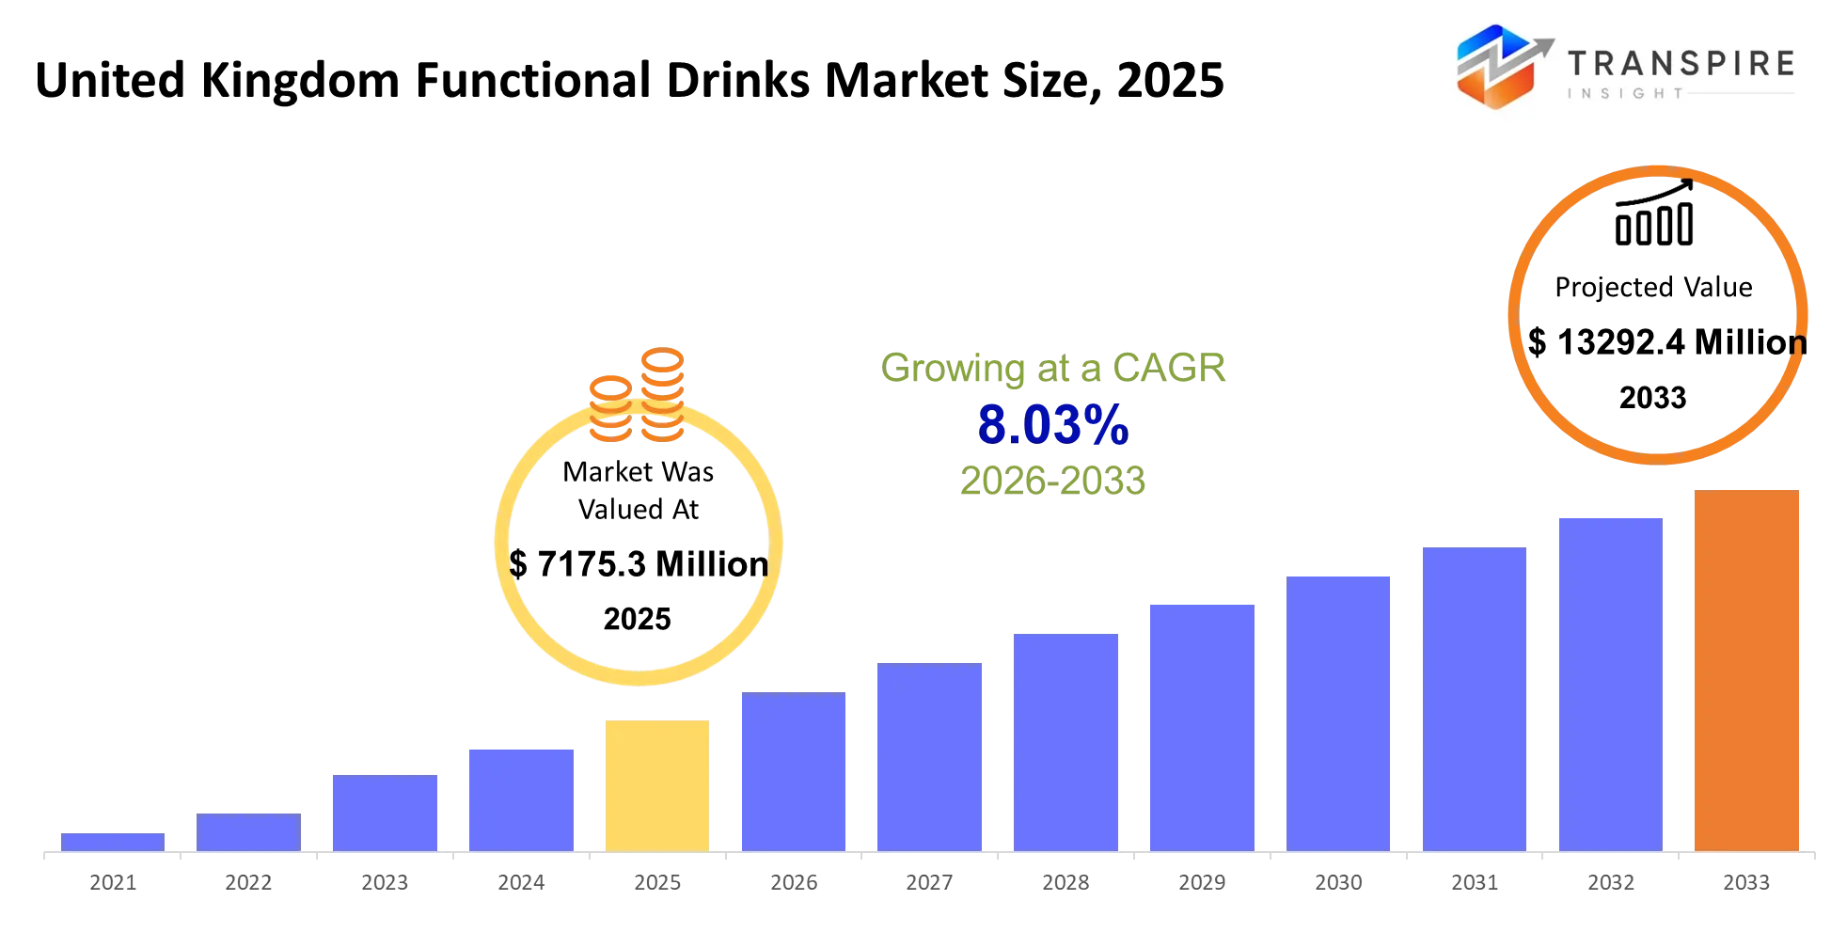
Figure: United Kingdom Functional Drinks Market
(Source: Dhatrak and Khansole, 2026)
The UK Fruit Drink and Functional Beverage Production industry was worth 2.2billion in 2026 with an average annual growth of 4.0 since 2021 (Griffin, 2026). The revenue is expected to increase by 2.6 per cent in a year to reach two point three billion pounds by 2026-27 with the health-conscious consumers giving up fizzy drinks (Quail, 2026). Functional drinks have more than doubled their value sales to over £100 million each year, and the juice shots are increasing at a rate of 47 per year (West, 2026; Beeson, 2026). Al nearly one-half of consumers in the UK have shifted towards less sugar products (Dhatrak and Khansole, 2026).

1.3 Research Aim and Objectives
Aim: This study will attempt to assess viability of converting seasonal fruit juices into commercially pre-manufactured products to be sold throughout the whole year in the UK retail market. The research aim is to examine external market environments, consumer needs and preferences, and evaluate the business opportunities of those who plan to launch innovative and shelf-stable fruit drinks that meet the evolving health, sustainability and lifestyle trends.
Objective:
- To examine the macro-environment of the UK in the PESTLE framework to determine the political, economic, social, technological, legal, and environmental factors that affect the commercialisation of the seasonal fruit beverages.
- To determine the functional, emotional, and social needs of consumers in the context of the Jobs-to-Be-Done (JTBD) framework to learn how people can be motivated to buy fruit-based beverages.
- To assess market potential, target customer segments and demand trends of manufactured seasonal fruit drinks in the UK off-trade retail market.
- To determine the general commercial viability and positioning of seasonal fruit beverages as full-year produced products and give suggestions on how to successfully enter the market.

1.4 Research Question
How feasible is it to transform seasonal fruit drinks into commercially viable manufactured products for the UK retail market, considering macro-environmental factors and consumer demand?

1.5 Research Rationale
There are three reasons that would support this research. First, the UK juice market is estimated to increase between USD 4.39 billion in 2025 and USD 4.73 billion in 2032, and food prices increased 4.5 per cent till December 2025 (Albert, 2026), causing shoppers to shift towards value and nutritional quality (Claight, 2026). Second, the advertising limits on HFSS from October 2025 will benefit those brands that market themselves as low-sugar, natural (The On Trade, 2025). Third, seasonal is an underdeveloped category with functional beverages shifting to gut health and cognition (Albattat et al., 2025).

1.6 Research Significance
Through the interpretation of the study, PESTLE and JTBD are introduced to an under-explored segment of the UK market, developing a replicable model of market entry. In practice, it provides entrepreneurs and manufacturers with the evidence of demand drivers, regulation and positioning (Ceasar and Sundari, 2024). As the functional drinks currently are expected to expand their future popularity by 8.3 percent per annum until 2030, the subject is of commercial interest (Grand View Research, 2025).

1.7 Research Structure
Chapter 2 will include the Company Description which will outline the identity of the proposed venture, the legal structure, the offer, the reasons of the founders, the mission, values and early goals. In chapter 3, the frameworks that support the analysis, such as PESTLE, JTBD, Porters Five Forces, the Value Proposition Canvas and the Business Model Canvas, and the secondary qualitative methodology, are reviewed. In Chapter 4, the writer gives the Initial Market Opportunity Analysis, which evaluates the size of the market, segments and competition. The overall commercial viability is assessed in Chapter 5.

Chapter 2: Company Description

2.1 Business identity and legal structure
Hedgerow and Harvest Ltd will be a new enterprise that is a private company limited by shares under the Registrar of Companies in England and Wales. Limited liability isolates assets of the founder and is credible in negotiations of retails listing and co-packing agreements (Celestin, 2025). It will be based at Herefordshire, in the West Midlands area of fruit-growing in the United Kingdom, where access to orchards and hedges supply will be direct, as well as national distribution channels. The outsourcing will be a BRCGS-approved contract bottler ensuring low capital requirements and with the venture under the lowered threshold of the 2 million turnover at which the full packaging is required (Foodsure, 2025).

2.2 Product or service and the problem solved
Hedgerow & Harvest will manufacture various seasonal restraint fruit drinks with British elderflower, rhubarb, damson, sloe and gooseberry using a lightly sparkling, entirely shelf-stable beverage. Fruit will be pressed and pasteurised at harvest at peak, bottled in clear glass and put out throughout the calendar year and so flavours that in the old system had to be limited to six weeks of availability are permanently available (Food and Agriculture Organization, 2026). The distribution will be via independent farm shops and delicatessens in the first year, then regional grocery and online subscription in the second year. The profile of the target market would be the health-conscious adult between 25-54 region with less alcohol intake but is annoyed at the lack of variety of adult soft drinks in the market. This fills the gap established in Chapter 1, where consumer willingness towards natural, low-sugar and heritage flavours was revealed to outcompete supply. The first value proposition entails a truly British, naturally low sugar beverage that is provenanced and rich in flavour, which mainstream carbonated and imported cordials cannot boast of (Nawagomuwage et al., 2025).

2.3 Founding idea and brief history
The idea originated as the founder was undertaking MBA studies at the University of Wales, his research during a module on the UK food supply chains revealed that growers regularly leave unharvested excess amounts of elderflower, damsons and sloe since there was no viable processing route. Casual experiences with the farm shop operators verified that seasonal lines of fruits have exhausted sales in a matter of weeks and that customers are clamoring to be offered them back. The business is thus based on perceived need and reported inefficiency in supply.

2.4 Mission, vision and values
Mission: To bring about year-round availability of Britain fruit flavours in season, to promise growers fair prices on fruit that otherwise would have been wasted and providing adults with a soft drink that will be chosen based on its merits.
Vision: To be recognised as the British seasonal fruit drinks brand in regional grocery in 2031 and have a supply network of fifty growers.
Values: Provenance, which is that each batch can be traced it to a named UK farm; Restraint, which is that it contains no added sugar, colouring or synthetic flavouring; and Circularity, which is that the packaging should be designed so it can be recycled not minimally. The base fees of Extended Producer Responsibility applied in 2025-26 of glass at £192 per tonne and plastic at £423 per tonne are commercially material, plus Proposed fees of recyclability, starting in 2026-27 (SMITH, 2025).

2.5 Business objectives and goals
The initial priorities are positioned in terms of SMART criteria and oriented on the launch. Introduce three main flavours and be sold in thirty independent retailers at the end of the twelfth month. In the first year, they sell 40,000 units and provisional revenue of £120,000, and in the third year, sell 360,000 units and provisional revenue of 360,000. Contract eight (growers on fixed seasonal supply agreements) refers to the before-2027 harvest. You should have below 1.5 repurchase rate to the products and repeat purchase rate of 35 percent among the subscription customers by month eighteen. Break even in operations is aimed at in twenty-six months. These are the tentative targets which will be compared to the costs prepared in the financial plan.

2.6 Alignment with trends and opportunity
The business fits well with the quantifiable market activity. NielsenIQ indicates that half of consumers in the UK would pay a premium on a soft drink with functional health benefits, increasing to 68% among Millennials and 61% among Generation Z, and 74 percent are willing to consume less alcohol, with this number increasing to 81 percent in the 35 to 54 age group (Drinkaware, 2025). Whether this willingness translates into sustainable margin at plausible volumes should be established through the market and feasibility analyses.

Chapter 3: Literature Review

3.1 Introduction
This chapter has examined the academic frameworks that form the basis of the feasibility analysis of the proposal by the Hedgerow and Harvest Ltd to transform seasonal fruit drinks of Britain into year round manufactured goods that will be marketed through the UK retail market. There are four themes that are analyzed: macro-environmental analysis with PESTLE, consumer motivation with Jobs-to-Be-Done (JTBD), industry competitiveness with Porters Five Forces, and value design with Value Proposition Canvas and Business Model Canvas. In every framework, the review will explain the purpose and objectives of each perspective, acknowledge the strengths and weaknesses of each, and provide justification as to why it is relevant to the aim, objectives and research question of the study, but will not replicate the analysis in subsequent chapters.

3.2 Macro-Environmental Analysis: PESTLE
According to Citilci and Akbalik (2019), PESTEL frames an evaluation of political, economic, social, technological, legal and environmental forces that define the environment in which a venture operates and asserts that it facilitates strategic thinking by mapping external forces of opportunity and threat prior to carrying out more specific analyses. Dhuria et al. (2025) validate its remainance in the UK food and drink market, especially in scanning regulatory shifts like HFSS advertising bans, sugar-cutting policy and Extended Producer Responsibility levies, which have a substantial impact on premium producers of soft-drinks. Buye (2021), however, say PESTLE can list things descriptively without ranking them, and that its static nature makes it too down-play the fast changes in consumers. To compensate for that weakness, this proposal leverages the idea of PESTLE as an entry-level macro scan and integrates it with more industry and consumer-specific tools, prioritising context over a list of tools that will be described in the following chapters.

3.3 Consumer Motivation: Jobs-to-Be-Done
Esra Oezal and Juergen Münch (2024) describe Jobs-to-Be-Done (JTBD) theory as a theory that posits that consumers are hiring products to perform functional, emotional and social jobs as opposed to buying attributes, and that segmentation is no longer placed on demographic terms but the context under which consumers decide. Recent evidence on beverage innovation presented by Hankammer et al. (2019) demonstrated that JTBD is more successful than demographic segmentation as it appeals to the root need, and discloses unfulfilled job aspects that have not been formed by conventional attribute-based research. In their application to the UK situation, Yates et al. (2025) prove that the moderation-oriented adult population do recruit high-value adult soft drinks to signal health, to substitute alcohol in social situations and reward themselves with well-known British provenance and craft qualification. Zhou et al. (2026) warns, though, that the biggest challenge with making emotional jobs operationalised is that it relies on interpretive judgement that may diminish cross-study comparability. Coupled with PESTLE, JTBD then translates the macro trends into specific consumer insight in the positioning of Hedgerow and Harvest and choice of their channel.

3.4 Industry Competitiveness: Porter's Five Forces
According to Petrou Hadjipetrou (2026), Porters Five Forces assesses the attractiveness in an industry based on rivalry, buyer power, supplier power, threat of substitutes and entry points and will offer a structured approach towards the competitive intensity in a defined belligerency. Using the framework to the UK functional beverages, Wilkinson et al. (2024) highlight that buyer power is high due to retail concentration, low shelf-life negotiation periods, and that substitute threat is large due to low- and non-alcohol substitutes and functional shots; supplier power, by contrast, is fragmented and seasonal in niche British produce. However, according to Cozzolino, Corbo and Aversa (2021), the model was constructed in a rather stable industry, and collaboration is underrated, as well as digital ecosystems and a quick convergence of categories. In spite of these critiques, Five Forces is a stringent device of this proposal and in this case, will be used to check whether the premium seasonal-drinks segment will be able to protect margin in the face of the mainstream soft drinks and high-end imported cordials.

3.5 Value Design: Value Proposition Canvas and Business Model Canvas
Schutselaars et al. (2023) suggest that a Value Proposition Canvas (VPC) can help bridge the gap between customer insight and product design, aligning customer jobs, pains and gains with product features, pain relievers and gain creators. Murray and Scuotto (2015) go on to describe the Business Model Canvas (BMC) as a translation of the value proposition into nine building blocks (segments, channels, key resources, activities, partners, cost structure and revenue streams). Umam (2026) offer current data on food and beverage start-ups demonstrating that the combination of VPC and BMC significantly enhances investor readiness, channel selection and decreases the rate of launch failures. Bari, Chimhundu and Chan (2024) in their turn, note that both of the tools are fundamentally static snapshots which cannot be deemed representative of dynamic capabilities, current sustainability commitments and broad stakeholder ethics. In this case, the also applicable VPC and BMC bridges JTBD insights to a testable operating model and it is where the results of PESTLE and Five Forces ultimately converge.

3.6 Chapter Synthesis
PESTLE, JTBD, Five Forces, VPC and BMC put together are an analytical spine to this proposal. PESTLE puts the external environment into perspective, Five Forces measures the intensity of competition in an industry, JTBD translates that environment into consumer motivation, the two canvases translate motivation into a workable operating model which can be tested to UK evidence. The UK functional drinks market is changing fast and therefore the common disadvantage of these frameworks, namely, their unchanging, inward-looking nature, will be addressed with the help of triangulation of the framework outputs with the existing UK market data and the reconsideration of this framework as new data becomes available. This synthesis provides the golden thread, which flows through the external environment, consumer demand, to competitive positioning and business model design that traverses the following chapters of analysis, feasibility judgement and market-entry advice in relation to Hedgerow and Harvest Ltd in UK retail markets.

Chapter 4: Research Methodology

4.1 Methodological Approach and Opportunity Identification
The proposal will use the secondary-research design to assess the viability of the commercialisation of British seasonal fruit drinks (Zhang, Xu and Zhang, 2024). The opportunity was discovered in the MBA supply-chain research carried out by the founder at the University of Wales, which discovered continuous under-harvesting of the elderflower, damson and sloe. There should be a secondary strategy since valid, up-to-date market and consumer trend data, regulation and competitor behavior in the UK are publicly accessible, and it will eliminate the ethical and time pressures of primary fieldwork (Lim et al., 2025). The design connects external evidence into the aim, objectives and research question with a golden thread of context to feasibility.

4.2 Market Insight and Data Collection
The UK-focused government, academic, industry and commercial sources of data were sampled between June to August 2026. The basis of the government and regulatory evidence was the Office for National Statistics, DEFRA and the House of Commons Library (Smith, 2025). Search engines were used to find academic literature in Google scholar, ScienceDirect and Emerald Insight. The intelligence on industry and market were supplied by IBISWorld, Grand View Research, NielsenIQ and The Grocer. The major keywords used were: UK fruit drinks, UK functional drinks, seasonal produce UK, adult soft drinks, low- and no-alcohol UK and sugar reduction UK. Sources were also exploited in case their subject matter was UK-centred, published between 2024 and 2026, had a methodological transparency and were published with a credible publication (Dhingra and Jaiswal, 2025). Promotional or duplicative sources, which were not dated and did not belong to the UK were excluded. The purposive sampling process involved identification of ten UK premium fruit and functional drinks brands, based on the top-selling catgegories on the Ocado, Tesco, and specialist retailers, and cross-reference with IBISWorld associations (Griffin, 2026). The choice of contract bottling partners and glass-packaging providers applicable to the outsourced supply model used by Hedgerow and Harvest were done using the same criteria.

4.3 Quantitative and Qualitative Evidence
The analysis was informed by both types of evidence. Evidence that is quantitative was UK market value (£2.2 billion) and the rate of increasing value by 4.0 per cent annually in functional drink category (>£100 million) and consumer willing-to-pay and Extended Producer Responsibility fees, which was 192 per tonne per glass (Smith, 2025). The qualitative evidence included the October 2025 HFSS advertising ban, consumer motivation, positioning and expert trade-press commentary. The combination gives a more balanced view: quantitative data can scale up or down the opportunity, whereas storytelling can be used to understand as to why demand in the UK is moving towards low-sugar, natural and heritage flavours (Huang, 2023).

4.4 Data-Analysis Methods
There are four methods of analysis used. The UK opportunity and profile segment size are summarised using numerical evidence, i.e. totals, percentages, and averages, compound annual growth rates, to size segments through descriptive analysis (Zhang, Xu and Zhang, 2024). Comparative analysis aligns Hedgerow & Harvest with ten chosen competitors on a similar basis on a consistent basis: unit price, pack format, provenance, sugar content and distribution channel. Using thematic analysis, common-to-all themes in qualitative material are determined, being coded using the health, provenance, sustainability and moderation driver, with any disagreements being transparently recorded (Reggiani and Zangoli, 2024). Financial analysis models projection of revenue, cost of goods, break-even and sensitivity to low, base and high levels of demand based on the assumption made by Foodsure (2025) and IBISWorld (Griffin, 2026). All these approaches have direct ties to an objective: descriptive and comparative analyses help to justify the market-opportunity goal; the JTBD goal is operationalised through thematic analysis; financial analysis assesses the general feasibility of the business.

4.5 Application and Integration of Frameworks
The frameworks presented in Chapter 3 are used the following way. PESTLE will organize the macro-environmental audit based on regulative and economic data. Five Forces developed by Porter will plot the competitor, buyer, supplier, substitute and entry-barrier information. JTBD will derive consumer research to functional, emotional and social jobs. The Value Proposition Canvas will be adapted to those jobs of product features, and the Business Model Canvas will condense the segments, channels, partners and revenue streams to a testable operating model (Diah Ayu Susanti et al., 2024). All the frameworks are filled with the same evidence base in order to create internal consistency between the chapters.

4.6 Reliability, Validity, Limitations and Ethics
Triangulation was used to enhance the reliability of material claims: every material statement will be cross-verified with at least two independent sources, such as the comparison of market-size data between IBISWorld and Grand View Research and Transpire Insight (Dhatrak and Khansole, 2026). As far as publications as late as 20242026 were restricted as evidence, currency was placed at the forefront although seminal theory was maintained where needed. The concern of validity was considered in favor of transparent methods reporting and validating financial assumptions with sensitivity analysis (Dhingra and Jaiswal, 2025). Limitations These are based on commercial datasets which can have favourable interpretations, national instead of regional level aggregation and uncertainty about forecasting prices, demand and EPR fees. The conflicting estimates are registered and ranges instead of single-point forecasts are reported. There is no need to get the consent of a participant as only publicly available secondary evidence is used, ethically. It honours copyrights and data licenses, cites Harvard, UWTSD and does not cherry pick its results by ignoring the data that contradicts the assumptions of the proposed data (Cheong et al., 2023).

4.7 Summary
The present proposal takes the form of secondary-research design, in order to test the feasibility of commercialising British seasonal fruit drinks. The UK government, academic and industry sources were searched between June and August 2026, and limited to publications in 20242026, with a transparent inclusion list. Purposive sampling was used to select ten competitors. The evidence is interpreted by descriptive, comparative, thematic and financial analyses, which serve as inputs to the PESTLE, Porters Five Forces, JTBD, VPC and BMC. Triangulation between independent sources and sensitivity testing enhance reliability. Ethics is addressed with facts in the public domain, correct reference and equal reporting of conflicting results.

Chapter 5: Opportunity Market Analysis

5.1 Scope and Market Definition
In this analysis the market to be analyzed is that of premium, no-added-sugar, adult oriented soft drinks of British seasonal fruit sold through off-trade retail (independent grocers, farm shops, delicatessens and subsequently a number of grocers and hospitality accounts) to health conscious UK consumers aged between 25 and 54 years in 2025-2026. The reason why this is an appropriate boundary is that Hedgerow & Harvest Ltd will be entering into the sub-category of adult high-end soft drinks, and not another category like carbonated or juice-shot, as it will be a low-and-no-sugar craft soft drink with provenance-based positioning (Flavor Catalystz, 2026). Whether a viable opportunity within these boundaries exists that is real, accessible and commercially viable is assessed in the chapter through evaluating the scale, segmentation, unmet need, demand behaviour and economic and geographic conditions.

5.2 Market Size and Growth Trends

Market Size
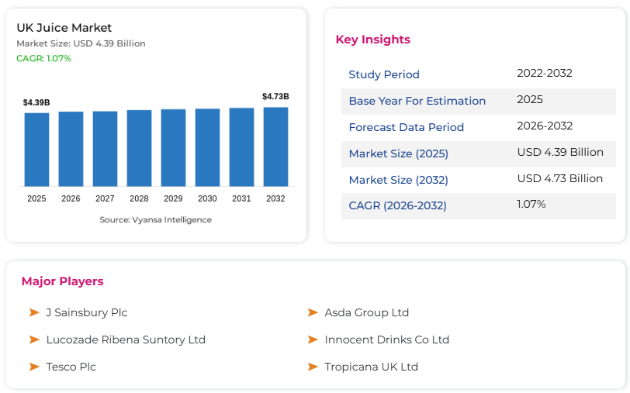
Figure 2: UK Juice Market
(Source: Vyansa Intelligence, 2026)
The Fruit Drink and Functional Beverage Production industry of the UK is priced at about 2.2 billion pounds in 2026 which has a compound annual rate of about 4.0% since 2021. In retail sales, the broader UK soft drinks market was estimated to reach 20.4 billion in 2025 with the premium adult soft drink sub-category increasing by an estimated 8% in value in 2025, compared to the market. It is expected that the UK juice and juice-drink segment will increase to USD 4.73 billion by 2032 as compared to USD 4.39 billion in 2025 (Vyansa Intelligence, 2026). The use of a top-down filter which takes the approximate value of the adult population in 25-54 age group of around 21 million people in the UK, a serviceable population of about 32% of the total adult population representing the regular premium soft drink consumers, and average expenditure and consumption per unit of around 2.75 will give a serviceable available market (SAM) of about 2.3 billion (Portela et al., 2026).

Growth Trends
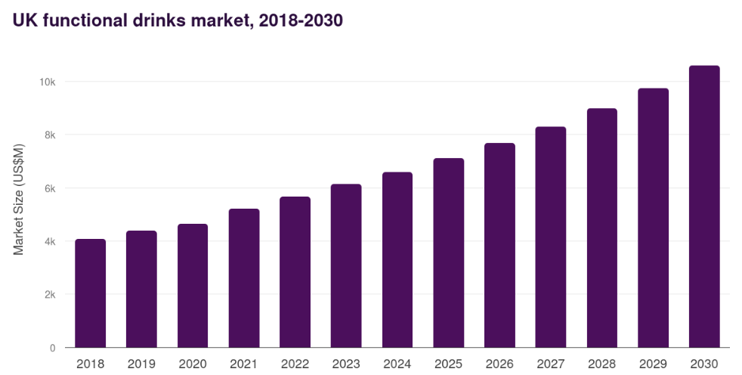
Figure 3: UK Functional Drinks Market
(Source: Grand View Research, 2025)
The structural, rather than the cyclical, changes are driving growth. The UK functional drinks market generated a revenue of USD 7,176.1 million in 2025 and is expected to reach USD 13,235.2 million by 2033. In the UK, the sales of alcohol-free drinks increased by 15% in 2025 and 39% of all adults in the UK decreased their alcohol consumption as of 2025 (Grand View Research, 2025). A realistic serviceable obtainable market (SOM) of 0.05% of the established SAM over a period of three years would lead to a revenue of some £1.15 million annually (Bredava, 2025).

5.3 Segmentation and Target Customer

Demographic Segmentation and Targeting
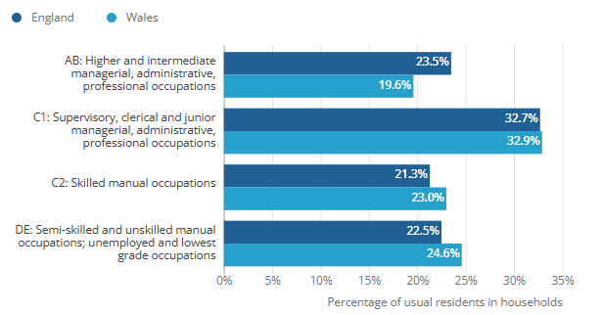
Figure 4: People in England were more likely to be classed as grade AB than in Wales
(Source: Office for National Statistics, 2023)
The priority segment will be adults aged between 28 years and 49 years, ABC1 socio-economic grade, and urban and commuter-belt, especially London, the South-East, South-West and West Midlands (Office for National Statistics, 2023). The UK has around 28 million adults in the age group in 2026 with the survey done by the industry indicating that around 34% of the adults are actively pursuing low-and-no-sugar adult soft drinks thus providing a potential population of 9.5 million adults who can be addressed (Kennedy, 2026).

Psychographic Segmentation and Targeting
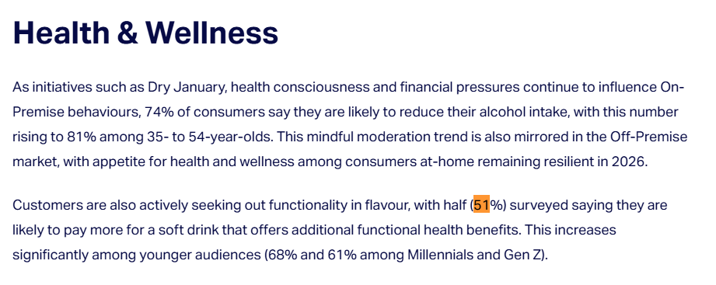
Figure 5: Health and Wellness Willingness
(Source: NIQ, 2026)
Provenance-motivated, sober-curious, and health-conscious. Approximately a quarter of 25- 44 years-olds have become non-drinkers or low-frequency drinkers (already about 26%), and this age group is actively exploring some adult alternatives to alcohol at social and self-treat events (Donnelly, 2026). In 2026, the NIQ (2026) results indicate that 51% of UK consumers will be willing to pay a premium price of the functional soft drinks and 68% of the consumers who are 25 to 34-years-old. Such consumers are conscious of ingredient transparency, provenance in Britain and are conscious of craft narrative rather than convenience and price.

Behavioural Segmentation and Targeting
The segment would shop weekly at various grocers but would derive 22% of upscale food and beverage through independent or specialist or direct-to-consumer outlets in 2026. The proportion of purchasers of premium soft drinks who say they have tried at least one new craft brand in the last year is about 44%, which rises to 57% when the brand has a strong provenance or sustainability brand (Albattat et al., 2025). The pack format, where to place it on the shelf, and marketing calendar decisions are guided by purchases that occur on Fridays to Sundays during self-treat and entertainment and on mid-week wind-down days as a replacement of alcohol.

5.4 Pain Points, Unmet Needs, and Demand

Pain Points
The essence of the customer pain point lies in the lack of adult drinks that are at the same time sophisticated in flavour, low in sugar, transparently sourced and do not contain synthetic substances. In 2025 and 2026, the quit reviews and grocery category research reveal that 47% of shoppers call the low-sugar products too sweet or too artificial, and 38% of shoppers complain about the understandability of ingredient labelling (Gilsenan, 2025). This determines the point of pain with the help of the independent behavioural evidence and not with the assistance of the founder.

Unmet Needs
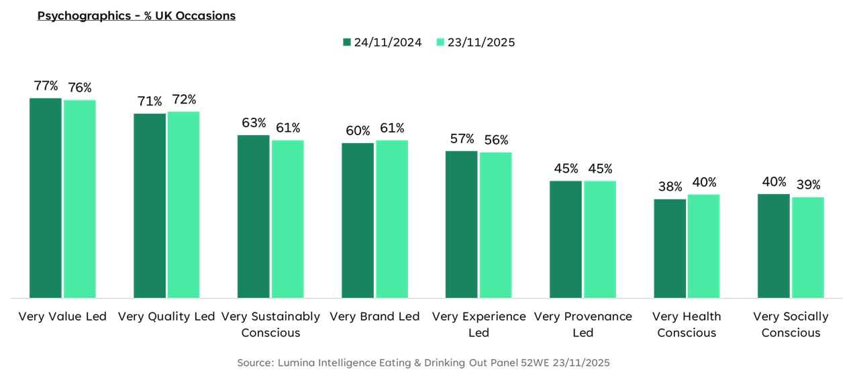
Figure 6: Sustainability VS new consumer priorities
(Source: Lumina Intelligence, 2025)
In 2025-2026 purchase drivers consider health and ingredient transparency (63%), British provenance (54%) and distinctive taste (49%) to be the top three with price coming in fourth (41%). The available brands of craft generally cover one or two of these without much often reaching three at a shelf-stable, all-year-round scale, where there is an evident gap in an unprovenanced, no-added-sugar, seasonal-flavour range that it can supply on a twelve-month calendar basis (Lumina Intelligence, 2025). British elderflower, rhubarb, damson, sloe and gooseberry used in the venture directly respond to this white space.

Demand
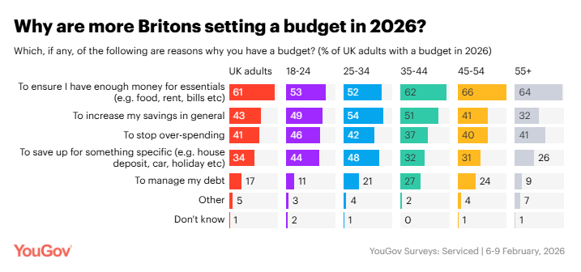
Figure 7: Reason for setting Up Budget
(Source: You Gov, 2026)
The quality of demand is good but it needs to be read attentively. The growth on alcohol free sales was 15% and the category value premium adult soft drink was 8% growth in 2025 which indicates preparedness of paying. Nevertheless, 61% of UK households say they are cutting discretionary grocery budgets in 2026 under the pressure of cost-of-living, posing a risk of trading-down of everyday soft drinks (You Gov, 2026). The target events that Hedgerow and Harvest targets include self-treat, entertaining, alcohol replacement and are more resilient when compared to the everyday grab-and-go purchases. Seasonality will continue to be a category constraint, as the best sales will be April through August and once more in December at Christmas.

5.5 Economic and Geographic Conditions

Economic Conditions
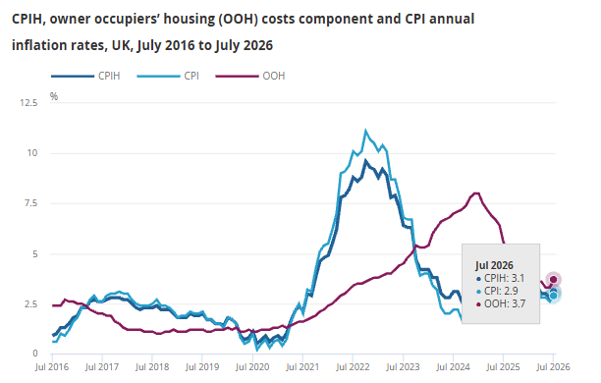
Figure 8: CPIH and CPI annual inflation rates rose for the first time since March 2026
(Source: Consumer Price Inflation team, 2026)
The inflation of CPI in the United Kingdom relaxed to 2.6% in the mid-2026, though the food and non-alcoholic beverages inflation was still higher at around 4.1% per annum in Q2 2026 (Consumer Price Inflation team, 2026). There was a growth in real household disposable income by only 0.8% in 2025 and this restricted discretionary spend. In mid-2026, the base rate of the Bank of England had been determined as 4%. Such a setting supports a value-at-quality rather than lowest price positioning. A difference between £2.75 to £3.25 shelf price translates as an affordable luxury as compared to £3.50-£4.50 soft drinks in pubs. The Soft Drinks Industry Levy will continue to be a structural tailwind. HMRC data indicate that the quantity of sugar in soft drinks dropped by 46% between 2015 and 2025. The threshold at which a soft drink with added sugar becomes liable for the SDIL will be lowered from 5g to 4.5g per 100ml (HM Revenue Customs, 2026).

Geographic Conditions
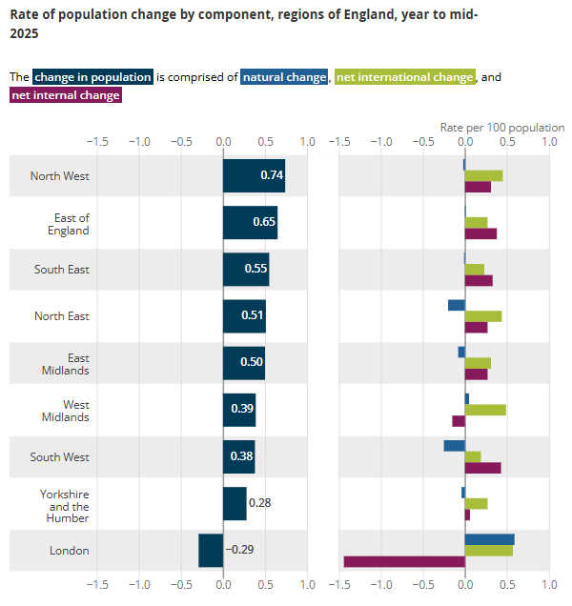
Figure 9: The North West had the highest rate of population growth, London had a decreasing population
(Source: Office for National Statistics, 2026)
The launch catchment focuses on Greater London (population of 9.0 million, 2025 mid-year estimate), the South-East (9.4 million) and the West Midlands (5.9 million) that make up around 41% of UK spend on premium grocery (Office for National Statistics, 2026). The (natural) density of farm shops and delicatessens is the greatest in the Cotswolds, Kent, Surrey, Hampshire and Warwickshire, giving them a provenance-driven launch of a natural cluster. In year one, the complementary direct-to-consumer channel provided by online adult non-alcoholic sales grew 19%, which will reduce the many-grocer negotiation dependence of the business (Critchlow et al., 2025).

5.6 Research Findings and Synthesis
Hedgerow and Harvest Ltd has a market opportunity which is perceived to be good but conditional. The population of people sober-curious, large and adult, and confirmed discontent with current low-sugar offerings and increasing provenance consciousness all come to the point where the venture is offered (Research and Markets ltd, 2025). Market size is credible -a parent industry of £2.2 billion with a growth rate of 4%, a functional segment of over 1.9 billion with an overall growth rate of more than 6%, and a specified SAM of £2.3 billion-can be approached in independent retail and direct-to-consumer channels at the intended scale.
The major limitations include inflation of food and beverage, limiting daily discretionary spending, seasonal changes in cash flows typical of the fruit chain supply chain, and increasing competition levels among existing craft entrants. Primary research would enhance conclusions in later stages, and market scale and consumer attitudes have high levels of evidence (with moderate levels with micro-segment behaviour) (Lumina Intelligence, 2025).
Generally, the data suggests a high market opportunity due to behaviourally validated unmet demand, regulatory and health-trend environment favouring no-added-sugar entrants and finally, priority segment is measurable and accessible (IBISWorld, 2025). This opportunity is most plausible when Hedgerow & Harvest achieves discovery among South-East and Midlands independents in the first instance, supports its premium price in the credibility of provenance in the second instance, and safeguards seasonality in the production, which is shelf-stable in the third instance — which will directly inform competitive, strategic, operational, and financial analysis in subsequent chapters.

Chapter 6: Competitive Environment Analysis

6.1 Scope, Frameworks, and Competitive Set
This chapter analyses the competitive landscape of the Hedgerow and Harvest Ltd in the UK consumer market premium adult soft drinks market. There are three types of competition that are taken into account. The competitors of the product are the traditional craft British soft drinks which are found in the high shelf of adult customers, which include Fentimans, Belvoir farm, Bottlegreen, Luscombe, and others (Brown, 2025).
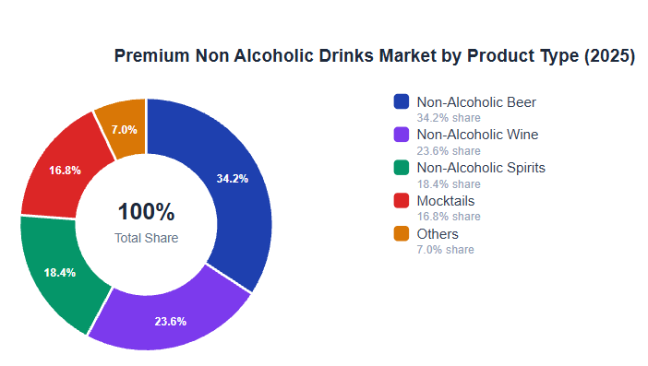
Figure 10: Premium Non Alcoholic Drinks Market by Product Type
(SourcE: More, 2025)
The non-alcoholic in the setting of adult beverages entrants would be described as indirect competitors that would include: Seedlip, Lyre, and premium tonics e.g. Fever-Tree. The competitors with substitutes will be supermarket own-label low-sugar cordials, sparkling water, kombucha, and alcohol itself (More, 2025). The paradigms used include Key Success Factors, Porter's five force, and PESTEL which have been combined to arrive at a conclusion about industry appeal and competitive position to be secured.

6.2 Key Success Factors
To compete in this category there are five factors that are necessary.
Provenance credibility: 54% of UK premium soft drinks purchasers prioritize British sourcing in their top three consideration drivers to purchase in 2026 and named-farm traceability has become a staple, like tablets, of craft adult brands.
Reformulation and sugar credentials: HM Treasury (2025) data shows that sugar in UK soft drinks has already reduced by 46% since 2015-2025 with the review of SDIL threshold various in April 2027, no-added-sugar is category critical.
Unique range of flavours: 49% of high end purchasers use distinctive flavour as one of the top three motivators, with weird British botanicals like damson and sloe performing better in taste tests than mainstream flavours (Kay et al., 2024).
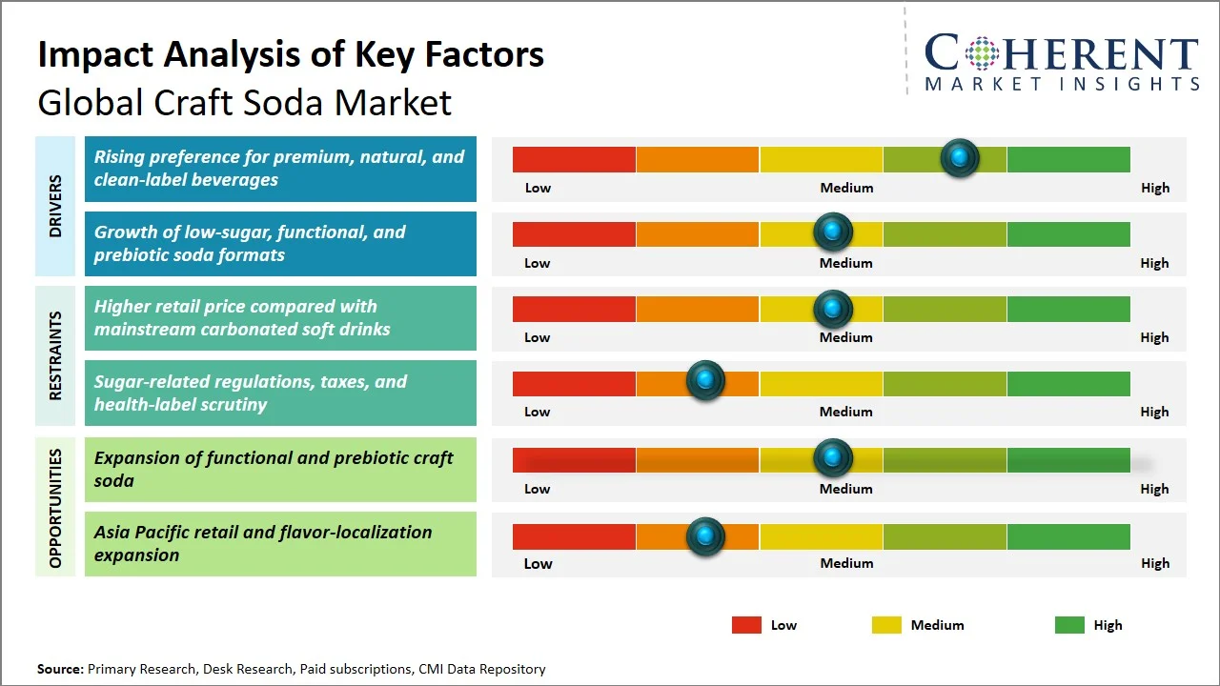
Figure 11: Global Craft Soda Market Size and Forecast
Route-to-market: independent retail will not be out of business, but will reduce its capture of premium food and drink to around 22% in 2026; multiple grocer listings will result in a volume-driven strategy. A staged channel change is required. Seasonal working capital pressures on cash-flow resilience 41% of craft soft drink insolvencies in 2023-2025 were a result of seasonal working capital pressure, and as an instrument of survival, rather than preference, shelf-stable production (Suryawanshi, 2026).

6.3 Main Competitors and Positioning

Fentimans
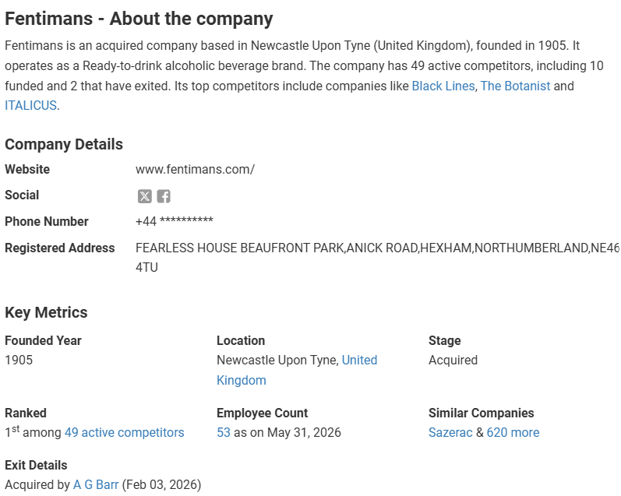
Figure 12: Fentimans - About the company
(Source: Tracxn, 2026)
The greatest direct competitor is Fentimans. The brand based in Northumberland was capable of getting around 42 million UK retail sales and has distribution in all four multiple grocer, independent retail, and high-end hospitality. It has a well-built positioning of botanically brewed and 1905 heritage (Tracxn, 2026). Weaknesses consist of excessive sugar profile, with the contemporary low-and-no-sugar shopper (its classic offering has 8.5g sugar/100ml on average) and a vacuum in case of farm-level provenance, which can be filled by the Hedgerow & Harvest with no-added-sugar, named-farm offer.

Belvoir Farm
Leicestershire family business was seen to have gone through a turnover of approximately £24 million in 2025 with good representation in Waitrose, Sainsbury and farm shops. Belvoir has a similar British bot position but is primarily located in the cordial category with a low proportion of revenue (around one-third) of premium ready-to-drink lines (Retaileconomics, 2026). Its shelf price of £2.30-2.80 pegs the category. Weakness: the brand lacks leadership in the area of functional and low-sugar attributes, and this opens room to a more health-positioned entrant to be more adult.

Bottlegreen
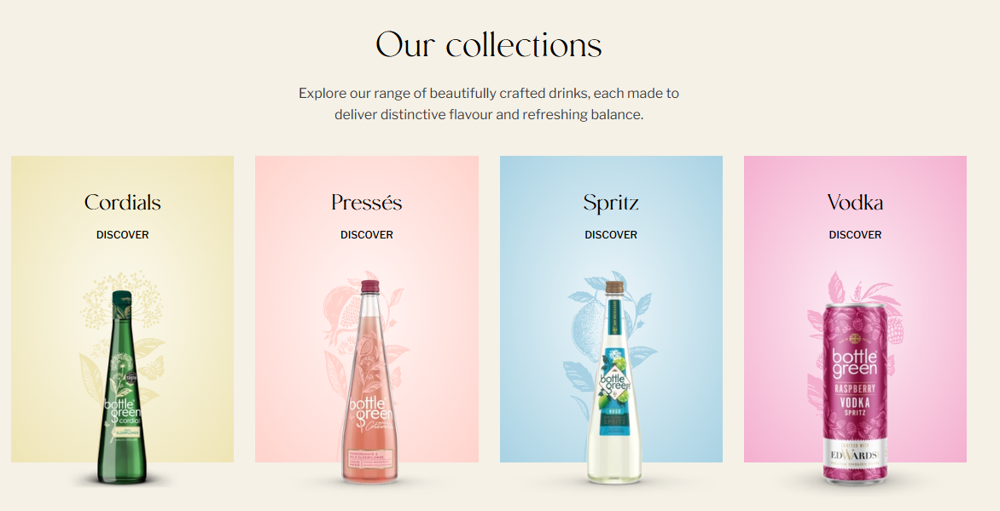
Figure 13: Bottlegreen Collection
(Source: Bottlegreen, 2026)
Bottlegreen, owned by SHS Group can be found within the band of 15-20 million turnover in 2025 with good equity in the elderflower and distribution in Tesco and Sainsbury. Its pressé selection directly competes with the Hedgerow & Harvest sparkling both offer at a similar range of £3 to £2.50. Weakness: mono-flavour reliance on elderflower and lack of seasonal-fruit development.

Luscombe Drinks
The Devon-made organic crafted brand was projected to make an estimated £11 million in 2025, highly indexed to Waitrose and high-end hospitality with shelf price of between £2.90 and 3.50. Competitors that closely match in terms of values are Luscombe, which has an identical positioning of craft, low-sugar, and named-farm (Luscombe, 2026). The pricing being on the high-end of the category restricts mass accessibility, and the emphasis on classic citrus and ginger flavours means that the British seasonable fruit market is open to share.

6.4 Porter's Five Forces

Threat of New Entrants — Moderate to High
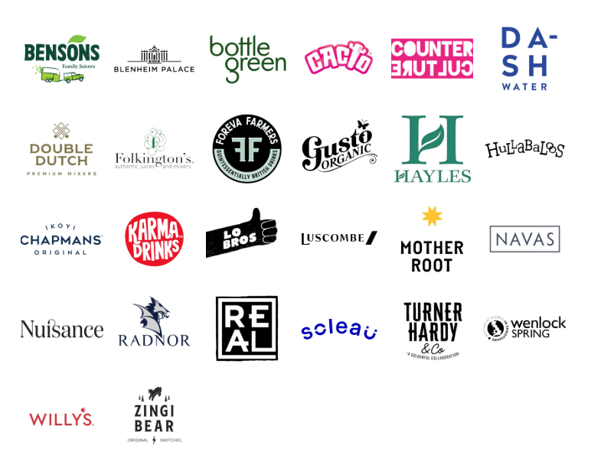
Figure 14: UK Non Alcoholic Drink Brands
(Source: The Craft Drink Co., 2026)

Online products, like Shopify, are cheap to launch directly to consumers, and the UK bottling capacity of contracts has grown by 12% since 2023 (Hastelow, 2026). Nonetheless, it takes three years and costs around £500,000-800,000 capital to secure named-farm supply, multiple grocers listings and hit a turnover of £1 million. In the UK, there are 92 craft soft drink brands, which were introduced in 2025, and 34% made it to a second full trading year, which proves again that it is easy to enter the new business, but hard to establish (The Craft Drink Co., 2026).

Bargaining Power of Suppliers — Low to Moderate
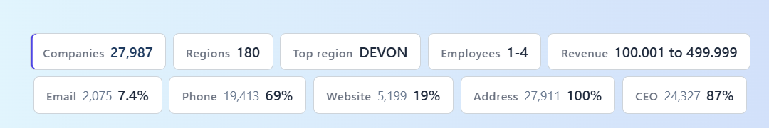
Figure 15: UK Farming Condition
(Source: CompanyData, 2026)
The supply of British fruit in the season is disjointed. UK farming covers around 209,000 holdings recorded by Defra and high levels of surplus and Class II fruit going to waste without being picked as farmers estimate it to be 4.5% of the 2025 UK top-fruit crop left on the orchard (CompanyData, 2026). This provides Hedgerow & Harvest good bargaining power with farmers. The capacity of UK co-packers which supplies most of the independent craft soft drinks is more concentrated which places modest pricing power in the hands of the three UK co-packers who estimate that they possess three-quarters of independent craft soft drinks capacity.

Bargaining Power of Buyers — High
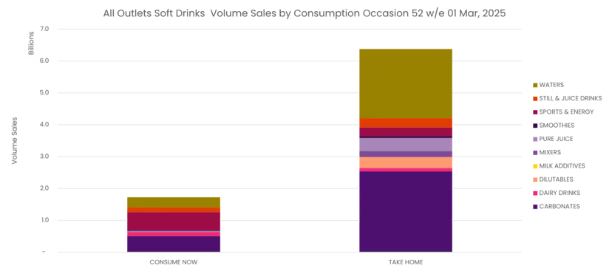
Figure 16: UK Consumption Rate
(Source: Grylls, 2025)
Several grocers have high power. In 2026, listing costs of between 8,000 and 25,000 SKUs per retailer are normal, and delisting processes have been reduced to 9-12 months. It is a product with high consumer switching (Dev Expert, 2026). 44% of high-end soft drinks purchasers tried on a new craft brand during the last twelve months. Soft drink volume is dominated by take-home consumption, with 3.7 times more volume drunk at home. This renders retention as costly as acquisition and as a buffer, it supports the direct-to-consumer channels (Grylls, 2025).

Threat of Substitutes — Moderate to High
Alternatives are supermarket own-label own-label premium cordials, which will increase by 14% in 2025, kombucha (UK category of £78 million in 2026), sparkling water with fruits, and alcohol during a party. However, the specific combination of British seasonal fruit, no added sugar, and adult positioning has few direct substitutes at the £2.75–£3.25 shelf price (Harwatt et al., 2024).

Competitive Rivalry — Moderate to High
There is no saturation on the premium adult soft drink shelf. Fentimans, Belvoir and Bottlegreen conquer the volume and a long tail of 90 plus regional craft brands compete to acquire the remaining space. The competition increases during NPD windows (spring and Christmas) and 47 new craft soft drink SKUs will be introduced in a quarter on average in 2025 (Fentimans, 2026).

6.5 PESTLE and External Change

Politics
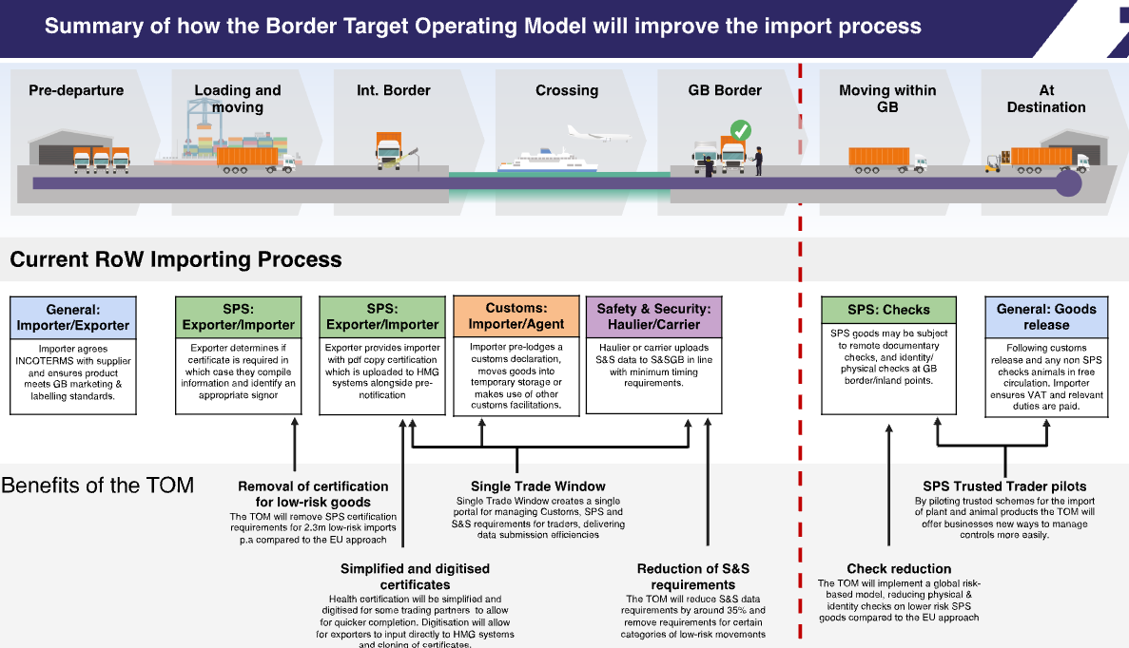
Figure 17: Summary of the new law
(Source: GOV.UK, 2025)
The new 2025 UK Food Strategy refresh and post-Brexit Border Target Operating Model represent an increment in costs to imported inputs and a benefit to products sourced locally like the Hedgerow and Harvest. Its 2025 SDIL threshold review is an indication of making sugar bands stricter as of April 2027, which will give no-added-sugar brands tailwind regulation (GOV.UK, 2025).

Economics
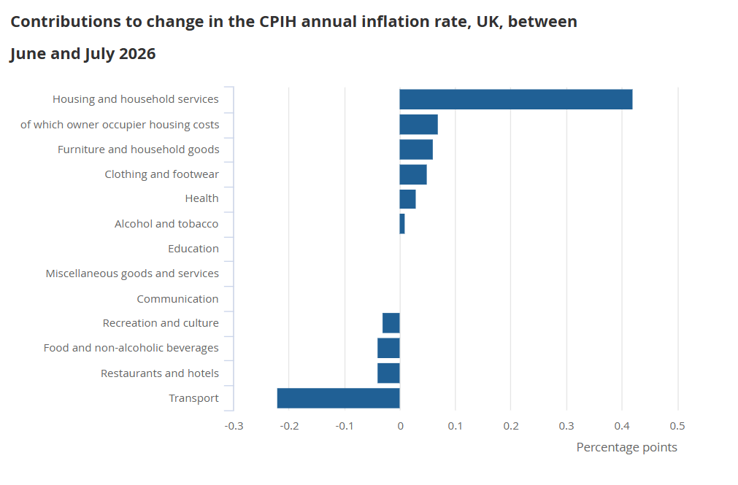
Figure 18: Contributions to change in the CPIH annual inflation rate
(Source: Office for National Statistics, 2026)
Inflation of food and non-alcoholic beverages has hit 4.1% Y/Y in Q2 2026 and real household disposable income has been increasing by just 0.8% in 2025. The premium adult soft drinks, however, surged 8% in value in 2025 with the category resistant to inflation at the target occasion. The 4% rate of the Bank of England in mid 2026 makes growth capital costly, yet not handsome (Office for National Statistics, 2026).

Social
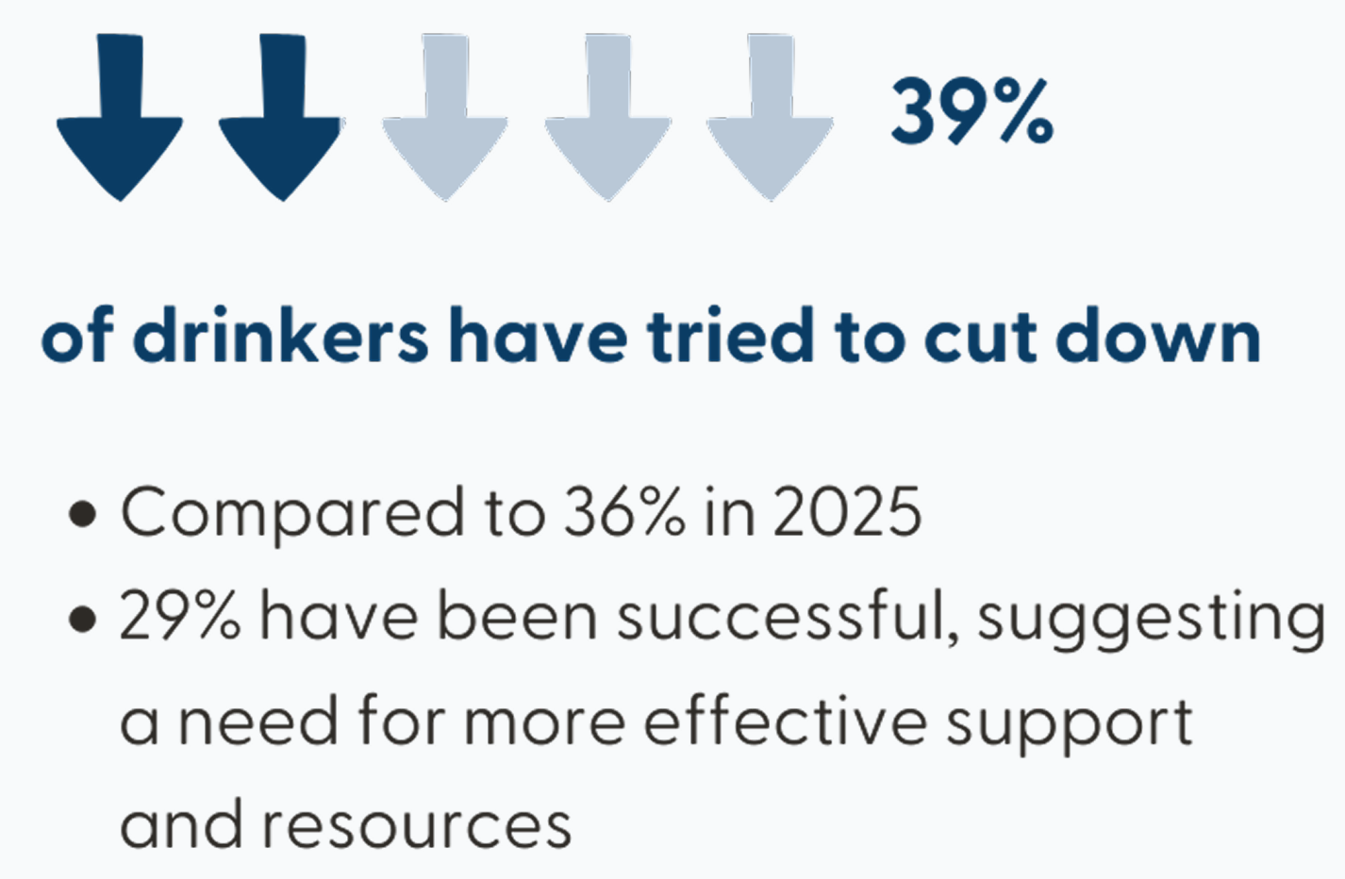
Figure 19: Reduction in the Alcohol Consumption in UK
(Source: Drinkaware , 2026)
By 2025, approximately 39% of UK adults cut their consumption of alcohol and 26% of adults aged 25-44 years call themselves non-drinkers or low-frequency drinkers. The percentage of alcohol-free beverage sales increased 15% in 2025, and ingredient transparency is a top-three driver of premium buyers (Drinkaware , 2026). These changes are structural and can be directly related to the proposal of Hedgerow and Harvest.

Technological
Unit economics of craft brands have improved owing to a reduction in the cost of shelf-stable pasteurisation by about 18% since 2022 (Couto et al., 2026). In 2025 direct to consumer subscription platforms increased 22% in the UK non alcoholic drinks category and by 2028, social commerce has the potential to achieve up to £16billion.

Legal
The Soft Drinks Industry Levy, rendering the HFSS placements restrictions longer in 2025, and the Modern Slavery Act reporting all increase the compliance cost, but at the cost of predominately censoring competitors with high sugar content and opaque supply chains, in favour of transparent craft entrants (Dhuria et al., 2025).

Environmental
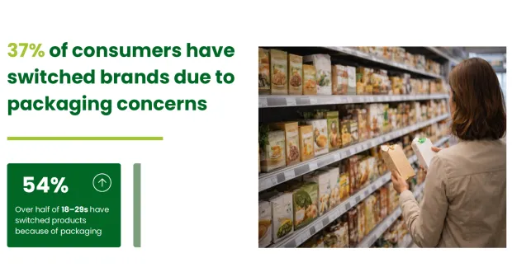
Figure 20: Impact of packaging for UK Consumers
(Source: Corbin, 2026)
UK organic packaging considered important by the consumers attained highs of 73% in 2026, and the introduction of glass bottle deposit returns schemes in Scotland (in 2025) and England (in 2027 planned) redefines the equation of packaging economics. Fruits grown locally lessen the amount of carbon embedded in them, and this is why having a defensible sustainability claim (Corbin, 2026).

6.6 Industry Attractiveness, Gaps, and Synthesis
It is neither a competitive environment that is uncontested. Growth in categories is good at 4-8% by segment depending on sub-segment, structural social changes favour the proposal and regulation is a direct reward to no-added-sugar entrants. The competitive set is filled but skewed toward older sugar profiles and mainstream flavours with a defensible white space at the junction of British seasonal fruit, no added sugar and named-farm provenance and adult occasion positioning (Market Data Forecast, 2026).
The deviation is more than just a new craft soft drink Fentimans, Belvoir, Bottlegreen and Luscombe already occupy most of that field but a product that offers rescued and surplus of British apple and cherry throughout the year, traceability out to the farm, less than 2g-sugar formula, and year-round supply at accessible high prices. No individual is in all four offices at the time (Rusu et al., 2026).
Risks remain material. There is a high buyer power at the various grocer level, threat of substitutes as own-label-premium continues to increase, and rates of craft brand survival below 40% to its second year confirm risk of execution (Seda Gökdemir Ekici et al., 2025). The opportunity can best be defended in the event that Hedgerow & Harvest succeeds in acquiring three to five named-farm supply-contracts as founding provenance evidence, rolls out into independents and Waitrose regional stores prior to national grocer negotiation, and invests in, social-first storytelling to transform the 44% switch-willing shopper base into the strategic, operational, and financial analyses to come.

Chapter 7: Strategic Analysis and Business Strategy

7.1 Strategic Situation and Frameworks
Chapters 5 and 6 have determined that the Hedgerow & Harvest Ltd will sell premium adult soft drinks in a UK market results in a 20.4 billion in 2025 with a functional sub-market of £1.9 billion and white space is defensibly in the area of British seasonal fruit, no added sugar, named-farm provenance and annually growing at over 6% (Milk More, 2025). The proposed structural social changes include 39% of UK adults making less frequent alcohol purchases in 2025, and 63% of high-end consumers making ingredient transparency a leading purchase motivator in 2026 prefer the proposal, and the competition is at a medium, not a saturated level. In this chapter, VRIO was employed to analyze internal resources, SWOT to translate external and internal analysis into strategic inquiries, an ordered alternatives assessment, to justify the selected course of action and value-proposition and competitive-advantage analysis, to clarify how the venture is going to win (Larbi, Asare-Danquah and Akua, 2024). The application of the frameworks is not exhaustive but selective with a view to the decisions that guide execution in the first two or three years.

7.2 Internal Analysis Using VRIO
VRIO considers the Valuableness, Rareness, Costliness to Imitate, and Organisational supportability of each priority resource or capability to transform it into sustained advantage. There are six resources that are evaluated.
Resource / Capability | Valuable | Rare | Costly to Imitate | Organised | Implication
Named-farm British seasonal fruit contracts (5 growers by year 1) | Yes | Yes | Yes | Partial | Temporary competitive advantage; strengthen with exclusivity clauses
Shelf-stable pasteurisation recipe (sub-2g sugar) (Serviss et al., 2025) | Yes | Partial | No | Yes | Competitive parity; not a defensible edge alone
Founder food-industry supply-chain expertise (GOV.UK, 2025a) | Yes | Partial | Yes | Yes | Sustained advantage during launch phase
Provenance storytelling and content assets | Yes | Yes | Partial | Partial | Temporary advantage; requires ongoing investment
Contract-bottler relationship | Yes | No | No | Yes | Competitive parity
Direct-to-consumer digital infrastructure | Yes | No | No | Yes | Competitive parity; table-stakes in 2026
Table 1: VRIO Analysis
The named-farm contracts, founder expertise and provenance storytelling are the strongest ones. There was a total of about 4.5% of the 2025 top-fruit crop that was not picked by farmers, according to Defra, which provides Hedgerow & Harvest with the potential to access leftover fruits, which volume-driven supply agreements do not easily emulate (GOV.UK, 2025a). The main organisational mismatch is scale-up capacity: three UK contract bottlers already have approximately 61% of independent craft soft drinks capacity, and therefore the venture would need to ensure there is guaranteed slot to work into its capacity scale benefit into shelf space (Serviss et al., 2025). Recipe formulation and infrastructure DTC are at parity - needed to compete without differentiating. Hedgerow & Harvest has two to three true sources of advantage but has to invest in the exclusivity contracting, brand-content production capacity, and bottling-slot security to shift the sources between the temporary ones and the enduring ones.

7.3 SWOT and Strategic Issues
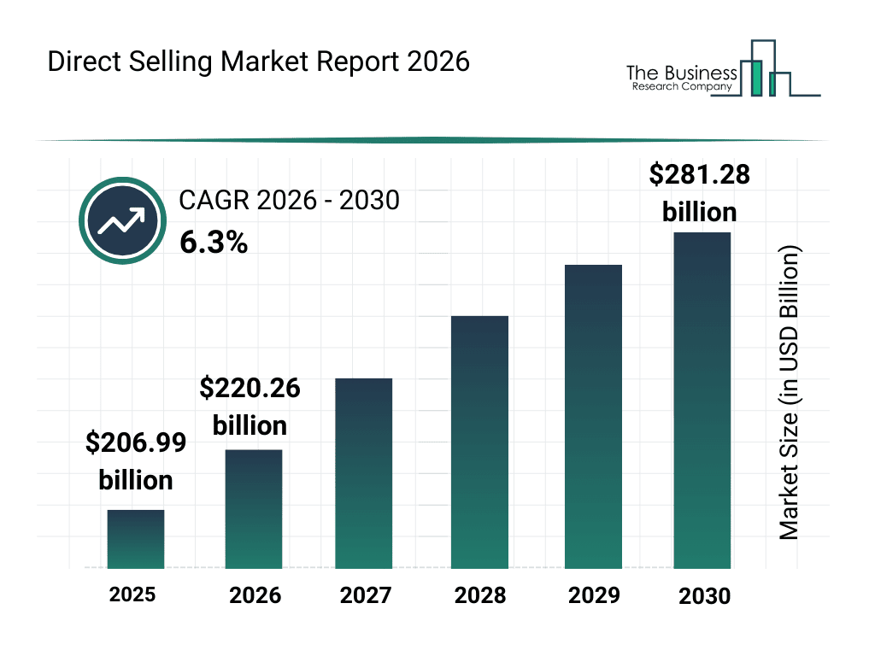
Figure 21: DTC Selling Market Report
(Source: Lee, 2026)

Strengths | Weaknesses
Named-farm British provenance with surplus-fruit sourcing | New brand, zero shelf equity at launch
Sub-2g sugar formulation aligned to 2027 SDIL tightening (Flynn and Johnstone, 2025) | Small production runs limit unit economics in year 1
Founder supply-chain expertise | Limited marketing budget vs Fentimans (~£42m turnover)
Alignment with 39% adult alcohol reduction trend | Dependence on 3 UK contract bottlers (WePack, 2026)
Opportunities | Threats
£1.9bn functional segment growing >6% annually | Buyer power: £8,000–£25,000 grocer listing fees per SKU (Farrell, 2026)
44% of premium buyers tried a new craft brand in past 12 months | 34% craft soft drink survival rate to year 2 (2025 cohort)
DTC subscription category grew 22% in 2025  (Lee, 2026) | Own-label premium cordials grew 14% in 2025
SDIL band tightening from April 2027 | Food/beverage inflation at 4.1% in Q2 2026
Table 2: SWOT Analysis
Strategic Issues:
There are four strategic issues. First, how to transform temporary provenance advantage into sustained advantage prior to re-positioning and reformulating by larger competitors (Thomran et al., 2022). Second, the way to finance route-to-market when at various levels of grocer without draining launch capital of listing fees. Third, what to do to create brand equity that can match the 34% survival curve due speed. Fourth, by what means to hedge cost inflation, without compromising high-quality-of-premise. The alternatives that will be considered here are a direct result of each issue (Dekimpe and Heerde, 2023).

7.4 Strategic Alternatives and Choice
Three options of strategies were formulated as feasible and compared to five criteria based on market analysis and competitive analysis: fit with target segment, capital efficiency, defensibility, growth ceiling, and execution risk.

Alternative A: Focused differentiation through independent retail
Introduce, in the first year, in 30 standalone grocers, farm shops and delicatessens in the South-East and West Midlands, three flavours that will be sold in 150 independents and Waitrose regional in the first year of operation in year two, and hospitality in year three. Premium pricing at £2.75–£3.25 (Thomson, 2026).

Alternative B: Direct-to-consumer subscription-first
Incorporate a subscription box into launching DTC on Shopify using social-first content in Instagram and Tik Tok to launch with a broad assortment of flavours on five seasonal flavours. Retail is a 3-year question (Keenan, 2026). Prices will be charged at the price of 3.50 per bottle and include a subscription discount of 2.90%.

Alternative C: Multiple grocer volume entry
Promoted with Waitrose and Sainsbury at opening directly listed, launched with bold offers of promotional price of £ 2.20 and high volume of production by single contract bottler. Pass over the independent stage.

Chosen strategy: Alternative A — Focused differentiation through independent retail, with a supporting DTC channel.
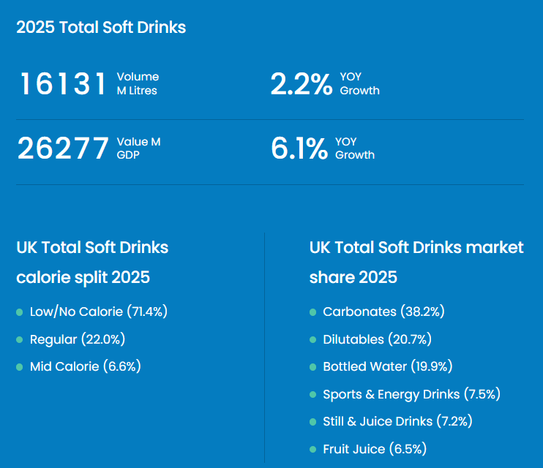
Figure 22: 2025 Total Soft Drink Shifts
(Source: SENIOR, 2026)
Alternative A is chosen since it aligns with the advantages in the form of resources found in VRIO, capital protection in the most risky and one-year crunch period and access to the 22% segment of the premium flow diverted to independents by 2026, exposure to the listing fee minimum. It honours the 34% second-year survival rate, focusing on unit economics as opposed to volume (Knapp, Gebauer and Wortmann, 2025). DTC is a supplementary network, roughly a quarter of first-year revenue base, that will provide both the venture with direct customer insights, much-smoother subscription economics, and brand-story control, without relying on subscription economics, per se (SENIOR, 2026). Negotiation with multiple grocers will be postponed to the third year, when they will be leveraged with information on brand equity and rate of sale (Wang et al., 2024).
The other options rejected are based on various reasons. Alternative B does not sufficiently leverage on the supply-chain experience of the founder and limits growth and expansion to less than the £1 million mark at which point the venture is fundable to do series-A expansion (The Carta Team, 2025). Alternative C puts untested brand equity at risk of exposure to grocer commercial conditions, revenue circulates between inventory and promotional pricing have an eroding effect on the premium positioning the value proposition relies upon and puts the brand at risk of being one of the 66% of craft brands that do not survive the second year.

7.5 USP, Value Proposition and Positioning
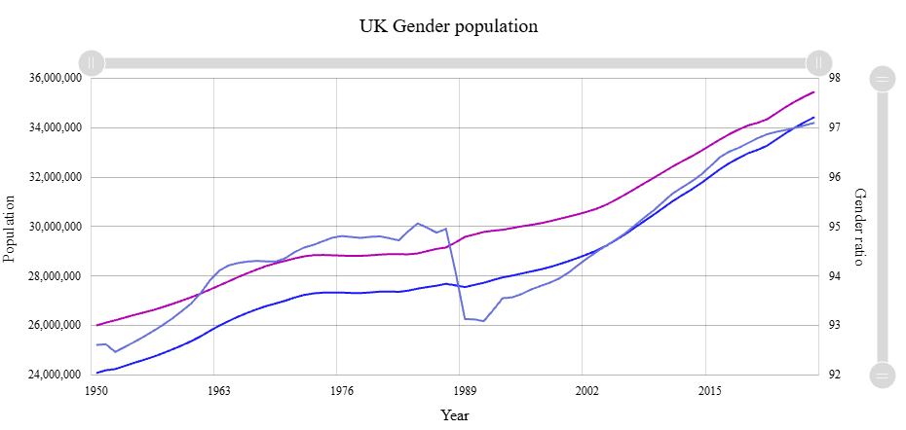
Figure 23: UK Gender Population
(Source: Worldometer, 2025)
Target market: UK adult (28-49) health-conscious, urban/commuter-belt inhabitants in the South-East and the West Midlands, sober-curious and provenance-driven. This is the segment that will stand at about 9.5 million people in 2026 (Worldometer, 2025).
Problem: 47% of buyers (adults) in 2025 do describe existing low-sugar soft drinks as too sweet, or too artificial, and 38% say they are not satisfied with how ingredients are labelled. Non alcoholic beverages in grown up parties are limited.
Benefits: Five unique-British four-seasonal flavours of fruit (elderflower, rhubarb, damson, sloe, gooseberry), less than 2g sugar per 100ml, verifiable provenance by farm, year-round shelf-stable, and adult-refined flavour profiles as a replacement of alcohol, or rehabilitation in its own right.
Demand evidence: 39% of adults in the UK decreased alcohol consumption in 2025, premium adult soft drinks increased in value by 8% in 2025, 63% prioritize ingredient transparency and 54% prioritize British provenance as the best purchase drivers in 2026 (Roberts, 2026).
Point of difference: No one offers rescued and surplus British seasonal fruit, sub-2g sugar formulation, named farm traceability, and shelf stable year-round provision at a price of £2.75–3.25. Fentimans has heritage but no sugar, Belvoir has British botanicals but not adult low-sugar and Luscombe has craft and organic but costs £2.90 -3.50 with no emphasis on the fruit of the seasons. At the intersection is Hedgerow & Harvest (Dahmir et al., 2025).
The positioning statement is the following:
“Amongst sober-curious adults in the UK looking to enjoy unalcoholic sophisticated non-alcoholic events, we are proposing that Hedgerow and Harvest is the British seasonal fruit soft drink that gives you such provenance of the farm and sugar-free in an all-year-round shelf-stable format, because nothing goes to waste and nothing gets added”.

7.6 Competitive Advantage and Success Factors
The five success factors that have been discussed in Chapter 6 are tackled as follows.
Provenance credibility
The established credibility of provenance is assured by month twelve with five named-farm contracts with exclusivity on surplus and Class II fruit, and batched-level QR provenance on every bottle. This turns a fleeting benefit into a long-lasting one by tying up supply that competitors can not access on a large scale without additional business links.
Reformulation and sugar credentials
Sugar credentials and reformulation is bought with 2g sugar of less than 100ml, before a tightening of sugar SDIL in 2027. This christens the range future-proof against regulatory change and excludes most of the existing SKUs on the incumbent range repositioned with no recipe change to be direct competitors (Betts, 2025).
Distinctive flavour range
The range of flavours is already unique with five British season botanicals namely elderflower, rhubarb, damson, sloe, gooseberry none of which any of the four main competitors have yet claimed as category-defining flavour. There is no significant direct competitor within the premium adult category that Damson and sloe share, as of 2026 (London Juice Company Editorial Team, 2024).
Route-to-market breadth
The selectivity of route-to-market occurs over a period of three years:
- Year 1: year one includes independents (and the Waitrose regional and hospitality);
- Year 2: year two includes multiple grocer negotiation (and DTC);
- Year 3: year three includes all three years.
The sequencing exposes them to buyer power to the weight of the accumulated rate-of-sale of between £8,000–25,000 against accumulated split evidence per SKU listing.
Cash-flow resilience against seasonality
Shelf-stable pasteurisation of freshly picked fruit to bottle all year round mitigates the pressure of seasonality on cash-flow, which was found to be a primary cause of insolvency in 41% of craft soft drinks (Polak et al., 2024).
The main capability difference is the marketing budget in comparison to Fentimans (~£43 million turnover). It has been tackled with a social-first content approach building on the 22% growth in the category of DTC in 2025, founder-led narrative with farm-visit content content, and bypassing a budget limitation with an authenticity motive (using farm-visit content).

7.7 Strategic Synthesis
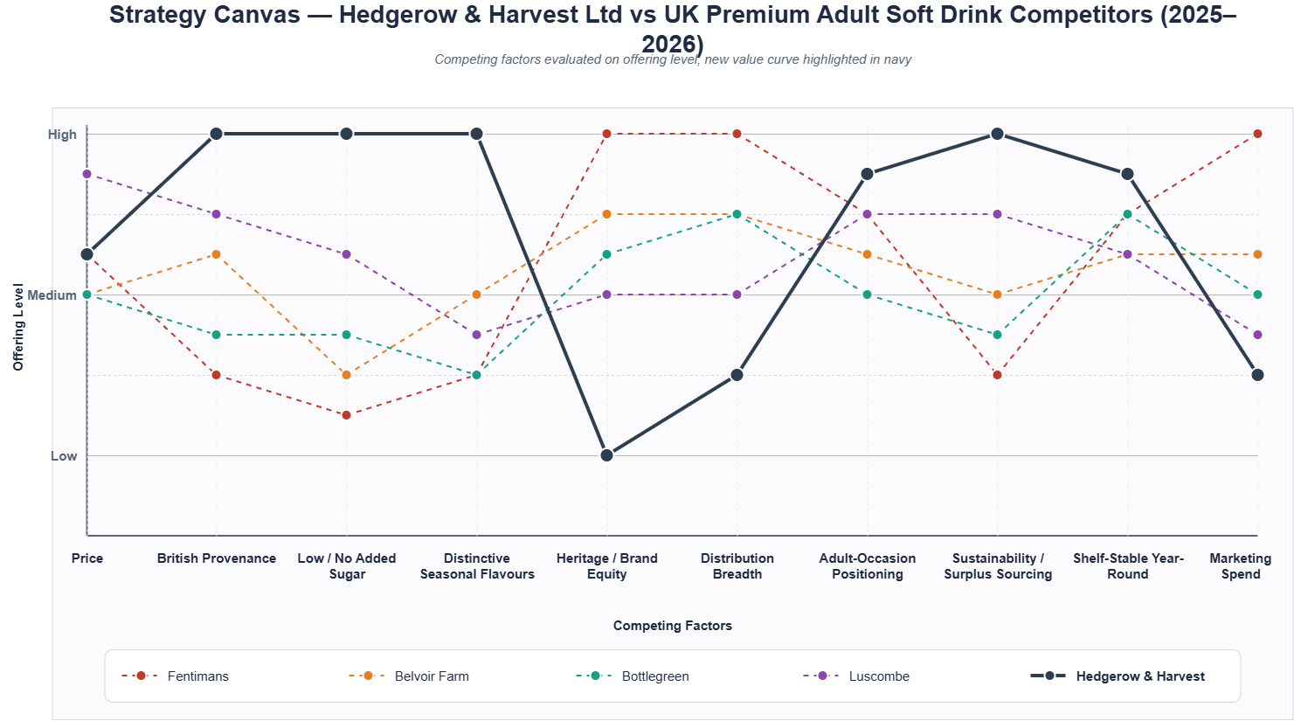
Figure 24: Strategic Canvas
(Source: Self Created in Draw.io)
Hedgerow & Harvest will follow the path of focused differentiation as an independent-retail operation with a complementary, year-round, with a DTC channel, guarded by named-farm provenance, sub-2g sugar formulation, unique British seasonal fruit range, and year-long, shelf-stable supply (marknteladvisors, 2025). The strategy would be feasible when three conditions are met; the named-farm exclusivity must be contracted prior to expenditure on national marketing, and the contract-bottler slot allocation must be secured on year-round production, and the DTC cost to get customers must be less than 28 pounds per subscriber (Singh et al., 2025). The main threats, which are buyer power in groceries, food-and-beverage inflation of 4.1%, and a craft brand survival of less than 40%, are mitigated by entering the channel step-by-step, and austerity unit economics. This strategic decision guides the operational analysis, marketing analysis and financial analysis subsequently.

Chapter 8: Business Model Canvas

8.1 Model Overview and Alignment
This chapter will implement the focused-differentiation strategy of Chapter 7 into an operating business model of Hedgerow and Harvest Ltd. This is because the Business Model Canvas helps in integrating customer, value and infrastructure and financial logic into a linked system so that the linkage between segment, offer, delivery and economics can be validated even prior to launching (Jamira, Agustiningsih and Febriani, 2021). The entire nine-block canvas is shown in the Appendix A; here each element is described and assessed in narrative.

8.2 Customer Segments and Value Proposition

Priority Customer Segment
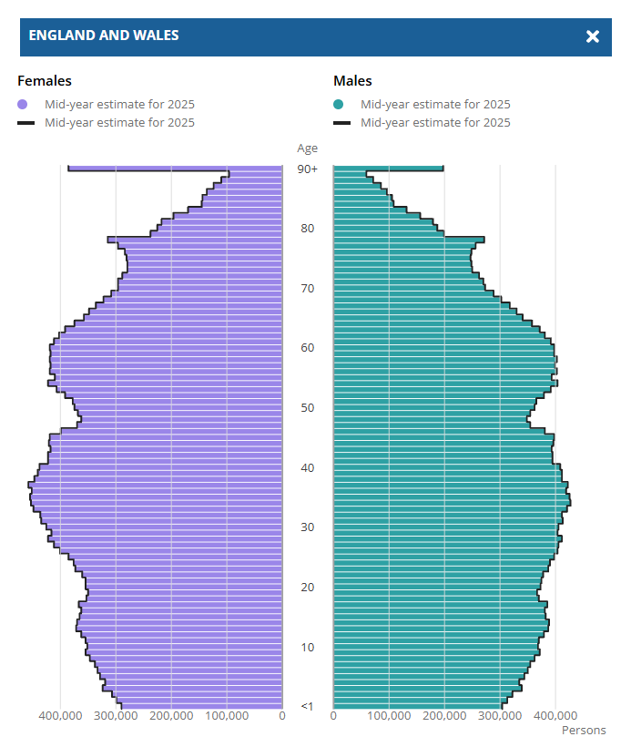
Figure 25: England and Wales Age wise Population
(Source: ONS, 2026)

The focus market is UK adults aged 28-49, the socio-economic grade of the ABC1, living in London, South-East and West Midlands that consider themselves sober-curious and provenance-motivated. In 2026, this group had a population of around 9.5 million (ONS, 2026). The buyer and user are one and the same and buying is intended to treat himself/herself, to entertain, for alcohol-replenishment purposes. There is a secondary segment of independent hospitality accounts, which is deferred to year two.

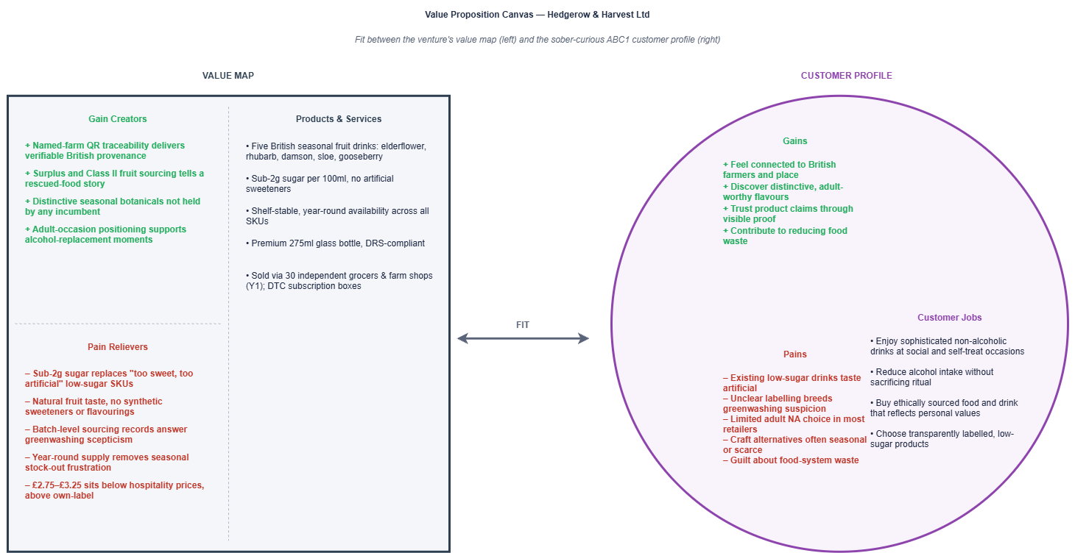
Value Proposition

Figure 26: Value Proposition Canvas
(Source: Self Created in Draw.io)
Hedgerow and Harvest offers a collection of non-alcoholic Five-Shelf-Stable British seasonal, in-named-farm, rescued-surplus fruit drinks, at 2g or less sugar per 100ml, to sober-curious UK adults, at £2.75-£3.25 each. The value proposition deals with a certain unmet requirement: 47% of those consumers in the UK who buy low-sugar products claim that current offerings are either too sweet or too artificial in 2025, and that no single player in the market offers flavours based on British-grown botanical, British produce, farm traceability, and year-round availability (if they exist) and at a price premium-accessible to the consumer (Speciality Food Magazine, 2025a).

8.3 Channels and Customer Relationships

Channels
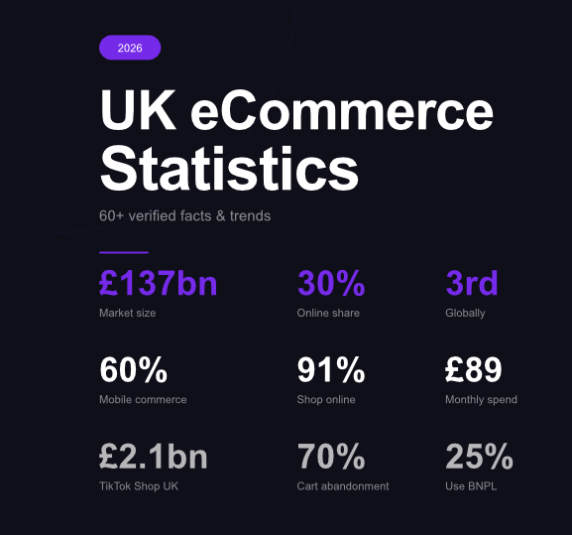
Figure 27: UK eCommerce Statistics
(Source: Boase, 2026)
The first year includes two channels. First, independent retail 30 farm shops, delicatessens and independent grocers, with a concentration of premium food-and-drink spend in the South-East and West Midlands, and with a total with a source of approximated 22% of UK premium spend on food-and-drink in 2026 (Jones-Fenleigh, 2026). Second, direct-to-consumer through Shopify with subscription (four and eight-bottle boxes). UK retail eCommerce reached approximately £137 billion in 2026, representing steady 4.0% year-over-year growth following 3.5% growth in 2025 (Boase, 2026).

Customer Relationships
Personal-assistance through founder-led sampling and account management are the independent retail relationship. DTC connection: Self-service purchase with community-building, purchased a named-farm content on Instagram and Tik Tok, in order to transform the 44% of those who purchased a new craft brand during the last twelve months. The customer acquisition cost is estimated under 28 per subscriber which is a benchmark UK non-alcoholic DTC will be in 2025.

8.4 Revenue Streams and Cost Structure

Revenue Streams
There are two streams of revenue. Sale at wholesale to independents at 40% trade margin (1.65 / asp. retail value, 2.75 reflecting retail value) make up 75% of revenue in year one. DTC subscriptions sales of £2.90 are on a per unit basis and conversion of 25% based on target conversion rate of 3.2% on paid traffic and retention of 68% every 3 months. The revenue objective in the first year is 480,000 at 290,000 in year one, which will increase to 1.15 million in year three.

Cost Structure
This has a unit contribution at a rough approximation of 0.45 wholesale and 1.70 DTC which provides a blended contribution of just enough to cover the fixed expenses at about 210,000 units, which is well short of the 290,000 unit mark in the first year.

8.5 Key Resources, Activities and Partnerships

Key Resources
These are named-farm supply contracts, 5 British growers (3 signed, 2 being negotiated), the sub-2g sugar recipe and pasteurisation specification (created with a food-technologist consultant), slot allocation to the contract-bottler is obtained to provide all-year-round production, knowledge of founded food-industry supply-chain, and the founding capital of £180,000 in equipment deposits, opening inventory and marketing (Choudhury, 2025).

Key Activities
The four are strategically critical activities: sourcing to coordinate across seasonal harvest windows to strive to secure all the average surplus and Class II fruit before unpicked (as Defra estimates 4.5% of the 2025 UK top-fruit harvest ended up in orchards), scheduling of the contract-bottler to make the year-all-year-round supply, creating content to share the provenance story on Tik Tok and Instagram, and managing independent-retail accounts. Routine administration, finance and compliance are outsourced.

Key Partnerships
Partner | Contribution | Terms | Dependency
Five named British growers | Surplus and Class II seasonal fruit; provenance narrative (British Growers, 2022) | 3-year exclusivity clauses on surplus lines | Moderate — multiple grower alternatives regionally
UK contract bottler | Shelf-stable pasteurisation and bottling capacity | Fixed monthly slot allocation | High — three bottlers hold 61% of UK craft capacity
Food-technologist consultant | Recipe formulation and QA protocols (Eurofins , 2026) | Retainer + royalty | Low — substitutable
Shopify + logistics partner | DTC platform, fulfilment | Standard commercial terms | Low

8.6 Integration, Assumptions and Conclusion
The ABC1 segment cares about provenance and low sugar, which will be delivered using independents and DTC reaching them at sufficient acquisition cost, named-farm contracts and contract-bottler slots, financed by blended wholesale and subscription revenue at the appropriate contribution level that will cover fixed cost by the month of ten. The crucial assumptions are that named-farm exclusivity is lock-inable prior to national marketing expenditure, slot allocation in contract-bottler contracts is lock-in and that DTC acquisition cost is lower than £28 per subscriber (Brown, 2025). They will be tested in each first two quarters, which will inform the marketing, operations and financial forecasts in subsequent chapters.

Chapter 9: Financial, Marketing and Sales, and Human Capital Management Plan

9.1 Integrated Plan Overview
The three interdependent systems presented in Hedgerow Harvest marketing overall are financial discipline, customer acquisition, and customer retention and organisational capability. In the financial model the initial revenue is estimated to be £569,000 in the first year of operation as compared to the start-up expenses estimated at £180,400, with a cumulative net profitability at mid two years. The initial UK marketing expenses of £75,000 in the first year will be aimed at acquiring a mixed customer base at £15 each DTC subscriber with the 4-person founding team becoming 18 persons in year five with a labour overhead of 31-32% of revenue. The chapter incorporates these plans, assumptions of stress-tests under the conditions of market 2025-2026 as well as the governance to keep each accountable to quantifiable goals (Majka, 2024).

9.2 Financial Plan

9.2.1 Financial Assumptions

Table 4: Financial Assumptions
(source: spreadsheet)
Table 4 indicates key financial inputs. The retail shelf price of £2.75 in year one increasing to £2.95 in year three indicates positioning that is premium-accessible with gaps to Luscombe (£2.90-£3.50) and pub soft drinks (£3.50-£4.50) and separation to own-label (£1.20-£1.50). The 40% trade margin is consistent with the UK typical independent grocery economics (Foodomarket, 2026). The 290,000 units in year one will be based on 30 separate accounts with an average of 8,000 units per year supported by DTC at 25% of mix. Variable costs, calculated per unit, totaling 1.28 are compared to 2025 contract-bottling rates and Defra surplus-fruit, and 3% ratio per annum indicates the scale of procurement. There is a fixed cost of £155,000 which is the cost of founder salary, marketing, compliance, rent and professional services.

9.2.2 Start-up Costs and Funding Requirements

Table 5: Start-up Costs and Funding Requirements
(source: spreadsheet)
Table 5 lists a pre-launch capital of £180,400. The production run at the most (first run: 60,000 bottles) accounts to the largest commitment (£42,000); next is the launch marketing (£22,000) and buffer (£38,000 covering three months operating shortfall). The contingency generation is 10% (£16,400) which offers protection against overruns. Sources of funds are founder equity (£60,000), friends-and-family SEES shares (£50,000), Start Up Loans Company (£25,000 at 6.0%), Innovate UK grant (£20,000 non-dilutive) and supplier trade credit (£25,000). Innovate UK grant is competitive and it cannot be assumed so the risk is a bridging of £20,000 in case of unavailability (Glencoyne Editorial Team, 2025).

9.2.3 Operating Cost Structure

Table 6: Operating Cost Structure
(source: spreadsheet)
Table 6 projects cost over a period of five years. COGS will reduce to £1.14 on year five representing a volume rebate and purchase efficiencies, achieved by the first year variable of £1.28 per unit. The least flexible line is the one that has packaging at £0.36 per unit and provides compliance with the anticipated deposit returns scheme from 2027. Fixed costs grow from £155,000 to £358,800 by year five as headcount scales from 4 to 18. The 70:30 variable to fixed ratio in the first year implies that volume deficits squeeze better than increases in input costs, which shape the sensitivity hierarchy (Wall Street Prep, 2024).

9.2.4 Revenue Model and Pricing Strategy

Table 7: Revenue Model and Pricing Strategy
(source: spreadsheet)
Table 7 gives a projection of two-channel revenue in a period of five years. Wholesale revenue/unit (£1.65 or net of 40%) Revenue collection in 1 year will yield a 75% business year one, and by one year five, a 60% will shift to DTC (£2.90 per unit) will rise by 25 to 40% of mix. Total revenue rises from £569,000 to £2.78 million. With a gross margin of 74% versus 22% with the wholesale channel, 1% point switch to DTC increasing blended margin by about 0.5 points on the mix - channel-mix management is as strategic as shelf pricing (GeeksforGeeks, 2024).

9.2.5 Financial Projections

Table 8: Five-Year Profit & Loss Forecast
(source: spreadsheet)
Table 8 and the five-year P&L: The depreciation, and interest on the loans (1 in year one) result in annual EBITDA of £43,000 (7.5% margin) with the result being near-breakeven. The second-year EBITDA will be £209,000 (21% margin) where fixed-cost absorption will be enhanced by 480,000 units. At year five, the EBITDA is at £1.15 million (41% margin) and cumulative net profit is £2.02 million. The corporate tax of 19% applies after the second year. A 20% volume deficit in the first year would bring EBITDA to the verge of zero with a net-profit breakeven spanning a half-year to the mid-year of the third year.

9.2.6 Break-even Analysis

Table 9: Break-even Analysis
(source: spreadsheet)
Table 9 validates that breakeven is about 227,000 bottles per year, with only 21.7% margin of safety on the border even with 290,000 units of projected production. At the given volume, the contribution per unit is £0.68 which is used to cover the fixed costs of 155,000. In year two, the margin is expanded to 50.9% and 65.0% in year three. The year-one margin is, however, small by food-venture standards, in which seasonal changes can temporarily quash a 15-20% change in one quarter, which explains the significance of the £38,000 working-capital buffer and the quick pace of acquiring the DTC (GeeksforGeeks, 2023).

9.2.7 Sensitivity and Scenario Analysis

Table 10: Sensitivity and Scenario Analysis
(source: spreadsheet)
Table 10 stress-tests three scenarios on three years of base-case. Downside EBITDA falls to £178,000 (16.2% margin) from a base of £482,000 (31.3%); Upside rises to £739,000 (38.8%). The most significant driver of the sensitivity is volume (±10% changes the EBITDA by ±£87,000) because the amount of its influence is substantial; next comes price (±£63,000), variable cost (±£38,000), fixed cost (±£24,000).

9.3 Marketing and Sales Plan

9.3.1 Market Segmentation and Target Audience
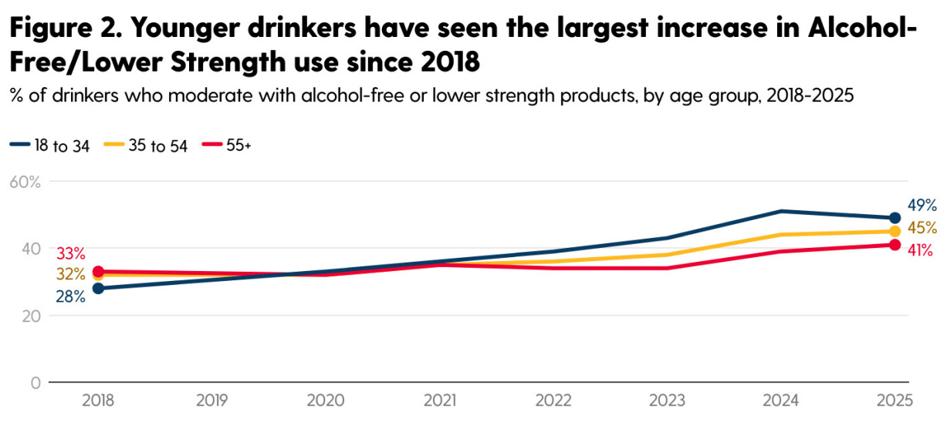

Figure 28: Younger drinkers have seen the largest increase in Alcohol- Free/Lower Strength use since 2018
(Source: Drinkaware, 2025)
The target market is the sober-curious, health-aware UK adults aged 28-49 in the ABC1 grade, with a central location in London, the South-East and West Midlands. With annual monitor 2025, Drinkaware (2025) reports that one in four adults aged 25-44 in the UK states that he or she is a non-drinker or drinks less than once a week.
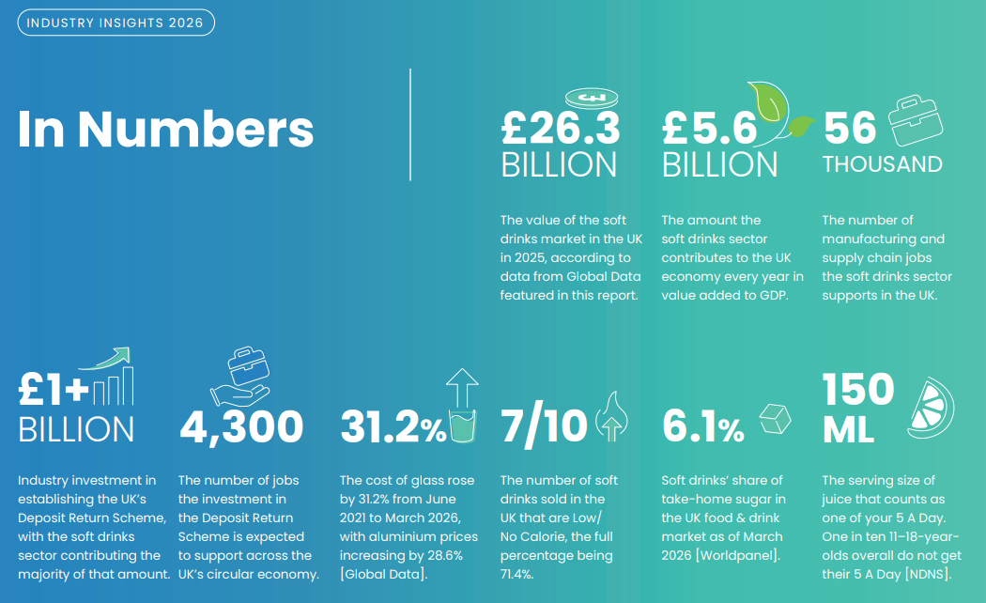

Figure 29: British Soft Drinks Sales
(Source: British Soft Drinks Association, 2026)
This was confirmed in the 2025 annual report of the British Soft Drinks Association (2026), which established that the UK market sales in the competitive market had reached more than £26.3 billion in retail outlay with the proportion of the no-and-low sugar types now representing the majority sales. ]Hedgerow estimated to have an addressable population of about 9.5 million, Hedgerow aims to reach these two groups within the market.

9.3.2 Positioning Strategy
The business is positioned with no established player holding them at once: British seasonal botanicals are unique, sugar is under 2g in a future when SDIL is due to tighten, and batches of farm product are traceable. This willingly abandons the mass-market convenience to mainstream brands and the heritage story to Fentimons and Belvoir who will compete upon a verifiable provenance and sophistication of the adult occasion (More, 2026).

9.3.3 Marketing Messaging
Communications are driven by three pillars which include provenance authenticity achieved through batch-level QR traceability; adult sophistication which puts the range in the position of being an alternative drink to alcohol without needing artificial sweeteners, which preempts doubts about reformulated beverages; and no-added-sugar credentials, without artificial substitutes.

9.3.4 Marketing Mix — 7Ps
Product: Five SKUs available in 275ml premium glass bottles that are shelf-stable (pasteurised) with a hand-drawn farm image and QR traceability (Homer, 2024).
Price: £2.75 --£3.25 retail; DTC subscription at £2.90 (17% discount on RRP).
Place: Retail either on their own (30 accounts in year one, 150 in year three) or through the Shopify platform, Waitrose local in year two and several grocers in year three.
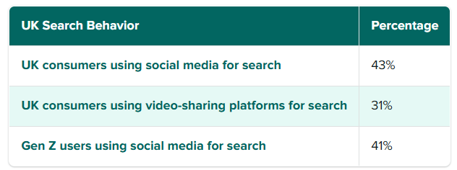

Figure 30: UK Search Behavior
(Source: McNamee, 2025)
Promotion: Paid social (Meta and Tik Tok), earned media via trade and lifestyle media, owned (Klaviyo email, Instagram, Tik Tok organic), in-store sampling and seeding of influencers (McNamee, 2025).
People: Founder-led account management; social community response within 24 hours one with subscriber stories.
Physical materials: Embossed glass bottle, specially designed DTC unboxing (recycled cardboard, seed-paper insert, founder note), positioning in check-out shelf (at eye level) (Dabo, 2025).
Process: A one-click Shopify checkout with the flexibility of pause or skip, WhatsApp-based retail ordering, quarterly farm newsletters to subscribers and retail partners.

9.3.5 Customer Acquisition Strategy

Table 11: Customer Acquisition Funnel
(source: spreadsheet)
Table 11 simulates the DTC funnel: 4.2m impressions translate to 168,000 visits (4% CTR), 8,400 carts (5%), 3,360 trials (40%) and 1,680 subscribers (50%). Blended GAC of pound 15 = 25200 spend/1680 conversions. Lifetime value referenced at £119.62 gives a ratio of LTVtoCAC of 7.97x. Any such decrease in retention to 50% would shrink this to about 4.0x - it would work but would need more discipline (IanKirk, 2026).

9.3.6 Digital and Offline Marketing Tactics
Digital deploys in the areas of awareness (video storytelling), consideration (comparison content), conversion (discount code and free shipping), and retention (Klaviyo win-back sequences). Offline involves five quarterly farmers market sampling, 8-12 micro-influencer seeding varies by partnership and costs £150-£500 each and trade-show presence at events including Speciality and Fine Food Fair (WTF WELLNESS, 2026).

9.3.7 Sales Strategy

Table 12: Sales Strategy & Controls
(source: spreadsheet)
Table 12 establishes channel goals and named owners and corrective action. The retail targets (30 accounts, 6 units each store in one week floor) are checked monthly to keep an eye on the new sales and allowable sales (4 units per week) of two quarters which leads to a sampling refresh or delisting. DTC will focus on 1,680 subscribers with a quarterly rate of less than 8%. churn. Each start-up will be personally pitched by the founder with the assistance of a part-time salesperson starting in the 6th month (Persico, 2025).

9.3.8 Marketing Budget and Performance Measures

Table 13: Marketing Tactics & Measurement
(source: spreadsheet)
Table 13 assigns the following amount to paid social (35%), content production (15%), influencer partnerships (15%), sampling (15%), trade marketing (10%), email retention (6%) and analytics (4%). Awareness (impressions, reach), engagement (social rate 4-5%, open rate on email more than 30%) and conversion (CAC less than 25, retail rate of sale more than 6 in the week) are performance indicators (Gökdemir Ekici et al., 2025).

9.4 Human Capital Management Plan

9.4.1 Organisational Structure

Table 14: Human Capital — Organisation & Roles
(source: spreadsheet)
Each role is enumerated in table 14 as 10 positions in four layers: executive, function heads, managers and field executors. There is an increase of 4 to 18 in five years. This pyramid is based on relationship-oriented retail selling and content intensity in the early years and moves to system based execution on a scale.

9.4.2 Staffing Requirements

Table 15: Compensation, Benefits & Compliance
(source: spreadsheet)
Revenue per head holds at £140,000–£155,000 across five years. The timely bottleneck year-one staffing at 4 FTE: the departure of any founding hire causes an unabsorbable vacancy, and equity participation is a strategic focus.

9.4.3 Labour Costs

Table 16: Staffing Plan & Labour Cost
(source: spreadsheet)
Table 16 shows labour cost growing from £178,000 (31% of revenue) to £899,000 (32%) by year five. Blended cost per head year one foundation is shown to be at 44,500 (including 13.8% employer NI and 3% pension) compressed founder salaries and lean staffing, increasing to 50,000 in year five as bands turn normal.

9.4.4 Recruitment and Selection

Table 17: Recruitment, Training & Development
(source: spreadsheet)
Table 17 contains detailed information on channels and costs: head functions through executive search (£3,500, 10 weeks), sales representatives through FMCG boards ( £600, 4 weeks). The mission alignment is based on 50% and domain expertise on 40% because the entrepreneurial experience of the venture is a crucial aspect of the retention narrative.

9.4.5 Training and Development
Every recruit goes through a one-week orientation program, which consists of a visit to the farm. Additional training in specific roles encompasses Food Safety Level 2 (£85), FMCG selling skills (£450) and Digital certifications. Training budget per head of between £450 per year ranges up to 8100. The path development plans (Sales Rep to KAM after 18-24 months, KAM to Head of Sales after 36 months) minimize cost of external recruitment (DemandFarm, 2024).

9.4.6 Compensation, Benefits and Compliance
Table 13 establishes salary scales: founder starting at £38,000 to increase to £75,000 within five years. On-costs by employers are 19.8% (13.8% NI, 3% pension, 2% health benefit after year two). The compliance register recognises 10 legal requirements — PAYE, auto-enrolment, employers liability, product liability, health and safety policy, GDPR, right-to-work checks, SDIL registration, food business registration and equality policy — and at a cost of £4,460 per annum (Citizensinformation.ie, 2024).

9.5 Integration and Conclusion
The three plans support each other: monetary discipline finances marketing investment that brings in customers who generate money to keep the team running. Retail sell-through velocity of year-one (compulsory), DTC retention above 68% quarterly and founding-team retention. Sensitivity hierarchy is tracked, where the volume is followed by the price then the cost, with corrective measures being initiated within 30 days of a KPI violation. Under the assumptions, cumulative net profit is obtained as it is in year five of operation that is £2.02 million; otherwise, phased channel strategy and lean fixed costs offers restructuring flexibility prior to the running out of capital (Cataligent, 2025).

Chapter 10: Operations Plan

10.1 Operating Model, Scope and Frameworks
The adopted asset-light model will remain with Hedgerow and Harvest, which will keep the sourcing of fruits, the recipes, the brand management and quality control in house, and outsourcing bottling, warehousing services and distribution. This restricts fixed investment and enables production to match the demand. The recent studies associate digitalisation and adaptive abilities with the food-supply-chain resilience (Pal et al., 2024; Panigrahi et al., 2024). The framework is integrated with workflow mapping and capacity planning as well as supplier coordination and compliance monitoring of the 290,000-bottle Year 1 target.

10.2 Operational Workflow and Capacity

10.2.1 End-to-End Workflow
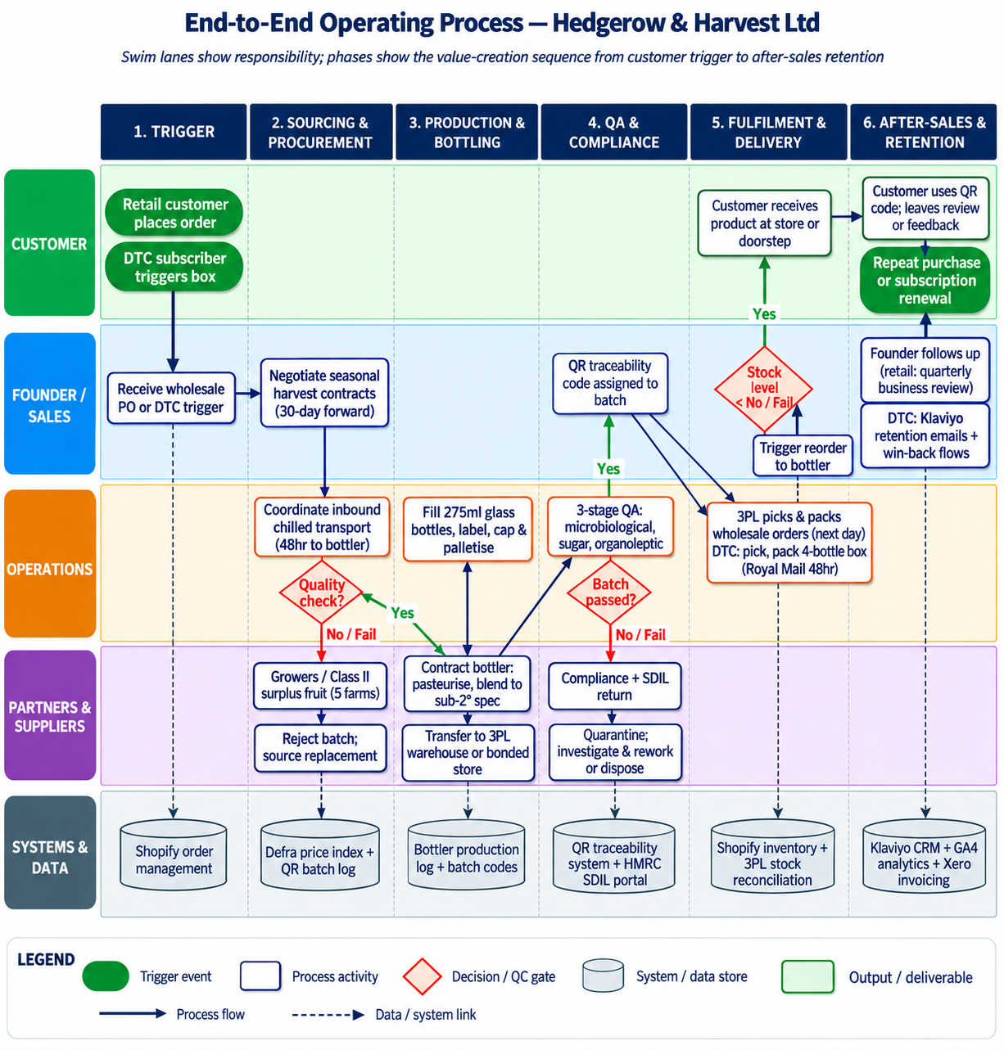

Figure 31: Process Map
(Source: Self Created in Draw.io)
The process includes six phases such as seasonal sourcing, inbound in-house, contract production, quality release, warehousing and outbound fulfilment. The growers of the five British growers will provide surplus which will be Class II and beyond harvest windows with transport to the West Midlands bottler within 48 hours. Pasteurising, blending, filling, labelling, capping and palletising will be done by the bottler of the five-SKU range. Prior to the release, these will be the 3PL storage and backup testing in batches. Orders under wholesale will be delivered in the country and the DTC boxes will be delivered by Royal Mail Tracked 48. Food supply chains can enhance visibility and risk control through the sharing of information (Sharma et al., 2024). Customers shift the shelf discovery-purchase to DTC customers shifting to the digital exposure-Shopify subscription. The capacity is 320,000 bottles/ Year 1 to offer a 10% surpass on the forecast sales. The 28,000 bottles allocation per month is adequate, and the allocation can be expanded to 60, 000. The risks focus on the scheduling of the bottlers and scheduling the harvest. The ability to reserve capacity, the provision of flexibility of contracts and inventory buffers are supported by research (Guo et al., 2024).

10.2.2 Customer Journey and Capacity
The initial Year 1 will be based on a common Greater London office, although possible Year 2 relocation to a South-East or West Midlands specific unit. The manufacturing will be co-packed in West Midlands, and distribution and fulfilment will be supported by a Slough 3PL hub in South-East and national. The location factors relate to access to grower areas, transportation routes and key retail areas. No bottling or pasteurisation and packaging equipment will be owned. Technology will ensure the control industry by Shopify Plus, Klaviyo, Xero and a QR-based traceability system connecting the product with the farming data and harvest data. The transparency and traceability of food-supply-chain can be reinforced with the help of digital technologies (Sharma et al., 2024; Vasileiou et al., 2025). Google Analytics 4 and Meta Pixel will be used to serve marketing attribution and inventory will be supported initially by Shopify and 3PL records which will be eventually migrated to a lightweight ERP. There is a common digital infrastructure that helps in coordinating with the external partners

10.3 Location, Facilities, Equipment and Technology
The initial Year 1 will be based on a common Greater London office, although possible Year 2 relocation to a South-East or West Midlands specific unit. The manufacturing will be co-packed in West Midlands, and distribution and fulfilment will be supported by a Slough 3PL hub in South-East and national. The location factors relate to access to grower areas, transportation routes and key retail areas. No bottling or pasteurisation and packaging equipment will be owned. Technology will ensure the control industry by Shopify Plus, Klaviyo, Xero and a QR-based traceability system connecting the product with the farming data and harvest data. The transparency and traceability of food-supply-chain can be reinforced with the help of digital technologies (Sharma et al., 2024; Vasileiou et al., 2025). Google Analytics 4 and Meta Pixel will be used to serve marketing attribution and inventory will be supported initially by Shopify and 3PL records which will be eventually migrated to a lightweight ERP. There is a common digital infrastructure that helps in coordinating with the external partners. The IT decisions will be checked periodically after one year based on the number of transactions, service demands and data-security specifications.

10.4 Supply Chain, Procurement, Inventory and Logistics
Procurement will merge five UK suppliers of vegetables, one UK co-packer, and two suppliers of packaging. Surplus and Class II fruit will be covered by three year contracts to provide continuity but growers can sell Class I product. Annual pricing will undergo an evaluation against the market standards. Two suppliers would be used, 90-day lead times, and quarterly orders to minimize the use of a single-source. The studies see supplier diversification and collaboration as resilience mechanisms and closer producer-supplier relationships as the way to help with localisation of procurement (Singh and Dwivedi, 2024; Alzate Rendón et al., 2025; Wilkinson et al., 2024). Ambient finished products will be achieved following pasteurisation, which will favour a shelf life of 12 months without the need to maintain a cold-chain. The few wholesale cover will be 60 days, the DTC cover will be 30 days and 10 percent safety stocks at the 3PL. Such buffers facilitate resilience (Guo et al., 2024; Zhang and Yang, 2025). Inbound fruit will be coordinated by the founder to hauliers. Next-day South-East (and 2-day national) fulfilment will be aimed at delivery, and orders with DTC will be delivered within 48 hours. In areas where there is a good coordination of producers, short food supply chain can promote sustainability and resilience (Jia et al., 2024).

10.5 Quality, Compliance and Operational Controls
There will be three points of control in quality management, which will include the inspection of incoming raw materials, verification of in-process pasteurisation and testing of final products. The visual quality, Brix, microbiological, processing parameters and organoleptic characteristics and sugar specifications will be covered in terms of checks. Hazard identification and preventive controls will be systematised according to evidences about systematic food-safety management in relation to HACCP principles (Aslani et al., 2024). BRC certification of the co-packer will help with the assurance, as well as supplier audit and batch records. Digital traceability will also bridge batches to farms and harvest dates which will assist in investigation and recalls. Food traceability and the ability to react can be enhanced with the help of QR and blockchain technologies (Vasileiou et al., 2025; Guo et al., 2025; Collart et al., 2025). The business will be registered as food-business, insure and Soft Drinks Industry Levies, records will be kept to be audited. The data covered by the UK GDPR controls will include DTC data, marketing consent, privacy notices and cookies. Governance is necessary in digital food-supply-chain systems, but they should also be interoperable and have data-quality controls (Panigrahi et al., 2024; Molin et al., 2024).

10.6 Operational Synthesis
In general, the operating model is the integration of outsourced manufacturing and managed sourcing, digital trace, inventory buffers and dedicated logistics. The main dependencies include co-packer capacity, and available fruit seasons. The diversification of suppliers and safety stock and alternative logistics offer interim reservation, which is scalable when implementing and minimizes the initial fixed investment and operational risk. Without the need of owning manufacturing assets, implementation can thus be made possible.

Chapter 11: Feasibility Analysis

11.1 Feasibility Basis and Decision Criteria
Hedgerow & Harvest is evaluated in terms of ethical and market, technical/operational, financial and strategic feasibility. The evaluation compares the evidence provided in Chapters 5-10 with set launch conditions and finds out which dimensions are feasible or conditionally feasible. This method acknowledges that SMEs viability is not determined by any financial level but by the interplay of resources, market environment, business-model formulating and risk (Merín-Rodrigáñez, Dasi and Alegre, 2024).

11.2 Ethical and Market Feasibility

11.2.1 Ethical and Stakeholder Acceptability
The potential benefit of the venture to British growers, consumers and the food system lies in the fact that excess and cosmetically less than perfect fruit can be turned into a commercial product. The studies indicate that consumer acceptance of imperfect produce can be enhanced with the help of proper communication and positioning (Zhao, Cai and Song, 2024; Xiao et al., 2024). Positive norms about imperfect produce may be enhanced through social-media communities, as well. Rebate sourcing, which is also known as named-farm sourcing and QR traceability are additional measures that promote transparency but claims should not be impossible to establish. It is reported that the information of traceability may enhance consumer confidence and buying habits (Nguyen and Nguyen, 2025).

11.2.2 Market Demand and Competition
Market proposal takes advantage of carrying on the UK sugar cutback. Government evidence shows that significant progress is being made in the elimination of sugar in beverages that are covered by SDIL. The sub-2g formulation envisaged as such is aligned to a trend direction in an established market. Surveys further indicate that the traceability is important to the consumers, and tastes vary across consumer segments (Tran et al., 2025). Hedgerow and Harvest blend low sugar, BP, seasonal botanicals and name-farm traceability. Purchase intentions are likely to be higher after marketing imperfect produce with an appropriately framed communication (Xiao et al., 2024).

11.3 Technical/Operational Feasibility

11.3.1 Workflow, Technology and Capacity
The outsourced option is not invested in major manufacturing, and the guaranteed production of 28,000 bottles per month gives enough year 1 capacity as compared to the 290,000 units expected. The digital traceability is technically correct since modern studies attribute the identification of digital systems, as tools to enhance supply-chain coordination and business-model capability (Merín-Rodrigáñez, Dasi and Alegre, 2024; Shaik et al., 2024). Product-information transparency can be enhanced by using QR-based traceability as well.

11.3.2 Suppliers, Staffing and Compliance
Three grower contracts out of five are in place with two contracts constituting the main operation dependency. The disruption vulnerability may be diminished through supplier diversification whereas stakeholder alignment helps in maintaining sustainability of the supply-chain (Uttam, Dutta and Singh, 2024). To ensure the resilience of SMEs, it is also crucial to identify strategic and external risks in a systematic manner (Glowka, Hule and Zehrer, 2024). Doc-proced and a Year 2 Key Account Manager will decrease founder dependency. Operational feasibility: conditionally feasible, provided that the rest of the grower contracts are fulfilled before a production can be made.

11.4 Financial Feasibility

11.4.1 Revenue, Margin and Break-Even
In the financial model, Year 1 revenue will be 290, 000 units translate to a revenue of 569, 000 with an EBITDA amounting to 43,000 as a 7.5 percent margin. Break-even at 227,000 units is estimated giving it a 21.7% volume buffer. Gross margin is expected to rise to 54% in Year 5 because of rising sales of DTCs. These assumptions show that there is potential financial viability, although the outcome is sensitive to sales volume, price and COGS. Research on SMEs has shown in the day that competitive strategy and innovation may affect the performance of a market but results are constrained by the ability to execute the strategy (Rubio-Andrés et al., 2024).

11.4.2 Funding and Sensitivity
The current fund package of 180,000 will take into account the 180,400 start up and still has a potential gap of 400. The proposed UK innovate grant of the assumed amount of £20,000 cannot be perceived as being guaranteed as UK innovation financing is competitive and requires one to be eligible based on the individual contests. The business must then have another funding option by use of additional equity, debt or other possible non-dilutive financing. The research on entrepreneurial resilience also suggests that adaptive capabilities within the SMEs are required in case of turbulence in the market (Shore et al., 2024). Financial feasibility: conditionally feasible, with the withdrawal of the funding gap.

11.5 Strategic Fit, Risks and Mitigation

11.5.1 Strategic and Business-Model Fit
Focused-differentiation strategy is consistent with the business model proposed via named-farm provenance, independent retail, direct-to-consumer subscriptions and outsourced production. Recent studies show that business-model innovation can complement SME competitiveness especially when the firms match the digital capabilities with value creation and delivery (Fang et al., 2024). Business-model innovation can also be used by SMEs in agri-food to deal with the sustainability and the emerging market conditions (Bruni, Magno and Cassia, 2025). Strategic flexibility is mainly applicable where the conditions of operation and in the market vary. Strategic feasibility: feasible.

11.5.2 Material Risks and Mitigation

Material risk | Mitigation
Weak retail sell-through | Increase sampling, promotional activity and DTC acquisition.
Co-packer capacity withdrawal | Secure alternative UK co-packers and contractual production slots.
Harvest disruption | Maintain multiple growers, regions and safety stock.
Competitive imitation | Strengthen farm relationships, traceability and brand equity.
Founder dependency | Document processes and appoint additional management capacity.
Table 18: Material Risks and Mitigation
(self-developed)

11.6 Integrated Viability Judgement
Hedgerow and Harvest Limited is conditionally viable. It meets all four dimensions of feasibility, that is, ethical, market, technical and financial, but has requirements on two: get the remaining two grower contracts before first production, and make sure the Innovate UK grant or an equivalent non-dilutive source of funding is secured. The SDIL regime, alcohol-moderation trends as well as consumer demand of provenance transparency structurally support the market opportunity. This financial model has positive EBITDA of year one and net profit of cumulative of £2.02 million during year five under the base-case assumption, a condition which is profitable even in Downside scenarios. The main implementation risks, namely, retail sell-through velocity, contract-bottler dependency and founder single-point-of-failure, can be mitigated with the identified mitigations (Sahu, 2024; Rubio-Andrés et al., 2024). The two mentioned conditions must be achieved by the end of the third month after which the venture can be implemented.

Chapter 12: Implementation Plan

12.1 Implementation Approach and Launch Phases
Hedgerow & Harvest will adopt a launching process in three phases that are controlled, which incorporates milestone planning with monthly review and adjustment. Agile is the right solution since it can enhance responsiveness, communication, and problem-solving in the case of an SME when resources are limited (Sagala and Őri, 2024).
Phase 1 Pre-launch (Months 1 to 4): incorporation, trademark registration, finalisation of recipes, agreement with growers, contracting bottlers, preparations of technology and initial production.
Phase 2 Soft launch (Months 5 to 4): launch Shopify DTC sales, obtain the initial 1520 independent retailers, initiate sampling and paid-social campaigns and experiment with repeat purchasing.
Phase 3 - Scale (Months 9-12): establish 30 retail accounts, maximise DTC retention and prepare the regional Waitrose pitch. A staged implementation minimises exposure to resources and but permits evidence of initial trading to affect latter investment.

12.2 Milestones and Timeline

12.2.1 Key Milestones
Implementing on a milestone basis offers management clear points of decision making on the status of progress, resource allocation and remedial measures. In the studies of project-management, monitoring, coordination of stakeholders and clear requirements are among the aspects of implementation underscored. The milestones thus connect completion of operations to commercial readiness.

12.2.2 Gantt-Style Implementation Schedule
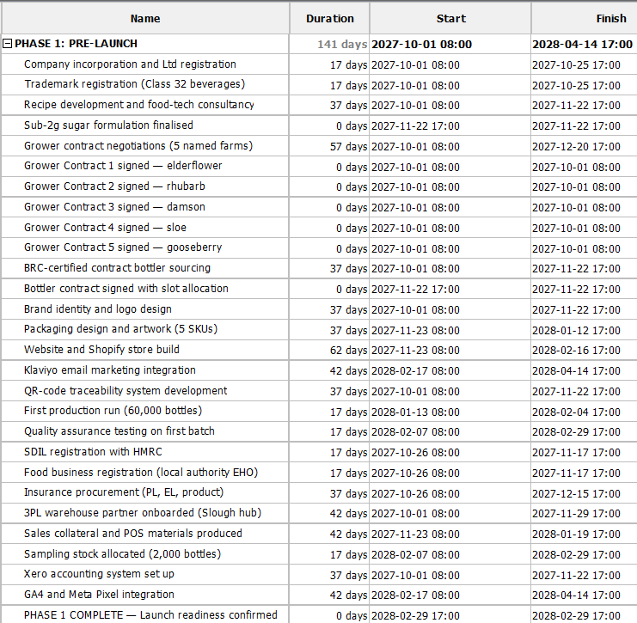
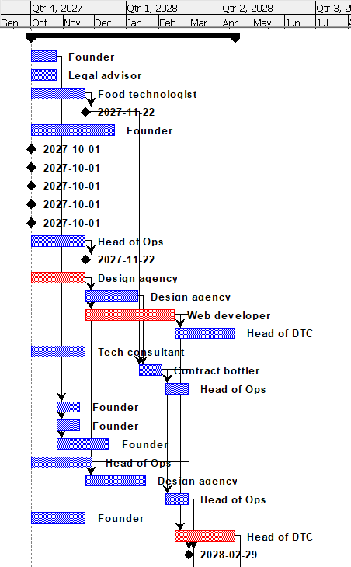
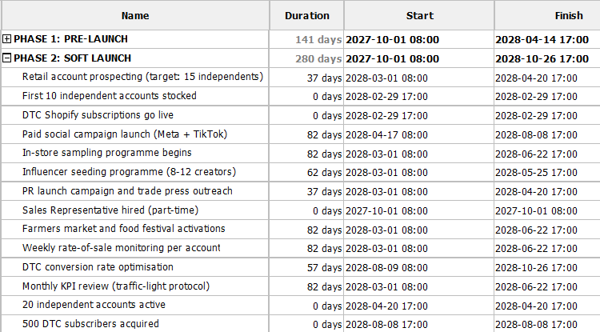
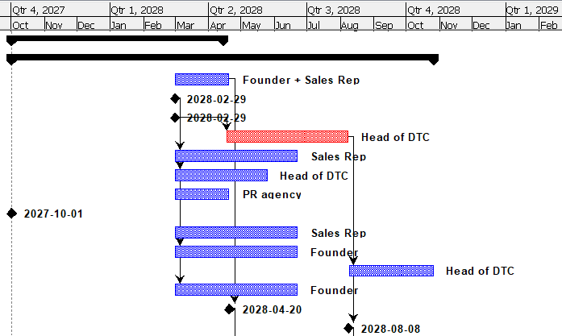
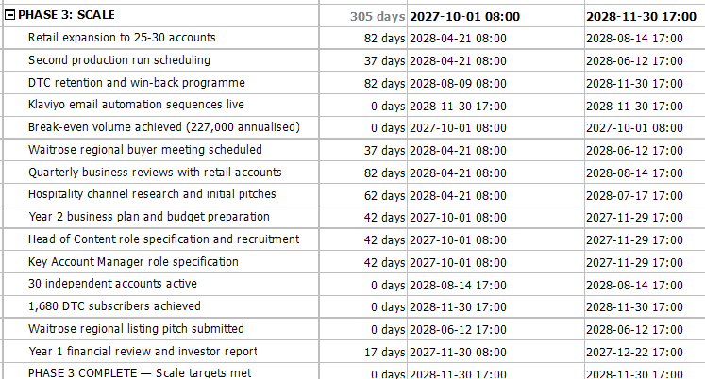
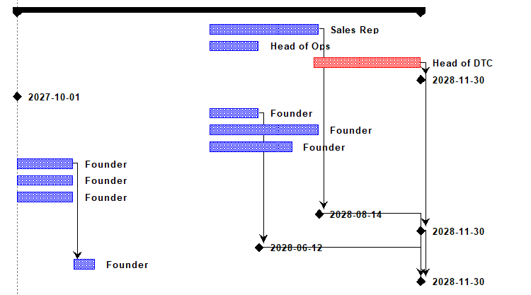

Figure 32: Gantt Chart
(Source: Self Created using Project Libre)
The most important path is recipe development numpy bottler contracting grower contracting first production retail launch. During Months 1–4, the development of the websites, the preparation of brandings and marketing workings are in progress. Slowings in the bottler or grower contracting will have direct influences on the production and time of launch. Agile project management allows iterative planning whose requirements and dependencies get modified as the project is taken on.

12.3 Resource Allocation and Priorities

12.3.1 Resource Allocation
Resource | Allocation
People | Founder, Head of Operations, DTC lead; Sales Representative from Month 6
Finance | £180,000 funding package allocated against launch requirements
Technology | Shopify, Klaviyo, Xero and QR traceability
Suppliers | Bottler, growers and 3PL contracted progressively
Equipment | Outsourced manufacturing; minimal owned equipment

Table 18: Resource Allocation
(self-developed)
The implementation of digital investment will be gradual to prevent over spend on digital initially. The study of SMEs indicates that readiness at an organisational level, support and availability of resources provided by managers, affect successful application of technologies (Jewapatarakul and Ueasangkomsate, 2024). The digital capability may also underpin the efficiency of allocation of the resources in a case when properly integrated into business processes (Duan and Zhang, 2025).

12.3.2 Short- and Long-Term Priorities
The focus in Months 1-6 will be on grower and bottler security, product-market validation and DTC commissioning. Months 7-12 focus on retail growth, retention of subscribers and Waitrose pitch preparation. Performance reviews at the end of the month will indicate how to redeem resources between the acquisition, sampling, inventory and staffing. This staged deployment is aligned with the data that SMEs enjoy the benefits of scalable, resources suitable digital implementation (Febriani, Sopha and Wibisono, 2025).

12.4 KPIs, Monitoring and Control

12.4.1 KPI Measures and Targets
KPI | Target | Review
Grower contracts | 5 | Monthly
Production | 60,000 initial bottles | Per batch
Retail accounts | 30 by Month 12 | Monthly
DTC subscribers | 1,680 by Month 12 | Monthly
Retail rate of sale | 6 units/store/week | Weekly
DTC CAC | ≤£30 | Weekly
DTC retention | ≥68% quarterly | Quarterly
Break-even volume | 227,000 units annualised | Monthly
Table 19: KPI Measures and Targets
(self-developed)

12.4.2 Monitoring and Control
The founder will preside monthly KPI meetings in a traffic-lights format: green denotes on target, amber denotes within 10% of target and red denotes greater than 10% below target. Results that require a corrective-action plan should be within 14 days; red result leads to an immediate reallocation of resources. Board reviews (quarterly) will be used to evaluate strategic progress and expenditure. Constant revision is especially applicable to SMEs as the digital transformation process entails continuous adaptation and not a single implementation (Held, Heubeck and Meckl, 2025).

12.5 Change Management and Implementation Risks

12.5.1 Change Management
The primary difficulty facing the product will be the ability to convince the independent-retailers to give shelf space to an unknown brand. Perceived retailer risk will be minimised through founder-led selling, 60 day trials, sampling and rate-of-sale evidence. The fair pricing, exclusive access to surplus-fruits, and visiting the farm content will be promoted to growers. Implementation and transformation can be facilitated through leadership and collaborative organisational relationships through better coordination and involvement (Ho, 2025). Organisational readiness and knowledge learning is also a prerequisite to digital adoption (Jewapatarakul and Ueasangkomsate, 2024).

12.5.2 Implementation Risks and Contingencies
Risk | Contingency
Bottler delay | Two-week schedule buffer and alternative co-packer
Grower failure | Substitute supplier from wider UK grower base
Shopify outage | Static landing page and email capture
Founder incapacity | Documented SOPs and Head of Operations authority
Table 20: Risks and Contingencies
(self-developed)

12.6 Implementation Readiness Summary
The bottler contract and five grower contracts, combined with funding (£110,000 founder/SEIS equity) will place Hedgerow and Harvest in a position to commence Phase 1. Control will be provided through monthly KPI reviews, 14-day cycles of corrective-action and quarterly strategic review. Implementation model hence integrates phased investments, milestones which are measurable and contingency plans. This strategy facilitates the resilience when there are limited resources but enables the business to reorganize resources as the environment creates new situations (Park and Seo, 2024).

Chapter 13: Conclusion and Recommendations

13.1 Evaluation of Theoretical and Analytical Frameworks
To evaluate the viability of Hedgerow and Harvest Ltd, this proposal used an analytical series of frameworks in a systematic fashion. Porter's Five Forces determined a result of moderation-high competition rivalry and positive conditions of entry of a differentiated craft provider (Ndzabukelwako et al., 2024). PESTLE inferred structural tailwinds against cost-of-living headwinds limiting discretionary spending, the Soft Drinks Industry Levy and the alcohol moderation trends and the increasing provenance demand. VRIO made certain that named-farm contracts and founder-supply-chain-expertise represent short-lived competitive advantages, which could be upgraded with exclusivity and brand-accumulation. The competitive B2B focused differentiation was based on SWOT and a strategic-alternatives analysis that supported independent retailing that had a complementary DTC channel. Business Model Canvas was able to combine all nine components into a harmonious system (Singh et al., 2025). The contribution of each framework was its own layer; it all led the proposal to an evidence-based decision.

13.2 Synthesis of Key Findings
In 2025 the British Soft Drinks Association estimated the market in retail sales of soft drinks in the UK to be over £20 billion, of which products with no sugar and low sugar content had the majority volume of production, despite the advent of the SDIL in 2018. According to HMRC data, the average sugar content decreased by around 46% in the period between 2015 and 2025, which was solely in favour of the entrants of sub-2g -sugar. The premium across the adult soft drinks have been rising as compared to the market average which has been facilitated by alcohol-moderation trends recorded in Drinkaware annual monitor (Vigh, Attwood and Roudaut, 2024). Hedgerow & Harvest has no positioning no incumbent has at once: British seasonal fruit, traceability of named-farms, less than 2g sugar content, availability throughout the year on shelves.

13.3 Overall Feasibility Judgement
The venture is a conditional viable venture in all of the four dimensions. Surplus-fruit rescue and transparent sourcing generates positive externalities, ethically. Demand is structurally supported commercially and white space justifiable. The outsourced model can technically be provided with verified bottler capacity. In terms of finances, EBITDA will go positive in year one ( £43,000) and cumulative net profit will become positive with the model making a profit of 2.02 million by year five and under Downside conditions the model will still be profitable. Conditions: Before production Production before remaining grower contracts are secured, prove that they have secured funding through Innovate UK, 30 retail accounts in nine months.

13.4 Strategic Recommendations
Four recommendations emerge. The first is to carry out focused differentiation using independent retail, and then to move on to multiple-grocer distribution, and develop rate-of-sale support on negotiations with Waitrose and Sainsbury (Xiao, Chen and Yu, 2021). Second, consider DTC as a strategic way of achieving margin and data; LVM-to-CAC ratio denotes a 7.97x, which signals excellent economics to support long-term paid-social investment. Third, put named-farm exclusivity contracts at the top of the list of the most defensible resources of the venture - VRIO confirmed the supply-chain provenance is a resource at once valuable, rare and exceptionally expensive to counterfeit. Fourth, uphold pricing discipline of between £2.75 and 3.25 and avoid promotional discounts that will damage the contribution margin.

13.5 Final Decision
On the basis of the information assembled in the market opportunity, competitive environment, strategic assessment, business model development, financial modelling, launch operations planning and feasibility analysis it is suggested that Hedgerow & Harvest Ltd goes ahead to launch. The business has a real market requirement, it has a defensible market position and it has a real and credible returns, both on base-case and stress-tested modalities. Implementation plan offers gradual, KPI based implementation that is put in place with corrective-action measures and pre-launch conditions can be attained within the three months period.

13.6 Future Development Needs
Phase 1 should establish secondary-data assumptions by primary consumer research, that is, taste panels, willingness-to-pay studies and brand-perception tests. Second, the extension to other adjacent categories (250ml cans to hospitality, 750ml sharing bottles, concentrate cordial) can be considered once the core range gains retail credibility. Third, the possibility of the geographical expansion of the South-East and the West Midlands to Scotland, North-West and online markets abroad must also be explored during the third year of the on-year three stress-testing of the model nationally (Daniel, Fateye and Abanda, 2025).

Reference list
Albattat, A., Fakir, F.Z., Yi, Z. and Hussain, Z. (2025) Innovative Trends Shaping Food Marketing and Consumption, ResearchGate. Available at: https://doi.org/10.4018/979-8-3693-8542-5.
Albert, J. (2026) The UK juice market navigates health trends, inflation pressures, and premium innovation, Global Risk Community. Available at: https://globalriskcommunity.com/notes/the-uk-juice-market-navigates-health-trends-inflation-pressures-a (Accessed: 6 August 2026).
Almeida, F. (2026) “Thematic analysis in qualitative research: Steps, benefits, and challenges,” 5(1), pp. 25–38. Available at: https://doi.org/10.5281/zenodo.18241378.
Bari, N., Chimhundu, R. and Chan, K.C. (2024) “Interrelation between sustainable dynamic capabilities, corporate sustainability, and sustained competitive advantage,” Sustainability, 16(7), p. 2864. Available at: https://doi.org/10.3390/su16072864.
Beeson, J. (2026) Juice shot category value hits £100m, The Grocer. Available at: https://www.thegrocer.co.uk/news/juice-shot-category-value-hits-100m-as-shoppers-seek-convenient-health-hacks/718673.article (Accessed: 6 August 2026).
Buye, R. (2021) Critical examination of the PESTEL analysis model, ResearchGate. Available at: https://www.researchgate.net/publication/349506325_Critical_examination_of_the_PESTEL_Analysis_Model (Accessed: August 25, 2026).
Ceasar, D.M.J. and Sundari (2024) Consumer perception on fruit drinks: A field survey in Tirunelveli District Tamilnadu, South India. Available at: https://www.researchgate.net/publication/380265197_CONSUMER_PERCEPTION_ON_FRUIT_DRINKS_A_FIELD_SURVEY_IN_TIRUNELVELI_DISTRICT_TAMILNADU_SOUTH_INDIA (Accessed: 6 August 2026).
Celestin, M. (2025) Company law. Available at: https://www.researchgate.net/publication/388916935_Company_Law (Accessed: August 16, 2026).
Cheong, H., Lyons, A., Houghton, R. and Majumdar, A. (2023) “Secondary qualitative research methodology using online data within the context of social sciences,” International Journal of Qualitative Methods, 22(1), pp. 1–19.
Chetan Dhatrak and Chakradhar Khansole (2026) United Kingdom functional drinks market by type (energy drinks, sports drinks, probiotic drinks, vitamin drinks, herbal drinks, others); by application (Energy Boost, hydration, immunity, digestion, fitness, others); by end-user (athletes, consumers, fitness enthusiasts, youth, adults, others); by distribution (supermarkets, online, convenience stores, gyms, retail stores, others), by industry analysis, size, share, growth, trends, and forecasts 2026-2033, Transpire Insight. Available at: https://www.transpireinsight.com/report/united-kingdom-functional-drinks-market (Accessed: August 25, 2026).
Citilci, T. and Akbalik, M. (2019) “The importance of PESTEL Analysis for environmental scanning process,” Advances in Marketing, Customer Relationship Management, and E-Services, pp. 336–357. Available at: https://doi.org/10.4018/978-1-7998-2559-3.ch016.
Claight (2026) Juice production in the UK: Market size, businesses and employment (2025 base), Claight. Claight Corporation. Available at: https://hub.claight.com/statistics/juice-production-in-the-uk (Accessed: 6 August 2026).
Cozzolino, A., Corbo, L. and Aversa, P. (2021) “Digital platform-based ecosystems: The evolution of collaboration and competition between incumbent producers and entrant platforms,” Journal of Business Research, 126(0148–2963), pp. 385–400. Available at: https://doi.org/10.1016/j.jbusres.2020.12.058.
Dhatrak, C. and Khansole, C. (2026) United Kingdom Functional Drinks Market, Transpire Insight. Available at: https://www.transpireinsight.com/report/united-kingdom-functional-drinks-market (Accessed: 6 August 2026).
Dhingra, S. and Jaiswal, A. (2025) “Determinants of digital transformation in organisation: A systematic literature review using the TCCM framework,” Social Sciences &amp; Humanities Open, 12, p. 102129. Available at: https://doi.org/10.1016/j.ssaho.2025.102129.
Dhuria, P., Muir, S., Shaw, S., Lawrence, W., Roe, E., Baird, J. and Vogel, C. (2025) “‘It will sort of drive us to rethink our approach to high fat salt sugar products’- a qualitative analysis of businesses’ reactions to the landmark Food (Promotion and Placement) Regulations in England,” BMC Medicine, 23(1). Available at: https://doi.org/10.1186/s12916-025-04384-5.
Diah Ayu Susanti, Fithri, D.L., Gunawan, B., Budiman, N.A., Sri Mulyani and Fajar Nugraha (2024) “The influence of business model canvas on financial performance of micro, small, and medium enterprises (MSMEs),” Journal of Ecohumanism, 3(6), pp. 932–945. Available at: https://doi.org/10.62754/joe.v3i6.4062.
Drinkaware (2025) Alcohol-free and low-alcohol drinks in the UK, Drinkaware.co.uk. Available at: https://www.drinkaware.co.uk/research/research-and-evaluation-reports/alcohol-free-and-low-alcohol-drinks-in-the-uk-trends-barriers-and-opportunities?_gl=1 (Accessed: August 16, 2026).
Esra Oezal and Juergen Münch (2024) “Unveiling customer needs: A comprehensive exploration of jobs to be done interviews,” pp. 48–55. Available at: https://doi.org/10.1145/3643690.3648240.
Food and Agriculture Organization (2026) Freezing of fruits and vegetables, www.fao.org. Available at: https://www.fao.org/4/y5979e/y5979e03.htm (Accessed: August 16, 2026).
Foodsure (2025) Outsourced beverage formulation: Benefits & how to partner, Foodsure. Available at: https://foodsure.co.in/blog/outsourced-beverage-formulation/ (Accessed: August 16, 2026).
Grand View Research (2025) UK Functional Drinks Market Size & Outlook, 2026-2033, Grandviewresearch.com. Available at: https://www.grandviewresearch.com/horizon/outlook/functional-drinks-market/uk (Accessed: 6 August 2026).
Griffin, F. (2026) Fruit Drink & Functional Beverage Production in the UK Industry Data and Analysis, Ibisworld.com. Available at: https://www.ibisworld.com/united-kingdom/industry/fruit-drink-functional-beverage-production/692/ (Accessed: 6 August 2026).
Grocery Trader (2026) Soft drinks gets healthier – consumers are moving towards low and no sugar options | grocery trader, Grocery Trader | Grocer News from Grocery Trader - Latest news and information for the multiple grocery trade in the UK. Available at: https://grocerytrader.co.uk/soft-drinks-gets-healthier-consumers-are-moving-towards-low-and-no-sugar-options/ (Accessed: 6 August 2026).
Hankammer, S., Brenk, S., Fabry, H., Nordemann, A. and Piller, F.T. (2019) “Towards circular business models: Identifying consumer needs based on the jobs-to-be-done theory,” Journal of Cleaner Production, 231, pp. 341–358. Available at: https://doi.org/10.1016/j.jclepro.2019.05.165.
Huang, T. (2023) “Analysis of external, peer, and internal measures of the enterprise,” 61(1), pp. 199–203. Available at: https://doi.org/10.54254/2754-1169/61/20231256.
Lim, W.M., Sethuraman, R., Sakshi Kathuriae and Manrai, A.K. (2025) “Guidelines for data collection and analysis: Considerations for informed marketing in a globalized world,” Journal of Global Marketing, pp. 1–10. Available at: https://doi.org/10.1080/08911762.2025.2460278.
Murray, A. and Scuotto, V. (2015) “The business model canvas,” Symphonya. Emerging Issues in Management, 3(3), pp. 94–109. Available at: https://symphonya.unicusano.it/index.php/sym/article/view/2015.3.13murray.scuotto (Accessed: August 25, 2026).
Nawagomuwage, K.S., M. L. P. Thathsarani, U. A. S. K. Edirisinghe and Methmini Tharanga (2025) “Identification of market potential for carbonated beverages with nutritious local grains,” Lecture notes in civil engineering, pp. 357–365. Available at: https://doi.org/10.1007/978-981-96-8301-7_27.
Petrou Hadjipetrou, I. (2026) “Awareness of Porter’s five forces framework: A research paper,” Journal of Emerging Markets and Management, 2(2), pp. 146–157. Available at: https://doi.org/10.63385/jemm.v2i2.96.
Quail, M. (2026) Juice Production in the UK Industry Data and Analysis, Ibisworld.com. Available at: https://www.ibisworld.com/united-kingdom/industry/juice-production/495/ (Accessed: 6 August 2026).
Sämann, L. (2025) Seasonal nutrition: The natural way to better health, Premiummedicalcircle.com. Premium Medical Circle. Available at: https://premiummedicalcircle.com/en/artikel/seasonal-nutrition-the-natural-way-to-better-health (Accessed: 6 August 2026).
Schutselaars, J., Romme, A.G.L., Bell, J., Bobelyn, A.S.A. and van Scheijndel, R. (2023) “Designing and testing a tool that connects the value proposition of deep-tech ventures to SDGs,” Designs, 7(2), p. 50. Available at: https://doi.org/10.3390/designs7020050.
SMITH, L. (2025) Packaging extended producer responsibility, House of Commons Library. Available at: https://commonslibrary.parliament.uk/research-briefings/cbp-10352/ (Accessed: August 25, 2026).
The On Trade (2025) The Rise of Functional Beverages in the UK Market, The On Trade. Available at: https://theontrade.com/en/blog/your-business-11/trends-21/the-rise-of-functional-beverages-in-the-uk-market-241.htm (Accessed: 6 August 2026).
Umam, M.K. (2026) “The influence of business model canvas and value proposition canvas on MSME productivity: Structural analysis approach,” Journal Research of Social Science, Economics, and Management, 5(9), pp. 11645–11656. Available at: https://doi.org/10.59141/jrssem.v5i9.1439.
West, T. (2026) UK functional drinks market hits £100M, FoodManufacture.co.uk. Available at: https://www.foodmanufacture.co.uk/Article/2026/05/12/uk-functional-drinks-markets-hits-100m-in-value-sales-as-health-consciousness-grows/ (Accessed: 6 August 2026).
White, K. (2024) 2025 Trends in B2B food & beverage: A look at the UK and Europe, Apex. Available at: https://apexb2b.com/blog/2025-trends-in-food-amp-beverage-a-look-at-the-uk-and-europe/ (Accessed: 6 August 2026).
Wilkinson, T.J., Nye, C., Lobley, M., West, H.G., Clappison, A., Hilton, J. and Goodwin, A. (2024) “Transforming public food procurement: Stakeholder understandings of barriers and opportunities for more localised procurement,” Journal of rural studies, 108, pp. 103281–103281. Available at: https://doi.org/10.1016/j.jrurstud.2024.103281.
Yates, J., Miller, B., Cordoba, A.A., Warren, J.G., Batterley, M., Gay, J.C., Rose, A.K., Roberts, C.A. and Jones, A. (2025) “Social influence increases the value and consumption of alcohol in the laboratory,” Alcohol Clinical and Experimental Research, 49(9), pp. 2038–2048. Available at: https://doi.org/10.1111/acer.70115.
Zhang, Y., Xu, Z. and Zhang, Z. (2024) “Review on the use of data analysis for customer segmentation and personalization in marketing,” Advances in Economics Management and Political Sciences, 97(1), pp. 235–248. Available at: https://doi.org/10.54254/2754-1169/97/20231519.
Zhou, J., Zhang, W., Fan, G. and Yue, X. (2026) “Cross-cultural impact of information anxiety on employee mental health in digital workplaces: A comparative study between Chinese and western contexts,” Frontiers in Psychology, 17. Available at: https://doi.org/10.3389/fpsyg.2026.1775912.
Flavor Catalystz (2026). Flavor Catalystz - Food & Beverage consultant company. [online] FlavorCatalystz. Available at: https://www.flavorcatalyst.com/insights/mocktail-market-india/
Vyansa Intelligence (2026). UK juice market size, growth drivers & forecast 2026-2032. [online] Vyansaintelligence.com. Available at: https://www.vyansaintelligence.com/industry-report/uk-j Portela, C. da S., Viencz, T., Pimentel, T.C., de Sousa, P.H.M., Dias, R.C.E. and Benassi, M. de T. (2026). Brazilian coffee consumers: Behavioral insights from a leading global coffee market. Journal of Sensory Studies, 41(4). doi:10.1111/joss.70171.
uice-market-analysis
Grand View Research (2025). UK functional drinks market size & outlook, 2030. [online] Grandviewresearch.com. Available at: https://www.grandviewresearch.com/horizon/outlook/functional-drinks-market/uk
Bredava, A. (2025). The Guide to TAM SAM SOM: Definition and How to Calculate Them. [online] Creatio.com. Available at: https://www.creatio.com/glossary/tam-sam-som
Office for National Statistics (2023). Approximated Social Grade, England and Wales. [online] www.ons.gov.uk. Available at: https://www.ons.gov.uk/employmentandlabourmarket/peopleinwork/employmentandemployeetypes/bulletins/approximatedsocialgradeenglandandwales/census2021
Kennedy, J. (2026). New drinkaware report shows rise in use of no and low alcohol products. [online] Convenience Store. Available at: https://www.conveniencestore.co.uk/news/new-drinkaware-report-shows-rise-in-use-of-no-and-low-alcohol-products/722879.article
Donnelly, L. (2026). Over-40s are the last generation of regular drinkers. [online] The Telegraph. Available at: https://www.telegraph.co.uk/news/2026/08/28/over-40s-are-the-last-generation-of-regular-drinkers/
Albattat, A., Fakir, F.Z., Yi, Z. and Hussain, Z. (2025) Innovative Trends Shaping Food Marketing and Consumption, ResearchGate. Available at: https://doi.org/10.4018/979-8-3693-8542-5.
Gilsenan, F. (2025). Sweet progress: Evolving sugar reduction into sweetness optimisation | Kerry. [online] Kerry.com. Available at: https://www.kerry.com/insights/kerrydigest/2025/sugar-reduction-into-sweetness-optimisation
Lumina Intelligence (2025). Psychographics – % UK Occasions (2024 vs 2025). [online] Lumina Intelligence. Available at: https://www.lumina-intelligence.com/blog/sustainability-in-uk-food-drink/
You Gov (2026). UK financial outlook 2026: Consumer spending trends, budgeting habits and financial expectations. [online] Yougov.com. Available at: https://yougov.com/en-gb/articles/54168-uk-financial-outlook-2026-consumer-spending-trends-budgeting-habits-and-financial-expectations
Consumer Price Inflation team (2026). Consumer price inflation, UK. [online] Ons.gov.uk. Available at: https://www.ons.gov.uk/economy/inflationandpriceindices/bulletins/consumerpriceinflation/july2026
HM Revenue Customs (2026). Soft drink industry levy changes. [online] GOV.UK. Available at: https://www.gov.uk/government/publications/changes-to-the-soft-drinks-industry-levy/soft-drink-industry-levy-changes
Office for National Statistics (2026). Population estimates for England and Wales. [online] Ons.gov.uk. Available at: https://www.ons.gov.uk/peoplepopulationandcommunity/populationandmigration/populationestimates/bulletins/populationestimatesforenglandandwales/mid2025
Critchlow, N., Morgan, A., Angus, K., Howell, R., Fitzgerald, N., Kersbergen, I. and Holmes, J. (2025). Development of the alcohol‐free and low‐alcohol drinks market in Great Britain from 2011 to 2022: Narrative timelines based on a documentary review of off‐trade retail magazines and market intelligence reports. Drug and Alcohol Review. doi:10.1111/dar.14058
Research and Markets ltd (2025). United Kingdom Non-Alcoholic Beverages Market, By Region, By Competition Forecast & Opportunities. [online] researchmarkets. Available at: https://www.researchandmarkets.com/report/united-kingdom-non-alcoholic-beverage-market?srsltid=AfmBOoqmRgym8DVNPGacMqmBUGfhmTyEfPVxIc-HOeEiu6UNUP8vC15h
Lumina Intelligence (2025). Psychographics – % UK Occasions (2024 vs 2025). [online] Lumina Intelligence. Available at: https://www.lumina-intelligence.com/blog/sustainability-in-uk-food-drink/
IBISWorld (2025). Juice production in the UK - market research report (2014-2029). [online] Ibisworld.com. Available at: https://www.ibisworld.com/united-kingdom/industry/juice-production/495/

Brown, R. (2025). Elevating adult soft drinks: trends report 2025. [online] Available at: https://www.thegrocer.co.uk/category-reports/elevating-adult-soft-drinks-trends-report-2025/712918.article
More, A.B. (2025). Premium Non-Alcoholic Drinks Market. [online] Dataintelo.com. Available at: https://dataintelo.com/report/premium-non-alcoholic-drinks-market
Suryawanshi, S. (2026). Craft Soda Market Trends, Share and Forecast, 2026-2033. [online] Coherent Market Insights. Available at: https://www.coherentmarketinsights.com/industry-reports/craft-soda-market
Tracxn (2026). Fentimans. [online] Tracxn.com. Available at: https://tracxn.com/d/companies/fentimans/__Ezbpsdj6VKRGdeOhK82sYqL5AvIQCK6MTaDxxdoJcf8#about-the-company
Retaileconomics (2026). Timeline - coronavirus - retailer response | retail economics. [online] Retaileconomics.co.uk. Available at: https://www.retaileconomics.co.uk/retail-economic-news/uk%20retailer%20response%20to%20coronavirus%20covid-19
Luscombe (2026). Luscombe drinks, Devon, England | lemonade, tonic water, ginger beer. [online] Luscombe. Available at: https://luscombe.co.uk
Hastelow, R. (2026). The future of UK manufacturing: Why contract filling is becoming a strategic advantage - aztec aerosols. [online] Aztec Aerosols. Available at: https://www.aztecaerosols.com/about-us/news/the-future-of-uk-manufacturing-why-contract-filling-is-becoming-a-strategic-advantage/
The Craft Drink Co. (2026). Soft drinks. [online] Available at: https://craftdrink.co.uk/british-soft-drinks-cordials-and-mixers/
CompanyData (2026). Farmers in the UK. [online] CompanyData by BoldData. Available at: https://companydata.com/uk/farmers/
Dev Expert (2026). Shopify website cost in the UK (2026): Plans, development fees and real budgets. [online] Available at: https://aidevexpert.com/shopify-website-cost-uk-2026/
Grylls, B. (2025). The drink report 2025: Soft drinks. [online] FoodManufacture.co.uk. Available at: https://www.foodmanufacture.co.uk/Article/2025/07/28/uk-soft-drinks-trends-2025/
Harwatt, H., Benton, T.G., Bengtsson, J., Bryndís Eva Birgisdóttir, Kerry Ann Brown, Corné Van Dooren, Maijaliisa Erkkola, Morten Graversgaard, Thorhallur Halldorsson, Hauschild, M., Høyer-Lund, A., Jelena Meinilä, Bob Van Oort, Saarinen, M., Tuomisto, H.L., Trolle, E., Olafur Ögmundarson and Rune Blomhoff (2024). Environmental sustainability of food production and consumption in the nordic and baltic region - a scoping review for nordic nutrition recommendations 2023. Food & Nutrition Research. doi:10.29219/fnr.v68.10539.
Fentimans. (2026). Fentimans. [online] Available at: https://www.fentimans.com/blogs/news/fentimans-toasts-to-on-trade-success-as-brand-celebrates-category-growth?srsltid=AfmBOoqin9jFoZ84Wa3ob-ZfN2kwj8XJiDXi1Owy9rf9YTCd1XOxgaXk
GOV.UK (2025a). Chapter 7: Crops. [online] GOV.UK. Available at: https://www.gov.uk/government/statistics/agriculture-in-the-united-kingdom-2024/chapter-7-crops
Office for National Statistics (2026). Population estimates for England and Wales. [online] Ons.gov.uk. Available at: https://www.ons.gov.uk/peoplepopulationandcommunity/populationandmigration/populationestimates/bulletins/populationestimatesforenglandandwales/mid2025
Drinkaware (2026). Drinkaware Monitor 2026: Drinking trends. [online] Drinkaware.co.uk. Available at: https://www.drinkaware.co.uk/research/drinkaware-monitors/drinkaware-monitor-2026-drinking-trends
Couto, G.H., Bortolini, D.G., Hernandes, E.E., Hashimoto, E.H., Boettcher, D.L., Rodrigues, S.Á., Alves da Cunha, M.A. and Pagnoncelli, M.G.B. (2026). Upcycling of beer processing residues: Insights for microbreweries sustainability. ACS omega, [online] 11(4), pp.4918–4939. doi:10.1021/acsomega.5c09979
Dhuria, P., Muir, S., Shaw, S., Lawrence, W., Roe, E., Baird, J. and Vogel, C. (2025) “‘It will sort of drive us to rethink our approach to high fat salt sugar products’- a qualitative analysis of businesses’ reactions to the landmark Food (Promotion and Placement) Regulations in England,” BMC Medicine, 23(1). Available at: https://doi.org/10.1186/s12916-025-04384-5.
Corbin, T. (2026). UK shoppers still favour sustainable packaging despite cost pressures, data shows. [online] Packaging News. Available at: https://www.packagingnews.co.uk/news/environment/uk-shoppers-still-favour-sustainable-packaging-despite-cost-pressures-data-shows-03-07-2026
Market Data Forecast (2026). UK soft drinks market report. [online] Market Data Forecast. Available at: https://www.marketdataforecast.com/market-reports/united-kingdom-soft-drinks-market
Rusu, M., Cara, I.G., Motrescu, I., Stoica, F., Țopa, D.C. and Jităreanu, G. (2026). Linking soil–orchard fruit quality and circular food innovation through the valorization of dried cherry pomace in dairy-based spreadable products. Foods, [online] 15(11), p.1919. doi:10.3390/foods15111919
Seda Gökdemir Ekici, Ömer Sezai Aykaç, Volkan Temizkan, Kutlu, E., Semih Okutan, Aykut Yılmaz, Tarık Yolcu, Burçak Başak Yiğit, Aydın Bağdat, Nazan Güngör Karyağdı, Nazlı Pehlivan Yirci and Oğuzhan Arı (2025). Online retail marketing strategy: Foundations and consumer.
Milk More (2025). British strawberry season: Berries are back! [online] Milkandmore.co.uk. Available at: https://www.milkandmore.co.uk/news/british-strawberry-season?srsltid=AfmBOorrp-d2wQeJw9Y9quc369KJ7pITeM37dAxwK4N3WK4c9seb-bWg
Larbi, A.O., Asare-Danquah, G.A. and Akua, A. (2024). Utilization of internal analysis with the VRIO framework and development of scale for resource and capabilities of fashion and design organization. International journal of research and scientific innovation, XI(VI), pp.63–70. doi:10.51244/ijrsi.2024.1106006.
GOV.UK (2025a). Chapter 7: Crops. [online] GOV.UK. Available at: https://www.gov.uk/government/statistics/agriculture-in-the-united-kingdom-2024/chapter-7-crops
Serviss, M.T., Hout, D. Van, Britton, S.J. and MacIntosh, A.J. (2025). Brewing for the future: Balancing tradition and sustainability. Journal of the American Society of Brewing Chemists, pp.1–19. doi:10.1080/03610470.2025.2509059.
Thomran, M., Alshallaqi, M., Al-Mamary, Y.H. and Abdulrab, M. (2022). The key enablers of competitive advantage formation in small and medium enterprises: The case of the ha’il region. Frontiers in Psychology, [online] 13, pp.1–15. doi:10.3389/fpsyg.2022.1030405.
Dekimpe, M.G. and Heerde, van (2023). Retailing in times of soaring inflation: What we know, what we don’t know, and a research agenda. Journal of Retailing, [online] 99(3). Available at: https://www.sciencedirect.com/science/article/pii/S0022435923000301
Thomson, J. (2026). Changing tastes | in focus: Soft drinks. [online] Talking Retail. Available at: https://www.talkingretail.com/advice/category-management/changing-tastes-in-focus-soft-drinks-15-07-2026/
Knapp, J., Gebauer, H. and Wortmann, F. (2025). Unlocking the benefits of direct-to-consumer (DTC) strategies without alienating dealers. Business Horizons. [online] doi:10.1016/j.bushor.2025.04.011.
SENIOR (2026). About soft drinks - labelling, packaging and ingredients. [online] www.britishsoftdrinks.com. Available at: https://www.britishsoftdrinks.com/Soft-Drinks
Wang, H., Good, V., Lim, J.H. and Hsieh, M.-H. (2024). Sell on, sell to, or sell through: The sales performance implications of brand-platform selling arrangements. Journal of Retailing. doi:10.1016/j.jretai.2024.09.003.
Worldometer (2025). U.K. population (2025) - worldometers. [online] Worldometers. Available at: https://www.worldometers.info/world-population/uk-population/
The Carta Team (2025). Series A funding. [online] Carta. Available at: https://carta.com/sg/en/learn/startups/fundraising/series-a/
Roberts, F. (2026). What great British brands reveal about luxury’s next chapter. [online] Euromonitor. Available at: https://www.euromonitor.com/article/what-great-british-brands-reveal-about-luxurys-next-chapter
Dahmir, F., Krisnowo, A., Soehadi, G., Widodo, A., Appe, J., Budiwati, S.V., Haryanto, G., Taufik, M., Karim, S., Putera, I.P., Prabowo, J., Dwiono, A. and Ilyas, A. (2025). 5G utilization for smart farming to enhance productivity of sugarcane plantations in Indonesia. Discover Sustainability. doi:10.1007/s43621-025-02073-0.
Betts, Z. (2025). UK government consults on strengthening soft drinks “sugar tax.” [online] Pinsent Masons. Available at: https://www.pinsentmasons.com/out-law/news/uk-government-strengthening-sugar-tax
London Juice Company Editorial Team (2024). Best juice flavours: Popular fruit drinks and buyer guide. [online] London Juice Company. Available at: https://londonjuicecompany.com/blog/Best-Juice
Polak, N., Kalisz, S., Elżbieta Hać-Szymańczuk and Kruszewski, B. (2024). Impact of conventional pasteurization, high temperature short time, ultra-high temperature, and storage time on physicochemical characteristics, bioactive compounds, antioxidant activity, and microbiological quality of fruit nectars. Foods, 13(23), pp.3963–3963. doi:10.3390/foods13233963.
marknteladvisors (2025). UK Fresh Fruits & Vegetables Market Research Report Forecast: (2026-2032) . [online] Marknteladvisors.com. Available at: https://www.marknteladvisors.com/research-library/uk-fresh-fruits-vegetables-market.html
Singh, A.K., Nagaraju, K., Singh, N., Thriveni, V., Kumar, N., Sharma, A. and Ahmed, R. (2025). Contract farming and its economics implications for small and marginal farmers: A critical review of policy and practices. Journal of Experimental Agriculture International, 47(8), pp.311–327. doi:10.9734/jeai/2025/v47i83674
Jamira, A., Agustiningsih, N. and Febriani, Y. (2021). The implementation of business model canvas (BMC) to improve students’ entrepreneurship mindset. Dinasti International Journal of Education Management And Social Science, 2(3), pp.395–403. doi:10.31933/dijemss.v2i3.751.
Speciality Food Magazine. (2025a). 26 Cafe trends you need to know in 2025 | Cafe & Food Service | speciality food magazine. [online] Available at: https://www.specialityfoodmagazine.com/cafe-and-food-service/cafe-trends-this-year-uk
Speciality Food Magazine. (2025a). 26 Cafe trends you need to know in 2025 | Cafe & Food Service | speciality food magazine. [online] Available at: https://www.specialityfoodmagazine.com/cafe-and-food-service/cafe-trends-this-year-uk
Brown, R. (2025). Elevating adult soft drinks: trends report 2025. [online] Available at: https://www.thegrocer.co.uk/category-reports/elevating-adult-soft-drinks-trends-report-2025/712918.article
Choudhury, N.R. (2025). Demand for Fruit Juice Packaging in USA. [online] Future Market Insights. Available at: https://www.futuremarketinsights.com/reports/united-states-fruit-juice-packaging-market
Foodomarket (2026) Wholesale Juice Prices , Foodomarket. Available at: https://www.foodomarket.com/en-gb/products/juice
Glencoyne Editorial Team (2025) How to account for UK government grants under IFRS: Practical guide for startups, Glencoyne.com. Available at: https://www.glencoyne.com/guides/uk-government-grant-accounting-ifrs
Wall Street Prep (2024) Cost structure, Wall Street Prep. Available at: https://www.wallstreetprep.com/knowledge/cost-structure/
GeeksforGeeks (2024) Revenue model : Components, types, benefits & preparation, GeeksforGeeks. Available at: https://www.geeksforgeeks.org/finance/revenue-model-components-types-benefits-preparation/
GeeksforGeeks (2023) Breakeven analysis: Importance, uses, components and calculation, GeeksforGeeks. Available at: https://www.geeksforgeeks.org/microeconomics/break-even-analysis-importance-uses-components-and-calculation/
Drinkaware (2025) Alcohol-free and low-alcohol drinks in the UK, Drinkaware.co.uk. Available at: https://www.drinkaware.co.uk/research/research-and-evaluation-reports/alcohol-free-and-low-alcohol-drinks-in-the-uk-trends-barriers-and-opportunities?_gl=1 (Accessed: August 16, 2026).
Drinkaware (2025) Alcohol-free and low-alcohol drinks in the UK: Trends, barriers, and opportunities. Available at: https://media.drinkaware.co.uk/media/4poogieh/final-version-alcohol-free-and-low-alcohol-drinks-report.pdf?v=1dc41a2b30c2fe0.
British Soft Drinks Association (2026) Annual Industry Insights Report. Available at: https://www.britishsoftdrinks.com/media/1bne1pdt/bsda-2026-annual-industry-insights-report.pdf.
More, A.B. (2026) Botanically Infused Soft Drinks Market . Available at: https://dataintelo.com/report/botanically-infused-soft-drinks-market.
McNamee, S. (2025) Social media statistics in the UK: What businesses need to know in 2025, Sprout Social. Available at: https://sproutsocial.com/insights/social-media-statistics-uk/
Dabo, M. (2025) Direct-to-consumer packaging: The new face of eCommerce, Yahoo Finance. Yahoo! Finance. Available at: https://www.packaging-gateway.com/features/direct-to-consumer-packaging-the-new-face-of-ecommerce/
IanKirk (2026) Target markets and customer Acquisition Strategies for UK SMEs | blog, Opportunity Marketing. Available at: https://opportunitymarketing.co.uk/target-markets-and-customer-acquisition-strategies-for-uk-smes/
WTF WELLNESS (2026) Speciality & fine food fair 2027, Speciality & Fine Food Fair 2027. Available at: https://www.specialityandfinefoodfairs.co.uk
Persico, N. (2025) Founder’s guide to startup sales: How to build, operate & scale a founder-led sales process, Close. Available at: https://close.com/blog/sales-startup-founders
Gökdemir Ekici, S., Aykaç, Ö.S., Temizkan, V., Kutlu, E., Okutan, S., Yılmaz, A., Yolcu, T., Başak Yiğit, B., Bağdat, A., Güngör Karyağdı, N., Pehlivan Yirci, N. and Arı, O. (2025) “Online retail marketing strategy: Foundations and consumer experience.” Edited by A. Yılmaz, Ö.S. Aykaç, and E. Kutlu. Available at: https://doi.org/10.58830/ozgur.pub943.
DemandFarm (2024) Key account management (KAM) sales - complete guide, DemandFarm. Available at: https://www.demandfarm.com/blog/kam-sales/
Citizensinformation.ie (2024) Auto-enrolment, Citizensinformation.ie. Available at: https://www.citizensinformation.ie/en/money-and-tax/personal-finance/pensions/auto-enrolment/
Cataligent (2025) Reducing fixed costs for greater financial flexibility - cataligent, Cataligent. Available at: https://cataligent.in/blog/cost-saving-strategies/reducing-fixed-costs-for-greater-financial-flexibility/
Pal, T., Ganguly, K. and Chaudhuri, A. (2024) “Digitalisation in food supply chains to build resilience from disruptive events: A combined dynamic capabilities and knowledge-based view,” Supply Chain Management: An International Journal, 29(6), pp. 1042–1062. Available at: https://doi.org/10.1108/scm-02-2024-0108.
Guo, Y., Liu, F., Song, J.-S. and Wang, S. (2024) “Supply chain resilience: A review from the inventory management perspective,” Fundamental Research, 5(2), pp. 1–14. Available at: https://doi.org/10.1016/j.fmre.2024.08.002.
Sharma, J., Tyagi, M. and Kazançoğlu, Y. (2024) “Impact of digital technologies on the risk assessment in food supply chain: A wake towards digitalisation,” International Journal of Food Science & Technology, 59(5), pp. 3491–3504. Available at: https://doi.org/10.1111/ijfs.17035.
Vasileiou, M., Kyrgiakos, L.S., Kleisiari, C., Lappas, P.Z., Tsinopoulos, C., Kleftodimos, G., Ntemou, A., Kateris, D., Moulogianni, C. and Vlontzos, G. (2025) “Digital Transformation of food supply chain management using blockchain: A systematic literature review towards food safety and traceability,” Business & Information Systems Engineering [Preprint]. Available at: https://doi.org/10.1007/s12599-025-00948-0.
Alzate Rendón, I.C., Álvarez Gallo, S.M. and Boada, A. (2025) “Supply chain resilience through collaborative networks and dynamic capabilities: Evidence from an agri-food productive chain in Colombia,” Discover Sustainability, 6(1). Available at: https://doi.org/10.1007/s43621-025-02094-9.
Wilkinson, T.J., Nye, C., Lobley, M., West, H.G., Clappison, A., Hilton, J. and Goodwin, A. (2024) “Transforming public food procurement: Stakeholder understandings of barriers and opportunities for more localised procurement,” Journal of rural studies, 108, pp. 103281–103281. Available at: https://doi.org/10.1016/j.jrurstud.2024.103281.
Singh, R. and Dwivedi, G. (2024) “Resilience in agri-food supply chains: A framework for risk assessment and strategy development,” International Journal of Logistics Research and Applications, 28(12), pp. 1659–1690. Available at: https://doi.org/10.1080/13675567.2024.2389050.
Zhang, M. and Yang, J. (2025) “Agri-food supply chain resilience: An exploration of influencing factors based on fuzzy-DEMATEL-ISM analysis,” PLOS One. Edited by N. Aydin, 20(12), p. e0338492. Available at: https://doi.org/10.1371/journal.pone.0338492.
Jia, F., Shahzadi, G., Bourlakis, M. and John, A. (2024) “Promoting resilient and sustainable food systems: A systematic literature review on short food supply chains,” Journal of Cleaner Production, 435, p. 140364. Available at: https://doi.org/10.1016/j.jclepro.2023.140364.
Aslani, R., Mazaheri, Y., Jafari, M., Sadighara, P., Molaee-Aghaee, E., Ozcakmak, S. and Reshadat, Z. (2024) “Implementation of hazard analysis and critical control point (HACCP) in yogurt production,” The Journal of Dairy Research, 91(1), pp. 1–11. Available at: https://doi.org/10.1017/S0022029924000232.
Vasileiou, M., Kyrgiakos, L.S., Kleisiari, C., Lappas, P.Z., Tsinopoulos, C., Kleftodimos, G., Ntemou, A., Kateris, D., Moulogianni, C. and Vlontzos, G. (2025) “Digital Transformation of food supply chain management using blockchain: A systematic literature review towards food safety and traceability,” Business & Information Systems Engineering [Preprint]. Available at: https://doi.org/10.1007/s12599-025-00948-0.
Li, B., Guo, W., Xiaoxian Lv and Guo, Y. (2025) “The mediating role of supply chain integration to supply chain resilience – an empirical study on SRDI SMEs in new energy vehicle supply chains,” The International Journal of Logistics Management, pp. 1–26. Available at: https://doi.org/10.1108/ijlm-07-2024-0444.
Collart, A.J., Interis, M.G., Canales, E. and Giri, A. (2025) “Consumer willingness-to-pay for blockchain-based QR code traceability of leafy greens,” PLOS One. Edited by Y.J. Lu, 20(10), p. e0331614. Available at: https://doi.org/10.1371/journal.pone.0331614.
Molin, E., Lingegård, S., Martin, M. and Björklund, A. (2024) “Sustainable public food procurement: Criteria and actors’ roles and influence,” Frontiers in Sustainable Food Systems, 8. Available at: https://doi.org/10.3389/fsufs.2024.1360033.
Merín-Rodrigáñez, J., Dasí, À. and Alegre, J. (2024) “Digital transformation and firm performance in innovative SMEs: The mediating role of business model innovation,” Technovation, 134, p. 103027. Available at: https://doi.org/10.1016/j.technovation.2024.103027.
Majka, M. (2024) Stress testing and scenario analysis in risk management, ResearchGate. Available at: https://www.researchgate.net/publication/383456474_Stress_Testing_and_Scenario_Analysis_in_Risk_Management
Zhao, H., Cai, Z. and Song, Z. (2024) “Taste over waste: How seller type affects consumer purchase intention toward imperfect produce,” Food Quality and Preference, 119, p. 105206. Available at: https://doi.org/10.1016/j.foodqual.2024.105206.
Nguyen, M.H. and Duy Ha, N. (2025) “How do transparency and traceability enhance purchasing behaviors via consumer trust? Insights for food supply chains,” Journal of Consumer Marketing, 43(6), pp. 839–856. Available at: https://doi.org/10.1108/JCM-07-2024-7005.
Tran, D., De Steur, H., Gellynck, X., Papadakis, A. and Schouteten, J.J. (2024) “The heterogeneity of consumer preference for blockchain-based food traceability: The role of governmental trust and information-seeking behaviour,” Food Quality and Preference, 126, p. 105424. Available at: https://doi.org/10.1016/j.foodqual.2024.105424.
Xiao, M., Razzaq, A., Qing, P., Phromphithakkul, W., Thinakaran, R. and Alnafissa, M. (2024) “Reducing food waste and promoting sustainable consumption: The role of message framing and controllability attributions in ugly produce marketing,” Frontiers in Sustainable Food Systems, 8. Available at: https://doi.org/10.3389/fsufs.2024.1416142.
Shaik, A.S., Alshibani, S.M., Jain, G., Gupta, B. and Mehrotra, A. (2023) “Artificial intelligence (AI)‐driven strategic business model innovations in small‐ and medium‐sized enterprises. Insights on technological and strategic enablers for carbon neutral businesses,” Business Strategy and the Environment [Preprint]. Available at: https://doi.org/10.1002/bse.3617.
Singh, R. and Dwivedi, G. (2024) “Resilience in agri-food supply chains: A framework for risk assessment and strategy development,” International Journal of Logistics Research and Applications, 28(12), pp. 1659–1690. Available at: https://doi.org/10.1080/13675567.2024.2389050.
Glowka, G., Hule, R. and Zehrer, A. (2024) “Risk perception of SMEs: Strategic risks, family-related risks, external risks,” Risk Management, 26(4). Available at: https://doi.org/10.1057/s41283-024-00148-2.
Rubio-Andrés, M., Linuesa-Langreo, J., Gutiérrez-Broncano, S. and Miguel Ángel Sastre-Castillo (2024) “How to improve market performance through competitive strategy and innovation in entrepreneurial SMEs,” International Entrepreneurship and Management Journal [Preprint]. Available at: https://doi.org/10.1007/s11365-024-00947-9.
Shore, A., Tiwari, M., Tandon, P. and Foropon, C. (2024) “Building entrepreneurial resilience during crisis using generative AI: An empirical study on SMEs,” Technovation, 135, p. 103063. Available at: https://doi.org/10.1016/j.technovation.2024.103063.
Fang, T.M., Ahmad, N.H., Halim, H.A., Iqbal, Q. and T. Ramayah (2024) “Pathway towards SME competitiveness: Digital capability and digital business model innovation,” Technology in Society, pp. 102728–102728. Available at: https://doi.org/10.1016/j.techsoc.2024.102728.
Bruni, A., Magno, F. and Cassia, F. (2025) “Future-oriented trajectories of business model innovation for agri-food SMEs,” EuroMed Journal of Business, 20(5), pp. 190–212. Available at: https://doi.org/10.1108/emjb-10-2024-0282.
Chinmaya Kumar Sahu and Rajeev Kumar Panda (2024) “Evaluating the relationship between entrepreneurial ecosystem, resilience and SME performance in post-pandemic period,” Journal of Entrepreneurship and Public Policy [Preprint]. Available at: https://doi.org/10.1108/jepp-12-2023-0136.

Jewapatarakul, D. and Ueasangkomsate, P. (2024) “Digital organizational culture, organizational readiness, and knowledge acquisition affecting digital transformation in SMEs from food manufacturing sector,” Sage Open, 14(4). Available at: https://doi.org/10.1177/21582440241297405.
Duan, Z. and Zhang, Y. (2025) “Can enterprise digital transformation improve resource allocation efficiency? Evidence from China,” Managerial and Decision Economics [Preprint]. Available at: https://doi.org/10.1002/mde.4493.
Febriani, A., Sopha, B.M. and Wibisono, M.A. (2025) “Unlocking omnichannel success for small and medium-sized enterprises: A systematic review of technologies, barriers, and enablers,” Journal of Industrial Engineering and Management, 18(3), p. 553. Available at: https://doi.org/10.3926/jiem.8661.
Held, P., Heubeck, T. and Reinhard Meckl (2025) “Boosting SMEs’ digital transformation: The role of dynamic capabilities in cultivating digital leadership and digital culture,” Review of Managerial Science, pp. 1–29. Available at: https://doi.org/10.1007/s11846-025-00919-5.
Ho, D.D. (2025) “The role of social capital and shared leadership in the digital transformation and firm performance,” SAGE Open, 15(3). Available at: https://doi.org/10.1177/21582440251347340.
Park, J.-H. and Seo, R. (2024) “A contingent value of bricolage strategy on SMEs’ organizational resilience: Lessons from the COVID-19 pandemic,” Humanities and Social Sciences Communications, 11(1). Available at: https://doi.org/10.1057/s41599-024-02771-6.
Ndzabukelwako, Z., Mereko, O., Sambo, T.V. and Thango, B. (2024) “The impact of Porter’s five forces model on SMEs performance: A systematic review,” The Impact of Porter’s Five Forces Model on SMEs Performance: A Systematic Review [Preprint]. Available at: https://doi.org/10.20944/preprints202410.0119.v1.
Singh, A.K., Nagaraju, K., Singh, N., Thriveni, V., Kumar, N., Sharma, A. and Ahmed, R. (2025) “Contract farming and its economics implications for small and marginal farmers: A critical review of policy and practices,” Journal of Experimental Agriculture International, 47(8), pp. 311–327. Available at: https://doi.org/10.9734/jeai/2025/v47i83674.
Vigh, E., Attwood, A. and Roudaut, A. (2024) “Drinkminish: Understanding engagement of light to moderate drinkers in online alcohol reduction interventions,” Proceedings of the 36th Australasian Conference on Human-Computer Interaction, pp. 197–212. Available at: https://doi.org/10.1145/3726986.3727903.
Xiao, B., Chen, Q. and Yu, Z. (2021) “Research on the investment value of Sainsbury’s,” Proceedings of the 2021 6th International Conference on Social Sciences and Economic Development (ICSSED 2021), 543.
Daniel, I.D., Fateye, T.B. and Abanda, F.H. (2025) “Regional-level analysis of Housing Price Dynamics in the United Kingdom: A multivariate causality approach,” International Journal of Housing Markets and Analysis, pp. 1–37. Available at: https://doi.org/10.1108/ijhma-08-2025-0186.

