Justin Brighton, 2306759, Contempory challenges, 2024 Coursework 2

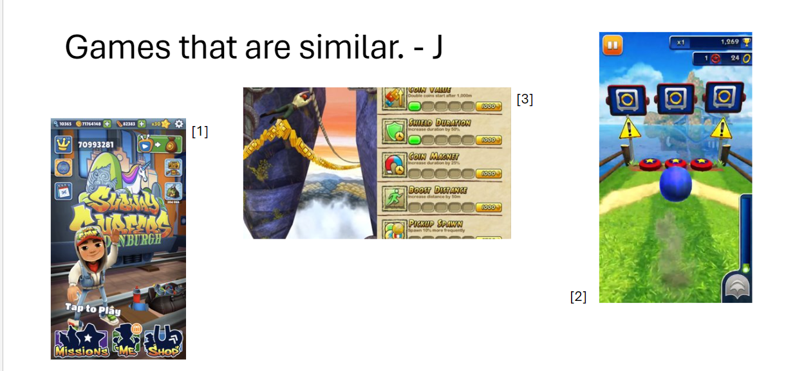

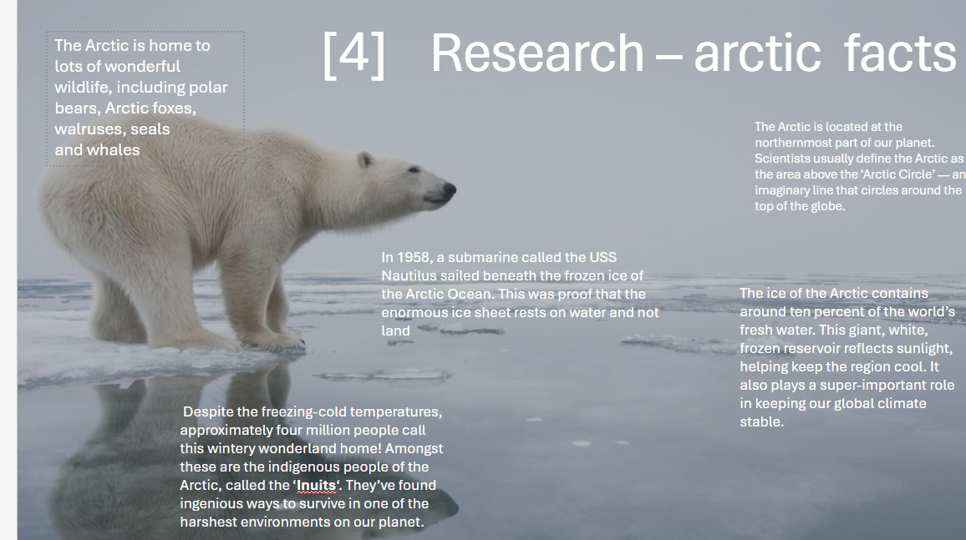

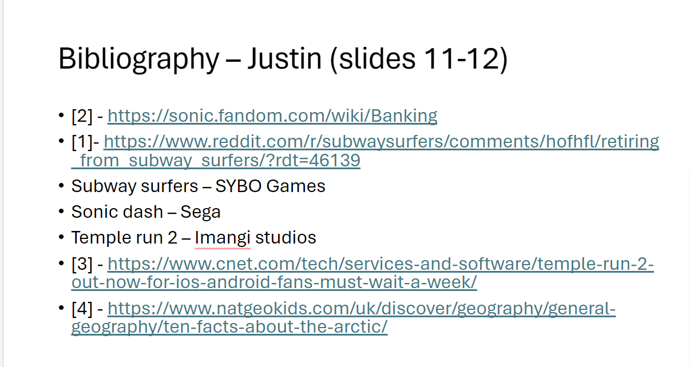

Coursework 2.pptx

A a a a aa a a aaa a a

