Skills for the Work Place
Module: Problem Solving and Decision Making
Module code: BMSK4004

Jorna Ali (1706149)
University of Wales – Trinity Saint David
20th April 2018

Executive Summary
The National Health service (NHS) was introduced by the health secretary Aneurin Bevan, with the aim of free healthcare service for all British Nationals, financed through taxation (NHS Choice,2015). The NHS is currently facing biggest challenges, including pressure on funding and increased demand, the sustainability of it is becoming more uncertain. The underlying NHS deficit, as of 2016/17 was £3.7 billion (Nuffield Trust,2017). The deficit has been funded by the taxpayer and is exacerbated by an increase in healthcare demand nationally largely due to social and demographic factors such as an ageing population, increased birth rates as well as poor diet and exercise habits. This rise in demand has also impacted recruitment within the NHS. Despite being the fifth biggest employer in the world (Nuffield Trust,2017) 1 in 9 posts are vacant (The guardian, 2017), the burden of the above issues is being carried by the current NHS workforce, deterring talented people away from the national employer.
There is a wide spread impact on the public, with a reduced workforce and increased demand, waiting lists have never been longer. The strain being placed on the workforce has resulted in longer working hours for nurses and doctors, which directly impacts these individuals work – life balance and, although not measurable, this surely impacts the level of care provided to patients. The NHS supply-chain in highly fragmented and many of its suppliers are small owner-managed businesses that rely on winning NHS contracts, these types of businesses are impacted immediately by any spending cuts made. Change is needed to ensure that the NHS can be operated sustainably, with the core mission being to provide the best care in the world for the nation as economically as possible.
This report will tackle issues and provide recommendations on how to alleviate the strain on the NHS. PESTEL model has been used to analyse the problems, as well as a discussion on the impact on internal and external stakeholders, and a fishbone model has been used to identify solution for social and economical issues.
Contents
- Introduction…………………………………………………………………………………………………………(4-7)
- Introducing PESTLE…………………………………………………………………………………..(5-6)
- SWOT………………………………………………………………………………………………………..(6-7)
- Findings………………………………………………………………………………………………………………….(8-18)
- Stakeholders……………………………………………………………………………………………….(8-9)
- Matrix…………………………………………………………………………………………………….....(10-11)
- PESTLE………………………………………………………………………………………………………..(11-14)
- Solutions; fishbone………………………………………………………………………………….….(15-18)
- Conclusions………………………………………………………………………………………………………….….[19]
- Recommendations…………………………………………………………………………………………….…….[20]
- References………………………………………………………………………………………………….…………...[21-22]

Introduction
The National Health Service (NHS) was introduced in 1948 by the Health Secretary at the time Aneurin Bevan, with the aim of providing healthcare services that were free to all, financed through taxation (NHS Choices, 2015). Over the years, the NHS has developed and changed, however what remains the same is that it is still a free service funded through taxation. The planned expenditure for the NHS England and Wales for 2017/18 is a staggering £123.8 billion, set to increase to £126.2 billion for 2018/19 (NHS Confederation, 2017). Despite this seemingly large budget which would appear sufficient to deal with the UK population, this is in fact being strained more and more each year. With the NHS facing its biggest challenge since inception, including pressure on funding and increased demand, the sustainability of it is becoming more uncertain. The underlying NHS deficit, as of 2016/17 was £3.7 billion (Nuffield Trust, 2017). This deficit has been funded by the taxpayer and is driving all decisions to aggressively cut costs and save wherever possible. However, the situation is exacerbated by an increase in healthcare demand nationally largely due to social and demographic factors such as an ageing population, increased birth rates as well as poor diet and exercise habits. This rise in demand has also impacted recruitment within the NHS. Despite being the fifth biggest employer in the world (Nuffield Trust, 2017) 1 in 9 posts are vacant (The Guardian, 2017), the burden of the above issues is being carried by the current NHS workforce, deterring talented people away from the national employer.
Due to the sheer scale of the NHS, any issues it faces impacts nearly every single person within the UK. Most significantly there is a wide spread impact on the public, with a reduced work force and increased demand, waiting lists have never been longer. The maximum wait time for non-urgent referrals is currently 18 weeks (NHS Choices, 2016). In addition, the strain being placed on the workforce has resulted in longer working hours for nurses and doctors, which directly impacts these individuals work-life balance and, although not measurable, this surely impacts the level of care provided to patients. It is widely known that the NHS supply-chain in highly fragmented and many of its suppliers are small owner-managed businesses that rely on winning NHS contracts; these types of businesses are impacted immediately by any spending cuts made.
Drastic change is needed to ensure that the NHS can be operated sustainably, with the core mission being to provide the best care in the world for the nation as economically as possible. Within this report we will explore these issues and provide recommendations on how to alleviate the strain on the NHS. This will be done using the PESTEL model to analyse the challenges, as well as a discussion on the impact on the associated stakeholders.
A PESTEL analysis is a framework or tool used by marketers to analyse and monitor the macro-environmental (external marketing environment) factors that have an impact on an organisation. The result of which is used to identify threats and weaknesses which is used in a SWOT analysis.
PESTEL stands for:
- P – political
- E – Economical
- S – Social
- T- Technological
- E- Environmental
- L- Legal

Pestle diagram:
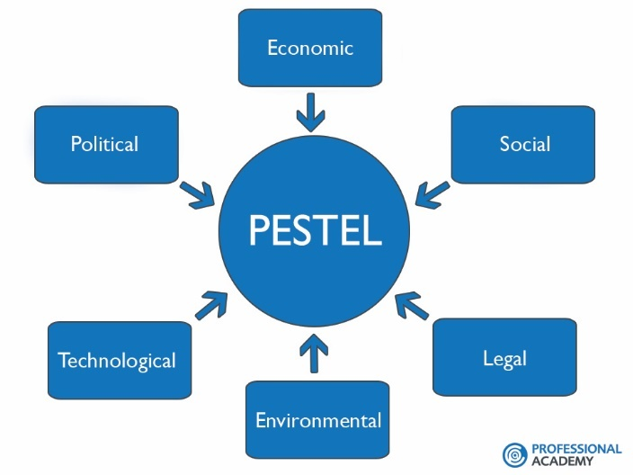
Political Factors
These are all about how and to what degree a government intervenes in the economy. This can include – government policy, political stability or instability in overseas market, foreign trade policy, tax policy, labour law, environmental law, trade restrictions and so on.
Economic Factors
Economic factors have a significant impact on how an organisation does business and also how profitable they are. Factors include – economic growth, interest rates, exchange rates, inflation, disposable income of consumers and businesses and so on.
Social Factors
Also known as social-cultural factors, are the areas that involve the shared belief and attitudes of the population. These factors include – population growth, age distribution, health consciousness, career attitudes and so on. These factors are of particular interest as they have a direct effect on how marketers understand customers and what drives them.
Technological Factors
Technological landscape changes very fast, this impacts the way we market our products. Technological factors affect marketing and the management thereof in three distinct ways:
- New ways of producing goods and services
- New ways of distributing goods and services
- New way of communicating with target markets
Environmental Factors
Theses factors have only really come to the forefront in the last fifteen years or so. They have become important due to the increasing scarcity of raw materials, pollution targets, doing business as an ethical and sustainable company, carbon footprint targets set by government (this is a good example were one factor could be classes as political and environmental at the same time). These are just some of the issues marketers are facing within this factor. More and more consumers are demanding that the products they buy are sourced ethically, and if possible from a sustainable source.
Legal Factors
Legal factors include – health and safety, equal opportunities, advertising standards, consumer rights and law, product labelling and product safety. It is clear that companies need to know what is not legal in order to trade successfully. If an organisation trades globally this becomes a very tricky area to get right as each country has its own set of rules and regulations.
SWOT:
SWOT is an acronym for Strengths, Weaknesses, Opportunities and Threats.
Strengths (S) and Weaknesses (W) are internal factors, also, opportunities (O) and threats (T) are external factors.
SWOT Analysis is the most renowned tool for audit and analysis of the overall strategic position of any organisation and its environment. It helps with the identification of suitable business strategies for an organisation to follow. It helps identify the strength, weaknesses, opportunities and threats of any organisation. Proctor, T (2006).

Below is a SWOT analysis based on the NHS. Which briefly explains the ongoing situation within the healthcare sector.
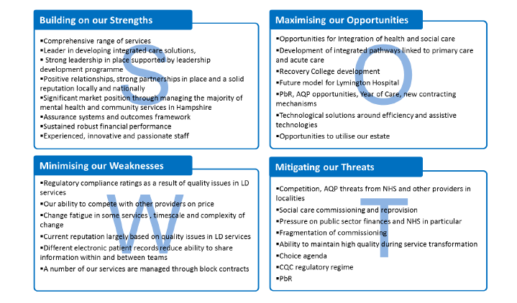
(Hatton, C. 2017)
The NHS has various sectors inside the healthcare. For example; ambulance services, care homes and hospitals etc. These all require funding, customer care and IT services and many more.
having care homes is beneficial to the NHS as they receive funds from patients and the patients are getting 24hours care from carers whereas they would not get it at home. If they were to get admitted in the hospitals then it would be the government paying for the expenses, this is hard as there is less funds as well as the patients will be taking over the beds and not having enough left when necessary. Certain hospitals have lack of IT services which cause a problem for many patients as well as employees. This is a threat as the NHS cannot have enough staff when needed to serve patients. To get opportunities for patients and employees there is a required amount of funding from the government so that they can receive what is important for all. (Prospects 2018).

Findings
Stakeholders
A stakeholder is one whom holds any relationship or interest with a specific company, in this instance the NHS. Just like all other businesses, the NHS has a duty to involve others in their decisions regarding planning and change within the organisation, this is outlined in the Health and Social Care Act 2012. These stakeholders are divided into internal and external stakeholders; internal stakeholders participate in funding, co-ordination, funding and well-being. External stakeholders contribute their views, and addresses issues important to patients, services users and carers (Health Knowledge). The NHS stakeholders are regarded highly for their opinions regarding their individual levels of expertise within the company; however, the impending departure from the European Union (EU), also referred to as ‘Brexit’ could have direct implications on the NHS due to uncertainty. Currently there is freedom of movement for residents of the EU, which impacts the number of recipients of NHS services as well the NHS workforce. Post Brexit, it is unclear whether free movement of people will continue and therefore what the net migration from the EU will be.

The list below of both internal and external stakeholders is based on a department within the NHS.

Internal Stakeholders | External Stakeholders
- Director of Public Health  - Head of Health Intelligence and Information  - Procurement  - Director of Nursing  - Public Health Strategists  - Public Health Management Analyst  - Director of Programmes and Services  - Research Scientist  - Communications  - Environmental Health Intelligence Analyst  - Public Health Manager  - Trustees  - Board committee members | - Local Authority/council  - Providers  - Acute trusts  - Patients  - Service users  - Customers  - Suppliers  - Funders  - Quality assessors  - Link group  - Special interest groups  - Health visitors/school nurses  - Wider public health workforce  - Media

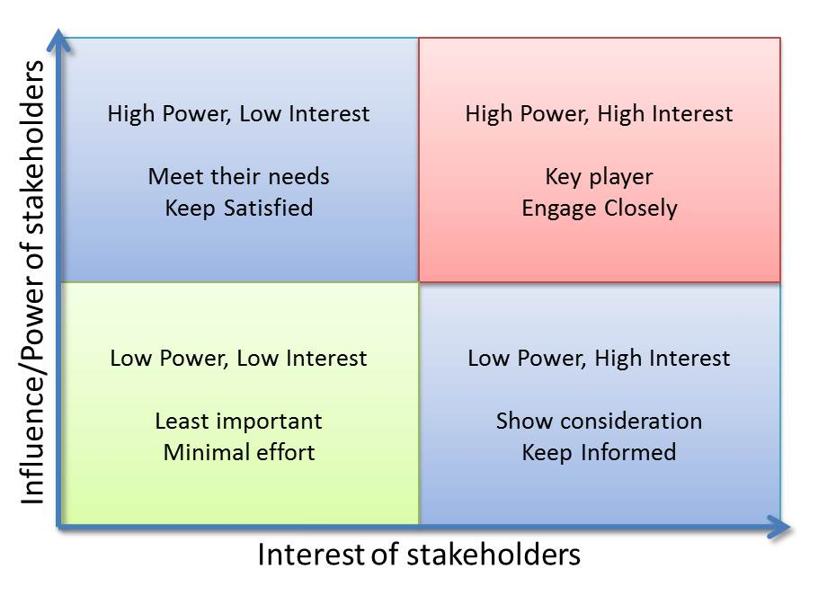
The Mandelows matrix has helped identify the key players within the NHS and how much of an influence they have. Below is a diagram which demonstrates the use of Matrix.

Resource

Showme,2017
Limitations
The National Health Service is a non-profit organisation dedicated to helping those in anyway regarding their health, this means that the stakeholders surrounding this company do not have the intent of maximising profit, but rather to stay afloat and benefit the quality of like with those they serve. In accordance to the Nuffield Trust, the Treasury’s Comprehensive Spending Review in November 2015 will set out public spending and deficit reduction plans for the four years up to 2020. It will include important decisions on the size and shape of many parts of Government, including the NHS, public health, clinical training and social care. For many years, there has been a shortage of nursing staff within the NHS. In a report by the Royal College of Nursing (RCN), it is stated that most hospitals do not have the recommended level of staffing required to ensure a safe level of care, primarily with reference to older people’s wards. (NHS Choices, 2012).
In a more recent survey from the British Medical Association (BMA), 71 percent of hospital doctors reported staff shortages and 47 percent of GPs stated they had at least one vacancy in their practice (The Independent, 2018). The result of this issue is that the key stakeholder, being the patient will not receive the required standard of care or treatment they should expect. Moreover, with staff struggling to cope with increased demand, it will have an adverse effect on staff morale and ability of the NHS to retain staff.

Another contributory factor to the challenges faced by the NHS are the rising costs associated with the service. Net expenditure has increased from £78.9bn in 2006/07 to £120.5bn in 2016/17 (NHS Confederation, 2017). This is further increasing as planned expenditure in 2017/18 is £123.8bn and £126.3bn in 2018/19 (NHS Confederation, 2017). This is linked to the increased cost of living and increased costs of energy and supply. The increase in costs are not met by an equivalent increase in funding as is evident with the NHS being in a net deficit position. These pressures and the current austere policy adopted by the UK Government will put additional pressure on the service and it’s ability to meet demand.
Ageing population
In the UK we have an ageing population, which burdens the NHS. Life expectancy in the UK is 79.1 for men and 82.8 for women. This is an average increase of 9.5 weeks a year for women and 13.1 weeks a year for men since 1980-82 (Office of National Statistics, 2013-15). As people live for a longer period, patients often will require ongoing treatment and specialist care. This adds to the resource requirements of the NHS, to deal with the ageing demographic. This is also linked to the nursing shortages in older peoples’ wards, where it is evident resources are under pressure as demand outstrips supply.
PESTLE Analysis
The key issues in which effect the fundamental decision making and problem-solving skills within the National Health Service include those of economic, political and related changes in the provision of quality services (Kolios and Read, 2013). Throughout this report, there will be reference to the key issues which need to be addressed for the continuation and success of the NHS.
Political
The Prime Minister has recently come under fire when addressed about the NHS pay freeze with her response to a nurse’s question “My wage slips from 2009 reflect exactly what I'm earning today. How can that be fair, in the light of the job that we do?” and answering, “there is no magic tree.” (The Independent). This begs the question, are politicians failing to address the evident need of sufficient funding within the NHS? The 2017/2018 budget for the NHS England and Wales is £123.8 billion (NHS Confederation 2017), in contrast to the ever-rising figure of patients claiming need of the NHS there is not sufficient funding. This creates the ultimate domino effect, if people aren’t being effectively treated or cared for, this will have an impact on sickness, statistics and the workforce, and inevitably the government will have to fund those who are unable to work. Britain is a democratic country, many votes being sold on the promise of a better healthcare system, and a better future. The Department of Health and Social Care has been accused of ignoring repeated warnings about stagnating life expectancy, academics have said that in recent years there had been “one of the greatest slowdowns [in life expectancy improvements] for both sexes since the 1890s” (Guardian, 2018), with rates even declining for some groups; the quality of life in Britain is falling rather than rising.
In June 2016, Britain had a referendum and conclusively voted to leave the European Union (EU), this became known as BREXIT. With a turnover of more than GBP 60 Billion a year, and exports and trade surplus worth GBP 30 Billion and GBP 3 Billion respectively, the pharmaceutical industry is of strategic importance to the UK. The way the UK researches, develops, manufactures and brings medical technologies to patients is regulated by the EU, so in this divorce, the separation may have a large effect on one of Britain’s most important trades by increasing costs and becoming a less attractive place for businesses to develop and manufacture such products. Protection of Intellectual Property Rights will also form a major part of the Brexit framework, giving Britain the issue of always appearing after the EU in product release. "Europe benefits from a high standard of Intellectual Property (IP) incentives in the form of Supplementary Protection Certificates (SPCs) (compensating for the amount of patent term that is lost during the lengthy development process of a pharmaceutical product), Regulatory Data Protection (RDP), orphan designation (for rare diseases) and rewards for investigations into paediatric uses and formulations. EU pharmaceutical incentives are currently being reviewed and it is important that the U.K. actively participates in that review, prior to leaving the EU, to prevent IP incentives being weakened." (WNS Decision Point, 2018)
The Home Office each year grants 20,700 Tier 2 visas for skilled migrants from outside the EEA, with a monthly limit of about 1,700, roughly a third go to NHS employees (Financial Times, 2018). Currently, there are 58,000 EU nationals working in the NHS, which equates to 10 percent of doctors and 5 percent of nurses (nhsonfed, 2017). If these employees were to leave the UK, either by choice or by mandate, this will have a significant impact on the ability of the NHS to provide the level of services required to patients.
Also linked to the issue of Brexit is the level of medical treatments that are currently received outside the UK. 27 million British citizens have European Health Insurance Cards (EHIC) which allows them to healthcare whilst abroad. In addition to this, 1.2m Britons living abroad are entitled to healthcare in the EU (NHS Confederation, 2017). The outcome of ongoing Brexit negotiations could mean that any medical cases that were previously treated abroad may need to be dealt with in the UK. Leaving the EU will inevitably have consequences on the UK economy, potentially resulting in economic downturn, which in turn will affect budgetary constraints on the NHS. It is estimated that the NHS budget could be £2.9bn lower than currently planned in 2019/20 (NHS Confederation, 2017).

Economic
The National Health Service is rising in its need by the public by roughly 3% each year, the growing demands being answered with a £1.6 billion increase in the 2018/2019 financial year; however this apparent answer to insufficient funding within the NHS will likely not be spent on extra spending e.g. extra nurses/doctors, more staff or extra drugs. (Nuffield Trust, 2018) The new promised budgets instead will likely be spent on the NHS Trust Deficit and pay off the debt the NHS is currently undergoing (Full Fact, 2016). Although it is financially beneficial to pay off the current debt, there is still the larger issue of actually diagnosing and treating the in-need public; will there ever be sufficient funding for the frontline of the NHS?
As stated above, on average the need for the NHS is increasing by 3% every year, along with new patients, there comes the positive of new treatments and technology, but how do we afford this? “Despite a difficult economic climate in which other sectors have struggled, the UK medical technology sector has rapidly grown over the last 4 years, with the combined turnover of UK medical technology companies increasing by 50% between 2009 and 2012 (UKTI GOV)”. To address the risks of complexity and cost, the government has introduced; targeted investment, funding initiatives and tax incentives to stimulate innovation and growth; funding R&D and manufacturing for start-ups and SMEs to large global enterprises. By locating in the UK your business also becomes eligible for funding initiatives from the European Commission.

Social
Lifestyle is referred to the characteristics of inhabitants of a region in special time and place; it includes day to day behaviours and functions of individuals in job, activities, fun and diet. There is currently research into the factors which impact our long-term health, if these issues are combated and dealt with in its early stages, with either prevention or resilience, this can save the NHS potential millions of pounds and above with the everyday health issues they are having to treat (The Health Foundation, 2017). Some of the main factors affecting long term health include: education and skills, food, money and resources, and social activity. These are simple issues which are affecting a dense amount of the population, with the right education and implementation, the NHS may not have to have the financial issue of dealing with health management advice and unneeded visits (Bowling, 2014).
In the late 1980s, the population of the UK began to grow when the 1960s’ baby boomers were having children, “echoing” earlier growth, 65.1 million in 2015, the largest ever, an increase of just over half a million people since 2014 (ONS, 2017). In combination with the current high birth rate, people in the UK are now living longer than ever; a study found life expectancy in England and Wales is expected to continue to rise from the 2012 average of 79.5 years for men and 83.3 for women, to 85.7 (95% credible interval 84.2 to 87.4) for men and 87.6 (95% credible interval 86.7 to 88.9) for women by 2030 (NHS, 2015). There are dire consequences of an ageing population, resulting in fewer people of working age to support those of pension age. This increase means that there will be fewer people of working age to support a larger population over State Pension age. While a larger population increases the size and productive capacity of the workforce, it also increases pressure and demand for services such as education, healthcare and housing.
Technological
New technology is transforming the delivery of health care and our management of population health, so why is the UK so hesitant to deploy such techniques within our healthcare system? There are many discussed benefits of such technological advances within the health sector, this includes; transforming how patients engage with services, improving efficiency and keeping up with the modern day ‘paperless’ agenda. Aside from information technology within the communication of doctors, patients and the stakeholders of the NHS, modern technology is becoming imperative to actually diagnose and treat patients, i.e. measuring, monitoring and being able to observe patients (Mockford et al, 2011).

Solutions
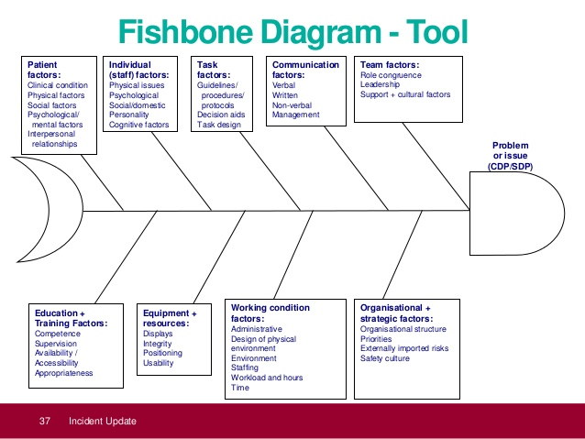
(asafon,2018)
Once establishing a fishbone analysis, it is vital to note that the problematic statement is the head of the fish. Within the NHS, fishbone is used to define the key differences required including the essential action to be taken; some stages are mentioned below:
- Clarifying the issues, in this case ever-increasing economic burden put on the NHS.
- Breakthrough potential causes of the core problem, such as staff, equipment, technology.
- Explain the leading reasons for the problem; this will entail searching the whole thing until the individual is assertive that the prime driver of the problem has been found.
The sub-bones include appropriate answers some of which are listed below:
- Increasing expense and expenditure
- Equipment
- Funding
- Increasing population
- Too many practitioners
- Unnecessary amount of admin staff

Solutions to Economic Problem
The picture below is an example of the financial situation of the NHS.
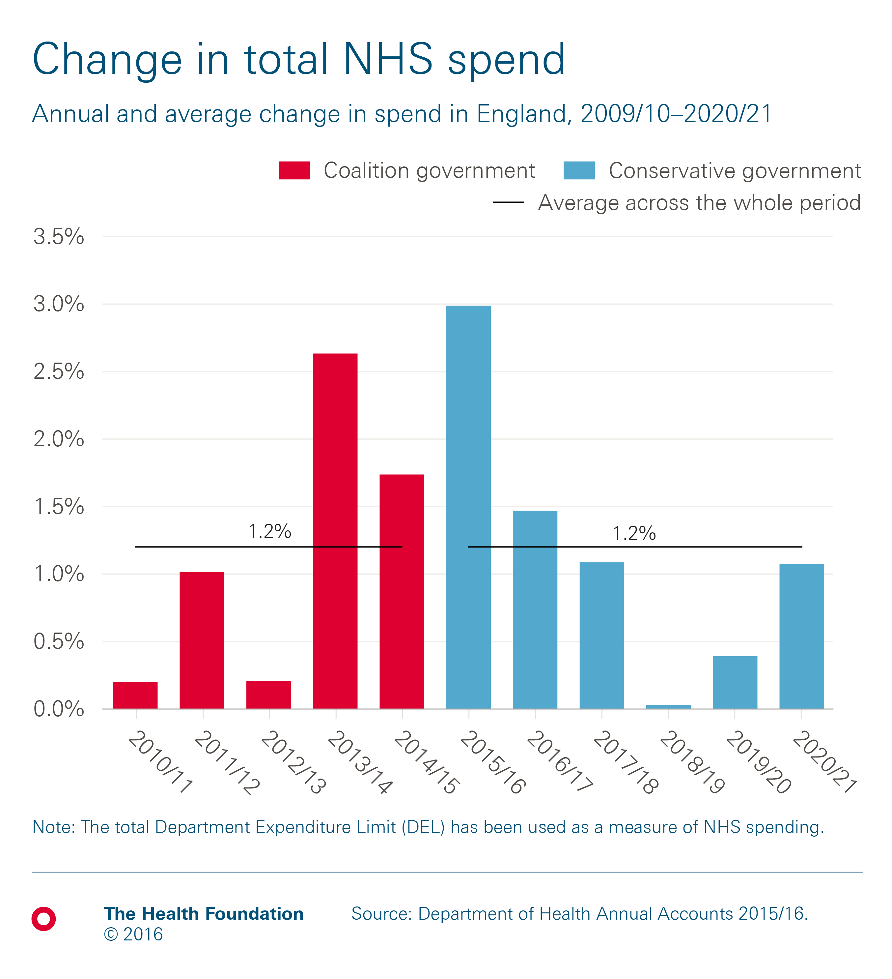
At present, the NHS is excessive spending as inhabitants increase, additionally to this people are admitted into hospitals on a day-to-day basis. Amplified expense attributes the elderly residents and the people of the sick; the rise in patients suggests a necessity to hire more doctors and nurses to deliver unparalleled care to each patient. Nonetheless, the government overpaying the medical practitioners is producing economic challenges in NHS and therefore leading more expenditures but fewer outcomes. It is domineering to perform a convincing and creative technique for nursing healthcare encounters.
A solution to the economic problem would be cutting costs on medicinal services that are rising, which will turn out to be considerably more of a weight soon than its standing today (Abel-Smith and Titmuss,2016). Individuals are endeavouring to concede the significance climb on human services in an ambiguous way relative to the environment of the structure. Individual disappointment collective with the forthcoming emergency due to the medicinal service value increase, preparation creators have instigated to look on credible changes to diminish social insurance costs without interchange access and quality.
Given the way the UK population is growing, the number of citizens and individuals with numerous continuing sickness is also escalating the burden on expenditure thus challenges in giving sufficient medicinal service. Consequently, it is crucial to embrace the use of advanced technology as it will aid to release the accumulative financial burden that is put on the NHS.
Solutions to Social Problems
The NHS is suffering from various social issues in terms of the company’s growth and sustainability, this mainly revolves around unhealthy lifestyle choices and the eminent issue of overpopulation from a combination of a baby boom and an ageing population.
Regarding unhealthy lifestyle choices, research has identified that the publics main health issues in these circumstances derive from; education and skills, food, money and resources, and social activity. With current research showing both short and long-term effects of these day to day choices, the remedy is found. To make England and Wales a healthier and more sustainable country, and to cut problems within the NHS, the government could offer resilience training and educational workshops to those lacking in education, skill and the early onset of mental health issues. Although this may be an economic burden in the short term, it will have a positive knock on effect over the next few generations. “Resilient people believe that they have the potential for control over their lives; they believe that they can influence their situation. Non-resilient people tend not to share this belief, and consequently their stress-coping efforts don't fair as well. People don't work at coping when they don't believe that coping can help.” (Grace Point Wellness, 2017). This type of research endorses the principle of self-help, allowing an improvement on both society and individuals quality of life.
The second social issue is the ever-increasing amount of people needing to use the NHS, the 3% addition annually comes from the problem of global overpopulation as a result of a baby boom and an increase in ageing population. The Government should set a national goal of stabilising and then reducing numbers to a sustainable level through promoting smaller families and limiting net migration. In addition, governments should give top priority to family planning and women’s education and empowerment programmes (BBC News, 2015); but how can this be carried out in an ethical manner? The key solution to solving the NHS’ issue of overpopulation and lack of resource is through family planning, “More than 40 percent of all pregnancies are unintended, with higher proportions in developed than in developing countries. Preliminary calculations based on conservative assumptions suggest that global fertility would immediately move slightly below replacement levels, putting world population on a path toward an early peak followed by gradual decline. The success of such a strategy would have many other benefits, such as reducing disability and deaths among mothers and their children and freeing more women to earn money and participate actively in social affairs.” (The Solutions Journal, 2011) This stands to help the NHS with overpopulation, unwanted pregnancies and the possibility of psychological trauma.

Conclusion
The report displays a detailed breakdown of the fish bone and SWOT model which is an emphatic approach to categorising the underlying causes of a problem. Throughout the NHS it is apparent that there are many elemental problems including an aging population, complicated health problems lack of exercise and improper diet to name a few. As a domino effect to these ongoing problems, there is a further pressure on the NHS which means functions are becoming increasingly problematic. These problems do suggest that further practices need to be implemented to formulate solutions. By instrumenting these social and economic changes, the effect on the NHS would be quite considerable. The services themselves would subsequently become more sufficient and efficient. These changes are likely to happen, as although it may require initial investment, the long-term advantage outweighs the investment.

Recommendations:
To make England and Wales a healthier and more sustainable country, and to cut problems within the NHS, the government could offer resilience training and educational workshops to those lacking in education, skill and the early onset of mental health issues. Although this may be an economic burden in the short term, it will have a positive knock on effect over the next few generations.
The Government should set a national goal of stabilising and then reducing numbers to a sustainable level through promoting smaller families and limiting net migration. In addition, governments should give top priority to family planning and women’s education and empowerment programmes. The key solution to solving the NHS’ issue of overpopulation and lack of resource is through family planning This stands to help the NHS with overpopulation, unwanted pregnancies and the possibility of psychological trauma.
A solution to the economic problem would be cutting costs on medicinal services that are rising, which will turn out to be considerably more of a weight soon than its standing today. Given the way the UK population is growing, the number of citizens and individuals with numerous continuing sickness is also escalating the burden on expenditure thus challenges in giving sufficient medicinal service. Consequently, it is crucial to embrace the use of advanced technology as it will aid to release the accumulative financial burden that is put on the NHS.

References:
(2016) Election, Available at: https://www.independent.co.uk/news/uk/politics/theresa-may-nurse-magic-money-tree-bbcqt-question-time-pay-rise-eight-years-election-latest-a7770576.html (Accessed: 13th March 2018).
(2016) NHS Waiting times, Available at: https://www.nhs.uk/NHSEngland/appointment-booking/Pages/nhs-waiting-times.aspx#maximum (Accessed: 13th March 2018).
(2018), Available at: http://dataforlb.blogspot.co.uk/2015/03/ (Accessed: 10th March 2018).
(2018), Available at: https://fullfact.org/health/nhs-trusts-deficit/ (Accessed: 25th March 2018).
(2018), Available at: https://www.nuffieldtrust.org.uk/chart/the-nhs-is-the-world-s-fifth-largest-employer (Accessed: 14th March 2018).
(2018) NHS History, Available at: https://www.nhs.uk/NHSEngland/thenhs/nhshistory/Pages/NHShistory1948.aspx (Accessed: 9th March 2018).
(2018) Brexit, Available at: https://www.wnsdecisionpoint.com/brexit/gclid/eaiaiqobchmiufp9utgk2givfdobch1pjar8eaayaiaaegjgl_d_bwe#resp-tab3 (Accessed: 19th March 2018).
(2018) Fishbone, Available at: http://asafon.ggec.co/root-cause-analysis-fishbone/ (Accessed: 9th March 2018).
(2018) Funding, Available at: http://www.health.org.uk/Health-and-social-care-funding-explained (Accessed: 11th March 2018).
(2018) PESTLE, Available at: https://www.professionalacademy.com/blogs-and-advice/marketing-theories---pestel-analysis (Accessed: 06th April 2018).
(2018) Statistics, Available at: http://www.nhsconfed.org/resources/key-statistics-on-the-nhs (Accessed: 9th March 2018).
(2018) Technology, Available at: https://www.gov.uk/government/uploads/system/uploads/attachment_data/file/301784/UK_Medical_Technology_Brochure.pdf (Accessed: 25th March 2018).

Asthana, A. (2018), Available at: https://www.theguardian.com/society/2018/feb/21/health-department-ignoring-uk-life-expectancy-concerns (Accessed: 17th March 2018).
Bazian. (2018), Available at: https://www.nhs.uk/news/medical-practice/uk-life-expectancy-expected-to-rise-to-late-80s-by-2030/ (Accessed: 17th March 2018).

Bibby, J. (2018) Healthy living, Available at: http://www.health.org.uk/blog/healthier-lives-our-plans-2017?gclid=EAIaIQobChMI4P-ijcWK2gIVSrvtCh2Zvw1eEAAYASAAEgKOWPD_BwE (Accessed: 22nd March 2018).
Farhud, D. (2018), Available at: https://www.ncbi.nlm.nih.gov/pmc/articles/PMC4703222/ (Accessed: 22nd March 2018).

Gainsbury, S. (2017) NHS Money, Available at: https://www.nuffieldtrust.org.uk/news-item/with-strings-attached-taking-a-closer-look-at-the-new-nhs-money#the-next-two-years (Accessed: 05th March 2018).
Gainsbury, S. (2018), Available at: https://www.nuffieldtrust.org.uk/files/2017-08/the-bottom-line-final-v2a.pdf (Accessed: 10th March 2018).
Helm, T. (2018) Nursing Recruitment, Available at: https://www.theguardian.com/society/2017/may/13/royal-college-nursing-nhs-recruitment-crisis (Accessed: 14th March 2018).
Kennedy, C. (2018), Available at: https://www.nwpgmd.nhs.uk/sites/default/files/02%20-%20Intro%20to%20Resilience%20Approaching%20CCT%2020%20Feb%2014.pdf (Accessed: 20th March 2018).
Knowles, E. (2018) Overview of the healthcare, Available at: https://www.prospects.ac.uk/jobs-and-work-experience/job-sectors/healthcare/overview-of-the-healthcare-sector-in-the-uk (Accessed: 15th April 2018).
Mills, H. (2018), Available at: https://www.gracepointwellness.org/298-emotional-resilience/article/5780-how-resilience-works (Accessed: 20th March 2018).
(2018) Population, Available at: https://www.populationmatters.org/about/vision-and-values/population-ethics/ (Accessed: 15th March 2018).
Proctor, T. (2006) CREATIVE PROBLEM SOLVING FOR MANAGERS, 2nd edn. Routledge.
Randall, M. (2018) Population, Available at: https://www.ons.gov.uk/peoplepopulationandcommunity/populationandmigration/populationestimates/articles/overviewoftheukpopulation/mar2017 (Accessed: 22nd March 2018).

