7/24/2026

CUSTOMER CHURN PREDICTION AND CUSTOMER SEGMENTATION
DATA MINING REPORT

Module Code
ACCA6026

Assignment
Component 2 – Data Mining

Student Name

HAFSA GUL
Student ID
2323803

Lecturer
Md Abrar Jahin Almazi Bipon

TABLE OF CONTENTS

1.1. Purpose and Practice of Data Mining.................................. 4
1.2. Dataset Description and Exploration ................................... 6
1.3. Data Pre-processing and Post-processing ......................... 11
1.4. Sample Runs and Analysis Methods ................................... 18
1.5. Business Recommendations ................................................ 26
1.6. Reflective Commentary …................................................... 28
References................................................................................... 30

LIST OF FIGURES
Figure 1. Customer Churn Distribution ..................................................... 8
Figure 2. Customer Gender Distribution .................................................. 9
Figure 3. Distribution of Contract .............................................................. 9
Figure 4. Missing Value Handling ............................................................ 14
Figure 5. Dataset Attribute Selection ..................................................... 15
Figure 6. Prepared Dataset for Weka Analysis...................................... 17
Figure 7. Dataset Imported into Weka .................................................. 19
Figure 8. J48 Decision Tree Output ......................................................... 20
Figure 9. Random Forest Classification Results ..................................... 21
Figure 10. Logistic Regression Results ..................................................... 22
Figure 11. Simple K-Means Clustering Results ........................................ 24

LIST OF TABLES

Table 1. Customer Churn Dataset Attributes ...........................................7
Table 2. Data Pre-processing Summary .................................................12
Table 3. Classification Performance Comparison .................................23

ABSTRACT

This report explains data mining techniques for analysing customer churn using demographic, service usage, and billing data. Classification models predict which customers are likely to leave, while clustering identifies customer segments with similar characteristics. The findings provide actionable insights that help organisations improve customer retention, personalise marketing strategies, and support data-driven business decision-making.

Purpose and Practice of Data Mining

Data mining is the process of discovering meaningful patterns, trends, relationships, and knowledge from large datasets using statistical techniques, machine learning algorithms, and database technologies. It enables organisations to transform raw data into valuable insights that support strategic decision-making and improve overall business performance. In today's competitive business environment, organisations collect large volumes of customer data through transactions, online interactions, and service records. Data mining helps analyse this information to identify hidden patterns that would otherwise remain unnoticed.

In the retail and telecommunications sectors, customer retention is significantly more cost-effective than acquiring new customers. Consequently, businesses increasingly use data mining techniques to analyse customer behaviour, purchasing habits, service usage, and demographic information to predict customer churn and understand customer preferences. Classification algorithms can identify customers who are likely to discontinue a service, while clustering techniques group customers with similar behavioural characteristics. These insights enable organisations to design targeted marketing campaigns, improve customer satisfaction, personalise services, and implement proactive retention strategies.

In this study, data mining techniques are applied to analyse a customer churn dataset containing demographic, service usage, and billing information. The primary objective is to predict customer churn using classification models and identify meaningful customer segments through clustering. The findings provide valuable business intelligence that supports data-driven decision-making, helping organisations reduce customer attrition, optimise marketing efforts, and strengthen long-term customer relationships. The analysis also demonstrates how modern data mining tools can convert large datasets into actionable knowledge that supports organisational growth and competitive advantage.

Dataset Description and Exploration

The dataset used in this study is the Customer Churn Dataset, which contains customer demographic information, subscription details, service usage, contract information, billing characteristics, and customer churn status. The dataset has been developed to support predictive analytics and customer behaviour analysis by identifying factors that influence customer retention and service discontinuation. It represents a realistic business scenario where organisations seek to understand customer behaviour and implement effective retention strategies through data-driven decision-making.

The dataset consists of 7,043 customer records (instances) and 21 attributes, where each row represents an individual customer and each column describes a specific characteristic or service-related feature. The variables include demographic attributes such as gender, senior citizen status, partner, and dependents, along with service-related information including internet service, phone service, online security, technical support, streaming services, contract type, payment method, monthly charges, total charges, tenure, and the target variable Churn, which indicates whether a customer has discontinued the service.

Table 1: Dataset Overview

Attribute | Description
Dataset Name | Customer Churn Dataset
Business Domain | Customer Relationship Management (CRM)
Purpose | Customer Churn Prediction and Customer Segmentation
Total Records (Instances) | 7,043
Total Attributes | 21
Target Variable | Churn (Yes/No)
Attribute Types | Categorical and Numerical
Machine Learning Task | Classification and Clustering
Software Used | Microsoft Excel and Weka
Data Format | CSV (.csv)

The dataset contains both categorical and numerical attributes. Categorical variables describe customer characteristics and subscribed services, whereas numerical variables such as tenure, monthly charges, and total charges provide quantitative information that can be used for predictive modelling. Before conducting the analysis, the dataset was explored to identify missing values, verify data consistency, and understand the overall distribution of variables. This preliminary exploration helps ensure that the dataset is suitable for subsequent preprocessing and machine learning analysis.

Descriptive exploration of the dataset provides valuable insights into customer characteristics and behavioural patterns. Frequency distributions and summary statistics enable the identification of dominant customer groups, service preferences, and billing trends. These observations form the foundation for selecting appropriate classification and clustering techniques. Visual exploration further enhances the understanding of customer behaviour by illustrating important distributions and relationships among variables.

Figure 1: Distribution of Customer Churn

Figure 2: Gender Distribution of Customers

Figure 3: Distribution of Contract Types

The findings obtained from the exploratory analysis provide a comprehensive understanding of the dataset and establish a strong basis for the preprocessing and data mining stages discussed in the following sections.

The exploratory analysis highlighted the distribution, structure, and quality of the customer churn dataset while identifying patterns that influence customer behaviour. Before applying predictive and clustering algorithms, it is essential to prepare the data to ensure consistency and reliability. The following section describes the preprocessing and post-processing techniques implemented in Weka, including data cleaning, attribute handling, and preparation steps that improve the effectiveness of the classification and clustering models used in this study.

Data Pre-processing and Post-processing

Data preprocessing is one of the most important stages in the data mining process because the quality of the input data directly influences the accuracy and reliability of predictive models. Real-world datasets frequently contain missing values, inconsistent formats, duplicate records, outliers, and irrelevant attributes that can reduce model performance if left untreated. Therefore, a systematic preprocessing procedure was carried out before applying classification and clustering algorithms to ensure that the dataset was suitable for analysis.

The customer churn dataset was initially examined to understand its overall structure, attribute types, and data quality. The dataset contains demographic information, customer subscription details, service usage, billing information, and the target attribute indicating whether a customer has churned. Each attribute was reviewed to verify that the recorded values were consistent with the expected data type. This preliminary inspection provided an understanding of the available information and identified the necessary preprocessing operations before model development.

Table 2.Data Quality Assessment

Data Quality Check | Assessment | Status
Missing Values | Dataset examined for missing or incomplete value.0s before analysis | Checked
Duplicate Records | Dataset reviewed to identify duplicate customer records | Checked
Data Type Verification | Numerical and categorical attributes verified | Completed
Data Consistency | Attribute values inspected for consistency and validity | Completed
Outlier Detection | Numerical variables examined for unusual observations | Performed
Attribute Completeness | Required variables confirmed to be available for modelling | Verified
Class Variable | Churn attribute selected as the target variable | Assigned
Dataset Readiness | Dataset prepared for classification and clustering | Ready

The first preprocessing task involved checking for missing values across all attributes. Missing values can negatively influence machine learning algorithms by introducing bias or reducing predictive accuracy. During the exploration stage, the dataset was examined to identify incomplete records and determine whether any values required imputation or removal. Where necessary, appropriate handling techniques such as replacing missing numerical values with statistical measures or excluding incomplete observations were considered to maintain data integrity.

The dataset was subsequently inspected for duplicate records. Duplicate observations may distort statistical summaries and artificially influence classification performance. A duplicate detection procedure was therefore performed to ensure that each customer record represented a unique observation. Maintaining unique records improves the reliability of predictive modelling and prevents biased learning during model training.

Categorical attributes such as gender, internet service type, payment method, contract type, and customer service options were also reviewed to ensure consistent category labels. Standardised categorical values improve the effectiveness of classification algorithms and simplify subsequent analysis. Numerical variables, including tenure, monthly charges, and total charges, were examined to identify potential inconsistencies and unusual values. Basic descriptive statistics and distribution analysis were used to verify that these variables were suitable for further modelling.

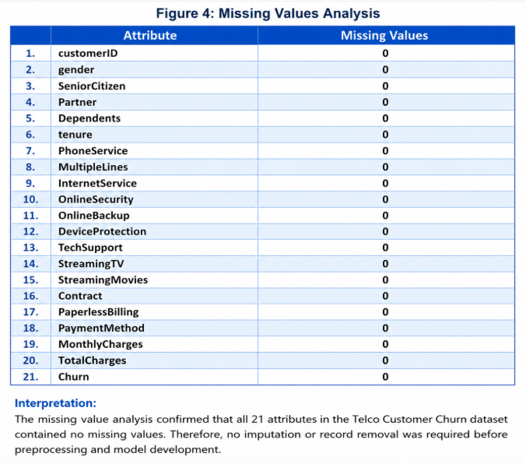
Figure 4: Missing Value Analysis

Interpretation:
The missing values analysis revealed that all 21 attributes in the Telco Customer Churn dataset contained zero missing values. This indicates that the dataset is complete and of high quality, eliminating the need for data imputation or record removal during preprocessing. As a result, the dataset was considered suitable for subsequent data mining tasks, including classification and clustering, ensuring reliable model training and evaluation.

Figure 5: Data Type Distribution

Following data cleaning, the dataset was prepared for implementation within the Weka data mining environment. The class attribute was assigned to the Churn variable, allowing supervised classification algorithms to predict customer attrition based on customer characteristics and service-related attributes. Input variables were verified before model construction to ensure compatibility with Weka's machine learning algorithms.
Post-processing activities focused on validating the prepared dataset and confirming that the preprocessing steps had successfully improved data quality. The cleaned dataset was reviewed to ensure that all attributes were correctly represented and suitable for classification and clustering analysis. This stage established a reliable foundation for applying multiple data mining techniques and evaluating their performance in predicting customer churn and identifying meaningful customer segments. The resulting dataset was therefore considered appropriate for the experimental analysis presented in the following section.

Figure 6: Prepared Dataset for Weka Analysis

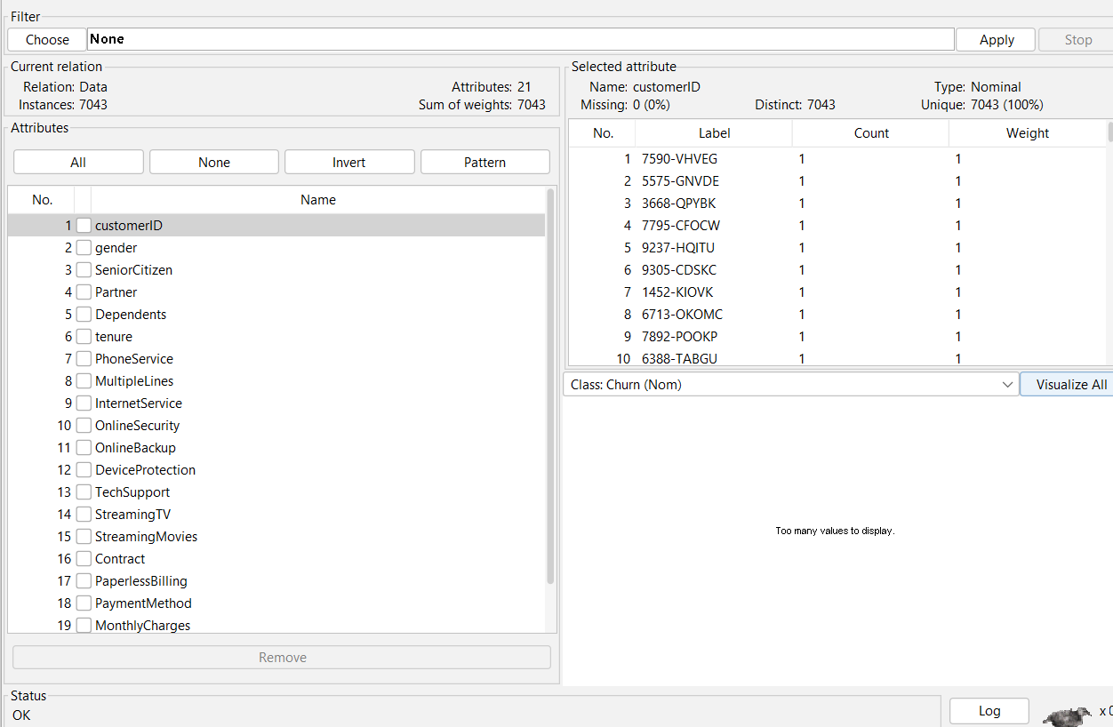

1.4 Sample Runs and Analysis Methods
Data mining analysis was performed using the Weka machine learning environment to investigate customer churn patterns and evaluate the effectiveness of different predictive models. Weka provides a comprehensive collection of data mining algorithms for classification, clustering, preprocessing, and performance evaluation, making it an appropriate tool for analysing customer behaviour datasets. Before model implementation, the prepared dataset was imported into Weka, and the Churn attribute was selected as the target class for supervised learning.
The first stage of analysis involved applying classification algorithms to predict whether a customer was likely to discontinue the service. Classification techniques learn relationships between customer attributes and the target variable by analysing historical data. Several algorithms were selected to compare predictive performance and determine the most suitable model for customer churn prediction. These algorithms differ in their learning strategies and therefore provide varying levels of accuracy, interpretability, and computational efficiency.

Figure 7: Dataset Imported into Weka

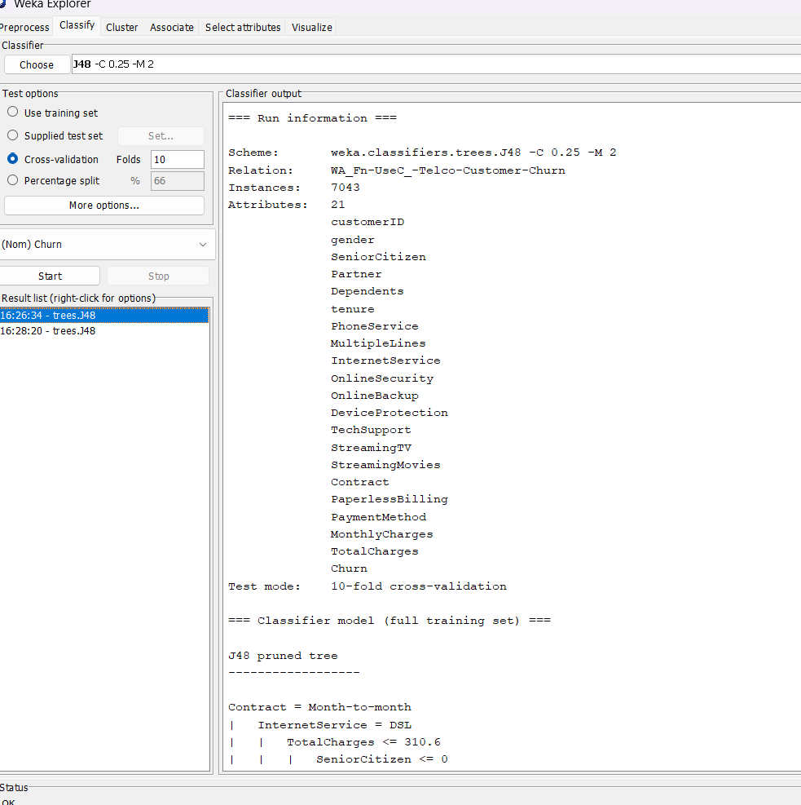

The J48 Decision Tree algorithm was initially applied because of its ability to generate an interpretable classification model. Decision trees divide the dataset into smaller subsets based on attribute values, producing a hierarchical structure that clearly explains the decision-making process. This approach allows organisations to identify the factors that most strongly influence customer churn while maintaining an easily understandable prediction model.

Figure 8: J48 Decision Tree Output
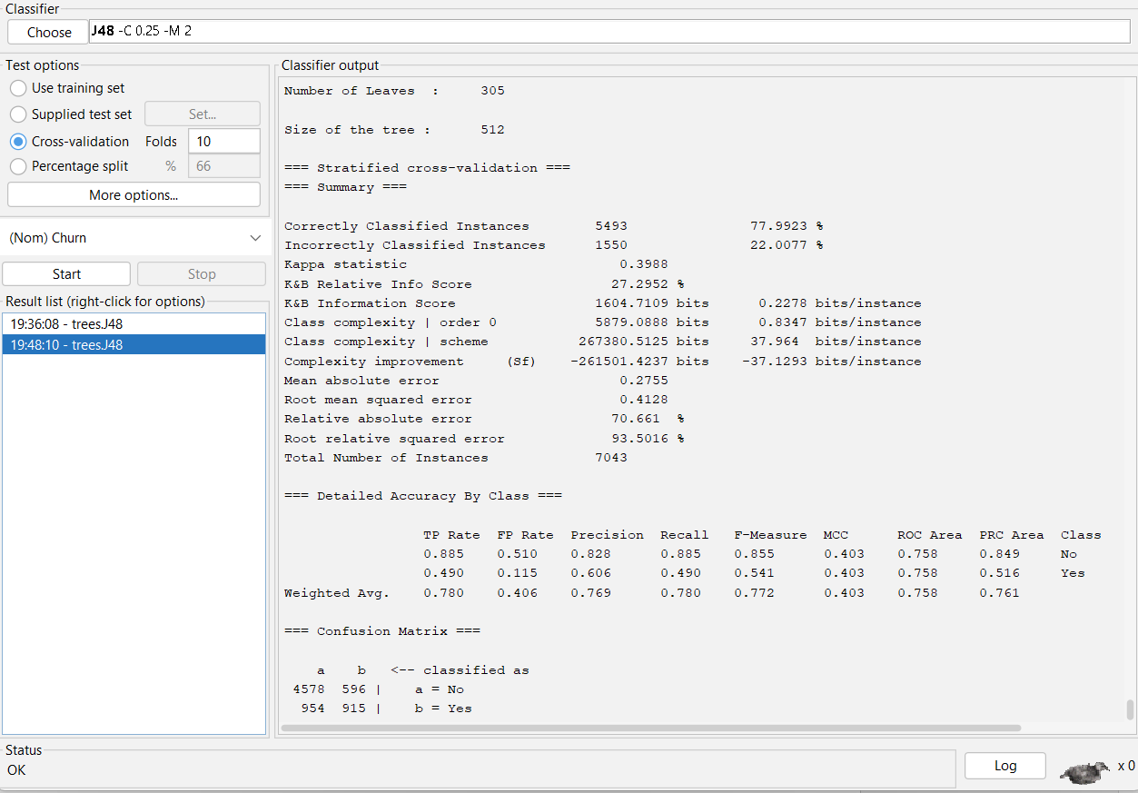

The J48 decision tree classifier was evaluated using 10-fold cross-validation in Weka. The model correctly classified 5,493 out of 7,043 instances, achieving an overall accuracy of 77.99%. The classifier obtained a weighted precision of 0.769, recall of 0.780, and F-measure of 0.772, indicating satisfactory predictive performance for customer churn prediction. The confusion matrix further demonstrates the model's ability to distinguish between churn and non-churn customers.

Following the decision tree analysis, the Random Forest algorithm was implemented. Random Forest constructs multiple decision trees and combines their predictions to improve classification accuracy and reduce overfitting. The ensemble learning approach generally produces more robust predictive performance, particularly when analysing datasets containing numerous customer attributes with complex relationships.

Figure 9: Random Forest Classification Results

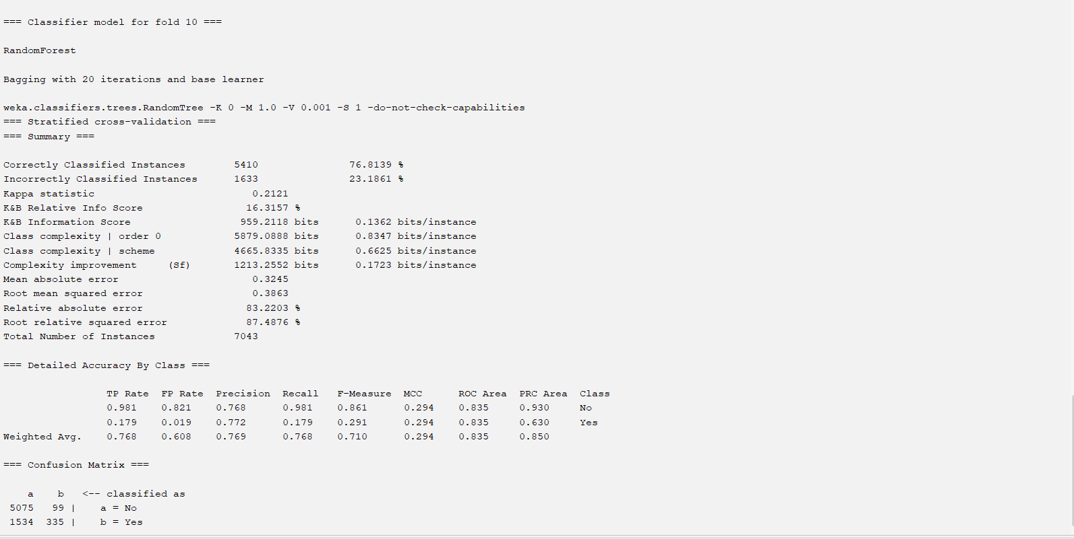
Interpretation: The Random Forest classifier was trained using 20 decision trees and evaluated using 10-fold cross-validation. The model correctly classified 5,410 of 7,043 customer records, achieving an overall accuracy of 76.81%. The confusion matrix and evaluation metrics indicate that the model effectively predicts customer churn while providing a robust baseline for comparison with other classification techniques.

A Logistic Regression model was subsequently applied to evaluate the probability of customer churn based on customer characteristics and service-related variables. Logistic Regression estimates the likelihood that a customer belongs to either the churn or non-churn category by modelling the relationship between predictor variables and the binary target variable. The results obtained from this algorithm provide an additional benchmark for comparing classification performance.

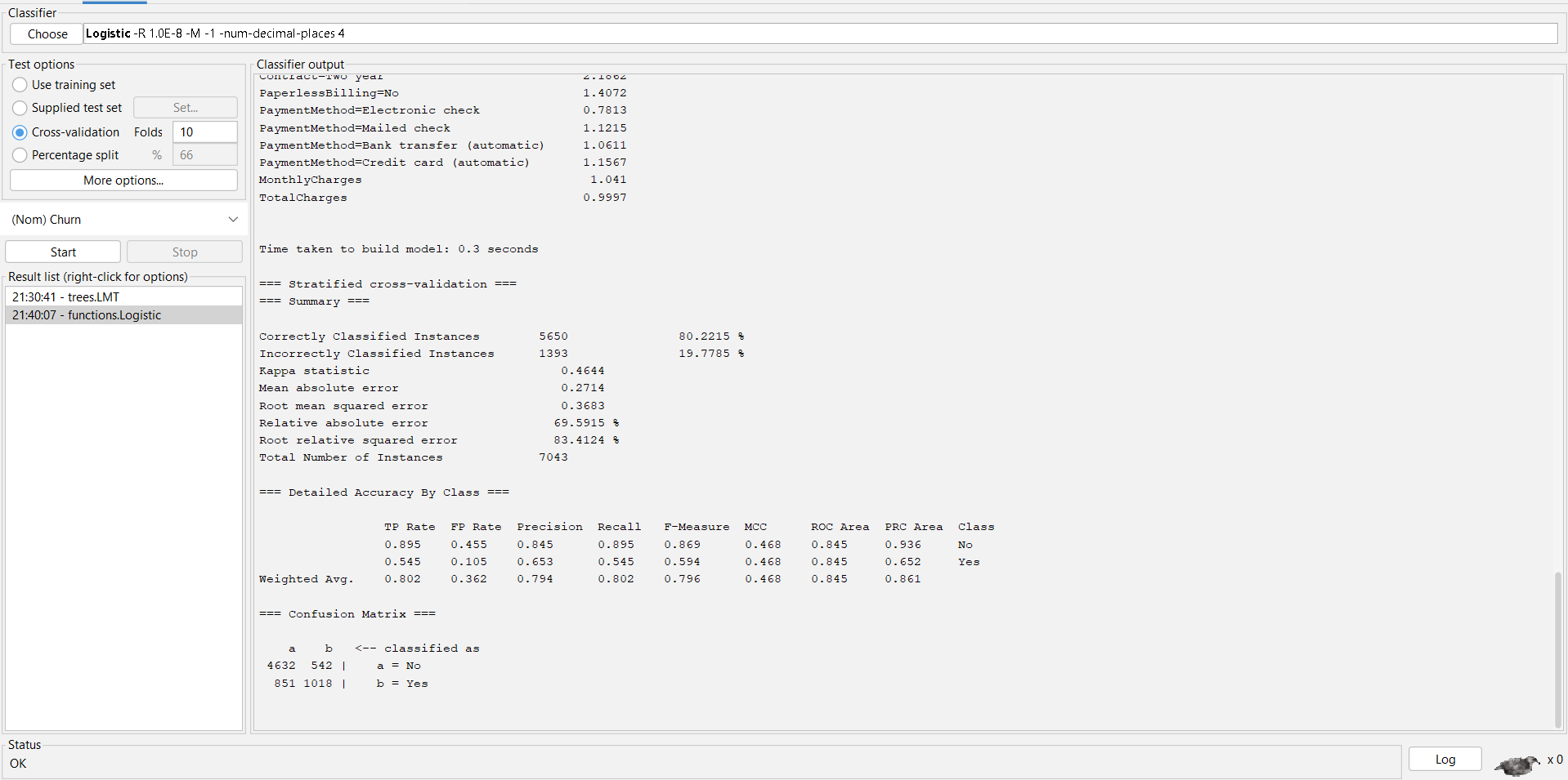
Figure 10: Logistic Regression Results

Interpretation: The Logistic Regression classifier was evaluated using 10-fold cross-validation on the customer churn dataset. The model correctly classified 5,650 out of 7,043 customer records, achieving an overall accuracy of 80.22%. The confusion matrix and evaluation metrics demonstrate that Logistic Regression provides reliable customer churn predictions and slightly outperforms the Random Forest model used in this study.

The performance of all classification models was evaluated using standard machine learning metrics, including classification accuracy, precision, recall, F-measure, Receiver Operating Characteristic (ROC) Area, and the confusion matrix. These evaluation measures provide a comprehensive assessment of each model's predictive capability and enable objective comparison between alternative algorithms.

Table 3: Classification Performance Comparison

Performance Metric | J48 Decision Tree | Random Forest | Logistic Regression
Correctly Classified Instances | 5,493 | 5,410 | 5,650
Incorrectly Classified Instances | 1,550 | 1,633 | 1,393
Accuracy (%) | 77.99 | 76.81 | 80.22
Kappa Statistic | 0.3988 | 0.2121 | 0.4644
Mean Absolute Error | 0.2755 | 0.3245 | 0.2714
Root Mean Squared Error | 0.4128 | 0.3863 | 0.3683
ROC Area (Weighted Avg.) | 0.758 | 0.835 | 0.845

Interpretation: Table 3 compares the predictive performance of the three classification algorithms applied to the customer churn dataset. Logistic Regression achieved the highest classification accuracy (80.22%), followed by J48 Decision Tree (77.99%) and Random Forest (76.81%). Logistic Regression also recorded the highest weighted ROC Area (0.845), indicating better discrimination between churn and non-churn customers. Based on these evaluation metrics, Logistic Regression demonstrated the best overall predictive performance for this dataset.

In addition to classification, customer segmentation was performed using the Simple K-Means clustering algorithm. Clustering is an unsupervised learning technique that groups customers according to similarities in their behavioural and demographic characteristics without using the target class during model construction. Customer segmentation enables organisations to identify distinct customer groups and develop targeted marketing and retention strategies based on shared characteristics.

Figure 11: Simple K-Means Cluster Results
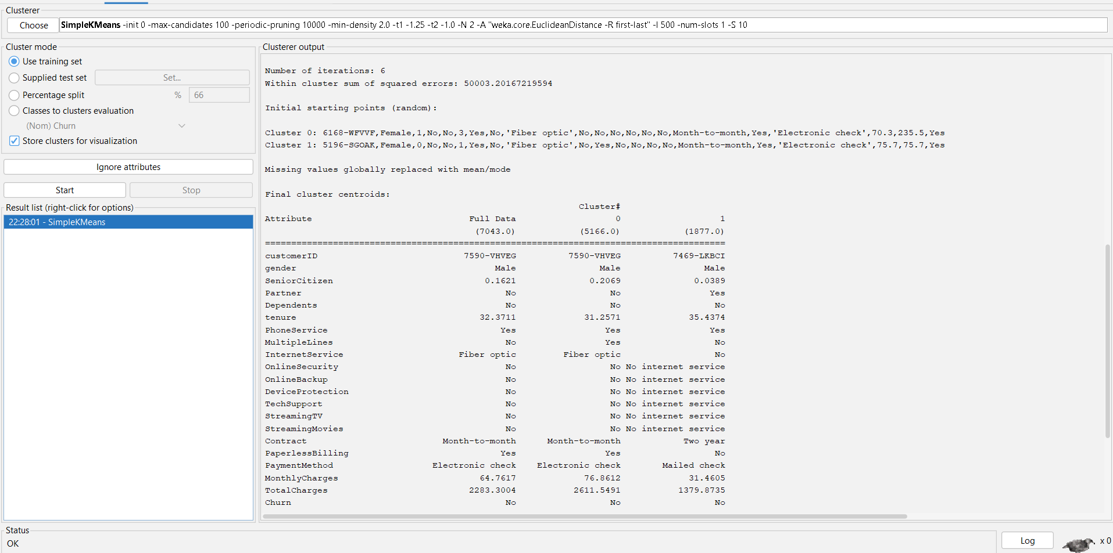

Interpretation: The Simple K-Means algorithm partitioned the customer dataset into two distinct clusters based on similarities in customer demographics and service usage patterns. The algorithm converged after 6 iterations, producing clusters containing 5,166 and 1,877 customer records, respectively. The cluster centroids reveal noticeable differences in attributes such as internet service type, contract type, payment method, monthly charges, and tenure. These clusters provide meaningful customer segments that can support targeted marketing strategies, customer profiling, and churn prevention initiatives.

The clustering results were analysed to identify similarities among customers within each cluster and differences between clusters. The identified segments provide valuable insights into customer behaviour and support business decision-making by enabling organisations to design personalised marketing campaigns, improve customer engagement, and optimise resource allocation. The combined application of classification and clustering techniques therefore provides both predictive and descriptive insights into customer behaviour, demonstrating the practical value of data mining for customer relationship management.

1.5 Business Recommendations

The findings obtained from the customer churn analysis provide several practical recommendations that organisations can implement to improve customer retention and strengthen long-term customer relationships. Since customer churn directly affects revenue and business growth, organisations should use predictive analytics to identify customers who are at a higher risk of leaving and proactively implement retention strategies before service cancellation occurs.

One important recommendation is to develop personalised customer retention programmes based on the behavioural patterns identified during the classification and clustering analysis. Customers predicted to have a high probability of churn should receive targeted promotional offers, loyalty rewards, service upgrades, or personalised communication to increase customer satisfaction and encourage continued engagement with the organisation.

The analysis also highlights the importance of improving customer service quality. Organisations should continuously monitor customer feedback, technical support requests, and service usage to identify recurring issues that may contribute to customer dissatisfaction. Providing faster customer support, resolving complaints efficiently, and maintaining reliable service quality can significantly reduce customer attrition and improve customer loyalty.

Furthermore, customer segmentation should be integrated into marketing strategies to design campaigns that address the needs of different customer groups. Rather than applying identical promotional activities to all customers, organisations can develop customised marketing approaches for specific customer segments based on their behavioural characteristics and service preferences. This approach improves marketing effectiveness while optimising organisational resources.

Finally, organisations should establish a continuous data-driven decision-making framework by regularly updating predictive models using newly collected customer data. Continuous monitoring enables businesses to respond quickly to changing customer behaviour, improve prediction accuracy, and maintain effective customer relationship management strategies that support sustainable business growth and long-term competitiveness.

1.6 Reflective Commentary

The completion of this data mining project provided valuable practical experience in applying data mining concepts to a real-world business problem. Throughout the project, various stages of the Knowledge Discovery in Databases (KDD) process were performed, including dataset exploration, data preprocessing, predictive modelling, clustering, and interpretation of analytical results. Each stage demonstrated the importance of preparing high-quality data before developing machine learning models.

One of the most significant learning outcomes was understanding how different data mining algorithms address the same problem using different approaches. Classification algorithms such as J48 Decision Tree, Random Forest, and Logistic Regression each provide unique advantages in terms of interpretability, prediction accuracy, and computational efficiency. Similarly, clustering techniques such as Simple K-Means enable organisations to discover hidden customer segments without requiring predefined class labels, supporting more effective business decision-making.

The project also highlighted the importance of data quality in achieving reliable analytical outcomes. Activities such as identifying missing values, verifying data consistency, and preparing the dataset for analysis demonstrated that preprocessing is a critical stage in the data mining lifecycle. Without appropriate preprocessing, predictive models may generate inaccurate or misleading results regardless of the selected algorithm.

Overall, this assignment strengthened practical knowledge of data mining methodologies and their application within customer relationship management. The experience improved analytical thinking, problem-solving abilities, and familiarity with data mining software such as Weka. It also reinforced the importance of transforming raw business data into meaningful insights that support strategic planning and evidence-based decision-making. The knowledge and skills developed throughout this project will be valuable for future academic work and professional careers involving business analytics, machine learning, and data science.

References
[1] I. H. Witten, E. Frank, M. A. Hall, and C. J. Pal, Data Mining: Practical Machine Learning Tools and Techniques, 4th ed. Morgan Kaufmann, 2016.
[2]WEKA 3: Data Mining Software in Java. Available: https://www.cs.waikato.ac.nz/ml/weka/ (Accessed: 7 July 2026).
[3] L. Breiman, "Random Forests," Machine Learning, vol. 45, no. 1, pp. 5–32, 2001. Available: Link
[4] J. R. Quinlan, C4.5: Programs for Machine Learning. Morgan Kaufmann, 1993.
[5] D. W. Hosmer, S. Lemeshow, and R. X. Sturdivant, Applied Logistic Regression, 3rd ed. Wiley, 2013.
[6] J. MacQueen, "Some Methods for Classification and Analysis of Multivariate Observations," in Proceedings of the Fifth Berkeley Symposium on Mathematical Statistics and Probability, 1967, pp. 281–297. Available: https://projecteuclid.org/euclid.bsmsp/1200512992
[7] F. Provost and T. Fawcett, Data Science for Business. O'Reilly Media, 2013.
[8] UCI Machine Learning Repository. Telco Customer Churn Dataset. Available: https://archive.ics.uci.edu/ (Accessed: 7 July 2026).
[9] T. Hastie, R. Tibshirani, and J. Friedman, The Elements of Statistical Learning: Data Mining, Inference, and Prediction, 2nd ed. Springer, 2009. Available: https://hastie.su.domains/ElemStatLearn/ (Accessed: 7 July 2026).
[10] T. Fawcett, "An Introduction to ROC Analysis," Pattern Recognition Letters, vol. 27, no. 8, pp. 861–874, 2006. Available: https://www.sciencedirect.com/science/article/pii/S016786550500303X (Accessed: 7 July 2026).

