Name: Gabriela Zosllei

Student Number: 2133167

Module Title: International meetings management for the hotel

Title: Event Management Polar Nights Festival

Module Code: BMIH6007

Lecturer Name: Kathryn Flynn

Declaration
I confirm that I have not used any AI tools in the research and creation of this assignment. I confirm that I have not presented any AI generated materials as my own work. I confirm I have copies of my drafts, notes, and other resources I used, which I may be asked to provide in evidence.

Abstract
The event of Polar Night is held in Scotland at the venue of Cairngorm Mountain Resort. The main goal of the event is described in the initiation stage. The Polar Night event is aimed to create an environment-friendly winter experience for the visitors through lighting, stargazing sessions, and storytelling. This event provides many different activities that represent the charm of the winter season. Cairngorm Mountain Resort will be the perfect location for this event because this resort is famous for its winter scenery and clean sky. The festival will need a lot of employees with different responsibilities to run the event smoothly. The marketing approach for this polar night event will incorporate a 7ps strategy to successfully advertise the festival and draw the attention of a lot of people from different backgrounds. The organizers plan to acquire sponsorships from WWF UK, VisitScotland, and Celestron UK to reduce the expenses of this event.

Table of Contents
Abstract 2
Declaration 3
List of figures 5
1 Introduction 6
2 Main Body 6
2.1 The Event Cycle 6
2.1.1 Initiation Phase 6
2.1.2 Planning Phase 7
2.1.3 Implementation Phase 7
2.1.4 Closure Phase 7
2.1.5 Integration of Core Values 7
2.2 Event Concept 7
2.2.1 Itinerary: 8
2.3 Aims and Objectives 9
2.3.1 SMART Objectives: 9
2.4 Event Management 9
2.4.1 Venue Management 9
2.4.2 Staffing Requirements 9
2.4.3 Marketing Strategy Using the 7Ps 10
2.4.4 Sponsorships 11
2.5 Event Budget 12
2.5.1 Projected Income Sources: 12
2.6 Industry Trends, Issues, and Impacts 13
2.6.1 Trends 13
2.6.2 Issues 14
2.6.3 Impact on the Event 14
2.7 Situational and Cultural Considerations 15
2.7.1 SWOT Analysis 15
2.7.2 Cultural Considerations 15
3 Conclusion 16
4 References 17

List of figures
Figure 1 EMBOK Model of Event Cycle 4
Figure 2 Polar Night Event 6
Figure 3 Demand of Eco-Tourism 12

Introduction
The event of Polar Night is held in Scotland at the venue of Cairngorm Mountain Resort. It is a winter-based festive for three days and involves light shows, interactive storytelling, and different other sessions. This event favours and motivates the sustainability of the environment with respect to the winter landscape. This report will include an evaluation of the expediency of the event by focusing on its strategy and execution as well as highlighting the considerations, budget, and overall sector trends and administration of the event via academic literature and theories (Ghazali et al., 2023).

Main Body

The Event Cycle
EMBOK stands for Event Management Body of Knowledge it is a systematic framework which provides guidance for the planning, implementation and evaluation of the Polar Night Event while ensuring smooth procedures to achieve positive outcomes.
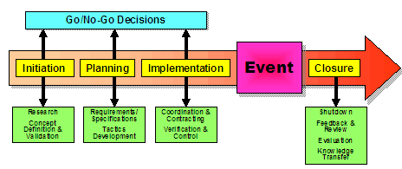
Figure 1 EMBOK Model of Event Cycle

Initiation Phase
The main goal of the event is described in the initiation stage. The Polar Night event is aimed to create an environment-friendly winter experience for the visitors through lighting, stargazing sessions, and storytelling. This procedure includes the following responsibilities: identification of a target audience for example astronomers and nature lovers etc., acquiring a venue that is Cairngorm Mountain Resort, and making strategic collaborations with companies VisitScotland and WWF UK for sponsorships (Bruns, Kraguljac and Bruns, 2020).

Planning Phase
The second stage is planning which concentrates on carrying out the concept of the festival through developing schedules, acquiring resources, and managing operations. The process includes hiring employees such as guides and event managers, booking licenses, and securing technical experts for sound and lighting. In this stage, the promotional team will start a program on their social media to secure potential sponsors and promote the event to increase sales of tickets. This stage also includes developing backup plans to address any uncertainties like bad weather (Bladen et al., 2022).

Implementation Phase
In this stage, the idea established by event managers is executed. The schedule of the festival includes fun activities like opening ceremonies, stargazing sessions, light shows that are inspired by Aurora, and storytelling around bonfires. The operational staff and social workers will handle the technical setups, visitors, and the administration whereas event managers will evaluate the progress of the festival to deal with any Kind of uncertainty to ensure a successful festival (Clarke, 2021).

Closure Phase
In this stage the post-event evaluation will be carried out to evaluate the outcomes of the event, this process includes collecting feedback from visitors, analyzing financial position, and reviewing the outcomes of sponsorships. The outcomes will be recorded to make consistent improvements in the festival that will be held in the future (Clarke and Tapia-Schythe, 2021).

Integration of Core Values
The event will focus on innovation ethics and ongoing enhancements in the complete life cycle of the festival. Every step will be evaluated to ensure that they align with ecotourism objectives and sustainable practices. This systematic framework guarantees that the Polar Night event provides visitors with unique experiences and memories while also Fostering environmental responsibility in the event. The EMBOK framework guarantees a smooth integration, eliminates any risks, and improves the efficiency of operations which contributes to the long-term success of the festival (Guan, Servranckx and Vanhoucke, 2024).

Event Concept
This event provides many different activities that represent the charm of the winter season, this event will provide its visitors with the following experiences:
- Aurora-Inspired Light Shows: A light show will replicate the Aurora every night along with visual effects and music playing behind this lighting.
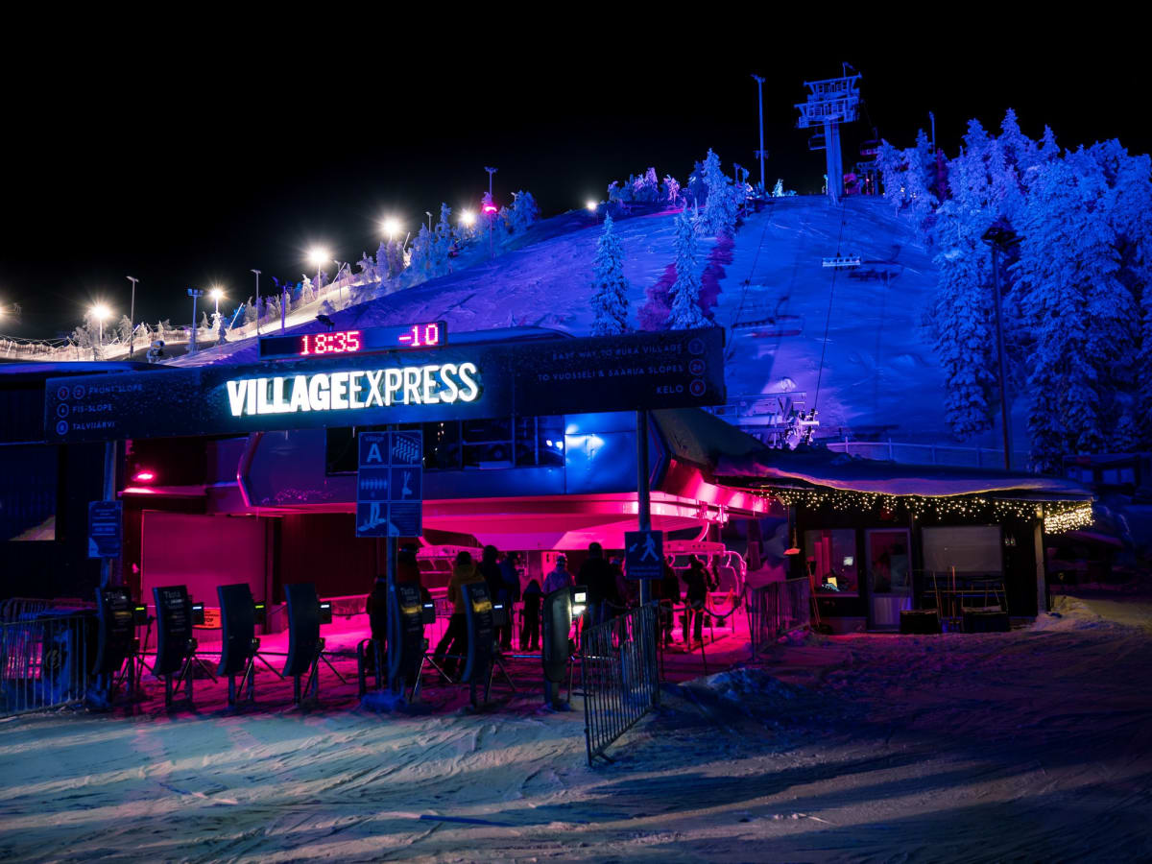
Figure 2 Polar Night Event
- Guided Stargazing Sessions: Astronomical experts will give the visitors a chance to view cosmic or night sky with the help of a telescope.
- Storytelling Sessions: The visitors will get to listen to winter tales and storytelling based on the polar environment around the campfires.
- Art Installations: An art display will be held in which Local artists will display their art to encourage the participation of attendees (Cornwell and Kwon, 2020).

Itinerary:
- Day 1: An opening ceremony will be held in which expert guides will lead the light show and stargazing session, visitors will have the opportunity to enjoy these cinematic scenes and interact with nature.
- Day 2: On the second day family-friendly activities will be executed in which art displays and workshops are included, the visitors will get to listen to stories around bonfires in which folk tales and winter stories will be included.
- Day 3: On the last day, a VIP stargazing event will be held for selected visitors to create a more immersive experience, the event will be closed by a live performance and a final ceremony that will give visitors everlasting memories of the festival (De Jans, Hudders and Constant, 2024).

Aims and Objectives
The overall objective of this event is to build an interactive and entertaining experience of winter.

SMART Objectives:
- Specific: Draw the attention of at least 5000 people within these three days.
- Measurable: Obtain almost 95% satisfaction rate in the feedback of post-event review.
- Achievable: Acquire five sponsors that match the theme of the festival.
- Relevant: Resonate with the increasing demand for eco-friendly tourism and nature-based experiences.
- Time-bound: Successfully execute the festival before the start of 2025.

Event Management
Efficient management plays an important role in achieving a successful polar night event, following are the requirements and responsibilities of staff:

Venue Management
Cairngorm Mountain Resort will be the perfect location for this event because this resort is famous for its winter scenery and clean sky. The infrastructure of this resort has a parking area, emergency services, and warm places. The location of this resort can facilitate different activities, for example, stargazing, art displays, and bonfire folktales, Cairngorm's experience in hosting winter festivals and the scenery of the locals makes it perfect for this event (Ravangard, Khodadad and Bastani, 2020).

Staffing Requirements
The festival will need a lot of employees with different responsibilities to run the event smoothly (Ibadiyah, Hermawan and Mukhlis, 2022).
Role | Number Required | Responsibilities
Security Personnel | 10 | Control crowds, protect festival areas, and ensure visitor's safety.
Stargazing Guides | 5 | Guide stargazing, give astronomical insights, and interact with visitors.
Event Coordinators | 5 | supervise operations, manage timelines, and ensure streamlined activities
Technical Crew (Lighting & Sound) | 8 | Install and control lights and sound within the resort
Volunteers | 12 | Help with administrative tasks like registration and hosting
These responsibilities are split to address the important features of event management, ensure the safety of visitors, impressive performances, and seamless alignment of the events. Social workers will also be important to reduce the cost of operations and support administrative activities (Phi, Dredge and Whitford, 2014).

Marketing Strategy Using the 7Ps
The marketing approach for this polar night event will incorporate a 7ps strategy to successfully advertise the festival and draw the attention of a lot of people from different backgrounds (Mohammad and Zahira, 2023).
- Product:
The festival provides an interactive experience that includes stargazing events, light shows inspired by Aurora, and storytelling with bonfires, to meet the increasing interest of people in eco-tourism.
- Price:
A flexible pricing approach will be used to attract people from different backgrounds this segmentation of tickets includes: family passes, exclusive stargazing events, general admissions, and All Access passes that will cost between £20 to £75 (Do and Vu, 2020).
- Place:
The location of the event is Cairngorm Mountain Resort in Scotland which is famous for its clear sky, scenery, and reputation.
- Promotion:
The organizers will use social media channels such as TikTok and Instagram to create hype for this event, local pamphlets and posters will also be distributed, and partnerships with eco-organizations and social media influencers will be made to increase the reach of the event (Jain, Jain and Jain, 2022).
- People:
Staff members will include expert guides, security members, and event managers to guarantee impressive experiences for the visitors, social workers will support the administration tasks to improve the productivity of the event.
- Process:
The festival will include a digital ticketing platform for making booking easier and providing details of programs to visitors about different activities this procedure is established to offer a smooth experience from start to finish (Sánchez and Bellogín, 2021).
- Physical Evidence:
Customized products, immersive art experiences, and well-designed venues will give a long-lasting experience to visitors that will be an achievement for the festival and it will increase the reputation of the event.

Sponsorships
The organizers plan to acquire sponsorships from WWF UK, VisitScotland, and Celestron UK to reduce the expenses of this event. These companies match the themes of this event which are the preservation of nature, ecotourism, and astrology (Maguire, 2022).
- VisitScotland: This agency will foster the promotion of this event to people of different backgrounds and provide both promotional help and financial support through their channels, their integration will improve the reputation and recognition of this festival in the tourism industry.
- WWF UK: WWF is an eco-organization that will provide sponsorships that match the sustainability initiatives of this event their integration will draw the attention of eco-conscious visitors and also give funds for green initiatives for example recycling programs and waste reduction (Gallego et al., 2020).
- Celestron UK: This is an organization that provides astronomical tools that will sponsor the stargazing sessions of the event by providing telescopes and other important equipment related to astrology, their integration will provide necessary tools and will also attract astronomy lovers toward this event through segmenting marketing techniques.

Event Budget
The table below provides the details of expected expenses and revenue:
Expense Category | Cost (£)
Venue Rental | 15,000
Lighting Installations | 12,000
Event Staff | 10,000
Permits | 2,000
Catering | 8,000
Marketing | 5,000
Safety Measures | 3,000
Total Estimated Costs | 55,000

Projected Income Sources:
The financial stability of this event is based on three main sources of income: sponsorships, ticket sales, refreshments, and product sales. These sources of income have been precisely calculated based on estimated product offerings, partnership deals, and attendance. The event wants to obtain 20-30% profitability with careful management of expenses to ensure both future and financial stability (Seinsche et al., 2023).
1. Ticket Sales: £110,000
The event organizers have estimated an overall income of £110,000 from the sales of tickets by projecting 5000 visitors for three three-day festivals. A flexible pricing approach has been used to attract visitors from diverse backgrounds this pricing technique includes:
- General Admission: £25 for each ticket
- Family Pass (2 Adults + 2 Children): £60
- VIP Stargazing Experience: £50 per person
- Full-Access Tickets: £75 for an all-encompassing pass
This division of prices guarantees availability while providing a VIP offer for people who are looking for immersive experiences. The sales of tickets are increased through group offers and early bird discounts to ensure maximum participation (Gök and Yalçınkaya‐Alkar, 2023).
2. Merchandise and Food Sales: £20,000
The festival is expected to obtain £20,000 from the sale of refreshments and products. Customized event products for example clothes and gifts will be included to encourage visitors to buy to take home as memories. Food stalls inspired by winter will provide a wide range of drinks and meals for example mulled wine, hot chocolate, and locally available dishes.
3. Sponsorships: £30,000
The event organizers focus on collecting £30,000 in sponsorships. These sponsors will manage certain areas of the festival for example eco eco-friendly infrastructure and tools. These collaborations will reduce the cost of operations and also improve the recognition and reputation of the festival (Sivaramakrishnan et al., 2022).
Profit Margin: 20-30%
The overall estimated revenue from the festival is:
- Ticket Sales: £110,000
- Merchandise and Food Sales: £20,000
- Sponsorships: £30,000
- Total Income: £160,000
The event focuses on achieving profitability between 20-30% which converts into £32,000 to £48,000 of profit in which the projected cost of operations is £55,000. This profit will be obtained through cost management by acquiring sponsorships, strategic planning, and increased sales of tickets and products (Rnic et al., 2023).

Industry Trends, Issues, and Impacts

Trends
Eco-Tourism Growth: The COVID-19 epidemic has led to a 61% rise in interest in sustainable traveling options. This increasing trend matches the eco-conscious concept of polar night promotes environmental awareness among visitors and draws the attention of more eco-conscious people and sponsors (Tiew, Holmes and de Bussy, 2022).
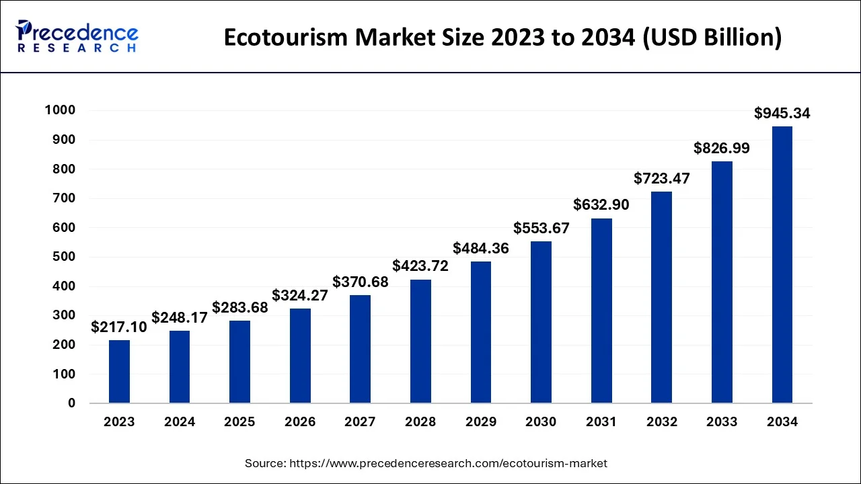
Figure 3 Demand of Eco-Tourism
Popularity of Stargazing: The Polar Nights Festival will feature guided stargazing sessions that have recently become famous, aiming to generate revenue from the growing popularity of stargazing activities by attracting more astronomy lovers that will distinguish this festival from other winter events around the world.

Issues
Weather Dependency: Weather condition is the main problem when organizing an outdoor festival in this situation bad weather like clouding and heavy snow can impact the Stargazing sessions which will minimize the number of visitors. Contingency plans like indoor folktales or substitute events will be required to address these uncertainties (Ghazali et al., 2023).
Environmental Impact: The Polar Night event must make waste reduction a priority, and strategies to minimize waste through the use of sustainable materials and recycling should be integrated. The festival will also take actions to reduce its ecological impact for example using eco-friendly transport options and locally available ingredients for food.

Impact on the Event
The incorporation of eco-friendly procedures will guarantee that this festival aligns with industrial trends and will increase its reputation as a responsible and appealing festival for visitors. These procedures will also improve the recognition of this event to attract more eco-conscious collaborators and sponsors. The event can build its reputation as a leading winter festival by adhering to eco-friendly requirements and sustainability trends in the market which will lead to long-term success and growth (Bruns, Kraguljac and Bruns, 2020).

Situational and Cultural Considerations

SWOT Analysis
Strengths:
This festival has an innovative concept that includes impressive activities such as a lighting show Stargazing, and storytelling that differentiates it from other festivals. Its concentration on eco-tourism matches with trending ideas that increase its attraction in eco-conscious visitors and eco-organizations (Clarke, 2021).
Weaknesses:
The festival has a high cost of operations because of resort rent, lighting, and the need for personnel. The event is also dependent on weather hence bad weather can disturb the outdoor events that can adversely affect the engagement and experience of visitors.
Opportunities:
The event can generate more revenue because of the rising demand for eco-conscious festivals and eco-tourism through providing remarkable experiences based on environmental awareness and nature. The potential opportunities from tourism agencies and eco-organizations increase the chances of growth and progress (Clarke and Tapia-Schythe, 2021).
Threats:
The main threat is that there are other winter events in the same region that might appeal to your target audience thus the sale of tickets will decrease. Event organizers should prioritize marketing and strategic collaborations to maintain the competition of the Polar Night Festival (Guan, Servranckx and Vanhoucke, 2024).

Cultural Considerations
Incorporating Scottish Traditions:
The event will integrate the winter culture of Scotland for example storytelling bonfires and live folk music to build a socially inspiring experience. These factors will bind the visitors to the local traditions that will improve the authenticity of the event.
Collaboration with Local Artisans:
Collaboration with regional artists to create products for the festival provides benefits like cultural integration and economic opportunities to the local society. This approach will also improve the reputation of the festival through the presentation of local arts and crafts (Cornwell and Kwon, 2020).
Environmental Stewardship:
Promotion of eco-friendly initiatives for example waste management and sustainable transportation alternatives will meet the requirements and desires of visitors making it an eco-friendly and innovative festival. This combination of regional partnerships, integration of traditions, and eco-friendly initiatives will improve the long-term success of the event and its impact on society (De Jans, Hudders, and Constant, 2024).

Conclusion
The Polar Nights event wants to build a distinctive and impressive winter atmosphere that increases awareness in the people regarding the polar environment and fosters eco-tourism. The event can identify the streamlined events and positive reviews from different visitors via strategic planning. The success of the festival can be improved by using the integration of sponsors, budget management, and supporting of industrial trends this event will also involve eco-friendly activities in reducing the environmental impacts in meeting the needs of visitors and enhance the competitive benefits (Ravangard, Khodadad and Bastani, 2020).

References
Bladen, C., Kennell, J., Abson, E. and Wilde, N., 2022. Events management: An introduction. Routledge.
Bruns, D.P., Kraguljac, N.V. and Bruns, T.R., 2020. <? covid19?> COVID-19: facts, cultural considerations, and risk of stigmatization. Journal of transcultural nursing, 31(4), pp.326-332.
Clarke, A.E., 2021. From grounded theory to situational analysis: What’s new? Why? How?. In Developing grounded theory (pp. 223-266). Routledge.
Clarke, D. and Tapia-Schythe, K., 2021. Implementing the panel event study. The Stata Journal, 21(4), pp.853-884.
Cornwell, T.B. and Kwon, Y., 2020. Sponsorship-linked marketing: Research surpluses and shortages. Journal of the Academy of Marketing Science, 48, pp.607-629.
De Jans, S., Hudders, L. and Constandt, B., 2024. # Sponsored: a systematic literature review and theoretical framework of gambling sponsorship research. Journal of Advertising, 53(3), pp.434-453.
Do, Q. and Vu, T., 2020. Understanding consumer satisfaction with railway transportation service: An application of 7Ps marketing mix. Management Science Letters, 10(6), pp.1341-1350.
Gallego, G., Delbrück, T., Orchard, G., Bartolozzi, C., Taba, B., Censi, A., Leutenegger, S., Davison, A.J., Conradt, J., Daniilidis, K. and Scaramuzza, D., 2020. Event-based vision: A survey. IEEE Transactions on pattern analysis and machine intelligence, 44(1), pp.154-180.
Ghazali, I., Abdul-Rashid, S.H., Dawal, S.Z.M., Irianto, I., Herawan, S.G., Ho, F.H., Abdullah, R., Abdul Rasib, A.H. and Padzil, N.W.S., 2023. Embedding green product attributes preferences and cultural consideration for product design development: A conceptual framework. Sustainability, 15(5), p.4542.
Gök, B.G. and Yalçınkaya‐Alkar, Ö., 2023. Clarifying the association of social anxiety with cognitive variables: The role of self‐esteem, self‐perception, fears of positive and negative evaluation, and post‐event processing. Scandinavian Journal of Psychology, 64(3), pp.278-287.
Guan, X., Servranckx, T. and Vanhoucke, M., 2024. Risk response budget allocation based on fault tree analysis and optimization. Annals of Operations Research, 337(2), pp.523-564.
Jain, R., Jain, S. and Jain, S., 2022. Analyzing and exploring the effectiveness of each element of the 7Ps of the marketing mix. International Journal of All Research Education and Scientific Methods (IJARESM), 10(1), pp.2455-6211.
Maguire, K., 2022. An examination of the level of local authority sustainable planning for event management: a case study of Ireland. In Events and Sustainability (pp. 112-136). Routledge.
Mohammad, W. and Zahira, S.I., 2023. Analyzing Starbucks' 7Ps Marketing Mix Strategy in the Global Coffee Industry. Yumeka: Journal of Digital Business and Economics, 1(1), pp.1-6.
Phi, G., Dredge, D. and Whitford, M., 2014. Understanding conflicting perspectives in event planning and management using Q method. Tourism Management, 40, pp.406-415.
Ravangard, R., Khodadad, A. and Bastani, P., 2020. How marketing mix (7Ps) affect the patient’s selection of a hospital: experience of a low-income country. Journal of the Egyptian Public Health Association, 95, pp.1-8.
Rnic, K., Santee, A.C., Hoffmeister, J.A., Liu, H., Chang, K.K., Chen, R.X., Neufeld, R.W., Machado, D.A., Starr, L.R., Dozois, D.J. and LeMoult, J., 2023. The vicious cycle of psychopathology and stressful life events: A meta-analytic review testing the stress generation model. Psychological Bulletin, 149(5-6), p.330.
Sánchez, P. and Bellogín, A., 2021. On the effects of aggregation strategies for different groups of users in venue recommendation. Information Processing & Management, 58(5), p.102609.
Seinsche, R.J., Walter, B., Fricke, S., Neudert, M.K., Zehtner, R.I., Stark, R. and Hermann, A., 2023. Social phobic beliefs mediate the relationship between post-event processing regarding the worst socially aversive experience and fear of negative evaluation. Current Psychology, 42(18), pp.15080-15089.
Tiew, F., Holmes, K. and de Bussy, N., 2022. Investigating stakeholder salience across the event management life cycle. Event Management, 26(6), pp.1297-1313.

