Jake Russell

1602835

AI Exam

QUESTION ONE
1a)
i)
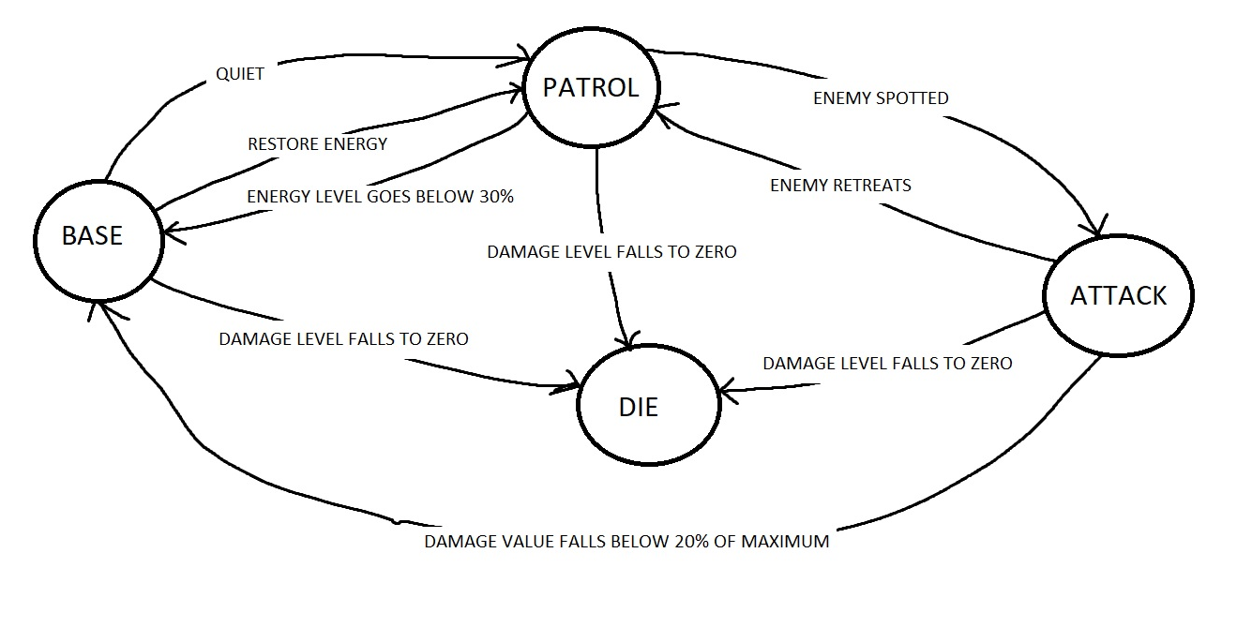ii)
Attack::Enter()
{
int damageLevel;
bool enemySpotted;
bool enemyRetreat;

}
Attack::Execute()
{
While(enemySpotted == true)
{
attackTheEnemy;
if (damageLevel == 0)
{
Die();
enemySpotted = false;
}
if(damageLevel < 20% of max)
{
Base();
enemySpotted = false;
}
If(enemyRetreat == true)
{
Parol();
enemySpotted = false;
}
}
1b) There are finite state machines which produce an output every time an input symbol is received. There are mealy machines which output data on each transition, this makes them good for sequential control problems. There are Moore machines which do not output symbols, the state determines the output instead. And there are transition arrays which are popularly represented in the form of a 2d array but can also be stored as vectors.

QUESTION 2
2a)
Fuzzy logic expert systems work with linguistic variables to define their fuzzy rules, for example you could have IF road is wet AND speed is fast THEN braking is bad.
2b) There is the Centre of Gravity method (COG), and the weighted average method
2c)
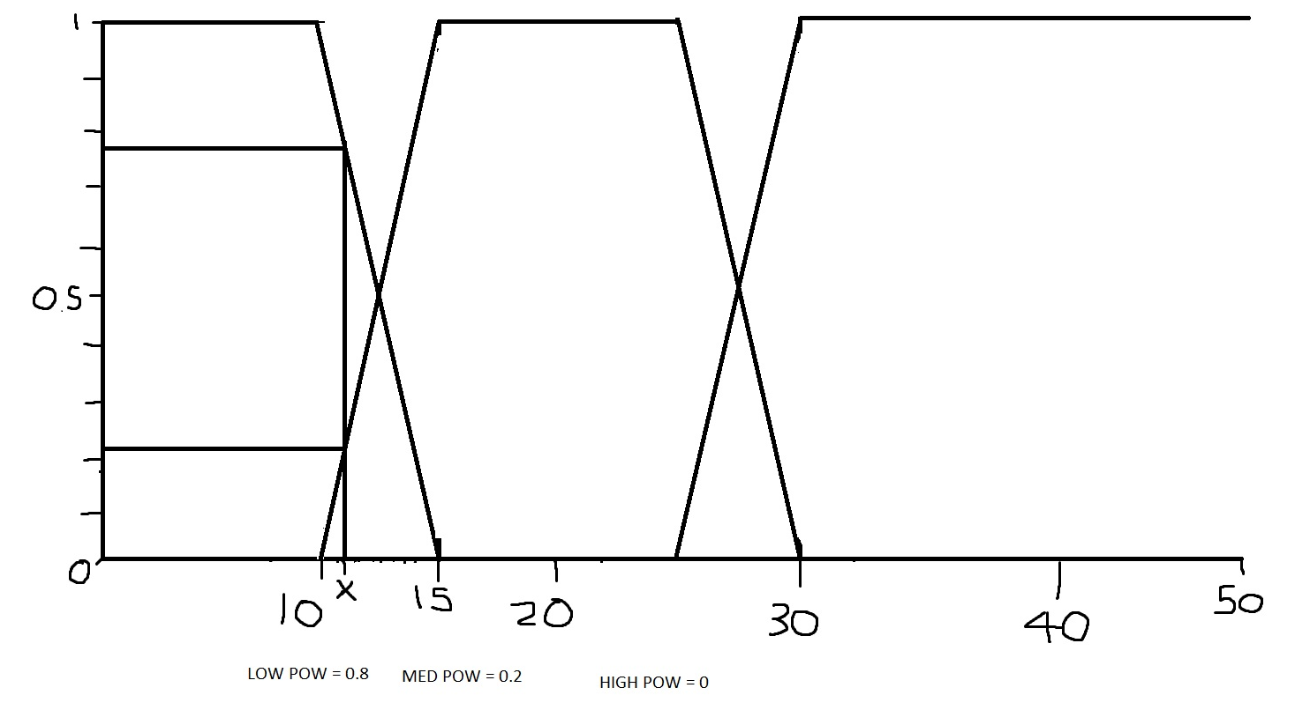
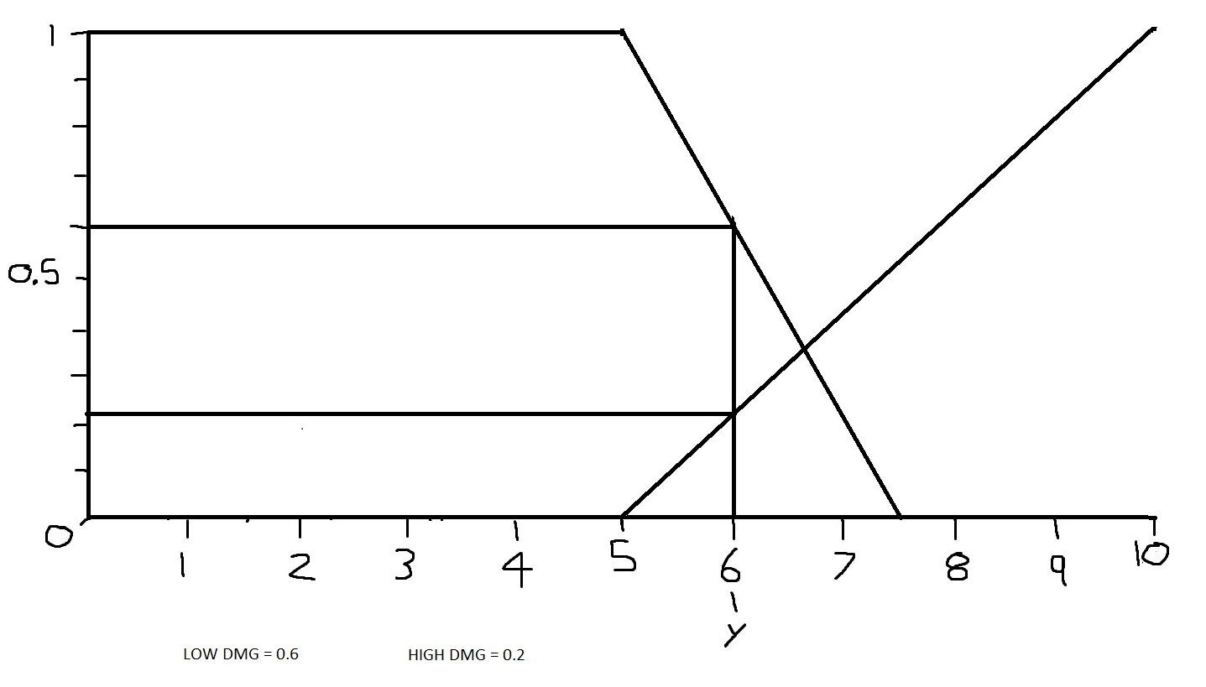
0 | 0.6
0.1 | 0.6
0.2 | 0.6
0.3 | 0.5
0.4 | 0.2
0.5 | 0.2
0.6 | 0.2
0.7 | 0.5
0.8 | 0.8
0.9 | 0.8
1 | 0.8
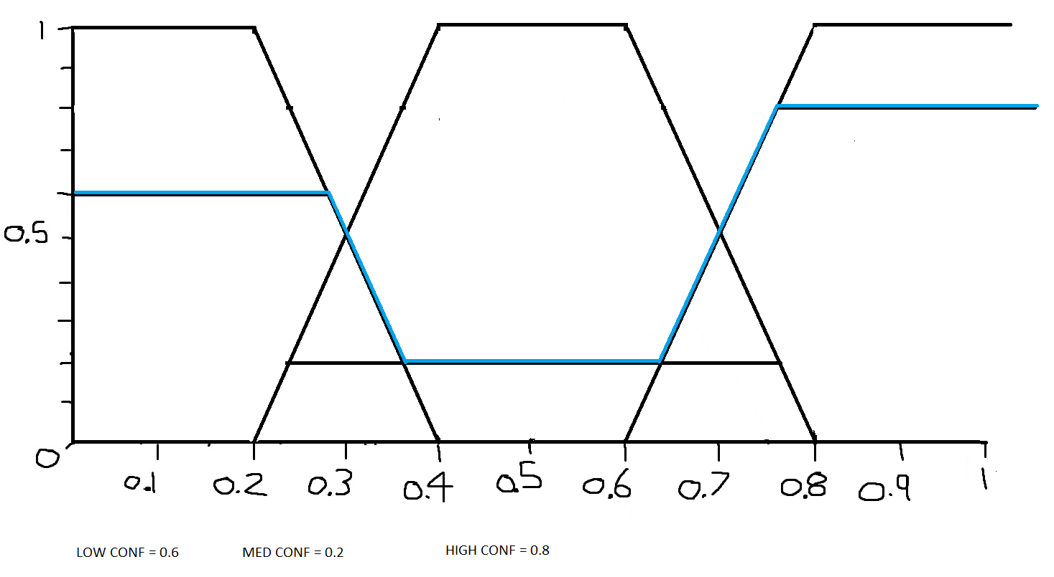
0.6(0 +0.1+0.2) + 0.5(0.3 + 0.7) + 0.2(0.4+0.5+0.6) + 0.8(0.8+0.9+1)
/ 3(0.6) + 2(0.5) + 3(0.2) + 3(0.8) = 0.54
The confidence level is 0.54 which is medium confidence.

QUESTION THREE

3a)
Classification and regression are both supervised example of machine learning. Regression is when the machine attempts to estimate the mapping function from the input variable to numerical or continuous output variables, whereas with classification the machine attempts to estimate the mapping function from the input variable to discrete of categorical output variables
3b)
H(x) = 0.163 * 0.6 + 0.418 = 0.5158

