Component 2 –

Research Report

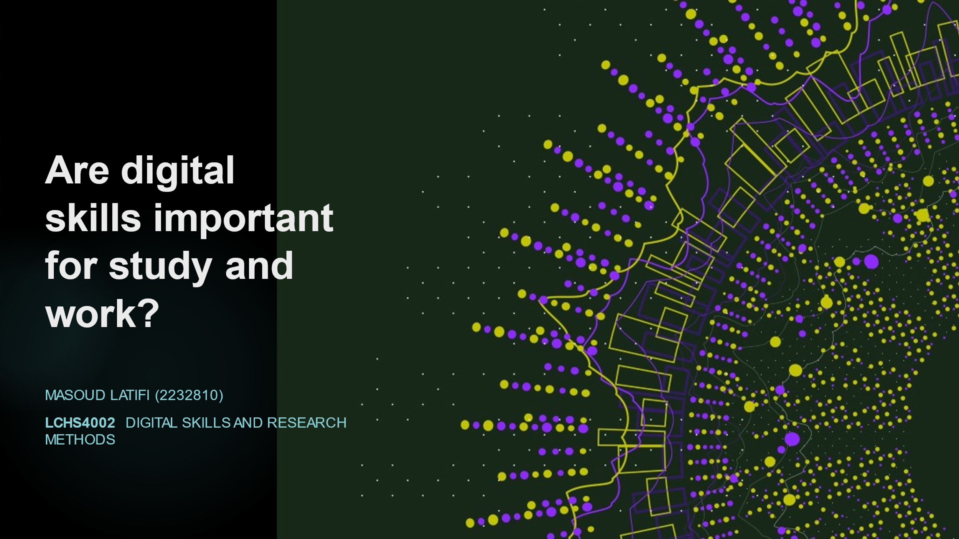

Student’s Name: Masoud Latifi
Student Number:2232810
Lecturer’s Name: Zeno Leung
LCHS4002_BIRM
Digital Skills and Research Methods

CONTENTS

1. INTRODUCTION p. 3
2. RESEARCH DESIGN p. 4
2.1. Research Question… …p. 4
2.2. Method p. 4
2.3. Ethical Considerations p. 5
3. RESULTS p. 6
4. DISCUSSION p. 8
5. CONCLUSION …….p. 10
6. REFERENCE LIST p. 11
7. APPENDIX A – A blank copy questionnaire. p. 12

- INTRODUCTION

This report is about the research project conducted by Masoud Latifi from January to March 2023 at the UTWSD University of Birmingham as part of “Digital skill and Research Method” Course. The object of the research is the value of Digital skill given by thirteen students of the University, and it is in particular focused on the approach towards some Digital tools. This study would inquire if communication tools are the most used and students have confidence in digital skill. An initial survey about the digital capabilities, in fact, can be a first step to structure learning, working and collaboration plans based on the most modern hints, as underlined by literature on the topic.

- RESEARCH DESIGN

  - Research Question
This research aims to define the most appreciated digital tool by people enrolled in UWTSD to confirm or refute the proposal hypothesis about a predominance of communication tool. The question can be strictly connected to the level of Digital Skill, because some digital tools required specific competencies, both digital and technological, to be used in a satisfied and productive way.

  - Method
The object of the research was investigated with a quantitative approach using a questionnaire. There are different forms (paper, electronic, online) and different delivery modes (post, email with attachment, email with link), but in this case, the best way to contact participants was a MS Form linked to a introductory email sent to a wide range of students of UWTDS University of Birmingham. By the point of the structure, it included a brief description of the research topic and purpose, completion instructions, permission and a list of questions. For this project, the questions were all closed. The five questions were about:
- permission;
- level of confidence in the use of a service (WhatsApp), two Microsoft 365 softwares (MS Word, MS Power Point) and a Microsoft file hosting service (OneDrive). The participants had to answer ranking the apps;
- agreement level to three statements about confidence in the use of a processing software (MS Word), a web application (MS Form) and difficulty in using computer in general;
- opinion on the most important tool among Microsoft products: three softwares (MS Word, MS Excel, MS Power Point), a web application (MS Form) and a workspace (Microsoft Teams);
- feedback.

- Do you give consent to participate in this survey voluntary?
- Please rank the following apps in term of your level of confidence in using them.
- How much do you agree to the following sentences?
- Which digital tool do you think is the most important?

  - Ethical Considerations
This project was based on an ethic reflection about the questions.
The first point was the introduction of the topic and of the researcher. All the participants received an email with a clear content of the research project.
The second point was the type of questions. After the permit request, mandatory by law, the questions did not inquire on personal data and sensitive information. The questionnaire were anonymous and the result were collected in aggregate form.
The third point was about the researcher, who must be always polite, even if someone will not answer and available to give all the details clearly.

- RESULTS

The results of the questionnaire are indicated separately for each question and illustrated with graphics from MS Form.

Question: Please rank the following apps in term of your level of confidence in using them.
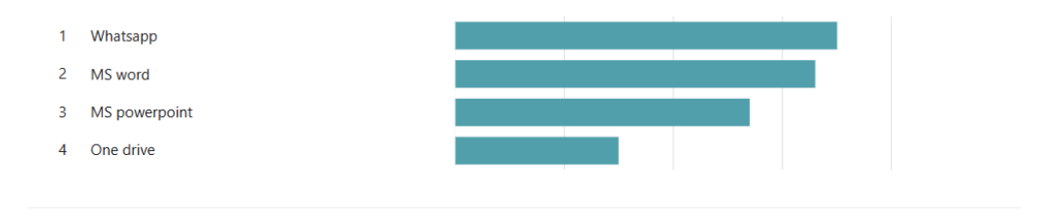

The students have more confidence in the use of WhatsApp (45%) than in MS Word (40%) but with little difference. A bigger difference is between MS Word and MS Power Point (10%). The app in which students have the least confidence is OneDrive (5%).

Question: How much do you agree to the following sentences?

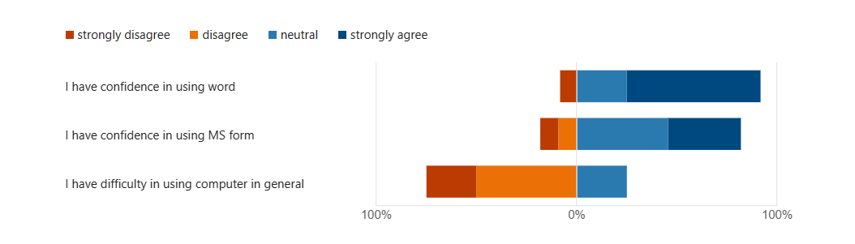

The students strongly agree with the statement about the confidence in MS Word (66%) and in a less way are neutral (25%). None disagree (0%), and few strongly disagree (9%).
The students are more neutral about confidence in MS Form (45.5%) and a few strongly agree (36.5%). The number of students that disagree (9.1%) is the same of ones strongly disagree (9.1%).
The students disagree with the statement about difficulty of using computer in general (50%) and the number of students that strongly disagree (25%) is the same of ones that express a neutral position (25%).

Question: Which digital tool do you think is the most important?

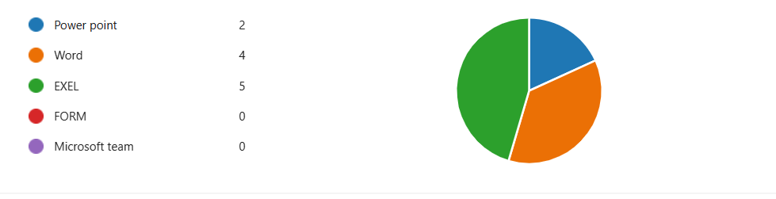
The students think that the most important digital tool are MS Excel (5) and MS Word (4). Few students expressed their preference on MS PowerPoint (2); none for MS Form (0) and Microsoft Team (0). Two students did not express their opinion.

Question: What feedback do you give to this questionnaire?
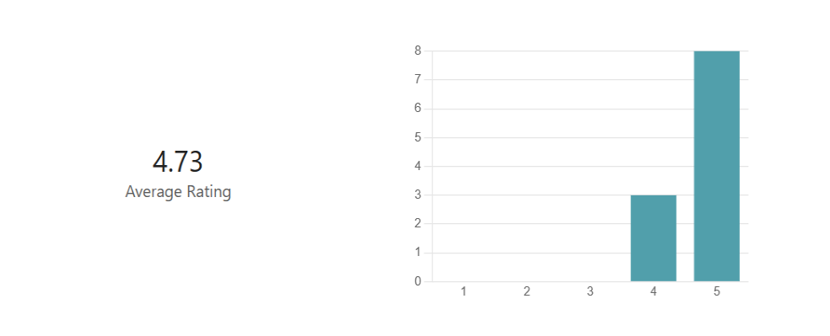
The participants evaluated this questionnaire with 5 points (8) and 4 points (3), with an average rating of 4.73. Two participants did not express their feedback.
- Discussion

The results shown that participants have expressed confidence in the use of WhatsApp (45%) and MS Word (40%) compared to the use of PowerPoint and OneDrive. They have confidence in MS Word (66%) and in MS Form (45.5%) and in the use of computer (50%). They think that the most important digital tool are MS Excel (5), then MS Word (4) and finally PowerPoint (2). The participant have expressed less confidence in the use of OneDrive (5%) and Microsoft Team (0).
It is interesting to observe how in the first question, the participants declare to have more confidence in WhatsApp, than in MS Word. When, as in the second question, WhatsApp is not present in the list, MS Word is preferred to MS Form and the participants declare a strong agreement in the general use of a computer. The result acquires a new meaning in the third question with the introduction of MS Excel, which is indicated more important than MS Word as digital tool. In other words, the students have more confidence in a multitasking service based on communication (WhatsApp) than in a software expressly developed for written communication (MS Word), but, what is partially unexpected, a software developed for managing and analysing data (MS Excel) is considered the most important digital tool.
The results confirm the research conducted by Gan, Menkhoff and Smith (2015). In both studies, it is clear the importance of communication tools such as WhatsApp among learners who have confidence in the use of computer, but less in the use of online professional products. MSPowerPoint, OneDrive, MS Form and Microsoft Teams are respectively a software developed for making presentations, a cloud file hosting service and an online workspace developed for meetings and exchange of ideas, but learners are not be able to use them productively. WhatsApp allows to text long messages, record and send voice messages, send files, photos, videos and make call and videocall with a person or a group everywhere and freely, only using personal mobile device, with a telephone number and Internet data or Wi-Fi connection. It is simpler and more ready-to-use than more professional softwares and services, suited for learning and working environments and purposes.
Nowadays, as suggested by Gan, Menkhoff and Smith (2015) and Barnes (2016), learners with good digital competencies with their mobile devices, “struggle” to match these digital abilities with a traditional learning process and their face-to-face communication is apparently poor. So, in an increasingly digital word, it become necessary to change teacher’s role from a traditional to a innovative teaching that help to transfer the interest and the abilities in digital technology in new ways of learning based on digital tools. In facts, the potentiality of Internet is not completely comprehended by many students and they lost a lot of opportunities to expand and spread their knowledge through the global learning and teaching (Barnes, 2016).
The results indicated that MS Excel is considered the most important digital tool by UTWDS students. It is a professional software less immediate than MS Word, but doubtless it offers interesting and attractive functions and it can be used for a wide range of purposes that request data organising, simple and complex calculations and data visualisation. It can be useful in everyday life, in learning and working environments, for example for time and financial management, task planning, tracking.

- CONCLUSION
This research project has confirmed two points present in the literature of the topic: how communication tools such as WhatsApp are considered important by students respect professional softwares and services; how students do not have difficulties in the use of computers, but do not have confidence in the use of online professional tools.
The results confirm the hypothesis about a predominance of communication tools, but also underline a particular interest in MS Excel, which is considerated the most important digital tool among other Microsoft 365 products, probably for its interesting functions, appliable in everyday life.
This research was conducted on a group of thirteen participants through a quantitative method (questionnaire) and can represent a first approach on the topic, that needs to be study in deep in consideration of the increasing digitalisation of the word with consequences in learning and working environments, such as new ways of teaching (global learning and teaching).

- REFERENCE LIST
Barnes, M. (2016). 5 skills for the global learner: what everyone needs to navigate the digital world. Thousand Oaks: Corwin.
Gan, B., et al. Enhancing students’ learning process through interactive digital media: New opportunities for collaborative learning. Computers in Human Behavior (2015), http://dx.doi.org/10.1016/j.chb.2014.12.048

APPENDIX A
- Do you give consent to participate in this survey voluntary?
- Yes
- No
- Other

- Please rank the following apps in term of your level of confidence in using them.
WhatsApp
Word
MS PowerPoint
One Drive

- How much do you agree to the following sentences?
 | Strongly disagree | Disagree | Neutral | Agree
I have confidence in using Word. | ○ | ○ | ○ | ○
I have confidence in using MS Form. | ○ | ○ | ○ | ○
I have difficulty in using computer in general. | ○ | ○ | ○ | ○

- Which digital tool do you think is the most important?
- PowerPoint
- Word
- Excel
- Form
- Microsoft Team

- What feedback do you give to this questionnaire?

