Cultural Awareness: Hotel Handbook
Name of the Student: GIANINA AGHINITEI
Student ID: 2126415
Module Lead: Rodrigo Aguilera
Word Count: 1027

Executive summary:
The hotel country is the UK and the guest country is Germany. Both countries have a cultural enriching background. Which influenced its culture and environment. Both countries have different types of differences and similarities in their cultures. With the help of Hofstede’s 6-dimension model, the note country’s cultural differences and similarities will be compared. There was a Do’s and Don’ts list that will be provided, which can be helpful for the hotel’s staff.

Table of Contents
Executive summary: 1
Introduction: 3
The culture of the UK (Hotel location): 3
The guest country: 4
Country analysis: 4
Hotel Handbook: 5
Do’s: 5
Don’t: 6
Conclusion: 6
Reference: 7

Introduction:
The first country for the framework will be the United Kingdom, which is also the hotel location. The cultural background of the UK is British culture which is mainly influenced by Wales, Northern Ireland, England, and Scotland’s unique traditions (Anderson 2022). The British culture or the UK’s vulture represents these locations’ cultures and traditions. As the hotel is stated in the UK, therefore, their main language is English. The country Germany is one of the most secular countries in the world, where their culture and religion is get regarded as personal matters (Kaasa and Minkov 2020). There most of the population followed Christianity religion as tradition and faith as dominant. In this report, further discussion will be focused on the UK’s culture which is the hotel’s location, and the culture of Germany which is the guest culture. There will be a comparison and critical analysis conducted with Hofstede's model tool.

The culture of the UK (Hotel location):
As the hotel will be situated in the UK therefore the main English culture was followed among the individuals. The Cultural background of the UK is heavily influenced by the past imperial of the United Kingdom (Bayly 2020). With the help of Hofstede's model, the UK’s culture can be evaluated. Identifying the 6 main key variables of Hofstede’s model can be helpful to understand the UK’s culture effectively. The power distance in the UK has a low score, which refers to the society’s less powerful people (Bruyneel et al. 2019). Individualism in the UK refers to an individual’s self-image, which has a high score in the UK’s culture. The masculinity and femineity in the UK’s culture refer to having a masculine culture country as it has a score over 66. The uncertainty avoidance culture in the UK refers to the comfortableness of uncertainty among the people. Uncertainty avoidance in the UK’s culture has a low interest in the UK culture. The long-term orientation in the UK’s culture refers to the existing challenges in society relies on. The long-term orientation in the UK’s culture has a neutral score. Indulgence in the UK has a weak score. Indulgence in the UK’s culture refers to the control and tendency of their desire.

The guest country:
The hotel is situated in Wales their most of the visitors were from Germany, which is a different cultural background from the culture of Wales or the UK. The cultural background of Germany is one of the rich and popular, which has a long history. In Germany their first language is German, where more than 95% population speak the first language, however, the other 5 % population speak other languages (Gazzola and Mazzacani 2019). As most of the gust were from Germany, therefore, the hotel staff needs to understand their cultural background and enrich the culture as well. This can be helpful to provide them with better services. With the help of the 6 key dimensions of Hofstede’s model, the German country’s cultural dimension will be evaluated. The power distance in Germany refers to it’s the society’s people’s inequality, which refer that Germany has fewer powerful members in their organization. Individualism in Germany refers to the interdependence of the society which is maintained by its members (Milosevic 2019). Individualism in Germany is strong individualism with a score of 67. Femineity and masculinity in the country’s culture are mainly driven by success, and competition, which has a high masculinity in their culture. Uncertainty avoidance in the culture of Germany has a score of 65, which refer to having control over the future. Long-term orientation in German culture refers to the teachings of Confucius, which has a score of 31 and indicates a short-term orientation culture.

Country analysis:
The county analysis will be complete with the help of the Hofstede model. The country UK’s power distance is 35, however, the country German’s Power distance is also 35 which refer that both countries have a similar power distance in their cultures (Hofstede Insights 2023). The individualism of the UK’s culture has a score of 67, however, the German’s individualism score is 89, which refer that the country German has more individualism rather than the UK (Hofstede Insights 2023). The Masculinity of the UK is 66, and the German masculinity is also 66 which refer that both counties have similar masculinity in their culture. Uncertainty avoidance in the UK has a 65 score and the country German has a score of 35 which refer that the country UK has better uncertainty avoidance in their culture. The long-term orientation in the UK has an 83 score, however, the German has a score of 51 in long-term orientation, which refer that the UK has more long-term orientation in their country’s culture (Hofstede Insights 2023). The Indulgence score of the UK is 40, however, the Germans’ indulgence score is 69, which refer that the UK has more indulgence in their culture.
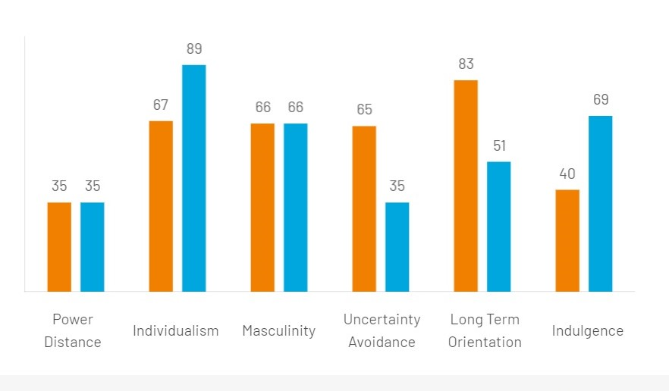
Figure 1: The comparison of the UK and German cultures by the Hofstede model
(Source: Hofstede Insights 2023)

Hotel Handbook:

Do’s:
- Welcome and greet the guest with a smile and gratefulness.
- It is important to communicate with the guest with politeness and softness.
- It is important to respect the guest’s culture.
- It is important to provide the best services according to the guest’s preference.
- The staff should understand the cultural differences and guide the guest accordingly (Lam et al. 2021).

Don’t:
- The staff should not misbehave or be rude to the guest.
- The staff should not lose their temper during assisting the guest.
- The staff should not misguide the guest regarding they do not have enough knowledge.
- The staff should not only suggest their preference in food, as it is important to take guest preferences first-hand (Li and Gao 2023).
- The staff should not be unnecessarily absent when the guest needs their assistance.

Conclusion:
In conclusion, the hotel location is in the UK and the guest's location is in German, however, both countries have differences in their cultural backgrounds. With the help of the model and its 6 dimensions, the different cultural insides could be evaluated. There was a list of do's and don’t are there which the hotel staff should be followed.

Reference:
Anderson, P., 2022. Spain and the United Kingdom: Between unitary state tradition and federalization. In Emerging Federal Structures in the Post-Cold War Era (pp. 49-72). Cham: Springer International Publishing.
Bayly, C., 2020. The British and indigenous peoples, 1760—1860: power, perception and Identity. In Empire and others: British encounters with indigenous peoples, 1600–1850 (pp. 19-41). Routledge.
Bruyneel, L., Lesaffre, E., Meuleman, B. and Sermeus, W., 2019. Power distance and physician–nurse collegial relations across 14 European countries: National culture is not merely a nuisance factor in international comparative research. Journal of Nursing Scholarship, 51(6), pp.708-716.
Gazzola, M. and Mazzacani, D., 2019. Foreign language skills and employment status of European natives: evidence from Germany, Italy and Spain. Empirica, 46(4), pp.713-740.
Hofstede Insights (2023) Country comparison tool, Hofstede Insights. Available at: https://www.hofstede-insights.com/country-comparison-tool?countries=germany%2Cunited%2Bkingdom (Accessed: 02 June 2023)
Kaasa, A. and Minkov, M., 2020. Are the world’s national cultures becoming more similar? Journal of Cross-Cultural Psychology, 51(7-8), pp.531-550.
Lam, R., Cheung, C. and Lugosi, P., 2021. The impacts of cultural and emotional intelligence on hotel guest satisfaction: Asian and non-Asian perceptions of staff capabilities. Journal of China Tourism Research, 17(3), pp.455-477.
Li, Z. and Gao, Y., 2023. Better Wealth, Better Health: Wellness Hotel Attributes and Consumer Preferences in China. Journal of China Tourism Research, pp.1-23.
Milosevic, D., 2019. A comparison of Hofstede’s cultural dimensions: Italy, Germany, and Serbia. The Economic and Management of Natural Resources.

