Please note!
It is essential that you DO NOT press the “End Event” button. Be careful, it is right next to the “Leave” button on the right hand side of the screen.
If you press the end event button, that will stop the event for everyone, and create all sorts of technical issues. So, please be careful if you need to leave the Essential Updates Day before it ends.
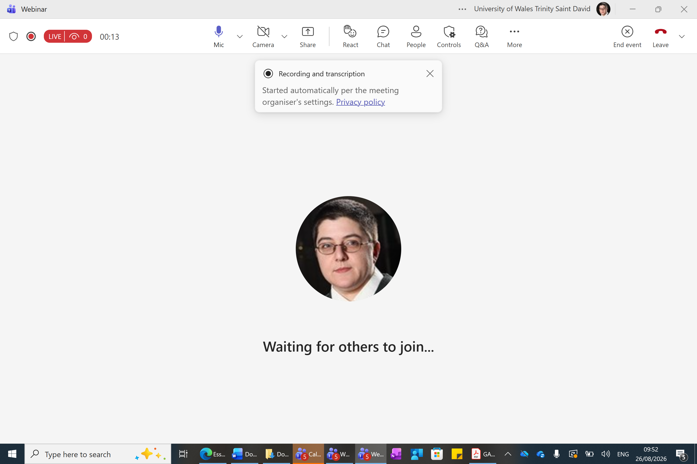

You will have presenter rights, so you will need to share your PowerPoint. If you have any technical issues, please do tell us immediately and one of us will share the PowerPoint for you.

