

Violence Against Women and Girls (VAWG)

Dissertation question:
Do high-profile femicide incidents indicate systemic failures in UK policing and government policy, and how effective are current efforts in protecting women against gender-based violence?

Natalia Konciak
2238990
University of Wales Trinity Saint David

Abstract

Violence against women and girls (VAWG) in the UK has reached a national emergency level. A man kills a woman every three days. This dissertation investigates whether high-profile cases of femicide reveal systemic failures within the police force and government. The survey, conducted among 46 participants, examines the implementation gap, the difference between what the law says and how safe women feel in their daily lives. The results showed a decrease in trust: 47% of respondents confirmed that their trust in the police had decreased following high-profile murders of women. None of the respondents reported an increase in trust. Furthermore, almost half of those surveyed had never heard of the national strategy to combat violence against women and girls (VAWG) or the word 'femicide'.
Ultimately, the dissertation indicates that people reject current strategies because they consider them to be mere promises rather than real protection. This is confirmed by the assessment's effectiveness of just 2.77 out of 5. Institutional misogyny, coupled with ineffective risk assessment, is severely undermining national efforts to address violence against women and girls. To rectify these issues, this dissertation calls for formal legal recognition of femicide, transparency in the police vetting process and the placement of domestic violence specialists in every emergency centre in the UK.

Acknowledgements

I would like to express my thanks to my supervisor, Jane Davies, for her support throughout the writing process. Their academic expertise and practical advice were vital in helping me structure my findings and completing this research on time.
I also wish to extend my thanks to Mike Durke, who supervised me last year; his early advice and support were fundamental in helping me establish the foundations of this research.
I am especially grateful to Nerys Musgrove for her incredible support during the final, most stressful days of this process. Her guidance and encouragement during my most challenging moments were invaluable, enabling me to maintain focus and confidently complete the task.
I would like to extend my sincere thanks to the 46 individuals who participated in my research survey. This dissertation deals with the sensitive and critical issue of femicide, and I am deeply grateful for your willingness to share your honest perspectives. Your contributions were vital in bridging the gap between theory and the lived reality of women's safety in the UK today.
Finally, I want to say a huge thank you to my family for their endless love and support. Thank you for believing in me, especially during the long months of writing and research when I was stressed and exhausted. I could not have finished this journey without your encouragement and patience.

Declarations

This work has not previously been accepted in substance for any degree and is not being concurrently submitted in candidature for any degree.
STATEMENT 1
This dissertation is being submitted in partial fulfilment of the requirements for the degree of BA/BSc.
STATEMENT 2
This dissertation is the result of my own independent work/investigation, except where otherwise stated.
Other sources are acknowledged in the Reference Section.
STATEMENT 3
I hereby give consent for my dissertation, if accepted, to be available for photocopying and for interlibrary loan, and for the title and summary to be made available to outside organizations.
STATEMENT 4
I hereby give consent for my dissertation, if accepted, to be available on the university’s IT system to those who have consent to use the system.

Student’s Name – Natalia Konciak

Signed: Konciak

Date:03.05.2026

Table of Contents

Abstract 2
Acknowledgements 3
Declarations 4
Chapter One - Introduction 6
1.1 Background and research focus 7
1.2 Overall research aim and objectives 8
1.3 Outline research methods and timescales 8
1.4 Values of the research 9
Chapter Two- Literature Review 10
2.1. Introduction 10
2.2. High-Profile Femicide and the Reality of Systemic Institutional Failures 11
2.2. 1.. Theoretical Framework: Defining Femicide and the Role of Intersectionality 11
2.2. 2.. Fatal Gaps in Protection: Sarah Everard, Sabina Nessa, Zara Aleena 12
2.2.3. Red Flags and the Pattern of Missed Opportunities in Policing 13
2.2.4. Institutional Misogyny: The Impact of the Casey Review 2023 13
2.3. Evaluating National Policy: The Efficacy of Legislative and Policing Strategies 14
2.3.1. The VAWG Tackling Strategy 2021-2024 and National Policing Framework 14
2.3.2. Local Strategic Implementation: The South Wales Police, Crime and Justice Plan 2025-2029 15
2.3.3. Raneem's Law-Improving the first defence line 16
2.3.4. Clare’s Law: The Illusion of Proactive Disclosure 16
2.3.5. Freedom from Violence and Abuse: Strategic Roadmap (2026-2029) 17
2.4. Navigating Barriers to Justice: Accountability, Reporting, and Prevention 18
2.4.1. Barriers to Reporting: Fear, Mistrust and Victim Blaming 18
2.4.2. Structural Problems with Police Accountability and Internal Vetting 19
2.4.3. Proposed Solutions for Public Policy 19
2.5. Conclusion 20
Chapter Three- Methodology 20
3.1 Introduction 21
3.2. Research Strategy 21
3.3 Data Collection 22
3.4. Data Analysis 23
3.5. Limitations and Potential Hurdles 24
3.6 Conclusion 25
Chapter 4 – Findings and Analysis 25
4.1 Introduction 25
4.2 Demographic Foundations and Public Knowledge 25
4.2.1 Gender and Age (Question 1 & 2) 26
4.2.2 Priority vs. Vulnerability: The Urgency Gap (Questions 3 & 4) 27
4.2.3 The "Femicide" Knowledge (Question 5 & 6) 28
4.3 The Crisis of Competency and Institutional Trust 30
4.3.1 Training and Professional Standards (Question 14) 30
4.3.2 The Effectiveness Rating (Question 16) 31
4.4 The "Invisible Walls" and Barriers to Reporting (Question 13) 32
4.5 Transparency vs. Legislation (Questions 15) 33
4.6 The Isolated incident and The Systemic Failures (Questions 7 & 8) 34
4.7 Recommendations for Improvement (Question 12) 35
4.8 Policy Awareness and the Call for Legal Reform (Questions 9, 10 & 11) 36
4.9 Conclusion 38
Chapter Five- Conclusion 39
5.1 Introduction 39
5.2. Objective 1: High-Profile Femicide and Systemic Failures 39
5.3 Objective 2: The Effectiveness of Current Strategies 40
5.4 Objective 3: Barriers and Suggested Solutions 41
5.5 Recommendations 41
5.6 Final Reflections 42

Chapter One - Introduction

1.1 Background and research focus

Violence against women and girls (VAWG) is one of the largest and-longest-lasting challenges globally (Murphy,2023). Femicide, defined as the intentional killing of a girl or woman because of her gender, stands as the most severe issue (Nowak,2022). According to Tsegay (2025), a man in the UK kills a woman, generally a current or previous partner, every three days. Despite decades of government efforts and the establishment of legislation aimed at protecting women, the incidence of femicide has remained largely unchanged (Barlow,2020). Although the term 'femicide' being introduced in 1976 to highlight gender-based killings, British law still classifies these acts as homicide (Standish,2022). Femicide is different from other kinds of murder because of the patterns and causes that are specific to women (Caicedo‐Roa,2020). However, it is hard to gather data on and put in place systematic prevention strategies because it is not officially recognised (Fitz-Gibbon,2023). The issue of "femicide”, has gained significantly more public attention since the murder of Sarah Everard (2021), by a police officer in London (Herbert,2025). These incidents gained national attention due to its unusual nature and arise the questions about effectiveness of police strategies in preventing femicide and government responses to this ongoing issue (Freeland,2025). Many women are becoming afraid and frustrated due to their belief that the system is not properly ensuring their safety. The public's faith in the police has decreased in the aftermath of cases of sexual assault, domestic violence, and other crimes. When victims lose faith in the police, they are less likely to come forward with reports of abuse or seek help (Horeck,2024). Strategies like the Tackling VAWG Strategy (2021) and the National Policing Framework (2024) aim to improve victim support and perpetrator pursuit (Home Office, 2021; NPCC, 2024b). But these efforts are still being hindered by systemic problems. When police investigate homicides, they often miss signals of coercive control or a higher risk (Kassing,2026). These issues demonstrate that new legislation is insufficient; both, the police force and the government itself require modifications.

1.2 Overall research aim and objectives

Aim:
This dissertation investigates how high-profile femicide cases reveal structural weaknesses in UK policing and government policy. By examining the link between institutional culture and women lived experiences of safety, the study evaluates whether current strategies provide genuine protection or reactive responses to public outcry.
Objectives:
1.Critically explore the relationship between high-profile femicide incidents and systematic failures within UK police and government.
2.To evaluate the effectiveness of current police and government strategies aimed to prevent femicide and to protect women from gender-based violence.
3. To identify barriers and suggest potential solutions to improve accountability, prevention, and trust in police and government actions regarding femicide.

1.3 Outline research methods and timescales

This research employs a quantitative survey to gather data from a sample of UK residents aged 18 and over. By utilizing a self-administered structured questionnaire via Microsoft Forms, the study identifies trends and correlations regarding public trust and the effectiveness of VAWG policies. Furthermore, ethical standards, including voluntary participation, anonymity, and informed consent, were strictly maintained throughout the data collection process.

1.4 Values of the research

This research highlights the connection between individual cases of femicide and broader systemic failures in police and government accountability. By addresing the gap between public perception and official strategy, the study provides evidence to support institutional reforms and the restoration of public trust in the UK justice system.

Chapter Two- Literature Review

2.1. Introduction

Violence against women and girls (VAWG) in the UK has escalated to a critical level and has recently been declared a national emergency (NPCC,2024c). Statistical data shows that every three days, a woman is murdered by a man, and this figure has remained constant for over a decade (Hughes,2016). This indicates that high-profile incidents are not just isolated events but are signs of a much wider systemic issue (Meyrick,2026). The primary objective of this literature review is to examine academic studies, government records, and legislation to understand the fundamental reasons for this trend. Chapter will examine why the rate of femicide remains high, despite the government’s implementation of various strategies designed to reduce it. Russell’s (1976) concept of femicide serves as a crucial foundation for this research. Her framework is essential because it categorises these murders as gender-based crimes rather than just random murders (Caicedo‐Roa,2020). This directly relates to a definitional gap in the UK, as the British legal system does not formally acknowledge femicide as a distinct type of crime. The absence of a clear legal name obscures the true scale of the issue in official statistics, which complicates the ability of the police to create effective prevention tactics (Wright,2024). This chapter follows these key issues:
- Theoretical Framework (2.2.1)
- High-Profile Case Studies to identify where the system failed despite known dangers (2.2.2)
- Overlooked Red Flags (2.2.3)
- Institutional Misogyny within police culture (2.2.4)
- Government Strategies (2.3)
- Barriers to Justice (2.4).
Overall, this review highlights the gaps in our current understanding of how safe women feel today, which is the focus of my own research and survey.

2.2. High-Profile Femicide and the Reality of Systemic Institutional Failures

2.2. 1.. Theoretical Framework: Defining Femicide and the Role of Intersectionality

Russell is a key figure in the research on violence against women, especially when it comes to defining the term femicide. She introduced this term in 1976 to emphasise that these killings are gendered and should be distinguished from other types of homicide (Giacinti,2022). For Russell, femicide is not just a random murder; it is the killing of women specifically because of their gender. Her work was designed to highlight male violence and discrimination, framing femicide as the most extreme form of violence against women (Meneghel,2017). A major issue in the UK is the lack of widespread acknowledgment or naming of femicide in legal jurisdictions. This contributes to the invisibility of gendered killings in both public talk and government policy (Sánchez-Prada,2023). Because there is no specific legal or social framework that names femicide in the UK, it creates big challenges for collecting accurate data and raising public awareness (Bansal,2023). It also makes it harder to create the right policy responses to stop these crimes. This is consistent with the fact that femicide is often undercounted and underreported, which makes it much more complicated to address the problem effectively (Giustina,2018). A woman’s experience of violence is shaped by more than just gender. Other factors like race, class, and disability also play a huge role. This is why intersectionality is so important for understanding femicide (Caterini,2023). Traditional definitions can be too narrow because they often focus on only one viewpoint. If the focus is only on gender, there is a risk of ignoring victims whose identities are more complex or less visible in the media (Knap,2021). Using an intersectional lens shows that femicide is a complex issue affected by overlapping social inequalities. This approach is necessary for better research and more accurate definitions. It also helps in developing prevention and policy responses that protect all women, not just certain groups. Understanding these layers is vital for this study, as it explains why some victims get more protection and media attention than others (Daher-Nashif, 2022).

2.2. 2.. Fatal Gaps in Protection: Sarah Everard, Sabina Nessa, Zara Aleena

To understand why public trust has dropped so much, we need to look at examples when the system did not protect women. A Metropolitan Police officer kidnapped and killed Sarah Everard in 2021. This is a clear illustration of how this system has failed. The criminal used his warrant card to falsely arrest the victim, then kidnapped, raped, and killed her (King,2021). This abuse of police power and equipment created a huge public outrage and a national outcry. It showed that the very institutions that are supposed to safeguard women could be used to hurt them (Bhattacharyya, 2021). The Everard case brought to light the fact that women are not secure in public places and showed that the current crisis in policing is caused by systematic problems, not just isolated incidents. This incident was a turning point that led to the Casey Review (The Economist,2021).
The murders of Sabina Nessa and Zara Aleena highlight how ethnicity and socioeconomic status can impact the way the police and media react to femicide (Bleakley,2023). The murder of Sabina Nessa in a London park in 2021 did not receive as much public attention or political pressure as the case of Sarah Everard. This difference has caused a lot of criticism about the "hierarchy of victimhood” (Jankowitz,2018). Due to their background, certain victims receive more attention than others. This suggests that institutional problems involve more than individual police mistakes. They also include the systemic undervaluing of urgency and protection for women in marginalised groups (Robson,2023). The killing of Zara Aleena in 2022 is also a clear example of how the system fails to monitor dangerous criminals effectively. The perpetrator had a long history of violence, and he had repeatedly broken his probation conditions. He was released from prison just days before the murder. He was able to commit the crime because he was wrongly labelled "medium risk" instead of "high-risk" (Cunliffe,2023). This failure in the risk assessment demonstrates that the police recognised the warning signs but failed to take adequate action (Saxton,2022). When looking at these cases together, it becomes clear that women in the UK are not being sufficiently protected by the police, the probation system, or the media, as evidenced by the failure to accurately assess risk levels and intervene in potentially dangerous situations (William,2025).

2.2.3. Red Flags and the Pattern of Missed Opportunities in Policing

The fact is that many femicides could have been prevented.High-profile cases demonstrate that authorities often overlook red flags, leading to a lack of intervention (Tulu,2026). An example is the officer who murdered Sarah Everard. He was repeatedly reported for indecent exposure, but no action was taken. Similarly, the murderer of Zara Aleena had a criminal history and repeatedly violated the terms of his probation. Despite these incidents, he was not sent to prison. These examples of femicides show that the murder is a crime that could have been predicted, not accidental killings (Turner,2024). The feeling of insecurity among women increases when the police do not respond to warning signs, such as harassment, stalking, and aggressive behaviour (Ellis,2015).Problems with risk management and assessment show that the police are unable to identify threats and appropriately address them, leading to a failure in preventing violence against women and contributing to a culture of fear and mistrust among the community (Spivak,2021). In the cases of femicides where there was no early intervention by the police despite clear warning signals, public trust in the police drops significantly (Atkins,2025).

2.2.4. Institutional Misogyny: The Impact of the Casey Review 2023

The 2023 Casey Review marked a significant milestone for the Metropolitan Police in documenting systemic failures. This review showed that the police force is institutionally racist, misogynistic, and homophobic. The report concluded that the murder of Sarah Everard was not an isolated incident but a systemic failure to adequately protect women in society (Sutherland,2024). This review has a key impact on femicide cases because it shows that misogyny is a structural problem within the police forces. The findings highlighted that poor vetting allowed unsuitable individuals to be placed in positions of authority, which contributed to a culture that undermines women's safety and perpetuates violence against them (Reed,2025). The report demonstrated that the police reputation was often prioritised over women's safety. This evidence points to a clear link between institutional culture and the failure to prevent femicide (Casey,2023).

2.3. Evaluating National Policy: The Efficacy of Legislative and Policing Strategies

2.3.1. The VAWG Tackling Strategy 2021-2024 and National Policing Framework

The Tackling Violence Against Women and Girls (VAWG) Strategy (2021-2024) marked a desperate attempt by the UK government to rebuild shattered public trust (NPCC,2021). Following a wave of institutional failures and the exposure of deep-seated misogyny within the police, this policy shifted the national narrative. For the first time, VAWG was officially named as a national emergency (Home Office,2021). This meant that crimes like femicide were considered just as important as terrorism. The decision was made deliberately to eliminate the harmful "isolated incident" view and replace it with a concerted, national action plan against male violence. The plan included prioritising prevention, providing support to victims, actively pursuing criminals, and strengthening the entire system (Hohl,2022). Central to the strategy was a public call for evidence, which allowed the government to integrate the lived experiences of women into the legislative framework. However, the true operational "teeth" of this strategy were the VAWG National Policing Framework (College of Policing,2021). This framework translated political rhetoric into frontline action by adopting the "4P" methodology, a tactical model borrowed directly from counterterrorism (Home Office,2021). Using this framework, police forces were mandated to standardise their responses, ensuring risk assessments and resource allocations were consistent across all regions. The framework required forces to analyse their work through a professional lens. The goal was to identify and stop "red flag" behaviours before they escalate into femicide (Home Office,2021).

2.3.2. Local Strategic Implementation: The South Wales Police, Crime and Justice Plan 2025-2029

The South Wales Police, Crime and Justice Plan (2025–2029), spearheaded by Emma Wools, is more than just another administrative update; it represents a shift in how institutions are held to account for VAWG (South Wales Police and Crime Commissioner, 2024). Wools’ strategy is not just about policing—it sets out a shared, vision for justice in South Wales. The plan addresses three key issues: restoring officer visibility in our communities, fostering social cohesion, and eliminating the secrecy surrounding crime handling (South Wales Police and Crime Commissioner, 2024). The goal is cutting VAWG by half in just ten years. Achieving that will not happen through minor tweaks. It demands a total overhaul of how the police function. What makes this strategy different is the "whole-system" approach. It is a legal mandate for the police, probation, and courts to finally act as a single, synchronised unit (Rogers,2021). For too long, high-risk offenders have "gone missing" in the cracks between different agencies. This plan bridges those gaps. By pulling health and social services into the line of fire, Wools has essentially built a blueprint that national mandates are now trying to follow. We are seeing a move away from the old, failed reactive methods, which often resulted in inadequate responses to community needs and escalating violence. Instead, the focus is now on data-driven policing and stopping "red flag" incidents before they turn into a headline (Birch,2025). Ultimately, this is not just about responding to emergency calls anymore; it is about turning the police into a preventative shield that stops violence before it starts (Office of the Police and Crime Commissioner for Gwent, 2024).

2.3.3. Raneem's Law-Improving the first defence line

Raneem's Law is named after Raneem Oudeh and her mother, Khaola Saleem, who were murdered by Raneem's ex-partner in 2018. This legislation stands as a response to the failure of the police to protect Raneem on the night she was slain, despite her calling for help five times (Maguire,2026). To address these structural weaknesses, the law introduces a revolutionary feature: placing domestic abuse specialists directly within 999 control rooms (Home Office,2025a). The core of this reform lies in moving beyond simple data entry. Instead of 'red flags' being buried in administrative logs, these specialists bring a much-needed level of expertise to the 999 control rooms, ensuring that risk is evaluated through a lens that understands the dynamics of domestic abuse ( West Midlands PCC ,2025) .By integrating tools like rapid video response, the police are trying to close the window of opportunity for perpetrators. This is not just about speed for the sake of it; it is about stripping away those 'deadly delays' that proved fatal in Raneem’s case. Having dedicated teams support these experts means that a victim is not just another number in the system but is actively steered toward specialist services when they reach out (Taylor-Dunn,2024). The primary objective of Raneem's Law is to ensure that no warning sign goes unnoticed and that every request for assistance is treated with urgency (Rhee,2024). This is a significant step toward institutional accountability, replacing the structural negligence of the past with a specialised, preventative help for women at risk (Goldberg,2026).

2.3.4. Clare’s Law: The Illusion of Proactive Disclosure

While Raneem’s Law focuses on the immediate crisis, the Domestic Violence Disclosure Scheme (DVDS), known as Clare’s Law, was supposed to be the ultimate preventative shield. It represents a fundamental, and overdue shift in how the country balances rights; it finally acknowledges that a person’s safety should outweigh a potential perpetrator’s privacy (Home Office,2023). In a perfect world, the law empowers women to leave before the "red flags" turn into a crime scene. However, examining how the law functions in practice reveals that the "implementation gap" cannot be ignored (Zare,2026). The strategy offers a sense of agency, but that agency is often strangled by a slow, bureaucratic machine. It is a bitter irony: a woman exercises her "right to ask" because she feels she is in danger, yet she is often left waiting 28 days or even months for a response (Bullock,2024). In the context of domestic abuse, where a situation can turn lethal in minutes, such a delay is not just a "process issue" it’s a systemic failure (Maple,2024). Without near-instant disclosure, Clare’s Law risks becoming a reactive tool masquerading as a proactive one. If it is going to be anything more than a "paper promise," the police need to stop treating these requests as administrative tasks and start treating them with the same life-and-death urgency as a 999 call (Elelleh,2024).

2.3.5. Freedom from Violence and Abuse: Strategic Roadmap (2026-2029)

The UK recently launched Freedom from Violence and Abuse Strategy signals a ten-year shift in how the state views VAWG. Its most striking feature is not just the policy shift but the way it brings the definition of violence into the modern age (Home Office,2026). By explicitly including tech-facilitated abuse from artificial intelligence (AI)-generated deepfakes to the toxic reality of "cyberflashing" the roadmap acknowledges that for many women, the threat has moved from physical street corners into the digital ether (Flynn,2025). On paper, treating online harassment as a high-risk precursor to physical femicide is a bold attempt at "future-proofing" protection (House of Commons Library ,2024). However, the cynical aspect of this rebranding is impossible to ignore. Despite the government's promises of cultural change and "root-cause" education, the burden of implementing these initiatives falls again on local police forces, which are already overwhelmed with backlogs. It is challenging to take a "technologically conscious" strategy seriously when the frontline response to basic 999 calls remain inconsistent. The success of this roadmap hinges on its ability to disarm abusers in a digital world (Home Office,2024a). Without reinvestment, it risks being another case of trying to fight a 21st-century digital war with the same, broken equipment, which may lead to continued victimisation and a failure to protect individuals from online abuse.

2.4. Navigating Barriers to Justice: Accountability, Reporting, and Prevention

2.4.1. Barriers to Reporting: Fear, Mistrust and Victim Blaming

It is difficult to argue for the success of any legislative framework when the very people it aims to protect are hesitant to use it (Davies,2024). In the UK, this is not just a minor issue; there is a fundamental breakdown in trust between women and the police that acts as a deterrent to reporting crimes like domestic abuse or stalking (Roux,2023). This stems from a long-standing, almost systemic habit of "victim blaming." Instead of focusing on the perpetrator’s history, the initial police response often turns into a scrutiny of the woman’s own life—what she was wearing, or how much she drank (Gill,2026). This is not just about bad individual apples; it is a structural problem compounded by institutional sexism and racial prejudice. You see this clearly that trust levels in policing are far lower in racially minoritised communities than in other ones (Mitchell,2026). It is a gap born from years of these groups being treated more suspects. Minor policy updates or a few disciplinary hearings will not fix this (Lum,2020). When high-profile cases show clear red flags were simply ignored by officers, it shatters any remaining faith in state protection (Fohring,2024).Until the justice system stops interrogation-style tactics and starts showing empathy and accountability, many women will continue to see silence as the only way to stay safe (European Union News,2024).

2.4.2. Structural Problems with Police Accountability and Internal Vetting

The integrity of any VAWG strategy rests on the people mandated to enforce it; however, recent evidence suggests that institutional safeguarding within the UK police is compromised (Huey,2024). The Angiolini Inquiry (2024), served as a reminder that vetting is not merely an administrative hurdle but a critical security failure. When the service fails to flag histories of indecent exposure or misogynistic misconduct, it effectively permits a perpetrator to remain within its ranks. For any victim, knowing that the officer who answers their call may have the same traits as their abuser is a huge barrier to reporting (Abdi,2025). Furthermore, the issue of accountability is plagued by what many critics describe as "governance gaps". Current misconduct assessments remain dangerously subjective, often shielding officers from the consequences of institutional racism or sexism under the guise of "procedural discretion" (Torrible,2026). In practice, this means that even the most progressive plans in Gwent or South Wales are built on shaky foundations. Without a radical overhaul that replaces "tick-box" vetting with a continuous, transparent monitoring system and training these policies remain performative (Cooper,2023).

2.4.3. Proposed Solutions for Public Policy

Addressing these fundamental gaps, on its own is not enough. There needs to be a push for transparency and higher professional standards. One idea that has come up in recent enquiries is establishing a "firewall" between immigration services and the police (Home Office,2025). Currently, the fear of deportation stops countless victims from stepping into a police station to report abuse. However, policy change on paper is usually insufficient. It must be backed by a complete overhaul of how officers are trained (NPCC,2024a). The problem remains that current training is often a "tick-box" exercise that ignores the complex reality of trauma or coercive control. The focus should not just be on learning the law but on how to handle survivors with expertise (College of Policing,2024b). For local forces in Gwent and South Wales, the real test is whether these national strategies lead to a tangible change in street behaviour. Ultimately, there is a need to move away from judging police success by arrest quotas alone. Shifting the focus toward victim satisfaction and long-term safety would offer a far more accurate way to determine if these 2025–2029 plans are truly transformative or merely replicating old, failing trends (Home Office,2026).

2.5. Conclusion

Based on the evidence, legislative changes and new frameworks have not managed to close the gap between policy and reality. Femicide should not be viewed as a series of random, tragic episodes; it is a deep-seated failure of the system, stemming from weak government oversight and a policing culture that feels fundamentally dysfunctional. While initiatives like Raneem’s Law or the latest five-year regional plans look decent on paper, they are likely to fail if the "tick-box" approach to training is not scrapped in favour of real accountability. As the Angiolini Review highlighted, public trust will not be restored without addressing the issues inside the force, specifically the vetting and toxic "canteen culture". Ultimately, protecting women needs more than just slogans—it requires a system that works for the most vulnerable and puts victim safety way ahead of any institution’s reputation.

Chapter Three- Methodology

3.1 Introduction

This chapter presents the methodology of the research conducted to explore femicide and systematic police failures in the United Kingdom. This study utilises a quantitative methodology to collect structured data on violence against women and girls (Matovic,2023). This chapter discusses the reasons quantitative surveys are an effective method for identifying patterns and trends among various groups of individuals (Kawar,2024). It explains how Microsoft Forms was used to gather data, with a particular emphasis on women, to obtain the perspectives of those who are most impacted by the legislations that are now in place (Lund,2023).
The section on data analysis discusses the methods used to investigate the connection between well-known individuals, such as Sarah Everard, and the loss in public confidence. This objective will be reached through the application of descriptive and inferential statistics. The chapter ends by discussing ethical concerns and limitations, ensuring that the research remains open and comprehensive, even though it deals with sensitive subjects (Lund,2023).

3.2. Research Strategy

The research method chosen for this study is a quantitative survey to collect useful data from different groups of people (Onwuegbuzie,2005). This methodology will collect structured data on VAWG (Bhandari,2022). Through a self-administered questionnaire including specific questions, the study will convert opinions and experiences into quantitative information (Nevedal,2025). Participants will be selected from the United Kingdom who are at least 18 years old. The survey is accessible to participants of both sexes and attempts to quantify the extent of societal change. The primary objective of this dissertation is to examine the incidents of femicide cases, which reflect the UK's approach to addressing VAWG. The research involves an in-depth study of government strategy and effectiveness and the public's views, rather than only individual experiences. The well-known cases of Sarah Everard, Sabina Nessa, and Zara Aleena have greatly affected faith in the system. Gathering perspectives from a varied demographic will help quantify the scale of public concern and determine the extent to which these high-profile cases have impacted institutional legitimacy (Evans,2018).This strategy makes it easier to collect data from many people at once, which is necessary for strong statistical analysis, and makes it possible to identify trends and patterns (Sha,2020). Research has an opportunity to provide objective evidence regarding whether current government strategies, such as the Violence Against Women Strategy or the National Policing Framework, are delivering significant change or only providing a temporary response to public outrage. Quantitative methods will achieve these objectives by assessing the decline in public trust in the police following high-profile cases. This technique offers a solid evidence foundation to verify if actions taken by the government are leading to meaningful change and to hold the police responsible for repeated systemic failures (Apuke,2017).

3.3 Data Collection

The primary data source for this study will be a non-probability convenience sampling of individuals currently residing in the United Kingdom. This technique is crucial for finding patterns in systems (Vogt,2014). Participants must be at least 18 years old and originate from diverse nations. To guarantee that the results appropriately represent the views of a more varied group of people about the effectiveness and safety of policies, participants will include individuals of both genders (Maxwell,2010). To determine whether there is a link between systemic views and women's perceived vulnerability, the research will employ a broad demographic distribution. The study will collect quantitative data using a standardised questionnaire administered by the participants themselves. The questionnaire was specifically designed to help the research look at the effects of the policies now in place. Using a structured tool ensures all participants answer a predefined set of questions. This approach makes it easier to do objective statistical analysis and find patterns (Leon,2022). The questionnaire is especially useful because it lets people provide honest judgements on sensitive issues like the reduction of faith in the police after cases like Sarah Everard. Data must be collected in a manner that respects moral and ethical principles. Participation is voluntary, and before engaging in the study, each respondent must provide their informed consent. To protect the participants, they will remain completely anonymous throughout and participants may withdraw from the research at any time without facing any repercussions (Marcano,2015).

3.4. Data Analysis

Data analysis will be carried out using a structured quantitative methodology with raw data gathered from the Microsoft Forms application. Upon completion of the research period, the data will be transferred to Microsoft Excel for the purpose of conducting a comprehensive statistical analysis (Regmi,2017). Research will uncover differences between individual views of police and the larger systemic problems. To improve frequency counts, responses will be categorised thematically using basic content analysis for questions 12 and 13, which provide qualitative data on reporting barriers and potential improvements to policing practices. In the initial stage of the research, descriptive statistics will be used to gather a general understanding of all the participants. Calculating frequencies and percentages for demographic data like age and gender will be part of the procedures. On scales ranging from one to five, the mean and standard deviation will be calculated for questions about public trust and safety. This will allow for an evaluation of the efficiency of the laws that are now in place in the United Kingdom, as well as the efficiency of present-day policing techniques. There will be the initial identification of patterns using the built-in visualisation features of Microsoft Forms. For researching the more profound relationship that exists between high-profile episodes of femicide and systemic mistrust, inferential statistics will be used. To evaluate whether there is a connection between the respondent's awareness of situations such as Sarah Everard and their belief in the police's capacity to protect women, a correlation analysis will be carried out. An independent samples t-test will be used to compare the mean scores of a subset of women with those of other respondents. The analysis will be made considering the respondents' perceived vulnerability to violence. It is vital to do this to determine whether individuals who are most impacted by violence have a different perception of the efficacy of the police compared to the broader public (Gelder,2010).
The results of the chi-square tests will be used to examine whether there is a significant association between age and perceptions of whether police wrongdoing is "isolated" or "systemic."

3.5. Limitations and Potential Hurdles

The quantitative strategy employed provides a robust dataset for evaluating police procedures; yet it is essential to delineate some limitations and challenges to maintain the general academic integrity of the research. Only those who can read and write digital technologies and have internet access can use Microsoft Forms. This method may exclude seniors and outsiders, who are less likely to take online polls (Heiervang,2011). The goal is to attract a wide range of people; however, using social media or academic networks often leads to "convenience sampling". Because of this, the results may not fully represent the whole population of the United Kingdom, which limits how far they may be applied. Quantitative surveys can tell us what people think but not tell us why people think things (Kost,2017). The survey does have a few open-ended questions (questions 12 and 13), but because it is mostly about organised data, it may miss the delicate and emotional depth that a qualitative interview may reveal about the impact of events, like Sarah Everard. Respondents may become emotionally exhausted or decide to withdraw from the survey; additionally, if the questions trigger memories of past traumatic experiences, participants have the option to refrain from completing the survey. Even while the self-administered approach lets people stay anonymous, they can still send in answers that are "socially acceptable" instead of what they really think. It can be challenging to attract enough people to participate so that the results are statistically significant (Rueda,2023). These limitations regarding sample representativeness may impact the generalisability of the findings and the statistical power of inferential tests such as T-tests and chi-square analyses.

3.6 Conclusion

The research on femicide and police strategies in the United Kingdom has been designed using this methodology to attain an important amount of independence and statistical significance. The study utilises anecdotal evidence to generate a quantifiable public perception about institutional culture. Using descriptive statistics to detect broad patterns and inferential tests to determine disparities between groups of people makes sure that the results will be strong enough to either support or go against the VAWG policies that the government is now putting in place. The outcome is that this organised process provides the empirical basis necessary to answer the research questions and propose system changes that are grounded in reality.

Chapter 4 – Findings and Analysis

4.1 Introduction

This chapter analyse data from 46 participants. In the shadow of institutional scandals like the murder of Sarah Everard, it is impossible to ignore the crisis of trust currently facing the British police. I have structured this analysis to follow the natural progression of the study. It begins with a profile of the participants, followed by an exploration of the core issues: do people believe the police are truly competent? Do they even recognise the term "femicide"? And what are the invisible "walls" or systemic barriers that stop victims from coming forward? By combining rigorous data from charts with the raw, blunt feedback from participants, this chapter offers a deeply honest snapshot of the state of trust in the British justice system today.

4.2 Demographic Foundations and Public Knowledge

4.2.1 Gender and Age (Question 1 & 2)

80% (37) identified as women and 20% (9) as men.
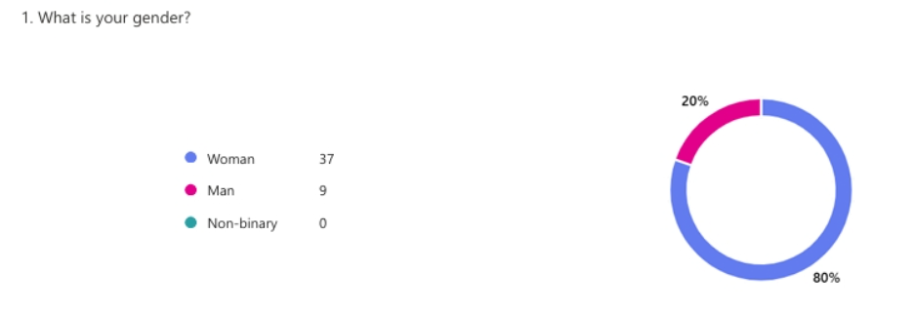

The age distribution was mature, with the largest groups being 26–35 (35%) and 36–45 (33%).

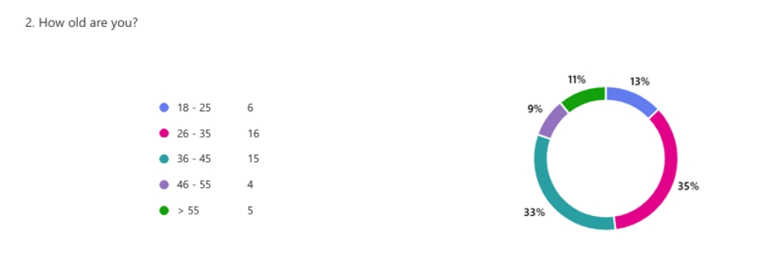

Analysis:
In a study focused on VAWG, this gender distribution is more than just a random statistic—it is a matter of research validity. By having a sample that is four-fifths female, the findings are deeply rooted in the perspectives of the people who are most likely to interact with the safeguarding systems discussed in Chapter 2. This is not just about numbers; it is about cantering the "lived experience" of the primary target group. The age profile adds another layer of credibility to the study. Because nearly 70% of participants are between 26 and 45, I am looking at a demographic that has a "long memory" when it comes to UK policing. Over the last decade, these adults have witnessed the evolution, failure, and rebranding of policing strategies. When we eventually look at the low trust ratings (like the 2.77 average), we must realise this scepticism comes from a group that has watched the system struggle for years.

4.2.2 Priority vs. Vulnerability: The Urgency Gap (Questions 3 & 4)

Moving the analysis toward how the public perceives this crisis, I looked at whether participants truly view VAWG as a top-tier issue in the current UK climate. The findings were a bit of a contradiction. While 54% of respondents labelled it a "major priority", 28% felt it remained "secondary to other national issues". However, the most striking part of this data comes when you look at Question 4—where 100% of participants agreed that women and girls are more vulnerable to violence.
Analysis: The data reveals a problematic "urgency gap" in the public mind. It is challenging to reconcile how a population can be in total agreement about the existence of a danger (100%) yet be so split on whether it is a national priority. This data suggests that while government messaging has worked at identifying the problem, it has not managed to instil a real sense of crisis. Even if the official rhetoric says we are in a state of crisis, nearly a third of participants seem to see VAWG as a background issue rather than a front-page one. This perception is a massive barrier for any future strategy.

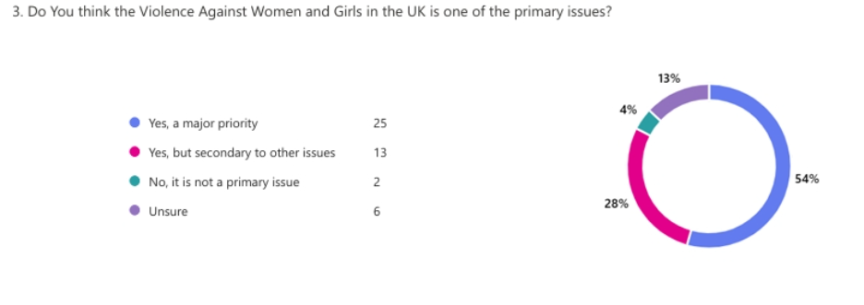

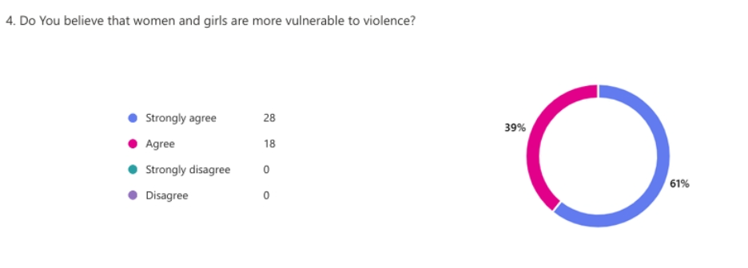

4.2.3 The "Femicide" Knowledge (Question 5 & 6)

Another aspect of this section was the public's understanding of the term "femicide". 56% of participants were familiar with this term, while 44% were entirely unaware of it. Question 6 examined how familiar participants were with specific, high-profile cases, such as Sarah Everard and Sabina Nessa. Interestingly, 43% of participants admitted they did not know the specific details of these events.

Analysis: As I argued in my literature review, naming a crime is a political act, and it moves it from a "private tragedy" to a systemic, societal issue. The Diana Russell framework showed that this naming is deeply significant. If nearly half of my respondents do not recognise the word, telling me that killing women is still viewed by the public as isolated domestic incidents rather than a gender-based pattern. This lack of shared vocabulary acts as an "invisible wall." You cannot mobilise a society to fight a "national emergency" if half the people lack the specific language to describe what is happening. It shows that high-level policy is staying "up there", while regular people are left in a vacuum where systemic violence is misunderstood as just random crime.
Understanding a term like 'femicide' is one thing, but knowing the actual reality of the crisis is a different matter. While the names of high-profile victims are stuck in the public’s mind, 43% of participants admitted they did not know the facts of these cases. To me, this is the most vital finding. It suggests the 'trust deficit' is not happening because people are sitting down and studying legal details or police procedures. Instead, it is a visceral, gut-level reaction to the headlines. Even without knowing every detail, the sheer weight of these tragedies has been enough to trigger a drop in trust.

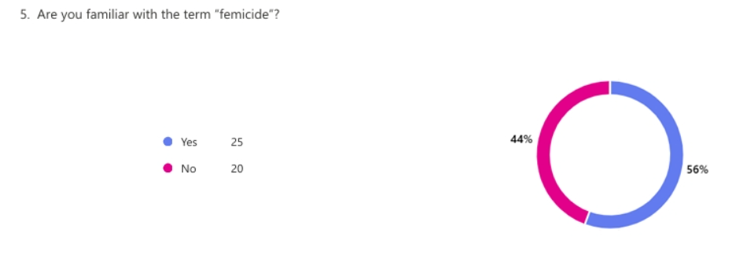

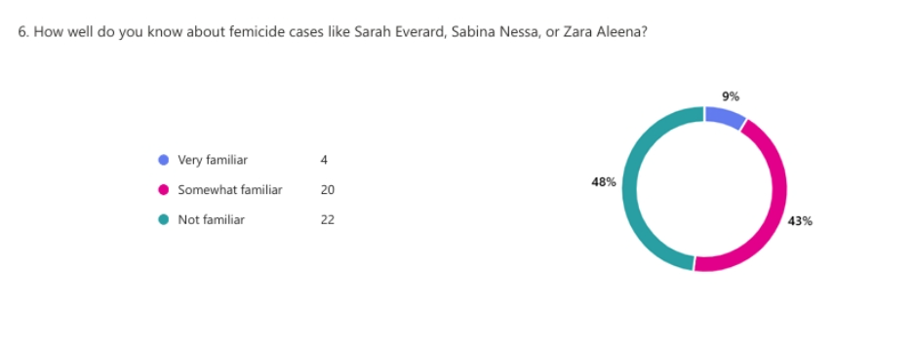

4.3 The Crisis of Competency and Institutional Trust

4.3.1 Training and Professional Standards (Question 14)

I asked whether respondents feel the police are properly trained to handle VAWG. Only 30% of participants said "Yes". 41% "No", while the remainder were unsure.
Analysis:
This result is most damning part of the survey. These results connect directly to the Casey Review highlighted earlier in this dissertation. Nearly 70% of participants (including those who are "unsure") do not have faith in police training, then every new law or policy the government passes is essentially performative. It proves that the "implementation gap" is not just a theory but is a reality. People perceive that the officers they encounter lack the fundamental empathy and expertise required for these cases, which poses a significant concern for the entire justice system.
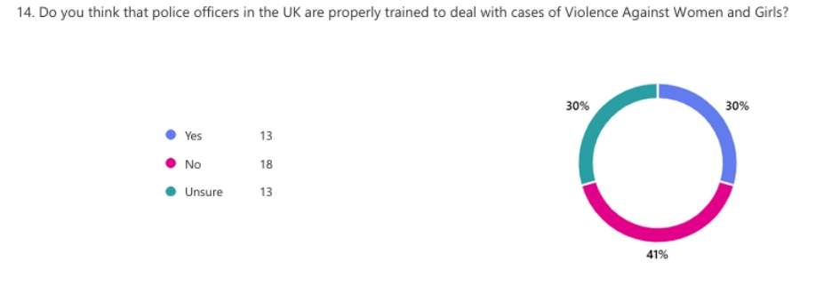

4.3.2 The Effectiveness Rating (Question 16)

To obtain a broader view, participants were asked to rate current police and government strategies on a scale of 1 to 5. The average score came out a 2.77.
Analysis:
In any other professional setting, a 2.77 out of 5 is a failing grade. It is a mediocre score that screams for improvement. Most respondents hovered around the "3" mark, telling me the public are in a "wait and see" state. They are not saying the police are doing nothing, but they are dissatisfied with the results so far.
This 2.77 rating is the numerical proof of the "trust deficit" discussed in the literature review. Despite the press releases and high-profile campaigns, public confidence remains stagnant. Until that score moves closer to a 4 or a 5, any claim by the government that they are "fixing" the system is just talk. This rating is a clear signal: the public wants to see actual, measurable change in their safety.

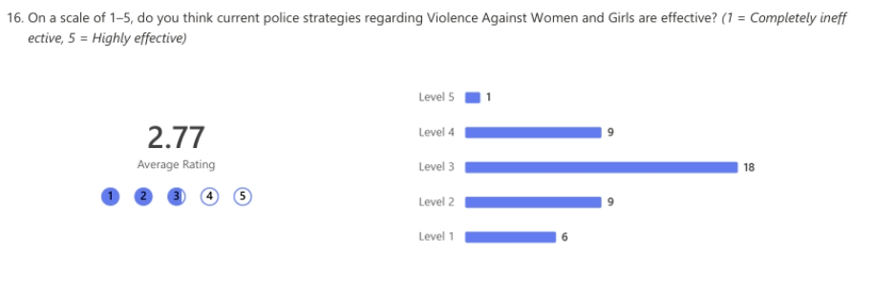

4.4 The "Invisible Walls" and Barriers to Reporting (Question 13)

Question 13 highlight what prevents victims from coming forward, revealing a complex web of systemic failures that force women into silence.
Analysis of the Data: 31% of the participants identified "fear" as the primary barrier. Looking at the word cloud and raw data, this is not just a general fear. It is a social stigma and the fear of retaliation from the perpetrator. This situation represents a breakdown of the social contract. If a victim feels that the institution meant to protect them is a threat to their emotional well-being, they simply will not report. This ties back to the "Implementation Gap" touched on in Chapter 1. Laws are useless if the officer at the front desk lacks empathy or proper training—something my data in Question 14 clearly supports. Many people also expressed a lack of faith in the conviction process, acknowledging the low charge rates in the UK right now. People do not see the results. They stop reporting, and the police lack the evidence to justify more resources. This perpetuates a cycle of underreporting and insufficient support for victims. By highlighting these 'invisible walls', my research indicates that the crisis is deeply rooted in an institutional culture that makes it too difficult for victims to speak up.

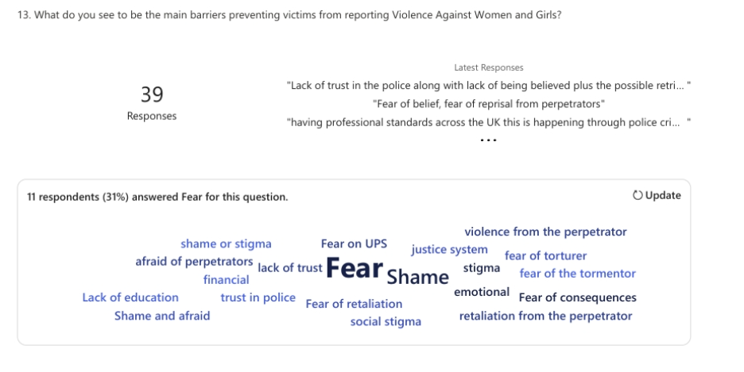

4.5 Transparency vs. Legislation (Questions 15)

Question 15 asked whether increasing police transparency is more valuable than introducing new legislation. 67% of respondents felt that both are equally important. However, when forced to choose between the two, 19% prioritised transparency, while only 14% leaned toward new legislation.
Analysis: New acts are passed in Parliament, but my data shows that the public does not think more rules are a fix. Nearly one-fifth of the sample explicitly prioritised transparency over new laws suggests that the real issue is a lack of honesty and accountability within the force. I would argue that this links back to the trust deficit. It proves that for the public, institutional integrity is just as important as the legal framework itself.
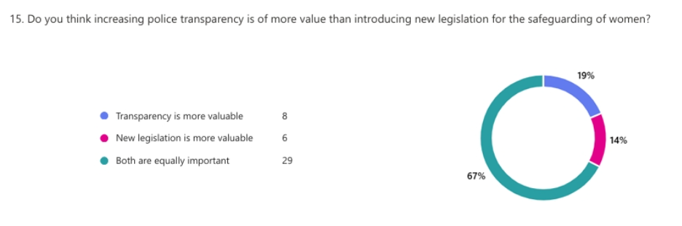

4.6 The Isolated incident and The Systemic Failures (Questions 7 & 8)

The impact of high-profile cases—like Sarah Everard and Sabina Nessa—still weighs heavily on public opinion. Although 43% of participants did not know the full details of these cases, the atmosphere left behind is devastating. When asked whether these were isolated incidents, 50% of respondents said they pointed to broader systemic problems within the British police force. Only 15% considered them one-off errors.
Analysis:
This finding is perhaps the starkest evidence of how much trust in the institution has eroded. 47% of respondents said their trust in the police had decreased because of these cases—and, significantly, no one saw an increase. It shows that the police are not only fighting crime but also their reputation. When half of the respondents perceive a systemic problem, we are dealing with a public deeply sceptical of the police's ability to protect women.

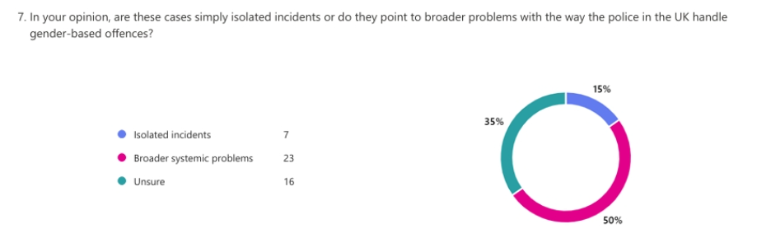

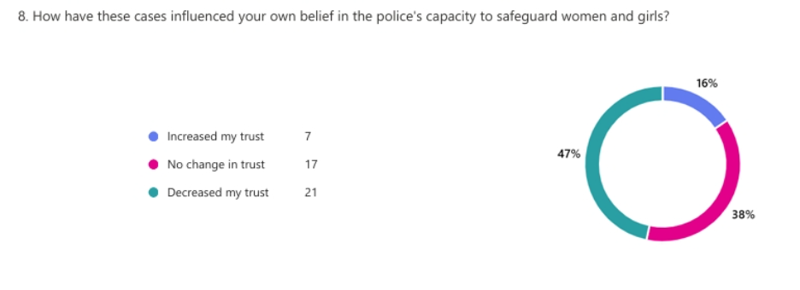

4.7 Recommendations for Improvement (Question 12)

In the final part of the survey, respondents the chance to offer their own solutions. Question 12, asked for specific improvements in police responses, and 36 responded.
Analysis:
The most dominant theme, mentioned by 18% of respondents, was training. However, the "word cloud" and raw text reveal that people are not just asking for any training; they are asking for specialist, trauma-informed training. One respondent noted that "police need to be able to establish a role that can be trusted", which highlights that the current approach is seen as too cold or detached. Other key themes that emerged include better recruitment. Several participants argued for the need to "recruit the right people" with higher standards. Response times: There is a clear demand for "faster responses" and more reliable support services. Victim Support: The terms "trauma" and "mental victim" appeared in the data, suggesting that the public wants the police to act more like a support system and less like a rigid bureaucracy.
Reflection:
These results confirm that the public understands the "Implementation Gap" better than the government might think. They are not asking for more laws; they are asking for better human beings in uniform. By looking at these suggestions, it is obvious that the solution is not just more funding, but a complete overhaul of how officers are trained to handle trauma. Without these changes, as one respondent put it, the current standards will continue to be "insufficient".

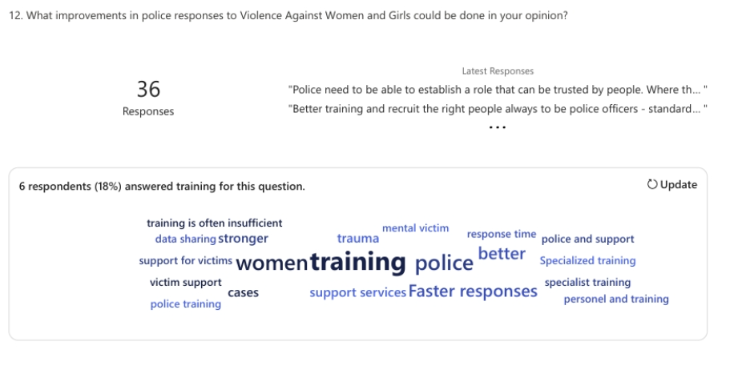

4.8 Policy Awareness and the Call for Legal Reform (Questions 9, 10 & 11)

I also wanted to see if the government’s efforts, like the 'Tackling VAWG Strategy', are making an impact on the ground. It turns out, they barely reach the public. The results for Question 9 showed a near-perfect split: 47% of respondents had never heard of the strategy. If nearly half the public is unaware that a national strategy even exists, it is impossible for that policy to build trust or make women feel safer.
However, even if they do not know the official policy names, the public has an idea of how the law should change. 72% of respondents believe that 'femicide' should be classified as a separate crime from homicide. This is one of the most powerful findings in my research. This demonstrates that the public is significantly more advanced than the existing legal framework. They want the gendered nature of these killings formally recognized.
When I looked at Question 11, the effectiveness of UK legislation received a dismal average rating of just 2.76 out of 5. That is a failing grade by any standard. What the data tells me is that people are simply exhausted by 'one-size-fits-all' laws that feel more like outdated relics than actual solutions. There is a clear sense that these generic frameworks just are not equipped to handle the specific, gendered reality of femicide as it exists today.

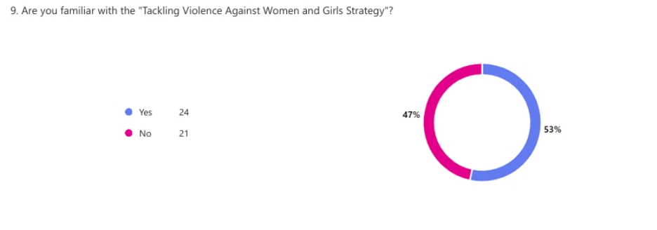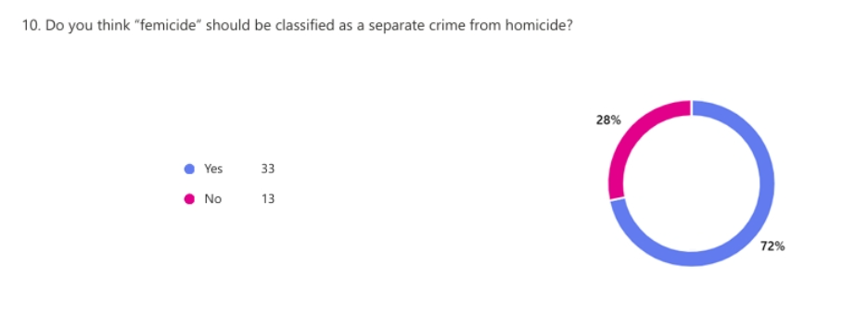.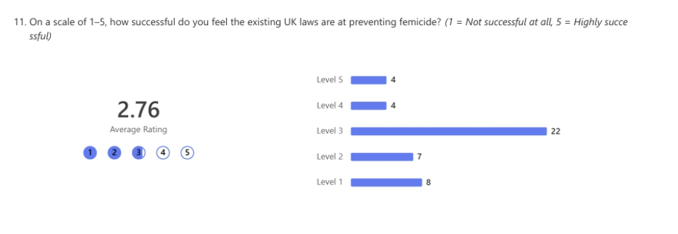

4.9 Conclusion

In conclusion of my findings, the results are obvious. There is a vast gap between what the government says and what is happening. Looking at the data from my 46 participants, I can see that these new initiatives are not reaching the public in any real way. The significant concern is the fact that nearly half the participants were unaware of the national VAWG policies. This evidence shows that while new laws might be passed in the UK, they are not changing how safe women feel in their daily lives. The most important thing I found is that the public is much further ahead than the legal system. When 72% of people say they want 'femicide' to be its own crime, it proves that the current laws feel outdated. People want the law to finally admit that these murders happen because of gender. They do not want them hidden in general statistics. On top of that, the deep lack of trust in the police is still the main reason why victims do not come forward. Many fear that the system will not take their reports seriously or that they will face further victimisation. In the end, my research indicates that women do not need more promises or "tick-box" training. They need a system that understands the risks they face and puts their safety before the reputation of the police.

Chapter Five- Conclusion

5.1 Introduction

The main goal of this research was to examine links between major femicide cases and weaknesses in the UK policing and government policies. This study aimed to move beyond seeing women’s killings as individuals, private tragedies and instead analyse them through the prism of institutional accountability and gendered trends. The study aimed to investigate the relationship between high-profile cases and systemic failures, assess the efficiency of national measures, and identify ongoing challenges that hinder victims from pursuing justice. This concluding chapter revisits and synthesises the findings from both the literature review and the survey data. From the disputes on the definition of 'femicide', initiated by Diana Russell, the research advances to the real-life issue of the 'implementation gap' found by the study findings. Finally, several evidence-based recommendations are made to help solve the present problem of confidence in the British judicial system.

5.2. Objective 1: High-Profile Femicide and Systemic Failures

Objective 1 research results indicate that the public does not consider the murders of Sarah Everard, Sabina Nessa, and Zara Aleena to be isolated incidents. Respondents perceive the situation as a failure of the current system in the UK. As many as 50% of people cited these murders as evidence of systemic negligence within the British police. A literature review confirms this belief, as authorities often ignore warning signs, such as previous complaints against officers or patterns of behaviour that indicate potential risks to public safety. The Wayne Couzens misconduct case showed that a lack of early intervention led to the death of a young woman (Bhattacharyya, 2021). Empirical data also revealed a deep-rooted deficit in trust in the police (Tulu, 2026). As many as 47% of respondents stated that their trust in the police decreased because of these high-profile murders. This evidence indicates that the police fight to protect their reputation as much as they fight crime. (Atkins, 2025). Importantly, none of the respondents in the study indicated an increase in trust in the police. These results reflect the findings of the Casey Review, which describes the institutional culture as sexist. Her review believes that the police place their reputation above the safety of women (Casey Review, 2023). In conclusion, the high-profile femicide cases reveal systematic failures in detection and risk assessment that occur consistently. These murders are not isolated events; they are the result of an institutional culture that ignores warning signs. As outlined in the Casey Report (2023), there is a culture that results in inadequate responses to reports of violence against women and a failure to prioritise women’s protection.

5.3 Objective 2: The Effectiveness of Current Strategies

The results of objective 2 indicate a significant gap between the government’s legislative ambitions and the actual implementation of these policies. The UK government has recognised violence against women and girls as a national emergency and introduced strategies, such as VAWG (Home Office,2021). These initiatives have proved to have very little impact on public awareness. As many as 47% of respondents have never heard of this national strategy. Empirical data shows a significant lack of trust in this legislation, as current government and police strategies have an average effectiveness rating of only 2.77 out of 5. Another finding is that, although 100% of respondents believe that women and girls are more vulnerable to violence, almost one-third (28%) see VAWG as a secondary issue in the country. This suggests that even though people are aware of the scale of the problem, they do not feel a real sense of crisis. In summary, objective 2: the research suggests that current strategy's function more as a reaction to social protests than as significant tools for change. As long as 41% of the public believe that officers lack the proper training and skills to handle such cases, the new regulations remain just a promise. The failure of these strategies lies not only in the law but also in institutional inertia and the canteen culture that prevent effective implementation of these regulations on the front lines (Casey,2023). This turn leads to a lack of accountability and perpetuates the cycle of mistrust between law enforcement and the community. This situation ultimately undermines public trust and makes real reforms more difficult.

5.4 Objective 3: Barriers and Suggested Solutions

Objective 3 revealed that fear is the primary barrier to reporting crimes, with 31% of respondents highlighting this concern. An analysis of the qualitative data indicated that this fear stems not only from the perpetrator but also from the system itself. Authorities often misunderstand or reject people, leading to fear of not being taken seriously or facing further victimisation (Roux, 2023). This evidence indicates that if victims feel fear of the institution, they will not report the crime (European Union News, 2024). The data also indicate (72% of respondents) that there is a need for legal reform to recognise feminicide as a separate crime from murder. Society prioritised transparency (19%) over the introduction of new regulations (14%), indicating a desire for accountability and trust in the system to encourage victims to come forward. In summary, objective 3 indicates that the crisis is rooted in the institutional culture, which makes it difficult for victims to report crimes (Abdi, 2025). Until the legal system recognises these crimes as separate and starts prioritising victims, barriers to accessing justice will persist (College of Policing, 2024b).

5.5 Recommendations

Recommendations to help bridge the implementation gap and enable the UK to move beyond promises:
1. Feminicide: formal legal recognition. Seventy-two percent of respondents said that the UK should formally recognise feminicide as a distinct crime (Bansal, 2023).
2. Domestic Abuse National Integration Specialists (999): Specialist responders need to be integrated in 999 control rooms around the country. This is a key attempt at identifying ‘red flags’ at an early stage so that high-risk situations may be controlled and properly intercepted before they develop into fatal violence (Home Office, 2025).
3. Transparency and verifiability. The police need to move away from checklists and engage in regular surveillance of their staff, which would help identify inappropriate behaviour (Casey, 2023).
4.Specialist Recruitment and Trauma-Informed Training. Survey participants pointed out the necessity to completely update police recruiting and training. The important thing is having people who can truly empathise. In addition, the focus needs to be on delivering specialist trauma-informed education to replace the present strict and insufficient bureaucratic requirements (College of Policing, 2024b). This approach will better prepare officers to handle sensitive situations and support victims effectively.

5.6 Final Reflections

The present dissertation demonstrates that high-profile femicides in the United Kingdom are not isolated incidents. They are clear signs of systematic failure and a dysfunctional policing culture. The research has verified a gap between the government’s official claim of a “national emergency” and the lived reality of women on the ground. The overall conclusion of this paper is that without a fundamental change in institutional accountability, legislative ambition is ineffective. The present “trust deficit” noted in the study is visceral because the institutions mandated to safeguard women have consistently placed their reputation and the preservation of an internal “canteen culture” over victim safety. Unless the judicial system acknowledges the gendered dimension of femicide and moves from a reactionary disposition into a preventive shield, women will continue to be locked in a cycle of silence and vulnerability.

Reference List:

Abdi, A.-N.M. and Hashi, M.B. (2025). “Exploring public cooperation with police: the role of police accountability, police effectiveness, and public trust,” International journal of comparative and applied criminal justice, 49(4), pp. 287–307. Available at: https://doi.org/10.1080/01924036.2024.2387853 .(Accessed: 4 May 2026).
Apuke, O.D. (2017). “Quantitative Research Methods: A Synopsis Approach,” Kuwait chapter of Arabian journal of business & management review, 6(11), pp. 40–47. Available at: https://doi.org/10.12816/0040336 .(Accessed: 8 February 2026).
Atkins, S. et al. (2025). “Communicating and categorising ‘kidnap’ incidents in UK police emergency calls: a conversation analytic study,” Policing & society, 35(2), pp. 149–170. Available at: https://doi.org/10.1080/10439463.2024.2386282 .(Accessed: 4 May 2026).
Bansal, E. et al. (2023). “Femicide and Public Health Ethics: Approaching Gender-based Violence and Death in the Health Professions,” Public health ethics, 16(2), pp. 117–122. Available at: https://doi.org/10.1093/phe/phac031 .(Accessed: 4 May 2026).
Barlow, C. and Walklate, S. (2020). ‘Policing Intimate Partner Violence: The “Golden Thread” of Discretion’, Policing: a journal of policy and practice, 14(2), pp. 404–413. Available at: https://doi.org/10.1093/police/pay001 .(Accessed: 28 October 2025).
Bhandari, P. (2022). “A Note on Survey Research Methods Levels of Measurement: Foundational Basis for Quantitative Analysis of Survey Data,” Dhaulagiri journal of sociology and anthropology, pp. 122–126. Available at: https://doi.org/10.3126/dsaj.v16i01.50982 .(Accessed: 8 February 2026).
Bhattacharyya, R. (2021). “Sarah Everard & Nirbhaya: Comparisons and Commonalities,” Space and culture, India, 8(4), pp. 1–6. Available at: https://doi.org/10.20896/saci.v8i4.1175 .(Accessed: 4 May 2026).
Birch, P. et al. (2025). “Policing Hate Crime: Exploring the Issue with a Cohort of Sworn Police Officers,” Journal of police and criminal psychology, 40(2), pp. 335–347. Available at: https://doi.org/10.1007/s11896-023-09641-y .(Accessed: 4 May 2026).
Bleakley, P. (2023). “‘Would your level of disgust change?’ Accounting for variant reactions to fatal violence against women on social media,” Criminology & criminal justice, 23(5), pp. 845–860. Available at: https://doi.org/10.1177/17488958221105155 .(Accessed: 4 May 2026).
Bullock, K. et al. (2022). “Problem-oriented policing in England and Wales: barriers and facilitators,” Policing & society, 32(9), pp. 1087–1102. Available at: https://doi.org/10.1080/10439463.2021.2003361 .(Accessed: 4 May 2026).
Caicedo‐Roa, M., Pereira, T. and Carlos Cordeiro, R. (2020). “PROTOCOL: Risk factors for femicide,” Campbell systematic review, 16(4), p. e1123. Available at: https://doi.org/10.1002/cl2.1123 .(Accessed: 4 April 2026).
Casey, L. (2023). Baroness Casey Review: Final Report: An independent review into the standards of behaviour and internal culture of the Metropolitan Police Service. London: Metropolitan Police Service.Available at: The Baroness Casey Review | Metropolitan Police .(Accessed: 6 April 2026).
Caterini, M. (2023). “Moving Towards More Inclusive Definitions of Femicide: Intersectionality and Marginalised Identities,” Contemporary Challenges, 4. Available at: https://doi.org/10.2218/ccj.v4.9119 .(Accessed: 4 May 2026).
College of Policing (2021). Violence Against Women and Girls: Toolkit 2021. Available at: https://www.college.police.uk/. (Accessed: 12 April 2026).
College of Policing (2024a). Angiolini Inquiry report published. Available at: https://www.college.police.uk/article/angiolini-inquiry-report-published .(Accessed: 13 April 2026).
College of Policing (2024b). Collapsing the canteen: Empowering and encouraging police to report sexual misconduct among their colleagues. Available at: https://www.college.police.uk/ .(Accessed: 19 April 2026).
Cooper, S. (2023). “Police relational accountabilities: The paralysis of police accountability?,” Policing: a journal of policy and practice, 17. Available at: https://doi.org/10.1093/police/paac081. (Accessed: 4 May 2026).
Cunliffe, R. (2023). “Out of the Ordinary,” New statesman (1996), 17 February, pp. 29–29.
Daher-Nashif, S. (2022). “Intersectionality and Femicide: Palestinian Women’s Experiences with the Murders of Their Beloved Female Relatives,” Violence against women, 28(5), pp. 1077–1097. Available at: https://doi.org/10.1177/10778012211014561. (Accessed: 4 May 2026).
Davies, A.J. et al. (2024). “What do we know about key influences on police attrition and retention rates? A literature review 2019–2023,” Policing: an international journal of police strategies & management, 47(5), pp. 725–769. Available at: https://doi.org/10.1108/PIJPSM-11-2023-0149 .(Accessed: 4 May 2026).
Dawson, M. and Carrigan, M. (2021). “Identifying femicide locally and globally: Understanding the utility and accessibility of sex/gender-related motives and indicators,” Current sociology, 69(5), pp. 682–704. Available at: https://doi.org/10.1177/0011392120946359 .(Accessed: 3 May 2026).
Elelleh, O. (2024). “Examining the Effectiveness of Consent Decrees in Relation to Police Accountability,” Imagine: A Promise Scholars & McNair Scholars Journal [Preprint]. Available at: qt10f3463n.pdf. (Accessed: 4 May 2026).
Ellis, D., Stuckless, N. and Smith, C. (2015). “Chapter 8 - Preventing Intimate Partner Homicide and Femicide,” in Marital Separation and Lethal Domestic Violence. Elsevier Inc, pp. 139–188. Available at: https://doi.org/10.1016/B978-1-4557-7675-7.00008-3. (Accessed: 4 May 2026).
European Union News (2024). ‘New report suggests trust still broken in policing violence against women’, 17 December. Available at: December: Policing of violence against women and girls | News and features | University of Bristol. (Accessed: 13 April 2026).
Evans, J.R. and Mathur, A. (2018). “The value of online surveys: a look back and a look ahead,” Internet research, 28(4), pp. 854–887. Available at: https://doi.org/10.1108/IntR-03-2018-0089 .(Accessed: 8 February 2026).
Fitz-Gibbon, K. and Walklate, S. (2023) “Cause of death: femicide,” Mortality (Abingdon, England), 28(2), pp. 236–249. Available at: https://doi.org/10.1080/13576275.2022.2155509. (Accessed May 5,2026).

Flynn, A. et al. (2025). “Sexualized Deepfake Abuse: Perpetrator and Victim Perspectives,” Journal of interpersonal violence, p. 8862605251368834. Available at: https://doi.org/10.1177/08862605251368834 .(Accessed: 4 May 2026).
Fohring, S. (2024). “WhyIDidntReport: Exploring victim accounts of non-reporting,” Criminology & criminal justice [Preprint]. Available at: https://doi.org/10.1177/17488958241283947 .(Accessed: 4 May 2026).
Freeland, J., Baroni, A. and Jogie, M. (2025). “Visualizing femicide in the print media: A comparison of Italy and the UK,” Media, Culture & Society, p. 01634437251336149.
Gelder, M.M.H.J., Bretveld, R.W. and Roeleveld, N. (2010). “Web-based Questionnaires: The Future in Epidemiology?,” American journal of epidemiology, 172(11), pp. 1292–1298. Available at: https://doi.org/10.1093/aje/kwq291 .(Accessed: 8 February 2026).
Giacinti, M. (2022). “The International Tribunal for Crimes against Women (March 1976),” Cahiers du genre, 73(2), pp. 85–110. Available at: https://doi.org/10.3917/cdge.073.0085. (Accessed: 4 May 2026).
Gill, A.K. and Anitha, S. (2026). “A matter of trust? Policing violence against women and girls,” Policing & society, pp. 1–17. Available at: https://doi.org/10.1080/10439463.2026.2623413 .(Accessed: 4 May 2026).
Giustina, J.D. (2018). “Femicide,” The Blackwell Encyclopedia of Sociology. Edited by G. Ritzer. Oxford, UK: John Wiley & Sons, Ltd. Available at: https://doi.org/10.1002/9781405165518.wbeos1115 .(Accessed: 4 May 2026).
Goldberg, J.C.P. and Zipursky, B.C. (2023). “Sherman v. Department of Public Safety: Institutional Responsibility for Sexual Assault,” Journal of tort law, 16(2), pp. 283–300. Available at: https://doi.org/10.1515/jtl-2023-0034 .(Accessed: 4 May 2026).
Heiervang, E. and Goodman, R. (2011). “Advantages and limitations of web-based surveys: evidence from a child mental health survey,” Social Psychiatry and Psychiatric Epidemiology, 46(1), pp. 69–76. Available at: https://doi.org/10.1007/s00127-009-0171-9 .(Accessed: 8 February 2026).
Herbert, S.R.J. et al. (2025). ‘How the Sarah Everard Case has Changed Public Perceptions of Police Officers’, Violence against women, p. 10778012251366237. Available at: https://doi.org/10.1177/10778012251366237. (Accessed: 28 October 2025).
Hohl, K. and Stanko, E.A. (2022). “Five Pillars: A Framework for Transforming the Police Response to Rape and Sexual Assault,” International criminology, 2(3), pp. 222–229. Available at: https://doi.org/10.1007/s43576-022-00057-y. (Accessed: 4 May 2026).
Home Office (2021). Tackling violence against women and girls strategy. Available at: https://www.gov.uk/government/publications/tackling-violence-against-women-and-girls-strategy .(Accessed: 28 October 2025).
Home Office (2023). Domestic Violence Disclosure Scheme (Clare's Law) guidance. Available at: https://www.gov.uk/government/publications/domestic-violence-disclosure-scheme-clares-law-guidance. (Accessed: 4 May 2026).
Home Office (2024). Freedom from violence and abuse volume 2: action plan. Available at: https://www.gov.uk/government/publications/freedom-from-violence-and-abuse-strategic-roadmap-2024-to-2029 .(Accessed: 4 May 2026).
Home Office (2025a). First domestic abuse specialists embedded in 999 control rooms. Available at: https://www.gov.uk/government/news/. (Accessed: 12 April 2026).
Home Office (2025b). Freedom from violence and abuse: a cross-government strategy to build a safer society for women and girls. Available at: https://www.gov.uk/government/publications/. (Accessed: 19 April 2026).
Home Office (2026). Freedom from Violence and Abuse: Strategic Roadmap (2026-2029). Available at: https://www.gov.uk/government/publications/. (Accessed: 4 May 2026).
Horeck, T. et al. (2024). ‘MeToo in British schools: Gendered differences in teenagers’ awareness of sexual violence’, European journal of cultural studies, 27(5), pp. 856–875. Available at: https://doi.org/10.1177/13675494231191490. (Accessed: 28 October 2026).
House of Commons Library (2024). Online harassment and cyber bullying. Research Briefing 7967. Available at: https://commonslibrary.parliament.uk/research-briefings/cbp-7967/ .(Accessed: 4 May 2026).
Huey, L., Ferguson, L. and Ricciardelli, R. (2024). “‘It’s all about covering your . . .’: The unintended consequences of police accountability measures,” Criminology & criminal justice, 24(3), pp. 585–607. Available at: https://doi.org/10.1177/17488958221140551. (Accessed: 4 May 2026).
Hughes, C., Marrs, C. and Sweetman, C. (2016). “Introduction to Gender, Development and VAWG,” Gender and development, 24(2), pp. 157–169. Available at: https://doi.org/10.1080/13552074.2016.1208471. (Accessed: 4 April 2026).
Jankowitz, S. (2018). “The ‘Hierarchy of Victims’ in Northern Ireland: A Framework for Critical Analysis,” The international journal of transitional justice, 12(2), pp. 216–236. Available at: https://doi.org/10.1093/ijtj/ijy003 .(Accessed: 4 May 2026).
Kassing, K. and Collins, A. (2026). “‘Slowly, Over Time, You Completely Lose Yourself’: Conceptualizing Coercive Control Trauma,” Journal of interpersonal violence, 41(3–4), pp. 662–684. Available at: https://doi.org/10.1177/08862605251320998. (Accessed: 3 May 2026).
Kawar, L.N. et al. (2024). “Quantitative, Qualitative, Mixed Methods, and Triangulation Research Simplified,” The Journal of continuing education in nursing, 55(7), pp. 338–344. Available at: https://doi.org/10.3928/00220124-20240328-03 .(Accessed: 8 February 2026).
King, G. and Williams, H. (2021). “Big New Developments in The Case of Sarah Everard,” CBinMornings [Preprint]. New York: VIQ Solutions Inc.
Knap, S. (2021). “Femicide,” Contemporary Challenges, 2, pp. 192–208. Available at: https://doi.org/10.2218/ccj.v2.5417 .(Accessed: 4 May 2026).
Kost, R.G. and Correa da Rosa, J. (2018). “Impact of survey length and compensation on validity and reliability,” Journal of clinical and translational science, 2(1), pp. 31–37. Available at: https://doi.org/10.1017/cts.2018.18. (Accessed: 8 February 2026).
Leon, R.J. et al. (2022). “Developing a self-administered questionnaire: methods and considerations,” Nurse researcher, 30(3), pp. 36–45. Available at: https://doi.org/10.7748/nr.2022.e1848 .(Accessed: 8 February 2026).
Lum, C. et al. (2020). “Examining the Empirical Realities of Proactive Policing,” Police quarterly, 23(3), pp. 283–310. Available at: https://doi.org/10.1177/1098611119896081. (Accessed: 4 May 2026).
Lund, B. (2023). “The questionnaire method in systems research: an overview,” VINE journal of information and knowledge management systems, 53(1), pp. 1–10. Available at: https://doi.org/10.1108/VJIKMS-08-2020-0156. (Accessed: 8 February 2026).
Maguire, L. et al. (2026). “Care for both victim-survivors and police investigators of rape and serious sexual offences,” Criminology & criminal justice, 26(2), pp. 426–445. Available at: https://doi.org/10.1177/17488958241248034. (Accessed: 4 May 2026).
Maple, E. and Kebbell, M. (2024). “‘DV Fatigue’: Work Stress and Officers’ Attitudes and Performance,” Violence against women, 30(8), pp. 1984–2014. Available at: https://doi.org/10.1177/10778012241239944 .(Accessed: 4 May 2026).
Marcano Belisario, J.S. et al. (2015). “Comparison of self‐administered survey questionnaire responses collected using mobile apps versus other methods,” Cochrane database of systematic reviews, 2015(7), p. MR000042. Available at: https://doi.org/10.1002/14651858.MR000042.pub2 .(Accessed: 8 February 2026).
Matović, N. and Ovesni, K. (2023). “Interaction of quantitative and qualitative methodology in mixed methods research,” International journal of social research methodology, 26(1), pp. 51–65. Available at: https://doi.org/10.1080/13645579.2021.1964857. (Accessed: 8 February 2026).
Matthias, N. (2022). Femicide: A Global Problem. Small Arms Survey. Available at: JSTOR (Accessed: 28 October 2025).
Maxwell, J.A. (2010). “Using Numbers in Qualitative Research,” Qualitative inquiry, 16(6), pp. 475–482. Available at: https://doi.org/10.1177/1077800410364740. (Accessed: 8 February 2026).
Meneghel, S.N. and Portella, A.P. (2017). “Femicides: concepts, types and scenarios,” Ciência & saude coletiva, 22(9), p. 3077. Available at: https://doi.org/10.1590/1413-81232017229.11412017 .(Accessed: 4 May 2026).
Meyrick, J. et al. (2026). “Across landscapes and lifespan causes and solutions of gender-based violence,” The journal of sexual aggression, 32(1), pp. 86–102. Available at: https://doi.org/10.1080/13552600.2024.2421197. (Accessed: 4 April 2026).
Murphy, M. et al. (2023). “Socioecological Framework for Drivers of Conflict and Post conflict Violence Against Women and Girls,” Violence against women, 29(2), pp. 406–427. Available at: https://doi.org/10.1177/10778012221094065 .(Accessed: 3 May 2026).
Nevedal, A.L. et al. (2025). “Optimizing qualitative methods in implementation research,” Implementation science, 21(1). Available at: https://doi.org/10.1186/s13012-025-01474-z. (Accessed: 8 February 2026).
NPCC (2021). Violence Against Women and Girls. Available at: https://www.npcc.police.uk/. (Accessed: 12 April 2026).
NPCC (2024a). Call to action as VAWG epidemic deepens. Available at: https://www.npcc.police.uk/ .(Accessed: 19 April 2026).
NPCC (2024b). Policing Violence Against Women and Girls – The National Framework for Delivery: 2024 – 2027. Available at: https://www.npcc.police.uk/ .(Accessed: 28 October 2025).
NPCC (2024c). Violence Against Women and Girls. Available at: Violence Against Women and Girls. (Accessed May 5,2026).
Office of the Police and Crime Commissioner for Gwent (2024). Police, Crime and Justice Plan 2025-2029. Available at: https://www.gwent.pcc.police.uk/. (Accessed: 12 April 2026).
Onwuegbuzie, A.J. and Leech, N.L. (2005). “Taking the ‘Q’ Out of Research,” Quality & quantity, 39(3), pp. 267–295. Available at: https://doi.org/10.1007/s11135-004-1670-0 .(Accessed: 8 February 2026).
Reed, W. (ed.) (2025). Getting away with murder: obstacles to police accountability. Blacksburg, VA: Virginia Tech Publishing.
Regmi, P.R. et al. (2017). “Guide to the design and application of online questionnaire surveys,” Nepal Journal of Epidemiology, 6(4), pp. 640–644. Available at: https://doi.org/10.3126/nje.v6i4.17258 .(Accessed: 8 February 2026).
Rhee, Y.-C. and Menifield, C.E. (2024). “Examining community policing policy implementation and racial disparities,” Policing: an international journal of police strategies & management, 47(6), pp. 949–965. Available at: https://doi.org/10.1108/PIJPSM-05-2023-0057. (Accessed: 4 May 2026).
Robson, H. (2023). Walking the Streets Without Fear: Investigating a Specific Offence of Public Sexual Harassment. Available at: https://doi.org/10.15124/yao-9fc8-7j60. (Accessed: 4 May 2026).
Rogers, C. and Wintle, E. (2021). “‘To serve others and do good’: An examination of volunteers in the New South Wales police force,” Salus journal, 9(1), pp. 18–38. Available at: DOAJ (Accessed: 4 May 2026).
Roux, E. le and Pertek, S.I. (2023). “Why religion matters in violence against women and girls,” in On the Significance of Religion in Violence Against Women and Girls. 1st ed. Routledge, pp. 3–20. Available at: https://doi.org/10.4324/9781003169086-2. (Accessed: 4 May 2026).
Rueda, M. del M. et al. (2023). “Enhancing estimation methods for integrating survey samples with machine‐learning techniques,” Biometrical journal, 65(2), p. e2200035. Available at: https://doi.org/10.1002/bimj.202200035. (Accessed: 8 February 2026).
Sánchez-Prada, A. et al. (2023). “Researching Intimate Partner Violence Against Women (IPVAW): Overcoming Gender Blindness,” Journal of family violence, 38(6), pp. 1043–1054. Available at: https://doi.org/10.1007/s10896-023-00577-9. (Accessed: 4 May 2026).
Saxton, M.D., Jaffe, P.G. and Olszowy, L. (2022). “The Police Role in Domestic Homicide Prevention,” Journal of interpersonal violence, 37(3–4), pp. NP1886–NP1907. Available at: https://doi.org/10.1177/0886260520933030. (Accessed: 4 May 2026).
Sha, M. and Gabel, T. (2020). The Essential Role of Language in Survey Research. Research Triangle Park, NC: RTI Press/RTI International.
South Wales Police and Crime Commissioner (2024). South Wales Police, Crime and Justice Plan 2025-29. Available at: https://www.southwales-pcc.gov.uk/. (Accessed: 12 April 2026).
Spivak, B. et al. (2021). “Implementing evidence-based practice in policing family violence,” Policing & society, 31(4), pp. 483–502. Available at: https://doi.org/10.1080/10439463.2020.1757668 .(Accessed: 4 May 2026).
Standish, K. (2022). “Everyday genocide: femicide, transicide and the responsibility to protect,” Journal of aggression, conflict and peace research, 14(3), pp. 215–230. Available at: https://doi.org/10.1108/JACPR-10-2021-0642. (Accessed: 3 May 2026).
Sutherland, A. (2024). “Using Research to Improve Policing post Casey—and Why that Might not Happen,” The Political quarterly, 95(3), pp. 450–458. Available at: https://doi.org/10.1111/1467-923X.13444. (Accessed: 4 May 2026).
Taylor-Dunn, H. and Erol, R. (2023). “Improving the ‘victim journey’ when reporting domestic abuse cyberstalking to the police,” Criminology & criminal justice, 23(5), pp. 694–715. Available at: https://doi.org/10.1177/17488958221129436. (Accessed: 4 May 2026).
The Economist (2021). “What Sarah Everard’s murder means for the Metropolitan Police,” 5 November.
Torrible, C. (2026). “The Casey Review, institutional racism and police accountability for use of force,” Legal studies, pp. 1–20. Available at: https://doi.org/10.1017/lst.2025.10099. (Accessed: 4 May 2026).
Tsegay, S.M. and Tecleberhan, S. (2025). “Violence against women: Experiences of Eritrean refugee women in Britain,” Violence against women, 31(3-4), pp. 892–915.
Tülü, İ.A. (2026). “Femicide from Perpetrator Typology to Risk Assessment, Prevention and Intervention Programs,” Psikiyatride güncel yaklaşimlar, 18(2), pp. 737–759. Available at: https://doi.org/10.18863/pgy.1706173 .(Accessed: 4 May 2026).
Turner, A. (2024). “Sexism and misogyny as traits of police culture: Problems, red flags and solutions,” International journal of police science & management, 26(2), pp. 279–291. Available at: https://doi.org/10.1177/14613557241228736 .(Accessed: 4 May 2026).
Vogt, W.P. (2014). Selecting the right analyses for your data: quantitative, qualitative, and mixed methods. 1st ed. New York: Guilford Press.
West Midlands Police and Crime Commissioner (2025). Regional ‘Raneem’s Law’ Domestic Abuse Specialist Service. Available at: https://www.westmidlands-pcc.gov.uk/regional-raneems-law-domestic-abuse-specialist-service/. (Accessed: 4 May 2026).
William, H. (2025). Women in UK ‘still not safe’ as mourners gather to remember murdered Zara Aleena. Press Association. London: Press Association Limited.
Wright, K. (2024). “‘A HIDDEN PROBLEM’: COMBATTING VIOLENCE AGAINST WOMEN AND GIRLS (VAWG) IN JERSEY,” Parliamentarian, 105(1), p. 82.
Zare, H. et al. (2025). “State-by-State Review: The Spread of Law Enforcement Accountability Policies,” Social sciences (Basel), 14(8), p. 483. Available at: https://doi.org/10.3390/socsci14080483 .(Accessed: 4 May 2026).

