FACULTY OF APPLIED DESIGN AND ENGINEERING

SCHOOL OF APPLIED COMPUTING

EXAMINATION SOLUTIONS: SESSION 2018/19

Programme: | HNC Electrical and Electronic Engineering | Year/Level: |  | Level 4
Module/Unit: | Electronics I (PSDE4004)
Author: | Jason Pointer |  | Page: |  | 1 of 8
Question 1  - Design a 5.6V voltage regulator using a zener diode and series resistor to provide a load with 250mA from 12V unregulated supply. For the design select a suitable zener diode from the data sheet below. |  |  |  |  | (6 marks)
Answer  From the data sheet select the BZX79C5V6 zener diode.  I_{z} = 5mA  P = I_{z} × V_{z} = 5×10⁻³ × 5.6 = 28mW (this is within the max power for the diode P_{max} = 500mW)  I_{s} = I_{L} + I_{z} = 250 + 5 = 255mA  And voltage drop across R_{s} = 12- 5.6 = 6.4V  ∴ R_{s} = $\frac{6.4}{255 × {10}^{-3}}$ = 25.1Ω  Rated at 255×10⁻³ × 6.4 = 1.63W  R_{L}  I_{L}  I_{Z}  I_{S}  R_{S}  D |  |  |  |  | (2 marks)  (2 marks)  (2 marks)
- Figure Q1.1 show an example of a load line for a transistor amplifier. Sketch the load the load line to show the position of quiescent current and the condition of the input signal for each of the biasing condition of the following transistor amplifier:  - Class A  - Class B  - Class AB |  |  |  |  | (6 marks)
Answer  Class A  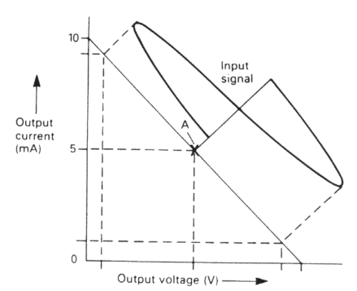  Class B  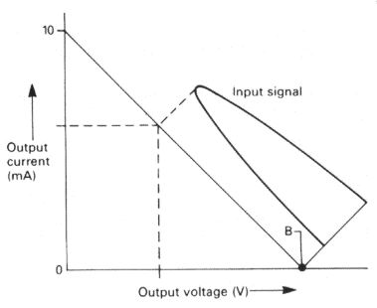  Class AB  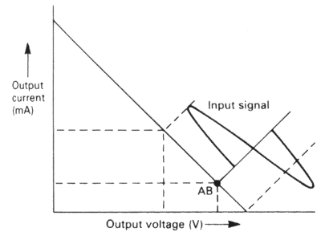 |  |  |  |  | (1 mark each for correct position of quiescent current)  (1 mark each for correct drawing of the input signal)
- State the biasing classification and requirements for a Tuned Amplifier. |  |  |  |  | (2 marks)
Answer  Tuned amplifier is class C and this is achieved by the device is biased beyond its cut-off held hard-off. The input signal must overcome this turn-off bias and then turn the device on in order to produce current flow in the load. |  |  |  |  | (2 marks)
- From the circuit calculate:  - The resonant frequency  - The quality (Q) factor  - The bandwidth of the amplifier. |  |  |  |  | (6 marks)
Answer  - F_{r} = $\frac{1}{2π\sqrt{LC}}= \frac{1}{2π\sqrt{100×{10}^{-9} × 1×{10}^{-3}}}$  F_{r} = 15.92kHz  - Q = $\frac{2πF_{r}L}{R}= \frac{2π × 15.92×{10}^{3} × 1×{10}^{-3}}{2.5}$  Q = 40.01  - Bandwidth = $\frac{F_{r}}{Q}= \frac{15920}{40.01}$  Bandwidth = 397.89Hz |  |  |  |  | (2 marks for each part)

Module/Unit: | Electronics I (PSDE4004) | Page: | 3 of 8
Question 2  (a) Figure Q2.1 shows the block diagram for a negative feedback amplifier. Using the block diagram derive the formula for the closed loop gain for the system. |  |  | (5 marks)
Answer  V_{S} = V_{in} - V_{β}  V_{out} = A_{o} × V_{S}  V_{S} = $\frac{V_{out}}{A_{o}}$  V_{β} = V_{out}β  So $\frac{V_{out}}{A_{o}}$ = V_{in} - V_{out}β  V_{out} = (V_{in} - V_{out}β)×A_{o}  V_{out} = A_{o}V_{in} - A_{o}V_{out}β  V_{out} + A_{o}V_{out}β = A_{o}V_{in}  V_{out}(1 + A_{o}β) = A_{o}V_{in}  So voltage gain, A_{v} = $\frac{V_{out}}{V_{in}}=\frac{A_{o}}{1+ A_{o}β}$ |  |  | (5 marks)
(b) Figure Q2.2 shows a series of electronic systems including the gain or loss of each block.  - Determine the dB value of each block  - Calculate the overall gain of the system |  |  | (4 marks)
Answer  A = 20log (20) = 26.02dB  B = 20log (105) = 40.42dB  C = 20log (0.5) = -6.02dB  Overall gain = 26.02 + 40.42 – 6.02 = 60.42dB |  |  | (1 mark for each correct part)
(c) State the characteristics for an ideal operation amplifier. |  |  | (5 marks)
Answer  - Infinite voltage gain.  - Infinite input impedance.  - Zero output impedance.  - Infinite bandwidth.  - Zero input offset voltage (i.e., exactly zero out if zero in). |  |  | (1 mark for each answer)
(d) Using an operational amplifier design a circuit that produce -20V for an input value of 40mV. |  |  | (6 marks)
Answer  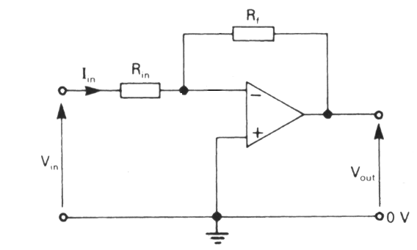  $$\frac{V_{out}}{V_{in}}= \frac{-R_{f}}{R_{in}}$$  $$\frac{-20}{40×{10}^{-3}}= \frac{-R_{f}}{R_{in}}$$  R_{f} = R_{in} × 500  Student to select a suitable for R_{in} i.e. let R_{in} = 1kΩ  R_{f} = 1 × 500 = 500kΩ |  |  | (3 marks for correct circuit)  (3 marks for calculation)

Module/Unit: | Electronics I (PSDE4004) | Page: | 5 of 8
Question 3  (a) Produce a sketch to show how an OR gate can be constructed using only NAND gates. |  |  | (2 marks)
 |  |  | (2 marks)
(b) Figure Q3.1 shows a logic circuit containing a number of gates.  - Produce the truth table for the circuit  - State the Boolean equation for the circuit and simplify the equation.  - Use DeMorgan theorem to change the equation to contain only NAND function and redraw the circuit using only NAND gates. |  |  | (12 marks)
Answer  - Truth table  - Boolean equation  X = $\overline{A}\overline{B}\overline{C}+\overline{A}B\overline{C}+\overline{A}BC+AB\overline{C}$  X = $\overline{A}\overline{C}(\overline{B}+B)+\overline{A}B(\overline{C}+C)+B\overline{C}(\overline{A}+A)$  X = $\overline{A}\overline{C}+\overline{A}B+B\overline{C}$  - DeMorgan  $\overline{X}$ = $\overline{\overline{A}\overline{C}+\overline{A}B+B\overline{C}}$  $\overline{X}$ = $\overline{\left(\overline{A}\overline{C}\right)}.\overline{\left(\overline{A}B\right)}.\overline{\left(B\overline{C}\right)}$  X = $\overline{\overline{\left(\overline{A}\overline{C}\right)}.\overline{\left(\overline{A}B\right)}.\overline{\left(B\overline{C}\right)}}$ |  |  | (1 marks each for the correct position of the logic 1 outputs)  (3 marks)  (2 marks)  (3 marks for the diagram)
  A | B | C | X
  0 | 0 | 0 | 1
  0 | 0 | 1 | 0
  0 | 1 | 0 | 1
  0 | 1 | 1 | 1
  1 | 0 | 0 | 0
  1 | 0 | 1 | 0
  1 | 1 | 0 | 1
  1 | 1 | 1 | 0
(c) TTL (Transistor-Transistor Logic) and CMOS (complementary metal-oxide-semiconductor) are classification of integrated circuits used in logic design work. Explain the differences between TTL and CMOS technology. |  |  | (6 marks)
Answer  - CMOS circuits do not draw as much power as TTL circuits while at rest. However, CMOS power consumption increases faster with higher clock speeds than TTL does. Lower current draw requires less power supply distribution, therefore causing a simpler and cheaper design.  - Due to longer rise and fall times, the transmission of digital signals becomes simpler and less expensive with CMOS chips.  - CMOS components are more susceptible to damage from electrostatic discharge than TTL components.  - CMOS components are typically more expensive than TTL equivalents. However, CMOS technology is usually less expensive on a system level due to CMOS chips being smaller and requiring less regulation. |  |  | (6 marks)

Module/Unit: | Electronics I (PSDE4004) | Page: | 7 of 8
Question 4  (a) Produce a sketch of the logic circuit for a D type flip-flop using only NAND gates. |  |  | (4 marks)
Answer  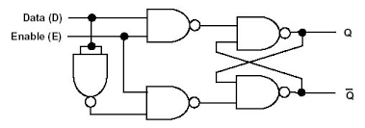 |  |  | (4 marks)
(b) Figure Q4 shows a 6-state up counter. Design the counter using a series of JK flip-flop, the design work must include:  - Transition table  - Karnaugh maps  - Final circuit diagram. |  |  | (16 marks)
Answer  Transition Table  Karnaugh Map  Circuit  J_{A}  Q_{A}  $${\overline{Q}}_{A}$$  K_{A}  J_{B}  Q_{B}  $${\overline{Q}}_{B}$$  K_{B}  J_{C}  Q_{C}  $${\overline{Q}}_{C}$$  K_{C}  A  B  C  1 |  |  | (6 marks)  (6 marks)  (4 marks)
  Present |  |  | Next
  A | B | C | A | B | C | J_{A} | K_{A} | J_{B} | K_{B} | J_{C} | K_{C}
  0 | 0 | 0 | 0 | 0 | 1 | 0 | X | 0 | X | 1 | X
  0 | 0 | 1 | 0 | 1 | 0 | 0 | X | 1 | X | X | 1
  0 | 1 | 0 | 0 | 1 | 1 | 0 | X | X | 0 | 1 | X
  0 | 1 | 1 | 1 | 0 | 0 | 1 | X | X | 1 | X | 1
  1 | 0 | 0 | 1 | 0 | 1 | X | 0 | 0 | X | 1 | X
  1 | 0 | 1 | 0 | 0 | 0 | X | 1 | 0 | X | X | 1
     | BC
    A |  | 00 | 01 | 11 | 10
     | 0 | 0 | 0 | 1 | 0
     | 1 | X | X | X | X
     |  | J_{A} = BC
     | BC
    A |  | 00 | 01 | 11 | 10
     | 0 | X | X | X | X
     | 1 | 0 | 1 | X | X
     |  | K_{A} = C
     | BC
    A |  | 00 | 01 | 11 | 10
     | 0 | 0 | 1 | X | X
     | 1 | 0 | 0 | X | X
     |  | J_{B} = $\overline{A}C$
     | BC
    A |  | 00 | 01 | 11 | 10
     | 0 | X | X | 1 | 0
     | 1 | X | X | X | X
     |  | K_{B} = C
     | BC
    A |  | 00 | 01 | 11 | 10
     | 0 | 1 | X | X | 1
     | 1 | 1 | X | X | X
     |  | J_{C} = 1
     | BC
    A |  | 00 | 01 | 11 | 10
     | 0 | X | X | 1 | X
     | 1 | X | 1 | X | X
     |  | K_{C} = 1

