Zlatka Petkova Ciorica
ID:1905836
BsC Cloud Computing
Information Engineering Exam
Date: 08/01/2020

Entity Relationship Diagram
Pizza for U Catering Services
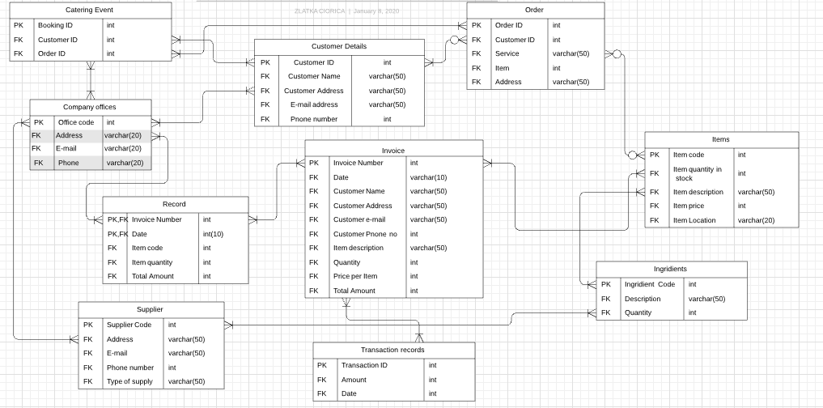

Data Flow Diagram
Pizza for U Catering Services


