BMHP5014 | COMPONENT 2

Dementia Access England
One supported route into local dementia services
Poster and written pitch proposing a blended digital and human navigation service to improve access to health, social care and voluntary-sector support for people living with dementia and unpaid carers.

Module | BMHP5014
Assessment | Component 2: Poster and Written Pitch
Student name | Anna yeboah
Student ID | 2429957
Word count | Poster: 1031  Pitch: 1015
Submission date | 6th August 2026

Contents
Section 1: Poster 4
Innovation Overview 4
The Issue: Fragmented Access to Support 5
Target Audience and Impact 5
How the Service Works 5
Technology Integration 6
Implementation 6
Development Timeline 6
Regulation, Ethics and Safety 7
Measuring Success 7
Promotion and Public Involvement 7
Conclusion and Call to Action 8
Reference List 9
Written Pitch 10
The proposal 10
Why is this an innovation 10
Health, wellbeing and the common good 10
Delivery model 11
Evidence and transferability 11
Policy, governance and safety 12
Feasibility, finance and sustainability 12
Evaluation and public involvement 12
Conclusion 13
Reference List 14

Section 1: Poster
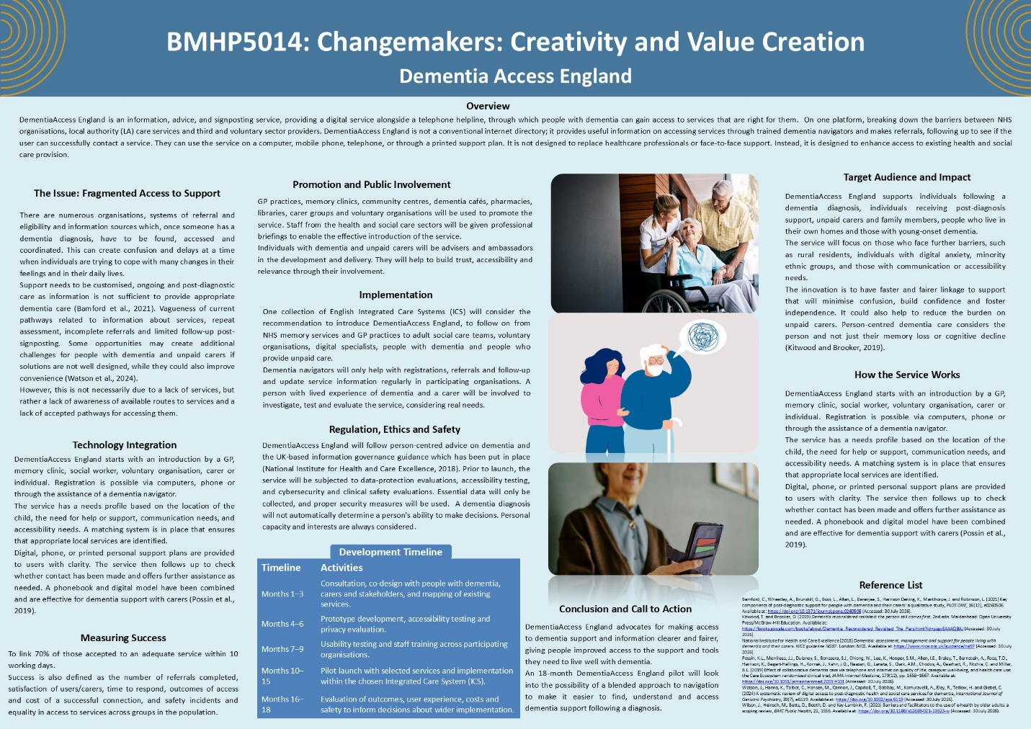

Innovation Overview
DementiaAccess England is an information, advice, and signposting service, providing a digital service alongside a telephone helpline, through which people with dementia can gain access to services that are right for them.
On one platform, breaking down the barriers between NHS organisations, local authority (LA) care services and third and voluntary sector providers. DementiaAccess England is not a conventional internet directory.
They can use the service on a computer, mobile phone, telephone, or through a printed support plan. It is not designed to replace healthcare professionals or face-to-face support. Instead, it is designed to enhance access to existing health and social care provision.

The Issue: Fragmented Access to Support
There are numerous organisations, systems of referral and eligibility and information sources which, once someone has a dementia diagnosis, have to be found, accessed and coordinated. This can create confusion and delays at a time when individuals are trying to cope with many changes in their feelings and in their daily lives.
Support needs to be customised, ongoing and post-diagnostic care as information is not sufficient to provide appropriate dementia care (Bamford et al., 2021). Some opportunities may create additional challenges for people with dementia and unpaid carers if solutions are not well designed, while they could also improve convenience (Watson et al., 2024).
However, this is not necessarily due to a lack of services, but rather a lack of awareness of available routes to services and a lack of accepted pathways for accessing them.

Target Audience and Impact
DementiaAccess England supports individuals following a dementia diagnosis, individuals receiving post-diagnosis support, unpaid carers and family members, people who live in their own homes and those with young-onset dementia.
The service will focus on those who face further barriers, such as rural residents, individuals with digital anxiety, minority ethnic groups, and those with communication or accessibility needs.
The innovation is to have faster and fairer linkage to support that will minimise confusion, build confidence and foster independence. It could also help to reduce the burden on unpaid carers. Person-centred dementia care considers the person and not just their memory loss or cognitive decline (Kitwood and Brooker, 2019).

How the Service Works
DementiaAccess England starts with an introduction by a GP, memory clinic, social worker, voluntary organisation, carer or individual. Registration is possible via computers, phone or through the assistance of a dementia navigator.
The service has a needs profile based on the location of the child, the need for help or support, communication needs, and accessibility needs. A matching system is in place that ensures that appropriate local services are identified.
Digital, phone, or printed personal support plans are provided to users with clarity. The service then follows up to check whether contact has been made and offers further assistance as needed. A phonebook and digital model have been combined and are effective for dementia support with carers (Possin et al., 2019).

Technology Integration
It provides features such as large text, web and mobile-friendly design, read aloud, plain text information, multilingual, appointment reminders and referral checking. Secure carer access and user roles and permissions, with audit records for personal information, will be realised, with strengthening of carer accountability. However, the service will not operate digitally only, and a logbook will maintain traditional postings. There will also be written information, human navigators, and a telephone helpline. Older adults uptake of digital health is related to the usability, confidence in, and privacy and accessibility of digital health (Wilson et al., 2021).

Implementation
One collection of English Integrated Care Systems (ICS) will consider the recommendation to introduce DementiaAccess England, to follow on from NHS memory services and GP practices to adult social care teams, voluntary organisations, digital specialists, people with dementia and people who provide unpaid care.
Dementia navigators will only help with registrations, referrals and follow-up and update service information regularly in participating organisations. A person with lived experience of dementia and a carer will be involved to investigate, test and evaluate the service, considering real needs.

Development Timeline
Consultation and co-design will be included in the first three months, as will be mapping existing services. The prototype will be developed, and accessibility and privacy will be tested in months 4-6. The usability testing should be conducted in Months 7-9, as should be staff training. The selected services will participate in the pilot launch, months 10-15. Outcomes, user experience, costs and safety will be measured in months 16–18 and used to make decisions for broader implementation after that.

Regulation, Ethics and Safety
DementiaAccess England will follow person-centred advice on dementia and the UK-based information governance guidance which has been put in place (National Institute for Health and Care Excellence, 2018).
Prior to launch, the service will be subjected to data-protection evaluations, accessibility testing, and cybersecurity and clinical safety evaluations. Essential data will only be collected, and proper security measures will be used.
A dementia diagnosis will not automatically determine a person's ability to make decisions. Personal capacity and interests are always taken into account.

Measuring Success
To link 70% of those accepted to an adequate service within 10 working days.
Success is also defined as the number of referrals completed, satisfaction of users/carers, time to respond, outcomes of access and cost of a successful connection, and safety incidents and equality in access to services across groups in the population.

Promotion and Public Involvement
GP practices, memory clinics, community centres, dementia cafés, pharmacies, libraries, carer groups and voluntary organisations will be used to promote the service. Staff from the health and social care sectors will be given professional briefings to enable the effective introduction of the service.
Individuals with dementia and unpaid carers will be advisers and ambassadors in the development and delivery. They will help to build trust, accessibility and relevance through their involvement.

Conclusion and Call to Action
DementiaAccess England advocates for making access to dementia support and information clearer and fairer, giving people improved access to the support and tools they need to live well with dementia.
An 18-month DementiaAccess England pilot will look into the possibility of a blended approach to navigation to make it easier to find, understand and access dementia support following a diagnosis.

Reference List
Bamford, C., Wheatley, A., Brunskill, G., Booi, L., Allan, L., Banerjee, S., Harrison Dening, K., Manthorpe, J. and Robinson, L. (2021) Key components of post-diagnostic support for people with dementia and their carers: a qualitative study, PLOS ONE, 16(12), e0260506. Available at: https://doi.org/10.1371/journal.pone.0260506 (Accessed: 30 July 2026).
Kitwood, T. and Brooker, D. (2019) Dementia reconsidered revisited: the person still comes first. 2nd edn. Maidenhead: Open University Press/McGraw-Hill Education. Available at: https://books.google.com/books/about/Dementia_Reconsidered_Revisited_The_Pers.html?id=psgvEAAAQBAJ (Accessed: 30 July 2026).
National Institute for Health and Care Excellence (2018) Dementia: assessment, management and support for people living with dementia and their carers. NICE guideline NG97. London: NICE. Available at: https://www.nice.org.uk/guidance/ng97 (Accessed: 30 July 2026).
Possin, K.L., Merrilees, J.J., Dulaney, S., Bonasera, S.J., Chiong, W., Lee, K., Hooper, S.M., Allen, I.E., Braley, T., Bernstein, A., Rosa, T.D., Harrison, K., Begert-Hellings, H., Kornak, J., Kahn, J.G., Naasan, G., Lanata, S., Clark, A.M., Chodos, A., Gearhart, R., Ritchie, C. and Miller, B.L. (2019) Effect of collaborative dementia care via telephone and internet on quality of life, caregiver well-being, and health care use: the Care Ecosystem randomized clinical trial, JAMA Internal Medicine, 179(12), pp. 1658–1667. Available at: https://doi.org/10.1001/jamainternmed.2019.4101 (Accessed: 30 July 2026).
Watson, J., Hanna, K., Talbot, C., Hansen, M., Cannon, J., Caprioli, T., Gabbay, M., Komuravelli, A., Eley, R., Tetlow, H. and Giebel, C. (2024) A systematic review of digital access to post-diagnostic health and social care services for dementia, International Journal of Geriatric Psychiatry, 39(7), e6119. Available at: https://doi.org/10.1002/gps.6119 (Accessed: 30 July 2026).
Wilson, J., Heinsch, M., Betts, D., Booth, D. and Kay-Lambkin, F. (2021) Barriers and facilitators to the use of e-health by older adults: a scoping review, BMC Public Health, 21, 1556. Available at: https://doi.org/10.1186/s12889-021-11623-w (Accessed: 30 July 2026).

Written Pitch
DementiaAccess England: one supported route into local dementia services

The proposal
At the same time, an individual may find they need to learn about new services, criteria, and roles following a dementia diagnosis. Changes in recall, interaction, self-assurance and familial functioning prompt a person to contact various agencies. DementiaAccess England responds with one supported navigation route to accessing the local health, social care and voluntary-sector provision. An 18-month pilot should be reviewed in one ECS region. The service will be accessible via a website, mobile application, and a free telephone helpline staffed by trained dementia navigators.

Why is this an innovation
Much existing provision merely offers information, leaving the individual or carer to interpret eligibility criteria and navigate access pathways, often requiring them to repeat their circumstances to multiple organisations. Our approach is different at DementiaAccess England because of personalised matching, referral, and follow-up. This distinguishes it from being merely a novel application, positioning it as a genuine service innovation. The development process will progress from initial stakeholder insight through co-design, prototyping, evaluation, and controlled deployment. In the context of the digital-health scholarship, one of the messages highlighted is the need to consider technology in relation to healthcare processes, their openness towards technological use, with privacy care, and in relation to how healthcare is delivered, rather than as a technical good per se (Rivas and Wac, 2018).

Health, wellbeing and the common good
While none of these navigation improvements can cure dementia, they can impact the conditions under which people live with this disease. Therefore, to maintain routines and relationships and reduce feelings of uncertainty, carer support, community nursing, respite, occupational therapy, and community activities can all provide support. Dementia policy and care should not be solely clinical impairment oriented, but also work towards social inclusion, quality of life and collective responsibility (Vandenbulcke, Dröes and Schokkaert, 2022). Better access to publicly-funded services, coupled with improved awareness of unmet needs and reduction of unnecessary duplication of effort among professionals, is good for everyone. However, being online is not necessarily liberating. Administrative burdens may be placed on families, and families may be subject to increased monitoring or disadvantage. Equality and data ethics will be monitored throughout the pilot (Lupton, 2018).

Delivery model
The pilot will be run with support from the Integrated Care Board. The first network will include memory services, general practices, teams that provide care for the elderly and voluntary organisations. The two full-time dementia navigators will be able to follow up on registration, explain options, complete registration and follow up on failed registrations. The project manager will be accountable for delivery, and a clinical lead, Data Protection Officer, and Clinical Safety Officer will take responsibility for quality and risk.
Technology will be using a transparent rules engine, driven by geo-location, needs expressed, eligibility information and preferred method of contact. Will not make any decisions relating to clinical urgency, autonomous eligibility decisions or diagnosis. Clear crisis information will be available and will be passed to a human pathway if there is an urgent risk. Carer access will be on a permissioned basis. The sharing of digital images will be stopped, and appropriate professional and legal procedures will be pursued and implemented by staff when consent is questionable or the ability to make a decision is in question.

Evidence and transferability
The trial of collaborative dementia care, delivered via telephone and internet, found that this approach can be helpful in preserving QoL and caring well as a model to be used in a blended-care approach (Possin et al., 2019). While the study, conducted in the United States, demonstrates the potential of trained human navigators to make remote assistance more responsive than unassisted directory services, the findings are not directly transferable to the English context. The pilot is therefore designed not as a definitive demonstration of effectiveness in the UK, but as a local feasibility evaluation. E-health for older people is also dependent on variables such as self-efficacy, knowledge, functionality, privacy, and support and integration services. (Wilson et al., 2021).

Policy, governance and safety
The proposal dovetails with the Department for Health and Social Care's 10 Year Health Plan for England 2025 (DHSC, 2025), which expects to transition from analogue to digital. Before launch, a data-protection, equality-impact assessment, accessibility and penetration testing, clinical hazard analysis and supplier due diligence will be undertaken. Data collection shall be limited to data that is being collected for matching and for referral evaluation. Users will be provided with clear explanations about what is collected, how it is used and displayed, how long it is stored for and how to withdraw from and complain about this use.

Feasibility, finance and sustainability
The proposed pilot budget is allocated as follows: £160,000 for technology, integration, and hosting, £180,000 for navigation and pilot staff, £45,000 for co-design, accessibility, and training, £30,000 for governance, cybersecurity, and clinical safety, £25,000 for independent evaluation, and £10,000 for a contingency fund.
Sustainability requires evidence that the service can enhance the number of connections, constructively decrease the need for other navigational tasks, and stay accessible to the group that may be at risk of disenfranchisement. The evaluation will quantify the cost per successful connection and identify which functions are essential, optional, or unsuitable.

Evaluation and public involvement
The key performance indicator of the main pilot measure will be that at least 70% of those accepting contact and successfully contacting the relevant service will be done within 10 working days. Secondary measures consist of satisfaction, registration abandonment, navigator response time, referral completion, cost per connection, accessibility performance and security incidents. Analysis will be by deprivation, rurality, disability, access route, age and ethnicity. Discussions will be held about what has proven effective and ineffective with pathways

Conclusion
DementiaAccess England represents a sensible solution to a common challenge: Services are available, but gaining access to them is often a difficult and torturous process. It can enhance the usability of technology and ensure user accountability through a human-centred approach during testing before mainstream implementation. Approval is sought for an 18-month pilot to determine whether a supported access point can contribute to improved, equitable, and sustainable access to support for people living with dementia.

Reference List
Department of Health and Social Care (2025) Fit for the future: 10 Year Health Plan for England. London: Department of Health and Social Care. Available at: https://www.gov.uk/government/publications/10-year-health-plan-for-england-fit-for-the-future (Accessed: 30 July 2026).
Kitwood, T. and Brooker, D. (2019) Dementia reconsidered revisited: the person still comes first. 2nd edn. Maidenhead: Open University Press/McGraw-Hill Education. Available at: https://books.google.com/books/about/Dementia_Reconsidered_Revisited_The_Pers.html?id=psgvEAAAQBAJ (Accessed: 30 July 2026).
Lupton, D. (2018) Digital health: critical and cross-disciplinary perspectives. London: Routledge. Available at: https://books.google.com/books/about/Digital_Health.html?id=0gsKkAEACAAJ (Accessed: 30 July 2026).
Possin, K.L., Merrilees, J.J., Dulaney, S., Bonasera, S.J., Chiong, W., Lee, K., Hooper, S.M., Allen, I.E., Braley, T., Bernstein, A., Rosa, T.D., Harrison, K., Begert-Hellings, H., Kornak, J., Kahn, J.G., Naasan, G., Lanata, S., Clark, A.M., Chodos, A., Gearhart, R., Ritchie, C. and Miller, B.L. (2019) Effect of collaborative dementia care via telephone and internet on quality of life, caregiver well-being, and health care use: the Care Ecosystem randomized clinical trial, JAMA Internal Medicine, 179(12), pp. 1658–1667. Available at: https://doi.org/10.1001/jamainternmed.2019.4101 (Accessed: 30 July 2026).
Rivas, H. and Wac, K. (eds.) (2018) Digital health: scaling healthcare to the world. Cham: Springer International Publishing. Available at: https://books.google.com/books/about/Digital_Health.html?id=87ZvswEACAAJ (Accessed: 30 July 2026).
Vandenbulcke, M., Dröes, R.-M. and Schokkaert, E. (eds.) (2022) Dementia and society. Cambridge: Cambridge University Press. Available at: https://books.google.com/books/about/Dementia_and_Society.html?id=5LZpEAAAQBAJ (Accessed: 30 July 2026).
Wilson, J., Heinsch, M., Betts, D., Booth, D. and Kay-Lambkin, F. (2021) Barriers and facilitators to the use of e-health by older adults: a scoping review, BMC Public Health, 21, 1556. Available at: https://doi.org/10.1186/s12889-021-11623-w (Accessed: 30 July 2026).

