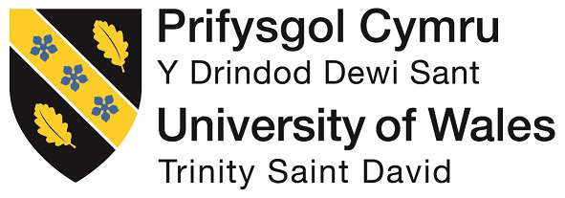
Master of Business Administration (MBA)
Module: Dissertation
Module code: LCMB7035

The Strategic Use of Sustainability Communications in Brand Reputation Management: A Study of Unilever UK

Supervisor: Amir Homayounfard

Student Name: Md Alauddin Sarker
Student ID: 2432631

Word count: 2554
Submission Deadline: 20 March 2026

Table of Contents
Background of the Study 4
Context of the Study 4
Problem Statement 5
Research Aim 5
Research Objectives 5
Research Questions 6
Literature Review 6
Sustainability and Corporate Communication 6
Brand Reputation Management 7
Figure 1: Brand Reputation Management 7
Source: (Allen, 2016; Altaf, 2022) 7
Consumer Perception and Trust 8
Figure 2: consumers’ perception regarding the ethics of online retailers 8
Source: (Prieto et al., 2024) 8
Research Gap 9
Methodology (Research Onion Model) 9
Figure 3: Research Onion Model 9
Source: (Saunders et al., 2023) 10
Research Philosophy 10
Research Approach 10
Research Strategy 10
Methodological Choice 10
Data Collection Method 11
Data Analysis Method 11
Ethical Considerations 11
Expected Findings / Contribution 11
Limitations 12
Timeframe 12
Conclusion 12
Reference 14

Background of the Study
Sustainability has become an important issue for businesses that operate in very competitive and socially-conscious markets. Over the last 10 years, increasing environmental issues, regulatory changes and increased consumer awareness have made it mandatory for organisations to ensure that sustainability is a part of core business strategy (Dessart and Standaert, 2023). Companies are no longer being evaluated by financial performance, but also by their environmental and social impact. As a result, communications around sustainability have become an important communication strategic usage tool in order to define the corporate image and to keep the stakeholders’ trust. Sustainability communication is the way in which organisations communicate their environmental, social and governance (ESG) practices in the form of reports, advertising and corporate messaging (Bodenheimer and Leidenberger, 2020). These communications do not serve the sole purpose of informing stakeholders, but also to impact perceptions and create a good brand image. In this context, brand reputation, in fact, has become strongly connected with the respect and transparency of communication with respect to the sustainability work of the companies. Honest communication establishes credibility, whereas overselling the offerings may be perceived by the customers to be greenwashing, and it easily makes the customer lose trust (Kalogiannidis et al., 2025). Unilever is famous for being a global frontrunner of business practices led by sustainability. Through programs such as the sustainable living plan, the company has attempted to find a balance between business growth and being socially and environmentally responsible. In the UK market, Unilever has been active in promoting and including sustainability messages in the company's branding and marketing mechanism, as well as promoting its products as environmentally friendly and socially responsible. However, the ability of these communications to sell the consumer perceptions of brands and build up the brand reputation is debated.

Context of the Study
The UK market is a very special background to study sustainability communications. Consumers in the UK are more apprehensively aware of ethical consumption, environmental and corporate responsibility. This shift has impacted purchasing behaviour with many consumers wanting to shop with brands which have a true commitment to sustainability (Aksoy and Misci Kip, 2025). At the same time, the ratcheting up of scrutiny from the media, regulators and advocacy groups has made sustainability communication complicated and riskier. Social media and digital sites have completely shifted the way sustainability stories are shared and heard. Brands are now interacting directly with consumers, and this can give access to transparency but can also leave them open to criticism. In this environment, it becomes important that companies carefully weigh the promotional messaging with authenticity and attempt to keep the credibility (Borges et al., 2023). Unilever UK is operating within this dynamic landscape, and so it is an ideal case study to investigate how sustainability communications has been used in a strategic manner in the management of brand reputation.

Problem Statement
Despite the ever-emerging importance of sustainability communications, there lies a high challenge of making sure that sustainability communications are perceived to be credible and trustworthy. While companies spend a lot of money to promote their sustainability program, consumers often have a doubtful approach towards the motive of companies (Helle Kryger Aggerholm and Thomsen, 2024). There is a potential to undermine brands due to the risk of greenwashing and reduce the effectiveness of communication strategies. Therefore, it is important to know how sustainability communications affect perceptions as well as being part of wider brand reputation management strategies.

Research Aim
This research aims to explore how Unilever UK strategically uses sustainability communications to manage and enhance its brand reputation, examining the impact of sustainability initiatives on consumer perceptions and brand image.

Research Objectives
The objectives of this study are:
- To review and analyse Unilever UK's sustainability communications and initiatives.
- To examine how Unilever UK's sustainability communications align with its overall brand reputation management strategies.
- To assess the influence of Unilever UK's sustainability communications on public perception and brand image.
- To identify the key challenges and opportunities in using sustainability communications for brand reputation management at Unilever UK.

Research Questions
- What sustainability initiatives has Unilever UK communicated through its marketing and corporate strategies?
- How do Unilever UK's sustainability communications align with its brand reputation management goals?
- What impact do Unilever UK's sustainability communications have on consumer perceptions and brand trust?
- What are the challenges and opportunities in using sustainability communications in Unilever UK's brand reputation management?

Literature Review

Sustainability and Corporate Communication
Sustainability has emerged as a central theme in contemporary business strategy due to a rise in environmental concerns, regulations and changing stakeholder expectations. Corporate sustainability communication is how organisations publish their environmental, social and governance practices to their stakeholders in the form of reports, marketing campaigns and digital platforms (Crumley et al., 2022). Scholars have discussed that transparency, consistency, and credibility are important elements of good sustainability communication. When organisations explicitly communicate about their efforts to be sustainable, they can develop strong relationships with their stakeholders and gain corporate legitimacy.
However, with sustainability communication, there are also great challenges. One of the main concerns discussed in the literature is greenwashing, in which companies overstate or misrepresent their efforts when it comes to environmental efforts. Such practices can lead to the loss of trust and damage the corporate reputation (Genç, 2017). It is therefore really important for organisations to make sure that the communications are appropriate to actual practices. Authenticity is also a very important aspect in determining how sustainability messages are perceived by consumers and other stakeholders. In the face of this, companies are forced to carefully plan their communication strategies in an effort to find the right balance between their promotion goals and their ethical responsibility.

Brand Reputation Management
Brand reputation has been defined as the overall perception of a company by its stakeholders over a period of time. It is believed to be a valuable intangible asset which influences consumer behaviour, investor confidence and the long-term organisational success. Reputation management is about communicating clearly and being honest in your actions to create and maintain people's trust. In recent years, sustainability has become an important consideration in terms of brand reputation (Golob,Podnar and Zabkar, 2023). Companies that demonstrate a strong environmental and social responsibility are more likely to be perceived as positive by consumers. Studies show that going green improves a brand's reputation because it proves that the company actually cares about ethics and the future. However, the effectiveness of such initiatives is very much dependent on the way they are communicated (Allen, 2016; Altaf, 2022). If the efforts to be taken for sustainability are not well communicated, their potential impact on the reputation may be limited.
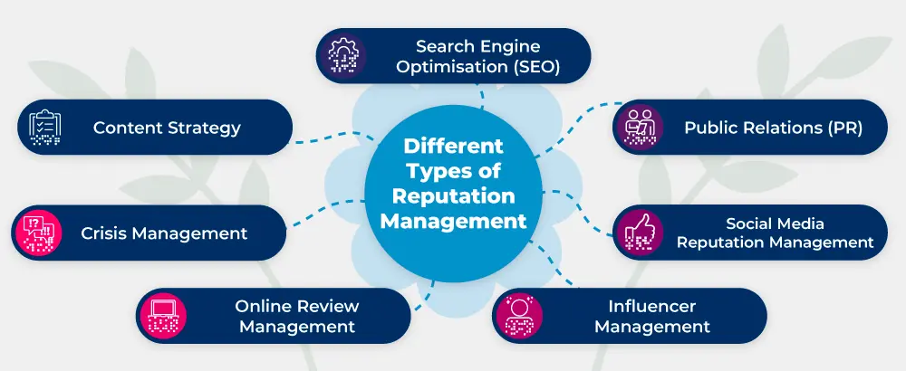
Figure 1: Brand Reputation Management
Source: (Allen, 2016; Altaf, 2022)
Furthermore, the literature emphasises the importance of the alignment of sustainability communication and overall corporate strategy. When sustainability is part of the core business practices and not used as a marketing tool, it's more likely to make a positive contribution towards the brand reputation (Allen, 2016; Altaf, 2022). This makes sustainability communication of strategic importance where reputation management is concerned.

Consumer Perception and Trust
Consumer perception is an important factor in the success of sustainability communication. Perception means that the consumers interpret and evaluate information about a brand. In the light of sustainability, consumers gauge the credibility, relevancy and the authenticity of corporate messages (Prieto et al., 2024). Trust is highly related to such perceptions and is significantly involved in the purchase decision and brand loyalty.
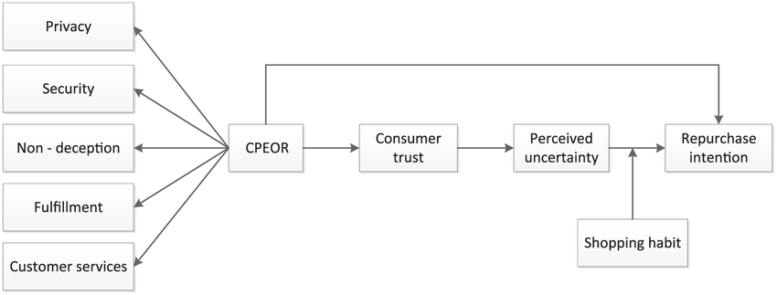
Figure 2: consumers’ perception regarding the ethics of online retailers
Source: (Prieto et al., 2024)
People trust brands more if they are honest with the facts and consistent about their green practices. Clear communication of goals, achievements and challenges can be helpful in building credibility and reducing scepticism (Reilly and Hynan, 2014). On the other hand, vague messages or messages that are overly promotional may create distrust. The rise of digital media has resulted in an even greater degree of consumer awareness and information, where consumers get to prove the claims of corporations and hold the companies responsible (Reilly and Hynan, 2014). At the same time, consumer attitudes towards sustainability are different for different groups of people. Some shoppers seek eco-friendly products while others are more concerned about a low price or a quick checkout. This variation in what consumers want to consume adds complexity to sustainability communication strategies and organisations will need to find ways of tailoring messages to different audiences.

Research Gap
As there is a dearth of such integrated studies exploring the relationship between the elements of sustainability communication, brand reputation and consumer perception in a given organisational context, there is value in the existing literature in providing insights related to these aspects (Margarida Custódio Santos et al., 2019). Most of the studies are done on either sustainability practices or reputation outcomes in isolation without looking at the strategic use of communication as a linking mechanism. Additionally, there is little empirical research with a focus on large multinational companies that operate in specific markets, such as the UK. This research is designed to fill these gaps by addressing the concepts of how Unilever UK uses sustainability communication in a strategic way in order to manage its brand reputation (Weder, 2023). By analysing the relation between the strategies of communication, perception of consumers and brand image, the research aims to provide a more complete understanding of how sustainability communication can be effectively used as a tool for reputation management in a real-life context.

Methodology (Research Onion Model)
This research uses the framework of the Research Onion to organise the methodological approach as a way of ensuring the methodology is organised and systematic.
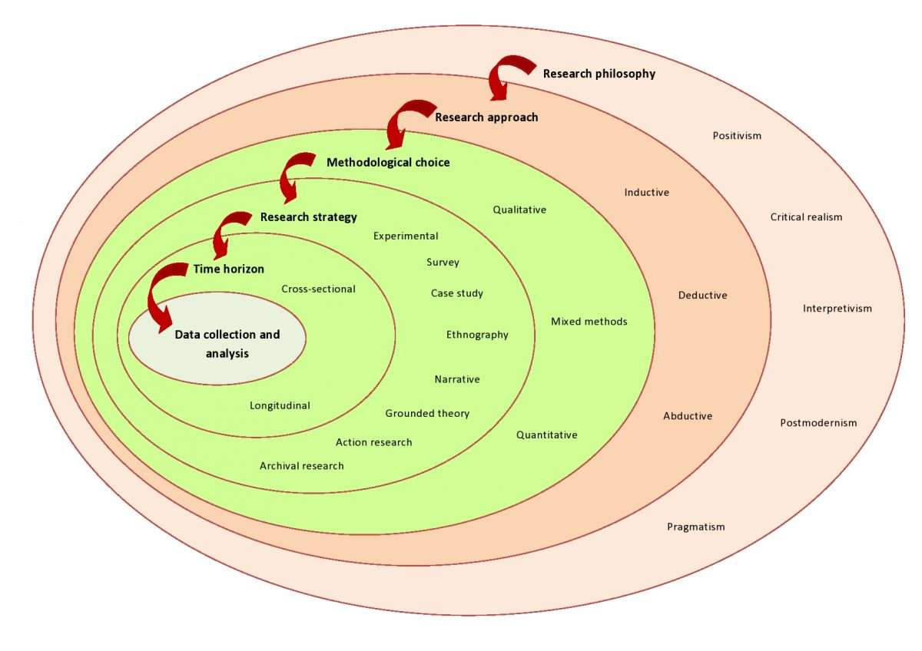
Figure 3: Research Onion Model
Source: (Saunders et al., 2023)

Research Philosophy
The research philosophy employed in this study is of interpretivism nature. Interpretivism is concerned with the way that social phenomena are understood, in terms of subjective interpretations and meanings (Saunders et al., 2023). This approach is suitable for exploring consumer perceptions and brand reputation as these concepts are affected by individual experiences and interpretations.

Research Approach
An inductive approach to research is adopted in this study. Inductive reasoning is a form of reasoning where this study forms insights and patterns from the collected data, rather than testing hypotheses that were in mind before starting (Saunders et al., 2023). This approach can be used well for looking at the complex relationship between sustainability communication and the reputation of the brand.

Research Strategy
The approach to the research is a case study strategy, and the company under study is Unilever UK. A case study allows this study to perform an in-depth analysis of one organisation in a real-world setting and can provide in-depth insights into how strategic practices and outcomes (Saunders et al., 2023).

Methodological Choice
A method of qualitative research has been adopted in this research. Qualitative research allows for a more in-depth knowledge of meanings, perceptions and experiences, key to analysing sustainability communication and brand reputation (Saunders et al., 2023).

Data Collection Method
The research is based on secondary sources of data. These include academic journal articles, industry reports, corporate publications, and official documents from Unilever (Weder, 2022). Sustainability reports, marketing campaigns, and communications to the public will be analysed to understand the way the company presents its sustainability initiatives. Secondary data provides access to a wide variety of information without the involvement of primary data (Saunders et al., 2023). Such an approach is appropriate given the scope and time constraints of the study.

Data Analysis Method
Thematic analysis is applied to the analysis of the data collected. This method is a process of identifying, analysing and interpreting patterns and themes in the qualitative data (Saunders et al., 2023). Key themes that are explored in relation to Unilever UK's sustainability communications include transparency, authenticity, consumer trust and brand image.

Ethical Considerations
The research is performed in accordance with the ethical guidelines for research. A sufficient reference will be provided in the Harvard referencing of all sources. The research is based on data which is available to the public, so that no confidential/private information is used in the research (Weder, 2022). This way, they keep their transparency and academic integrity.

Expected Findings / Contribution
This research is expected to prove that sustainability communication has a significant role in shaping the brand reputation. It is expected that Unilever UK's strategic approach to using sustainability messaging helps to build trust among consumers and build its brand image (Kargbo, Terrence and Palmer, 2025). However, the ability of such communication may be dependent on their perceived authenticity and the congruence with actual practices. The study is also expected to shed light on the challenges related to sustainability communication, such as the risk of greenwashing and the scepticism of consumers (Weder, 2022). At the same time, it may find opportunities to improve communication strategies through building increased transparency and engagement with stakeholders. From an academic point of view, this research contributes to the already existing literature by providing a detailed analysis of the relationship between sustainability communication and brand reputation (Crumley et al., 2022). From a practical view, it offers some insights to managers on how to make effective use of sustainability communication for reputation management as a strategic tool.

Limitations
This research has a number of limitations. The use of secondary data may limit the type of information that can be gathered about consumer perceptions and internal organisational strategy (Genç, 2017). A lack of primary data, such as interviews or surveys, may limit the opportunity of gathering real time consumer opinions (Margarida Custódio Santos et al., 2019). Additionally, the research currently being undertaken is focusing on one case organisation which may have limited the research findings presented to the general population (Reilly and Hynan, 2014). Time constraints may also affect the scope of analysis. Therefore, it should be noted that the outcomes of the findings should be considered indicative and not definitive.

Timeframe
The research will be conducted in twelve weeks. The first two weeks will be spent on the development of the introduction and literature review. The next three weeks will be spent in methodology design. Data collection and analysis will continue for the next four weeks. The last three weeks will be spent on the writing, revision and completion of the dissertation.

Conclusion
This research proposal is an outline of a study on strategic use of sustainability communications in brand reputation management, and is focused on Unilever UK. The research is planned to investigate the communication of sustainability initiatives and their impact on consumer perceptions and brand image (Allen, 2016; Altaf, 2022). By adopting the qualitative case study approach, the research aims to determine an in-depth understanding of the relationship between sustainability communication and brand reputation. Understanding this relationship is very important in today's business environment, where sustainability is becoming an important factor in the success of a company (Prieto et al., 2024). The findings of this study are expected to contribute to the academic knowledge and practical strategies of managing brand reputation through the communication of sustainability.

Reference
Aksoy, Z. and Misci Kip, S. (2025) ‘From tactical to strategic sustainability communication: a qualitative study on corporations in Türkiye’, Corporate Communications: An International Journal, 30(2), pp. 313–334. Available at: https://doi.org/10.1108/ccij-07-2024-0135.
Allen, M. (2016) Strategic Communication for Sustainable Organizations, CSR, Sustainability, Ethics & Governance. Springer International Publishing. Available at: https://doi.org/10.1007/978-3-319-18005-2.
Altaf, M. (2022) ‘Strategic Communication: A Tool to Engage Multiple Stakeholders for Corporate Sustainability’, Journal of Management and Research, 9(2). Available at: https://doi.org/10.29145/jmr.92.04.
Bodenheimer, M. and Leidenberger, J. (2020) ‘COVID-19 as a window of opportunity for sustainability transitions? Narratives and communication strategies beyond the pandemic’, Sustainability: Science, Practice and Policy, 16(1), pp. 61–66. Available at: https://doi.org/10.1080/15487733.2020.1766318.
Borges, E., Campos, S., Teixeira, M.S., Lucas, M.R., Ferreira-Oliveira, A.T., Rodrigues, A.S. and Vaz-Velho, M. (2023) ‘How Do Companies Communicate Sustainability? A Systematic Literature Review’, Sustainability, 15(10), p. 8263. Available at: https://doi.org/10.3390/su15108263.
Crumley, E.T., Grandy, K., Sundararajan, B. and Roy, J. (2022) ‘Media interviews as strategic external communication to maintain legitimacy for sustainability activities’, Corporate Communications: An International Journal, 27(1), pp. 148–166. Available at: https://doi.org/10.1108/ccij-05-2021-0053.
Dessart, L. and Standaert, W. (2023) ‘Strategic Storytelling in the Age of Sustainability’, Business Horizons, 66(3), pp. 371–385. Available at: https://doi.org/10.1016/j.bushor.2023.01.005.
Genç, R. (2017) ‘The Importance of Communication in Sustainability & Sustainable Strategies’, Procedia Manufacturing, 8, pp. 511–516. Available at: https://doi.org/10.1016/j.promfg.2017.02.065.
Golob, U., Podnar, K. and Zabkar, V. (2023) ‘Sustainability communication’, International Journal of Advertising, 42(1), pp. 42–51. Available at: https://doi.org/10.1080/02650487.2022.2144035.
Helle Kryger Aggerholm and Thomsen, C. (2024) ‘Strategic communication in contexts of high sustainability pressure: balancing purposefulness, transparency and participation in pursuit of organizational legitimacy’, Journal of Communication Management, 28(1). Available at: https://doi.org/10.1108/jcom-12-2022-0131.
Kalogiannidis, S., Kagioglou, F., Kalfas, D. and Kagioglou, A. (2025) ‘Business communication strategies as an internal locus of sustainability in SMEs. A case study of Greece’, Discover Sustainability, 6(1). Available at: https://doi.org/10.1007/s43621-025-00894-7.
Kargbo, U., Terrence, B. and Palmer, T.B. (2025) ‘Redefining Corporate Social Responsibility: The Role of Strategic Communication Practices’, Sustainability, 17(9), p. 4226. Available at: https://doi.org/10.3390/su17094226.
Margarida Custódio Santos, Célia Veiga, Paulo Águas and José António C. Santos (2019) ‘Sustainability communication in hospitality in peripheral tourist destinations : Implications for marketing strategies’, Worldwide Hospitality and Tourism Themes, 11(6), pp. 660–676. Available at: https://doi.org/10.1108/WHATT-08-2019-0049.
Prieto, L., Simone T.A. Phipps, Robertson, M. and Reynolds, S. (2024) ‘Strategic communication & corporate sustainability within global supply chains’, Strategy & leadership, 52(2). Available at: https://doi.org/10.1108/sl-09-2023-0095.
Reilly, A.H. and Hynan, K.A. (2014) ‘Corporate communication, sustainability, and social media: It’s not easy (really) being green’, Business Horizons, 57(6), pp. 747–758. Available at: https://doi.org/10.1016/j.bushor.2014.07.008.
Saunders, M.N.K., Lewis, P. & Thornhill, A. (2023) Research Methods for Business Students (9th ed.). Pearson.
Weder, F. (2022) ‘Strategic problematization of sustainability reframing dissent in strategic communication for transformation’, Public Relations Inquiry, 11(3), p. 2046147X2110268. Available at: https://doi.org/10.1177/2046147x211026857.
Weder, F. (2023) ‘The Evolution of the Sustainability Story: Strategic Sustainability Communication as Niche Construction’, International journal of strategic communication, 17(3), pp. 228–244. Available at: https://doi.org/10.1080/1553118x.2023.2229304.

