
Module Name: Academic Skills in the Digital Era
Module Code: BMSW4013
Assessment 1: E-Portfolio
Student Name: Cosmina Ramona Adamache
Student Number:2528497
Lecturer: Chris Wilkin
Deadline: 27th February 2026

Wordcount:1,544
AI Acknowledgement
I confirm that I have not presented any AI-generated text as my oy own.
Contents
Component 1 – Development of Academic Skills (500 words) 4
Component 2 – Application of Academic Skills (1,000 words) 6
Component 3 – Academic Poster 8

Component 1 – Development of Academic Skills
Source 1
Aris, S.R.S., Teoh, S.H., Deni, S.M., Nadzri, F.A. and Dalim. S.F. (2022)
“Digital skills framework in higher education” Proceedings, (82), pp. 1-6.
This source was accessed via Google Scholar.
An evaluation of this source using the CRAAP test indicates that the sources used has a strong currency. The strong currency is due to its published date of 2022, making the source directly relevant and reliable for the topic of digital skills in higher education. Moreover, another factor that demonstrates The source relevance is that it focuses specifically and directly on the topic of digital skills in higher education As this makes the content of the source align with the relevant focus of the research. The authors academics supports the authority of the source and the journal publication. Furthermore, the currency of the source is demonstrated through a variable of reliable an unbiased methods which were also assessed by experts. The purpose of this article is shown to be academic as it supports academic research and knowledge and informational as it supports information.
Source 2
Mena-Guacas, A.F., Meza-Morales, K.A., Fernandez, E. and Lopez-Meneses, E. (2024) “Gamification and learning engagement in higher education: A systematic review,” Education Sciences, 14 (1), pp. 1-21.
The source was accessed via Google Scholar.
Using the crop framework the article shows multiple strengths including credibility. It was published in 2024 demonstrating currency. Moreover, the focus of digital competencies and collaboration demonstrates the relevance of the source on digital education. Furthermore, the authority of the source can be demonstrated through the fact that the authors are researchers and the publication of it was on an academic journal. The accuracy is reliable as shown to research design as it was nonexperimental using a self-perception questionnaire claiming data from a wide range of 1316 students. The purpose of the article is academic as it contributes evidence-based insights to higher education research among higher education students.
Synthesis of Academic Sources
The theme that both sources share is the examining of digital learning in higher education (Aris et al., 2022; Mena-Guacas et al., 2024). Moreover, while both the sources highlight the importance of digital skills in higher education, the focus of the sources differ in method used. The first source created a structure framework, while the second source used gamification as a method to use student engagement. The sources also complement each other as they combine theory and practice. In conclusion, by combining these sources, it helps to understand digital learning in higher education and to apply digital competencies.

Identifying a Key Challenge and Opportunity
One key challenge students are facing in digital era is the ability to understand and effectively apply digital competencies in higher education. One source demonstrates the importance of a structured framework to overcome the challenges. (Aris et al., 2022). However, one key opportunity for students in the digital era can be illustrated by gamification environments which can help students apply digital skills through practice and self-assessment (Mena- Guacas et al., 2024). In conclusion, by combining a clear and structured framework with interactive ways to develop digital skills, key challenges which can be addressed to improve motivation and overall performance.
Academic Planning for Component 2
I will prioritise the challenges and strategies section of my component 2 as I need to do more research and write in more depth. I need to develop my time management skills as I heavily lack it, and I also need it to avoid damaging my mental health with academic stress and to cope with the academic workload. My component 2 will begin with an introduction, then next I will evaluate opportunities and challenges students face in the digital era. It will then include strategies students can use to succeed academically, followed by a conclusion.
Timeline
Task | Date/ Deadline
Finish research | 06/02/2026
Draft first section | 17/02/2026
Complete first draft | 23/02/2026
Final editing | 26/02/2026

Reference List – Component 1
Mena-Guacas, A.F., Meza-Morales, K.A., Fernandez, E. and Lopez-Meneses, E. (2024) “Gamification and learning engagement in higher education: A systematic review,” Education Sciences, 14 (1), pp. 1-21.
Sharipah Ruzaina Syed Aris et al. (2022) “Digital Skills Framework in Higher Education,” in International Academic Symposium of Social Science 2022. MDPI AG, p. 61. Available at: https://doi.org/10.3390/proceedings2022082061.

Component 2 – Application of Academic Skills
1.Introduction
Digital learning in higher education covers the use of digital tools that has digital course materials, assignments, libraries and academic platforms where students can access timetables, modules and recorded lessons. In the current digital era, academic and universities rely on digital learning tools to increase access to education as the new labour demands new qualities and transferable skills arising from digitalisation. (Leon- Perez et al., 2020). A key factor in using digital learning tools is understanding that there are challenges and opportunities which come with it and has the power to influence students’ academic success. By recognising challenges, it offers the opportunity for universities and academics to address these challenges by designing better support systems (Pihlainen et al., 2023). Moreover, this report will explore key challenges which students face in the digital era, while considering opportunities arising from digital learning tools available, and offering insights on strategies to overcome challenges to succeed in higher education.
Challenges for Students in the Digital Era
One key challenge students encounter is the heavy dependence on digital tools. Study shows that students which rely excessively on digital tools are more likely to struggle with learning and engagement, ultimately reducing opportunities to develop transferable skills which are essential in higher education (Li, 2022). Also, relying on technology to validate ideas, it can become a problem when technology is not available, especially when it is required to make decision in real-world context. Moreover, this challenge can affect students on the long term as it would be difficult to apply transferable skills in real world and strengthen critical thinking.
Another key challenge students face in the digital era is health issues caused by increased screen time. There is a study showing that 62% of students agreed that online education increased overall screentime (Rehman et al., 2023). Moreover, research shows that students in digital learning are more likely to develop physical effects such as computer vision effect syndrome, and mental effects such as fatigue which can lead to reduce attention during learning (Li, 2022). These health challenges can lead to risk of reduced capacity to manage deadlines effectively or develop problem solving and critical thinking which are fundamental skills needed for education success.
Opportunities in the Digital Era
One key opportunity for students in the digital era is that it supports innovation and adaptive skills. Research implies that there is an increasing need for creativity and entrepreneurial skills in higher education (Alezi et al., 2023). It emphasizes the fact that innovation is essential due to a decline in traditional jobs, and by using digital learning, students learn how to adapt and develop skills required. For example, digital learning has digital tools which are seen as an opportunity for students to experiment and generate new ideas by contributing to innovative practices. However, the opportunity for innovation depends on the quality of the support provided by instructors or teachers. Without the relevant support, students struggle with developing meaningful skills. Also, the opportunity may not be beneficial for all students who lack motivation, confidence or struggle with using technology. It is important that students are provided with feedback and chances to participate as well with sensible guidance. Therefore, digital learning provides an opportunity for students to develop or strengthen essential skills, which are needed to prepare students for the growing digitalised job market, but its effectiveness relies on suitable training, guidance and student engagement in group communication and platforms.

How Students Can Adapt to Succeed
There are strategies students can use to succeed academically:
- One key strategy students can use to succeed is the use of effective study techniques such as active recall. Active recall is a learning method which involves a practice of stimulating the memory to retain information more efficient rather than relying on passive study. For example, research shows that many students rely on learning habits such as rereading and rewriting notes which is an ineffective and limited technique (David et al., 2024). Digital learning promotes passive studying by providing recorded lectures, slides and PDFs, whereas active recall helps overcome challenges such as learning without depth and with poor management of learning materials. Active recall also has the power to address opportunities by turning digital tools into active learning environments where, for example, online tools and recorded lectures can be used to test knowledge and understanding rather than passively going over academic content. Furthermore, the strategy of using active recall can help students develop skills such as critical thinking and independent problem solving.
- A second strategy used to succeed academically, is setting clear long-term goals. This strategy can overcome the challenge of procrastination or low engagement caused by the lack of traditional classrooms; however clear goals help students to track their progress, stay motivated and provide direction. For example, research shows that students which set clear academic goals are more likely to adjust their study methods and stay motivated through challenges (David et al., 2024). Moreover, this strategy gives students the opportunity to use digital tools such as online calendars. Moreover, by setting defined objectives for studies, students can overcome challenges and develop transferable academic skills such as planning or reflective learning.
- A third strategy students can use is creating a consistent study time. Due to flexibility offered by digital learning, students can be affected by distraction and reduced engagement. However, by setting fixed times for learning or self-study students can manage their time effectively and balance course work and personal life, while making the most of digital tools. For example, research shows that students which use a consistent routine are more likely to complete tasks on time and retain information (David et al., 2024). Furthermore, creating a routine helps students overcome mental health challenges, and take full advantage offered by opportunities by digital platforms.
Conclusion
To conclude, digital learning presents challenges such as over dependence of technology and health issues but offers opportunities for innovation and skill development which is caused by the decline of traditional jobs and the arise of technological demand. Students can succeed by using learning such as active recall and setting clear academic goals and creating study routines to improve time management skills. By applying the strategies, students can overcome challenges and make the most of digital learning.
Reference List – Component 2
(Alenezi, M., Wardat, S. and Akour, M. (2023) “The Need of Integrating Digital Education in Higher Education: Challenges and Opportunities,” Sustainability, 15(6), p. 4782. Available at: https://doi.org/10.3390/su15064782.
Devi, K.A. and Singh, S.K. (2023) “The hazards of excessive screen time: Impacts on physical health, mental health, and overall well-being,” Journal of Education and Health Promotion, 12(1), pp. 413–413. Available at: https://doi.org/10.4103/jehp.jehp_447_23.
León-Pérez, F., Bas, M.-C. and Escudero-Nahón, A. (2020) “Self-Perception about Emerging Digital Skills in Higher Education Students,” Comunicar (Huelva, Spain), 28(62), p. 89. Available at: https://doi.org/10.3916/C62-2020-08.
LI, D., 2022. The Shift to Online Classes during the Covid-19 pandemic: Benefits, Challenges, and Required Improvements from the Students’ Perspective: EJEL. Electronic Journal of E-Learning, 20(1), pp. 1-18.
Pihlainen, K. et al. (2023) “Older adults’ reasons to participate in digital skills learning: An interdisciplinary, multiple case study from Austria, Finland, and Germany,” Studies in the education of adults, 55(1), pp. 101–119. Available at: https://doi.org/10.1080/02660830.2022.2133268.
David, L., Biwer, F., Crutzen, R. et al. The challenge of change: understanding the role of habits in university students’ self-regulated learning. High Educ 88, 2037–2055 (2024). https://doi.org/10.1007/s10734-024-01199-w

Component 3 – Academic Poster
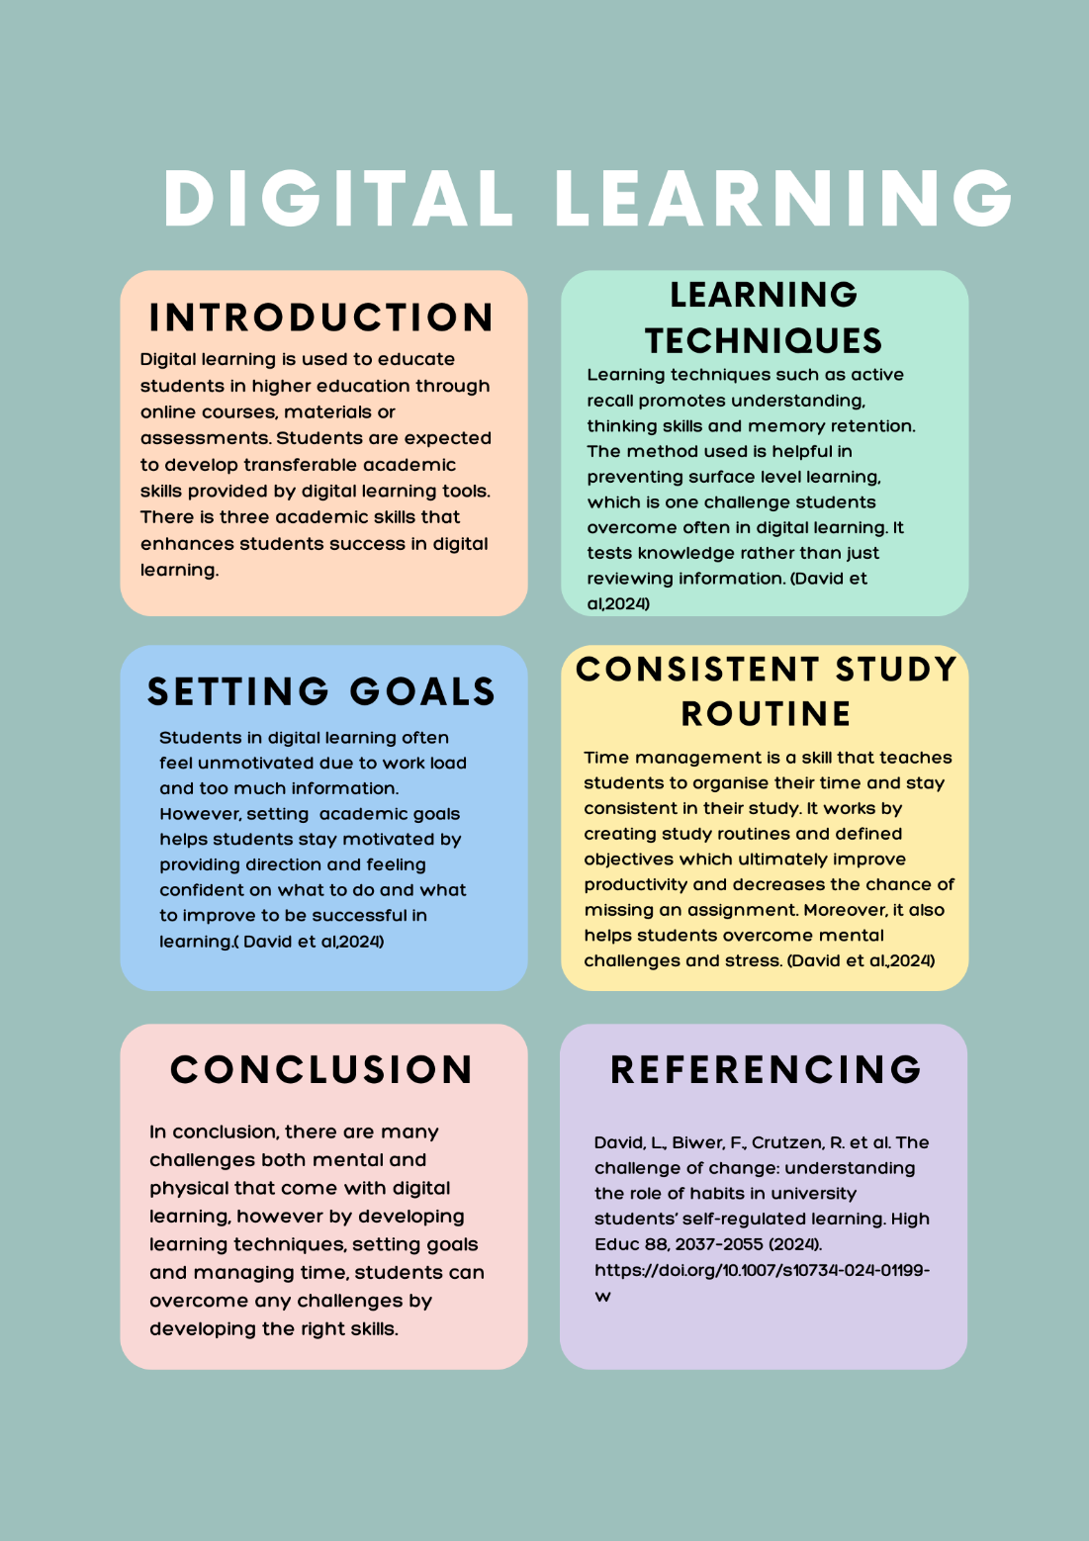

Reference List – Component 3
David, L., Biwer, F., Crutzen, R. et al. The challenge of change: understanding the role of habits in university students’ self-regulated learning. High Educ 88, 2037–2055 (2024). https://doi.org/10.1007/s10734-024-01199-w

