

Osvaldas Stanelis

1802408

Computing (Data and Information Systems)

Data Analysis and Visualisation

20.02.2020

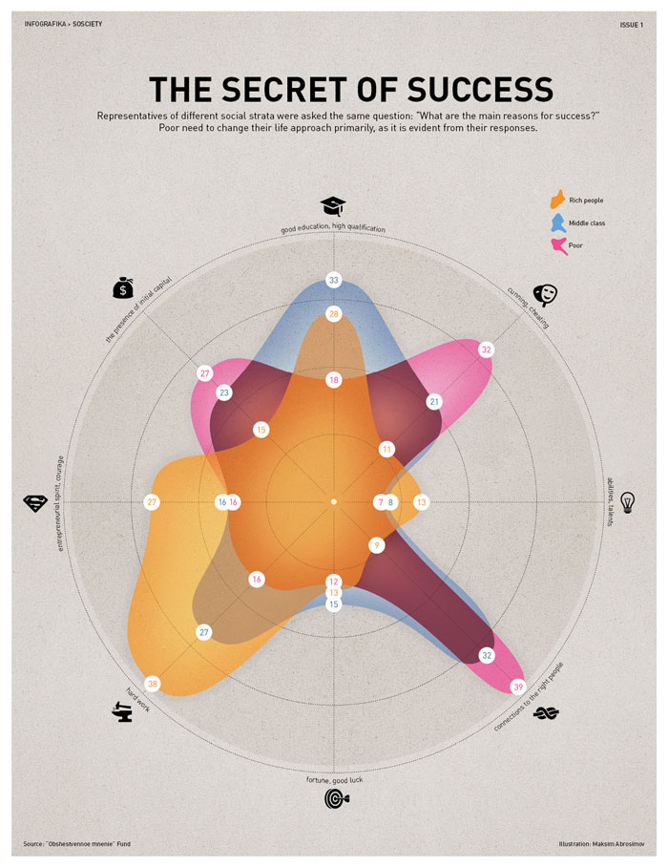

What message is the poster trying to provide? Poster trying to provide: responses from various social circles to what are the main reasons for success. And it is desired to emphasize that poor people have to change their attitude to life, as is visible from their answers. And all this is attempted to show in the graph. One of the criteria for choosing apartments colours. In this case, we have three colours. Yellow colour for rich people. Blue colour for middle class people. Pink colour for poor people. In my opinion, the colours in this graph can be of any importance to the different ones, so that the difference is visible in the colour which the social layer represents. The text in the chart is difficult to read because it is too small and very dimly selected. If you choose a larger font size for a poster, it's much easier to look and read. How much is the visible font style is selected one. In my opinion it is good that poster chose only one font style instead of a few. His error in this case is the text size. At a glance, the graph is difficult to understand. Because the colours of the places converge with each other. But a closer look at goes on to understand what is wanted to show. In this case, the figures come to the rescue and help to better understand all the essence. Well done graph, because there is no graph that does not provide any information. The overall design in my opinion is not bad any demanding attention to the drill. For improvement I suggest you highlight the text and enlarge it. In my opinion, apartments can be added three more graphs which would show separately the answers of these three social circles to the main reasons for success.

