Leighton Bowd (2320479)
L4 - Introduction to Web and Database Concepts
ACCA4023
HTML & CSS Web Development

Contents
Introduction 2
Requirements 3
Goals for User Experience: 3
Implementation 4
Validation 6
Evaluation 7
Usability 7
Accessibility 8
Search Engine Optimisation 8
Final Evaluation of My Website 9
Usefulness (usability and utility) 9
Search Engine Optimisation of My Website 10
The Accessibility of My Website 11
Appendices 12

Introduction
This report examines creating and enhancing a personal website showcasing my favourite football club, Swansea City AFC, and its players. The document is organised into sections, each focusing on key aspects of the project:

Requirements: This section outlines the essential objectives for creating the website, including the desired features, functionality, and goals for user experience.

Implementation: I will provide screenshots of all the completed website pages (excluding the code) here.

Validation: This section discusses the methods and tools used to ensure that the website and its HTML and CSS meet the specified requirements and standards. I will validate my completed website's HTML and CSS code and present the validation results. If I encounter any errors, I will briefly describe how I corrected each one.

Evaluation: This section critically analyses the website's usability, accessibility, and search engine optimisation for its intended purpose. It also discusses any challenges faced during the development process and the solutions implemented to overcome them. I will also carry out some research on Website usability, accessibility, and search engine optimisation. And its role in web development

This comprehensive report aims to thoroughly understand the project's progression, from the initial concept to the final implementation, ensuring a successful and engaging website experience for the intended audience.

Requirements
This website is dedicated to celebrating and documenting my favourite football players from Swansea City AFC and some memorable matches I have experienced. It highlights their significant contributions and unforgettable moments. This site serves as a personal tribute and captures cherished memories related to the club and its players.

Player profiles and memorable matches: Comprehensive profiles for each highlighted player, including biographical information, career highlights, and personal anecdotes from matches I have attended.

Images and Videos: Relevant photos and embedded videos enhance the website's storytelling and visual appeal.

Navigation Menu: A user-friendly, horizontal navigation menu for easy access to different website sections.

Responsive Design: Ensuring the website is accessible and visually appealing across various devices and screen sizes.

SEO Optimisation: Implement on-page SEO techniques to improve search engine visibility and attract more visitors.

Goals for User Experience:

Engagement: Create an engaging and immersive experience for visitors by presenting compelling content and captivating visuals.

Usability: Ensure the website is easy to navigate, with a clean and intuitive layout that allows users to find information quickly and effortlessly.

Accessibility: Adhere to accessibility standards to ensure the website is usable by people with disabilities and provides an inclusive experience for all visitors.

Content Clarity: Present clear and well-organised content that conveys my passion for Swansea City AFC and its players.

Interactivity: Incorporate interactive elements like search functionality and hyperlinks to enhance user engagement and provide a seamless browsing experience.

By achieving these objectives, the website aims to offer visitors a memorable and enjoyable experience, celebrating Swansea City AFC's rich history and iconic players.

Implementation
This section will show screenshots of my completed website.
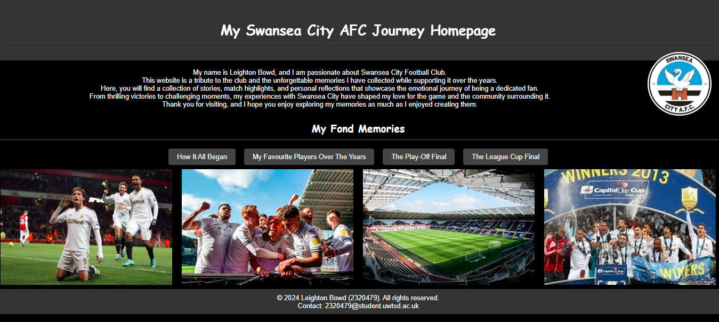
Figure 0-1 My website’s homepage
Figure 0-2 Screenshot of my introduction page
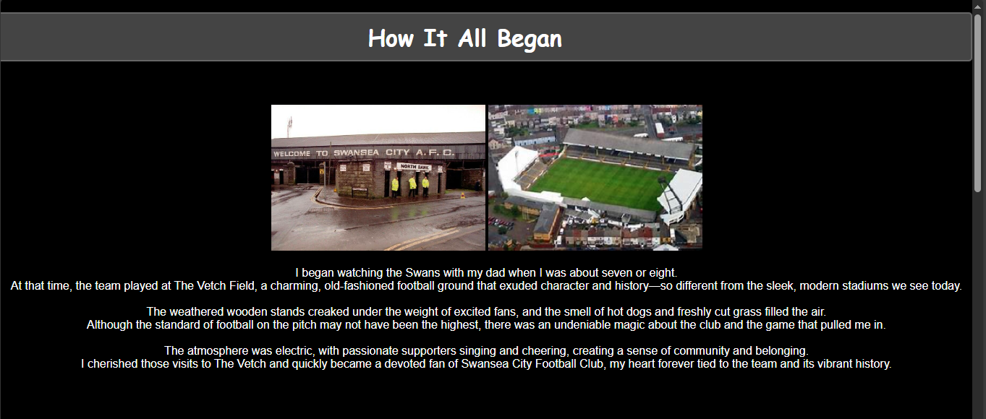

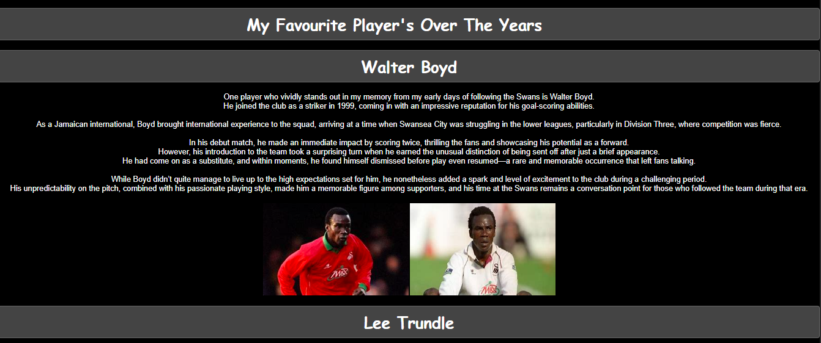
Figure 0-3 A screenshot of my favourite player's page
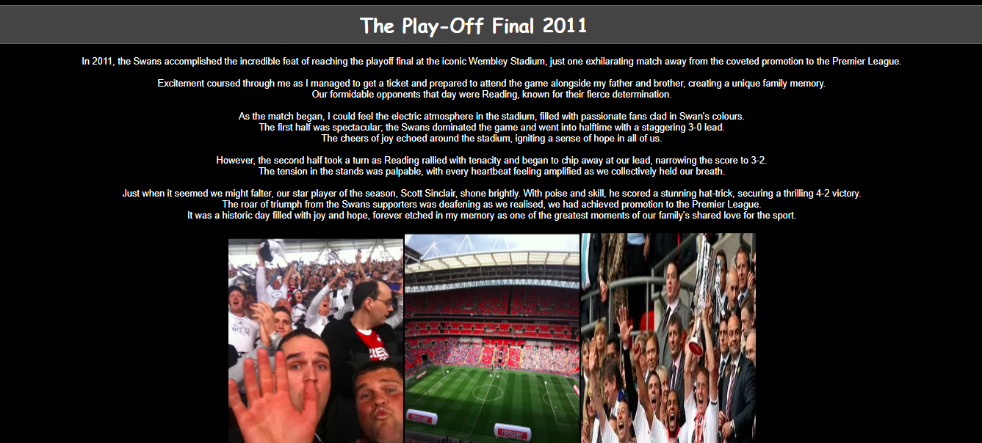
Figure 0-4 Screenshot of the play-off final page
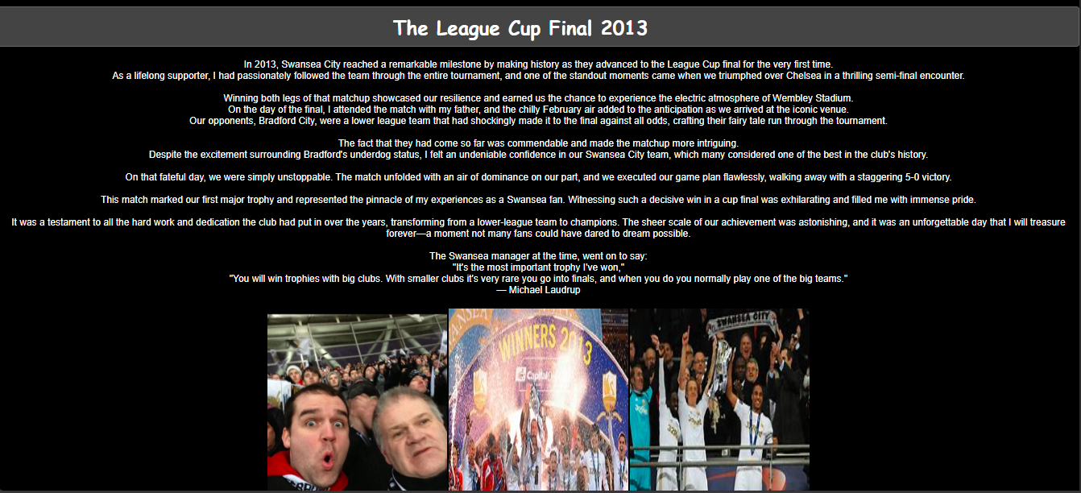
Figure 0-5 Screenshot if the League Cup Final page

Validation
In this section, I ran my HTML and CSS code through an online validator to check for errors. While validating the code for my homepage, I encountered an error.:
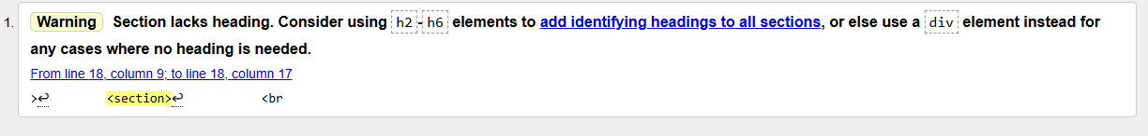

I replaced the <section> element with a <div>, which fixed the errors.
My following webpage had no errors when I ran the HTML through the validator. However, the page for my favourite players and play-off final pages returned the following error:
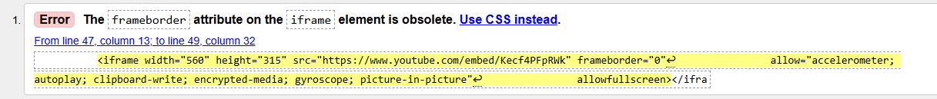

I modified the code and utilised CSS to ensure the iframe was displayed without borders, adhering to modern HTML standards. This change eliminated any error messages from the validator, and my final page showed no errors. Additionally, I encountered some typos when reviewing the HTML, but I was able to identify and correct them effectively along the way. I ran my final CSS through the validator, and it returned with no errors.

Evaluation
This section will cover three essential features when analysing a website's quality: Usability, Accessibility, and Search Engine Optimisation.

Usability
Usability is key in assessing a website's quality, as it dramatically influences user satisfaction, engagement, and overall effectiveness. It encompasses various aspects, including ease of navigation, accessibility, readability, and the efficiency with which users can achieve their goals. A website with strong usability enables users to find information quickly, interact with features seamlessly, and complete tasks without frustration.

The International Organisation for Standardisation (ISO) defines usability as "the effectiveness, efficiency, and satisfaction of the user’s interaction with the object of interest." When designing a system, product, or service, consider the following essential points:

* If usability is lower than expected, the intended users may struggle to use the system, product, or service or choose not to use it.

* If usability meets expectations, the system, product, or service will deliver the intended personal, social, and economic benefits to users, employers, and suppliers.

* If usability exceeds expectations, the system, product, or service can gain a competitive advantage, such as improved customer retention or customers willing to pay a premium [1]

The concept of usability originates from the field of human-computer interaction (HCI), which examines how people engage with computers and other electronic systems and has existed even before the advent of the World Wide Web. Researchers have utilised HCI's cognitive frameworks to create models illustrating user behaviour when interacting with digital technology. [2]

Accessibility
Accessibility is essential when assessing a website's quality because it allows all users, including those with disabilities, to interact effectively with its content and features. Accessible websites enhance user experience through inclusive design practices, such as providing text alternatives for images, enabling keyboard navigation, and ensuring compatibility with screen readers. This inclusivity improves usability for a wider audience and meets legal standards and guidelines, such as the Web Content Accessibility Guidelines (WCAG). [3].

Ensuring universal access to online information is a valuable goal for academic institutions. Significant legislation and attention have been focused on levelling the playing field for individuals with disabilities through enhanced accessibility measures. This paper, which I am referencing, focuses explicitly on web accessibility.

According to the Web Accessibility Initiative (WAI), a project of the World Wide Web Consortium (W3C), "Web accessibility means that people with disabilities can use the Web. More specifically, web accessibility means that people with disabilities can perceive, understand, navigate, and interact with and contribute to the Web" (WAI, 2005a). Additionally, the WAI facilitates the development of an international set of technical standards known as the Web Content Accessibility Guidelines (WCAG) (WAI, 2012). [4]

Search Engine Optimisation
The Internet is an essential communication tool recognised for its significant potential to reach customers. With the advent of network marketing, one notable and effective technique for increasing sales is Search Engine Optimisation (SEO) for online products. Successful websites leverage internet advertising and modern, cost-effective marketing strategies like SEO.
SEO is a strategy that helps a website appear in the top results of search engines for specific keywords by using meta tags. Numerous factors and methods can enhance a website's ranking for relevant search queries and improve its position in search results. These include website design and redesign, link building, backlink development, high-quality text content, the use of tags, blogging to boost link popularity, mobile app development, and metadata implementation.
Ultimately, effective SEO significantly increases a web page's visibility and accessibility. Visibility, in this context, refers to the ranking position of a professional organisation or company, and every internet publisher strives for high webpage visibility in search engine results. [5].

Final Evaluation of My Website
Finally, I will provide an evaluation of my website covering its Usefulness (usability and utility), Search Engine Optimisation (SEO) and Accessibility.

Usefulness (usability and utility)
My website features a clean and straightforward layout that is easy to navigate. The consistent use of fonts and colours creates a cohesive appearance. The well-integrated images enhance visual interest and provide context for the content. However, the overall design could be improved in some areas, and I want to learn more about implementing this in the future.

The website has essential navigation links that enable users to access different sections efficiently. The images include appropriate alt attributes, enhancing both accessibility and SEO. One improvement I could have made is adding a search function to the website, as I have not tried this before.

The site is user-friendly, featuring straightforward navigation and legible text. Still, it could benefit from a more interactive user experience. I am eager to explore additional ways to enhance the website and its design.

The content is engaging and personal, offering a unique perspective. It is well-structured, featuring clear headings and supportive images. However, there is room for improvement. Adding more detailed descriptions or captions to the photos could provide additional context.

The CSS creates a cohesive dark theme that is visually appealing and consistent across the website. The hover effects applied to elements like `.nav-button: hover` and `.centered-flex-image img: hover` enhance interactivity and improve user experience. One area for improvement is to incorporate more colour throughout the site's pages. I still have much more to learn about CSS and its impact on styling websites.

Search Engine Optimisation of My Website
My website incorporates several essential on-page SEO techniques that enhance its visibility and usability. Each page features well-crafted title tags that provide clear and concise descriptions of the content, helping users and search engines understand the page's purpose. Additionally, header tags are used to structure the content, making it more readable and assisting search engines in grasping the hierarchy and significance of various sections.

All images include alt text, which offers descriptive information that improves accessibility and aids search engines in indexing the images. Internal linking through navigation menus enhances the user experience by making it easier to navigate the site while distributing link equity across the pages. The website's responsive design ensures optimal functionality on various devices, enhancing user experience and boosting SEO rankings.

The content is high-quality, relevant, and engaging, focusing on my experiences with Swansea City AFC. This approach helps retain user interest and encourages more extended visits to the site. Simple, descriptive URLs, alongside the natural inclusion of relevant keywords throughout the content, further improve the website’s search engine rankings by clearly communicating the page topics to both users and search engines. These well-implemented on-page SEO techniques significantly improve the website's effectiveness and discoverability.

The Accessibility of My Website
My website's accessibility can be evaluated based on the four main principles of WCAG 2.1: Perceivable, Operable, Understandable, and Robust (POUR).

Perceivable
This principle guarantees that all users can access and understand the information presented. My website utilises alt text for images, assisting visually impaired users in comprehending the content through screen readers. The text is displayed in a high-contrast format, with white text on a black background, which benefits users with visual impairments.

Operable
Operability ensures user interaction with the interface, regardless of navigation method. My website features structured and clear navigation menus that allow keyboard browsing.

Understandable
This principle emphasises the importance of clarity and predictability in content. My website features a consistent layout and navigation structure, assisting users in locating information quickly. The language used is simple, and link descriptions enhance overall understandability.

Robust
Robustness ensures that content is accessible through various assistive technologies. My website follows standard HTML and CSS practices, which support compatibility with screen readers and other assistive devices. Additionally, properly implementing ARIA (Accessible Rich Internet Applications) roles can further enhance accessibility, particularly for dynamic content. [3].

Appendices
index.html
<!DOCTYPE html>
<html lang="en">
<head>
<meta charset="UTF-8">
<meta name="viewport" content="width=device-width, initial-scale=1.0">
<title>Leighton Bowd HTML & CSS Web Development</title>
<link rel="stylesheet" href="styles.css">
</head>
<body>

<header>
<h1>My Swansea City AFC Journey Homepage</h1>
<img src="images/swansealogo.png" alt="Swansea City club Badge" width="150" height="150" class="top-right-image">
</header>

<main>
<!-- brief introduction to my website -->
<div>
<br>
<p class="center-text">My name is Leighton Bowd, and I am passionate about Swansea City Football Club.<br>
This website is a tribute to the club and the unforgettable memories I have collected while supporting it over the years.<br>
Here, you will find a collection of stories, match highlights, and personal reflections that showcase the emotional journey of being a dedicated fan.<br>
From thrilling victories to challenging moments, my experiences with Swansea City have shaped my love for the game and the community surrounding it.<br>
Thank you for visiting, and I hope you enjoy exploring my memories as much as I enjoyed creating them.</p>
</div>

<section>
<h2>My Fond Memories</h2>
<ul class="nav-menu">
<li><a href="about.html" class="nav-button">How It All Began</a></li>
<li><a href="favourite-players.html" class="nav-button">My Favourite Players Over The Years</a></li>
<li><a href="playoff-final.html" class="nav-button">The Play-Off Final</a></li>
<li><a href="league-cup-final.html" class="nav-button">The League Cup Final</a></li>
</ul>

<div class="image-container">
<img src="images/michu.webp" alt="Swansea players celebration">
<img src="images/Swansgoal.jpg" alt="More Swansea celebrations">
<img src="images/stadium.jpg" alt="The Swansea.com Stadium">
<img src="images/cupwinner.jpg" alt="League Cup Winners 2013">
</div>
</section>
</main>

<footer>
<p>&copy; 2024 Leighton Bowd (2320479). All rights reserved.</p>
<p>Contact: <a href="mailto:2320479@student.uwtsd.ac.uk">2320479@student.uwtsd.ac.uk</a></p>
</footer>

</body>
</html>

about.html

<!DOCTYPE html>
<html lang="en">

<head>
<meta charset="UTF-8">
<meta name="viewport" content="width=device-width, initial-scale=1.0">
<title>How It All Began</title>
<link rel="stylesheet" href="styles.css">
</head>

<body>

<h1 class="move-left center-title">How It All Began</h1>
<br>

<div class="centered-flex-image">
<img src="images/nb.jpg" alt="The Famous North Bank at the old Vetch Field">
<img src="images/vetch.jpg" alt="The old Vetch Field">
</div>

<p class="center-text">
I began watching the Swans with my dad when I was about seven or eight.<br>
At that time, the team played at The Vetch Field, a charming, old-fashioned football ground that exuded character
and history—so different from the sleek, modern stadiums we see today.<br><br>
The weathered wooden stands creaked under the weight of excited fans, and the smell of hot dogs and freshly cut
grass filled the air.<br>
Although the standard of football on the pitch may not have been the highest, there was an undeniable magic about
the club and the game that pulled me in.<br><br>
The atmosphere was electric, with passionate supporters singing and cheering, creating a sense of community and
belonging.<br>
I cherished those visits to The Vetch and quickly became a devoted fan of Swansea City Football Club, my heart
forever tied to the team and its vibrant history.
</p>

<br><br><br>

<h2 class="center-title">The 1994 Autoglass Trophy Final</h2>
<br><br><br>

<p class="center-text">
One of my fondest memories of supporting the Swans is from 1994 when they triumphantly made their journey to
Wembley for the Autoglass Trophy.<br>
I was lucky to accompany my father on a supporters' bus from Port Talbot, filled with the exhilaration and
anticipation of the day ahead.<br>
The excitement in the air was palpable as we approached the iconic stadium.<br><br>
</p>

<p class="center-text">
Once the match began, I was captivated by the energy of the crowd, thousands of passionate fans cheering and
singing in unison.<br>
When the Swans clinched victory, the roar of celebration was overwhelming—I could hardly believe I was witnessing
such an unforgettable moment in front of so many other devoted supporters.<br><br>
Recently, in a beautiful tribute to that remarkable occasion, the club unveiled a replica kit to commemorate the
30th anniversary of that historic day, allowing us all to relive the excitement and pride we felt back then.
</p><br>
<pre class="center-text">
Final Score 1-1: Swansea City 3 - 1 Huddersfield Town on penalties
Goal Scorers:
- Andy McFarlane
- Steve Torpey
- John Williams
</pre>

<div class="centered-flex-image">
<img src="images/autoglass.jpg" alt="The Autoglass Trophy final 1994">
<img src="images/kit.jpg" alt="The Replica Kit">
</div>

<br><br><br>

<ul class="nav-menu">
<li><a href="index.html" class="nav-button">Home</a></li>
<li><a href="favourite-players.html" class="nav-button">My Favourite Players Over The Years</a></li>
<li><a href="playoff-final.html" class="nav-button">The Play-Off Final</a></li>
<li><a href="league-cup-final.html" class="nav-button">The League Cup Final</a></li>
</ul>
<br>
<footer>
<p>&copy; 2024 Leighton Bowd (2320479). All rights reserved.</p>
<p>Contact: <a href="mailto:2320479@student.uwtsd.ac.uk">2320479@student.uwtsd.ac.uk</a></p>
</footer>

</body>

</html>

favourite-players.html

<!DOCTYPE html>
<html lang="en">

<head>
<meta charset="UTF-8">
<meta name="viewport" content="width=device-width, initial-scale=1.0">
<title>My Favourite Player's Over The Years</title>
<link rel="stylesheet" href="styles.css">
</head>

<body>

<h1 class="move-left center-title">My Favourite Player's Over The Years</h1>

<section>
<h2 class="center-title">Walter Boyd</h2>
<p class="center-text">
One player who vividly stands out in my memory from my early days of following the Swans is Walter Boyd.<br>
He joined the club as a striker in 1999, coming in with an impressive reputation for his goal-scoring abilities.<br><br>
As a Jamaican international, Boyd brought international experience to the squad, arriving at a time when Swansea City was struggling in the lower leagues, particularly in Division Three, where competition was fierce.<br><br>
In his debut match, he made an immediate impact by scoring twice, thrilling the fans and showcasing his potential as a forward.<br>
However, his introduction to the team took a surprising turn when he earned the unusual distinction of being sent off after just a brief appearance.<br>
He had come on as a substitute, and within moments, he found himself dismissed before play even resumed—a rare and memorable occurrence that left fans talking.<br><br>
While Boyd didn’t quite manage to live up to the high expectations set for him, he nonetheless added a spark and level of excitement to the club during a challenging period.<br>
His unpredictability on the pitch, combined with his passionate playing style, made him a memorable figure among supporters, and his time at the Swans remains a conversation point for those who followed the team during that era.
</p>
<div class="centered-flex-image">
<img src="images/walter.jpg" alt="Walter Boyd">
<img src="images/boyd.jpg" alt="Walter Boyd Swansea City">
</div>
</section>

<section>
<h2 class="center-title">Lee Trundle</h2>
<p class="center-text">
Lee Trundle is undoubtedly one of the most remarkable players in Swansea City Football Club's history.<br>
His exceptional goal-scoring ability and his flair for entertaining fans have left a lasting impression on all who have watched him play.<br>
Trundle joined Swansea City in 2003 and made a significant impact during his initial four-year stint, lasting until 2007.<br>
He returned to the club for a second spell from 2009 to 2010, further solidifying his legacy.<br><br>
Trundle scored a remarkable total of 83 goals throughout his time at the club. Many of these goals stand out for their sheer quality and creativity, showcasing his technical prowess.<br>
Some of his goals are considered among the finest in the club's history, displaying his ability to score from various positions and angles.<br><br>
Despite his undeniable talent, Trundle never had the chance to compete in the Premier League while wearing a Swansea jersey, as his tenure with the club coincided with their time in the lower leagues.<br><br>
Nevertheless, it was evident that he was a class above many of his peers at that level, often leaving fans in awe with his array of skills, tricks, and clever play.<br><br>
For those interested in experiencing his brilliance, there’s a compilation on YouTube that highlights some of Trundle's most impressive moments on the pitch, showcasing why Swansea City supporters hold him in such high regard.
</p>
<div class="video-container">
<iframe width="560" height="315" src="https://www.youtube.com/embed/Kecf4PFpRWk"
allow="accelerometer; autoplay; clipboard-write; encrypted-media; gyroscope; picture-in-picture"
allowfullscreen></iframe>
</div>
</section>

<section>
<h3 class="center-title">Leon Britton</h3>
<p class="center-text">
Leon Britton was an absolute pleasure to watch in the Swansea City midfield.<br>
Over the course of his remarkable career with the Swans, he made an impressive 520 appearances, solidifying his status as one of the few players who have had the distinction of representing a club across all four professional divisions of English football, from the lower leagues to the Premier League.<br>
Britton was known for his unwavering dedication and commitment to the team. His tireless efforts were instrumental in guiding the club through its transformation journey, helping it achieve promotion from the lower leagues into the topflight of English football.<br><br>
His tactical awareness and understanding of the game allowed him to excel in various situations, making him a key figure in the team’s success.<br>
What truly set Leon apart was his exceptional passing ability. He was a midfield maestro, adept at controlling the game's tempo and orchestrating play precisely. I often liken him to a Rolls Royce in the midfield—smooth, efficient, and rarely losing possession of the ball.<br>
His passing range was remarkable, whether it was a simple short pass to maintain possession or a long ball to switch play and create goal-scoring opportunities.<br><br>
In addition to his passing prowess, Britton was also a reliable defensive presence.<br>
He was known for his well-timed tackles and interceptions, demonstrating a strong understanding of when to press and hold back.<br>
His contributions on both ends of the pitch showcased his versatility and made him invaluable to the team's overall performance.<br><br>
Leon Britton will undoubtedly be remembered as one of the all-time greats at Swansea City Football Club. His legacy is not only defined by the number of appearances he made but also by his impact on the team and the affection he garnered from fans. He truly deserves the recognition that comes with being a club legend.
</p>
<div class="centered-flex-image">
<img src="images/leon.jpg" alt="Leon Britton">
<img src="images/leonlate.jpg" alt="Leon Britton towards the end of his great time with the Swans">
</div>
</section>

<section>
<h4 class="center-title">Michu</h4>
<p class="center-text">
In 2012, Michu made a significant move to Swansea City, a decision that would redefine his career.<br>
Upon joining the club, he immediately and profoundly impacted the team's performance, showcasing his exceptional talent by scoring 22 goals across all competitions in his debut season.<br>
This remarkable feat highlighted his goal-scoring prowess and played a crucial role in helping Swansea secure their first major trophy by winning the League Cup that year.<br><br>
Arriving at Swansea as a relatively obscure player from Spain, Michu quickly captured the hearts of fans with his dynamic playing style, relentless work ethic, and ability to find the back of the net.<br><br>
His energetic presence on the pitch and his knack for crucial goals made him a standout player, earning him a beloved status among the Swansea supporters.<br><br>
Sadly, his promising tenure at the club was hindered by injuries that limited his appearances and effectiveness. Despite these challenges, Michu's impactful performances left a legacy, and he became a cult hero for fans who cherished his contributions to the team.<br><br>
Many were left disappointed that his time at Swansea was not longer, as he demonstrated immense potential and skill during his brief stint.<br>
His iconic goal celebration, full of exuberance, remains etched in fans' memories, further solidifying his status as an unforgettable figure in the club's history.
</p>
<div class="centered-flex-image">
<img src="images/michugoal.jpg" alt="Michu celebration">
<img src="images/michuaway.jpg" alt="Michu after scoring against Valencia">
</div>
</section>

<section>
<h5 class="center-title">Wilfried Bony</h5>
<p class="center-text">
In 2013, the Swans invested significantly by signing striker Wilfried Bony for £12 million.<br>
From the moment he joined the team, Bony quickly showcased his skills, establishing himself as a prolific goal-scorer and becoming a vital asset to the club.<br>
His powerful shots and keen sense of positioning earned him a strong reputation among fans and players alike.<br><br>
During his time with the Swans, Bony scored several memorable goals that left a lasting impression.<br>
One of his standout performances came in a crucial match against their Welsh rivals, Cardiff City, where he played a key role in leading the team to a decisive 3-0 victory.<br>
The exhilaration of that game not only bolstered the Swans' morale but also solidified Bony's legacy as a fan favourite.<br><br>
Bony had two separate stints at the club, but his first spell proved to be the most successful. During this period, the Swans were experiencing their peak, competing at a high level in domestic and European competitions.<br><br>
His contributions on the field were instrumental in helping the team achieve several notable victories, making him a pivotal figure in the club's history during those years.
</p>
<div class="centered-flex-image">
<img src="images/bony.jpg" alt="Bony when he first signed for the Swans">
<img src="images/wbony.jpg" alt="Bony celebrating his goal against Cardiff">
</div>
</section>

<ul class="nav-menu">
<li><a href="index.html" class="nav-button">Home</a></li>
<li><a href="about.html" class="nav-button">How It All Began</a></li>
<li><a href="playoff-final.html" class="nav-button">The Play-Off Final</a></li>
<li><a href="league-cup-final.html" class="nav-button">The League Cup Final</a></li>
</ul>
<br>
<footer>
<p>&copy; 2024 Leighton Bowd (2320479). All rights reserved.</p>
<p>Contact: <a href="mailto:2320479@student.uwtsd.ac.uk">2320479@student.uwtsd.ac.uk</a></p>
</footer>

</body>

</html>

playoff-final.html

<!DOCTYPE html>
<html lang="en">
<head>
<meta charset="UTF-8">
<meta name="viewport" content="width=device-width, initial-scale=1.0">
<title>The Play-Off Final</title>
<link rel="stylesheet" href="styles.css">
</head>
<body>
<h1 class="move-left center-title">The Play-Off Final 2011</h1>

<p class="center-text">
In 2011, the Swans accomplished the incredible feat of reaching the playoff final at the iconic Wembley Stadium, just one exhilarating match away from the coveted promotion to the Premier League.<br><br>
Excitement coursed through me as I managed to get a ticket and prepared to attend the game alongside my father and brother, creating a unique family memory.<br>
Our formidable opponents that day were Reading, known for their fierce determination.<br><br>

As the match began, I could feel the electric atmosphere in the stadium, filled with passionate fans clad in Swan's colours.<br>
The first half was spectacular; the Swans dominated the game and went into halftime with a staggering 3-0 lead.<br>
The cheers of joy echoed around the stadium, igniting a sense of hope in all of us.<br><br>

However, the second half took a turn as Reading rallied with tenacity and began to chip away at our lead, narrowing the score to 3-2.<br>
The tension in the stands was palpable, with every heartbeat feeling amplified as we collectively held our breath.<br><br>
Just when it seemed we might falter, our star player of the season, Scott Sinclair, shone brightly. With poise and skill, he scored a stunning hat-trick, securing a thrilling 4-2 victory.<br>

The roar of triumph from the Swans supporters was deafening as we realised, we had achieved promotion to the Premier League.<br>
It was a historic day filled with joy and hope, forever etched in my memory as one of the greatest moments of our family's shared love for the sport.<br>
</p>

<div class="centered-flex-image">
<img src="images/playoffwithbob.png" alt="The play-off final with my brother">
<img src="images/playofffinal.png" alt="View of Wembley">
<img src="images/winners.jpg" alt="Swans with play-off Trophy">
</div>

<p class="center-text">
Here is a YouTube video showcasing the highlights of one of the best games I have ever watched. A brilliant day!
</p>

<div class="video-container">
<iframe width="560" height="315" src="https://www.youtube.com/embed/sh-7qlJbk1g" allow="accelerometer; autoplay; clipboard-write; encrypted-media; gyroscope; picture-in-picture" allowfullscreen></iframe>
</div>

<ul class="nav-menu">
<li><a href="index.html" class="nav-button">Home</a></li>
<li><a href="about.html" class="nav-button">How It All Began</a></li>
<li><a href="favourite-players.html" class="nav-button">My Favourite Players Over The Years</a></li>
<li><a href="league-cup-final.html" class="nav-button">The League Cup Final</a></li>
</ul>
<br>
<footer>
<p>&copy; 2024 Leighton Bowd (2320479). All rights reserved.</p>
<p>Contact: <a href="mailto:2320479@student.uwtsd.ac.uk">2320479@student.uwtsd.ac.uk</a></p>
</footer>
</body>
</html>

league-cup-final.html

<!DOCTYPE html>
<html lang="en">
<head>
<meta charset="UTF-8">
<meta name="viewport" content="width=device-width, initial-scale=1.0">
<title>The League Cup Final</title>
<link rel="stylesheet" href="styles.css">
</head>
<body>
<h1 class="move-left center-title">The League Cup Final 2013</h1>

<p class="center-text">
In 2013, Swansea City reached a remarkable milestone by making history as they advanced to the League Cup final for the very first time.<br>
As a lifelong supporter, I had passionately followed the team through the entire tournament, and one of the standout moments came when we triumphed over Chelsea in a thrilling semi-final encounter.<br><br>
Winning both legs of that matchup showcased our resilience and earned us the chance to experience the electric atmosphere of Wembley Stadium.<br>

On the day of the final, I attended the match with my father, and the chilly February air added to the anticipation as we arrived at the iconic venue.<br>
Our opponents, Bradford City, were a lower league team that had shockingly made it to the final against all odds, crafting their fairy tale run through the tournament.<br><br>
The fact that they had come so far was commendable and made the matchup more intriguing.<br>

Despite the excitement surrounding Bradford's underdog status, I felt an undeniable confidence in our Swansea City team, which many considered one of the best in the club's history.<br><br>
On that fateful day, we were simply unstoppable. The match unfolded with an air of dominance on our part, and we executed our game plan flawlessly, walking away with a staggering 5-0 victory.<br><br>

This match marked our first major trophy and represented the pinnacle of my experiences as a Swansea fan. Witnessing such a decisive win in a cup final was exhilarating and filled me with immense pride.<br><br>
It was a testament to all the hard work and dedication the club had put in over the years, transforming from a lower-league team to champions. The sheer scale of our achievement was astonishing, and it was an unforgettable day that I will treasure forever—a moment not many fans could have dared to dream possible.<br>
</p>
<br>
<p class="center-text">The Swansea manager at the time, went on to say:</p>

<blockquote class="center-text">
"It's the most important trophy I've won,"<br>
"You will win trophies with big clubs. With smaller clubs it's very rare you go into finals, and when you do you normally play one of the big teams."<br>
&mdash; Michael Laudrup
</blockquote>

<div class="centered-flex-image">
<img src="images/mecupfinal.png" alt="Dad and me at the cup final">
<img src="images/swanscup.jpg" alt="Cup winners">
<img src="images/cup.jpg" alt="The League Cup">
</div>

<ul class="nav-menu">
<li><a href="index.html" class="nav-button">Home</a></li>
<li><a href="about.html" class="nav-button">How It All Began</a></li>
<li><a href="favourite-players.html" class="nav-button">My Favourite Players Over The Years</a></li>
<li><a href="playoff-final.html" class="nav-button">The Play-Off Final</a></li>
</ul>
<br>
<footer>
<p>&copy; 2024 Leighton Bowd (2320479). All rights reserved.</p>
<p>Contact: <a href="mailto:2320479@student.uwtsd.ac.uk">2320479@student.uwtsd.ac.uk</a></p>
</footer>
</body>
</html>

References
[1] C. Yu-Hui, C. A. Germain and Abebe Rorissa. C. Yu-Hui, C. A. Germain and Abebe Rorissa. Web usability practice at ARL academic libraries. Web usability practice at ARL academic libraries. Portal : Libraries and the Academy Portal : Libraries and the Academy 2323(3), 2023. Available: https://www.proquest.com/scholarly-journals/web-usability-practice-at-arl-academic-libraries/docview/2854574005/se-2?accountid=130472 https://libkey.io/libraries/1422/openurl?ctx_ver=Z39.88-2004&ctx_enc=info:ofi/enc:UTF-8&rfr_id=info:sid/ProQuest&rft_val_fmt=journal&rft.genre=article&rft.jtitle=Portal+%253A+Libraries+and+the+Academy&rft.atitle=Web+Usability+Practice+at+ARL+Academic+Libraries&rft.au=Yu-Hui%252C+Chen%253BGermain%252C+Carol+Anne%253BAbebe+Rorissa.&rft.aulast=Yu-Hui&rft.aufirst=Chen&rft.date=2023-07-01&rft.volume=23&rft.issue=3&rft.spage=537&rft.isbn=&rft.btitle=&rft.title=Portal+%253A+Libraries+and+the+Academy&rft.issn=15312542&rft_id=info:doi/10.1353%252Fpla.2023.a901567 https://doi.org/10.1353/pla.2023.a901567. DOI: 10.1353/pla.2023.a901567.
[2] K. M. Swigger. K. M. Swigger. Review of "the psychology of human-computer interaction by stuart K. card, thomas P. moran and alan newell", lawrence erlbaum associates, hillsdale, NJ, 1983. Review of "the psychology of human-computer interaction by stuart K. card, thomas P. moran and alan newell", lawrence erlbaum associates, hillsdale, NJ, 1983. SIGCHI Bulletin SIGCHI Bulletin 1515(4), pp. 26. pp. 26. 1984. . DOI: 10.1145/1044786.1044789.
[3] Anonymous Anonymous Web content accessibility guidelines (WCAG) 2.1. Web content accessibility guidelines (WCAG) 2.1. Available: https://www.w3.org/TR/WCAG21/
[4] B. L. Galbreath. B. L. Galbreath. Web accessibility: Exploring the disconnect between increased awareness and persistent website error. Web accessibility: Exploring the disconnect between increased awareness and persistent website error. Tennessee Libraries Tennessee Libraries 6363(1), 2013. Available: https://www.proquest.com/scholarly-journals/web-accessibility-exploring-disconnect-between/docview/1559887914/se-2?accountid=130472 https://libkey.io/libraries/1422/openurl?ctx_ver=Z39.88-2004&ctx_enc=info:ofi/enc:UTF-8&rfr_id=info:sid/ProQuest&rft_val_fmt=journal&rft.genre=article&rft.jtitle=Tennessee+Libraries&rft.atitle=Web+Accessibility%253A+Exploring+the+Disconnect+between+Increased+Awareness+and+Persistent+Website+Error&rft.au=Galbreath%252C+Blake+L.&rft.aulast=Galbreath&rft.aufirst=Blake&rft.date=2013-01-01&rft.volume=63&rft.issue=1&rft.spage=&rft.isbn=&rft.btitle=&rft.title=Tennessee+Libraries&rft.issn=&rft_id=info:doi/.
[5] M. Lotfipanah. M. Lotfipanah. Does search engine optimisation (SEO) increase scientific journals visibility, prestige, and impact factor as a new method? Does search engine optimisation (SEO) increase scientific journals visibility, prestige, and impact factor as a new method? International Journal of Knowledge Management and Practices International Journal of Knowledge Management and Practices 44(1), 2016. Available: https://www.proquest.com/scholarly-journals/does-search-engine-optimisation-seo-increase/docview/1845226614/se-2?accountid=130472 https://libkey.io/libraries/1422/openurl?ctx_ver=Z39.88-2004&ctx_enc=info:ofi/enc:UTF-8&rfr_id=info:sid/ProQuest&rft_val_fmt=journal&rft.genre=article&rft.jtitle=International+Journal+of+Knowledge+Management+and+Practices&rft.atitle=Does+Search+Engine+Optimisation+%2528SEO%2529+Increase+Scientific+Journals+Visibility%252C+Prestige%252C+and+Impact+Factor+as+a+New+Method%253F&rft.au=Lotfipanah%252C+Mahdi.&rft.aulast=Lotfipanah&rft.aufirst=Mahdi&rft.date=2016-01-01&rft.volume=4&rft.issue=1&rft.spage=51&rft.isbn=&rft.btitle=&rft.title=International+Journal+of+Knowledge+Management+and+Practices&rft.issn=23207523&rft_id=info:doi/.

