An individual reflective response to the Professional Teaching Experience.

In this essay I will be reflecting on my professional teaching experience, identifying targets I have been set during my experience so far, and how I will work towards improving in the future. Dewey is seen to be the founder of reflection, he says “Reflection is a deliberate and active process. It is about thinking to learn.” Implying, that in order to move forward, further children’s learning and develop teaching strategies, it is very important to reflect. (Dewey: 1904). As reflection is so important in everyday life, I believe it was important to find a reflection style that worked well personally for me, which was using the ARC reflection forms provided by university.

During my first lesson I carried out with the children, one thing my class mentor picked up on was my handwriting. She spoke about the comparative sizing of my letters, thus relating to the standard S1: Professional Values and Practice, specifically S1.3 “They demonstrate combinations of professional characteristics which aim to motivate and inspire learners and secure their intellectual and personal development.”.(Education Wales, 2009) As the children I was working with were foundation phase children, my mentor made it clear that it was very important that my handwriting was in line with the school policy, as this is the prime age for children to develop their handwriting. According to the ‘National Handwriting Association’, developing handwriting skills within the early years, pays off dramatically as the children get older. They say, “Legible writing that can be produced comfortably, at speed and with little conscious effort allows a child to attend to the higher-level aspects of writing composition and content.” (Thameside Media/National Handwriting Association/Date:2019) After considering this, it was important that I spent some time practicing my handwriting in order to model this to the children, as I found out quickly that the children were copying my letter formation, resulting in some of their letters not looking how they should. “According to Vygotsky (1978), much important learning by the child occurs through social interaction with a skilful tutor. The tutor may model behaviours and/or provide verbal instructions for the child.” (McLeod/Simply Psychology/Date:2018) This shows that being the adult in the class, children will image what I am doing, which is why I seen this as an important target which I ensured I worked on quickly. My class mentor had sympathy for me, as she understood that everyone develops their own style of handwriting and it is hard to change. However, I practiced and practiced until I became used to differentiating between the comparative sizing of letters. After being observed by my class mentor the next week, she gave me some amazing feedback which said “during the observation I was able to observe that you have taken advice on board form earlier during your placement. (I spoke to you about ensuring that your writing reflects school policy, particularly the comparative size of letters - your writing during the observed lesson was correctly sized.)” This really boosted my confidence, motivating me to succeed my next targets.

Due to being in a mixed year group class of year 1/2, differentiation became one of my biggest and most difficult targets, thus relating to the QTS standard S3.1: Teaching: Planning, Expectations and Targets, specifically S3.1.1 ‘They set challenging teaching and learning objectives which are relevant to all learners in their classes. They base these on their knowledge of: the learners; evidence of their past and current achievement; the expected standards for learners of the relevant age range; and the range and content of work relevant to learners in that age range.’ (Education Wales, 2009) During my first teaching week I encountered this issue. I found it difficult to differentiate effectively due to the wide range of abilities within the two year groups, I found that some children in year 1 were working at a year 2 level, however some were still working at reception level. After speaking with my class mentor, I was made aware that in fact, she does not differentiate within topic lessons, each year group is expected to be working at year two level. This obviously became an issue for me as I noticed some individuals were not coping, also it was my responsibility to ensure I was showing clear differentiation between the two year groups. It is said that “Differentiation in the classroom is an important skill for teachers to give pupils the best chance at learning, regardless of their abilities, strengths and weaknesses.” (ResourceEd/Differentiation in the classroom/Date:2018) After reading this, it empowered me to ensure I was making every effort to differentiate as well as I can. During my observation week, I made notes on specific children I was sitting with which I knew required a lot of support. During my lesson plans, I did not differentiate as I should, which is why my tutor made this a target for my next part of the professional teaching experience. During my observed session by my tutor, I had differentiated between the higher and lower ability, providing recount work sheets for the lower and only connective cards for the higher ability, who would write their recount straight into their books. (See appendix 1) As I knew the lower ability group would need more support, I worked with smaller groups. In my first lower ability group I worked with four children, during this time I found that one individual was struggling more than the rest, he was not as motivated and was struggling significantly with spelling. I therefore took it upon myself to use my initiative and remove him from the group, to ensure I didn’t exclude him I provided him with an extra activity I had created and told him I would work one to one with him one I had finished with the group, I reflected on this in my ARC. (see appendix 2) My tutor praised this. However, although I noticed this, I did not ensure in my next lesson that procedures were put in place to move his learning on, therefore my target from my tutor said; “As the teaching experience develops, you will need to show greater understanding of differentiation in your planning to meet individual needs.” After agreeing on this target with my tutor, I engaged with ‘Assessment and Student Success in a Differentiated Classroom.’ Below is a diagram I have used to develop my differentiation strategies.
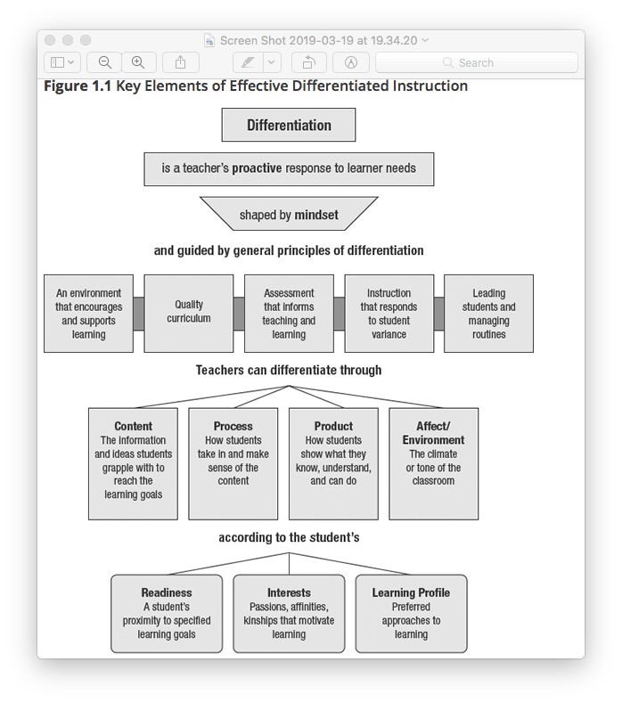

During my observation my tutor informed me that the children would have benefited from having stimulus for their writing rather than depending entirely on their memory or on my support. As Vygotsky supports this by saying “when a student is in the ZPD for a particular task, providing the appropriate assistance will give the student enough of a "boost" to achieve the task.” (McLeod/Simply Psychology/Date:2012) I will most definitely take this advice on board in order to reach my target within my next part of teaching experience. Another strategy I will use to develop my differentiation is ‘following the child’ asking them what it is they need to develop and be challenged on, I have chosen to use this strategy as Montessori says “Follow the child, they will show you what they need to do, what they need to develop in themselves and what area they need to be challenged in.” (Daily Montessori, Montessori Theory, No Date) although I believe this is a useful strategy to help me as children love to be in control of their learning, “there isn’t enough opportunity” (Locus Assignment, Advantages and disadvantages of Montessori Education, Date:2019) it will be difficult to speak to every child in the class to see what they need to be challenged with, although this is a disadvantage, I will use my observation week to do this as I believe it is important that children’s voices are heard.

In conclusion, after reflecting in depth on my teaching experience so far. I believe that I could not have got this far without reflection. Dewey says, “A real problem arises out of present experiences, suggestions for a solution come to mind, relevant data are observed, and a hypothesis is formed, acted upon, and finally tested.” (Dewey:1938) This supports the ARC models I have used during my time at PTE so far, identifying the problem, understanding why it went wrong, identifying what I will do next and most importantly testing this out to see if it works next time. This has most definitely helped me throughout my experience and will continue to do so. Although I have many targets to improve on for my next experience, differentiation is definitely one of the most important targets that I will continue to improve and gain confidence doing throughout my next placements, after reflecting on the importance of this I will definitely ensure I succeed this target.

Reference List
Daily Montessori (no date) Montessori Theory, Available at: http://www.dailymontessori.com/montessori-theory/ (Accessed 21 March 2019)

Dewey, J. (1904) The relation of theory to practice in education. In M. L. Borrowman ~Ed.!, Teacher education in America: A documentary history. New York: Teachers College Press.
DEWEY. J. 1938. Experience and Education. New York: Macmillan.

Education Wales (2009) Qualified Teacher Standards Wales 2009. Cardiff: Welsh Government.
http://www.ascd.org/publications/books/108028/chapters/Differentiation@-An-Overview.aspx (Accessed 19 March 2019)

McLeod, S. A. (2012). Zone of proximal development. Available at: https://www.simplypsychology.org/Zone-of-Proximal-Development.html (Accessed 19 March 2019)

McLeod, S. A. (2018). Lev Vygotsky. Available at: https://www.simplypsychology.org/vygotsky.htm (Accessed 11 March2019)

National Handwriting Association (2019) Why is handwriting important?, Available at: http://nha-handwriting.org.uk/handwriting/why-is-handwriting-important/ (Accessed: 19 March 2019)

Resource Ed (2018) Differentiation in the classroom - engaging different learning profiles, Available at: https://resourced.prometheanworld.com/differentiation-classroom-engaging-different-learners/ (Accessed :19 March 2019)

Tomlinson A, Moon R (2019) Differentiation: An Overview, Available at: http://www.ascd.org/publications/books/108028/chapters/Differentiation@-An-Overview.aspx (Accessed:19 March 2019)

Appendix 1
Name of Trainee: | Abigail Jones |  |  | Session ref: |  | 15/03/2019/01 |  | Date: |  | 15/03/2019 |  |  | Class: | Year 1/2 |  |  | Cynllun Ffocws y Cyfnod Sylfaen  2d
Targed(au) Hyfforddi Personol |  |  | To use effective classroom and behaviour management strategies. |  |  |  |  | Number of learners: |  |  |  | 24 | Age: | 5 - 7 |  |  | Cynllun Ffocws y Cyfnod Sylfaen  2d
Learning objectives/intentions: |  | To write a recount of something that happened. |  |  |  |  | Success Criteria |  | I can write sentences about what happened in folly farm, using connectives and in the third person and write what happened in order (Y2) |  |  |  |  | Meeting learners’ needs: |  | A greater amount of support will be given to children with a lower ability. My questions will differentiate throughout the tasks.
Introduction/plenary tasks |  |  |  |  | Main activities |  |  |  |  |  | Resources/  Key Vocabulary |  |  |  | Assessment for Learning (strategies and opportunities)
Introduction  Circle Time-  The children will form a circle on the carpet, we will talk about their visit to folly farm. Go around the circle and ask each child either;  What have you learnt?  What was your favourite part?  What was amazing? What will they always remember about the trip?  Each child will have the chance to give an answer. |  |  |  |  | Writing a recount  After sharing their ideas on the carpet, the children will be split into groups based on ability. If the children are not working with an adult, they will be working independently on drawing their favourite animal from folly farm.  Lower ability group; they will be given a template with sub headings with specific things to fill in. They will write in the past tense and in chronological order using adjectives. The teacher will work with this group with about 4 per group.  Higher ability group; Higher ability children will write straight into their books without a template, they will be provided with word cards to help them remember. They will use connectives, openers related to time, similes and preposition. |  |  |  |  |  | Resources  Recount tempate for lower ability.  Recount word cards  Colouring pencils  Favourite animal template.  Key Vocabulary  Animals  Enjoy  Learn  Folly Farm  Trip  First  Next  Then  I  They  Last |  |  |  | Key Questions  What was your favourite part about folly farm?  What did you enjoy the most?  What did you learn?  Are all children engaged?  Think, Pair, Share – tell their partner their idea to ensure everyone has an answer, and for children who don’t understand their friend may explain it in a different way.  Lolli-pop sticks – this method ensures all children are engaged and listening, as they don’t know if they are going to be chosen or not.
Additional adult tasks (purpose, outline of additional adults’ role and children’s learning):

The additional adult will work with a group, providing support and ensuring they are all on task.
Plenary |  |  |  |  | Independent learning opportunities:  There will be a task for children to do if they are not working, they will be provided with a sheet titled ‘my favourite animal from folly farm’ it will then be up to them to draw, colour and name the animal neatly and independently.
Curriculum coverage (range and skills)
Knowledge and Understanding of the World
Range
- Participate in different types of play including those that build on past experiences.
- Sequence events.
- Identify some animals and plants that live in the outdoor environment.
Skills
- Expressing their opinions and feelings.
- Reflecting and evaluating their own works.
- Listening to others ideas.
Literacy (LNF)  - Use some ordering words e.g. first, then.  - Use ordering words e.g. first, next, then, lastly. (Y2)  - Use specific words which relate to the topic of their writing.  - Organise writing with a beginning, middle and end. (Y2)  - Follow a form modelled by the teacher.  - Re-read and improve their writing to ensure that it makes sense. (Y2) |  |  |  |  |  |  |  |  |  |  | Numeracy (LNF)
DCF |  |  |  |  | Thinking  The children will need to think about what they can remember from folly farm, thinking about what order things happened in and how to write them in full sentences that make sense. |  |  |  |  |  | ESDGC |  |  |  | YCC  Incidental welsh will be used throughout the lesson.

Appendix 2

Model Beirniadau Wedi Adfyfyrio (BWA)

Assisted Reflective Conclusions (ARC) Model
Dyddiad/Date:15/03/19
Digwyddiad critigol (Ffocws)/Critical incident (focus): Recount – whole class teaching.

Profiad/ Experience

Teimladau/  Feelings  Beth yw eich teimladau ynghylch y profiad?  What are your feelings regarding the experience? | I felt happy that I worked through every member within the class in ability groups. However, I feel I didn’t plan the lesson effectively as the children weren’t as engaged as I hoped they would be.
Cofio a Deall/  Remember and Understand  Allwch chi restru’r agweddau ar y profiad dysgu a aeth yn dda?  Can you list the aspects of the learning experience that went well?  Pa elfennau o'r profiad dysgu oedd yn siomedig?  What were the elements of the  learning experience that were disappointing? | - Majority of children listened  - During circle time, every child contributed.  - Every child completed their work to a high standard.  Elements of the learning experience that were disappointing;  - Distraction from some children on the carpet.  - Didn’t plan the hook to the lesson effectively, so not everyone was engaged,  - The transition between groups was slow, due to children being in different classes completing other work.  The main element of today’s disappointing experience was the engagement of the children. I believe I didn’t hook the children at the beginning of the lesson and therefore they weren’t as engaged as I hoped.
Gwerthuso a dadansoddi/  Evaluate and analyse  Beth fyddwch chi'n cadw'r un fath i sicrhau dysgu ac addysgu effeithiol yn y dyfodol?  What will you keep the same to ensure effective teaching and learning in the future?  Beth oedd achos yr elfen siomedig bwysicaf?  What was the cause of the most important disappointing element? | An example of effective teaching and learning in today’s session would be the differentiation. I believe I planned for this effectively and the outcome was good. The majority of the children met the learning objectives, also many children worked above the objectives.  Something that may have been seen as disappointing, was the fact children were unable to work independently. The lower ability group needed my full support, and during circle time the children needed my support to remember what happened during the trip to folly farm which they were writing about. Also, I provided a success criteria ladder for the children which they could use whilst doing their work, however I made the mistake of forgetting to hand this out to them before they started.  Another issue which arose was the lack of resources available. I had not set out my resources properly which resulted in time taken to get everything I needed, and get the children settled down.
Casgliadau a chamau gweithredu/  Conclusions and actions  Beth yw eich atebion posibl i'r materion siomedig a nodwyd?  What are your possible solutions to the disappointing issues identified?  Beth ydych yn mynd i’w wneud nesaf?  What will you do next? | The most important issue to address would be the engagement of the children in today’s session. To solve this issue, I would consider putting pictures of folly farm on the board first to jog the children’s memories of what happened during the trip and what they saw. I believe this would excite the children and they would be more excited to answer the questions I had and also to write about them.  One individual in particular needed one to one support to complete the recount. First, I had this individual working in a small group, however he was struggling to keep up with the pace, so I gave him another activity to complete until I got the chance to work with him one to one. This worked really well as he was able to complete the task to a high standard when I worked with him.  Next, to create a more effective learning experience I would ensure my planning was suited to all children in the class, providing word mats suited to the task, with common words and phrases they needed, to extend their learning and encourage them to work without as much support.
Y profiad newydd / Transformed experience

