Ahmed Youssouf Assiata (2407208)
[Email address]
Module code: ACCA5019
Lecture: DR Mobolanle Bello
Submission deadline: 23rd October 2026

Component 1 website redisigne for online business presence
Business and Web management

Contents
1.0 INTRODUCTION 2
2.0 WELLCARE CONNECT WEBSITE REDESIGN 2
2.1 Confusing Navigation 2
2.2 Poor Mobile Responsiveness 3
2.3 Outdated Visual Design 3
2.4 Difficult Appointment Booking 3
2.5 Limited Accessibility 4
2.6 Important Information Is Difficult to Find 4
2.7 Slow Loading Times 4
2.8 Weak Call-to-Action Buttons 5
2.9 Lack of Personalised Services 5
2.10 Trust and Security 5
3.0 RESPONSIVE DESIGN IMPLEMENTATION 5
Implications of Responsive Design in E-Commerce Websites for Improving User Experience 6
Implications of Responsive Design in E-Commerce Websites for Increasing Mobile Sales 6
4.0 Implementation section 7
4.1 MOODBOARD AND WIREFRAME DESIGN 15
5.0 CONCLUSION 17
REFERENCES 18

1.0 INTRODUCTION
This report explains the design of a new website for WellCare Connect, an online healthcare service. The main purpose of the project is to improve the current website and make it easier for patients to use. The new design will help patients find important services such as booking appointments, having online consultations, viewing medical records and accessing prescriptions.
The report covers the main stages of the UI/UX design process. First, a mood board is created to choose the colours, fonts, images and overall style of the website. Next, wireframes are created to plan the layout and position of the main information and buttons. Finally, I design an interactive prototype using Inkscape. The prototype includes five main pages: Homepage, Services, About Us, Contact Us, and Book Appointment.
The five pages are connected so that users can move from one page to another by clicking buttons or navigation links. The design focuses on making the website simple, clear and easy to understand. It also considers accessibility, mobile users and patient needs. This report explains the design choices and shows how the new website can provide a better experience for WellCare Connect patients.

2.0 WELLCARE CONNECT WEBSITE REDESIGN
The current WellCare Connect website has several issues that can make it difficult for patients to use. The redesign will focus on making the website simple, clear, accessible, secure and easy to navigate. Good UI/UX design should help users understand what is happening and allow them to complete tasks without unnecessary difficulty [1].

2.1 Confusing Navigation
The current website has confusing navigation. Patients may find it difficult to locate important services such as appointment booking, health records, virtual consultations and specialist information. If users cannot easily find what they need, they may become frustrated and leave the website.
The new website will have a simple navigation bar at the top of every page. It will include Home, Services, About Us, Contact Us, and Book Appointment. Important services will also be available as large buttons on the homepage. Consistent navigation helps users understand where they are and what they can do next [2].

2.2 Poor Mobile Responsiveness
The current website does not work well on mobile devices. Text, buttons and other information may be difficult to see or use on a small screen. This is a problem because patients may access healthcare services using smartphones or tablets.
The redesigned website will use a responsive layout. The content will adjust to different screen sizes, including computers, tablets and smartphones. Buttons will be large enough to select easily, and important information will remain visible on smaller screens. Accessibility guidelines also recommend that websites work across different devices [3].

2.3 Outdated Visual Design
The current website has an outdated appearance and does not have a strong and consistent visual style. Different colours, fonts or layouts can make a website look less organised.
The new design will use a consistent colour scheme based on blue, teal and white. These colours will be used throughout the five prototype pages. The same font styles, buttons, icons and page layouts will also be used. This will create a consistent brand identity and make the website easier to understand.

2.4 Difficult Appointment Booking
Booking an appointment is an important healthcare task, but the current process is unclear. Patients may have difficulty finding a doctor, choosing a date or selecting an available time.
The new appointment page will use a simple step-by-step process. The patient will select the service, doctor, date and time. A clear “Confirm Appointment” button will then complete the process. The page will also show the user’s selections clearly before confirmation. This gives users more control and helps prevent mistakes [4].

2.5 Limited Accessibility
Some patients may have difficulty using the website because of small text, poor colour contrast or unclear buttons. People with visual, physical or cognitive disabilities may require additional support.
The redesigned website will use clear text, suitable font sizes, strong colour contrast and clearly labelled buttons. Important information will not rely only on colour. The design will follow the principles of WCAG 2.2, which provides recommendations for making websites accessible to people with different disabilities [5]. For example, WCAG recommends a minimum contrast ratio of 4.5:1 for normal text [6].

2.6 Important Information Is Difficult to Find
Patients may have difficulty finding important services such as emergency contacts, specialist directories, virtual consultations and prescriptions.
The homepage will provide quick-access buttons for the most important services. For example, users will be able to select Book Appointment, Virtual Consultation, Prescriptions and Health Records. Emergency information and specialist services will also have clear links. This reduces the amount of searching required by the patient.

2.7 Slow Loading Times
The current website may take too long to load. Slow websites can negatively affect the user experience and may cause users to leave before completing a task [6].
The redesigned website should use optimised images and avoid unnecessary animations and large files. The website should also be tested using performance tools. Google identifies loading performance, responsiveness and visual stability as important aspects of web performance [7].

2.8 Weak Call-to-Action Buttons
The current website does not always make it clear what the patient should do next. Important actions may be difficult to notice.
The redesign will use clear call-to-action buttons such as “Book an Appointment,” “Start Consultation,” “View Health Records” and “Get Prescription.” These buttons will be placed where users can easily see them. Clear feedback and visible actions help users understand the next step [8].

2.9 Lack of Personalised Services
The current platform does not provide enough personalised information based on the patient’s activities. Patients may not receive useful reminders about appointments, medication or health checks.
A Personalised Dashboard will be added to the new design. It will show information such as upcoming appointments, medication reminders and health tips. This will give patients quick access to information that is relevant to them.

2.10 Trust and Security
Healthcare websites deal with sensitive personal information. If patients do not understand how their information is protected, they may be less confident using online healthcare services.
The redesigned website will include clear information about privacy, security and how patient information is handled. Secure login and clear privacy information should be included. NIST highlights confidentiality, integrity and availability as important security considerations for health information technology [9].

3.0 RESPONSIVE DESIGN IMPLEMENTATION
Responsive design is a web design approach that allows a website to automatically change its layout to fit different screen sizes. This means that a website can work correctly on desktop computers, tablets and mobile phones. Responsive design uses flexible layouts, images and CSS media queries to make sure that content remains easy to read and use on different devices [5]. A responsive website can change from a multi-column layout on a desktop to a single-column layout on a mobile phone.

Implications of Responsive Design in E-Commerce Websites for Improving User Experience
Because many customers explore and buy products on their mobile devices, responsive design is critical for e-commerce websites. If an e-commerce website is not responsive, consumers may need to zoom in, scroll left to right, or struggle to click small buttons. This can make the website difficult and aggravating to use. Responsive design aims to avoid these issues by adjusting the size and positioning of website elements to match the user's screen [10].
Responsive design can also help improve website navigation. A desktop website, for example, may have multiple navigation options across the top of the page, whereas a mobile version may only have one menu button. Product photos, text, buttons, and forms can be adjusted or changed to fit smaller screens. This provides a more consistent experience for users as they switch between devices [10].
The checkout page is very crucial for an online store. Clients must input details including their name, address, and payment information. Customers can leave before finishing their purchase if the form is challenging to use on a mobile device. Mobile e-commerce websites have numerous usability issues, such as issues with forms, navigation, and checkout procedures, according to research by Baymard [11]. Consequently, responsive design can facilitate and ease the purchasing process.

Implications of Responsive Design in E-Commerce Websites for Increasing Mobile Sales
Responsive design can help e-commerce businesses increase mobile sales by making it easier for customers to browse products and complete purchases on their smartphones. A clear product page should show the product image, price, description and purchase button in a way that is easy to see on a small screen.
The checkout process should also be simple. Large buttons, clear labels, fewer unnecessary fields and easy-to-use payment options can reduce difficulties for mobile users. Baymard’s research shows that a poor checkout experience can cause customers to abandon their purchases [3]. This means that improving the mobile checkout experience can help reduce barriers to completing a sale.
Overall, responsive design improves an e-commerce website’s usability by making it easier to navigate, read information, and complete purchases across devices. For businesses, this can improve customer experience and create more opportunities for customers to complete purchases on mobile devices [11].

4.0 Implementation section
Moodboard Screenshot
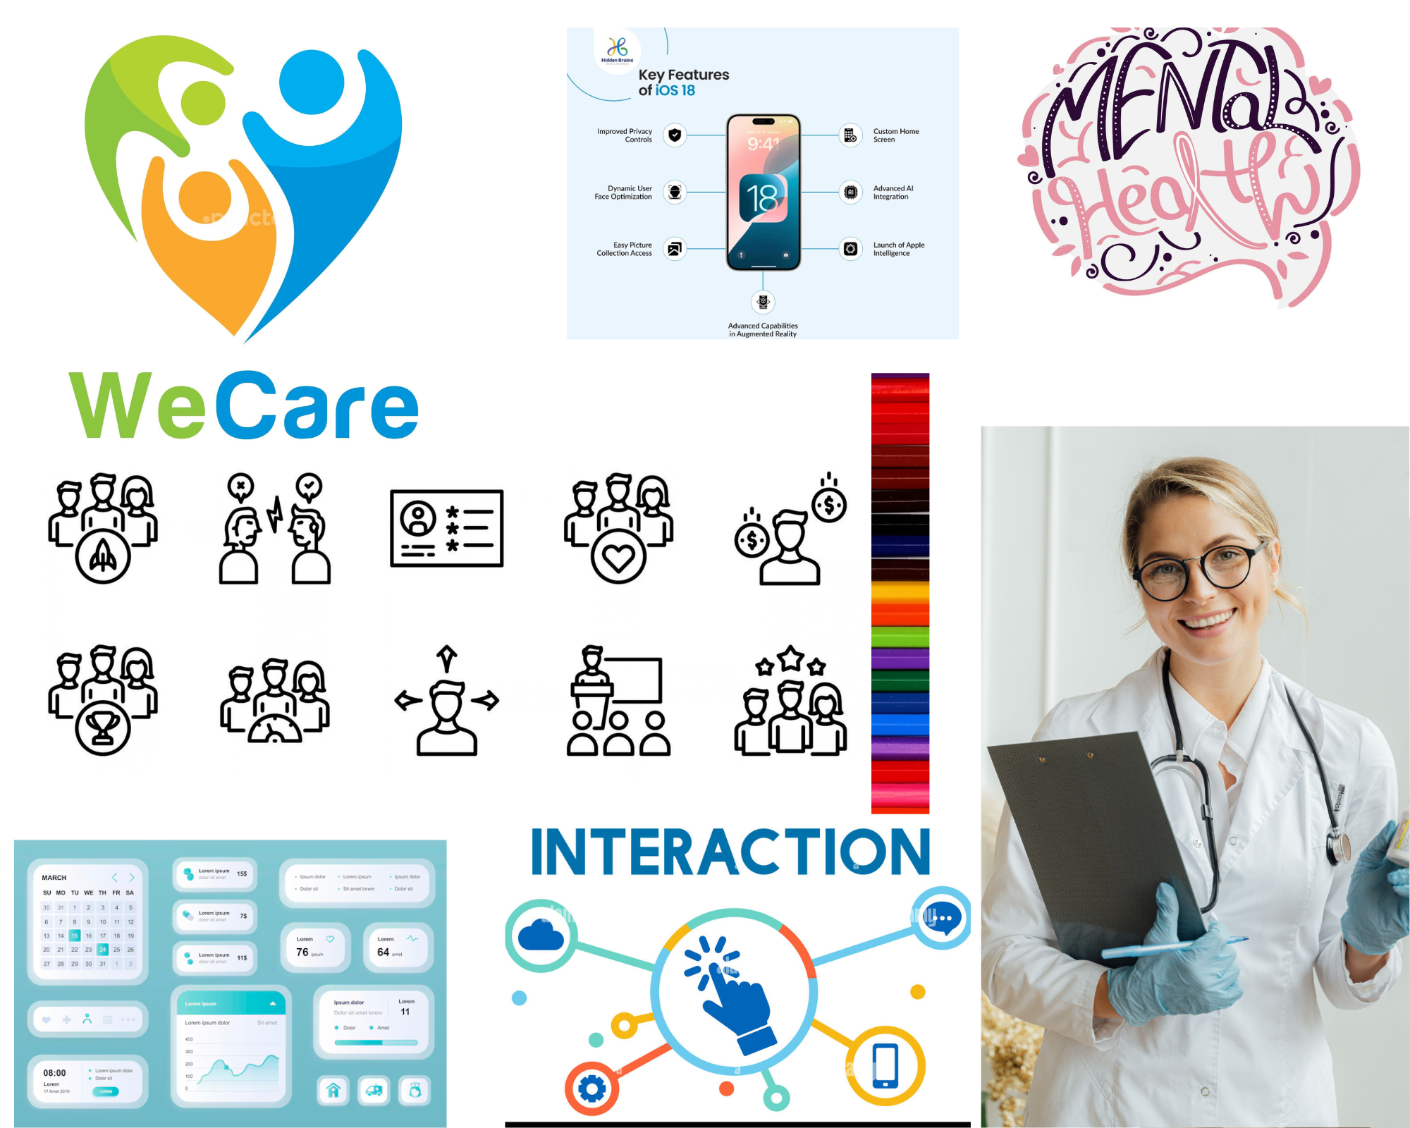

Wireframe Screenshots Page1
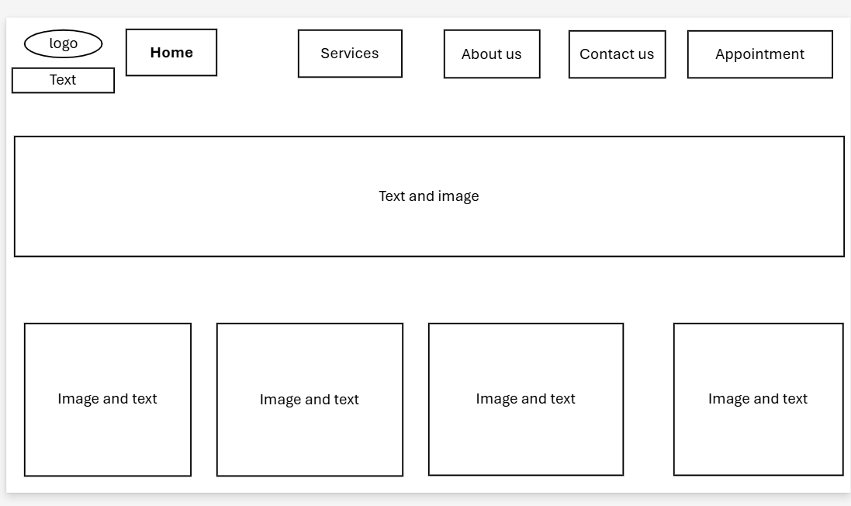

Wireframe Screenshots Page 2
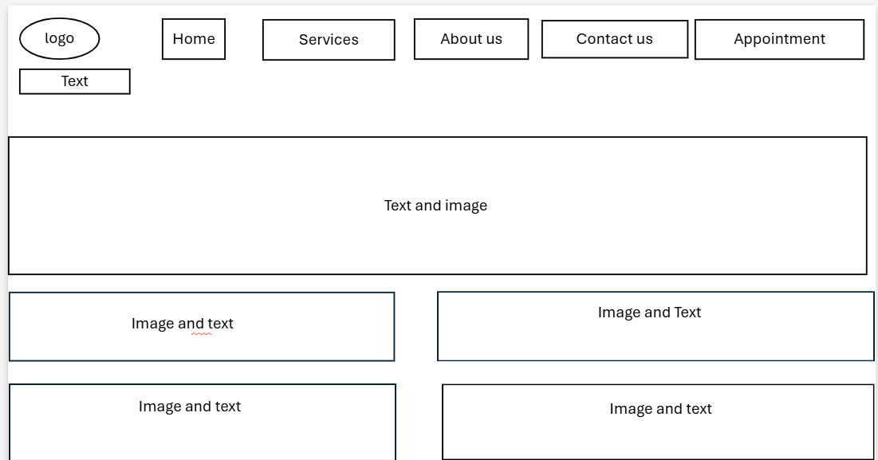

Wireframe Screenshots Page 3
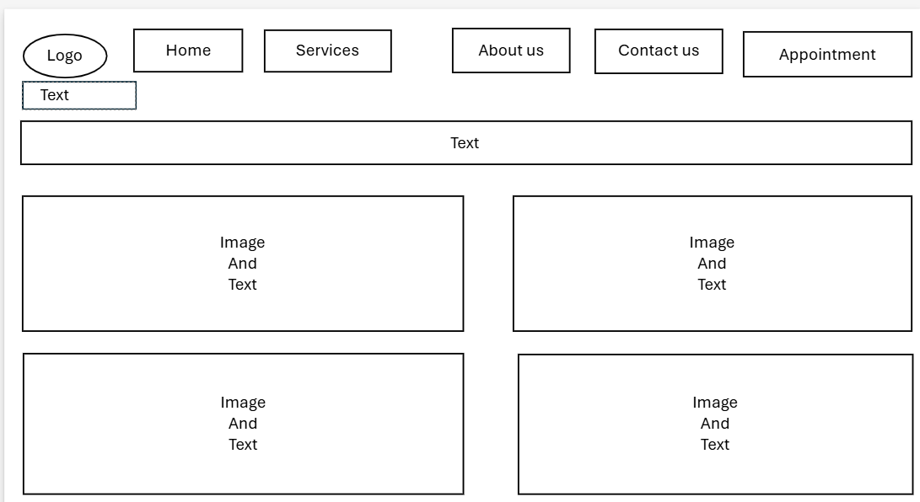

Wireframe screenshots Page 3
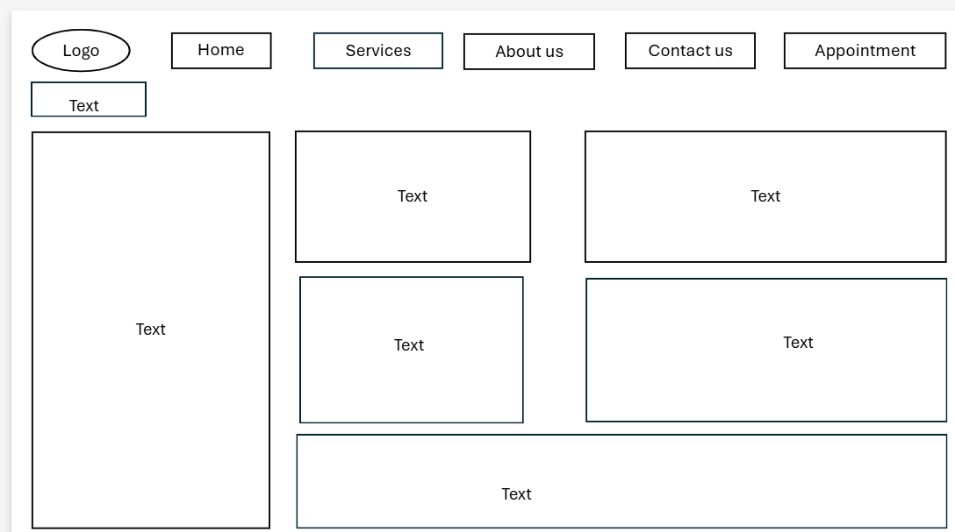

Wireframe Screenshot Page 4
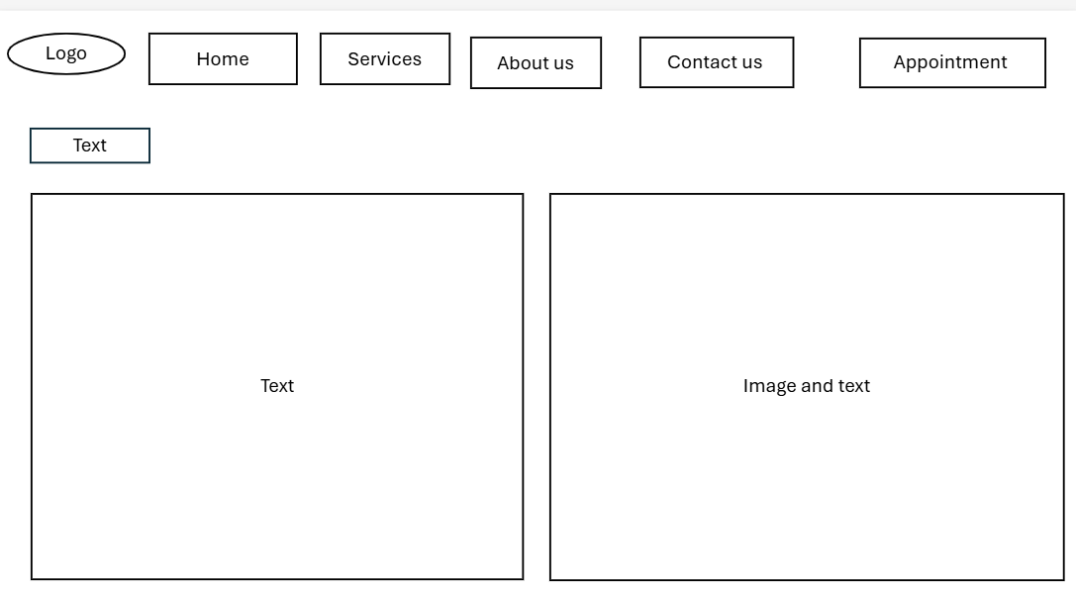

Web design Page 1:
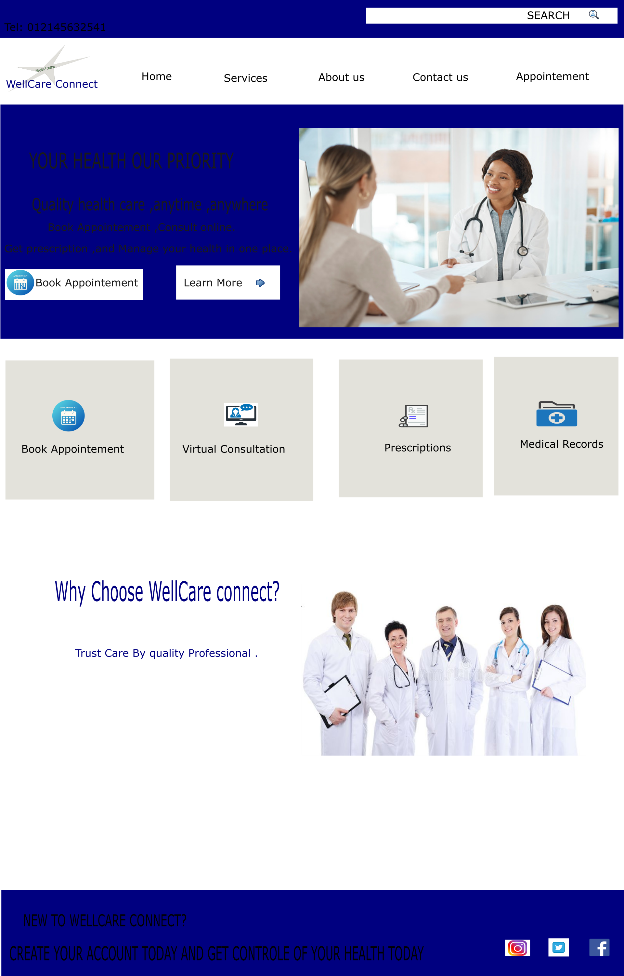

Web design page 2
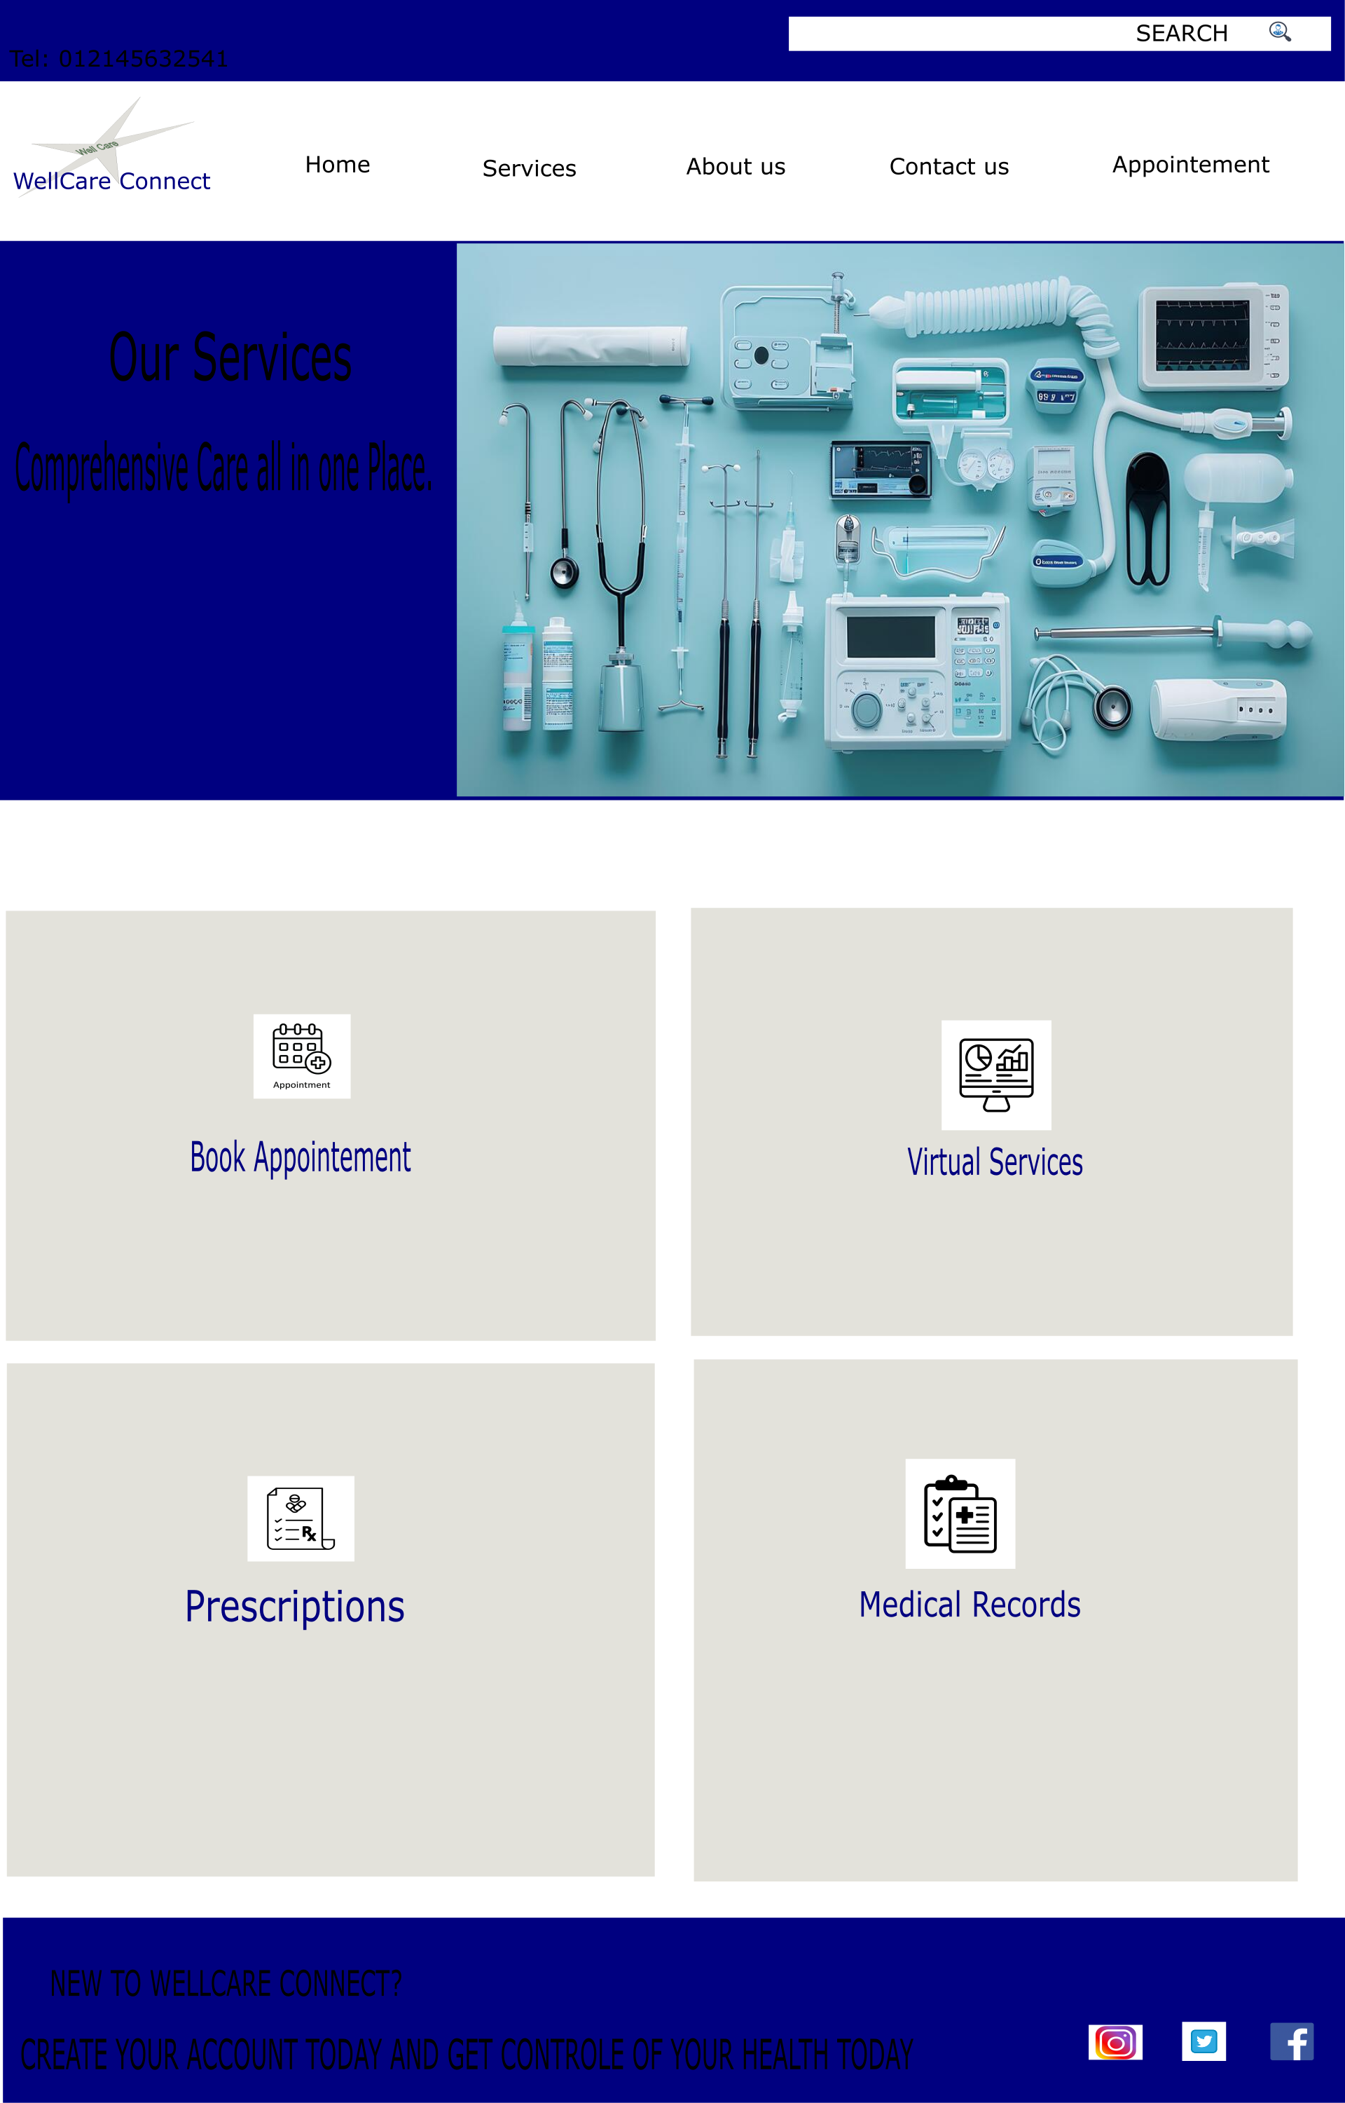

Web design Page 3
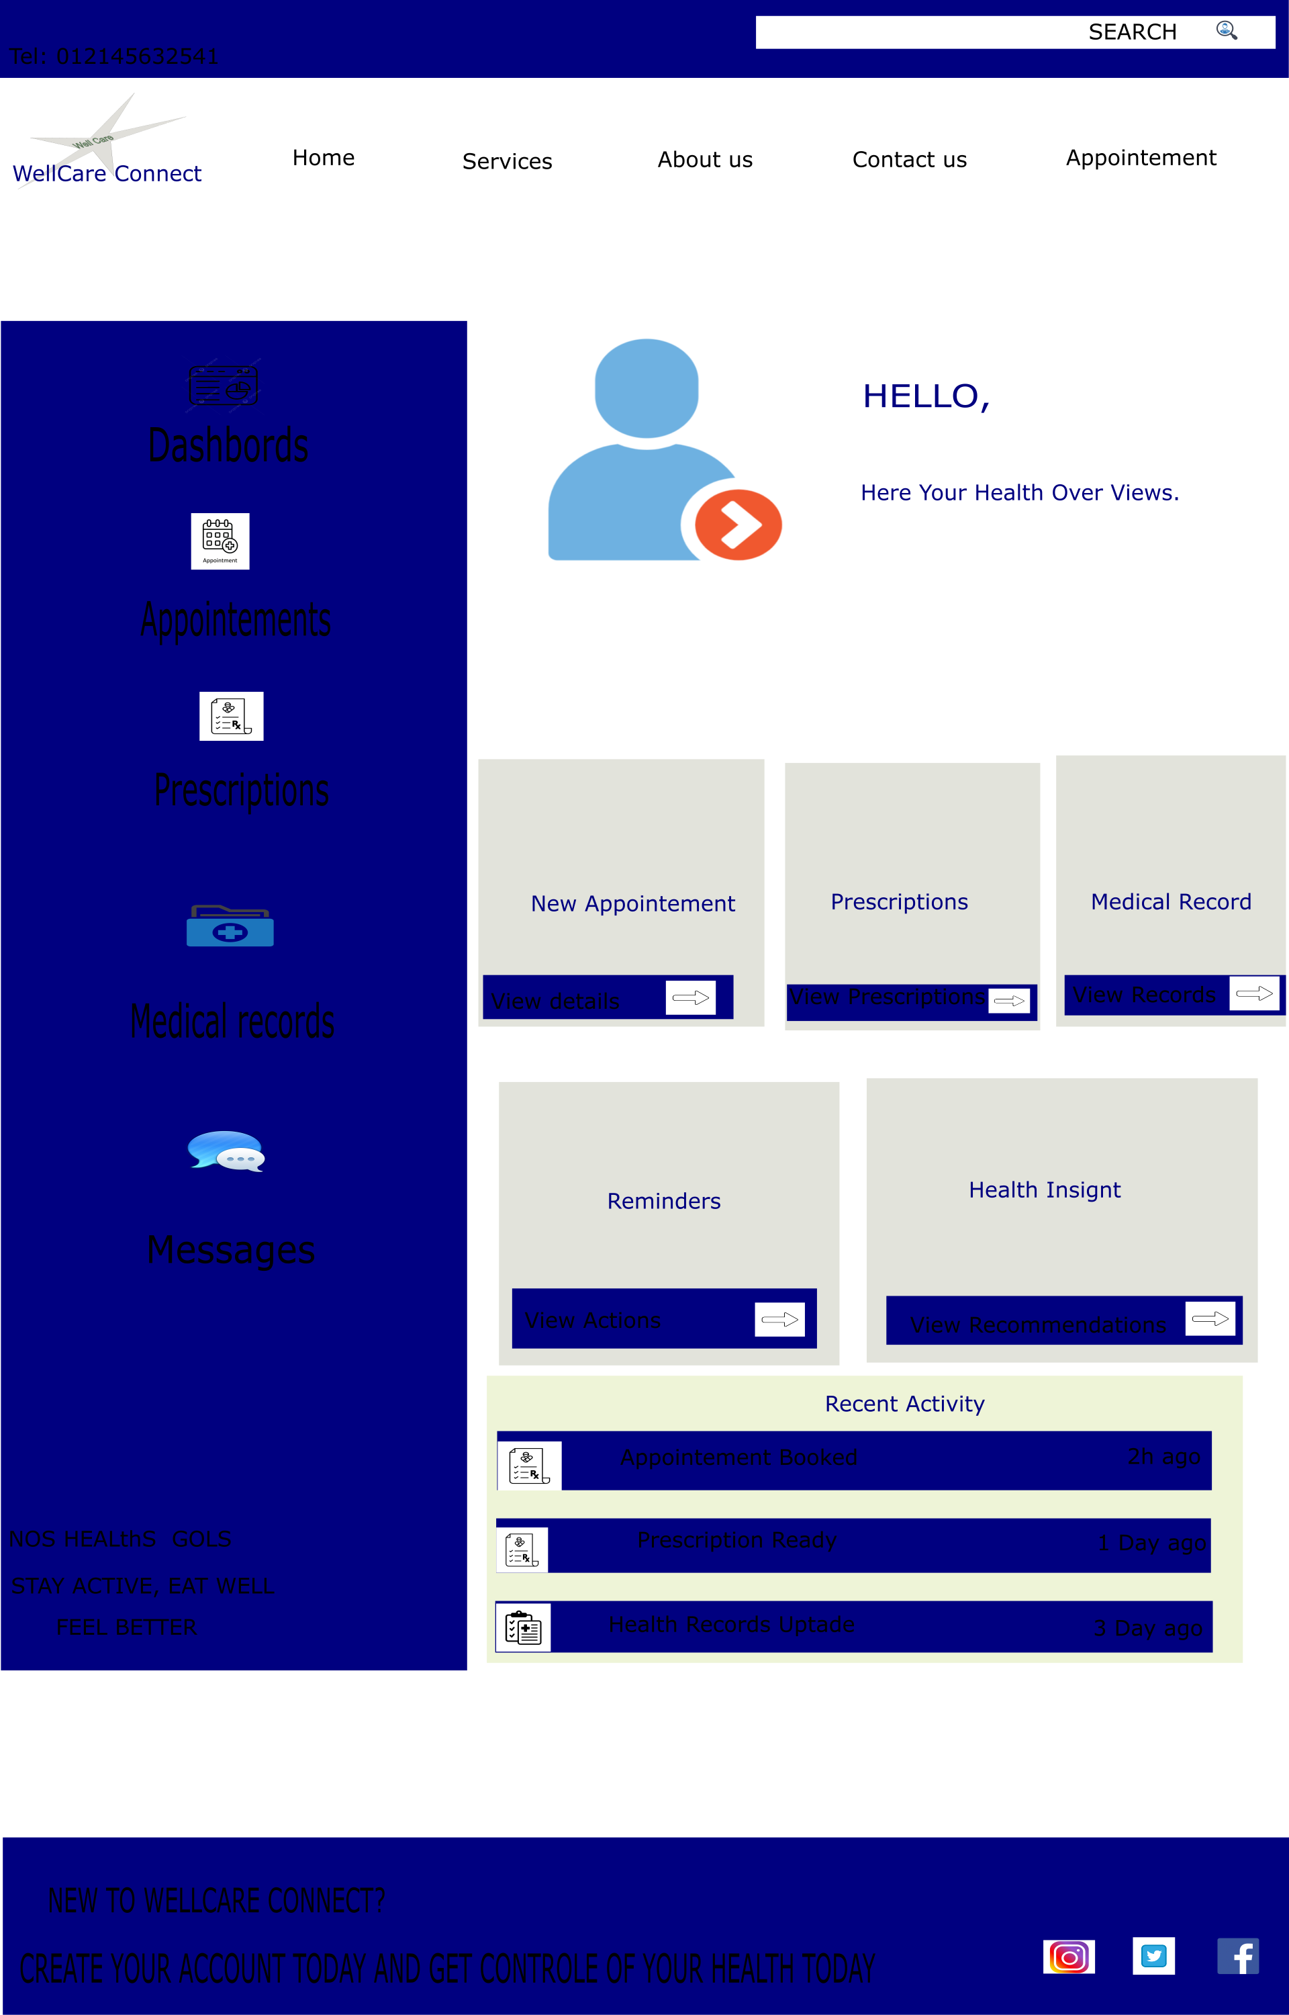

Web design Page 4
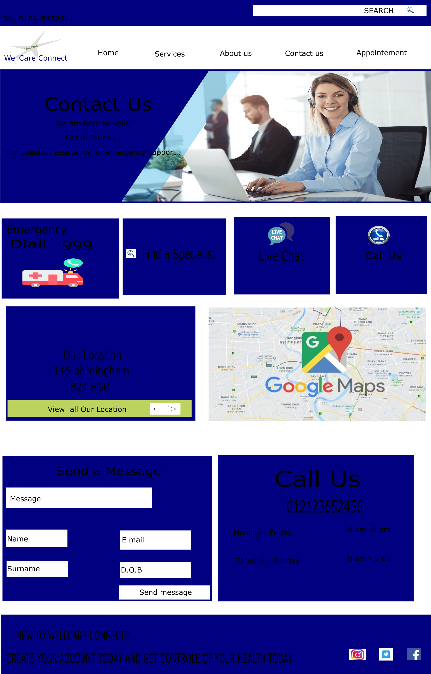

Web design Page 5
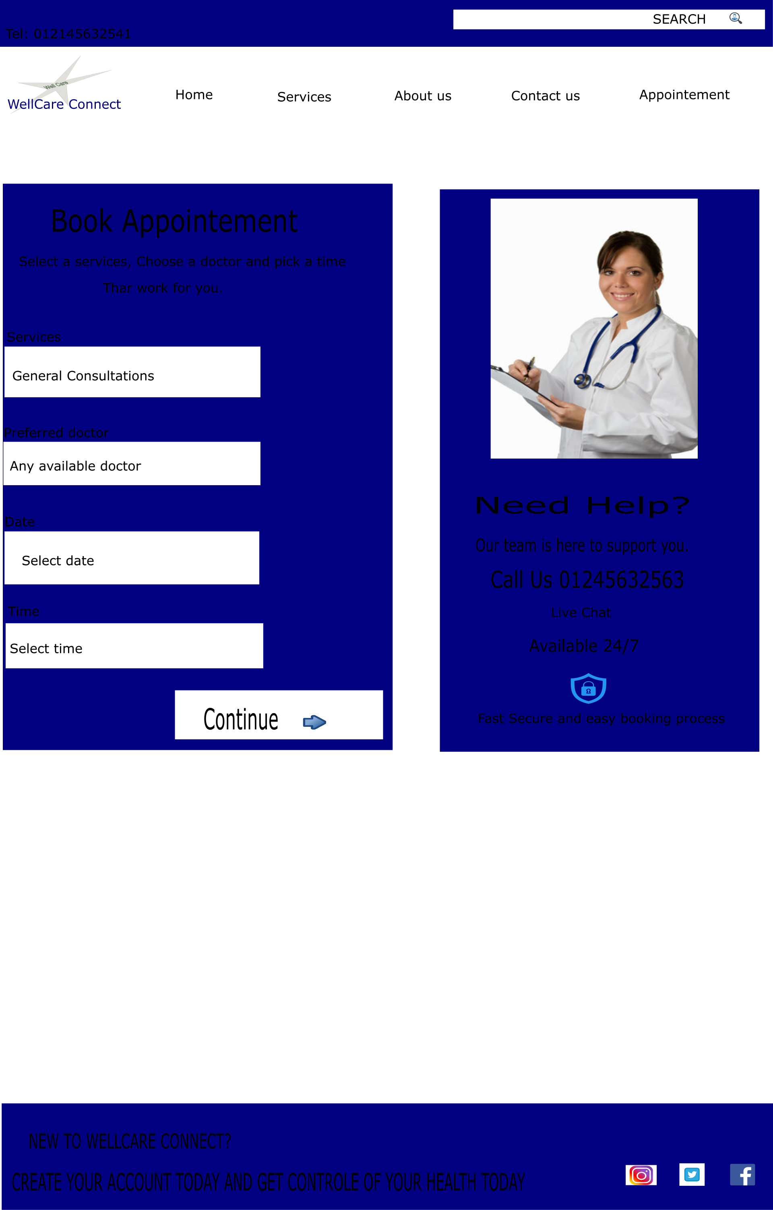

4.1 MOODBOARD AND WIREFRAME DESIGN
Moodboard
A moodboard is a collection of visual elements such as colours, images, fonts, icons and design styles that are used to show the overall look and feeling of a design. It helps designers decide the visual direction of a website before creating the final design [12].
For the WellCare Connect website, the moodboard uses a healthcare style with blue, teal and white colours, simple medical images and clear typography. These elements are chosen to create a clean, calm and professional appearance.
The moodboard influenced the design by helping me keep the same colours, fonts and visual style throughout the website. For example, I used blue and teal for buttons, headings and important features because these colours can help create a professional healthcare appearance. also used simple medical icons and images to make the website easy to understand. Using the moodboard as a guide helps make all five pages look consistent and connected rather than looking like separate websites. Moodboards can help designers communicate the visual direction of a project and maintain consistency across different design elements [12].
Wireframe
A wireframe is a simple visual plan or basic layout of a website that shows where important elements such as navigation, buttons, images, text and content will be placed. It focuses mainly on the structure and functionality of a page rather than detailed colours and visual design [13].
For the WellCare Connect website, wireframes were created to plan the layout of the five main pages: Homepage, Appointment Booking, Health Records, Virtual Consultation and Personalised Dashboard. The wireframes show where the navigation menu, headings, buttons, information boxes and other important features will be placed.
The wireframes influenced my design by helping me organise the information before creating the final prototype. For example, the Homepage was planned with the main navigation at the top, an appointment button in a clear position and service boxes underneath. The Appointment Booking page was planned with simple steps for selecting a service, doctor, date and time. This makes the website easier for users to understand and navigate.
Wireframes also helped identify possible usability problems before developing the final prototype. They provide a basic structure that allows designers to check the layout and user flow and make changes before adding detailed visual design [14]. Therefore, the moodboard influenced the visual appearance of WellCare Connect, while the wireframe influenced the layout, structure and navigation of the website.

5.0 CONCLUSION
This project provided an opportunity to develop a new UI/UX design for the WellCare Connect website. The main aim was to improve the usability, accessibility, appearance and overall user experience of the healthcare platform. The design process showed that creating a successful website requires more than just making a website look attractive. It is important to understand users' needs and organise information clearly and simply.
The moodboard helped establish the visual style of WellCare Connect. The use of blue, teal and white colours, clear fonts and simple healthcare icons helped create a professional, clean and trustworthy appearance. The wireframes were then used to plan the structure and layout of the main pages before creating the interactive prototype.
The five-page prototype included the Homepage, Services, About Us, Contact Us, and Book Appointment. Connecting these pages showed how users could move through the website and access key healthcare services. The design also included clear buttons and navigation to make the user journey easier.
Overall, the project demonstrated the importance of following a structured UI/UX design process. Moodboards, wireframes, and prototypes helped develop a consistent, user-friendly design that supports WellCare Connect’s business needs. The final design aims to improve patient engagement, accessibility, trust and convenience while providing a modern healthcare experience.

REFERENCES

[1] D. Benyon, Designing User Experience: A Guide to HCI, UX and Interaction Design, 4th ed. Harlow, U.K.: Pearson, 2019. (Pearson)

[2] N. Alajarmeh, “Evaluating the accessibility of public health websites: An exploratory cross-country study,” Universal Access in the Information Society, vol. 21, no. 3, pp. 771–789, 2022, doi: 10.1007/s10209-020-00788-7. (DOI)

[3] M. Hertzum, Usability Testing: A Practitioner’s Guide to Evaluating the User Experience. Cham, Switzerland: Springer, 2020/2022. doi: 10.1007/978-3-031-02227-2. (Springer)

[4] A. Marcus and E. Rosenzweig, Eds., Design, User Experience, and Usability: Design for Contemporary Interactive Environments, DUXU 2020, Lecture Notes in Computer Science, vol. 12201. Cham, Switzerland: Springer, 2020. doi: 10.1007/978-3-030-49760-6. (Springer)

[5] A. Marcus and E. Rosenzweig, Eds., Design, User Experience, and Usability: Interaction Design, DUXU 2020, Lecture Notes in Computer Science, vol. 12200. Cham, Switzerland: Springer, 2020. doi: 10.1007/978-3-030-49713-2. (Springer)

[6] M. M. Soares, E. Rosenzweig, and A. Marcus, Eds., Design, User Experience, and Usability: Design for Emotion, Well-being and Health, Learning, and Culture, DUXU 2022, Lecture Notes in Computer Science, vol. 13322. Cham, Switzerland: Springer, 2022. doi: 10.1007/978-3-031-05900-1. (Springer)

[7] B. A. Kumar, “Mobile-first usability guideline for responsive e-commerce websites,” International Journal of Web Portals, vol. 14, no. 1, pp. 1–12, 2022, doi: 10.4018/IJWP.310060. (ScienceDirect)

[8] B. Luceri, T. H. A. Bijmolt, S. Bellini, and S. Aiolfi, “What drives consumers to shop on mobile devices? Insights from a meta-analysis,” Journal of Retailing, vol. 98, no. 1, pp. 178–196, 2022, doi: 10.1016/j.jretai.2022.02.002. (ScienceDirect)

[9] M. A. de la Cruz, et al., “From e-commerce to m-commerce: An analysis of the user’s experience with different access platforms,” Electronic Commerce Research and Applications, vol. 58, 101240, 2023, doi: 10.1016/j.elerap.2023.101240. (ScienceDirect)

[10] B. A. Kumar, “Mobile-first usability guideline for responsive e-commerce websites,” International Journal of Web Portals, vol. 14, no. 1, pp. 1–12, 2022, doi: 10.4018/IJWP.310060. (IGI Global)

[11] J. L. Campbell and H. Monkman, “The application of a novel, context-specific, remote, usability assessment tool to conduct a pre-redesign and post-redesign usability comparison of a telemedicine website,” Studies in Health Technology and Informatics, vol. 281, pp. 911–915, 2021, doi: 10.3233/SHTI210311. (PubMed)

[12] R. N. Aldekhyyel, J. A. Almulhem, and S. Binkheder, “Usability of telemedicine mobile applications during COVID-19 in Saudi Arabia: A heuristic evaluation of patient user interfaces,” Healthcare, vol. 9, no. 11, p. 1574, 2021, doi: 10.3390/healthcare9111574. (PubMed)

[13] J. L. Campbell and H. Monkman, “Pre- and post-redesign usability assessment of a telemedicine interface based on subjective metrics,” Studies in Health Technology and Informatics, vol. 290, pp. 872–876, 2022, doi: 10.3233/SHTI220204. (PubMed)

[14] J. Gille, S. Smith, and N. Mays, “What is public trust in the healthcare system? A new conceptual framework developed from qualitative data in England,” Social Theory & Health, vol. 19, pp. 1–20, 2021, doi: 10.1057/s41285-020-00129-x. (DOI)

