Connor Daniel
Gower College Swansea

electrical principles theory
HND Electrical and Electronic Engineering

Table of Contents
Task 1 2
Task 2 3
Task 3 4
Task 4 8
References 11

Task 1
- Write down an explanation for how one might differentiate simple periodic, complex periodic, impulse and noise waveforms by their shape.

The simple periodic waveform will represent one harmonic and will show a sine wave. The sine wave shows the maximum and minimum value alternating over a period of time. This period of time is usually measured in seconds and shows how long it takes for the wave to complete on of its cycles a sine wave is shown below. (Electronincs tutorial, n.d.)

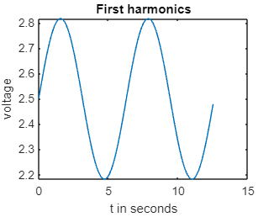
Figure 1- simple periodic waveform
The complex waveform is a combination of multiple harmonics. There are different types of complex waveforms which you can identify by the different shapes they make. For example the square and saw tooth waveforms. A square waveform is made up of only odd harmonics and is identified as it looks like a square. The saw tooth waveform is made up of both odd and even harmonics and can be identified by its saw tooth like shape. The triangular waveform also consists of only odd harmonics however, each harmonic is in the opposite phase to the previous harmonic. These three wave forms are shown below. (Learnabout Electronics, n.d.)

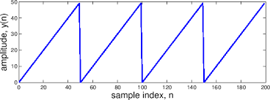
Figure 2- saw tooth waveform

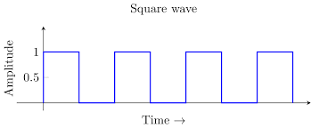
Figure 3- square waveform
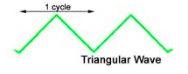
Figure 4 - triangular waveform
The impulse waveform shows a spike at the range of a certain frequency this is shown below
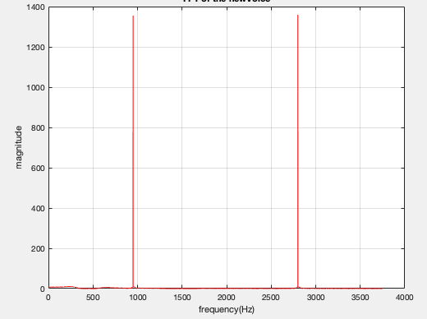
Figure 5 - impulse waveform
A noise waveform is one the does not have a reoccurring amplitude pattern. This means it is a non-periodic waveform as it does not have a repeating single cycle this is shown below. (Hulse, n.d.)

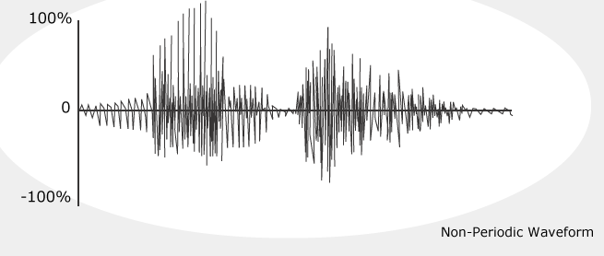
Figure 6 - Noise waveform

- Define Fourier series and Fourier Transform. Explain the importance of Fourier Transform in the field of engineering.

The Fourier series is a mathematical method of decomposing a periodic signal in to a sum of sin and cosine terms. The Fourier transform is a method of converting a signal from its time domain in to a representation of the signal in the frequency domain. (Panigrahi, 2022)

The Fourier transform is very important within the field of engineering this due to the fact it allows you to analyse what sine waves make up a signal. This mathematical ability transcends in to multiple engineering fields.

- Discuss the limitations of using an FFT.

The limitations of using an FFT comes from the restricted range of data that is possible to transform. Another limitation is the need for a window weighing function to be applied due to the need to compensate for spectral leakage. (Dataq Instruments, n.d.)

- Write out definitions in your own words of the terms fundamental frequency, harmonic and spectrum.

Fundamental frequency is the 1st harmonic that is produced from the harmonic series.

Harmonics are whole number multiples of the fundamental frequency for example if the fundamental frequency was at 50 Hz we would see the second harmonic at 100 Hz and the third are harmonic at 150 Hz. (Gowda, 2020)

This is shown below:
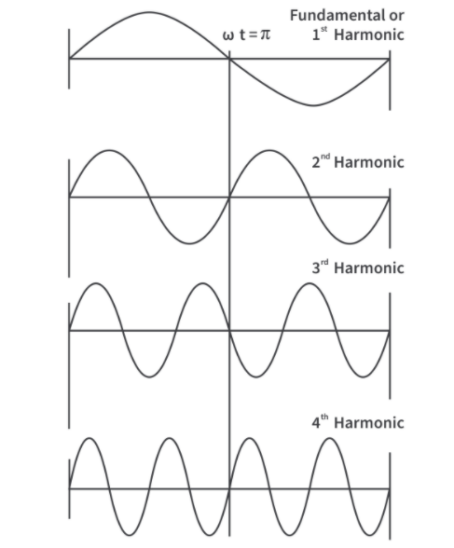
Figure 7- Fundamental frequency and harmonics
The term spectrum refers to the signals magnitude and phase characteristics as a function of frequency.

- Explain the amplitude relationship of the harmonics in triangular, sawtooth and square waveform.

The amplitude of a triangular waveform has the ratio 1/the harmonic number squared this means that the first harmonic will be 1/1 therefore being 1, the third harmonic will be 1/9 and so on.

The amplitude of the saw tooth waveform has the ratio 1/the harmonic number this means the first harmonic will be 1/1, the second will be 1/2, the third will be 1/3 and so on.

The amplitude of the square waveform has the ratio 1/ the harmonic number the same as the sawtooth waveform however, the square waveform only consists of odd harmonics so the three harmonics would be 1/1, 1/3 and 1/5.

Task 2
Computing and plotting a sawtooth wave using MATLAB

%Task 2 Electrical principles assignment
a0 = 5;
W = 1; %Omega (angular frequency)
t = 0 : 0.1 : 4*pi; % time span from 0 in increments of 0.1 to 4*pi(12.6)

%First harmonics
y = a0/2 + 1/pi * sin(W*t);
subplot(2,2,1);%2 columns 2 rows position 1
plot (t,y);
xlabel('t in seconds');
ylabel('voltage');
title('First harmonics');

%Three haronics
y = a0/2 + 1/pi * sin(W*t) + 1/(2*pi) * sin(2*W*t) + 1/(3*pi) * sin(3*W*t);
subplot(2,2,2);
plot (t,y);
xlabel('t in seconds');
ylabel('voltage');
title ('Three harmonics');

%Five haronics
y = a0/2 + 1/pi * sin(W*t) + 1/(2*pi) * sin(2*W*t) + 1/(3*pi) * sin(3*W*t) + 1/(4*pi) * sin(4*W*t) + 1/(5*pi) * sin(5*W*t);
subplot(2,2,3);
plot (t,y);
xlabel('t in seconds');
ylabel('voltage');
title ('Five harmonics');

%Ten haronics
y = a0/2 + 1/pi * sin(W*t) + 1/(2*pi) * sin(2*W*t) + 1/(3*pi) * sin(3*W*t) + 1/(4*pi) * sin(4*W*t) + 1/(5*pi) * sin(5*W*t) + 1/(6*pi) * sin(6*W*t) + 1/(7*pi) * sin(7*W*t) + 1/(8*pi) * sin(8*W*t) + 1/(9*pi) * sin(9*W*t) + 1/(10*pi) * sin(10*W*t);
subplot(2,2,4);
plot (t,y);
xlabel('t in seconds');
ylabel('voltage');
title ('Ten harmonics');

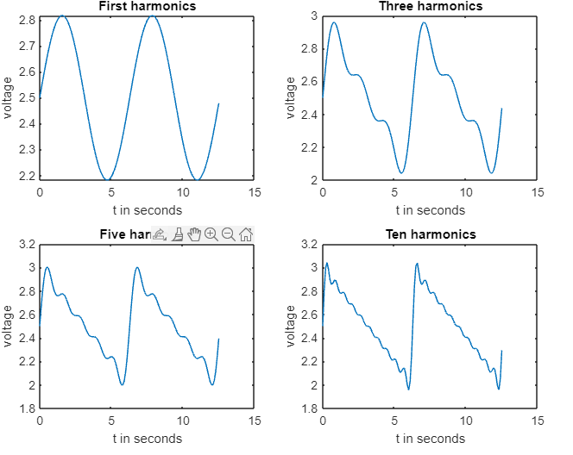
Figure 8- sawtooth waveform forming
As you can see from the image above the more harmonics you add the more sawtooth like shape takes place.

Task 3

$$X\left(if\right)= \int_{-∞}^{+∞}{x\left(t\right) e^{-j2πft} dt}$$

$$X\left(if\right)= \int_{-2}^{+2}{1 e^{-j2πft} dt}$$

$$dt= \frac{1}{-j2πf} \left[e^{-j2πf}\right]$$

$$X\left(if\right)= \frac{1}{-j2πf} \left[e^{-j2πf\left(2\right)}-e^{-j2πf\left(-2\right)}\right]$$

$$X\left(if\right)= \frac{1}{-j2πf} \left[e^{-j4πf}-e^{j4πf}\right]$$

$$X\left(if\right)= \frac{1}{πf}\left(\frac{e^{j4πf}-e^{-j4πf}}{j2}\right)$$

$$X\left(if\right)= \frac{4}{4πf}\left(\frac{e^{j4πf}-e^{j4πf}}{j2}\right)$$

$$X\left(if\right)= \frac{4}{4πf}\sin{4πf}$$

$$sinc 4πf= \frac{\sin{4πf}}{4πf}$$

$$X\left(if\right)=4 × \frac{\sin{4πf}}{4πf}$$

$$X\left(if\right)=4 ×sinc 4πf$$

freq = -2 : 0.02 : 2;
x = 4 * sinc(4*pi*freq);

%plotting graph
plot(freq,x);
title('Task 3 b')
xlabel('Frequency')
ylabel('Aplitude')
grid on

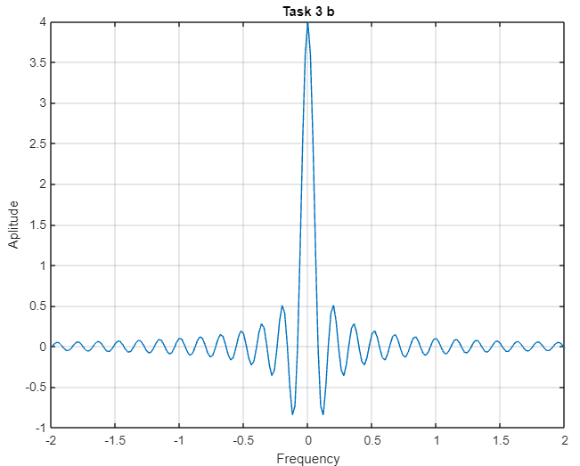

%Task 3 c
freq = -2 : 0.02 : 2;
x = 4 * sinc (4*pi*freq);

%figure 1
figure
plot(freq,abs(x))

title('figure 1 - Absoloute function of x');
xlabel('Frequency');
ylabel('Amplitude');
grid on

%figure 2
figure
plot(freq,angle(x))

title('figure 2 - Angle of x');
xlabel('Frequency');
ylabel('Amplitude');
grid on

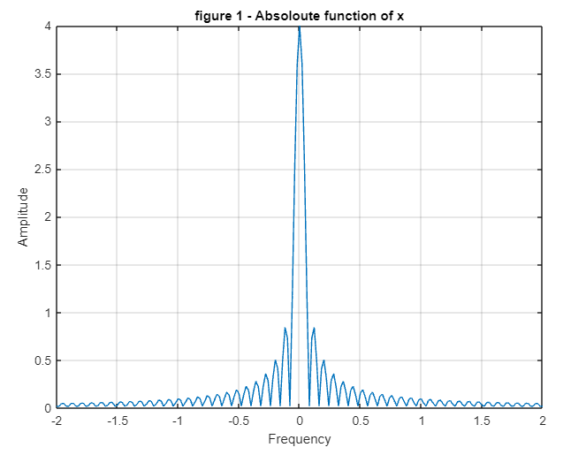

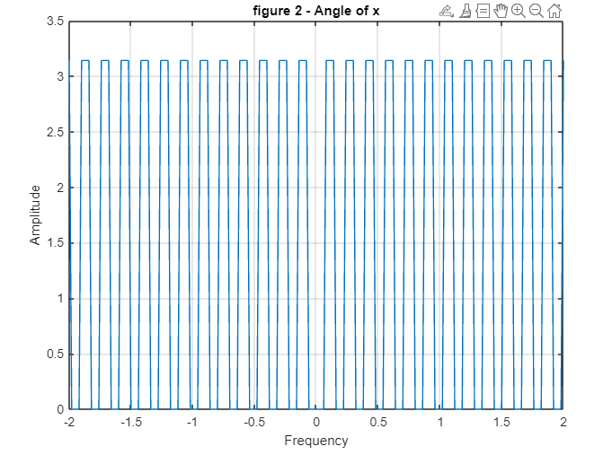

$$Y\left(if\right)= \int_{-∞}^{+∞}{e^{-7\left|t\right|}}e^{-jπft}dt$$

$$Y\left(if\right)= \int_{-∞}^{+∞}{e^{-7t-jπft}}dt$$

$$Y= \int_{-∞}^{0}{e^{7t-jπft}}dt+\int_{0}^{∞}{e^{-7t-jπft}}dt$$

$$Y= \int_{-∞}^{0}{e^{\left(7-jπf\right)t}}dt+\int_{0}^{∞}{e^{-\left(7+jπf\right)t}}dt$$
$$Y= \frac{1}{(7-jπf)} \left[e^{\left(7-jπf\right)t}\right]+ \frac{1}{-(7+jπf)} \left[e^{-\left(7+jπf\right)t}\right]$$

$$\frac{1}{(7-jπf)}+\frac{1}{(7+jπf)}= \frac{7+jπf+7-jπf}{7^{2}-{\left(jπf\right)}^{2}}$$
$$Y\left(if\right)= \frac{14}{7^{2}-{\left(jπf\right)}^{2}}$$

%Task 3 e
t = -2 : 0.005: 2;
freq = 0;
y=trapz(exp(-7*abs(t)-t*1i*2*pi*freq));
disp(y)

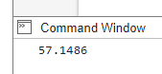

freq = -10 : 0.02 : 10; %frequency values from -10 to 10 in increments of 0.02
- t = -1 : 0.01 : 1;

- for m = 1 : length(freq)%loop frequency funtion
- y(m)= trapz(exp(-7*abs(t)-1i*2*t*pi*freq(m)));
- real(m)=abs(y(m));
- end
- %plotting graph
- plot(freq,real)
- title('trapezium function integration')
- xlabel('frequency')
- ylabel('Amplitude')
- grid on

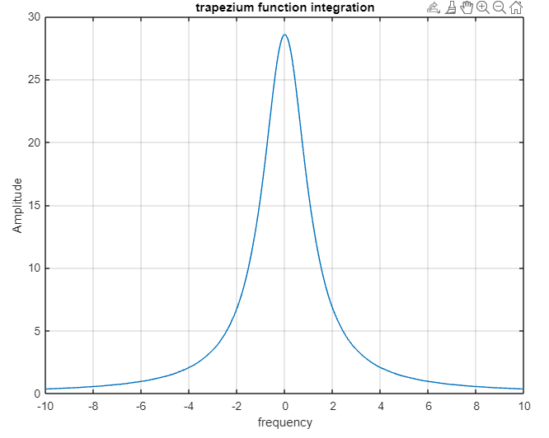

Task 4

clear all;
clc;
N = 1000; %length of sequence from assignment brief
Ts = 0.0002; %sampling period from the assignment brief
Ttotal = N*Ts;% total time = length of sequence * sampling period
t = 0:Ts:Ttotal;
x = 5*cos(2*pi*160*t)+4*cos(2*pi*170*t)+0.75*cos(2*pi*580*t)+1.5*cos(2*pi*600*t);
f = [0,N]*(1/Ttotal);
plot (t,x);

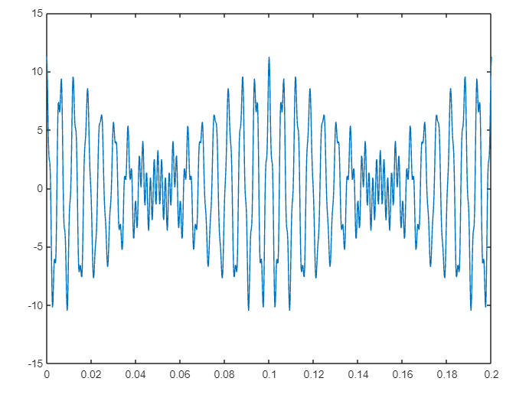

clear all;
clc;
N = 1000; %length of sequence from assignment brief
Ts = 0.0002; %sampling period from the assignment brief
Ttotal = N*Ts;% total time = length of sequence * sampling period
t = 0:Ts:Ttotal;
x = 5*cos(2*pi*160*t)+4*cos(2*pi*170*t)+0.75*cos(2*pi*580*t)+1.5*cos(2*pi*600*t);
f = [0:N]*(1/Ttotal);
xf = fft(x);
plot (f, abs(xf))

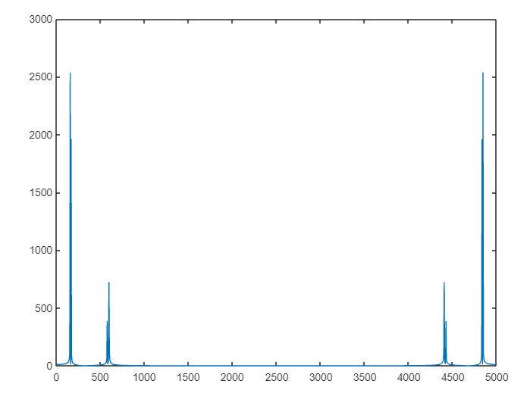

clear all;
clc;
N = 1000; %length of sequence from assignment brief
Ts = 0.0002; %sampling period from the assignment brief
Ttotal = N*Ts;% total time = length of sequence * sampling period
t = 0:Ts:Ttotal;
x = 5*cos(2*pi*160*t)+4*cos(2*pi*170*t)+0.75*cos(2*pi*580*t)+1.5*cos(2*pi*600*t);
f = [0:N]*(1/Ttotal);
xf = fft(x);
figure(1)
plot (f, abs(xf))
figure(2)
plot (t,ifft(xf))

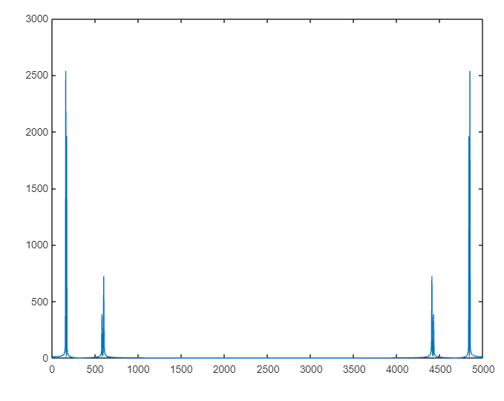
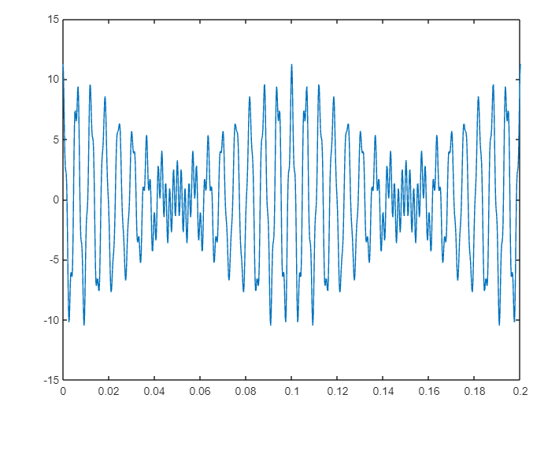

References
Dataq Instruments. (n.d.). FFT (Fast Fourier Transform) Waveform Analysis. Retrieved from Dataq Instruments: https://www.dataq.com/data-acquisition/general-education-tutorials/fft-fast-fourier-transform-waveform-analysis.html#:~:text=A%20disadvantage%20associated%20with%20the,discrete%20Fourier%20transform%20(DFT).
Electronincs tutorial. (n.d.). Electrical Waveforms. Retrieved from Electronincs tutorial: https://www.electronics-tutorials.ws/waveforms/waveforms.html
Gowda, K. (2020, July 27). What are Harmonics and how does it affect an Electrical System? Retrieved from CircuitBread: https://www.circuitbread.com/ee-faq/what-are-harmonics-and-how-does-it-affect-an-electrical-system
Hulse, C. (n.d.). The synthesis process. Retrieved from Electronic music interactive: https://pages.uoregon.edu/emi/4.php
Learnabout Electronics. (n.d.). AC Waves. Retrieved from Learnabout Electronics: https://learnabout-electronics.org/ac_theory/ac_waves01.php#:~:text=A%20complex%20wave%20is%20a,the%20COMPLEX%20WAVE%20being%20created.
Panigrahi, K. K. (2022, December 1). Difference between Fourier Series and Fourier Transform. Retrieved from Tutorials point: https://www.tutorialspoint.com/difference-between-fourier-series-and-fourier-transform

Figure 1- simple periodic waveform 2
Figure 2- saw tooth waveform 2
Figure 3- square waveform 3
Figure 4 - triangular waveform 3
Figure 5 - impulse waveform 3
Figure 6 - Noise waveform 3
Figure 7- Fundamental frequency and harmonics 4
Figure 8- sawtooth waveform forming 6

