Module title: Management and Organisational Behaviour
Module code: BMIH5004
Assignment Title: Report
Module Tutor: Daniel Payne

Student Name: Sabiana Oprea
Student Id: 2237673

I confirm that I have not used any AI tools in the research and creation of this
assignment. I confirm that I have not presented any AI generated materials as my own
work. I confirm I have copies of my drafts, notes, and other resources I used, which I
may be asked to provide in evidence.
Executive summary
This report sheds light on a particular mode of transport which is road transport-cars, to understand its impact on the hospitality sector. The focus has been given to statistical data in the context of the UK to understand its impact on the hospitality sector. A distinct perspective related to the subject matter has been considered in this regard. The emphasis has been given to understanding the mode of transport initiative and deciding damages caused by it. Necessary information was provided to make sure that an organisation in the hospitality sector use the benefits of such modes of transport discussed in detail. The benefits of the solution have also been considered in this regard. This study also sheds light on the cost-effectiveness and realistic approach associated with this mode of transport in the context of the hospitality sector.

Table of Contents
Assignment 2 3
Introduction 3
Main findings 3
Conclusion and Recommendations 8
References 10
Appendix 1: Market size of hospitality sector in the UK 12

Assignment 2

Introduction
Hospitality transport includes different modes of transport including Airlines, Water transport like cruises, ships or ferries and road transport like cars or buses. In this study, the focus will be given to the concept of road transport with a special focus on cars, which leads to the process of enhancing the experience of the service users in the hospitality sector. The impact of road transport in the hospitality sector can be evaluated from a unique perspective. The focus can be given to discussing damage caused by this mode of transport in the hospitality sector to find effective solutions to the problem. Road transport like cars is considered an integral part of the hospitality sector since it helps in the process of moving individuals from one place to another. On the other hand, issues related to increasing casualties due to the enormous number of traffic can be identified as a major problem in this regard. Organisations need to ensure that they focus on finding effective solutions to the problem caused by road transport. The focus can also be given to the fact that road transport provides tourists with an opportunity to access or reach a particular destination. The impact of road transport on destination marketing and achieving the desired economic growth can also be highlighted in this context.

Main findings
Mode of transport initiative
Road transport helps in the process of maintaining an interrupted supply of services within the hospitality sector since it ensures increased accessibility for service users. They can access remote areas or reach destinations quite easily with the help of road transport, such as cars. This type of transport ensures that organisations in the hospitality sector can serve their service users quite effectively by ensuring that they do not face difficulty in terms of commute (Lu et al. 2021). On the other hand, issues related to accidents or breakdowns can be highlighted as a major concern for the concerned authority. Issues regarding road safety have been a major concern of organisations in many countries. For instance, it has been estimated that 1645 individuals died in car accidents in the year 2023 in the UK. There has been a 4% decline in this context from the previous year, which is 2022 (Gov.uk, 2024). Issues regarding road safety have been a major concern for organisations in the hospitality sector that often affect the overall number of visitors. The hospitality industry in the UK which is regarded as the largest employer by engaging 3.5 million individuals needs to take necessary action to deal with the issues like car accidents (Uk Hospitality.org.uk, 2025). The hospitality industry in the UK is expected to achieve $ 66.67 billion by the end of 2030 (Mordorintelligence.com, 2025). To retain its position in the competitive market, organisations in the hospitality sector need to access a better version of road transport.
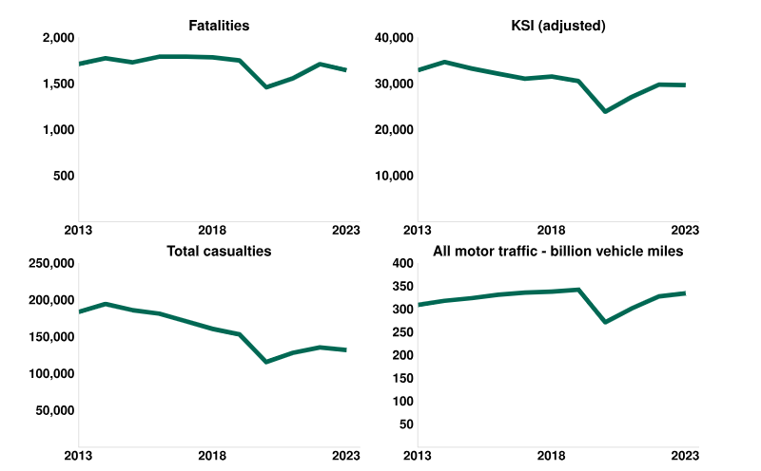
Figure 1: Statistical data regarding road accidents in the UK
(Source: Gov.uk, 2024)
It is vital for the concerned authority to make sure that they can provide organisations in the hospitality sector with a range of opportunities to achieve the desired growth in the competitive market. Enhancing issues related to road safety, issues related to slow speed or huge traffic can be mitigated (Bao et al. 2023). 128920 car accidents have occurred in the UK in the year 2024 (Gov.uk, 2024). In this context, 4% decline has been witnessed from the year 2023. Most car crashes have occurred in London followed by Birmingham. For instance, the number of car crashes in London and Birmingham are respectively 32164 and 9025 (Anthonyjones.com, 2024). The focus can also be given to avoiding vulnerable impacts of weather, as well as climate change, to make sure that it can serve the service users looking for distance, as well as long-distance travel options to reach their destination within the hospitality sector.
Impact of the mode of transport on the environment/landscape/community
Understanding the effect of road transport such as cars on the environment, community, as well as landscape is supposed to be evaluated from a distinct perspective. This can help in the process of understanding positive, as well as derogatory impacts. As stated by Inkson and Minnaert (2022), noise pollution, which is created due to road transport, cannot be ignored. For instance, huge traffic and an increasing number of road networks affect natural areas.
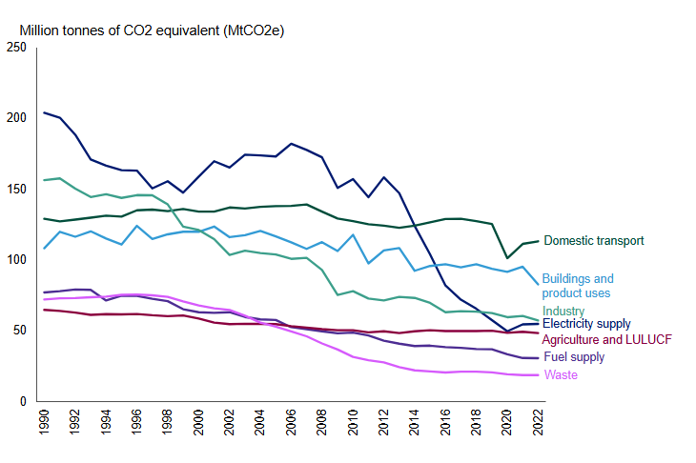
Figure 2: Statistical data regarding Co2 emission due to roads in the UK
(Source: Gov.uk, 2024)
This also restricts individuals from moving from one place to another and shrinks those natural areas (Aloui et al. 2021). Cars, which is an integral part of the hospitality sector, enhances the emission of greenhouse gases. For instance, the focus can be given to the fact that 80% of the carbon emission in the UK is caused by road transport (Gov.uk, 2025). The impact of domestic transport can be highlighted in this context. For instance, 113.2 million CO2 or Carbon dioxide were emitted in the year 2022 by road transports in the UK (Gov.uk, 2025). Road Transport also has a significant impact on changing the landscape of a particular place. For instance, it often divides natural habitats and affects the mortality rate among wildlife creatures. For instance, landscape alteration due to the construction of roads can also be highlighted (Haski-Leventhal, 2018). Eliminating vegetation can lead to changes in the landscape, which eventually affects the topography of a certain place. In terms of understanding its impact on the community, the positive, as well as innovative impact is supposed to be understood. For instance, the local community benefited due to improved access to road transportation (Legrand et al. 2022). This provides individuals from this community with an opportunity to get placed in an organisation within the hospitality sector. In this way, road transport ensures that employees in this sector are provided with a chance to have an improved travel experience during the daily commute. On the other hand, slow traffic or an increasing number of accidents can have a detrimental effect on both the service users as well as, the employees of an organisation in the hospitality sector (Erol et al. 2022). Talented individuals coming from different social and cultural backgrounds are provided with the chance to visit their workplaces regularly without facing much difficulty with the help of road transport.
Ways to improve
Several ways can be adopted for improving road transportation in the UK. For instance, the focus can be given to applying effective technology such as vehicle safety systems. It is vital for the concerned authorities to make sure that they can reduce congestion by applying technologies properly (Shah et al. 2021). They focus on reducing congestion and avoiding the slowing down of traffic in a particular place with the help of modern technology. In this context, warnings related to land departure or an effective system for avoiding collision can also be quite effective in improving transportation (Ladwas.com, 2025). Improving the overall design of the roads and enhancing infrastructure has no alternative in this regard. Another significant aspect which can be highlighted is that elevating the existing safety standard of a certain place is also essential to avoid a substantial number of accidents. In this context, adopting an effective signalling system can also be beneficial. Furthermore, organisations are required to apply strict rules to avoid mishaps (Sattari et al. 2021). The authorities in the UK can focus on enforcing strict laws for violating traffic rules so that issues related to accidents can be avoided effectively. Road safety can also help in the process of attracting visitors from various parts of the globe to a certain place. Influenced by the ideas of Englund et al. (2021), the authority can focus on introducing smart traffic signals with the help of Artificial Intelligence or AI. The impact of creating awareness among individuals about the rules applicable on roads is also necessary to avoid any problem soon. Furthermore, achieving sustainable development has no alternative since it ensures that issues related to greenhouse gases can be eliminated (Obaideen et al. 2022). In this context, they need to conduct awareness campaigns so that daily commuters get to understand the benefits of riding pollution-free vehicles. Checking out their vehicle's capability to emit greenhouse gases at regular intervals is also necessary in this regard (Massar et al. 2021). Managing the existing demand in the hospitality sector is also essential. This can help in the process of reducing the vast number of traffic at a certain place. For instance, it is required for organisations in the hospitality sector to arrange cars in such a way so that they can serve the greatest number of individuals in a single vehicle. Reducing the number of cars by convincing their service users to share vehicles can also be quite effective in this regard.
Cost-effectiveness and realistic approach associated with road transport like cars
Road transports like car is usually a cost-effective option for travel since it provides individuals with an opportunity to cover short distances. Flexibility and affordability in terms of reaching several types of locations provide service users with a wide range of opportunities to access relevant services in the hospitality sector quite effectively. Furthermore, the operating cost of road transport is quite lower than other modes of transport. It is vital for the concerned authority to make sure that they use the opportunity related to the low cost of infrastructure (Mell and Whitten, 2021). The focus can also be given to flexibility in terms of adapting to the requirements of a specific individual. For instance, road transport can be arranged depending on the time of delivery or as per the schedule of the customers. They need not maintain rigid schedules like other modes of transport. This makes it easy for service users to avail themselves of countless opportunities. Another important aspect which cannot be ignored is that road transport helps in the process of delivering several types of belongings or products, including heavy ones.
The way improvement can benefit the environment.
Improving traffic signals and reducing Greenhouse gas by applying smart Technology can be quite effective in benefiting the environment. For instance, a reduction in GHG can be quite effective in maintaining the air quality of a certain place (Zhang et al. 2024). Proper infrastructure and focusing on design can be effective in avoiding problems related to a particular landscape. This will eventually benefit the local community by providing them with the opportunity to maintain their natural habitats, which are an integral part of the ecosystem (Seddon et al. 2021). The focus can also be given to the impact of reducing noise pollution by making necessary changes related to traffic regulation. For instance, no horn zones can be included to reduce noise pollution. The focus can also be given to following strict regulations by constantly monitoring the activities which take place on a particular road. Taking necessary action against the ones who violate rules can be quite beneficial eventually.

Conclusion and recommendations
From the overall research, it can be concluded that it is vital for organisations to utilise road transport effectively to attain high growth in the hospitality industry. The existing market size of the hospitality sector in the UK is evolving rapidly. Utilisation of road transport by eliminating the issues or damages caused by it is essential. For instance, addressing the problems related to noise pollution or degrading air quality by emitting more Greenhouse gases can be highlighted in this context. On the other hand, the incorporation of a strong infrastructure with a special focus on integrating modern technology like Smart Technology has no alternative. Organisations in the hospitality sector can be benefited usually by utilising the benefits of cars in the UK. They need to ensure that they can avoid harm to the landscape or the local community. On the other hand, workers, as well as service users belonging to a particular community, can utilise the benefit of road transport to reach a particular destination (Hasselwander et al. 2022). In this way, the hospitality sector can flourish soon. They also need to ensure that they can deal with issues related to collisions or accidents on the road, which are integral parts of road transport in the UK.
Aloui, A., Hamani, N., Derrouiche, R. and Delahoche, L., 2021. Systematic literature review on collaborative sustainable transportation: overview, analysis, and perspectives. Transportation Research Interdisciplinary Perspectives, 9, p.100291.

Anthonyjones.com, (2025). UK Cities Where Most Car Accidents Happen. Available at: https://anthonyjones.com/uk-cities-most-car-accidents/[Accessed on 22.02.2025]
Bao, L., Kusadokoro, M., Chitose, A. and Chen, C., 2023. Development of socially sustainable transport research: A bibliometric and visualization analysis. Travel behaviour and society, 30, pp.60-73.
Englund, C., Aksoy, E.E., Alonso-Fernandez, F., Cooney, M.D., Pashami, S. and Åstrand, B., 2021. AI perspectives in Smart Cities and Communities to enable road vehicle automation and smart traffic control. Smart Cities, 4(2), pp.783-802.
Erol, I., Neuhofer, I.O., Dogru, T., Oztel, A., Searcy, C. and Yorulmaz, A.C., 2022. Improving sustainability in the tourism industry through blockchain technology: Challenges and opportunities. Tourism Management, 93, p.104628.
Gov.uk, 2024. Reported road casualties Great Britain, provisional results: 2023. Available at: https://www.gov.uk/government/statistics/reported-road-casualties-great-britain-provisional-results-2023/reported-road-casualties-great-britain-provisional-results-2023 [Accessed on 24.01.2025]
Gov.uk, 2025. Official statistics. Available at: https://www.gov.uk/government/statistics/transport-and-environment-statistics-2024/greenhouse-gas-emissions-from-transport-in-2022#:~:text=Chart%203:%20Domestic%20greenhouse%20gas%20emissions%20for,MtCO2e%20)%20of%20domestic%20transport%20GHG%20emissions. [Accessed on 24.01.2025]
Haski-Leventhal, D., 2018. Strategic corporate social responsibility: Tools and theories for responsible management. Sage.
Hasselwander, M., Bigotte, J.F., Antunes, A.P. and Sigua, R.G., 2022. Towards sustainable transport in developing countries: Preliminary findings on the demand for mobility-as-a-service (MaaS) in metro Manila. Transportation Research Part A: Policy and Practice, 155, pp.501-518.
Inkson, C. and Minnaert, L., 2022. Tourism management: an introduction. Sage.
Ladwas.com, (2025). How Can Road Safety be Improved in India? Available at: https://ladwas.com/how-can-road-safety-be-improved-in-india/#:~:text=Increased%20use%20of%20Technology&text=For%20example%2C%20advanced%20traffic%20management,the%20risk%20of%20road%20accidents. [Accessed on 24.01.2025]
Legrand, W., Chen, J.S. and Laeis, G.C., 2022. Sustainability in the hospitality industry: Principles of sustainable operations. Routledge.
Lu, C.W., Huang, J.C., Chen, C., Shu, M.H., Hsu, C.W. and Bapu, B.T., 2021. An energy-efficient smart city for sustainable green tourism industry. Sustainable Energy Technologies and Assessments, 47, p.101494.
Massar, M., Reza, I., Rahman, S.M., Abdullah, S.M.H., Jamal, A., and Al-Ismail, F.S., 2021. Impacts of autonomous vehicles on greenhouse gas emissions—positive or negative?. International Journal of Environmental Research and Public Health, 18(11), p.5567.
Mell, I. and Whitten, M., 2021. Access to nature in a post Covid-19 world: Opportunities for green infrastructure financing, distribution, and equitability in urban planning. International Journal of Environmental Research and Public Health, 18(4), p.1527.
Mordorintelligence.com, 2025. Hospitality Industry in UK Size & Share Analysis - Growth Trends & Forecasts (2025 – 2030). Available at: https://www.mordorintelligence.com/industry-reports/hospitality-industry-in-the-united-kingdom [Accessed on 24.01.2025]
Obaideen, K., Abdelkareem, M.A., Wilberforce, T., Elsaid, K., Sayed, E.T., Maghrabie, H.M. and Olabi, A.G., 2022. Biogas role in achievement of the sustainable development goals: Evaluation, Challenges, and Guidelines. Journal of the Taiwan Institute of Chemical Engineers, 131, p.104207.

References
Sattari, F., Macciotta, R., Kurian, D. and Lefsrud, L., 2021. Application of Bayesian network and artificial intelligence to reduce accident/incident rates in oil & gas companies. Safety Science, 133, p.104981.
Seddon, N., Smith, A., Smith, P., Key, I., Chausson, A., Girardin, C., House, J., Srivastava, S. and Turner, B., 2021. Getting the message right on nature‐based solutions to climate change. Global change biology, 27(8), pp.1518-1546.
Shah, K.J., Pan, S.Y., Lee, I., Kim, H., You, Z., Zheng, J.M. and Chiang, P.C., 2021. Green transportation for sustainability: Review of current barriers, strategies, and innovative technologies. Journal of Cleaner Production, 326, p.129392.
Uk Hospitality.org.uk, 2025. Facts and stats. Available at: https://www.ukhospitality.org.uk/media-centre/facts-and-stats/ [Accessed on 24.01.2025]
Zhang, H., Irfan, M., Ai, F., Al-Aiban, K.M. and Abbas, S., 2024. Analysing barriers to the adoption and development of electric vehicles: A roadmap towards sustainable transportation system. Renewable Energy, 233, p.121136.

Appendix 1: Market size of hospitality sector in the UK
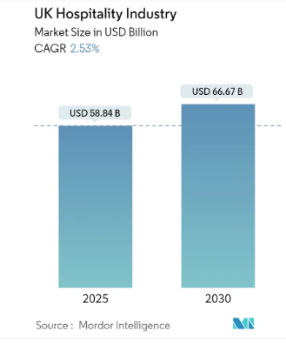
(Source: https://www.mordorintelligence.com/industry-reports/hospitality-industry-in-the-united-kingdom)

