

Component 2: Written Assessment – Problem Analysis and Solution Development

Student Name: Sandu Doncila
Student ID: 2509918
Programme: Applied Computing (Foundation)
Module: Analysing & Solving Problems (ACCA4019)
Word Count: ~2000
Submission Date: 26 March 2026

1. Introduction
Efficient classroom allocation plays an important role in the effective organisation of educational institutions. Colleges and universities must manage limited physical resources such as classrooms while accommodating a large number of students, lecturers, and teaching activities. When classrooms are not allocated efficiently, several problems may occur, including overcrowded rooms, unused teaching spaces, timetable clashes, and unnecessary movement between classrooms. These issues can negatively affect both the quality of teaching and the overall learning experience.
In the scenario presented in this assessment, a local college is experiencing difficulties in managing its classroom allocation process. Some classrooms are overcrowded while others remain underused. In addition, timetable conflicts occasionally occur when more than one class is scheduled in the same room at the same time. These problems lead to confusion for both students and lecturers and cause valuable teaching time to be lost.
The aim of this report is to analyse the classroom allocation problem and develop a structured solution that can improve the scheduling process. The problem is first deconstructed in order to identify the main requirements, constraints, and variables that influence classroom allocation. The MoSCoW prioritisation method is then used to organise the requirements based on their level of importance.
After analysing the problem, a logical solution is proposed using a flowchart that illustrates the process of allocating classrooms. The proposed system evaluates class sizes, room capacity, timetable availability, and lecturer schedules before assigning rooms to classes. This structured approach helps ensure that classrooms are used efficiently while avoiding scheduling conflicts.
Several problem-solving techniques are applied throughout this report, including abstract thinking, problem decomposition, and logical reasoning. These techniques make it possible to break down a complex scheduling problem into smaller, manageable steps. According to Sommerville [1], structured problem analysis and clear identification of system requirements are essential when designing solutions that involve multiple constraints and resources. By applying these principles, the proposed solution aims to improve classroom allocation while providing a practical system that could realistically be used by college administrative staff.

2. Problem Deconstruction
2.1 Key Requirements
Before a solution can be developed, the main requirements of the classroom allocation system must be clearly identified. These requirements represent the essential objectives that the system must achieve in order to function effectively.
The most important requirement is the efficient allocation of classrooms according to class size and room capacity. Each class must be placed in a room that is large enough to accommodate all students safely and comfortably. If the number of students exceeds the capacity of a room, overcrowding may occur and the learning environment may be negatively affected.
Another essential requirement is the avoidance of timetable conflicts. Two classes must not be scheduled in the same classroom at the same time. Accurate scheduling is therefore necessary to ensure that lessons can begin on time and continue without disruption.
The system should also aim to minimise unnecessary movement between classrooms for both students and lecturers. Excessive movement between buildings or distant rooms can waste valuable teaching time and create confusion for students who need to move quickly between classes.
Finally, the system should provide a level of flexibility so that timetable adjustments can be made when necessary. For example, unexpected events such as lecturer illness, room maintenance, or timetable changes may require classrooms to be reassigned.

2.2 Constraints
Constraints are factors that limit the possible solutions to a problem. In the classroom allocation scenario, several constraints must be considered when assigning rooms to classes.
One of the main constraints is room capacity. Each classroom has a fixed number of seats and cannot accommodate more students than its maximum capacity. Therefore, class sizes must be matched carefully with appropriate rooms.
Another constraint is the availability of timetable slots. Classes can only be scheduled during the operating hours of the college. This limits the number of time slots available for teaching activities.
The availability of lecturers also acts as an important constraint. Lecturers may only be available at certain times, so the scheduling system must ensure that classes are assigned to time slots when the lecturer is able to teach.
In addition, some modules may require specialised equipment or facilities, such as computer laboratories or science laboratories. These requirements further limit the number of classrooms that can be used for certain classes.

2.3 MoSCoW Prioritisation
In order to organise the system requirements effectively, the MoSCoW prioritisation method was applied. This technique is widely used in requirements engineering to classify system requirements based on their importance [4].
Requirement | Priority | Justification
Allocate classrooms according to class size | Must | Prevents overcrowding and ensures safety
Avoid timetable conflicts | Must | Essential for accurate scheduling
Minimise movement between classes | Should | Improves efficiency for students and staff
Flexibility for timetable changes | Could | Useful but not essential
Special equipment allocation | Won’t | Rare cases handled manually

Using the MoSCoW method allows the most critical requirements to be addressed first, ensuring that the core functionality of the system is prioritised before additional features are considered.

2.4 Variables
Several variables influence the classroom allocation process. These variables represent the data that must be considered when assigning classrooms to classes.
Variable | Description | Example
ClassSize | Number of students enrolled | 15 students
RoomCapacity | Maximum number of seats in a room | 31 seats
TimeSlot | Scheduled teaching time | Thursday, Friday  09:15 – 13:15
RoomLocation | Physical classroom location | Victoria House,  Room 04
Breaktime | Gap between classes | 15 minutes
Equipment | Requirement for specific facilities | Laptop, notebook,  Pen, Bag
Identifying these variables ensures that the allocation system can evaluate all relevant factors when determining the most appropriate classroom for each class.

3. Proposed Solution and Explanation
3.1 Flowchart
A structured solution was developed to optimise the classroom allocation process. The solution follows a logical sequence of steps that evaluate classroom capacity, timetable availability, and lecturer schedules before assigning rooms to classes.
The process is illustrated in Figure 1, which presents the classroom allocation algorithm using a flowchart. Flowcharts are commonly used in algorithm design because they provide a clear visual representation of decision-making processes and logical workflows.

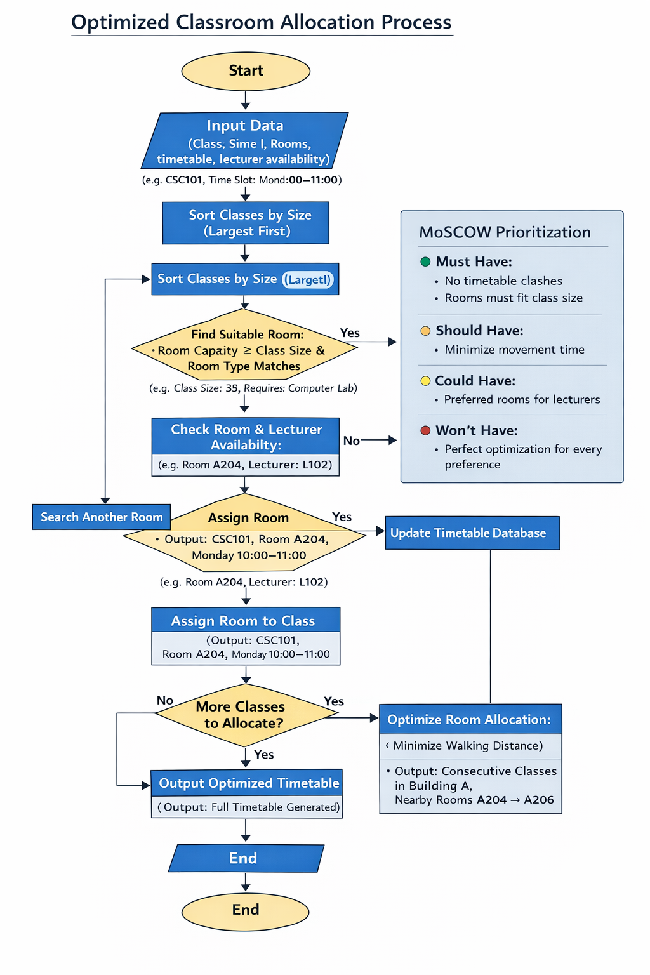

Figure 1: Classroom Allocation Process Flowchart

3.2 Explanation of Steps
The classroom allocation process consists of several logical stages that ensure rooms are assigned efficiently while avoiding scheduling conflicts.
Step 1: Data Collection
The process begins with the collection of relevant data. Information such as class sizes, available classrooms, timetable slots, and lecturer availability must first be gathered. Accurate data is essential for ensuring reliable scheduling results.
Step 2: Sorting Classes by Size
Classes are sorted in descending order according to their size. Larger classes are allocated first because they have fewer available classroom options. This approach increases the likelihood that suitable rooms will be found for large groups.
Step 3: Checking Room Capacity
For each class, the system evaluates available rooms to determine whether they can accommodate the required number of students. Only rooms with sufficient capacity are considered for allocation.
Step 4: Checking Time Slot Availability
The system then verifies whether the selected classroom is available during the required time slot. If the room is already booked, another suitable classroom must be considered.
Step 5: Checking Lecturer Availability
The lecturer assigned to the class must also be available during the selected time slot. If the lecturer is not available, alternative scheduling options may need to be explored.
Step 6: Assigning the Classroom
Once a room satisfies all conditions including capacity, time availability, and lecturer availability, the class is assigned to that classroom.
Step 7: Updating the Schedule
After a classroom has been assigned, the timetable is updated to indicate that the room is now occupied during the selected time slot.
Step 8: Repeating the Process
The process continues until all classes have been allocated appropriate classrooms.
Step 9: Conflict Resolution
If no suitable classroom is available, the system flags the issue for manual intervention. Administrative staff can then review the timetable and make necessary adjustments.
Step 10: Generating the Final Timetable
Once all classes have been processed, the system produces a final timetable showing classroom assignments, lecture times, and lecturer details.

4. Reflection and Justification
There were several problem-solving approaches used in the development of the proposed solution for the allocation of classrooms. This ensured that the solution was practical and systematic. One of the problem-solving approaches used was problem decomposition. This approach entails breaking down the problem into smaller, more tractable problems. By analyzing each of the factors, including room sizes, class sizes, availability of lecturers, and availability of slots, it was possible to solve each of the problems effectively. This ensured that the entire problem was considered, and no details were left out. In addition, it was possible to have a logical approach to the allocation of classrooms.
Abstract thinking was also essential in ensuring that the proposed solution was effective. This approach helped in the development of a general approach to the problem, which is flexible enough to be applied in different scenarios. By thinking abstractly, it was possible to come up with a solution that not only considered the allocation of classrooms but also ensured that the entire scheduling system was optimized. This ensured that the movement of staff and students was also optimized, thus improving the academic environment.
The MoSCoW prioritisation technique helped organise requirements by importance, ensuring essential needs, such as preventing timetable conflicts and matching classroom capacity to class size, were addressed first. Less critical factors, such as rare specialised equipment requirements, were incorporated without complicating the process. This prioritisation maintained focus on the most impactful issues while keeping the system practical and efficient.
From a computational perspective, the solution resembles a greedy allocation algorithm, prioritising larger classes to increase the probability of assigning suitable rooms.
The flowchart enhances clarity and usability by visually representing the decision-making process, making the system easier to understand and implement [3].
Limitations remain: the system relies on accurate, up-to-date data, and unexpected changes, such as staff absences, emergency room closures, or special classroom needs, may require manual intervention. Nonetheless, the structured approach provides a reliable framework for improving efficiency, reducing conflicts, and supporting a well-organised timetable. Future enhancements, such as real-time updates or predictive scheduling tools, could further increase flexibility and effectiveness.

5. Conclusion
Efficient classroom allocation is a fundamental aspect of managing teaching and learning effectively within educational institutions. Poor scheduling can lead to overcrowded classrooms, underutilised spaces, confusion among students and lecturers, and unnecessary delays between lessons, all of which negatively impact teaching quality and the student experience.
This report analysed the classroom allocation problem by identifying key requirements, constraints, and relevant variables. The MoSCoW prioritisation method was applied to classify requirements by importance, ensuring critical issues such as avoiding timetable conflicts and matching class sizes with room capacity were prioritised. Less critical considerations, such as rare specialised equipment needs, were addressed without complicating the allocation process.
A systematic solution was proposed using a flowchart to demonstrate the step-by-step allocation process. The system evaluates class size, room capacity, timetable availability, and lecturer schedules before assigning classrooms, ensuring lessons are scheduled accurately, resources are optimised, and unnecessary movement is minimised.
While the system is robust, its effectiveness relies on accurate and up-to-date input data, and unexpected changes, such as staff absences or emergency room closures, may still require manual adjustments. Future enhancements, such as real-time updates or predictive analytics, could further improve responsiveness and resource utilisation.
Overall, the report demonstrates that careful analysis, structured planning, and practical solution design can significantly improve classroom management. By prioritising essential requirements and following a clear, systematic process, educational institutions can enhance efficiency, reduce wasted time, and create a more organised and productive learning environment, supporting better teaching and learning outcomes.

6. References
[1] I. Sommerville, Software Engineering, 10th ed. Pearson, 2020.
[2] S. Russell and P. Norvig, Artificial Intelligence: A Modern Approach, 4th ed. Pearson, 2021.
[3] J. Brown, “Flowcharts in Algorithm Design,” Journal of Systems Design, vol. 15, no. 3, pp. 45–53, 2023.
[4] K. Miller, Requirements Engineering and System Analysis. Oxford University Press, 2020.
[5] Project Management Institute, “MoSCoW Prioritisation Method,” PMI White Paper, 2022.

