Assessment 2- Characteristics and reception of either Abraham, Isaac or Jacob. As well as engaging with primary and secondary sources, you are also encouraged to evaluate and critique other material relating to the reception of the patriarchs in culture (may include gendered perspective, reviewing paintings, looking at poems, analysing films etc.)

Introduction:
Looking at the biblical narratives to explore the characteristics and reception of Jacob can be very interesting where even from Jacob’s birth there is much to explore about the third patriarch of Judaism. After looking further into the character of Jacob, two questions have come to mind in regard to Jacob’s life, including was Jacob receiving the blessing from Isaac intentional and should Jacob really be labelled as a deceiver in his narrative? I aim to explore various chapters within Jacob’s life that have determined him as the third patriarch of Judaism rather than his brother, Esau, and will also be evaluating and comparing two art pieces, by Eugene Delacroix and Herbert Mandel, both depicting Jacob’s battle with an angel towards the end of his narrative.

Section 1: Jacob’s birth and the double deception- The early life of Jacob
We first hear of Jacob where his parents, Isaac and Rebekah, are struggling to conceive. With this however, Rebekah reaches out to God who reassures her that she will conceive twins. What is significant to highlight here is what God also said to Rebekah: “two nations are in your womb, and two peoples born of you shall be divided; one shall be stronger than the other, the elder shall serve the younger.” (Gen.25:23) David Zucker also makes a good point to add where he recalls an extract quoted in Hosea as he states that “Hosea notes ‘In the womb he tried to supplant his brother,” further adding to this struggle between the brothers during their early life. This can also highlight further struggles between the brothers, such as Jacob’s deception and later return to his family, which will be explored further. This begins many discussions of the brothers even before their birth, where we, as the reader, are already being told of a rift between the siblings and what will happen in their future, as we see Jacob returning to his family home and Esau met with his brother and bowed to him. (Gen.33:4) Erhard Blum goes on to highlight importantly on how “[Jacob and Esau’s] struggle begins in their mother’s womb (Gen.25:22), and the birth reveals Jacob’s ambition to be the first one by grasping Esau’s heel (Gen.25:25-26)” With this, Blum has begun this discussion instantly with Jacob’s bitterness of being ‘born second’ after his brother Esau, where even from conception there is this struggle between the twins for the right of being first born son. This only manifest further into the narrative as the twins are older and Jacob sees an opportunity for his first deception. Yair Zakovitch makes a good point by stating: “how can Esau brazenly claim Jacob cheated him of his birthright after he himself relinquished it, even swearing to Jacob beforehand?” With this insight, it is made harder to judge Jacob’s character on the next deception, where Esau is clearly willing to give his birthright over to his brother who then uses this to further gain his father’s blessing. This further asks more questions on the motivations of Jacob knowing that he now has the birthright, where he can then go on to receive the blessing by deceiving his elderly father in the process too.
We see Jacob’s hatred towards his older brother where Esau is forced to sell his birthright to Jacob (Gen.25:29-34) This is the first act of deception that Esau encounters from his brother Jacob, where the narrative takes a turn further into the involvement of Rebekah and Jacob in the next deception. As Zakovitch goes on to highlight is how “the story told in Genesis 27, where Jacob steals the blessing his father intended for Esau, is the direct continuation of the birthright purchase story,” which highlights significantly how the story explores this second deception by Jacob, where we can see that this want from Jacob to receive the rights of his brother intensifies. Zucker adds to this as he implies that: “…Jacob, at the instigation of and collusion with his mother Rebekah, shamelessly ‘steals’ the primogeniture blessing, which in principle, belongs to his older brother Esau.” This further adds to Jacob’s desire to receive not only the birthright from his brother successfully but also to steal the blessing from Isaac successfully too. This also highlights Jacob’s character throughout his early life- this does not seem like the person who would deceive his own family to then become the patriarch that is renowned for and remembered to well. During Jacob’s deception of Isaac, the difference between both brothers is mentioned again by their appearance; one brother full of hair and the other brother of smooth skin, both of which was also mentioned at their birth. Zakovitch highlights on the word ‘smooth’ that Jacob uses to describe himself which he states that it “can also connote one whose lips are ‘smooth,’ that is, one who speaks falsely, a meaning found in Psalm 12:3: ‘Men speak lies to one another; their speech is smooth, they talk with duplicity.” With this, Zakovitch has highlighted an important point, where Jacob has made the choice of the word ‘smooth’ to describe not only his appearance but which also has the wider connotations of being a deceiver by nature also, which has been proved time again with his family.
However, Jacob is soon to learn from his own misdeeds when he is sent away by his mother to her brother, Laban, where he is sent by Isaac and Rebekah to escape his angry brother. Blum points out that “in Aram, however, Jacob is reminded of his past as a trickster when Laban gives him Leah after he had worked 7 years for Rachel. In answer to his reproach ‘why have you deceived my?’ Laban holds up a mirror to Jacob: ‘this is not done in our country- giving the younger before the first-born.” For Jacob, he felt deceived himself by Laban who had promised a wife, and gave his other daughter Leah, where Jacob had asked for Rachel, the second-born. After working another 7 years however Rachel was eventually given to Jacob. Jacob soon encounters another threat from Laban where he is guided by God to return to his familial home, with his wives and 11 children. Joel S Baden comments on this threat by saying that “the threat of violence presented by Laban against Jacob is, of course, not the only such threat that Jacob encounters,” where Jacob as first sent out of his home from the threat of his brother Esau, he is now being sent away from Laban’s home with the threat of more violence. This protection from God is important once more with the patriarch Jacob, where Baden also highlights “it is a promise of protection on Jacob’s specific journey home, looking ahead to his encounter with Esau in Genesis 32-33.” This is quite ironic when we think about this promise of protection from God to the patriarchs and in this case, with Jacob on his way home, where he feels his major encounters will come with his brother Esau, however it is actually with God himself. This is a difficult idea to grasp where God promises the protection of the patriarchs, as he has done previously, however on the other hand an angel or potentially God himself descends upon Jacob in the darkness and wrestles with him. Was this deception, therefore, justified by Laban or did Jacob deserve his happiness with Rachel as he had originally intended? With this, he eventually had the life that he wanted and could look back at his past and look further to the future of not only himself but the generations to come from him.

Section 2: (546/739 words) Jacob to Israel- significance of name change and return to his familial home.
Jacob’s later life, with his large family and learning from his past, we see a change in the character of Jacob as he is not only getting older but is also reaching a point of wanting to return to his familial home in Genesis 31. On his return home, Jacob encounters, what is revealed by Jacob as God, a struggle between himself and God in the night. After becoming victorious, it is mentioned in Genesis 32:28 that Jacob is no longer identified as ‘Jacob’ but rather as ‘Israel.’ Blum highlights this name change as “the new name he receives marks his change: he is a new man, not the ‘trickster’ anymore, as Esau rightly called him.” It is important for not only Jacob but also for the memory of him as a patriarch to be looked up to for generations to come, where a previous life can be overturned and come out anew through a change in character and life. This significance of Jacob’s name now becoming ‘Israel’ and reinstating the covenant between God and his people, where Marian Kelsey writes how “Abram was similarly renamed when God made a covenant with him (Gen.17:5) Moreover the narrative contains the first biblical occurrence of the name ‘Israel.’” This is significant firstly with the connections between Jacob and his grandparents, Sarah and Abraham, who both also had their names changed by God when blessing the patriarch with the covenant. The significance then of the use of the name ‘Israel’- who would later be the father of many nations after him, further reinstates the importance of the character of Jacob within the patriarchs but also as one of the founding fathers of the Jewish nation today.
As Jacob had proved with his battle with God and also the return to his family, Zakovitch recalls how Jacob has “been blessed twice, once through trickery, it is true, but the second blessing has reassured us of his chosen status,” where this is even more important to the narrative of Jacob and his changed life through strife and triumph. Kelsey also makes a great point where she highlights that “Jacob fled in fear having stolen a blessing but returns in peace with a blessing he has won.” This further encapsulates the journey that Jacob has been on throughout his life, from being a young and naïve ‘trickster’ and deceiver of others, to learning and growing from his past in his older years and becoming a highly regarded man of God and even being welcomed back by his once angry brother. Blum further highlights the significance of the encounter with Esau after Jacob’s battle with the angel as he mentions that “…the blessed one, as he bows to the unblessed one, gives up any triumphant claim on his superior status… Esau shows- by embracing and kissing his brother- that he has given up the old strife.” This can further highlight the change of both brothers towards the end of the narrative, where we have a new beginning for Israel and his family but also a beginning for the brothers moving forward from their past encounters.
Section 3- Art analysis evaluate and critique- Jacob wrestling with God?
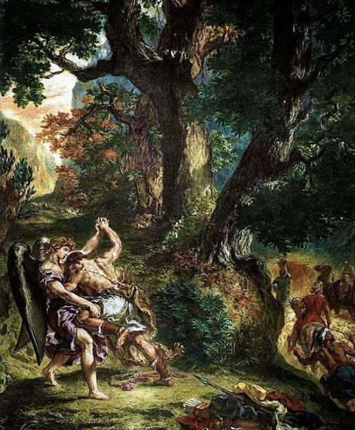
Fig 1
I have chosen to look at Jacob’s battle with God through art by Eugene Delacroix (Fig 1) for this section where I will also be highlighting specific aspects of the piece compared with the work of Herbert Mandel’s piece of the same name.
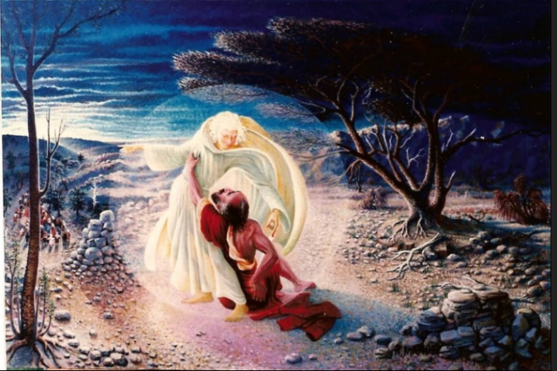
By looking at this specific art piece, by Eugene Delacroix we can explore a few different interpretations and also examine the significance of the painting. When choosing a recreation of the wrestle between Jacob and an angel, there was many pieces that stood out however this piece by Delacroix stood out to me the most. Interesting to highlight first is the depiction of Jacob, not only in this image but in other pieces of art depicting his life. The first thing that stands out to me when looking through different pieces of art on this matter is the depiction of Jacob himself. He is mainly painted as a young-looking man, where we know by this point that he most likely is not as young and strong as the art depictions of him are showing. I have decided to examine a piece of art by Eugene Delacroix entitled “Jacob wrestling with the Angel,” which can be seen in Fig.1. Richard Stracke comments that “there is no particular iconography or attribute associated with [Jacob], except that in the Joseph he is old and in his own stories he is young.” I find this comment fascinating as, clearly shown in Fig 1, Jacob is portrayed as a young, fit and healthy man battling a mysterious character depicted commonly as an angel. What can also be highlighted within this piece is the “…powerful build of Jacob, whose heavy physical presence contrasts with the dancing lightness of the angel.” This is significant where, as previously mentioned, Jacob is depicted as being strong, young and healthy where the reality at this stage was more likely to be a much older man.

Fig 2
Some depictions such as Herbert Mandel’s ‘Jacob Wrestling with God’ (Fig 2) highlights this perfectly where we can clearly see a much older Jacob, not a young and strong Jacob that is highlighted in Fig 1. Also, unlike in Fig 1, the pinnacle of the battle is also portrayed where we can see an almost defeated Jacob on the floor in this image where he is holding his hip after being struck by the angel. There are many depictions of Genesis 32:22-32 which highlight the important part of Jacob’s final journey back to his hometown, where he had originally thought that his toughest encounter would have been meeting with his brother, Esau, once more. However, “Jacob was left alone, and a man wrestled with him until daybreak.” (Gen.32:24) I find it fascinating how in such a small chapter of Jacob’s life, there has been much art and discussion around this encounter. Possibly with God or possibly with an angel which is very interesting. As it may have seemed, Jacob did not come out entirely victorious from this encounter, where he had been given a limp, as he was struck on his hip during the battle as is stated in Genesis 32:25.
Upon further insights into both Fig 1 and Fig 2, it is evidently clear that there are many differences in both the portrayal of Jacob and also the portrayal of the angel. What is also striking to see is the colour palettes used in both images. Where Fig 1 is a lot darker and capturing the forest in its darkest hour during the battle, Fig 2 however is a lot clearer and brighter mainly around the central two characters. Exploring then the character of the angel or man, as explored by Kelsey who states that “the narrator is reticent concerning the identity of Jacob’s opponent and only refers to the opponent as a man,” as is also suggested in Genesis 32:24-29, where the character battling Jacob is referred to constantly as ‘he’ or a ‘man.’ The identity of the character battling with Jacob has been depicted in many pieces of art or sculptures, where Kelsey also notes that “visual art, perhaps unavoidably, resolves the ambiguity concerning the identity of the opponent, most often depicted straightforwardly as an angel.” This is evident in Fig 1 where the character can be seen with wings and is being portrayed as an angel, also included in the image title. However, when looking at the character in Mandel’s piece, there is a less obvious inclusion of wings but rather the image of an older man with white hair and a white robe, shrouded by a halo of light. Could this then be the argument by some that, as Jacob exclaims himself in Genesis 32:30, could this character depict God Himself as the one who was wrestling with Jacob? Many theories could suggest either God’s messenger or God himself was present in the battle however it is interesting to see the two different artists perspectives of this character and the character of Jacob in this chapter.

Conclusion:
Looking back through the narratives involving Jacob, it is evident therefore that much can be said about this character whether he was a trickster or a deceiver, or whether this path was destined for him at his birth. Much can also be established about the character of Jacob where we can imply that as his father, Isaac, was also second born but given the covenant by God, this was therefore destined also for Isaac’s second born son, Jacob, to receive the blessings over his brother Esau. As explored, this could then come back to why Esau was willing to so easily sell his birthright to his brother and possibly explaining why Jacob didn’t deceive his father for the blessing of the ‘first born son’. Furthermore, as previously argued, there can be much said about Jacob’s life through art where there are many depictions of Jacob, especially from his battle with an angel or God. It is difficult also to forget Jacob’s early life and misdeeds however life has thrown him in many directions where he had learnt, grown and eventually changed for the better where his character was fully established towards the end of his later life and especially moving forward with the new name of Israel.

Bibliography:
Baden, Joel.S., The Promise to the Patriarchs (New York: Oxford University Press, 2013)
Blum, Erhard, ‘The Jacob Tradition,’ in The Book of Genesis (United States: Brill, 2012), pp.181-211
Dunn, Ashley, Jacob Wrestling with the Angel by Eugene Delacroix, (2018) https://www.metmuseum.org/art/online-features/metcollects/eugene-delacroix-jacob-wrestling-angel [accessed: 19 July 2023]
Kelsey, Marian, ‘Jacob Wrestling (Genesis 32:22-32) in Annunciations: Sacred Music for the Twenty-First Century, ed. By George Corbett, (Open Book Publishers, 2019), 127-139
Robinson, George, Essential Judaism: A Complete Guide to Beliefs, Customs and Rituals (New York: Pocket Books, 2000)
Segal, Eliezer, ‘Reading Jewish Religious Texts’ (London: Routledge, 2012)
Stracke, Richard, Jacob the Patriarch (2023) https://www.christianiconography.info/jacob.html [accessed: 13 July 2023]
Van Wolde, Ellen. “A Stairway to Heaven? Jacob’s Dream in Genesis 28:10-22”. Vetus Testamentum 69 (2019): 722-735
Zakovitch, Yair, and Valerie Zakovitch, ‘He should cheat me twice? He took my birthright and now he has taken my blessing! Jacob the Deceiver’ in Jacob: Unexpected Patriarch. (United States: Yale University Press, 2012), pp.28-45
Zucker, David J. “Choosing Jacob: The Coded Language of Genesis 27.” Scandinavian Journal of the Old Testament 29:2 (2015): 233-240

Fig 1-
N.D, Jacob Wrestling the Angel (2009) https://www.eugene-delacroix.com/jacob-wrestling-with-the-angel.jsp#prettyPhoto [accessed: 19 July 2023]
Fig 2-
Robidoux, Jim, Jacob Wrestles with God (2018) https://manchesterinklink.com/jacob-wrestles-god/ [accessed: 18 July 2023]

David Zucker, ‘Choosing Jacob: The Coded Language in Genesis 27’, Scandinavian Journal of the Old Testament, 29:2 (2015), p.233.
Erhard Blum, ‘The Jacob Tradition’, in The Book of Genesis (2012), p.p182-183.
Yair Zakovitch, and Valerie Zakovitch, ‘He should cheat me twice? He took my birthright and now he has taken my blessing! Jacob the Deceiver’ in Jacob: Unexpected Patriarch (United States: Yale University Press, 2012), p.35.
Zakovitch, Jacob: Unexpected Patriarch (United States: Yale University Press, 2012) p.28.
Zucker, Scandinavian Journal of the Old Testament 29:2 (2015) p.233.
Zakovitch, Jacob: Unexpected Patriarch (United States: Yale University Press, 2012) p.30.
Blum, The Book of Genesis (United States: Brill, 2012) p.p.183-184
Joel S Baden, The Promise to the Patriarchs (New York: Oxford University Press, 2013) p.15.
Ibid.,p.p.11-12.
Blum, The Book of Genesis (United States: Brill, 2012) p.185.
Marian Kelsey, ‘Jacob Wrestling (Genesis 32:22-32’ in Annunciations: Sacred Music for the Twenty-First Century, (Open Book Publishers, 2019) p.128.
Zakovitch, Jacob: Unexpected Patriarch (United States: Yale University Press, 2012) p.45.
Kelsey, Annunciations: Sacred Music for the Twenty-First Century, (Open Book Publishers, 2019) p.131.
Blum, The Book of Genesis (United States: Brill, 2012) p.p.185-186.
N.D, ‘Jacob Wrestling the Angel’ (2009) https://www.eugene-delacroix.com/jacob-wrestling-with-the-angel.jsp#prettyPhoto [accessed: 19 July 2023]
Richard Stracke, Jacob the Patriarch (2023) https://www.christianiconography.info/jacob.html [accessed: 13 July 2023]
N.D, ‘Jacob Wrestling the Angel’ (2009) https://www.eugene-delacroix.com/jacob-wrestling-with-the-angel.jsp#prettyPhoto [accessed: 19 July 2023]
Jim Robidoux, ‘Jacob Wrestles with God’ (2018) https://manchesterinklink.com/jacob-wrestles-god/ [accessed: 18 July 2023]
Kelsey, Annunciations: Sacred Music for the Twenty-First Century, (Open Book Publishers, 2019) p.129.
Ibid., p.137.

