Business Report -Comparison of Two Hospitality Organisations

Student Name: Roxana Pesu
Student ID: 2243649
Module Code: BMIH5007Financial Management for the Hotel Industry
Lecturer Name: Tristan Hawkins

Acknowledgement
I acknowledge the use of Grammarly (https://www.grammarly.com/) on 10 October 2024 to check my work using the prompt:
“Please do check the whole text below to find any grammatical issues”
I confirm that I have not presented any AI generated text as my own work. I confirm I have copies of my drafts, notes, and other resources I used before, and after the use of AI tools which I may be asked to provide in evidence.

Table of Contents
1. Introduction 1
2. Analysis and Comparison 2
2.1 Revenue 2
Price/Revenue per available room and occupancy rate 5
2.2 Market Position 5
Positioning through Strategy block and D&S model theory 7
2.3 Growth Potential 8
2.4 Financial Commitment to CSR 10
3. Recommendations 11
4. Conclusion 12
5. References 13
6. Appendix 15

Introduction

Hospitality industry refers to firms that offer accommodation, food and beverages, travel and tourism agency and services and event management services. They range from hotel and restaurant industries to resorts, and cruise operations, with an emphasis in customer satisfaction (Walker, 2021). This paper makes a comparative evaluation of the two large hotel chains: Shangri-La Hotels and Premier Inn Hotels in terms of their performance regarding managing their financial resources. Moreover, it analyses the strengths and opportunities of each organization through a critical examination of their total revenue, their market standing, growth prospects and their financial commitment to CSR.

Analysis and Comparison

2.1 Revenue
The revenue of the two brands is given below. As for comparability, the dollar amount converted to GBP, which are given below:
Figure 1: Revenue Premier Inn and Shangri-La Hotel (Shangri-La Group, 2018-2023; Whitbread PLC, 2018-2023)
Figure 2: Cost of Premier Inn and Shangri-La Hotel (Shangri-La Group, 2018-2023; Whitbread PLC, 2018-2023)
Total revenue is an essential item for evaluating the performance of the business in operation in the hospitality industry. Shangri-La Hotels and Premier Inn Hotels both of which operate in the accommodation sector, adopt diverse business models, which determine their revenue and cost style. The revenue and cost comparison of both companies are conducted below:
Revenue analysis shows that in 2018 Premier Inn generated (32.95) much more revenue compared to Shangri-La (1925.75). This gap illustrates how much more advanced Premier Inn is within the subsectors of a budget and mid-range hotel, whereas, due to luxury orientation Shangri-la had lower revenue.
In 2019, It is visible that total revenue decreased for both companies; however, Premier Inn retained market domination.
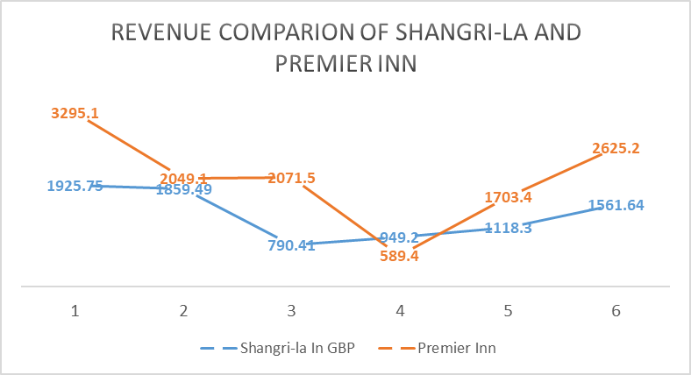
Figure 3: Revenue of Shangri-la and Premier Inn from 2018-2023
In 2020, the COVID-19 outbreak was very devastating for Shangri-La’s revenue as its revenue declined from 853.26 to 849.72. Meanwhile, Premier Inn has a comparatively smaller Downfall in revenues this year primarily because it specializes in catering to domestic tourists, and its cost is more reasonable compared to the other brands.
Shangri-La had a gradual expansion in 2021 primarily because its sales only slightly improved from the previous year. Notably, Premier Inn reported a steep decline in its revenue which might suggest that even such value hotel chain suffered from recurrent limitations and unstable financial situations.
However, by the year 2022, the two firms clawed back their positions little by little. Shangri-La’s its revenue slightly increased however it was still a far cry from its earnings prior to the Covid-19 breakout. While Premier Inn returned to growth aggressively faster in comparison with Shangri-La which was still struggling with restricted global mobility.
The following sections cover the cost of both companies from 2018-2023
2018-2019: The results showed that the operating costs of the Premier Inn were higher than that of the Shangri-La throughout the year due to the operational dimensions.
2020 (Pandemic Year): Shangri-la has cut its operating costs massively while Premier Inn’s costs have not fluctuated significantly which demonstrated the company’s resilience during the pandemic.
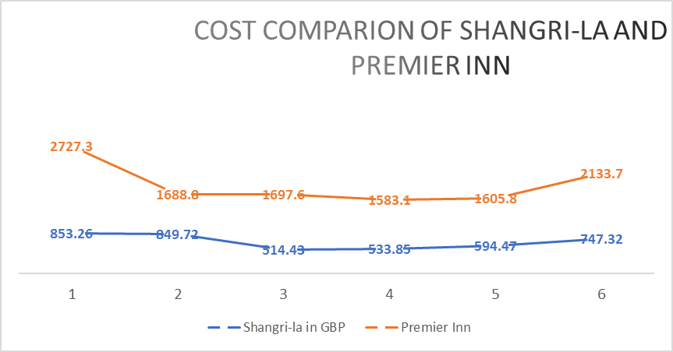
Figure 4: cost comparison of Shangri-la and Premier Inn (Author’s calculation)
2021-2022: The recurring operational costs of both companies registered mild fluctuations; Shangri-La gradually began to recover, while Premier Inn continuously adjusted to adapt its functioning to periods of variable demand.
2023: Premier Inn costs were higher post-pandemic, adding to the fact that operating costs increased with the expansion of the operation scale.

Price/Revenue per available room and occupancy rate
 | 2018 | 2019 | 2020 | 2021 | 2022 | 2023
Occupancy rate Premier Inn | 79% | 81% | 34% | 45% | 50% | 66%
Revenue per available room GBP | 47 | 51 | 25 | 29 | 38 | 52
Occupancy rate Shangri-la hotel | 68% | 67% | 39% | 42% | 46% | 62%​
Revenue per available room USD-Shangri-la hotel | 115 | 85 | 51 | 64 | 100 | 108​
Revenue per available room GBP-Shangri-la hotel | 87.4 | 64.6 | 38.76 | 48.64 | 76 | 82.08

Figure 5: Price/Revenue per available room and occupancy rate (Annual report of Shangri-La and Premier Inn, 2018-2023)
The data presented below shows comparison between Premier Inn and Shangri-La Hotel based on occupancy rate as well as RevPAR from the year 2018 to 2023.
Premier Inn’s annual occupancy rate in 2018 and 2019 were 79% and 81% respectively, while in the year 2020 it reduced to 34% due to the COVID-19 impact. Recovery starts from 2021 hence the rate will be 66% by the end of 2023. RevPAR also moved in tandem declining to 25 GBP in 2020 and improving to 52 GBP in 2023.
Shangri-La Hotel also declined from 68% in 2018 to 39% in 2020 but slightly recovered in 2023 to 62%. RevPAR is shown in USD and demonstrated a decrease from 115 to 51 USD in 2020, rising to 108 USD in 2023, in GBP the values range from 87.4 to 38.76 in 2020, up to 82.08 in 2023.

2.2 Market Position
Market positioning refers to the nature and extent of the hotel brand competition and is therefore a function of market share, customer demographics and perceived brand image (Kotler & Keller, 2016). Shangri-La Hotels and Premier Inn Hotels are relatively quiet poles apart in the hospitality industry serving different customer bases.
Shangri-La Hotels: It is most clearly situated in the luxury tier target market and mainly targets international travelers. The brand has a network of own 100 hotels in 22 countries and regions, however, most of the brand’s hotels are in Asian countries especially China where the brand has a comparative advantage over other luxury brands (Atrill & McLaney, 2021). The travel destinations preferred by the hotels include people with high purchasing power, working executives and travelers who are choosy and would prefer services from the best hotel chain or brand like Shangri-La (Shangri-La Group, 2023).
Premier Inn: It occupies a lower strategic point in the industry offering economy and relatively cheaper products to the guests (Brotherton, 2013). The UK’s largest hotel chain by room and strongly competitive in the value segment, Premier Inn operates over 840 hotels and has a portfolio of over 83,000 rooms in the UK (Walker, 2021). It has unlimited clients, as it covers business individuals, families, domestic tourists and less wealthy citizens (Williams, 2019). With its prices that are well below those of competitors, and locations covering most of the UK and Germany, Premier Inn can keep occupancy rates as high as needed, although it might target the segment of business travelers and tourists who do not necessarily require luxurious accommodations.
From a brand association perspective, the Shangri-La company is a luxury brand related to elegance, luxuriousness, and high-quality customer care. That is why its business model is based on offering individual approaches to the guests and providing them with high-quality services that only well-off guests can afford (Walker, 2021). This focus on the value of money saved has been accompanied by the organization’s huge chain of hotels, making it a unique market dominion for domestic tourists in the UK.

Positioning through Strategy block and D&S model theory
Strategy clock:
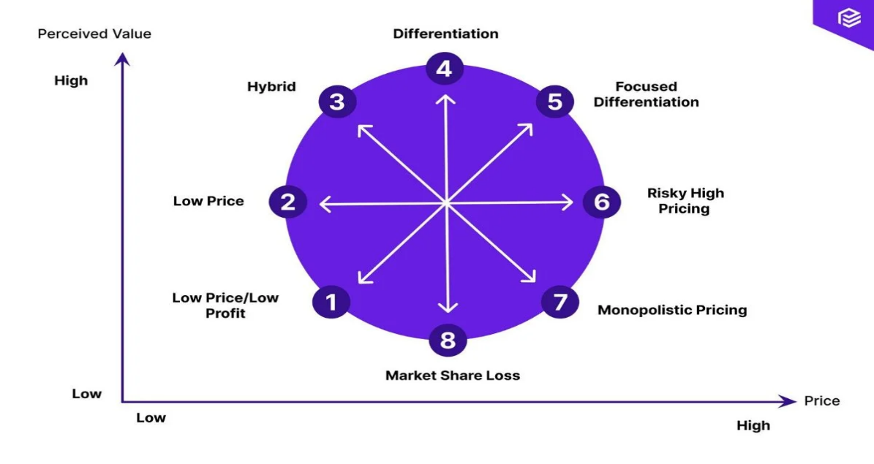
Figure 6: Bowman’s Strategy Clock (Seal, 2019)
Premier Inn operates from low-price, high-volume that targets the economical population who are willing to spend a small amount of money for accommodation services, specifically in the hotel business. In achieving its competitive advantage, it focuses on operating efficiency going for a wide base of customers especially with the domestic’s market. But here, by cutting costs, it also confronts on price without compromising the number of rooms or their accessibility (Bhimani, 2006). However, Shangri-La has placed itself squarely in the differentiation strategy zone where it provides luxury services at high-end charges. The key strategy is its orientation on offering special propositions, high-quality services, and the image of a luxurious hotel that attracts the clients from the groups of the high income and the Holiday Maker willing to spend more money when travelling (Guilding, 2014).

Supply and Demand Theory:
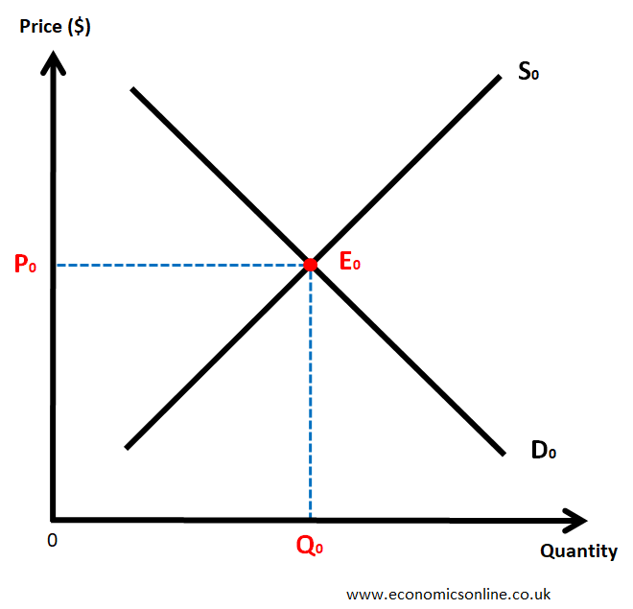
Figure 7: The supply and demand curve (Drury, 2021)
Analyzing demand and supply conditions, Premier Inn use price elasticity; by increasing price elasticity it stabilizes the occupancy rates enjoying economies of scale. On the other hand, Shangri-La has an inelastic demand curve because customers are not so sensitive to price as they are to supply factors such as travel disruptions around the world (Jagels, 2007). This difference shows that both brands are flexible in their marketing strategies depending on customer base and price sensitivity.

2.3 Growth Potential
Growth potential is an essential factor that signifies the competitive prospect for a company, and for both Shangri-La Hotels and Premier Inn, there are appropriate strategies and opportunities of improvement and, consequently, threats that can influence growth potentiality.
Shangri-la Hotel
Shangri-La Hotel has vast unexplored growth opportunities given that affluence and tourist traffic in the region particularly in Asia are on the rise. Speculated due to changes in consumer behavior and demand patterns that have occurred over time, the firm has in the past relied on organic growth, especially in established markets like China and Southeast Asia, as well as the Middle East (Deloitte, 2022). These regions’ economic development patterns and higher middle and upper-class populations supplement the demand for luxury travel and hospitality (Williams, 2019). Shangri-La’s proficiency in utilizing a superior brand image and high-quality services affords it an opportunity to seize new opportunities while exploiting opportunities in emerging cities and tourist attractions.
However, there are factors that may limit the growth prospect of Shangri-La. The luxury sector remains very much saturated, with such players as Four Seasons, Ritz-Carlton, and Mandarin Oriental Group all keen on grabbing the largest proportional market share as possible (Jagels, 2007). However, the high costs of constructing and managing luxurious properties act as a check to the growth of more projects in the market (World Travel & Tourism Council, 2023).
Premier Inn
The economy brand, Premier Inn, operating in both the low-cost segment and the mid-price segment, has a higher growth pace, especially in geographic expansion. Currently, it is the leading hotel brand in the UK, and this has made it open new sites to fulfil the increasing market from domestic tourists and businesspersons. The company is also entering Germany, one of Europe’s biggest and most saturated hotel markets. With the new chain, the company is also diversifying into Germany, one of Europe’s largest and most competitive hotel economies (World Travel & Tourism Council, 2023). Thus, the company is planning to integrate its cost-effective business model with a high occupancy level targeting the mid-segment in Germany because the budget hotel market there is currently highly dispersed.
However, in this growth there are some limitations that affect Premier Inn as follows; The market is highly competitive with some well-established brands in the budget hotel segment such as Ibis and Travelodge (Seal, Garrison & Noreen, 2008). In the same way, these two and other related factors increased vacancies because economic conditions might dip or change, whereas consumers may opt for other forms of accommodation like those copied from Airbnb’s business model. However, good financial controls, an extensible model and dominance over the domestic market in the UK give Premier Inn every opportunity to expand further.

2.4 Financial Commitment to CSR
Shangri-La Hotels brand give significant importance to CSR principles and undertakes sustainability and community upliftment (Jiang, 2020). Under its Sustainability Program, it approaches greenhouse gas emissions, water usage, and the elimination of single-use plastics at its properties. Moreover, under the “Sanctuary” program positive impacts on the conservation of biodiversity, especially in Asia can be mentioned, as well as educational and health programs for the local population (Patterson & Williams, 2020). These massive CSR activities are exemplary of Shangri-La’s obligation to deliver more than what such a customer expects in the social side of luxury travel, making it a costly affair.
On the other hand, Premier Inn is committed to social responsibility and sustainability issues established by Force for Good. It is reducing emissions to net zero by 2040, increasing the energy efficiency of its operating sites, and cutting food waste in its budget hotels (Tranter, Stuart-Hill & Parker, 2014; Wild, 2018). It also employs local people and encourages community sponsorship, especially focused on efficient and efficient activities.

Shangri-La: Luxury Sustainability – Strategy or PR
Shangri-La ensures that it focuses its emission reduction, as well as biodiversity initiatives, to meet and match the expectations of the high-end spender hence elevating its brand worth. Nevertheless, such actions may be in part due to green marketing because luxury operations continue to be resource-intensive (Shangri-La Hotel, 2024). They have a dependency on international suppliers which has the potential of increasing the carbon footprint. More local buying and employee engagement may strengthen that pledge, the writers posit.

Premier Inn: Cost-Driven Sustainability – Is It Real or Compliance
Like many businesses, Premier Inn’s environmental management addresses energy efficiency and waste minimization but it is most notable for its cost-cutting goals, as a low-cost operating company. While it is laudable that the “Force for Good” campaign plan envisages a net-zero emission by 2040, some of the actions may still appear to be compliance or marketing-oriented (Premier Inn, 2023). While local sourcing has clear benefits, the petal needs to reach out into the broader community and train its employees if it wants to effect change at a deeper level.

What They Should Be Doing
The two brands should embrace sustainability across operations without limiting themselves to compliance or branding to guarantee a transformative shift as well as lasting effects.

Recommendations
Shangri-la Hotel: Based on its current strategy, this brand has too limited space. It is recommended for the brand to make an expansion strategy in the western countries and increase its service line in the options.
Premier Inn: Premier Inn is only limited to the UK and Germany markets. This brand should be focused on other European countries to make a large volume in income and market share.

Conclusion
The two organizations that have been discussed above in different strategies based on their categories in the markets. Shangri-La operates as a luxury hotel and has a narrow market share targeting a high level of price that causes higher costs and slow growth due to the intensified competition on the global level. Premier Inn has by far the largest market share in the UK’s limited-budget hotel sector and adopts a cost leadership strategy primarily based on geographical market penetration.

References
Atrill, P., & McLaney, E. (2021). Management Accounting for Decision Makers. FT Prentice Hall.
Baker, M. (2019). Financial Management in the Hospitality Industry. 2nd ed. New York: Delmar Cengage Learning.
Bhimani, A. (Ed.). (2006). Contemporary Issues in Management Accounting. Oxford.
Brotherton, B. (2013). The International Hospitality Industry: Structure, Characteristics, and Issues. 5th ed. New York: Wiley.
Deloitte (2022). 2022 Travel and Hospitality Industry Outlook. Available at: https://www2.deloitte.com [Accessed 6 Oct. 2024].
Drury, C. (2021) Management and Cost Accounting. 11th ed. London: Prentice Hall.
Guilding, C. (2014). Accounting Essentials for Hospitality Managers (3rd ed.). London: Routledge.
Jagels, M. (2007). Hospitality Management Accounting. London: Wiley.
Jiang, Y. (2020). The Impact of Corporate Social Responsibility on Business Performance in the Hotel Industry. International Journal of Hospitality Management, 85, pp. 102-113.
Kotler, P., & Keller, K. L. (2016). Marketing Management. 15th ed. Harlow: Pearson.
Patterson, I., & Williams, D. R. (2020). The Role of CSR in the Hospitality Industry: A Review and Future Directions. International Journal of Hospitality Management, 91, pp. 102-116.
Premier Inn (2023). Force For Good. [online] Premier Inn. Available at: https://www.premierinn.com/gb/en/why/force-for-good.html.
Seal, W., Garrison, R.H., & Noreen, E. (2008). Management Accounting. McGraw Hill.
Seal, W. (2019) Management Accounting. 6th ed. London: McGraw Hill.
Shangri-La Group (2023). Annual Report 2023. Available at: https://www.shangri-la.com [Accessed 6 Oct. 2024].
Shangri-La Hotel (2024). Area of Focus. [online] Shangri-la.com. Available at: https://www.shangri-la.com/group/sustainability/stay/.
Tranter, K., Stuart-Hill, T., & Parker, J. (2014). Introduction to Revenue Management for the Hospitality Industry. London: Pearson.
Whitbread PLC (2023). Annual Report 2023. Available at: https://www.whitbread.co.uk [Accessed 6 Oct. 2024].
Wild, J. (2018). Fundamental Accounting Principles. New York: McGraw Hill.
Walker, J. (2021). Introduction to Hospitality. Harlow: Pearson.
Williams, A. J. (2019). The Role of Market Positioning in the Hospitality Sector. Journal of Hospitality and Tourism Research, 43(7), pp. 1234-1250.
World Travel & Tourism Council (2023). Economic Impact Reports. Available at: https://wttc.org [Accessed 6 Oct. 2024].

Appendix
Statement of Profit or Loss of Shangri-La Hotel
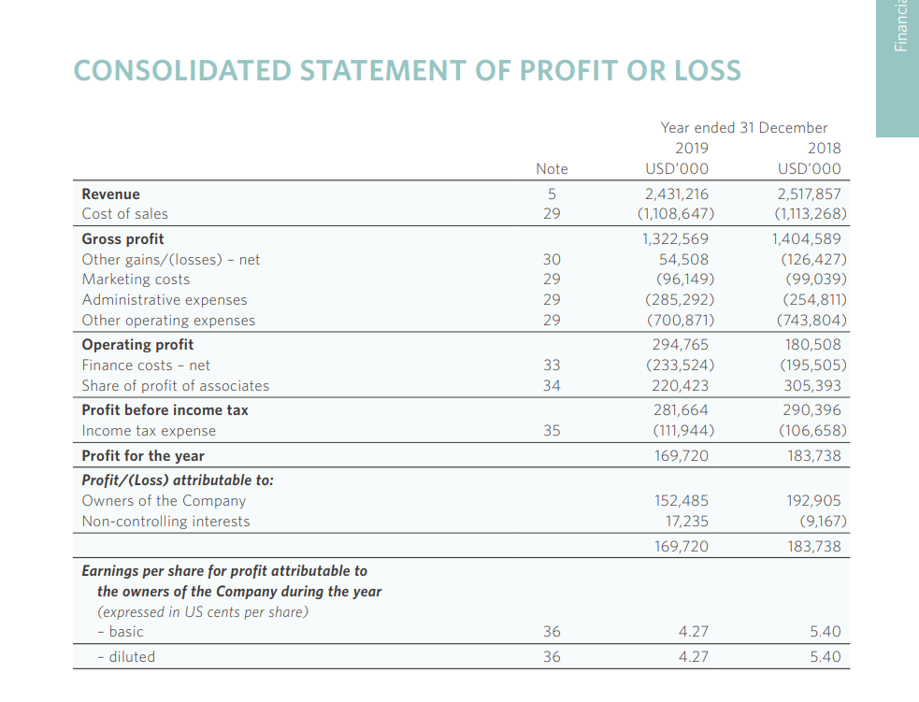

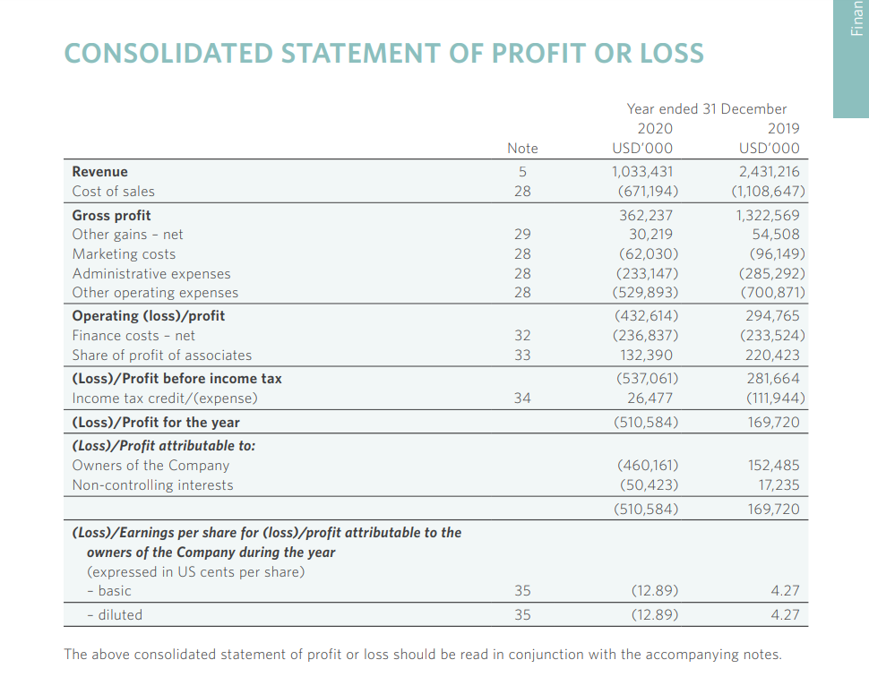
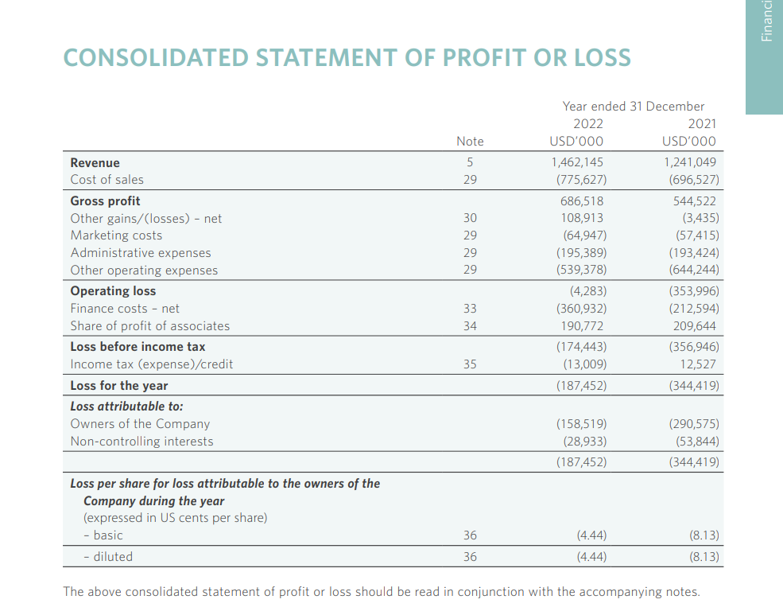
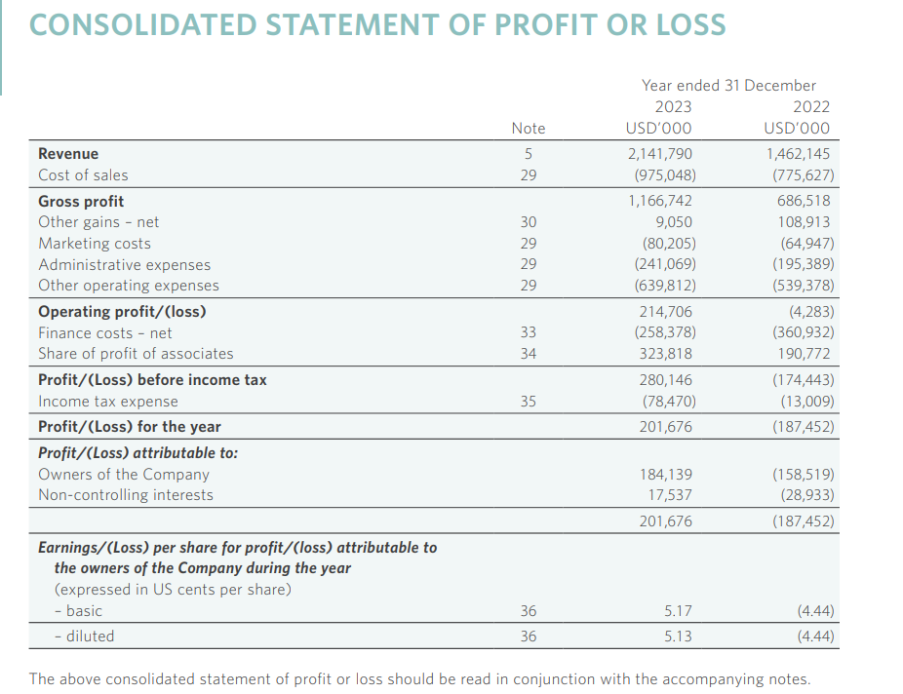

Statement of Profit or Loss of Premier Inn Hotel


