

University of Wales Trinity Saint David

School of Engineering

Heat Exchanger Laboratory Analysis

Thermofluid Mechanics

M5X00406

Christian Parry

1808165

24/04/2020

Contents
1 Introduction 1
1.1 Aims 1
1.2 Objectives 1
2 Background Research 2
2.1 Examples of heat exchanger: 3
2.2 Flow Types: 3
2.3 Relevance of the Heat exchanger in the Laboratory 6
3 Methodology 8
3.1 Experiment 1 8
3.2 Experiment 2 8
3.3 Experiment 3 8
3.4 Calculations 8
4 Results 11
4.1 Tables 11
4.1.1 Experiment 1 11
4.1.2 Experiment 2 11
4.1.3 Experiment 3 11
4.2 Graphs 12
4.2.1 Experiment 1 12
4.2.2 Experiment 2 14
4.2.3 Experiment 3 15
5 Conclusion 18
6 References 19

Introduction

Aims
To complete 3 experiments in a laboratory session using the standard 32 tube heat exchanger apparatus, and then evaluate the experiments in a report.

Objectives
- Complete an experiment varying the water flow rate into the heat exchanger
- Complete an experiment varying the air flow rate into the heat exchanger
- Complete the same experiment as experiment 2 but vary the temperature
- Log the results in tables on excel
- Produce graphs
- Evaluate the 3 different experiments

Background Research
A heat exchanger is a device which transfers heat from one liquid or gas to another. The transfer of heat is always from the hot liquid/gas to the cold liquid/gas. There are various different types of heat exchanger, but the main 2 types are:
- The Shell and Tube type heat exchanger
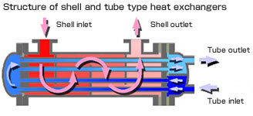
(http://www.kamui.co.jp/english/products/shell_and_tube/shell_and_tube_img02.jpg, accessed 24/04/2020)
- The plate type heat exchanger
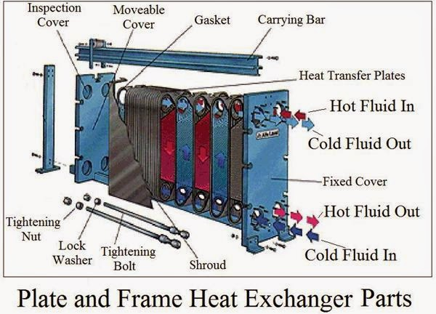
(http://2.bp.blogspot.com/-04Oe7Q1Tsp4/VEtTvFoB1xI/AAAAAAAAAuI/cK2WeTC8itY/s1600/aa8aba1bb4af184c3a271d26409e9cd7518fe261_large.jpg, accessed 24/04/2020)
The main reasons for using a heat exchanger are as follows:
- To cool a hot liquid by using a cool liquid
- To cool a gas so it becomes a liquid
- To condense a gas whilst boiling a liquid
- To boil a liquid by using a hotter liquid
- To heat a cool liquid using a hotter liquid

Examples of heat exchanger:
An example of a heat exchanger commonly used would be a car radiator whereby coolant flows around the engine and when it reaches the radiator the heat is transferred from the liquid in the radiator to the air flowing through it, thereby heating up the air coming into the engine bay. This would be a crossflow type heat exchanger. Another example is a heat sink used in electrical applications, whereby the heat generated from the appliance is transferred to a liquid cooling system flowing around the appliance. This would generally be a parallel or counterflow type heat exchanger.

Flow Types:
All the experiments undertaken used crossflow.
- Parallel Flow:
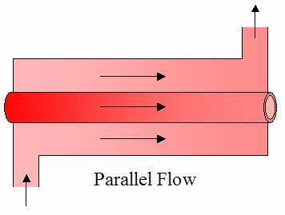
(https://www.real-world-physics-problems.com/images/parallel_flow_heat_exch.png, accessed 24/04/2020)
As can be seen in the diagram above a parallel flow heat exchanger has both hot and cool fluid/gases running in the same direction. With there generally being a very high temperature difference at the input. At the output the heat transfer between the two always means that the hottest temperature achieved in the cool side of the exchanger is always less than the coldest temperature achieved in the hot side of the exchanger.
- Counter flow
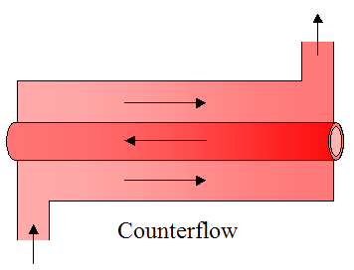
(https://qph.fs.quoracdn.net/main-qimg-dede73cd9fa2c1c8f54069e0c91dedb0, accessed 24/04/2020)
As can be seen in the diagram, a counterflow heat exchanger involves the cold fluid/gas running in the opposite direction to the hot fluid/gas. This type of heat exchanger is the most efficient type as it allows for the most heat transfer to occur as the cold fluid/gas travels towards the hot fluid/gas input, this means that unlike the parallel flow type heat exchanger the hottest temperature achieved in the cool side can be hotter than the coldest temperature achieved in the hot side of the exchanger.
- Crossflow
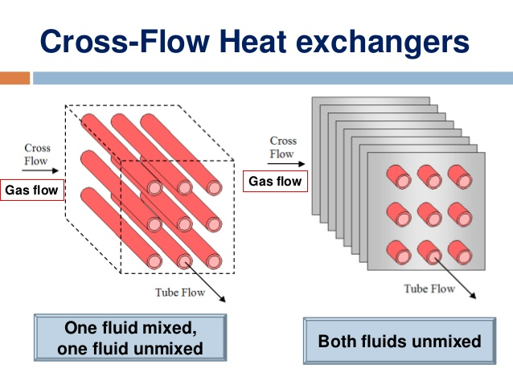
(http://image.slidesharecdn.com/6chapter4heatexchanger-140329015915-phpapp02/95/heat-exchanger-8-638.jpg?cb=1396058411, accessed 24/04/2020)
This type of heat exchanger has the cold fluid/gas running perpendicular (90 degrees) to the hot fluid/gas, this type of heat exchanger is most commonly used to condense a gas in the hot stream into a liquid by cooling it down; this is known as a 2-phase flow.
Those are the fundamental types of heat exchangers as they are the basis for all the different variations of heat exchanger. The most effective type as stated before is the counterflow type heat exchanger. There are more complex designs for heat exchangers which are focused on increasing the heat transfer area between the hot and cold streams, which increases the efficiency of the heat exchangers, for example:
There is the helical coil heat exchanger:
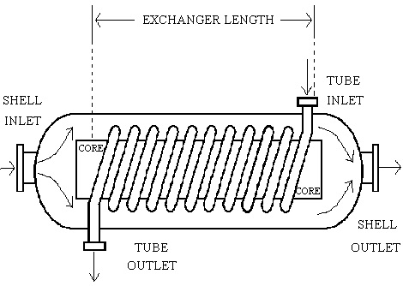
https://en.wikipedia.org/wiki/Heat_exchanger#/media/File:HCHE.jpg, accessed 24/04/2020)

and another design is the spiral type:
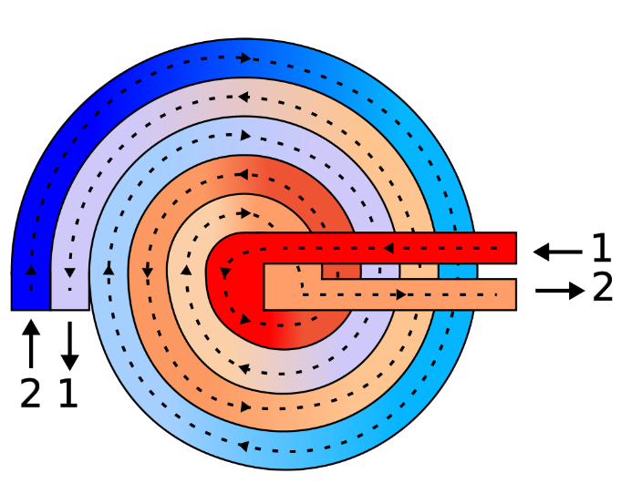
(https://en.wikipedia.org/wiki/Heat_exchanger#/media/File:Spiral-heat-exchanger-schematic-workaround.svg, accessed, 24/04/2020)

Relevance of the Heat exchanger in the Laboratory
The heat exchanger used in the laboratory is a crossflow type heat exchanger with the liquid running through 2 blocks of 16 tubes and the air flowing across those tubes to cool the liquid down, due to there being 2 separate blocks there is the ability to run the tubes in series so they flow through one set and then into the other, or in parallel where the fluid stream is split between the 2 inputs.
Series setup:
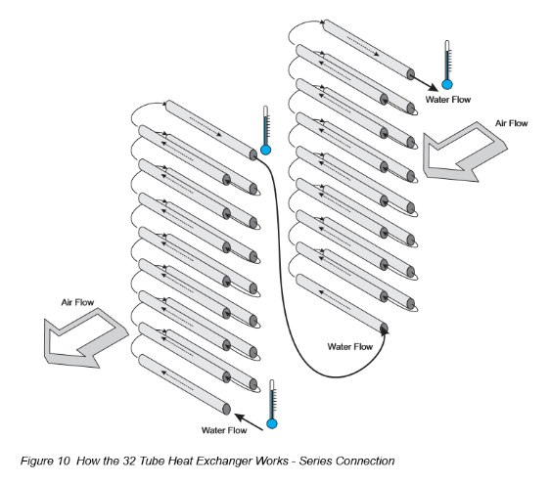
(https://moodle.uwtsd.ac.uk/pluginfile.php/145911/mod_resource/content/1/TD1007_HX_laboratory_guide.pdf, last accessed 24/04/2020)

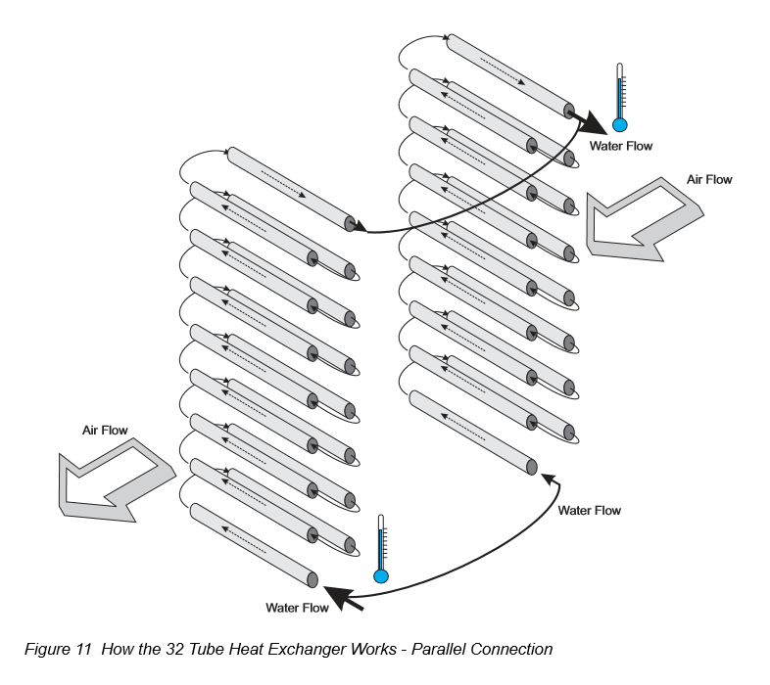
(https://moodle.uwtsd.ac.uk/pluginfile.php/145911/mod_resource/content/1/TD1007_HX_laboratory_guide.pdf, last accessed 24/04/2020)
This heat exchanger is relevant to the real world as it is a crossflow type which is the type found in the radiator used on Internal Combustion Engines (ICE), therefore it is relevant to us on a Motorsport engineering course as the thermal efficiencies of ICE is a very important aspect of motorsport.

Methodology

Experiment 1
Experiment 1 – The effect of varying water flow rate
Method:
- Setup the standard 32 tube heat exchanger in parallel flow, set the water temperature to 60 degrees Celsius
- Inspect the ambient air pressure, recorded a figure of 1009mBar
- Inspect orifice to check its diameter, recorded a figure of 101.11mm
- Switch on the fan and adjust the sliding valve to give a pressure drop of 250pa
- Switch on the water pump and set the water flow to 2L/Min
- Note down the inlet temp and outlet temp for both air and water
- Repeat for water flow rates of 1.75, 1.5, 1.25, 1 and 0.75 L/Min

Experiment 2
Experiment 2 – the effect of varying air flow rate
Method:
- Same setup as experiment 1, parallel flow and a water temp of 60 degrees Celsius
- Same orifice diameter and ambient pressure
- Same pressure drop of 250pa
- Set the water flow rate to 0.25L/Min
- Then alter the slide valve to adjust the pressure, and note down the temps for 200, 150, 100, 50 and 25Pa

Experiment 3
Experiment 3 – the effect of varying the temperature (Driving Force)
Method:
- Identical to experiment 2, however adjust the water temperature to 50 degrees Celsius.

Calculations
For each experiment there were a variety of calculations required to fill out all the data needed.
- The change in temperature for water and air
TW2 - TW1 and TA2 – TA1
- The average temperature for air and water
(TW1 + TW2)/2 and (TA1 + TA2)/2
- The Water Density
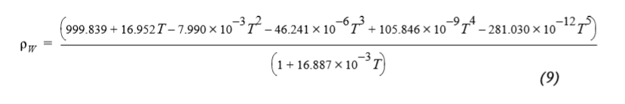
- The Air Density
Ambient Pressure / R (dry air specific gas constant) * Temperature
- The water mass flow rate (converting from L/Min to Kg/Sec)
Flow rate (L/Min) / 60000 * Air Density
- The air mass flow rate
Coefficient of Discharge (0.6) * Area of orifice (Pi * 0.05055^2) * square root (Air Pressure*2*Air Density)
- The Specific Heat Capacity of Water
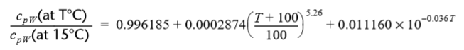
- The Specific Heat Capacity of Air
This value was given to us and was: 1005J.Kg-1.K-1
- QW (The heat emitted by the water)
Water Mass Flow Rate * Water Specific Heat Capacity * Change in water temps
- QA (The heat absorbed by the air)
Air Mass Flow Rate * Air Specific Heat Capacity (1005) * Change in air temps
- CEB (the energy balance co-efficient)
QA/QW

- The temperature efficiency of water
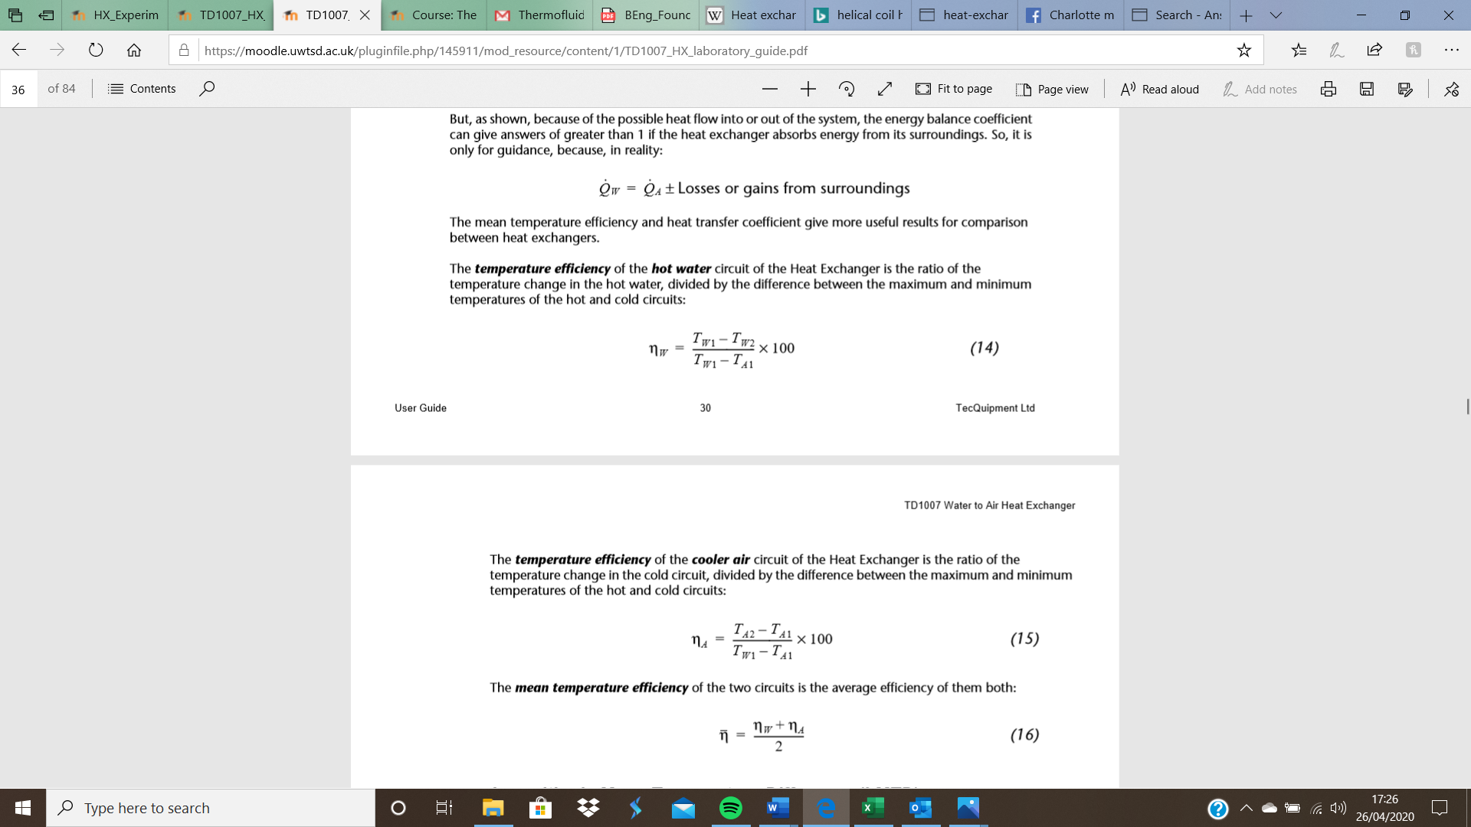
- The temperature effeciency of air
- The mean temperature effeciency of the whole system
- LMTD (Logarithmic Mean Temperature Difference)
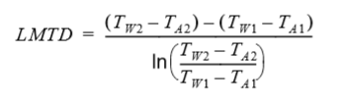
- U (Heat Transfer Coefficient)
QW / Mean Heat Transfer Area (0.1558m2) * LMTD

Results

Tables

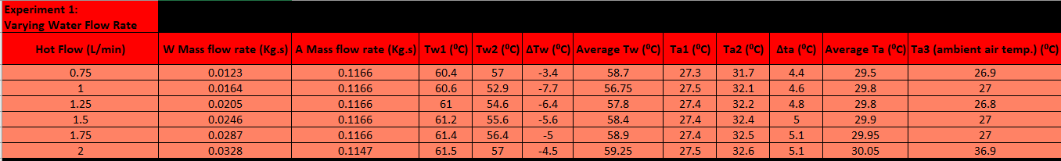
Experiment 1
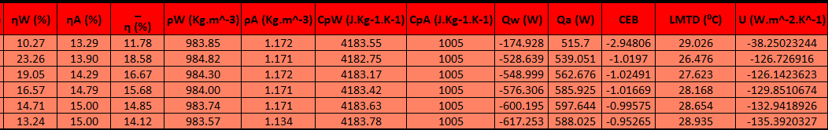

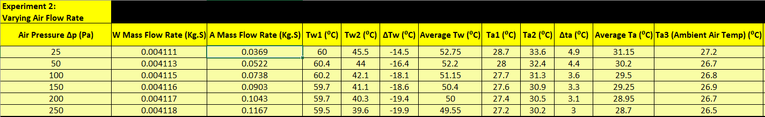
Experiment 2
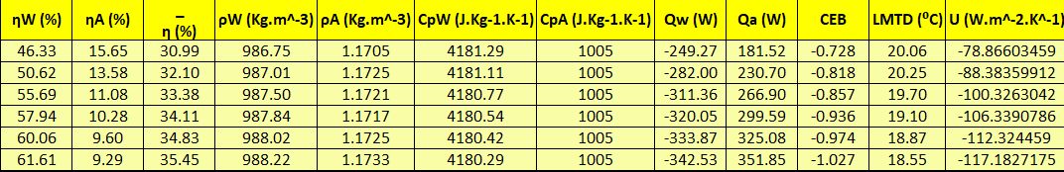

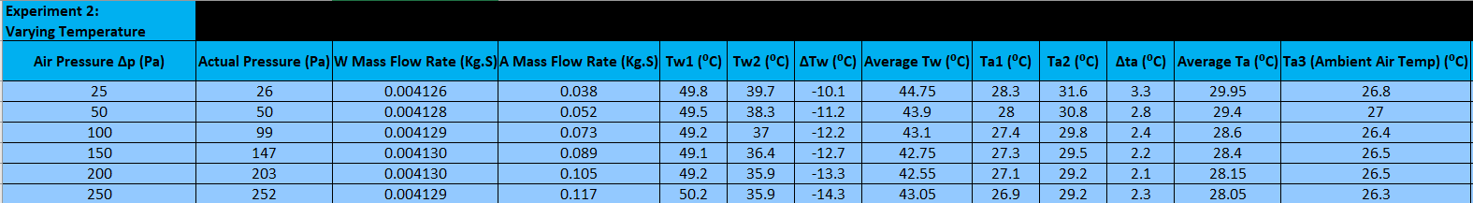
Experiment 3
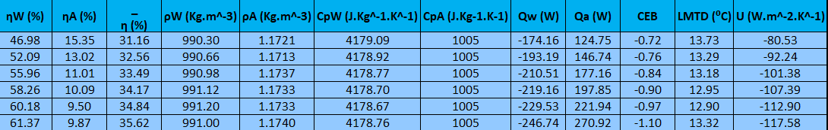
One issue I had to overcome when I came to plot my graphs was that they were in the wrong direction, to fix this I swapped the order of the tables around, from chronological to size order for either water pressure or air pressure, this way it gave the correct shape graph. The original order of experiment 1 can be seen below:
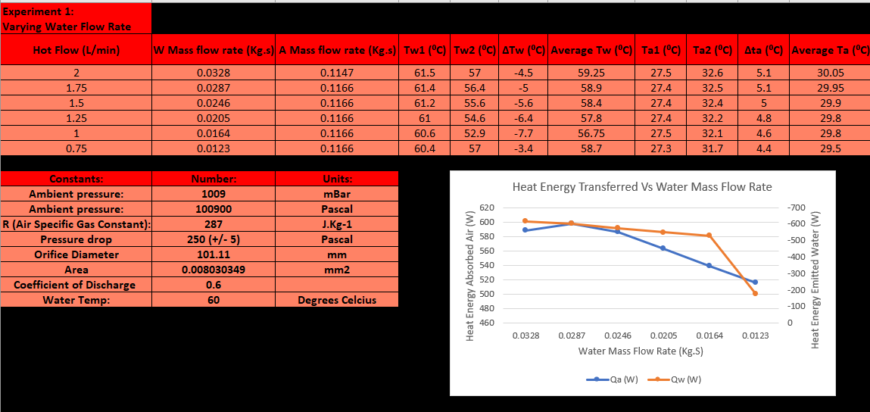
as you will see below, the graph above is the wrong shape to convey what is happening in the heat exchanger.

Graphs

Experiment 1

This graph shows that as the water mass flow rate increases so does the power/energy transfer between the water/air. The graph suggests that the peak energy transfer has occurred at around 0.0275Kg.s water flow and that the energy transfer will drop off , if the mass flow is further increased. If I compare this to the energy balance coefficient calculated (CEB) it varies from -0.95 to -1.04 this shows that there is a good energy balance coefficient.

In this graph you can see that the efficiency of both the water and air change with the increase in water mass flow rate, the temperature efficiency of the water decreases whereas the air temperature efficiency increases. This is expected due to the larger change in temperature from the input to the output for the water, as if you compare the temperature differences the water changes a maximum of 9.6 degrees whereas the air changes a maximum of 5.1 degrees. If you look at the grey line, the mean temperature efficiency you can see that it gradually decreases as water mass flow increases. This is to be expected as when the water mass flow is low the water is spending more time in the tubes and therefore the air is cooling it down for longer, whereas when the flow rate is increased the water spends less time in the tubes getting cooled down and therefore is less efficient.

From this graph its clear to see that increasing the mass flow rate has very little effect on the heat transfer coefficient, which suggests that there is no benefit to increasing the water mass flow.

Experiment 2

From this graph you can see that the energy being transferred between the water/air increases as the Mass air flow rate is increased. At the start of the graph the energy emitted by the water is higher than the energy being absorbed by the air, this could be due to the metalwork within the exchanger conducting some of the heat away, this is not an issue as the mass air flow is increased. The two lines converge at around 0.11kg.s mass air flow, which suggests that the energy emitted by the water will start to drop off further, however the energy absorbed by the air looks as if it will keep increasing with an increase in mass air flow, this suggests that the heat transfer between the 2 will still continue to increase despite the heat energy emitted by the water dropping off. The energy balance coefficient for this experiment varied from -0.728 to -1.027 so there is a wider spread than in experiment 1.

This graph shows that as the mass air flow is increased the temperature efficiency of the water increases as well, whereas the efficiency of the air decreases. This gives an average temperature efficiency which is gradually increasing, with no sign of dropping off.

This graphs shows that there is a fairly linear correlation between the heat transfer coefficient and the mass air flow rate, it also shows no sign of dropping off yet, so if the air flow was to continue increasing it looks as if the heat transfer coefficient will keep increasing too.

Experiment 3

This graph shows the same trend as experiment 2 whereby the energy transfer is increasing still as the mass air flow is increased, however unlike in experiment 2 where the 2 lines converge there is a much greater difference afterwards with the energy emitted by the water looking as if it is going to drop off; on the other hand the energy absorbed by the air seems to spike and looks as if it will increase further. The energy balance coefficient is also very similar going from -0.72 to -1.1 so it appears that overall it just lowered the energy being transferred. The graph below compares the energy emitted by the water at 50 degrees and at 60 degrees.

From this you can see that the lines still follow the same trend just the energy has been reduced due to the lower heat.

The results for the efficiencies are essentially identical to experiment 2, with the mean temperature efficiency increasing gradually.

The heat transfer coefficient follows the same trend as experiment 2, looking as if it will continue to follow the linear trend and keep increasing when the air mass flow rate is increased.

Conclusion
To conclude from the results it is evident that with the setup we used in the experiment, a 32-tube crossflow heat exchanger with the pipes attached in parallel, the more airflow going across the pipes the more heat transfer is going to occur. At a certain point, the energy emitted by the water starts to drop off however if you continued to increase the airflow further then the air would continue to absorb the heat energy from the water. It is also evident that the water flow rate has an effect on the efficiency of the heat exchanger so if you were to increase the flow rate of water, to maintain the efficiency you would also have to increase the airflow as well. This is evident in a cars radiator as when the car is moving faster there is more airflow through the radiator, however the coolant would be hotter as the engine would be producing more heat to go faster.
The only anomaly encountered was where the temperature took time to adjust between each experiment so the figures were not exactly as they should have been there was a minor discrepancy throughout the experiments. If I were to do this again, I would spend more time allowing the temperatures to settle therefore increasing the accuracy of the experiment, I would also have set out the tables before starting the experiment as it would have been easier to log them down.

References
Shell and tube diagram: http://www.kamui.co.jp/english/products/shell_and_tube/shell_and_tube_img02.jpg – accessed 24/04/2020
Plate type diagram:
(http://2.bp.blogspot.com/-04Oe7Q1Tsp4/VEtTvFoB1xI/AAAAAAAAAuI/cK2WeTC8itY/s1600/aa8aba1bb4af184c3a271d26409e9cd7518fe261_large.jpg, accessed 24/04/2020)
Parallel flow diagram:
(https://www.real-world-physics-problems.com/images/parallel_flow_heat_exch.png, accessed 24/04/2020)
Counterflow diagram:
(https://qph.fs.quoracdn.net/main-qimg-dede73cd9fa2c1c8f54069e0c91dedb0, accessed 24/04/2020)
Crossflow diagram:
(http://image.slidesharecdn.com/6chapter4heatexchanger-140329015915-phpapp02/95/heat-exchanger-8-638.jpg?cb=1396058411, accessed 24/04/2020)
Helical coil heat exchanger diagram:
https://en.wikipedia.org/wiki/Heat_exchanger#/media/File:HCHE.jpg, accessed 24/04/2020)
spiral type diagram:
(https://en.wikipedia.org/wiki/Heat_exchanger#/media/File:Spiral-heat-exchanger-schematic-workaround.svg, accessed, 24/04/2020)
32 tube heat exchanger parallel/series setup:
https://moodle.uwtsd.ac.uk/pluginfile.php/145911/mod_resource/content/1/TD1007_HX_laboratory_guide.pdf, last accessed 24/04/2020)

