
Lecturer Name: Afzal Munna
Student Name: Varzari Cristina
Student ID: 2110951
Module code : LCBB6000
Module Title: Dissertation

Dissertation
Topic: “DIGITAL MARKETING AND ITS IMPACT ON CONSTRUCTION COMPANIES”

Table of Contents
Chapter 1: Introduction 3
1.1 Statement of the Problem 3
1.2 Theoretical or Conceptual Framework 3
1.3 Statement of the Purpose 4
1.4 Research Questions 5
1.5 Significance of Study 5
Chapter 2: Review of Literature 6
2.1 Introduction 6
2.2 Theme-based Review 6
2.3 Literature gap 9
Chapter 3: Method 11
3.1 Introduction 11
3.2 Research Questions 11
3.3 Study Design 11
3.4 Study Context and Intervention 11
3.5 Participants 12
3.6 Data Sources. 12
3.7 Data Collection 12
3.8 Data Analysis 13
3.9 Ethical Considerations 13
3.10 Assumptions, Delimitations, and Limitations 13
3.11 Timeline 14
Chapter 4: Results 16
4.1 Introduction 16
4.2 Survey 16
4.3 Data Collection Table 22
4.4 Summary of data collection table findings/Analysis 27
Chapter 5: Conclusions 29
Reference List 31

Chapter 1: Introduction

1.1 Statement of the Problem
With the advent of digital marketing in the construction industry of the UK, businesses have increasingly adopted digital methods of marketing leading to influence their way of interacting with customers, and promoting their product products or services and also driving business growth. The construction industry traditionally known for its reliance on offline marketing has increasingly adapted to digital marketing practices that recognise the potential of digital marketing services to enhance overall brand image, streamline operations and also attract new clients. However, the main problem can be drawn from challenges imposed by digital marketing strategies to the business organisation within the construction of the UK (Yilmaz et al., 2023). This is because it is believed that the lack of knowledge regarding digital marketing services which encompasses the inability to develop effective marketing strategies, lack of customer knowledge, market trends and so on can have a negative influence on the overall digital marketing strategies.

1.2 Theoretical or Conceptual Framework
Theoretical framework
The theoretical framework for starting the digital market and its impact and construction companies integrates several key theories and concepts that help in understanding how digital marketing strategies have the ability to influence construction companies.
Diffusion of innovation theory: this theory developed by Rogers explores how new ideas and technologies are likely to spread within societies or organisations while being aware of their accessibility and uses. Referring to the research study, it can be said that Companies help identify that early adoption of digital marketing focuses on utilising key digital marketing services, and while also having the ability to be influenced by several factors (Acikgoz et al., 2023). The theory also highlights the role of opinion leaders and influences in driving adoption across the industry, leading to an impact on competitive dynamics and market position of construction companies.
Technology acceptance model or TAM: This theory is considered to suggest that usefulness and ease of use are the critical factors that have their ability to influence individuals to accept and adopt new technologies (Davis et al., 2024).
Applying to the research study here it can be said that digital marketing in construction companies is likely to perceive the benefits and ease of use of the digital marketing approaches for the business organisations that further helps in improving marketing effectiveness and customer engagement.
As a result they are likely to understand the usefulness of technology, and the digital marketing methods that lead to guiding their overall marketing strategies, and eventually accept the technology as a core marketing strategy and adopt it within the industry.
Marketing mix framework or 4ps of marketing: This marketing framework focuses on four pieces of marketing namely the product price, place, and promotion having key significance for the business organisations in their marketing plan. Out of the 4 Ps, promotion plays a key role as promotion is typically associated with activities used for promoting the product while also considering marketing techniques (Batat, 2024). Referring to the research study here it can be said that the construction companies promoting their business organisation and offerings by integrating digital channels such as social media marketing, email, and marketing services into the promotional mix leads to further enhancing the engagement and also conversion rates among the target audience as additional of which it will help the business organisation to have a positive outcome in the context of marketing approaches. Also to note that the theoretical framework helps in understanding how digital marketing strategies are more effective than other traditional marketing.
By applying all these theoretical frameworks and understanding the research has the ability to explore how digital marketing services can implement the overall business setting while also implementing core areas such as competitive advantage, brand perception, organisation, performance, customer service, and so on within the construction companies. Also to note that the theoretical framework helps in understanding the digital transformation journey while integrating effective digital marketing strategies that are tailored to the unique challenges and opportunities in the construction industry. Moreover, understanding the theoretical framework associated with the research study helps in bridging the gap between academic research and practical implications for the construction industry in the context of digital technologies and their impact.

1.3 Statement of the Purpose
This research study on the topic of understanding the impact of digital marketing and construction companies has been formulated to summarise and acknowledge the impact of digital marketing on the businesses within the construction industry of the UK.
It has the ability to enable future generations and business organisations to be aware of issues and challenges faced by the companies during the implementation of digital marketing strategies. This research study has also determined the purpose of using digital marketing strategies over traditional forms of marketing approaches while highlighting the key reason, benefits, and importance of digital marketing for business organisations in today's competitive and dynamic business landscape.

1.4 Research Questions
- What is the concept of digital marketing in construction companies?
- Why is digital marketing important for construction companies?
- What are the challenges of digital marketing faced by construction companies?
- What strategies can contribute to overcoming the challenges of digital marketing?

1.5 Significance of the Study
This research study is significant in nature as it has the ability to address a gap in understanding how digital marketing can be applied by construction companies to achieve business objectives while actively being aware of the benefits and challenges associated with it. As a part of this, it will enable the companies to have a diverse knowledge regarding the core importance of implementing digital marketing services over traditionally followed marketing approaches and also be aware of challenges while setting actionable steps to overcome them and have a successful implementation of the digital marketing strategies. The findings collected from the research study will help the marketers with the construction companies to benefit in the field of marketing with the help of several attention-seeking strategies and effective approaches for the audiences. The research study will also contribute to the research field of digital marketing in construction companies.

Chapter 2: Review of Literature

2.1 Introduction
The following chapter is focused on reviewing the literature while emphasising the theme-based review. The researcher has made use of research objectives as the key research team and explored, analysed and reviewed through the wide consideration of secondary sources and scholarly sources available on Google Scholar. The following literature review chapter serves the key purpose of offering a conceptual understanding of this research study while exploring different literatures and academic studies and perspectives.

2.2 Theme-based review
“Concept of digital marketing in the construction industry”
According to Nuseir et al. (2023), the concept of digital marketing in the construction industry typically represents a drastic shift from traditional approaches to the adoption of digital technology technologies and strategies to enhance overall effectiveness. Emphasising the UK industry, the businesses within the industry have gradually implemented digital marketing strategies in order to increase their marketing approaches' effectiveness and also address challenges such as market competition, changing consumer behaviour and technological advancements. The digital marketing in the construction industry typically encompasses the active utilisation of digital channels, technology, and strategies to promote businesses while also promoting their services to clients using online platforms. As per Musarat et al. (2023), The construction industry is historically known for its reliance on traditional marketing approaches but with globalisation and technological advancement, construction companies have increasingly embraced digital marketing to adapt to evolving consumer behaviours, technological advancement and to the competitor pressures in the industry. The adoption of digital markets can be typically drawn from the social media marketing approaches where in platforms such as Facebook, Instagram, and Twitter, art utilised by the construction companies to connect with stakeholders, share project updates and also engage with a broad audience. The application of social media services in the context of the digital magnet strategy has enabled the business organisation in the construction industry of the UK to brand awareness, establish relationships with clients and also reach wider audiences including key stakeholders, such as engineers, subcontractors, architects, and so on. As argued by Indahsari et al. (2023), traditionally construction companies relied on word of mouth and the print advertising method with the collective effort of promoting their businesses with traditional marketing approaches.
The construction companies made use of brochures, trade magazines and so on which led them to have limited exposure to the market and also to brand visibility. Moreover, as digital capabilities and advancement continue to evolve, construction companies that effectively integrate and innovate within digital magnets are likely to have positive outcomes and prosper in the competitive industry landscape.
“Significance of digital marketing for the construction industry”
According to Wang et al. (2023), digital marketing and its practice within the construction industry of the UK holds significant importance as it offers transformative opportunities to enhance the overall business organisation. One of the key advantages of digital marketing for construction companies can be drawn from its ability to enhance visibility and reach. This is because market approaches have the ability to enable construction companies to expand their reach beyond traditional geographic limitations, while also leading to have improvement of their business and reach to the wider customer segment. Through the application of search engine optimisation, digital channels or approaches, the companies can improve their website visibility in search engine results will also attract more potential clients from the global level. Likewise, the social media platforms like Twitter, and Instagram provide platforms to showcase projects and connect with a broader audience of clients that eventually increase the overall brand visibility and reach. It is to also note that it is by getting approach is significant for the construction companies as the ability to help in targeted marketing and lead generation, this is so because it is believed that the digital marketing practice has the ability to allow the construction companies to target specific demographics, industries and geographic areas leading to have reached potential clients based on their interest and also their such intent. Such a targeted approach has the ability to increase the likelihood of generating qualified leads and convergence that increases the optimisation as companies compare to the traditional marketing methods. As per Khan and Siddiqui (2023), cost-effectiveness remains to be one of the biggest advantages of digital marketing operators for construction companies. This is because digital platforms and channels are likely to be available on the Internet leading to a cost-effective approach towards promoting the brand and the services as compared to the traditional advertising channels like print media and direct mail. Digital bargaining is far more cost-effective in nature also allowing the construction companies to allocate resources efficiently, optimise market spend and have potential benefits. Therefore, all these benefits help in understanding the key significance of digital marketing for the construction industry.

“Challenges of digital marketing for the construction industry”
According to Xia et al. (2023), despite the advantageous outcomes, digital marketing practices also have the ability to impose certain challenges for construction companies that lead to creating barriers to the successful implementation of digital marketing strategies. One of the key challenges to digital marketing that can be faced by construction companies within the industry is resistance to change. This is because it is believed that the construction industry is known for its conservative approach and overreliance on traditional methods. As a result, it may have the ability to create resistance within the forms to adopt digital marketing due to the unfamiliarity, lack of digital skills, the perceived complexity of the technological systems and also scepticism regarding the effectiveness of digital channels compared to the traditional networking and approaches. Likewise, another challenge has the ability to stem from the construction project complexities in the context of services and products. This is so because construction projects are often complex and typically involve specialised services, long project timelines and so on. As a result, it might be difficult to communicate the complexities and demonstrate expertise through the use of digital channels. Also, content creation with the application of digital solutions must strike a balance between technical detail and accessibility to resonate with the inner professionals which can be challenging for construction companies. As per Economou et al. (2023), it is believed that construction projects are likely to be localised with regulations and quotes across the different operating regions. As a result , it may have the ability to create difficulty for the construction companies to address regional norms and compliance requirements through digital marketing. Such localisation typically contributes towards the complexity of the content creation and also targets specific geographic customer segments. The construction industry is highly competitive in nature as many construction companies have already embraced digital technologies which might create challenges for other companies to stand out in a competitive landscape. As a result, it may be required for business organisations in the construction industry to have innovative strategies that differentiate themselves from the existing brands in the online platforms. Therefore, it can be said that digital marketing presents significant challenges for the construction industry and overcoming such challenges typically requires strategic planning and adaptation to industry-specific requirements.

“Strategies which can contribute to overcoming the challenges of digital marketing for the construction industry”
According to Barbosa et al. (2023), the construction companies in the context of digital marketing approaches can focus on developing content marketing that is highly innovative and informative in nature that is tailored to the construction industry, unique needs and challenges. As a part of this construction businesses within the industry focus on utilising case studies projects, and also technical articles to demonstrate the expertise of their business services and further enhance the business credibility. To be more specific, construction companies can make use of detailed project case studies on their online websites to highlight their capabilities and also attract potential clients searching for similar services. As a result, it will allow the companies to have an appealing content marketing approach that also helps in developing unique marketing approaches and helps in gaining a competitive advantage. Similarly, construction companies can even focus on implementing customer relationship, management or CRM systems like SalesForce, and HubSpot. Ultimately it will help the companies to manage lead track, and client interactions and also personalise the marketing efforts the system will allow the company to facilitate effective lead nurturing processes. While also managing the custom relationship through the application of digital channels to be more specific. The construction companies can make use of customer relationship management systems to streamline the communication with potential clients and also understand their basic needs and preferences ultimately helping in improving the conversion rate and addressing the client request. According to Bühler (2023), navigating challenges in the context of digital marketing channels for construction companies can also involve collaborating with industry partners to enhance digital marketing efforts. Also note that the company can focus on partnering with architecture engineers and suppliers on joint marketing initiatives that lead to fostering credibility and expanding the business reach to be more specific. The construction companies can collaborate and partner up with the technology providers to showcase innovative methods and solutions that lead to enhancing the overall brand offerings and also promotional activities

2.3 Literature gap
The key literature gap that can be drawn from the above literature includes the lack of longitudinal studies to check the digital marketing efforts over extended periods to understand their substance effect on brand perception, market share and customer service in the construction industry. The above also fails to incorporate the contemporary understanding of the utilisation of construction companies to showcase how digital marketing has the ability to favour the brand and also the challenges experienced by them.

Chapter 3: Method

3.1 Introduction
The following chapter has been based on demonstrating and understanding the research methods and techniques utilised to collect, interpret and analyse data and information. In addition, the researcher has made use of a wide variety of research methods and techniques under specific research contexts by considering their suitability and effectiveness.

3.2 Research Questions
- What is the concept of digital marketing in construction companies?
- Why is digital marketing important for construction companies?
- What are the challenges of digital marketing faced by construction companies?
- What strategies can contribute to overcoming the challenges of digital marketing?

3.3 Study Design
Study design or research design typically refers to the overall plan and structure that guides the collection analysis and interpretation of research data. It typically outlines the framework within which the researcher will be able to collect data and address the research problem and questions effectively. Some of the key study designs include experimental design, quasi-experimental design, qualitative research design, quantitative research design, mixed research design and so on. Among the key types, the researcher has made use of mixed research design wherein the researcher has combined both quantitative and qualitative methods to provide a comprehensive understanding of digital marketing impacts while considering both of the methods (Hirose and Creswell, 2023). The application of mixed research methods has enabled a holistic view that has helped in diverse results to understand the research topic.

3.4 Study Context and Intervention
The study context is focused on investigating the impact of digital marketing and construction companies. As a part of this, the researcher has focused on investigating the positive impact while focusing on the key benefits and significance of digital marketing for construction companies over traditional marketing approaches. Furthermore, the research has also focused on investigating the challenges imposed by digital marketing services to construction companies while also fostering and suggesting ways to overcome and navigate the challenges in the context of digital marketing implementation.

3.5 Participants
The participants for this research study have been selected with the consideration of a simple random sampling method. Since the researcher has made use of a quantitative survey based on 6 questions the participants are focused among the 20 participants from the construction industry of the UK.

3.6 Data Sources.
In order to collect the data research has made use of two data sources namely surveys for quantitative data and secondary sources for qualitative data. A survey as the data source is typically based on the practice of gathering information from a sample of respondents through standardised questions. The practice of survey as a data source has enabled the researcher to have efficient data gathering across diverse populations, leading to having quantitative responses for the statistical analysis in understanding the research study. In addition, it has enabled the researcher to have candid responses on the sensitive topics that provide valuable insights into the attitude, behaviour and preferences of the participants making the survey a versatile tool for analysing the research questions. On the other hand, the researcher has also made use of secondary data sources that have provided valuable insights for gathering existing information without the need for primary data collection across the journals extracted from Google Scholar (Zahle, 2023). For the qualitative research approach, the researcher has focused on utilising 10 highly informative journals relevant to the research topic. In the process of selecting the participants for the survey, the researcher has made use of ethical conduct by formally approaching through an email with full informed consent and voluntary participation. Also to note that the practice of simple random sampling method has enabled in elimination of any forms of biases in selecting the population for the research study.

3.7 Data Collection
Data collection is typically referred to as the practice of collecting data with the active utilisation of techniques and tools. There are typically two types of data collection methods such as primary data collection and secondary data collection. The researcher has made use of both data collection methods, primary data collection has been used with a focus on collecting primary and quantitative data from primary sources such as surveys. The application of primary data collection has enabled the researcher to have accuracy, reliability and relevance of the data collected (Wallwey and Kajfez, 2023). On the other hand, a secondary data collection method has been used with an active focus on collecting and gathering information from secondary sources such as journals. The practice of the secondary data collection method has an the researcher collect data from white variety of sources that are accessible through various channels, leading to a broad range of information across different topics and disciplines associated with the research study.

3.8 Data Analysis
In the context of analysing primary data collected from the survey, the researcher has made use of statistical data analysis methods. This data analysis method is about the researcher to uncover patterns and relationships within the responses and further derive a statistical understanding of research themes and topics (Peck et al., 2020). On the other hand, the data collected through secondary data collection has made use of a thematic analysis table wherein the research themes are explored using secondary sources and analysed by showcasing your publication, author's reason for inclusion and descriptive analysis.

3.9 Ethical Considerations
The overall research study has been developed in an ethical manner by considering a wide variety of research ethics principles. To be more specific, the participants for the research study have been approached in a formal manner with their own will, reflecting the voluntary participation in research ethics considerations. Likewise, the researcher has also maintained anonymity and confidentiality by presenting the survey responses in an anonymous manner and the participant's names and personal names are confidential in nature. Also to note that all the physical, social and psychological potential harms are kept at a minimum for the safety of the participants.

3.10 Assumptions, Delimitations, and Limitations
In the context of assumptions, the researcher has assumed that the participants will respond truthfully in surveys and also noted that these certain variables are related to the existing vertical framework. In the context of the delimitations which refers to certain specific boundaries and limitations that the researcher has set within the study, it includes that the survey participants are only the employees working within the construction industry of the UK. Lastly, the limitation emphasises the factors that constrain the validity of the research study including the complexity imposed by the quantitative and qualitative findings as it may result in dynamic and complex data outcomes.

3.11 Timeline
Time Prospects
Activities | Start Date | End Date | Duration in days
Selecting research topic | 9 Apr | 11 Apr | 2
Analysing aims and objectives | 12 Apr | 16 Apr | 4
Reviewing different literature | 17 Apr | 25 Apr | 8
Analysing data analysis method | 26 Apr | 2 May | 6
Conducting research | 3 May | 11 May | 7
Analysing research outcome | 12 May | 18 May | 6
Compilation of the research | 19 May | 21 May | 2
Table No. 1: Work Breakdown Structure
(Source: learner)

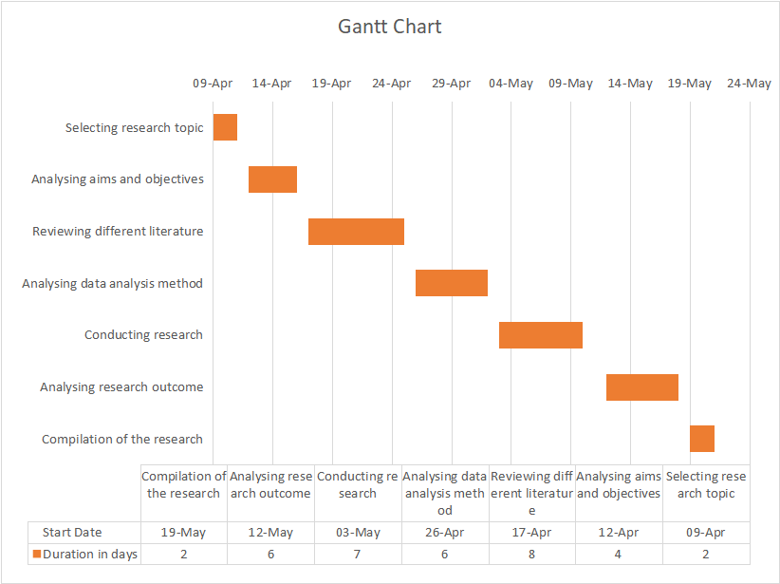
Chart No. 1: Gantt Chart
(Source: Learner)

Chapter 4: Results

4.1 Introduction
The researcher initially conducted a survey based on 6 questions among the 20 participants working within the construction industry of the UK.

4.2 Survey

Question 1 | For how long have you been working within the construction industry of the UK?
Options | Total Participants | Responses | Percentage
2 to 3 years | 20 | 12 | 60%
More than 3 years | 20 | 6 | 30%
Prefer not to answer | 20 | 2 | 10%
Table 02: Survey Question 1
Source (created by the learner)
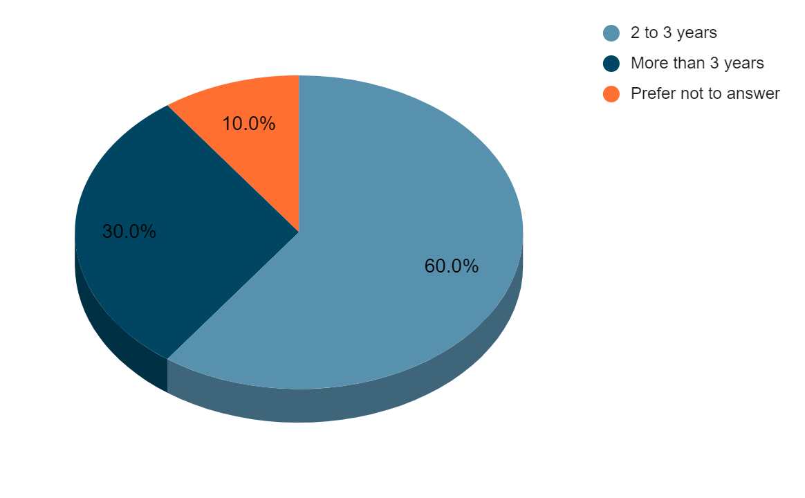

Figure 02: Survey Question 1
Source (created by the learner)
Analysis: From the above table and illustrated figure here it can be said that 60% of the survey participants have been working within the construction industry of the UK for 2 to 3 years. Likewise, 30% of the survey participants have been working for more than 3 years. Also to note that 10% of the server did not refer to the answer to the present question.

Question 2 | How do you perceive digital marketing approaches over traditional marketing approaches?
Options | Total Participants | Responses | Percentage
Digital marketing involves use of digital tools | 20 | 8 | 40%
Digital marketing is more effective than traditional marketing | 20 | 10 | 50%
Prefer not to answer | 20 | 2 | 10%
Table 03: Survey Question 2
Source (created by the learner)
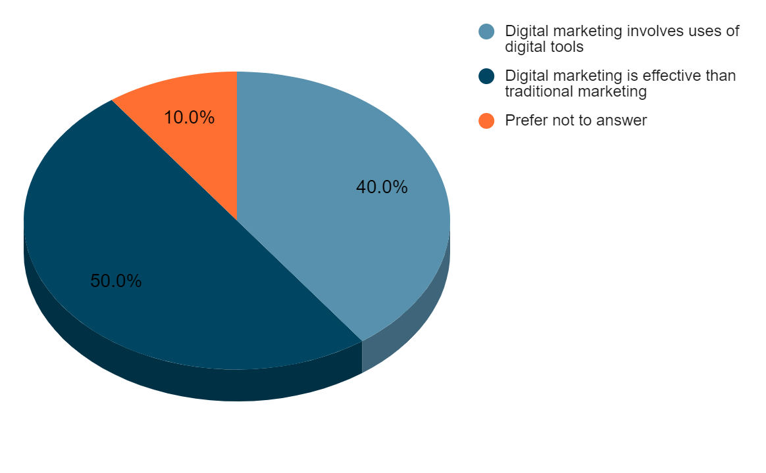

Figure 03: Survey Question 2
Source (created by the learner)
Analysis: From the above illustrated figure and table here it can be said that 50% of the participants believe that digital marketing is more effective than traditional marketing leading to indicate their perception regarding the digital marketing approach over traditional marketing approaches. Likewise, 40% of the survey participants believe that digital marketing involves the use of digital tools. Also to note that 10% of participants did not prefer to answer.

Question 3 | Do you believe that digital marketing has influenced brand visibility and recognition within the industry?
Options | Total Participants | Responses | Percentage
Yes | 20 | 15 | 75%
No | 20 | 5 | 25%
Prefer not to answer | 20 | 0 | 0%
Table 04: Survey Question 3
Source (created by the learner)
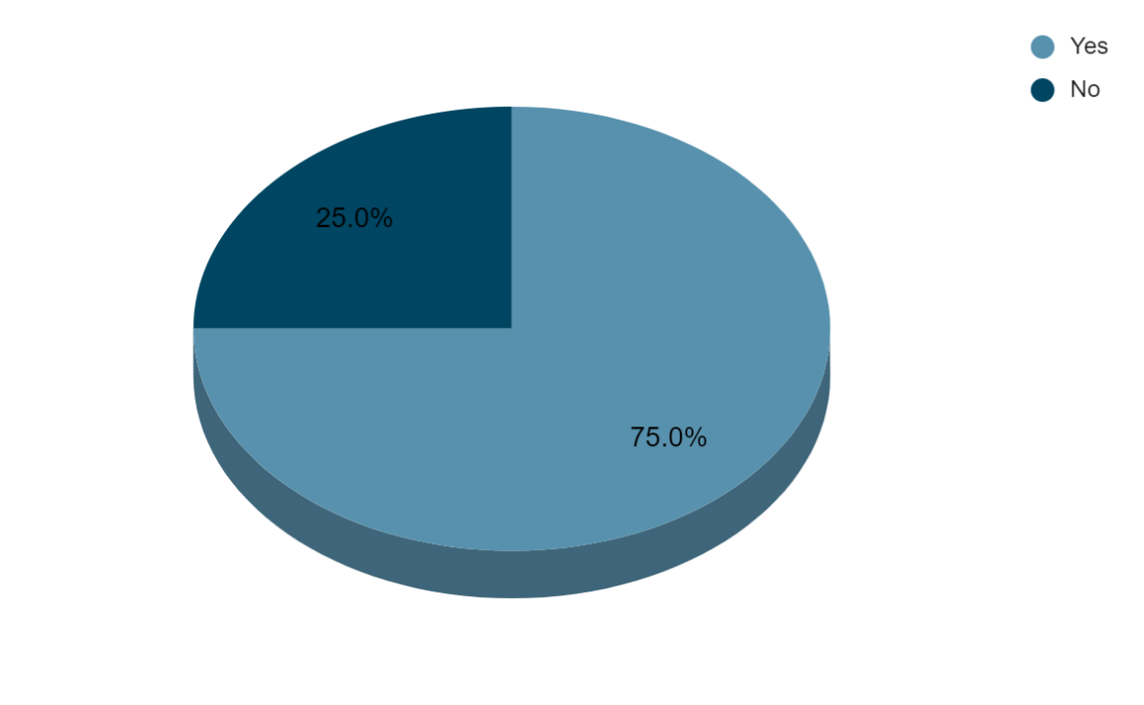
Figure 04: Survey Question 3
Source (created by the learner)
Analysis: From the above, illustrated figure and table, it can be said that 75% of the employees agreed that digital marketing has influenced brand visibility and recognition within the construction industry. On the other hand, 25% of the survey participants do not agree that digital marketing has influenced brand visibility and organisation within the industry.

Question 4 | Among the list which is one of the potential advantages that compels the significance of digital marketing for construction businesses?
Options | Total Participants | Responses | Percentage
Cost-effectiveness | 20 | 13 | 65%
Targeted marketing approach | 20 | 7 | 35%
Prefer not to answer | 20 | 0 | 0%
Table 05: Survey Question 4
Source (created by the learner)
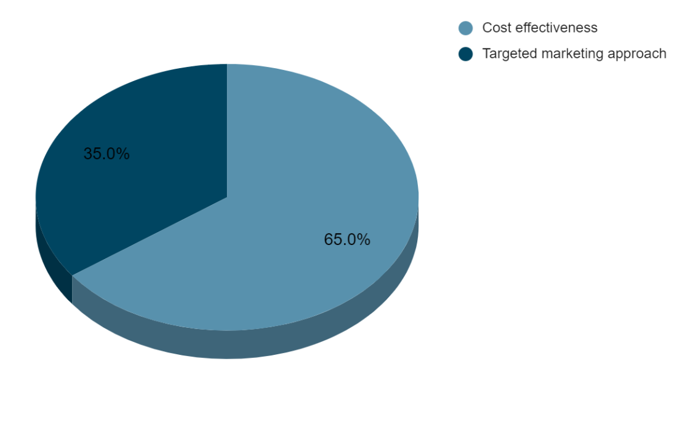
Figure 05: Survey Question 4
Source (created by the learner)
Analysis: From the above-illustrated figure and table here it can be said that 65% of the survey participants believe that cost-effectiveness is one of the potential advantages that compels the significance of digital marketing for construction businesses. On the other hand, 35% of the survey participants believe that targeted parking approaches as the potential advantages that compel the significance of digital marketing for construction businesses.

Question 5 | Which among the lists can be seen as the primary challenge faced by construction companies in digital marketing implementation?
Options | Total Participants | Responses | Percentage
Security challenge | 20 | 16 | 80%
Resistance to change | 20 | 3 | 15%
Prefer not to answer | 20 | 1 | 5%
Table 06: Survey Question 5
Source (created by the learner)
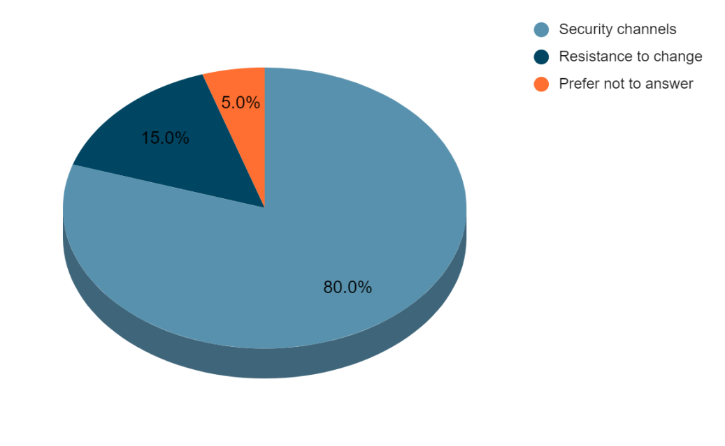
Figure 06: Survey Question 5
Source (created by the learner)
Analysis: from the above-illustrated figure and table here, it can be said that 80% of the survey participants believe that security is the primary challenge faced by construction companies in the context of digital marketing implementation. On the other hand, 15% of the survey participants believe that resistance to chains is the primary challenge faced by construction companies in digital marketing implementation. Also to note that 5% of the server participants did not prefer to answer.

Question 6 | Suggest a method to develop effective digital marketing initiatives for construction companies.
Options | Total Participants | Responses | Percentage
Developing comprehensive plan | 20 | 12 | 60%
Using KPIs in Initiatives | 20 | 8 | 40%
Prefer not to answer | 20 | 0 | 0%
Table 07: Survey Question 6
Source (created by the learner)
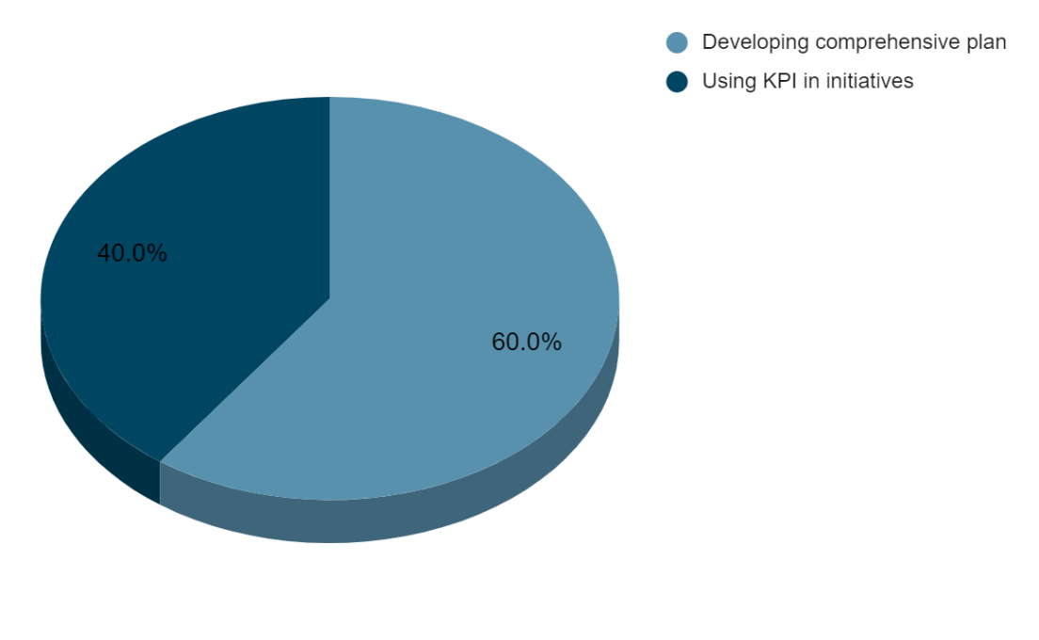
Figure 07: Survey Question 6
Source (created by the learner)
Analysis: From the above-presented table and figure here, it can be said that 60% of the survey participants believe that developing comprehensive plans is a method to develop effective digital marketing initiatives. 40% of the server participants believe that using KPI in initiatives is a method to develop effective digital initiatives for construction companies.

4.3 Data collection table

SL NO | Themes | Author and Year of Publication | Title/Topic | Reason for inclusion
1 | Concept of digital marketing in construction companies | - Mihajlović, L.S. and Mihajlović, M., (2023). | Digital Marketing in Practice. | The key reason for the inclusion of this source is that it has focused on explaining digital marketing and its practices while emphasising practical applications.
2 | Concept of digital marketing in construction companies | - Drugova, E.S., Zhelnovakova, M.F., Pomuleva, Y.A. and Vayrakh, Y.V., (2022) | Digital marketing technologies in the promotion of modern construction organisations | The reason for the inclusion of this source is that it helps in understanding the concept of digital marketing and its uses to promote modern construction organisations.
3 | Concept of digital marketing in construction companies | - Yurchuk, N., (2021). | Digital marketing tools in the context of digitization processes. | the reason for the inclusion of this source is that it helps in understanding the wide variety of digital marketing tools in the context of digitisation processes are also in answering the represented theme
4 | Importance of digital marketing for construction companies | - Malesev, S. and Cherry, M., (2021) | Digital and social media marketing market share for construction SMEs | the key reason for the inclusion of this source is that it helps in understanding the significance of digital marketing for construction companies while focusing on social media marketing and the growing market share
5 | Importance of digital marketing for construction companies | - Hussain, H.N., Alabdullah, T.T.Y., Ries, E. and Jamal, K.A.M., (2023). | Implementing Technology for Competitive Advantage in Digital Marketing. | the key reason for the inclusion of this source is that it helps in understanding the advantages of implementing technology for competitive advantage, which further helps in demonstrating the significance of digital marketing for construction companies
6 | Importance of digital marketing for construction companies | - Denga, E.M., Vajjhala, N.R. and Rakshit, S., (2022) | The role of digital marketing in achieving sustainable competitive advantage | the key reason for the inclusion of this source is that it helps in understanding the key role played by digital marketing for construction companies in terms of benefits and also demonstrates the significance of its application
7 | Challenges of digital marketing for construction companies | - Setkute, J. and Dibb, S., (2022). | “Old boys' club”: Barriers to digital marketing in small B2B firms. | the key reason for the inclusion of this source is that it helps in understanding the barriers to digital marketing in the construction forms, while also answering the challenges faced by the company in terms of barriers to digital marketing
8 | Challenges of digital marketing for construction companies | - Herrhausen, D., Miočević, D., Morgan, R.E. and Kleijnen, M.H., (2020). | The digital marketing capabilities gap | the key reason for the inclusion of the source is that it helps in assigning the potential gap of digital-making capabilities that have the ability to face the construction companies
9 | Strategies which can contribute to overcoming the challenges of digital marketing in construction companies | - Nikmehr, B., Hosseini, M.R., Martek, I., Zavadskas, E.K. and Antucheviciene, J., (2021). | Digitalization as a strategic means of achieving sustainable efficiencies in construction management: A critical review | The key reason for the inclusion of this source is that it helps in understanding the various means of digital marketing services that can help in achieving sustainable efficiencies and construction management and also for effective marketing initiatives.
10 |  | - Behera, R.K., Bala, P.K., Rana, N.P. and Kizgin, H., (2022). | Cognitive Computing Based Ethical Principles for Improving Organisational Reputation: A B2B Digital Marketing Perspective | the key reason for the inclusion of the sources is that it has focused on answering the strategies which can further contribute to the overcoming challenges of digital marketing in the construction companies
Table 08: Thematic table
Source (created by the learner)

4.4 Summary of Data Collection Table Findings/Analysis
“Concept of digital marketing in construction companies”
The above theme has been analysed from a wide perspective using different journals and articles. As per Mihajlović and Mihajlović (2023), digital marketing is typically referred to as the practice of online marketing with the usage of online platforms, such as social media platforms, email marketing and so on. As per Drugova et al. (2022), modern construction organisations are rapidly adapting the concept of marketing through the use of digital channels and platforms that provide them with enhanced business marketing opportunities. As per Yurchuk (2021), the new concept of marketing that is influenced by digital media, advertising and marketing tools is referred to as digital marketing which allows the construction companies to have a digitisation process. It is beneficial for increasing brand image, visibility and wider customer reach.
“Importance of digital marketing for construction companies”
The above theme has been analysed from a wide perspective using different journals and articles. Out of sources, and studies claimed by Denga et al. (2022), digital marketing has the ability to create a sustainable competitive advantage for the business organisation. This is because the digital marketing initiatives and practices and the business organisations to have a wider reach of audiences developed personalised marketing approaches by customer needs preferences that eventually upon meeting help in deriving the sales. As areas in which it provides the business organisation with potential advantages, including competitive advantage in the market.
“Challenges of digital marketing for construction companies”
The above theme has been analysed from a wide perspective using different journals and articles. Setkute and Dibb (2022), suggest that one of the key challenges faced by the business or additions in the context of digital marketing include inconsistent content. This is so because many business organisations tend to lack creativity and innovative skills which leads to delivering ineffective content as an effective and engaging content necessary for making initiative.
“Strategies which can contribute to overcoming the challenges of digital marketing in construction companies”
The above theme has been analysed from a wide perspective using different journals and articles. Nikmehr et al. (2021), suggested that business in order to create effective decision, making strategies needs to focus on adapting to the different market requirements from constant monitoring to the practice of analysing the market trends that help in positioning their marketing initiative directly to the consumer preferences and market trends and eventually have a positive outcome.

Chapter 5: Conclusions
The findings gathered from the survey, data collection table and literature review help in having vast amounts of quantitative data and qualitative information which collectively helps in addressing the research objectives, research and overall aim. The research question of understanding the concept of digital marketing has been addressed and achieved from the findings gathered from the survey, data collection table and literature review. As per the literature review findings, digital marketing in the construction industry typically represents a drastic shift from traditional approaches to the adoption of digital technologies and strategies to enhance overall effectiveness (Nuseir et al., 2023). In contrast to the findings of the survey, it has been identified that 40% of the participants perceive digital marketing as a marketing that involves the use of digital tools, likewise, 50% of the survey participants believe that digital marketing is an approach that is more effective than traditional marketing. From the findings of the data collection table, the new concept of marketing that is influenced by digital media, advertising and marketing tools is referred to as digital marketing which allows the construction companies to have a digitisation process. It is beneficial for increasing brand image, visibility and wider customer reach (Yurchuk, 2021).
The research question of analysing the importance of digital marketing for construction companies has been addressed from findings gathered from the survey, data collection table and literature review. As per the findings of the literature review, it has been found that the social media platforms like Twitter, and Instagram provide platforms to showcase projects and connect with a broader audience of clients eventually increasing the overall brand visibility and reach. It is to also note that it is by getting approach is significant for the construction companies as the ability to help in targeted marketing and lead generation, this is so because it is believed that the digital marketing practice has the ability to allow the construction companies to target specific demographics, industries and geographic areas leading to have reached potential clients based on their interest and also their such intent. Such a targeted approach has the ability to increase the likelihood of generating qualified leads and convergence that increases the optimisation as companies compare to the traditional marketing method ( Wang et al., 2023). As per the findings of the survey, it has been identified that 65% of the server participants believe that digital marketing services are cost-effective which compels the significance of digital marketing practices for the construction businesses. From the findings of the data collection table, it has been identified that digital marketing has the ability to create a sustainable competitive advantage for the business organisation (Malesev and Cherry, 2021).

The third research question of evaluating the challenges of digital marketing for construction companies has been addressed from the findings of the survey, literature review and data collection table. As per the findings of the literature review, it has been identified that One of the key challenges to digital marketing that can be faced by construction companies within the industry is resistance to change. This is because it is believed that the construction industry is known for its conservative approach and overreliance on traditional methods (Xia et al., 2023). The fourth research question of analysing the strategies which can contribute to overcoming the challenges of digital marketing in construction companies has been addressed from the findings of the survey, literature review and data collection table. From the survey findings, it is believed that 60% of the survey participants believe that developing comprehensive plans is a method for developing effective digital marketing initiatives.

Reference List
Acikgoz, F., Elwalda, A. and De Oliveira, M.J., (2023). Curiosity on cutting-edge technology via the theory of planned behaviour and diffusion of innovation theory. International Journal of Information Management Data Insights, 3(1), p.100152.
Barbosa, B., Saura, J.R., Zekan, S.B. and Ribeiro-Soriano, D., (2023). Defining content marketing and its influence on online user behaviour: a data-driven prescriptive analytics method. Annals of Operations Research, pp.1-26.
Batat, W., (2024). Why is the traditional marketing mix dead? Towards the "experiential marketing mix"(7E), a strategic framework for business experience design in the digital age. Journal of Strategic Marketing, 32(2), pp.101-113.
Behera, R.K., Bala, P.K., Rana, N.P. and Kizgin, H., (2022). Cognitive computing based ethical principles for improving organisational reputation: A B2B digital marketing perspective. Journal of Business Research, 141, pp.685-701.
Bühler, M.M., Nübel, K., Jelinek, T., Riechert, D., Bauer, T., Schmid, T. and Schneider, M., (2023). Data cooperatives as a catalyst for collaboration, data sharing and the digital transformation of the construction sector. Buildings, 13(2), p.442.
Davis, F.D., Granić, A. and Marangunić, N., (2024). The technology acceptance model: 30 years of TAM. Springer International Publishing AG.
Denga, E.M., Vajjhala, N.R. and Rakshit, S., (2022). The role of digital marketing in achieving sustainable competitive advantage. Digital Transformation and Internationalization Strategies in Organizations, pp.44-60.
Drugova, E.S., Zhelnovakova, M.F., Pomuleva, Y.A. and Vayrakh, Y.V., (2022), August. Digital marketing technologies in the promotion of modern construction organizations. In AIP Conference Proceedings (Vol. 2434, No. 1). AIP Publishing.
Economou, E., Luck, E. and Bartlett, J., (2023). Between rules, norms and shared understandings: how institutional pressures shape the implementation of data-driven communications. Journal of Communication Management, 27(1), pp.103-119.
Herhausen, D., Miočević, D., Morgan, R.E. and Kleijnen, M.H., (2020). The digital marketing capabilities gap. Industrial Marketing Management, 90, pp.276-290.
Hirose, M. and Creswell, J.W., (2023). Applying core quality criteria of mixed methods research to an empirical study. Journal of Mixed Methods Research, 17(1), pp.12-28.
Hussain, H.N., Alabdullah, T.T.Y., Ries, E. and Jamal, K.A.M., (2023). Implementing Technology for Competitive Advantage in Digital Marketing. International Journal of Scientific and Management Research, 6(6), pp.95-114.
Indahsari, B., Heriyadi, H., Afifah, N., Listiana, E. and Fauzan, R., (2023). The Effect of Online Advertising and Electronic Word of Mouth on Purchase Intention through Brand Image as a Mediating Variable. South Asian Research Journal of Business and Management, 5(1), pp.1-9.
Khan, F. and Siddiqui, K., (2023). The importance of digital marketing. An exploratory study to find the perception and effectiveness of digital marketing amongst the marketing professionals in Pakistan.
Malesev, S. and Cherry, M., (2021). Digital and social media marketing market share for construction SMEs. Construction Economics and Building, 21(1), pp.65-82.
Mihajlović, L.S. and Mihajlović, M., (2023). Digital Marketing in Practice. SCIENCE International Journal, 2(4), pp.25-31.
Musarat, M.A., Irfan, M., Alaloul, W.S., Maqsoom, A. and Ghufran, M., (2023). A review of the way forward in construction through Industrial Revolution 5.0. Sustainability, 15(18), p.13862.
Nikmehr, B., Hosseini, M.R., Martek, I., Zavadskas, E.K. and Antucheviciene, J., (2021). Digitalization as a strategic means of achieving sustainable efficiencies in construction management: A critical review. Sustainability, 13(9), p.5040.
Nuseir, M.T., El Refae, G.A., Aljumah, A., Alshurideh, M., Urabi, S. and Kurdi, B.A., (2023). Digital marketing strategies and the impact on customer experience: A systematic review. The Effect of Information Technology on Business and Marketing Intelligence Systems, pp.21-44.
Peck, R., Short, T. and Olsen, C., (2020). Introduction to statistics and data analysis. Cengage Learning.
Setkute, J. and Dibb, S., (2022). “Old boys' club”: Barriers to digital marketing in small B2B firms. Industrial Marketing Management, 102, pp.266-279.
Wallwey, C. and Kajfez, R.L., (2023). Quantitative research artefacts as qualitative data collection techniques in a mixed methods research study. Methods in Psychology, 8, p.100115.
Wang, R., Bush-Evans, R., Arden-Close, E., Bolat, E., McAuley, J., Hodge, S., Thomas, S. and Phalp, K., (2023). Transparency in persuasive technology, immersive technology, and online marketing: Facilitating users' informed decision making and practical implications. Computers in Human Behavior, 139, p.107545.
Xia, L., Baghaie, S. and Sajadi, S.M., (2023). The digital economy: Challenges and opportunities in the new era of technology and electronic communications. Ain Shams Engineering Journal, p.102411.
Yilmaz, G., Salter, L., McFarlane, D. and Schönfuß, B., (2023). Low-cost (Shoestring) digital solution areas for enabling digitalisation in construction SMEs. Computers in Industry, 150, p.103941.
Yurchuk, N., (2021). Digital marketing tools in the context of digitization processes. The Scientific Heritage, (61-1), pp.32-41.
Zahle, J., (2023). Reactivity and good data in qualitative data collection. European Journal for Philosophy of Science, 13(1), p.10.

