Tom Schultze
11/05/20 13:00
Mathematics M4X00391
I need a word count of twenty words so please ignore me fluffing the word doc up
Q2
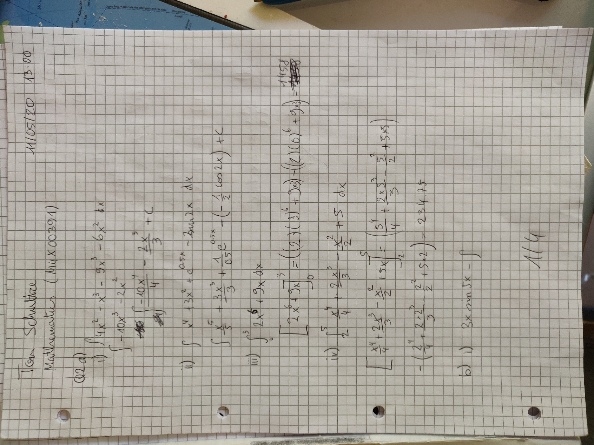
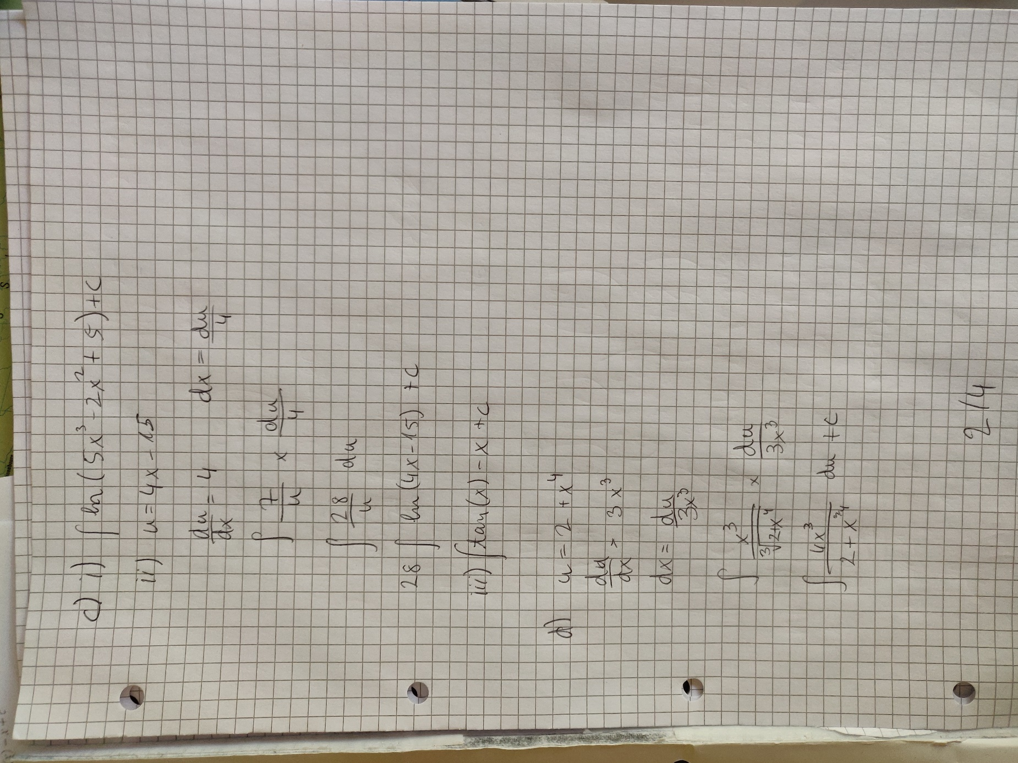
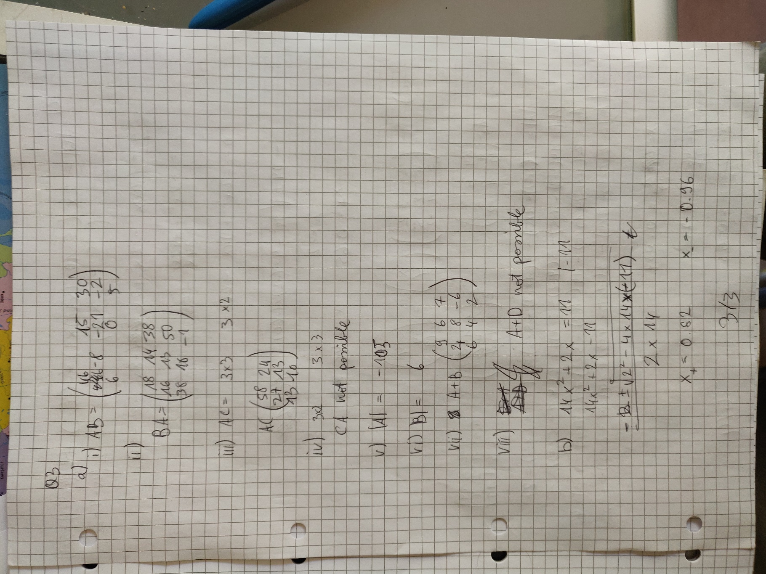
Q3



