Business Skills for International Hotel Industry

Module code:M4X01917
Name: Simona Elena Pavalache
Student Number: 1816300
Lecturer: Dale Clark
Written Assignment part 1

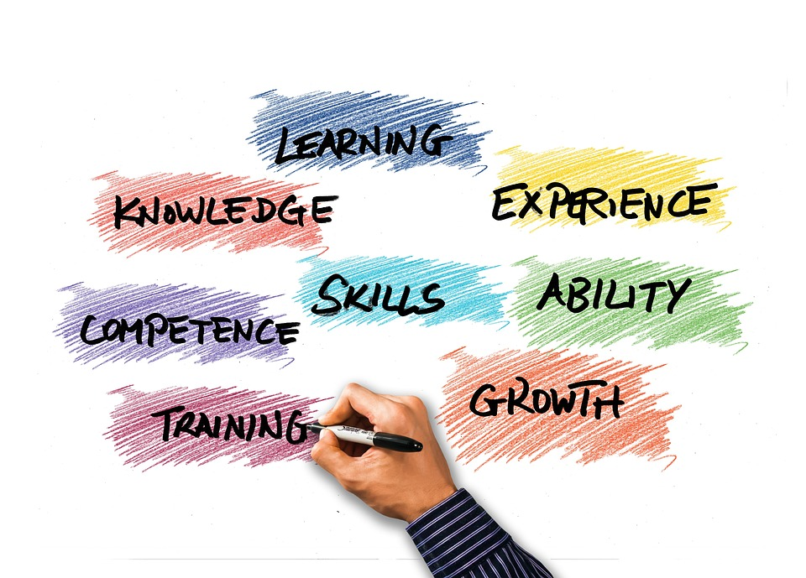
Table of content
Content…………………………………………………………………………………..1
Introduction…………………………………………………………………………….1
SWOT……………………………………………………………………………………….1-2
Personal Development Plan PDP……………………………………………….3
Skills…………………………………………………………………………………………3-4
Conclusion…………………………………………………………………………………5
References………………………………………………………………………………..6

INTRODUCTION
To present this assignment, I will talk about myself and my current academic and employability skills. As part of my analysis I will also create and talk about my SWOT analysis and outline my Personal Development Plan (PDP) so I will know what more I can develop or learn in future as well of what I need to change and also outline how I intend to use these skills to become a Hotel manager. First, I am 27 years old, and I am from Romania, I used to work as a waitress back in my country for a few years, and I used to love the job. Despite having quite good working conditions, I'm was always looking for opportunities to advance in my career, but every I was failed because of my Academic skills. And now because I am at the university, I believe that I can develop and expand both academic and employability skills.

SWOT
SWOT analysis his date it way back from the year of the 1960s. (Learned et al., 1965). Because the SWOT analysis is a method used to evaluate Strengths, Weakness, Opportunities and Threats (SWOT). SWOT analysis is an essential tool in decision-making and is very often used to systematically analyse the strategic situations and identify the level of organisations for internal and external environments (Gao, C-Y., and Peng, D-H., 2011). Developing my SWOT is not that easy as it sounds. For creating my personal SWOT, I asked my friends and family about what my strengths and my weaknesses are. The strong points represented by the skills, competencies, knowledge of a specific field or professional experience, characteristics that differentiate us from others. That can help us to achieve a goal. And for the weakness’s points are all personal aspects but which can be impediments when we are proposing something, and it is good to consider them precisely to correct them in the future. Opportunities are those external factors that benefit us in achieving the intended goal, among them being the new technology, domicile in a city that offers multiple possibilities, etc. Threats are those external conditions that cannot always be controlled by those effects may diminish. I'm going to start with the S in the analysis, Strengths points.
Strength
-To analyse their skills and performance. I have worked with many people before in my job, that help me to learn different dynamic changes that happened within the organisation I use to work. And I can work under pressure environment of the business.
-I'm very punctual and organised.
-I am a hard worker.
-I adapt fast to a new environment.

These points stimulate me to use them to create opportunities for me to achieve my goals.
Next is W from the SWOT analysis, which is the weak points. Those controllable and transformable issues can bring me problems in the way I work and in the relationships with people.
Weaknesses
-I have always confused to mark the priority task due which my work has not accomplished on time. So this is my biggest weakness that restricts me to gain managerial skills.
-Lack of experience in the field in which I want to work.
-I need to improve my decision-making skills
Enumeration of these aspects not only highlights my flaws but stimulates me to solve them gradually and with perseverance.
Opportunities- favourable circumstances:
-I have teachers around me who will teach and support me with many important things during my time at school.
-I have access to immense sources of information.
-I am open to learning a foreign language
-and I have some unique interpersonal skills that might help achieve my future objective.

Threats
-The existence of high professional standards.
-Experienced candidates can create a threat for me in my future career to getting my desired position.

This SWOT analysis has helped me to understand better the strengths and weaknesses of my personality that can influence my career in one way or another. So now, after creating my own SWOT, I can make my Personal Development Plan (PDP). A PDP is simply a clear summary of one`s learning needs and an action plan for meeting them. Should be written in the context of your thoughts about your current job and your future aspirations. As for PDP, his power approach is that your plan is personal. (Personal development plans. 1995)

PERSONAL DEVELOPMENT PLAN
Skills required | Action | Resources | Time | Outcomes
Time management | I must learn time management skills to grow my skills further and taking involvement in management activities | Either I ca take mentoring from my seniors, or I can join any workshop of time management. | Two months | After I learned time management skills, I can better tackle my uncertain situations properly.
Technical skills | I also need to learn technical skills to understand the software better and in a productive way. | I can take a workshop or monthly yearly classes to learn more different types of software. | Six months | By gaining knowledge of technical skills. I can increase my strength and achieve higher opportunity in my future career.
Managerial skills | I must learn managerial skills to nourish my managerial skills and get a better position in the hospitality sector | I need to get some mentoring and classes to understand better the scope of management and how I can make a better environment in my future company. | Six months up to 1 year | After learning and adding one more skill. I can apply my resume in the most branded hospitality organisation.
To improve my written skills | To read an learn more English words. | Technical descriptions ok but lack in presenting critical thinking. | One year | After learning how to write better, I can add in my resume was written skills.

SKILLS
In my educational career, I controlled and managed my team-mates work, and that practices my leadership skills. Is another strength of me that makes me a good manager in my future career (Abdalla, Youssef and Mostafa 2019)
As of skills, I think they are an attribute or complex of mental and physical characteristics that ensure success, succeed in one activity or another, like Self-efficacy is about our confidence in our ability to manage, whether it is in higher education, employment or life generally. Spencer and Spencer (1993:80). Self-confidence is a person`s belief in his ability to accomplish a task. Includes the person expressing confidence in dealing with increasingly challenging circumstances, in reaching decisions or forming opinions and in handling failure constructively. The presence of ability indicated by the ease with which the knowledge and skills of a given field are learned is reduced as a result of the work done, the successful application of the information acquired in the area. The clue of aptitude appears here in the ease to learn, to take advantage of exercise in a particular activity. Skills are also the premise and learning outcomes these differences are real, and we continue to highlight them.

Conclusion
From the above report, where I identified my SWOT analysis and explained my strength, weaknesses, opportunity and threat. Besides, this report also mentioned my personal development plan get overcome from the mentioned weaknesses. Overall, the study concluded the individual strength or weaknesses and how I can make a plan for the new development process and make my career in the hospitality sector. Is the best academic practices through I can learn and quickly develop my capacity and get the best career opportunity.

REFERENCE
1. Learned et al.; Learned, E. P., Christensen, C. R., Andrews, K. R. and Guth, W., 1965. Business Policy: Notes for Analysis, Dow Jones-Irwin, Homewood, III
2. Gao, C-Y, and Peng, D-H, Consolidating Swot Analysis with Nonhomogeneous Uncertain Preference Information, Knowledge-Based Systems, Volume 24, Issue 6, 2011, pp. 796-808
3. Personal development plans. 1995. Management Services, 39(4), pp. 3.
4. Abdalla, O.H., Youssef, K.and Mostafa, A.A., 2019.SWOT Analysis of Photovoltaic Energy in Egypt.
5. Spencer, L and Spencer, S. (1993) Competence of Work: Models for Superior Performance New Your; John Willey.

