Assessment 1
LCMB7000
Human Resource Management

Contents
Abstract 2
Introduction 2
Critical analyses of the current and predicted changes in the external environment as they relate to the people resourcing strategies of a J Sainsbury Plc 2
Economic Factor 3
Current changes: 4
Predicted changes: 5
Political and Regulatory Factors 5
Current and predicted changes: 6
Technology Factor 6
Current changes: 6
Predicted changes: 7
Critical analysis of relationship between changes in the external environment and company’s people resourcing strategy 7
People resourcing 8
Strategic resourcing 8
Recruitment and selection 8
Resourcing practice 8
Talent management 9
Assess and evaluate how the company has responded to these changes in the external environment within their resourcing strategies 9
Conclusion 10
References: 10

Abstract
The research of the current projected changes in the external environment in J Sainsbury Plc, is the main goal of this study. The links between changes in the external environment and the human resources strategy of the In J Sainsbury Plc will be shown in that study. Also, it will provide an important overview of the situation. The reaction of the company's management to the given situation will also be assessed.

Introduction
The second largest retailer in the United Kingdom is J Sainsbury Plc. John James and Mary Ann Sainsbury founded Sainsbury’s in 1869. Retail, financial services and real estate investments are the three main segments through which the company operates. This report focuses on the Retail segment. The moto of the company is “Every little help”.
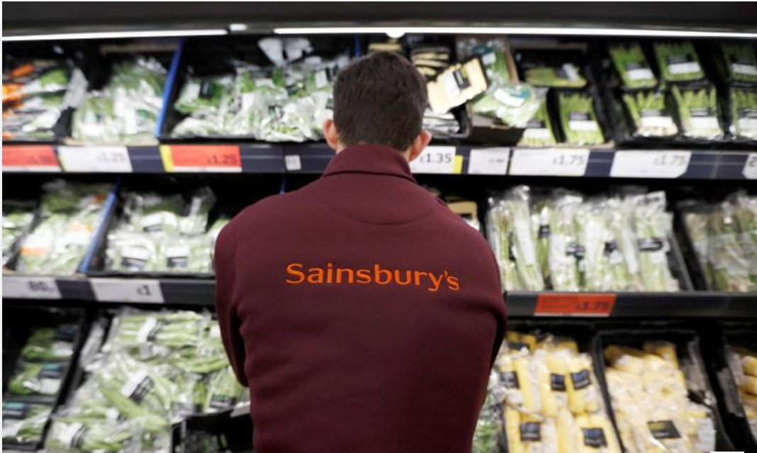

Critical analyses of the current and predicted changes in the external environment as they relate to the people resourcing strategies of a J Sainsbury Plc
Every business organization has a Human Resources Management (HRM) department that deals with the recruitment, management and dismissal of staff. The focus of this department is on the well-being of the human resources working in the organization. The factors that influence the external strain of organizations are economic, scientific and technological, social, political and cultural. The economies of different countries are further integrated by globalization (Liao and Wu, 2010: 1095). The consequences are that the economies of the countries that are integrated become interdependent. National strategies for economic development and economies are influenced by sustainability, which redefines global economic prosperity and value (Deloitte Touche Tohmatsu, 2010). Improved organizational response is driven by growing global interconnectedness and diversity in the workplace (EIU, 2014) And at the heart of organizational strategies, puts adaptability (Davies, Fidler & Gorbis, 2011). Nowadays, the external environment of organizations is characterized as complex and unstable with dynamic changes that affect management. In order, an organization to survive and prosper despite external changes, there must be very good, functioning human resource management. In order to be successful and at the level of maintaining good management of processes in the organization, managers must respond quickly and accurately to changes in the external environment. They must apply new strategies and theories so that the organization can keep pace with changes in the external environment. There are several external factors that organizations need to consider and adapt to. It is essential for the survival of the company to make economic and strategic changes in the organization and to adapt their strategy to them. This report going to put accent on Economic, Political and Technological external factors in J Sainsbury Plc.

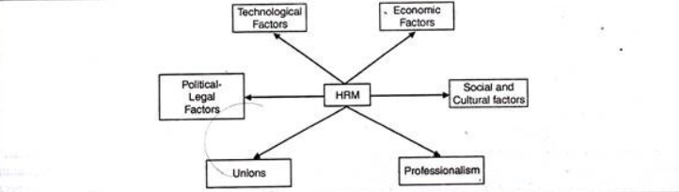

Economic Factor
Nowadays, the economy plays a big role in the daily life of every individual. In the same way, it has a great influence on the management of companies and organizations. A direct impact of sales in an organization can be a recession or a market crash. When the economy thrives and people spend their money to buy products or services from a company, everything looks good. On the other hand, things are not good when people do not have enough money to spend or decide to go and place an order from another organization (www.courses.lumenlearning.com).
Crucial to the company's survival is the rapid adaptation to changes that occur outside the organization. The world is currently marked by the Covid-19 pandemic. The work of managers who work with human resources is twice as difficult. Organizations need to respond to and adapt to change and manage the workforce accordingly, in the face of dramatic changes around the world due to the pandemic (Carnevale & Hatak, 2020). Companies need to develop new business models and adapt to new platform-based technologies, debate Sheppard (2020). Unexpected difficulties that employees go through, as well as helping to cope with them, is a major responsibility of human resources managers (Carnevale & Hatak, 2020).
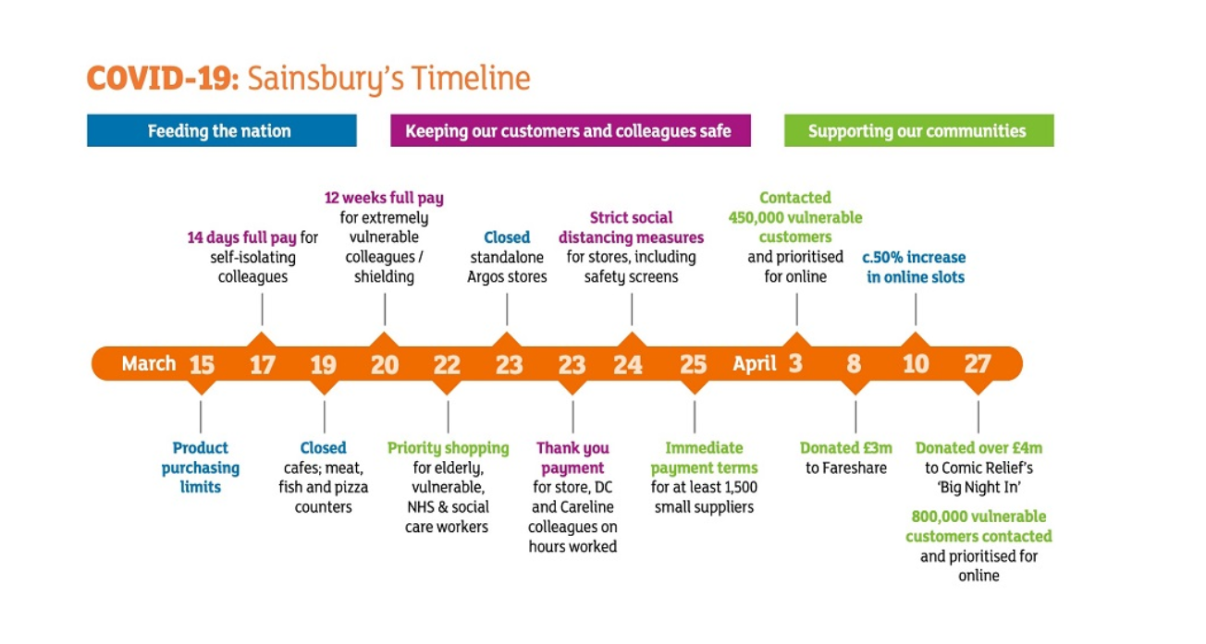

Current changes:
All forms of payment or remuneration of employees at different organizational levels, and arising from their employment in the organization, is understood as a reward system (Armstrong & Murlins, 2012). For the timely and effective performance of tasks in the workplace, there are financial or non-financial incentive. Since the beginning of March, Covid-19 has had a significant impact on the Sainsbury business. The labour market was strongly concerned. HR Manager did a lot of changes to protect their staff. Their main goals and motto were - maintaining the safety of service personnel and customers, supporting the most vulnerable in society and last but not least, supporting the nutrition of the nation. (www.sainsburys.co.uk,2020)
- More vulnerable employees or those who have a vulnerable family member receive 12 weeks of paid leave.
- Employees who were in contact with a sick person and needed self-isolation received 14 days of paid leave.
- Finding and connecting with vulnerable customers and offering a priority, for booking, for online shopping.
- Closing of clothing and household goods stores, from the chain of Sainsbury and Argos and switching only to online sales. This leads to 13 percent rebate in Argos sales and 16 percent in Sainsburys clothing sales.
- Argos employees were redeployed to the Sainsbury store and especially to those with an Argos store in them. So, customers can order online, and just come to receive their purchase.
- In order to minimize the contact between the customer and the seller, the Smart Shop system is introduced in larger stores.
- “Thanks” payment, for the managers and employees who worked on the front line at the beginning of the pandemic. Remuneration is expressed in 10% of the workers' wages from 8th of March to 5th April, added to their monthly salary. This is part of the reward system they have.
- Hiring temporary staff such as supply drivers, first line managers and even fruit and vegetable pickers.
- Delivering food to over 80 WHSmith stores in hospitals across the UK. This helps hospital staff to have easier access to food. It is part of the good Social responsibility activity of the managers of Sainsburys (www.sainsburys.co.uk, 2020)

Predicted changes:
- In order to ensure proper strategic guidance and financial, operational and regulatory decision-making, an incident response team was convened in Sainsbury, which often reported to the Operations Council. Ensuring that the systems and processes work effectively, the team continues its work and so far, focusing on all stakeholders during the crisis.
- Business recovery plans are beginning to be activated, with the introduction of new and temporary ways of working. To offset some of the business costs arising from Covid-19, business tariff reductions are a great help.
- Part of the recovery strategy is to track the decisions taken in response to Covid-19 so that they can be included as appropriate.
- Decision of the Board of Directors to postpone the payment of dividends until later in the financial year, when the potential impact of COVID-19 on the business as a whole will be clarified.
- Decision not to accept the government's proposal to reimburse additional payments through the government's retention scheme. The same applies to the government's motion to extend the deadline for VAT payment. (www.sainsburys.co.uk, 2020)

Political and Regulatory Factors
The obligation of the organization for the impact of its activities on society and the environment is corporate social responsibility. Government policies and legislation have a huge effect on the organization's performance. The new tax on the advertising of high-fat processed foods, which was introduced by law, is a good example of this. (www.about.sainsburys.co.uk). By modifying its products but also complying with legal requirements, Sainsbury has adapted to this new tax. The influence of political institutions on the human resources management department is covered by the political and legal environment. Organizational culture can be influenced in different ways by policy. The way the organization works can be greatly changed by the laws and regulations that are created by Congress. Organizational culture can also be influenced by relationship policy, but on a smaller scale. The way an organization chooses to operate may be influenced by the organization's competition with other organizations, for customers, or market share, which may be political in nature. This political nature can fully influence the way the company works, as well as change its goals and objectives (www.courses.lumenlearning.com). The government encourages all retailers to encourage each other and work together to provide the population with food. In this type of work there is a danger of violating legal provisions such as competition law. Another political factor is Brexit. After New Year 2021 UK will leave Europe. It was voted in 2016. This factor can also be economic. After leaving the EU, the availability of products from Europe could be very difficult. Therefore, the prices of this type of products will be inflated. The end victim in this case will most likely be the end user. Sainsbury will try to secure its revenue, and in this case will strongly insist that consumers can spend as much as possible.

Current and predicted changes:
- Active involvement with government and regulatory bodies in support of current and emerging legislation.
- Continue the focus on working with other retailers, supporting the government in responding to dealing with the Covid-19 situation.
- To ensure that legal issues are managed in the right way, the incident response team also takes an active part in dealing with Covid-19
(www.sainsburys.co.uk, 2020)
- Consequently, from Brexit increasing the price of the food products from Europe

Technology Factor
Nowadays, business is affected on many levels by new technologies. The employee turns out to be more productive when he is more efficient. Businesses are more likely to build a strong customer loyalty base when they have a greater connection with their current and potential clients. All this can be achieved with the development and implementation of new technologies in business. Continuous monitoring of the development and updating of technological changes is one of the main tasks of strategic managers. In this way, they not only maintain their awareness of technological innovations in the market, but also improve their performance. In this way, in order to become significant, they will develop innovative strategies. The demand for people with multi-skills will grow due to the introduction of new technologies in organizations. Very soon some of the jobs will be replaced by robots(Coovert & Thompson, 2014).

Current changes:
- Implementation of Nectar point card
- Implementation of self–service checkout in the stores
- Implementation of coupon technology in processing
- Implementation of the Smart Shop app
- Online sales (www.about.sainsburys.co.uk)

Predicted changes:
- Acquisition of new skills or upgrading the ones learned so far
- Increasing demand for more skilled employees
- Reducing the need for labor, in parallel with the introduction of new technologies
- To maintain profitability reduce labor
- Changes in technology lead to teamwork. All projects must be done together.

Critical analysis of relationship between changes in the external environment and company’s people resourcing strategy
For the future growth of the company, human resource strategies are essential, which are used to identify the needs of these human resources. This serves as a connection between strategic planning and human resource management and helps to achieve the organization's aims easily. However, forecasting allows the organization to get out of the worst conditions that the future may provide (Wilton & Nick, 2013). In other words, to know in the future how many people will leave and how many more people will come to their places, this can be easily calculated with the help of strategic planning management (Berman & Evans, 2013).

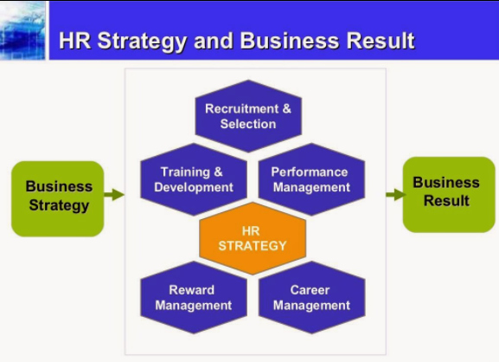

People resourcing
That part of the staff and development that focuses on the recruitment and dismissal of individuals from the organizations, as well as their representation, management and potential while employed by the organization, can be defined as the resourcing of people.

Strategic resourcing
In order to improve business results and link human resources with strategic goals and objectives, the development of organizational culture can give the definition of strategic human resource management (SHRM). SHRM has many definitions. The most popular is the definition of Wright and McMehan (1992: 298), who argues that to achieve the goals of the organization depends on the model of the planned deployment of human resources and activities. The right approach to management is one that encompasses those HR strategies that are designed to improve organizational effectiveness and measure the impact of these strategies on organizational results (Boxall, 2007: 1). The strategic business goals, in order to be achieved most effectively, contribute to the management of the human resources of the organization, through its selection, arrangement and integration (Kaufman, 2015: 404). In their efforts to formulate and realize the strategic needs of the business, they include all those activities that affect the behavior of individuals (Schuler, 1992: 30). Achieving the goals of the organization is the main goal of SHRM. This is the common factor in all these definitions. The basis for strategic resource guidance is the opportunities of the resource of people in the organization to manifest itself and to show the strategic ability of a company. In order to be competitive, every single organization wants to attract, appoint and retain more capable people than those who work in competition (Armstrong, 2014).

Recruitment and selection
Reward schemes are an important tool for attracting and retaining employees(Brown & Purcell, 2007), Universal recognition of recruitment and selection is a key activity in human resources (Milllmore, 2003). On the one hand, the focus is more on the person's choice according to the organizational criteria, and not so much on the specifics of the work (Bowen & Ostroff, 2004). While on the other hand, it is argued that strategic orientation requires line managers to be more involved in the process (Truss et al., 2002). The recruitment and hiring of new workers in Sainsbury was different from the previous ones. Due to the situation with covid-19, all live interviews were transformed into online. The clothing and household goods stores switched entirely to online sales. Workers from these stores were moved to larger ones in the chain to help their colleagues

Resourcing practice
The goals that the organization sets to achieve by recruiting new staff are specified in the strategy for providing resources. This can be achieved through further development of existing employees or through external recruitment. The recruitment process must be clearly reflected in the policy; in the sectors of the organization the consistency must be clearly demonstrated; the recruitment strategy of the organization must reflect detailed information about its activities; strategic and operational objectives to be integrated. Every successful company can meet the needs of people, both to provide them with a great job where they can work with interest, and a good job. In doing so, it is no coincidence that they receive the nickname "employer of choice" (Purcell et al, 2003).

Talent management
Talent management has been highly developed in the last few years. Expanding the responsibilities of the HR profession, the goals and strategy of the organization include it. Talent management already leads to organizational results through the administrative process. For the best talent on the market, rival companies are at war. Talent management is considered a top business priority, business leaders believe it is. A complex combination of uncertainty, complexity, ambiguity and instability, this is the economic situation today. The company's strategy must deeply integrate the talent management strategy. Demographic change combined with globalization is giving rise to the current workforce. To connect business with the changing demographics and to build strong organizations is in the possibilities of talent management (Younger, et al 2007).

Assess and evaluate how the company has responded to these changes in the external environment within their resourcing strategies
To achieve its goals and successes and maintain the company's good name, Sainsbury focuses on seven of its strategies. In this way, they aim to balance well in the rapidly changing retail market, to satisfy the wishes of their customers, but also to deliver value to their shareholders (www.sainsburys.co.uk, 2020).
- Competitiveness - Maintaining affordable and affordable prices to meet customer needs
- Presentation of new product categories - Introducing more distinctive and exclusive assortments in order to meet more than the needs of our customers
- Embodied digital and material - The reward for our loyal customers is the use of the Nectar card, where they can collect points.
- Promptly, polite and comfortable - In order to save customers time and money by shopping in Sainsbury, while at the same time being served with respect by kind and helpful employees.
- Increase efficiency and reinvestment - Delivering inflation to cover cost savings, as well as structural reduction of the organization's costs by investing in our customer offer
- Keeping the workplace in good condition where everyone loves to work - By helping clients live well for less, we respect and reward our colleagues for great
work they do.
- Net Zero by 2040 - By working with farmers, producers and suppliers throughout our supply chain, creating value for future generations by reducing the environmental impact of Sainsbury (www.sainsburys.co.uk, 2020).

Conclusion
In this report, the effect of changes in the external factors of Sainsbury on the human resource strategy was investigated and analysed. This effect also had a significant impact on the human resources hired in the organization. The results of the investigation are that the managers in Sainsbury, despite the conditions of Kovid-19 and Brexit, managed to manage their activities successfully. They successfully use and apply a large part of the rules and laws of the Strategic Human Resource.
[word count:2885]

References:
Armstrong, M., & Murlins, H., 2012: Reward Management. London Biddles, Limited
Armstrong, M (2014) Armstrong’s handbook of Human Resource Management practice
Armstrong,M. & Brown,D. (2019) - Strategic Human Resource
Management: Back to the future? https://www.employment-studies.co.uk/system/files/resources/files/517_Strategic-Human-Resource-Management-Back-to-the-future-IES-CIPD-2019.pdf [Accessed - 01/12/2020]
Berman, B.R. & Evans, J.R., 2013. Retail management: a strategic approach. Pearson Higher Ed.
Boxall P F (2007), ‘The goals of HRM’, in (eds) Boxall P, Purcell J and Wright P, Oxford
Handbook of Human Resource Management, Oxford, Oxford University Press, pp 48-67
Bowen, D. E., & Ostroff, C. (2004). Understanding HRM-firm performance linkages: The role of the “strength” of the HRM system. Academy of Management Review, 29, 203–221. [Crossref], [Web of Science ®], [Google Scholar]
Brown, D., & Purcell, J. (2007). Reward management: On the line. Compensation & Benefits Review, 39, 28–34. http://dx.doi.org/10.1177/0886368707302649 [Accessed - 29/11/2020]
Carnevale, J. B., & Hatak, I. (2020) - Employee Adjustment and Well-Being in the Era of COVID-19: Implications for Human Resource Management. Journal of Business Research(116), 183-187.
Coovert, MD, Thompson, LF (2014) Toward a synergistic relationship between psychology and technology.
Davies, A., Fidler, D., & Gorbis, M. (2011) - Future work skills 2020. Palo Alto, CA: Institute for the Future for the University of Phoenix Research Institute.
Deloitte Touche Tohmatsu (2010) - World Economic Forum - Redesigning business value: A roadmap for sustainable consumption. Geneva: World Economic Forum.
Economist Intelligence Unit (2014) - Evolution of work and the worker, what’s next: Future global trends affecting your organization. New York: SHRM Foundation.
External Factors Affecting Human Resources https://www.yourarticlelibrary.com/essay/human-resource-management/external-factors-affecting-human-resources/75324 [Accessed - 06/12/2020]
How Sainsbury's is using technology to drive sales and engage customers - https://www.theguardian.com/media-network/media-network-blog/2012/nov/14/sainsburys-technology-sales-customer-engagement [Accessed - 02/12/2020]
HR Strategy - https://www.surrey.ac.uk/sites/default/files/2018-08/hr-strategy.pdf [Accessed - 03/12/2020]
J Sainsbury Plc - Annual report and Financial statements 2020 - https://www.about.sainsburys.co.uk/~/media/Files/S/Sainsburys/documents/reports-and-presentations/annual-reports/sainsburys-ar2020.pdf [Accessed - 29/11/2020]
Kaufman, B. E. (2015), ‘The evolution of strategic HRM as seen through two founding
books: a 30th anniversary perspective on development of the field’, Human Resource
Management, 54 (3), pp 389–407
Liao, S. H. ve Wu, C. C. (2010), “System perspective of knowledge management, organizational learning and organizational innovation”, Expert System with Applications, 37, pp. 1096-1103.
Milllmore, M. (2003). Just how extensive is the practice of strategic recruitment and selection? Irish Journal of Management, 24, 87. [Google Scholar]
Organizational Behavior and Human Relations - Module 5: Organizational Culture- External Factors- https://courses.lumenlearning.com/wm-organizationalbehavior/chapter/external-factors/ [Accessed - 29/11/2020]
Purcell,J, Kinnie,K, Hutchinson,S, Rayton,B and Swart,J (2003) People and performance: How people management impact an organizational performance, London CIPD
Sheppard, B. (2020, May 18) - A guide to thriving in the post-COVID-19 workplace. Retrieved July 30, 2020, from World Economic Forum: https://www.weforum.org/agenda/2020/05/workers-thrive-covid-19-skills/
Schuler, R. S. (1992), ‘Strategic human resource management: linking people with the strategic needs of the business’, Organisational Dynamics, 21 (1), pp 18-32
Skip the queue, scan & go: Sainsbury’s launches till-free shopping - (13/08/2018) https://www.about.sainsburys.co.uk/news/latest-news/2018/new-till-free-shopping#:~:text=In%20a%20UK%20supermarket%20first,and%20skip%20the%20checkout%20completely. [Accessed - 05/12/2020]
Truss, C., Gratton, L., Hope-Hailey, V., Stiles, P., & Zaleska, J. (2002). Paying the piper: Choice and constraint in changing HR functional roles. Human Resource Management Journal, 12, 39–63. [Crossref], [Google Scholar]
Update on the impact of COVID-19 and Preliminary Results for the 52 weeks to 7 March 2020 (2020, April 30) - https://www.about.sainsburys.co.uk/news/latest-news/2020/30-04-2020-prelims [Accessed - 29/11/2020]
Wilton & Nick, 2013. An introduction to human resource management. Sage
Wright P M and McMahan G C (1992), ‘Theoretical perspectives for SHRM’, Journal of Management, 8 (2), 295-320
Younger, J, Smallwood, N and Ulrich, D (2007) Developing your organization’s brand as a talent developer, Human Resource Planing, 30(2),pp 21-29

