
Financial Performance Analysis of Diageo PLC & Capital Investment Appraisal for Westward PLC
Finance for Business Managers (BMMB7005D)


Student Name: MINHAJUR RAHMAN KHAN MISU
Student ID: 2511789
Programme: MBA
Lecturer: Marie Pitson
Submission Date: 19th April 2026
Word Count: ~6,891 words

Executive Summary
In this report, there are two sections combined. Part 1 consists of a strategic financial performance analysis of Vodafone Group PLC covering the 2024 and 2025 financial years, and applying the ratio analysis in five key dimensions, i.e., profitability, liquidity, and gearing, efficiency, and returns to the investor. Part 2 provides a capital investment analysis of Westward Plc a UK based manufacturer of quality curtains on the basis of three strategic expansion options using Net Present Value and Internal rate of return analysis.
The review period did not show very good Vodafone financial performance. Revenue was slightly increased to show an increase between the years of 36, 717m to 37, 448m with gross profit margin being the same in both years at about 33.4% which shows that direct costs were well controlled. Nevertheless, the operating profit margin decreased drastically by 9.98% to -1.10% and ROCE went into the negative zone at -0.38% due to a large amount of impairment charges in 2025. There was significant improvement in liquidity, a current ratio of 0.92 increased to 1.26 and quick ratio of 0.89 to 1.23. The debt-to-equity ratio was a little more than 93.42 and it has risen to 98.57 implying an ongoing reliance on the debt financing. The ROE was at -6.95, which means that the net loss position is 2025.
Under option B in Part 2, an internet sales channel with a start-up cost equals 1,000, 000 is recommended as the value maximising investment with a NPV of 792.23k once NPV analysis is done at a cost of capital of 6 percent with a corporation tax of 25 per cent and straight-line capital allowances of 20 per cent. The rough IRR of option B is 32.23. The best policy of divisible investment with a budget of capital rationing of 2,500,000 would give a total NPV of 1853.04k. The report ends with a critical evaluation of ways Westward Plc can be financed.
Table of Contents
Executive Summary 2
Part 1: Financial Performance Analysis of Diageo plc 4
Introduction 4
1. Strategic Financial Performance Review 4
1.1 Profitability Ratios 4
1.2 Liquidity Ratios 5
1.3 Gearing Ratios 5
1.4 Efficiency Ratios 6
1.5 Investor Ratios 6
2. Limitations of Ratio Analysis 7
Conclusion 7
Recommendations 8
1. Context and Scope of the Appraisal 9
2. Net Present Value Analysis 9
2.1 Methodology 9
2.2 NPV Calculation Table – All Three Options 9
2.3 Results and Recommendation 10
3. Internal Rate of Return – Option B 11
3.1 Method and Workings 11
3.2 IRR Calculation and Interpretation 11
4. Interpretation of Results 11
4.1 Theoretical Arguments for NPV as the Superior Appraisal Method 11
4.2 The Continued Popularity of Non-Discounting Methods 12
4.3 Other Factors to Consider Before Investment 12
5. Capital Rationing: Optimal Investment Policy 13
5.1 Framework 13
5.2 Optimal Allocation Table 13
5.3 Conclusion on Capital Rationing 14
6. Financing the Investment Programme 14
6.1 Retained Earnings 14
6.2 Bank Term Loan (Secured Debt) 14
6.3 Equity Finance 14
6.4 Asset Finance and Leasing 15
6.5 Government Enterprise Finance Schemes 15
References 16
Appendices 18
Appendix A – Diageo plc: Financial Statements (FY2024 & FY2025) 18
Appendix C – Westward Plc: After-Tax Cash Flow Workings 23

Part 1: Financial Performance Analysis of Diageo plc

Introduction
Diageo plc is a major firm in high quality alcohol business in the entire globe. It has an outstanding portfolio of over 200 brands, including Johnnie Walker, Guinness and Smirnoff that are consumed by people in over 180 countries (Diageo, 2025). The business of this particular consumer goods industry involves huge investments in worldwide brand marketing and inventory preservation. It has complex operation demands and requires a strong financial standing to facilitate their operation and provide regular dividend payouts to shareholders (Niu, 2024).
The main aim of this report is to provide an in-depth financial analysis of the Diageo plc to the senior management team that includes the fiscal years 2024 and 2025. Published financial statements are a crucial means of communication, as it gives the stakeholders a chance to assess the past performance and adopt future business strategies. The systematic application of the ratio analysis is employed in this report to transform the tricky accounting numbers into managerial knowledge (Arunkumar, 2025).
This evaluation will be based on the five key performance categories; profitability, liquidity, gearing, efficiency and investor returns. The trend analysis of the two years has demonstrated the strengths of the company in their operations and those areas that might result in a source of financial risk (Andiena et al., 2024). Limitations that come with the inherent application of ratio analysis will also be identified in the discussion and finally, actionable recommendations of the overall financial strategy of the organisation will be made (Effiong and Enya, 2020).

1. Strategic Financial Performance Review
Financial statements are historical report of the activity of the corporate but absolute values need to be firmly contextualised in order to reflect the real health of operation in an organisation. To be able to perform this assessment, all the mathematical formulae, extraction and step by step ratios of the raw data have been divided and presented in Appendix B. This critical analysis is solely founded on the understanding of the calculated metrics so as to decide how well the executive management of Diageo plc has been able to manoeuvre the business in a complex global micro economic environment over the 2024 and 2025 financial years. The assessment is differentiated in a systematic manner in five thematic sections, which are margin evolution, working capital dynamics, capital structure, asset utilisation and shareholder value creation (Niu, 2024) (Matevosyan et al., 2023).

1.1 Profitability Ratios
The profitability ratios are employed to gauge the ability of the business to make profit out of the sales and capital used. These ratios are important to the Diageo company because they will tell whether the company is still registering high returns as the costs and challenging trading environments keep rising (Gu, 2025).
Diageo gross profit margin has been quite stable with a marginal decline of 60.18 (2024) to 60.13 (2025). This implies that the firm still enjoyed a high brand value and price power. A gross margin of more than 60 percent is an encouraging indicator of a manufacturing company, and it means that Diageo was in a large capacity to safeguard its product margins (Brownlee, 2008).
Nonetheless, the operating profit margin decreased considerably in 2024 as compared to 29.61 percent in 2024, and 21.41 percent in 2025. This means that the operating expenses increased at a greater rate than revenue or other business forces affected the operating profit during the year (Losbichler et al., 2011). This is a warning to the management since it indicates that high gross margins did not necessarily result in high levels of operating performance (Khan, 2015).
The same case applies to the Return on Capital Employed (ROCE) that dropped to 11.23 compared to 16.85. It is an indication that the business is making a lower claim on the capital invested in doing business in 2025 compared to its claim in 2024. Even though the ratio is still positive, the decreasing tendency implies the decreased efficiency of the long-term funds use. The management should, therefore, re-evaluate whether the new investment and the operating decisions are paying off satisfactorily (Khan, 2015) (Esser and Jernigan, 2015).

1.2 Liquidity Ratios
Liquidity ratios are used to evaluate how the current assets can be used to settle the short-term liabilities as they fall due. The ratios are also crucial in an international company with a large scale of operation because the suppliers, employees and other operating commitments require consistent cash flow to go on with their daily activities (Endang Purwanti, 2022).
The current ratio of Diageo rose in 2025 to 1.63 as compared to 1.53 in 2024. This demonstrates that the company was slightly higher on the liquidity position in the short-term at 2025 and that increasing current assets can be used to cover current liabilities. In general, this means that the financial risk in the short-term was contained (Ying and Chan, 2025).
The quick ratio also was better as it was raised to 0.64. This is less than 1 but must be construed with caution since Diageo has large inventories as one of its business models. The inventory in the premium spirits business usually has products which must be aged before being sold. Therefore, a relatively low quick ratio is not an exception (Ali Gull, 2013).
In general, the liquidity situation is satisfactory. The increase in the two liquidity ratios suggest that the company has been relatively stable in the short-run financially, although, it is still important to note the working capital (Lyroudi and Lazaridis, 2000).

1.3 Gearing Ratios
Gearing ratios are crucial sources of information about the financial riskiness of a business in the long run as they consider the proportion of the amount of funds the business has raised by way of external debt to the amount of funds contributed by the shareholders expressly.
Diageo has a very high capital structure. The debt equity ratio has been increasing; in 2024, it stood at 178.14 percent and the following year, it increased to 180.21 percent. The above ratio below 180 percent, the more significant is the fact, that the company is incredibly reliant on external borrowing, since it has nearly twice as much debt as the shareholder equity base. Such financial leverage would have been thought to be very high and a warning of credit rating downgrades in most conventional industries (Muradoglu, Bakke and Kvernes, 2005).
Further, the management tends to employ this borrowed capital strategically. They also rely on debt to fund important takeovers of new beverage brands to kill potential competition in the future, and to execute aggressive share buyback programmes. Although the present debt position can be easily brought under control because of the good cash flows, the board of directors should be on their guard. In a perplexing global macroeconomic environment where central bank interest rates are fluctuating, over 23 billion dollars aggregate borrowings exposes the company to rising interest costs. This will increase the cost of financing in case debt has to be refinanced at a higher future interest rate, potentially crippling the net profit margins in the future (İlhan Dalci, Hasan Ozyapici and Doğan Unlucan, 2019).

1.4 Efficiency Ratios
Activity ratios or efficiency measures are ratios that are used to gauge the vigor and efficiency by which the management team is utilizing the asset base of the company to produce sales revenue. Converting the physical stocks and accumulating cash in a short period of time is the convention of the activities in a global consumer goods company to have a prosperous business cycle.
Diageo has a very sluggish inventory turnover because it was anticipated according to the liquidity analysis when compared to the traditional retail businesses. Its turnover rate was slightly better since it was 0.83 times per year in 2024, and 0.76 times per year in 2025 (Eze Ibiam Eze, Oliver Ike Inyiama and Ikechukwu Ezugwu, 2024).
On the other hand, the receivables turnover ratio was stable and very healthy with 5.81 and 5.78 times in 2024 and 2025 respectively. This translates into an average collection period in cash of about 63 days. Having a stable and dependable collection cycle is a good pointer of a strong credit control unit. Diageo is able to effectively use its huge market strength to force its key distributors globally, hospitality establishments and international supermarket chains, to make favourable payment agreements. This makes sure that credit sales are changed to real liquid cash at the right time and predictable fashion avoiding bad debts and the cash operating cycle runs seamlessly (Eryatna, Eltivia and Handayawati, 2021).

1.5 Investor Ratios
Finally, the executive board has the main fiduciary role of producing actual financial gains to the equity shareholders. The final litmus test of corporate success is the investor ratios which are highly reviewed by the stock market in order to determine the appeal of the company shares and its ability to pay dividends.
The Return on Equity (ROE) ratio also dropped, declining to a staggering 19.26 percent in 2025 as compared to the incredible 34.51 percent in 2024. This sizeable fall is a direct mathematical impact of the reduction in the net profit of the year which has fallen significantly as compared to over 4.1 billion dollars and on to about 2.5 billion dollars. Such a drastic fall would give rise to alarm at first to retails investors but professionalism should be exercised.
This is a high payoff rate combined with a long history of the company paying high dividends to its investors in constant and non stagnant amounts makes Diageo a most attractive defensive stock among long term institutional investors (Lynch, Gillam and Forman, 2017).

2. Limitations of Ratio Analysis
Ratio analysis is an effective tool in assessing financial performance, but it has a number of weaknesses and cannot be applied alone by the management to make decisions.
Firstly, ratio analysis is based on the past financial statements. These 2024 and 2025 ratios can only be indicative of the past performance and not the future performance. Performance in future may also change depending on the change in consumer demand, taxation, exchange rates, cost of inputs and general economic conditions that cannot be fully explained by previous ratios.
Second, the ratio analysis does not capture qualitative aspects. The financial statements have not clearly captured critical strengths of Diageo brand name, quality of products, capacity to distribute products in the world and knowledge in management. These are aspects that may significantly influence the performance in the long term, but they cannot be easily quantified with ratios (Swee and Islam, 2026).
Third, the ratios can be construed differently, based on accounting policies and historical cost accounting. The certain asset values indicated in the statement of financial position do not always disclose the existing market values, and it can lead to a distortion of such measurements as ROCE or gearing (Rani et al., 2025).
Fourth, the analysis of ratios will be more relevant when comparisons are made carefully. There are different business models, cost structure and pattern of inventory in various industries. Therefore, the Diageo ratios cannot be evaluated within the context of the beverage industry in isolation unless they are directly compared to other companies that are not a part of the same industry.
Lastly, ratio analysis can be influenced by accounting judgment at the end of the year and choice of presentation. It means that the assistance of the ratios should be promoted with the help of the wider coverage of annual report notes, business strategy and market conditions.
Ratio analysis should therefore be viewed as one of the assistance tools of analysis but it has to be interwoven with the qualitative and strategic analysis and then conclusive decisions are reached.

Conclusion
The Diageo plc financial analysis is a financial analysis of the company that shows a combined overall performance of the company between 2024 and 2025. On the positive side, the firm had continued to have a high gross profit ratio of over 60 percent and a small increase in liquidity. This means that Diageo continued to have good brands, power of pricing and relatively stable short term financial position.
However, it also had its flaws. The operating profit margin decreased significantly and ROCE decreased also an indicator of reduced operating efficiency and reduced returns to capital used. In addition, the debt-equity ratio was extremely high and this increases the financial risk. Inventory turnover also decreased signifying that 2025 had a greater amount of capital tied up in inventory.
All in all, Diageo is still a strong and lucrative company but the decrease in operating performance, and the regular use of debt shows that in the future, the management must pay more attention to cost management, working capital optimization and capital discipline (Niu, 2024).

Recommendations
According to the analysis, it is suggested to improve the financial performance and long-term stability of Diageo with the help of the following recommendations.

Recommendation 1: Enhance cost control. The management should have a closer look at operating costs especially selling, marketing and administration costs. With a stricter control mechanism, it can assist in safeguarding the operating profit margin and enhance efficiency in general.
Recommendation 2: Decrease the risk of finance by the use of incremental debt management. The debt to equity ratio is very high and hence the company ought to consider settling some of its borrowings by utilizing some of its cash flow in the long run. Less geared would mitigate financial risk and enhance the resilience in case of an increase in interest costs.
Recommendation 3: Better inventory planning. Diageo business should also strengthen the demand forecasting and inventory planning, in such a way that the efficiency of the stock cannot be compromised at any time, without affecting the production and ageing requirements. Current working capital strain and effectiveness would be enhanced by better inventory management.
Recommendation 4: Update returns on capital investment. The management should also find out whether the new investments are paying off. More emphasis on allocation of capital and post investment review could be useful in enhancing ROCE in future.
Part 2: Capital Investment Appraisal – Westward Plc

1. Context and Scope of the Appraisal
Westward Plc is a firm based in the United Kingdom, which produces quality curtains and window furnishings. The Board of Directors of the company has established three strategic investment options that are mutually exclusive under which the business can be grown within a four-year planning period. The choices available are: Option A - expansion of the current retail store to a full range of products (initial capital requirement: £600,000); Option B - development of an online direct to consumer sales facility (initial capital requirement: £1,000,000); and Option C - diversification into the manufacture of wooden blinds and Roman blinds (initial capital requirement: £1,600,000).
This appraisal has been prepared to help the Board make an informed decision in terms of finances and a sound strategy in making this investment. This methodology is a best practice in corporate capital budgeting (April, 2020; Mclaney, 2017) with the following assumptions throughout: capital allowances are calculated on a straight-line basis of 20% of initial investment per annum, which results in annual allowances of £120,000 (Option A), 200,000 (Option B).

2. Net Present Value Analysis

2.1 Methodology
The Net Present Value (NPV) method of capital investment appraisal is the most academically preferred and mathematically sound. The technique deducts the initial capital outlay and reduces any anticipated after-tax cash flows to the firm's current cost of capital. When two or more competing projects are taken into consideration, the project with the best positive net present value (NPV) provides wealth maximization and should be selected. A project with a positive NPV generates a shareholder value over the minimum required return (April, 2020).
After determining the taxable profit, which is the pre-tax cash flow less the yearly capital allowance, the pre-tax cash flows are taxed at the 25% corporation tax rate. The after-tax cash flow to be discounted is obtained by deducting the resulting tax charge from the pre-tax cash flow. The following 6% discount factors are used: First year: 0.9434; second year: 0.8900; third year: 0.8396; fourth year: 0.7921. Appendix C contains the after-tax calculations.

2.2 NPV Calculation Table – All Three Options

Item | Option A (£600k) | Option B (£1,000k) | Option C (£1,600k)
Initial Outlay (£000) | -600 | -1,000 | -1,600
Annual Capital Allowance (£000) | 120 | 200 | 320
Year 1 Pre-tax Cash Flow | 200 | 400 | 450
Year 2 Pre-tax Cash Flow | 400 | 450 | 700
Year 3 Pre-tax Cash Flow | 500 | 720 | 900
Year 4 Pre-tax Cash Flow | 700 | 980 | 1200
Year 1 After-tax Cash Flow | 180.0 | 350.0 | 417.5
Year 2 After-tax Cash Flow | 330.0 | 387.5 | 605.0
Year 3 After-tax Cash Flow | 405.0 | 590.0 | 755.0
Year 4 After-tax Cash Flow | 555.0 | 785.0 | 980.0
Year 1 PV (DF = 0.9434) | 169.81 | 330.19 | 393.87
Year 2 PV (DF = 0.89) | 293.70 | 344.88 | 538.45
Year 3 PV (DF = 0.8396) | 340.04 | 495.36 | 633.90
Year 4 PV (DF = 0.7921) | 439.62 | 621.80 | 776.26
Total Present Value (£000) | 1243.17 | 1792.23 | 2342.48
Less: Initial Investment | -600.00 | -1,000.00 | -1,600.00
NET PRESENT VALUE (£000) | 643.17 | 792.23 | 742.48

2.3 Results and Recommendation
The results of the NPV analysis of each option are as follows:
Option A — Retail Expansion (£600k): NPV = £643.17k
Option B — Internet Sales (£1,000k): NPV = £792.23k
Option C — Blinds Production (£1,600k): NPV = £742.48k
The suggested investment is Option B, the development of an internet sales channel, based on NPV analysis. It produces the highest Net Present Value of £792.23k, which is the highest increase in shareholder wealth in present-value terms, after taking into account the time value of money, 6 per cent cost of capital, corporation tax and capital allowances. Although the initial outlay of Option B is the second-largest at 1,000,000, the cash flow graph is projected to be well above the initial outlay.
Option C generates the largest absolute pre-tax revenues in the four-year time frame, but has a much higher initial investment of £1,600,000, lowering its NPV to £742.48k, which is lower than that of Option B. Option B is the unambiguous recommendation, on NPV grounds.
Board is recommended to adopt the internet sales channel, which is option B. The online retail development trend in the home furnishing and interior design industry and the comparatively less fixed cost base of digital commerce than diversification in physical manufacturing, make the strategic appeal of this alternative independent of NPV analysis.

3. Internal Rate of Return – Option B

3.1 Method and Workings
The Internal Rate of Return (IRR) is the discount rate that causes a project's net present value (NPV) to equal zero, or the anticipated annualized rate of return on the capital invested in the project. In this case, it is calculated using the linear interpolation method with trial discounts of 30% and 35% applied to Option B's after-tax cash flows. The NPV of Option B switches sign between 30 and 35 percent, according to preliminary analysis, which is why these rates were selected (Mclaney, 2017).IRR ≈ Lower Rate + [NPV@Lower / (NPV@Lower – NPV@Higher)] × (Rate Range)
Year | After-tax CF (£000) | DF @ 30% | PV @ 30% (£000) | DF @ 35% | PV @ 35% (£000)
Year 1 | 350.0 | 0.7692 | 269.22 | 0.7407 | 259.25
Year 2 | 387.5 | 0.5917 | 229.28 | 0.5487 | 212.62
Year 3 | 590.0 | 0.4552 | 268.57 | 0.4064 | 239.78
Year 4 | 785.0 | 0.3501 | 274.83 | 0.3011 | 236.36
Total PV |  |  | 1041.90 |  | 948.01
NPV |  |  | 41.90 |  | -51.99

3.2 IRR Calculation and Interpretation
Applying the interpolation formula: IRR ≈ 30% + [ 41.90 / (41.90 – -51.99) ] × 5% ≈ 32.23%
The estimated Internal Rate of Return of Option B is 32.23. This is significantly higher than the cost of capital of the company of 6%, which proves that Option B is projected to provide a payoff significantly higher than the minimum threshold that is needed to pay investors off. The 26.23 percentage point premium over the cost of capital (the so-called hurdle rate) is a big safety cushion: the project would still be projected to produce positive NPV even in case the actual cash flows would turn out to be slightly below the projections. This finding supports the NPV-based suggestion to go on with Option B.

4. Interpretation of Results

4.1 Theoretical Arguments for NPV as the Superior Appraisal Method
The Net Present Value technique has a status of unsurpassed theoretical dominance in the scholarly sources of corporate finance (April, 2020; Mclaney, 2017). The reasons as to why it is superior to other appraisal methods are as follows:
- Clear identification of the time value of money: NPV discounts all future cash flows based on the cost of capital of the firm and it is a basic financial concept that a pound now is worth more than a pound tomorrow. This correction is not only theoretically right, but also practically necessary with comparing projects with varying cash flow timing patterns.
- Direct measure of shareholder wealth creation: as opposed to the Payback Period or ARR, which report non-monetary measures (time or percentage), NPV measures in absolute monetary terms the value increase in the firm that is expected to be the result of a project. This goes directly to the main financial goal of shareholder wealth maximisation.
- Proper inclusion of the cost of capital: the discount rate applied in the NPV calculations is the risk-adjusted minimum return to the investors in the firm - its weighted average cost of capital. Projects which have a value exceeding this threshold add value to the firm; those with lower increase value are rightly discarded. This theoretical basis does not exist in the non-discounting techniques.
- Additive property: NPVs of independent projects may be summed to determine the overall value impact of a portfolio of investments to allow coherent, consistent capital budgeting decisions to be made for multiple simultaneous projects.
- Unique and unambiguous solution: NPV gives one unique answer irrespective of the trend of cash flows throughout the life of the project. This is unlike the IRR method which may yield more than one solution when there is a change of sign more than once in cash flows, which can cause confusion in the analysis.

4.2 The Continued Popularity of Non-Discounting Methods
Although the theoretical superiority of NPV is well-known, empirical studies always reveal that non-discounting approaches, including the most popular ones the Payback Period and the Accounting Rate of Return (ARR), are still widely used by businesses of any size (April, 2020). A variety of reasonable considerations explain why they persisted:
- Ease and simplicity: the Payback Period calculation does not need any familiarity with the mathematics of discounting, and can be comprehended by those not in the finance field at a glance. Something like this investment will pay back in two years and five months does not need any further explanation, but an NPV value would need the bare minimum knowledge of the concepts of present value.
- Liquidity management and risk proxy the Payback Period will give preference to those investments that are going to give capital back in the shortest time possible, a sensible guard against those businesses that are susceptible to cash flow constraints. It can also serve as an informal metric of risk exposure: the shortest payback periods imply that the investment is exposed to unknown negative events over a shorter period, which is significant in the trading environment that is volatile or uncertain.
- Correlation with management incentives: the Accounting Rate of Return is a measurement of profitability as a book value of assets and thus would be naturally correlated with the periodic performance measures employed in management compensation plans. Another application of ARR is where senior managers are evaluated based on accounting-based targets, it offers an intuitive balance between investment appraisal and incentive systems.

4.3 Other Factors to Consider Before Investment
A favourable IRR and positive NPV are prerequisites, rather than the final bases on which to make a decision on the investment. The qualitative and strategic considerations that the Board of Westward Plc should put into serious consideration before committing capitals are:
- Market and competitive analysis: the market of online home furnishings is developing at a high pace, yet it is becoming more and more competitive, with the long-established stores, as well as platform-based marketplaces, fiercely competing over price and variety. The digital competitive environment should be carefully examined prior to making the internet sales investment.
- Operational ability and digital preparedness: effective e-business activities require the skills in web development, online marketing, search engine optimisation, delivery logistics, customer relationship management and returns handling. The Board will have to determine whether Westward Plc already has these capabilities or it can obtain them at a cost that it can afford based on the projected budget.
- Brand consistency and customer experience: the high-quality positioning of the curtain range of Westward Plc should be maintained online. Such an incompetently implemented online presence might water down perceived quality of the brand, with negative connotations to both online and current physical sales.
- Sensitivity of the cash flow projections: the NPV result is sensitive to the accuracy of the projected revenues. An official sensitivity analysis - determining the effect of a 1020 percent downside to the revenues of Year 1 and Year 2 - would enable the Board to comprehend the profitability level of the suggestion when allocating capital.

5. Capital Rationing: Optimal Investment Policy

5.1 Framework
The capital rationing is used when the investment budget available to the firm is not adequate to finance all the positive-NPV projects on a large scale. In this scenario, Westward Plc has a total available budget of £2,500,000, whilst the aggregate cost of all three options at full scale is £3,200,000 (£600,000 + £1,000,000 + £1,600,000). Given that the three projects are mentioned to be divisible i.e. that a given fraction of any project can be pursued, the Profitability Index (PI) is used to find out the optimum allocation of the limited budget. The PI prioritizes the projects by the NPV generated per pound of capital invested; available budget is assigned to projects in decreasing order of PI until it is depleted (April, 2020).
Profitability Index (PI) = NPV / Initial investmentment

5.2 Optimal Allocation Table

Project | Cost (£000) | NPV (£000) | PI = NPV/Cost | NPV Earned (£000) | Fraction
Option A | 600 | 643.17 | 1.0719 | 643.17 | 100%
Option B | 1000 | 792.23 | 0.7922 | 792.23 | 100%
Option C | 1600 | 742.48 | 0.4641 | 417.64 | 56.3%
TOTAL | 1,500 |  |  | 1853.04

5.3 Conclusion on Capital Rationing
The best investment policy given a budget constraint of less than or equal to 2,500,000 is: invest 100% in Option A (investment of 600k, yielding NPV of 643.17k); invest 100% in Option B (investment of 1000k, yielding NPV of 792.23k This yields an overall NPV of £1853.04k - the highest that can be accomplished with the budget available. Both Option A (maximum PI of 1.0719) and Option B (PI of 0.7922) are fully funded; the remaining £900,000 of the budget is then invested in a 56.3% portion of Option C. The Board ought to mention that the operational project divisibility, especially the manufacturing and retail expansion alternatives, can be quite practical and thus, it might be necessary to arrange these options with care, and the analysis presupposes the proportional increase/decrease of both capital expenses and revenues.

6. Financing the Investment Programme
The Board of Westward Plc needs to determine the most suitable mix of financing instruments to finance the proposed investment. The main sources that the company will have, along with the critical evaluation of the main pros and cons of each, are highlighted below.

6.1 Retained Earnings
Reinvestment of accumulated after tax profits is the cheapest source of investment capital of an already profitable business. Retained earnings do not dilute ownership, they do not involve any transaction or issuance costs and do not impose any repayment obligation which is mandatory. The opportunity cost (forgone return that could otherwise have been paid out in the form of dividend income) is, however, an implicit cost that the Board has to take into account. Additionally, the amount of retained earnings present at any particular moment might not be enough to finance the entire investment without the additional external financing (April, 2020).

6.2 Bank Term Loan (Secured Debt)
With a commercial bank, a medium-term secured loan is a structured debt financing that is repayable over a specific time at an agreed interest rate (fixed or variable). The interest due on the loan is deductible as tax and the net after-tax cost of debt is lowered. The major drawbacks are the duty to service principal and interest, whether or not the trading performs, the necessity to secure assets which can limit the ability to operate freely and the lender may impose financial covenants. Investment values under consideration in Westward Plc especially in A and B are likely to be within the normal commercial lending appetite of the UK high street and regional banks (Mclaney, 2017).

6.3 Equity Finance
New equity capital, which is raised by the use of private investors, business angels or a private equity fund offers permanent capital which does not require the repayment and also does not have a fixed interest cost. This causes equity as a strong source of financing in situations when initial cash flows can be less than anticipated. The major drawbacks are that equity investors will demand a share in the company and related rights in the board, which may restrict the strategic freedom of the management; equity is generally the most expensive capital source, in terms of investor return demanded; and the introduction of outside shareholders will impose transparency, governance and exit-related obligations that can be administratively burdensome to a company the size of Westward Plc (Ross, Westerfield and Jordan, 2011).

6.4 Asset Finance and Leasing
In situations where a part of the investment programme entails acquiring tangible assets, i.e. the equipment in the warehouse, internet platform IT infrastructure or fit-out of the retail store, leasing and hire purchase options enable the firm to gain access to productive assets without incurring substantial capital expenditure. Lease payments are made on the cost of the asset over their useful life, which conserves the working capital to use in its operations. The drawback is that the overall cost of a leased asset throughout its life is usually higher as compared to outright purchase because the margin and the financing cost of the lessor are incorporated in the rental schedule. The current IFRS 16 accounting rules mean that majority of the leases should be reflected in the balance sheet, impacting the reported position of gearing (April, 2020).

6.5 Government Enterprise Finance Schemes
The concessionary funding can be offered to Westward Plc by the schemes supported by the UK government including the Enterprise Finance Guarantee provided by the British Business Bank or by regional growth fund grants especially when the investment is linked to creation of jobs, to development of manufacturing or to increase exports. These schemes may lower the cost of debt finance which is effectively incurred or may offer a non-repayable grant contribution. They are however, subject to eligibility, lead times on application and conditions, which do not necessarily coincide with the investment schedule of the company.

Suggested financing method: since Westward Plc is a profile company; an established manufacturer in the UK with a proven track record in trading, the most appropriate financing method will be a hybrid approach. The initial tranche of the investment should be funded by available retained earnings, which will reduce the cost of capital and will avoid dilution of ownership. This should be supplemented by a structured bank term loan that is secured by the assets of the company to finance the rest of the amount of capital required - repayments should be designed to fit the cash flow projection of Alternative B. The method spreads the financial risk between the owners and a lending institution without giving up management control and future borrowing freedom (strategic opportunities). The Board must make sure that loan service requirements are comfortably within their reach when cash flows are forecasted to be conservative with sufficient liquidity on hand at all times.

References
Andiena, P., Djaniar, U., Lumentah, N.R., Mutmainah, M. and Mere, K. (2024). Financial Performance Analysis of Companies through Liquidity and Profitability Ratio Approaches. Journal of Economic, Bussines and Accounting (COSTING), 7(6), pp.5317–5320. https://doi.org/10.31539/costing.v7i6.12949
Ali Gull, A. (2013). Influence of Working Capital Management and Liquidity on Financial Soundness of Firms Listed at Karachi Stock Exchange. IOSR Journal of Business and Management, 11(2), pp.52–57. https://doi.org/10.9790/487x-1125257
Arunkumar, M.R. (2025). Strategic Financial Performance Analysis in 2025: A Multi-Year Perspective of a Selected Company. International Journal for Research in Applied Science and Engineering Technology, 13(7), pp.690–692. https://doi.org/10.22214/ijraset.2025.72650
Atrill, P. (2020). Financial Management for Decision Makers. 9th edn. Harlow: Pearson.
Brownlee, R. (2008). Distillers Delight in the U.K. SSRN Electronic Journal. https://doi.org/10.2139/ssrn.1276975
Diageo (2025). Annual Report 2025. Available at: https://www.diageo.com/en/investors/results-reports-and-events/annual-report-2025
Effiong, A. and Enya, E.F. (2020). Liquidity Risk Management and Financial Performance: Are Consumer Goods Companies Involved? International Journal of Recent Technology and Engineering, 9(1), pp.580–589. https://doi.org/10.35940/ijrte.a1692.059120
Endang Purwanti (2022). Liquidity Level Analysis of Food and Beverage Companies. JurnalIlmiahManajemen, Ekonomi, dan Akuntansi, 6(3), pp.625–634. https://doi.org/10.31955/mea.v6i3.2013
Eryatna, E.N., Eltivia, N. and Handayawati, K.U. (2021). The Effect of Cash Turnover, Receivable Turnover, and Inventory Turnover Towards Profitability of Consumer Goods Companies in Indonesia. Proceedings of AMBEC 2020, 183. https://doi.org/10.2991/aebmr.k.210717.039
Esser, M.B. and Jernigan, D.H. (2015). Multinational Alcohol Market Development and Public Health: Diageo in India. American Journal of Public Health, 105(11), pp.2220–2227. https://doi.org/10.2105/ajph.2015.302831
Eze Ibiam Eze, Oliver Ike Inyiama and Ikechukwu Ezugwu (2024). Current Assets Management and Operational Performance of Consumer Goods Firms in Nigeria. European Journal of Business and Innovation Research, 12(2), pp.67–83. https://doi.org/10.37745/ejbir.2013/vol12n26783
Gu, R. (2025). Comparing Global Beverage Giants from a Value Investing Perspective. Journal of Innovation and Development, 13(1), pp.324–332. https://doi.org/10.54097/zswgjm70
İlhan Dalci, Hasan Ozyapici and Doğan Unlucan (2019). The Firm-Specific Determinants of Capital Structure in Beverage Industry in Europe. Springer Proceedings in Business and Economics, pp.161–172. https://doi.org/10.1007/978-3-030-30387-7_11
Khan, I.M. (2015). Managing Innovation and Marketing in a Globally Dynamic Firm: Best Practices in Management at Diageo. Advances in Social Sciences Research Journal, 2(5). https://doi.org/10.14738/assrj.25.1168
Losbichler, H., Hofer, P., Eisl, C. and Zauner, B. (2011). An Investigation of ROCE and Its Drivers: Empirical Analysis of European Companies. Contributions to Management Science, pp.119–148. https://doi.org/10.1007/978-3-7908-2747-7_7
Lynch, L.J., Gillam, G. and Forman, J. (2017). Working Capital: A Summary of Ratios by Industry. Darden Business Publishing Cases, 1(1), pp.1–7. https://doi.org/10.1108/case.darden.2016.000352
Lyroudi, K. and Lazaridis, Y. (2000). The Cash Conversion Cycle and Liquidity Analysis of the Food Industry in Greece. SSRN Electronic Journal. https://doi.org/10.2139/ssrn.236175
Matevosyan, A.V., Hovakanyan, L.Y., Matevosyan, M.H. and Grigoryan, A.Z. (2023). The Proposed Approach to Current Financial Requirement Management in Organizations of The Alcoholic Beverages. Journal of Law and Sustainable Development, 11(12), pp.e1721–e1721. https://doi.org/10.55908/sdgs.v11i12.1721
Mclaney, E. (2017). Business Finance: Theory and Practice. 11th edn. Harlow: Pearson.
Muradoglu, G., Bakke, M. and Kvernes, G.L. (2005). An investment strategy based on gearing ratio. Applied Economics Letters, 12(13), pp.801–804. https://doi.org/10.1080/13504850500365780
Niu, Z. (2024). Risk and Opportunity of Diageo: PESTEL and SWOT Analysis. Finance & Economics, 1(9). https://doi.org/10.61173/wdw94h39
Rani, P.B., T. Vamsi, M. Venkata Lakshmi and Naga, K. (2025). Understanding Financial Performance – A Conceptual Framework for Ratio Analysis. TECHNO REVIEW Journal of Technology and Management, 5(1), pp.19–25. https://doi.org/10.31305/trjtm2025.v05.n01.003
Ross, S.A., Westerfield, R. and Jordan, B.D. (2011). Essentials of Corporate Finance. 8th edn. New York: McGraw-Hill Irwin.
Swee, C. and Islam, S. (2026). Fashion Entrepreneurship. Taylor & Francis.
Ying, Z. and Chan, S.-K. (2025). Exploring the Interplay Between Current Ratio, Working Capital Management, and ROA. Journal of Economics, Finance and Management Studies, 8(8). https://doi.org/10.47191/jefms/v8-i8-30

Appendices

Appendix A – Diageo plc: Financial Statements (FY2024 & FY2025)
Income Statement (2024):
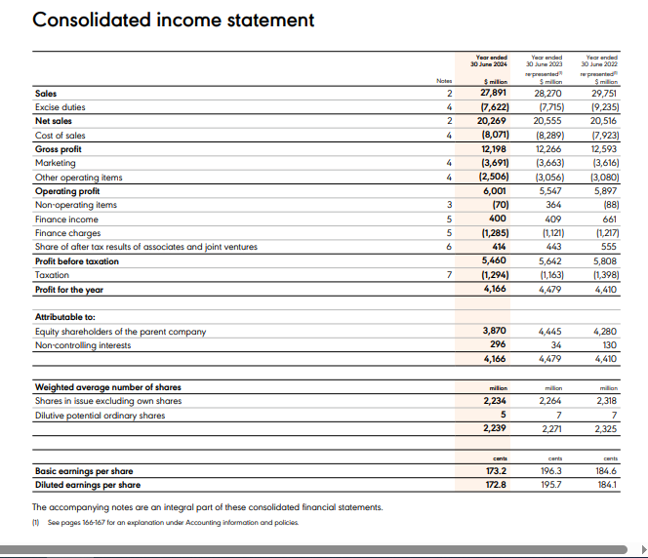

Balance Sheet (2024):
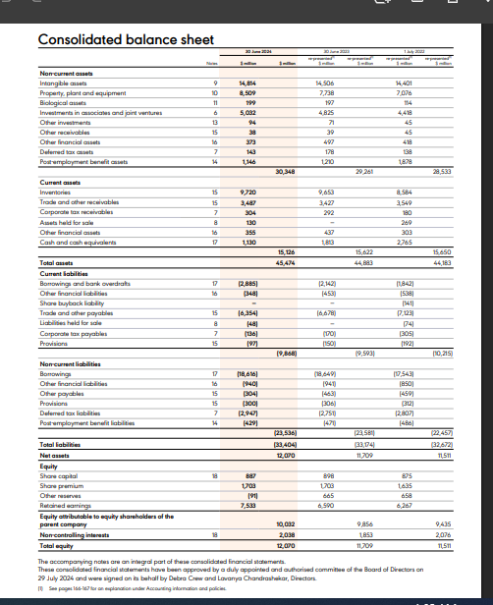

Income Statement (2025):

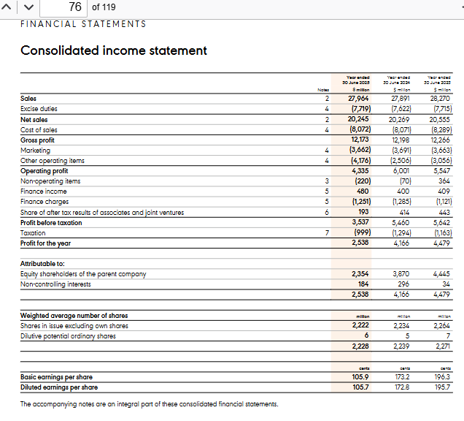

Balance Sheet (2025):

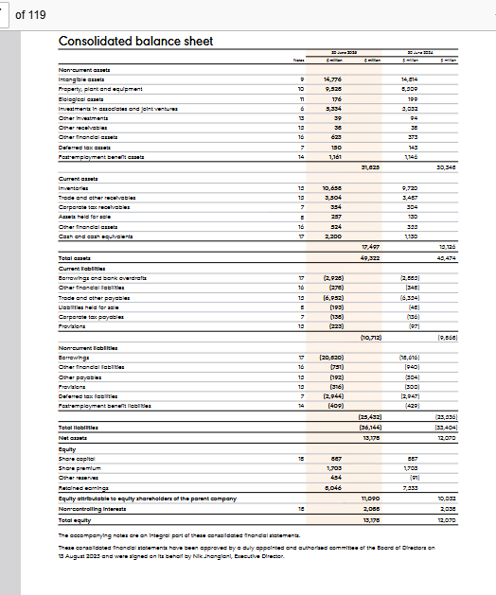

Appendix B: Ratio Calculations and Financial Data (Diageo plc)
1. Profitability Ratios
- Gross Profit Margin:
  - Equation: (Gross Profit / Net Sales) * 100
  - 2024 Calculation: ($12,198m / $20,269m) * 100 = 60.18%
  - 2025 Calculation: ($12,173m / $20,245m) * 100 = 60.13%
- Operating Profit Margin:
  - Equation: (Operating Profit / Net Sales) * 100
  - 2024 Calculation: ($6,001m / $20,269m) * 100 = 29.61%
  - 2025 Calculation: ($4,335m / $20,245m) * 100 = 21.41%
- Return on Capital Employed (ROCE):
  - Equation: (Operating Profit / Capital Employed) * 100
  - (Note: Capital Employed = Total Assets minus Current Liabilities)
  - 2024 Calculation: ($6,001m / $35,606m) * 100 = 16.85%
  - 2025 Calculation: ($4,335m / $38,610m) * 100 = 11.23%
2. Liquidity Ratios
- Current Ratio:
  - Equation: Current Assets / Current Liabilities
  - 2024 Calculation: $15,126m / $9,868m = 1.53
  - 2025 Calculation: $17,497m / $10,712m = 1.63
- Quick Ratio (Acid Test):
  - Equation: (Current Assets minus Inventories) / Current Liabilities
  - 2024 Calculation: ($15,126m - $9,720m) / $9,868m = 0.55
  - 2025 Calculation: ($17,497m - $10,658m) / $10,712m = 0.64
3. Gearing Ratios
- Debt to Equity Ratio:
  - Equation: (Total Debt / Total Equity) * 100
  - (Note: Total Debt = Short term borrowings plus Long term borrowings)
  - 2024 Calculation: ($21,501m / $12,070m) * 100 = 178.14%
  - 2025 Calculation: ($23,748m / $13,178m) * 100 = 180.21%
4. Efficiency Ratios
- Inventory Turnover:
  - Equation: Cost of Sales / Inventory
  - 2024 Calculation: $8,071m / $9,720m = 0.83 times
  - 2025 Calculation: $8,072m / $10,658m = 0.76 times
- Receivables Turnover:
  - Equation: Net Sales / Trade Receivables
  - 2024 Calculation: $20,269m / $3,487m = 5.81 times
  - 2025 Calculation: $20,245m / $3,504m = 5.78 times
5. Investor Ratios
- Return on Equity (ROE):
  - Equation: (Net Profit for the year / Total Equity) * 100
  - 2024 Calculation: ($4,166m / $12,070m) * 100 = 34.51%
  - 2025 Calculation: ($2,538m / $13,178m) * 100 = 19.26%

Appendix C – Westward Plc: After-Tax Cash Flow Workings
Corporation tax at 25% is applied to taxable profit. Taxable profit = pre-tax cash flow less annual capital allowance (20% straight-line of initial investment). Option A: £120,000 p.a.; Option B: £200,000 p.a.; Option C: £320,000 p.a. All figures in £000.



