Geo-technics and foundation technology
Soil mechanics practical report
Morgan Davies
1910276@student.uwtsd.ac.uk

Table of Contents
Introduction 2
Constant head permeameter 2
Results 4
Analysis 5
Atterberg limits 6
Liquid limit 7
Plastic limit 10
classification of soils 12
Conclusion 14
References 15

Introduction

In this report I will be taking two tests which are the Atterberg limit tests and the constant head permeameter test. With these two tests, an explanation of the methodology will be produced, showing pictures of the apparatus used for both tests and explaining how everything works. Once the methodology has been covered, we will then move onto the results and analysis of the tests. This is where calculations will be done to find the correct answer for each test, once the results of the tests have been calculated, these results will be placed onto graphs where we can show the classification of the soil that is being tested. To finish the report, a conclusion will be done to conclude the results and what that tells us about that specific soil. Some information will be found by some secondary research.
Hydraulic conductivity
Hydraulic conductivity is the soil property where the rate at which water passes through the soil, this is very important for the designs for landfills and dams. There are two types of hydraulic conductivity tests. One is the constant head test, which is used for coarse-grained soils, the other test being the falling head test where this would be used for fine-grained soils.
Constant head permeameter
This test is used for soils with higher (granular soils) down to ‘K’ value of about 10-4m/s.
A constant head of water is maintained across a sample under test. Once equilibrium flow has reached, the rate of flow is then measured, and the coefficient of permeability is calculated. This lab test is to determine the permeability of soils. The soils suitable for a test like this are sands and gravels.
Filters of coarse material are usually placed at the top and the bottom of the sample to prevent any fine material from washing out.
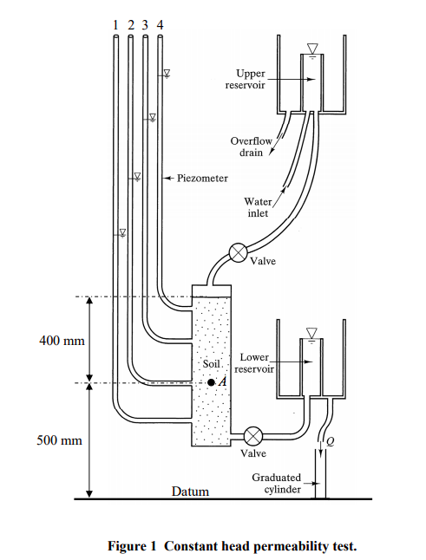
Apparatus
• The soil sample is placed in the centre of the ‘cylindrical Perspex tube’ (this can be shut on the top or the bottom.).
• This sits on top of a stand.
• Two positions in the tube that give us 2 points at which will measure the head of pressure to look at the parameter of hydraulic head.
• As we allow a flow of water through the sample, the pressure is transferred to a measurement on the monometer scale we can take the difference between the first and second point.
• The cylinder is then connected to a constant head of water supply where it’s set above the apparatus as shown in the diagram here, this is constantly fed with fresh water and given a top-off pipe where the level is kept the same so the pressure through the sample is standardised throughout the whole test. Allowing the water to flow through the tubes.
• As the test begins, allow the water to flow through the sample.
• The sample needs to be saturated to prevent any air from evacuating.
• Having it saturated will allow the flow value to be calculated correctly.
• Wait for 2 to 3 minutes for the flow of water to completely saturate the sample.
• Leave the valve open for measuring the cylinder.
• As water flows through the sample, air is being evacuated.
• Use the measuring cylinder to collect a certain amount of water flow.
(User, n.d.)

  - Constant head test, methodology
1. Take around one KG of coarse soil, then place it in a container.
2. Record the mass of containers.
3. Place the screen on the bottom of the cylinder to prevent any soil from being carried out.
4. Fill the cylinder with soil sample.
5. Split soil into three layers, compact each layer with a hammer.
6. Fill the cylinder to the top, should be enough space to place the cap on top.
7. Place screen and separator on top of the cylinder.
8. Put cap on top after placing the screen and separator.
9. Measure the container plus what is left of the soil.
10. Connect the top of the cylinder to the reservoir with a tube.
11. Connect tubes for the two monometers to the two outlets on the side (these are used for measuring pour water pressure at a specific point.).
12. Close the valve on the intake of the test cylinder.
13. Turn the tap on and allow the reservoir to fill up.
14. Once the water is filled to a certain level in the reservoir, water will start to discharge into the sink (if this happens, you know that the level of water is constant.).
15. Open the valve to allow water to pour into the sample.
16. Before taking the flow rate, we must wait until water flows through the sample, this is to remove any trapped air.
17. Let the water run through the system for a couple of minutes.
18. Take a beaker and measure the mass.
19. Start the stopwatch and fill beaker 300ml. Records mass of beakers and time taken to fill.
20. Use a ruler and measure the head of top monometer and the bottom monometer.
21. Find vertical distance between both monometers.

Results

in our constant head permeameter test, the following results were obtained:
- Water collected was 920 x 10⁻⁶ m³in 2 minutes and 45 seconds
- Water collected was 185 x 10⁻⁶m³ in 5 minutes and 30 seconds
- water collected was 36.8 x 10⁻⁶m³ in 11 minutes

the sample was 0.1m in diameter.
The head difference of 0.068m was measured between points 0.2m apart.
The equation used to find the answer is as followed:

K= Q x L
A x h x t

This is where:

Q= flow over time ‘t’ in M³/s
A= Area of flow
K= Coefficient of permeability
L= Length of the flow line
h= Hydraulic head difference
t= time is seconds

‘Darcy’s law states that
V= ki
Where K is the coefficient of permeability which has the units of velocity. Remember that for coarse-grained soil K > 10⁻²m/s while for fine-grained soils k < 10⁻⁸m/s; these very large differences mean that coarse-grained soils with high permeability can act as drains while fine-grained soils with very low permeability can be used as nearly watertight barriers.’
(Atkinson, 2007)

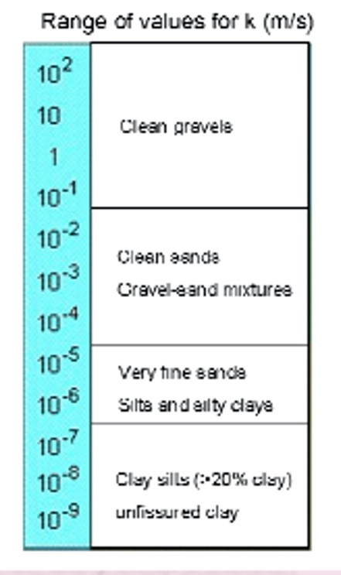
  - Solutions
solution 1:

(920 x 10⁻⁷) x 0.2
Π x 0.05² x 0.068 x (2.75 x 60)
=2.086 x 10⁻⁴ m/s
solution 2:
(185 x 10⁻⁶) x 0.2
Π x 0.05² x 0.068 x (2.75 x 60)
= 2.086 x 10⁻⁴m/s
Solution 3:
=(36.8 x 10⁻⁵) x 0.2
(Davies, geotechnics, 5)
Π x 0.05² x 0.068 x (11 x 60)

=2.085 x 10⁻⁴m/s

after calculating the results from the test, we were able to take the mean value from the 3 solutions, this is would give us a coefficient of permeability of 2.092 x 10⁻⁴m/s

Analysis
After gathering the results from the 3 solutions and finding the mean value, after taking that result and putting it into the table of the value K. we can see that the sample is at the lower end of the gravel and mixtures, we can also say that this result of 10⁻⁴m/s is at the border of the very fine sand.

Effect of permeability
Springs- If the top surface of a relatively impermeable layer is tilted (dips) and outcrops on the side of a valley or slope, instead of the groundwater building up to any extent, water will flow through the aquifer and emerge at the surface as a natural spring.
Under-washing- The under-washing of frictional soils by springs can be a huge effect on its structural stability. Flowing and percolating water can lubricate, loosen and remove loose particles. As these particles are moved, gravity takes over and there is an eventual inevitable downhill movement of water and soil.

  - From a civil engineering perspective, what is the purpose and value of this analysis method?
The field of geotechnics is very important from a civil engineering perspective. The reason for this is, construction projects involve excavations of soil and rock and rock tunnelling, projects involve the loading of substrata in the consequent build, an example of this is the kingdom tower in Saudi Arabia, tests like a constant head test are carried out for buildings like this so that they know what type of soil they’re dealing with so they can use the correct construction method. The purpose of these analysis methods is for the planning and design of a project, the construction methodology and its costing, but this will depend critically on the geological condition present on the proposed site. It effects the initial site investigation and the subsequent physical analysis of a sample where we encounter and substantiate geological feasibility.

Atterberg limits

The Atterberg limits, are the water contents at which certain changes in the physical behaviour of the clay can be observed. The Atterberg limits are focussed on the water contents.

Soil consistency where:
- Liquid limit (LL): the lowest water content above which soil behaves like a liquid.
- Plastic limit (PL) the lowest water content at which soil behaves like a plastic material.
- Plastic limit index (PI) the range between LL and PL.
- Shrinkage limit (SL): the water content below which soils do not decrease their volume anymore as the they continue to dry out. A better indication of properties is

gained by measuring the water content at which certain changes in physical behaviour occur.

Water content
Liquid
limit
Plastic limit
Shrinkage
Limit
0

Liquid
Plastic
Semi-
Solid
Brittle-
Solid
(Davies, geotechnics, 7)

Towards the end of the line, the soil acts as a liquid due to the saturation of the grains being pushed apart.

  - Plasticity
- the strength decreases as water content increases
- soil swells-up when water content increases
- fine-grained soils at very high-water content passes properties similar to liquids.
- As the water content is reduced, the volume of the solid decreases and the soils become plastic.
- If the water content is further reduced, the soil becomes semi-solid when the volume does not change.

Liquid limit
The liquid limit is when the water content at which soil changes from a plastic consistency to a liquid consistency. It is the moisture content that defines where the soil changes from a plastic to a viscous fluid state. It was defined by the lab test concept developed by Atterberg in 1911 using the ‘Casagrande’ apparatus.

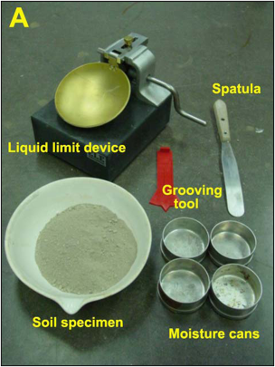
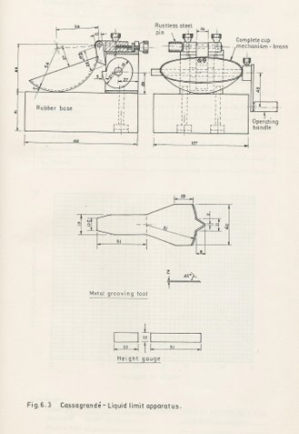
  - Casagrande apparatus
Here is the apparatus for the Casagrande test.
This is where a dish is sat on a heavy block of metal, as you rotate the handle shown in this image, the can lifts and drops over a standard height. As this drops it is measured via a counter. We have a soil specimen,
Moisture cans, a spatula so that we can mic our sample for the test, also a grooving tool. A height gauge is used to measure the drop of the dish back onto the steel base, this is a 10mm drop, so every time the can is turned this is lifted 10mm before dropping to the base. Grooving tool is used to put a standard cut through the specimen.

The liquid limit (LL) is arbitrarily defined as ‘the water content, in percent at which a part of soil in a standard cup and cut by a groove of standard dimensions will flow together at the base of the groove for 12mm under the impact of 25 blows in the device’. The cup being dropped 10mm in a standard liquid limit apparatus operated at a rate of two shock per second. This will be put through a 40-micron sieve, we can only use everything that falls below 40-micron sieve (smaller sizes), anything above this and the methodology wouldn’t work when the specimen is within the tin. You want this being between 8mm-10mm at the centre of the tin. Use the grooving tool to cut a line down the centre of the specimen.

  - Liquid limit procedure
1. 150g dry soil passing through a 40 sieve
2. Add 20% of the water mix thoroughly. (in mixing bowl)
3. Place a small sample of soil into a liquid limit device. (the deepest part about 8mm-10mm)
4. Cut a groove (2mm at the base) run the device, count the number of blows, N.
5. Stop when the groove in the soil closes through 0.5 inches.
6. Take a sample and find the moisture content (using a spatula) dropping it into sample containers, weigh it having a wet weight then place into an oven to dry for 24 hours.
7. 3 measurements- weight of container, weight of container with wet soil and weight of container with dry soil.
8. Repeat the test four times for different moisture contents. Once established first test with number of blows, after this, clean the bowl out totally putting the sample back into the mixing bowl and add in some more moisture.
9. Re-mix again so you have the same sample but an increased moisture content.
10. Repeat this process four times.
11. We want a set of results that gives us a number of blows required for the 0.5-inch closure over a scalar which we want to range for 10 blows to close and 45 blows to close it because the definition of the Atterberg limit is to measure from the 25-blow mark.
12. Once all results are completed, a graph will be drawn.
13. Once it has hit the 25 blows mark, that will be the consideration of the liquid limit for that sample.

  - test results
Test number | 1 | 2 | 3 | 5 | 6 | 7 | 8
Test type | LL | LL | LL | LL | PL | PL | PL
Container test | LL1 | LL2 | LL3 | LL4 | PL1 | PL2 | PL3
Weight of wet soil and container (g) | 9.43 | 13.35 | 13.39 | 12.89 | 8.01 | 9.4 | 8.18
Weight of dry soil and container (g) | 8.02 | 10.66 | 10.68 | 10.24 | 7.24 | 8.31 | 3.39
Weight of container (g) | 4.72 | 4.69 | 4.69 | 4.72 | 4.73 | 4.73 | 4.81
Weight of moisture (g) | 1.41 | 2.69 | 2.71 | 5.52 | 0.77 | 1.09 | 0.79
Weight of dry soil (g) | 3.3 | 5.97 | 5.99 | 5.52 | 2.51 | 3.58 | 2.58
Moisture content (%) | 42.72 | 45.06 | 45.24 | 48.01 | 30.67 | 30.44 | 30.62
Number of blows | 32 | 22 | 19 | 15
(Davies, geotechnics, 9)

Weight of moisture = weight of wet soil & container – Weight of dry soil & container

LL1- 9.43 – 8.02= 1.41g

LL2- 13.35 – 10.66=2.69g

LL3- 13.39 – 10.68= 2.71g

LL4- 12.89 – 10.24= 5.52g

Weight of dry soil= weight of dry soil & container – weight of container

LL1- 8.02 – 4.72= 3.3g

LL2- 10.66 – 4.69= 5.97g

LL3- 10.68 – 4.69= 5.99g

LL4- 10.24 – 4.72= 5.52
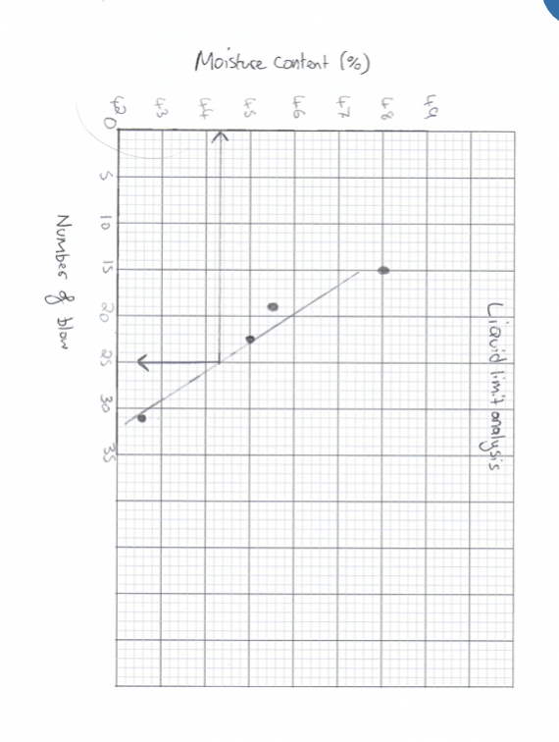

Moisture content= weight of moisture x 100
Weight of dry soil

LL1- 1.41 X 100 = 42.72%
3.3

LL2- 2.69 X 100 = 45.06%
5.97

LL3- 2.71 X 100 = 45.24%
5.99

LL4- 5.52 X100 = 48.01%
5.52

(Davies, geotechnics, 10)

From looking at the graph here we can see that the average is around 44.6% for the liquid limit.

Plastic limit
‘the minimum water content at which a soil will begin to crumble when it is rolled into a thread of approximately 3mm in diameter’.
It is the moisture content that defines where the soil changes from semi-solid to a plastic (flexible) state.

- 3 cans to put the sample in
- Glass plate for us to roll the sample
- Spatula to mix our moisture content into the soil sample.

  - Procedure
1. Take 20g of soil passing 40-micron sieve into a dish.
2. Add water and mix thoroughly.
3. Prepare several ellipsoidal-shaped soil masses by working the soil in hand.
4. Put soil in rolling device, or hand roll the soil until the thread reaches 1/8 inch, when it starts breaking at 1/8 inch, that’s when we can take the sample for the weight.
5. Determine the moisture content of about 6g of the crumbled soil.
6. Need enough moisture, so that we are rolling the specimen, it doesn’t crack.
7. This may take multiple attempts, as we need the moisture to be correct.
8. Measure wet, then put in the oven for 24 hours and then measure the dry weight of the sample.
Here are the handwritten results for the plastic limit, also the plasticity index
.

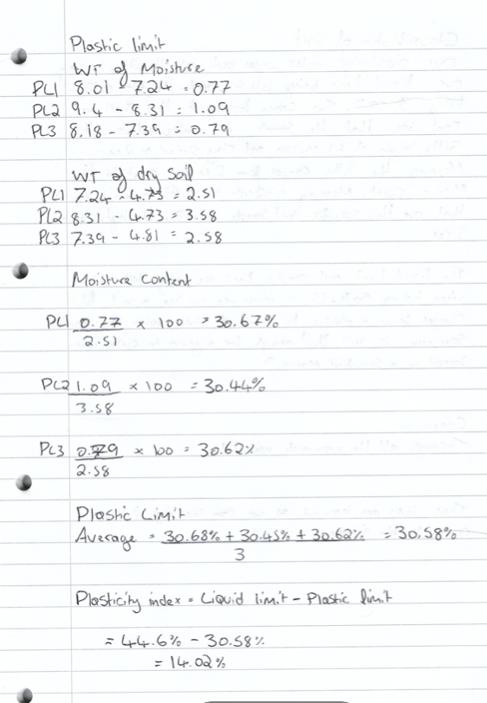

(Davies, geotechnics, 11)

classification of soils
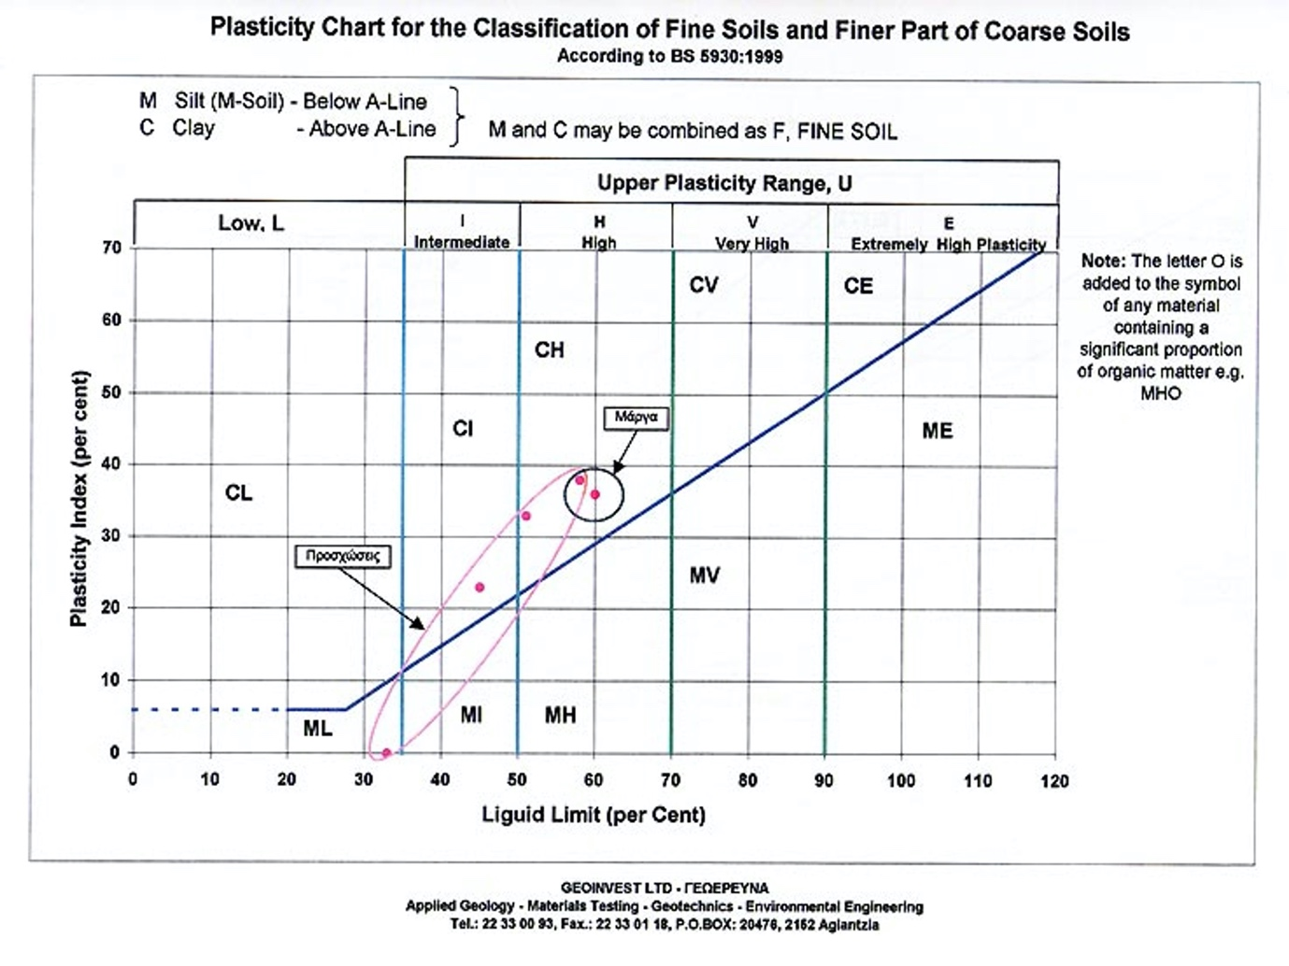
our plasticity index comes out as 14.02%, having our liquid limit being at 44.6%. from looking at this chart we can see that the sample tested are intermediate silts. Silts begin at 63 micron and clay start at 2 microns, meaning that the silts range from 2-micron to 63-micron. meaning 0.02mm to 0.63mm is amongst the higher grain sizes.

  - Case study- Aberfan disaster
‘The Aberfan disaster was a catastrophic collapse of a colliery spoil tip in the Welsh village of Aberfan, near Merthyr Tydfil, on 21 October 1966, killing 116 children and 28 adults. It was caused by a build-up of water in the accumulated rock and shale, which suddenly started to slide downhill in the form of slurry.
Over 40,000 cubic metres of debris covered the village in minutes, and the classrooms at Pantglas Junior School were immediately inundated, with young children and teachers dying from impact or suffocation. Many noted the poignancy of the situation: if the disaster had struck a few minutes earlier, the children would not have been in their classrooms, and if it had struck a few hours later, the school would have broken up for half-term.
Great rescue efforts were made, but the large numbers who crowded into the village tended to hamper the work of the trained rescue teams and delayed the arrival of mineworkers from the Merthyr Vale Colliery. Only a few lives could be saved in any case.
The official inquiry blamed the National Coal Board for extreme negligence, and its Chairman, Lord Robens, for making misleading statements. Parliament soon passed new legislation about public safety in relation to mines and quarries.’
(Aberfan Disaster 1966- Mining Accident Database, n.d.)
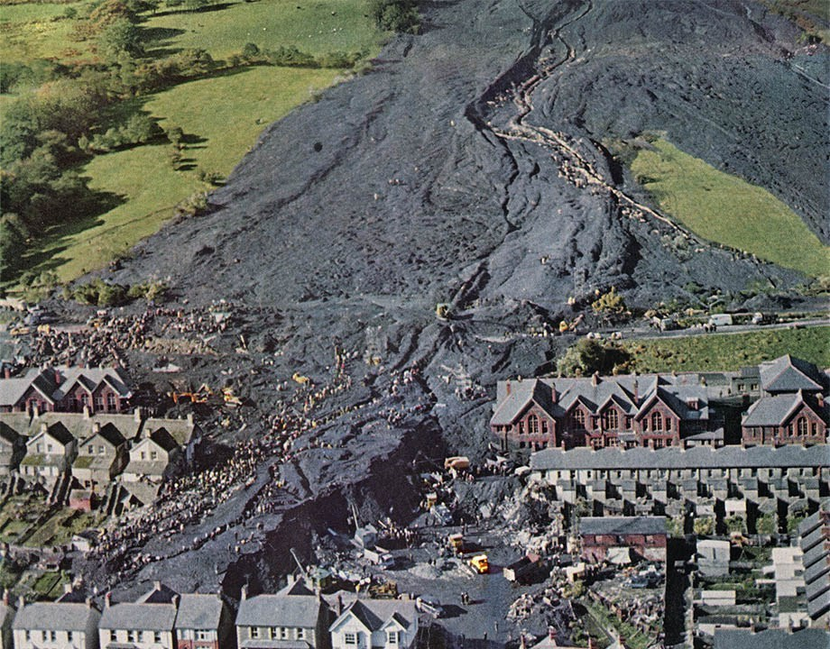

(HanesCymru, 2016)

  - Significance of liquid limit (LL) and plastic limit (PL)
As moisture contents increase, clay and silt soils go through four distinct states of consistency: solid, semi-solid, plastic, and liquid. Each stage exhibits significant differences in strength, consistency, and behaviour. Atterberg limit tests accurately define the boundaries between these states using moisture contents at the points where the physical changes occur. The test values and derived indexes have direct applications in the foundation design of structures and in predicting the behaviour of soils infills, embankments, and pavements. The values assess shear strength, estimate permeability, forecast settlement, and identify potentially expansive soils.
(Backus, n.d.)

Conclusion

The purpose of the constant head test is to see the permeability of the granular soils, such as gravel and sands, containing minimal or zero silts. Once the apparatus was set up correctly, we were able to start the test and start collecting data. From the test we saw that the coefficient of permeability was 2.092 x 10⁻⁴, this gives us the indication that this sample was on the border of very fine sands.
For the Atterberg limits, there were two tests carried out, a liquid limit (LL) test and a Plastic limit (PL) test. Once the apparatus for the Casagrande was set up we were then able to collect results for the liquid limit and plastic limit, after drawing a liquid limit analysis chart, we found that the average for the liquid limit was 44.6%. And after calculating the mean value of the results for the plastic limit, we had the result of 30.58%, once both results were collected, we were able to calculate the plasticity index which was 14.02%. we then put these results into a classification of soils chart where we saw that the sample was an intermediate clay.

References

- (Morgan Davies, 2021,’geotechnics and foundations’, ACBA5004, UWTSD, unpublished work)

- Backus, B., n.d. Atterberg Limits: A Quick Reference Guide. [online] GlobalGilson.com. Available at: <https://www.globalgilson.com/blog/atterberg-limits-a-quick-reference-guide> [Accessed 23 April 2021].

- Mineaccidents.com.au. n.d. Aberfan Disaster 1966- Mining Accident Database. [online] Available at: <http://www.mineaccidents.com.au/mine-accident/119/aberfan-disaster-1966> [Accessed 23 April 2021].

- User, S., n.d. Constant head permeability test. [online] Geotechdata.info. Available at: <http://www.geotechdata.info/geotest/constant-head-permeability-test> [Accessed 23 April 2021].

- : HanesCymru, V., 2016. The Political Aftermath of the Aberfan Disaster. [online] Martin Johnes. Available at: <https://martinjohnes.com/2016/10/20/aberfan/> [Accessed 23 April 2021].

- User, S., n.d. Constant head permeability test. [online] Geotechdata.info. Available at: <http://www.geotechdata.info/geotest/constant-head-permeability-test> [Accessed 23 April 2021].

