
Problem Analysis and Solution Development
Module Name: Analysing and Solving Problems
Module Code: ACCA 4019
Student Name: Alina Mateta
Student ID: 2511187
Lecturer Name: Dr. Abida Perveen
Date submission: 22/03/2026
Contents
Introduction 2
MoSCoW 2
2.1 Must Have 2
2.2 Should Have 3
2.3 Could Have 3
2.4 Won't Have 3
Decomposition 3
IPO 4
IPO Table 4
Variables 5
Variables PascalCase Table 5
Logical implementation 6
6.1 Pseudocode 6
6.2 Flowchart 8
6.3 Flowdiagram 8
Conclusion 9
Referenses: 9

Introduction

This dissertation provides an explanation of various approaches to preparing for coding. It examines different techniques for translating a scenario into a programming language, including methods such as MoSCoW prioritisation and decomposition, as well as the use of IPO tables and variable tables. Furthermore, it explores different naming conventions in coding, the development of pseudocode, and the construction of flowcharts.

MoSCoW

The MoSCoW method is a prioritisation technique used in software development. It is an acronym representing the categories Must have, Should have, Could have, and Won't have. The MoSCoW technique enables priorities to be assigned to each feature and its subtasks. This approach helps determine the relative importance of each component and ensures that the most critical aspects are addressed first. [1].

2.1 Must Have
Creation of a comprehensive database containing accurate information on classroom capacities and class enrolment numbers.
Implementation of allocation software capable of matching group sizes with appropriate rooms based on capacity analysis.
Development of a structured timetable (e.g., using Microsoft Excel or specialised scheduling software) to prevent timetable clashes and overlapping sessions.
Automated scheduling control system ensuring that: each student group is assigned a suitable classroom; each lesson is allocated a specific time slot; no lecturer, classroom, or student cohort is double-booked; all sessions are able to start on time.

2.2 Should Have
Minimisation of travel time and distance between consecutive lessons, particularly for academic staff delivering multiple sessions.
Prioritised allocation of specialised facilities, such as laboratories, seminar rooms, or lecture theatres, according to subject requirements.
Balanced classroom utilisation, ensuring equitable distribution of room usage across the campus to avoid persistent overcrowding or underuse.
Improved spatial planning, grouping sessions geographically where possible to enhance punctuality and reduce disruption.

2.3 Could Have
Further digitalisation of the scheduling process, allowing both planned and emergency timetable adjustments.
Real-time room reallocation capability in cases of maintenance issues or unexpected changes.
Integration with attendance monitoring systems to improve administrative accuracy and reporting.
Analytical reporting tools to monitor room usage trends and support long-term planning decisions.

2.4 Won't Have
Structural or infrastructural redevelopment, such as rebuilding or physically redesigning facilities
Complete restructuring of academic programmes or course frameworks.
Expansion of campus capacity through construction of new buildings.

Decomposition
A database of classroom capacity and the number of students.
To determine the capacity of the classrooms.
To determine the number of students.
Develop a timetable aimed at minimising time wastage and unnecessary movement.
Determine the working hours of the teaching staff.
Define the learning requirements for each group in relation to the material that must be covered.
Analyse the location of classrooms and the distances between them.
Create an appropriate and efficient timetable.
Provide contingency arrangements and substitutions in the timetable in case of unforeseen circumstances.
Finalise the schedule, taking all relevant factors into account.
Inform students and teaching staff of the approved timetable.

IPO
IPO is a data processing cycle. Input is used to enter the initial data that will be processed. The processing stage, aimed at obtaining the required information, may include various operations such as recording, duplication, validation, classification, sorting, merging, calculation, and searching. Output is used to present the result to the user.[2].

IPO Table

Input | Process | Output
Classroom capacities.  The number of classrooms.  Distance between classrooms.  Number of students.  Number of groups and Academic subjects.  Number of lecturers.  Time spent moving between classes. | Cross-referencing student group sizes with available seating to ensure optimal occupancy rates.  Defining the maximum threshold of simultaneous sessions possible across the campus.  Calculating the physical proximity of rooms to keep consecutive lessons within the same building/wing.  Linking specific student cohorts to their required modules and specialised learning environments.  Automated checking to ensure no staff member is double-booked or lacks transition time.  Automatically inserting "travel windows" into the schedule based on mapped distances. | Analytics showing the percentage of filled vs. empty seats per room.  A real-time calendar showing which rooms are occupied or vacant.  Departments are assigned "hubs" to reduce cross-campus travel.  Weekly schedules tailored for every specific student group.  Individualised teaching schedules for all lecturers.  A logical timetable that accounts for realistic transit times.

Variables

Variables have three key aspects: a name, a type, and a value. It can also be represented as a container that stores different types of data. This data may consist of text, logical values, or numbers. Therefore, variable names are used to enable efficient processing and manipulation of information within a created program.
There are naming conventions for variables which recommend maintaining a consistent coding style, avoiding unnecessary abbreviations, and assigning names that clearly indicate the purpose of the variable. In addition, several commonly used naming styles exist, such as PascalCase, camelCase, snake_case, and kebab-case [3].

Variables PascalCase Table

Input | Process | Output
ClassroomCapacity  TotalClassroomCount  DistanceBetweenClassrooms  StudentCount  GroupsAndSubjects  LecturerCount  TravelTimeLimit  AverageWalkingSpeed | AvailableSeats = RoomCapacity - StudentCount  RequiredTravelTime = DistanceBetweenClassrooms / AverageWalkingSpeed  TravelGap = TravelTimeLimit – RequiredTravelTime | AvailableSeats  RequiredTravelTime  TravelGap  TravelGap

Logical implementation

6.1 Pseudocode
Pseudocode is a powerful tool in algorithm development that facilitates the creation of more efficient and effective solutions to computational problems. It reflects the structural conventions of programming languages while removing detailed syntax. Thus, it serves as an intermediate stage in the development of algorithms [4].

Start
DISPLAY “Enter classroom capacities. ”
INPUT ClassroomCapacity
DISPLAY “What is the number of classrooms?”
INPUT TotalClassroomCount
DISPLAY “What is the distance between classrooms?”
INPUT DistanceBetweenClassrooms
DISPLAY “What is the number of students?”
INPUT StudentCount
DISPLAY “What is the time spent moving between classes?”
INPUT TravelTimeLimit
DISPLAY “What is the average walking speed?”
INPUT AverageWalkingSpeed
FOR CurrentClassroom FROM 1 TO TotalClassroomCount DO
SET AvailableSeats = ClassroomCapacity – StudentCount
SET RequiredTravelTime = DistanceBetweenClassrooms / AverageWalkingSpeed
SET TravelGap = TravelTimeLimit – RequiredTravelTime
IF AvailableSeats >= 0 THEN SeatsEnough = TRUE
ELSE SeatsEnough = FALSE
DISPLAY “Is this classroom suitable for the schedule? (YES or NO)”
INPUT SuitableSchedule
IF SuitableSchedule = YES THEN SuitableSchedule = TRUE
ELSE SuitableSchedule = FALSE
IF TravelGap >= 0 THEN SuitableTravelGap = TRUE
ELSE SuitableTravelGap = FALSE
IF SeatsEnough AND SuitableSchedule AND SuitableTravelGap = TRUE THEN
DISPLAY ”Suitable room found!”
DISPLAY ”Current room number:” CurrentClassroom
ELSE
DISPLAY “Room is not suitable.”
END FOR

6.2 Flowchart

As stated by the principle of equifinality, any objective can be achieved through different methods. Therefore, one graphical representation of an algorithm, that is, a sequence of steps, is a flowchart, which schematically illustrates the direction of actions by means of symbols and arrows. The connecting lines represent the flow of operations. Flowcharts are generally divided into two categories: program flowcharts and system flowcharts [5].

6.3 Flowdiagram

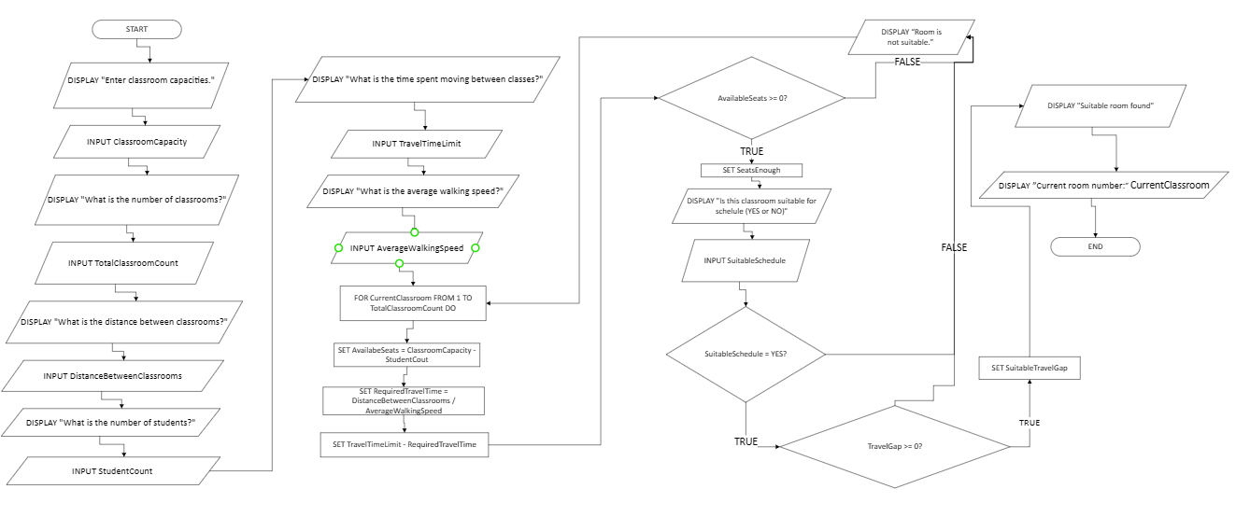

Reflection
During the development of this work, I found the most challenging aspect to be the writing of pseudocode. I believe I would have managed this task more effectively had I been provided with a predefined scenario involving numerical variables. It proved difficult to determine how to present information accurately and coherently in a way that would facilitate both the coding process and its subsequent interpretation by the machine (or shell).

In completing this work, I engaged both abstract and critical thinking skills, alongside conducting research through supplementary literature and online sources. This process enabled me to develop an understanding of how information should be structured within the language of algorithms, as well as to gain insight into the processes that occur following data input.

However, I recognise that my level of understanding is not yet comprehensive; I would estimate it at approximately 65%. I would have preferred a more in-depth engagement with the creation of variables and pseudocode to strengthen my competence and avoid potential difficulties when working with algorithms in the future.

Conclusion
In conclusion, the MoSCoW technique enables a problem to be structured into distinct categories, namely the primary objective Must Have, secondary priorities Should Have, potential sub-tasks Could Have, and non-essential elements Won’t Have. In addition, the problem may be further analysed through decomposition, whereby it is divided into several principal tasks, each of which is subsequently broken down into smaller components with clear explanations and defined actions.

Furthermore, an IPO table is presented, representing the three fundamental stages of a program: input, process, and output, alongside a variables table employing the PascalCase naming convention. In addition, the principal styles of variable naming are outlined, including camelCase, snake_case, kebab-case, and PascalCase. The study also explains and demonstrates how to construct pseudocode for algorithm development, as well as examining the graphical representation of algorithms through the creation of flowcharts.

Referenses:
[1]“XPS-MoSCoW - A Prioritization Based Hybrid Agile Model of SCRUM and Extreme Programming,” International Journal of Software Innovation, vol. 10, no. 1, Jan. 2022, doi: https://doi.org/10.4018/ijsi.297989.
[2]J. BHATTACHARYA, RUDIMENTS OF COMPUTER SCIENCE. Academic Publishers.
[3]F. Wellington and AI, Programming Logic. Publifye AS, 2025.
[4]Cybellium Ltd, Compiler Design Exam Prep. YouGuide Ltd, 2024.
[5]Anil Bikas Chaudhuri, The art of programming through flowcharts & algorithms. India: Firewall Media, 2005.

