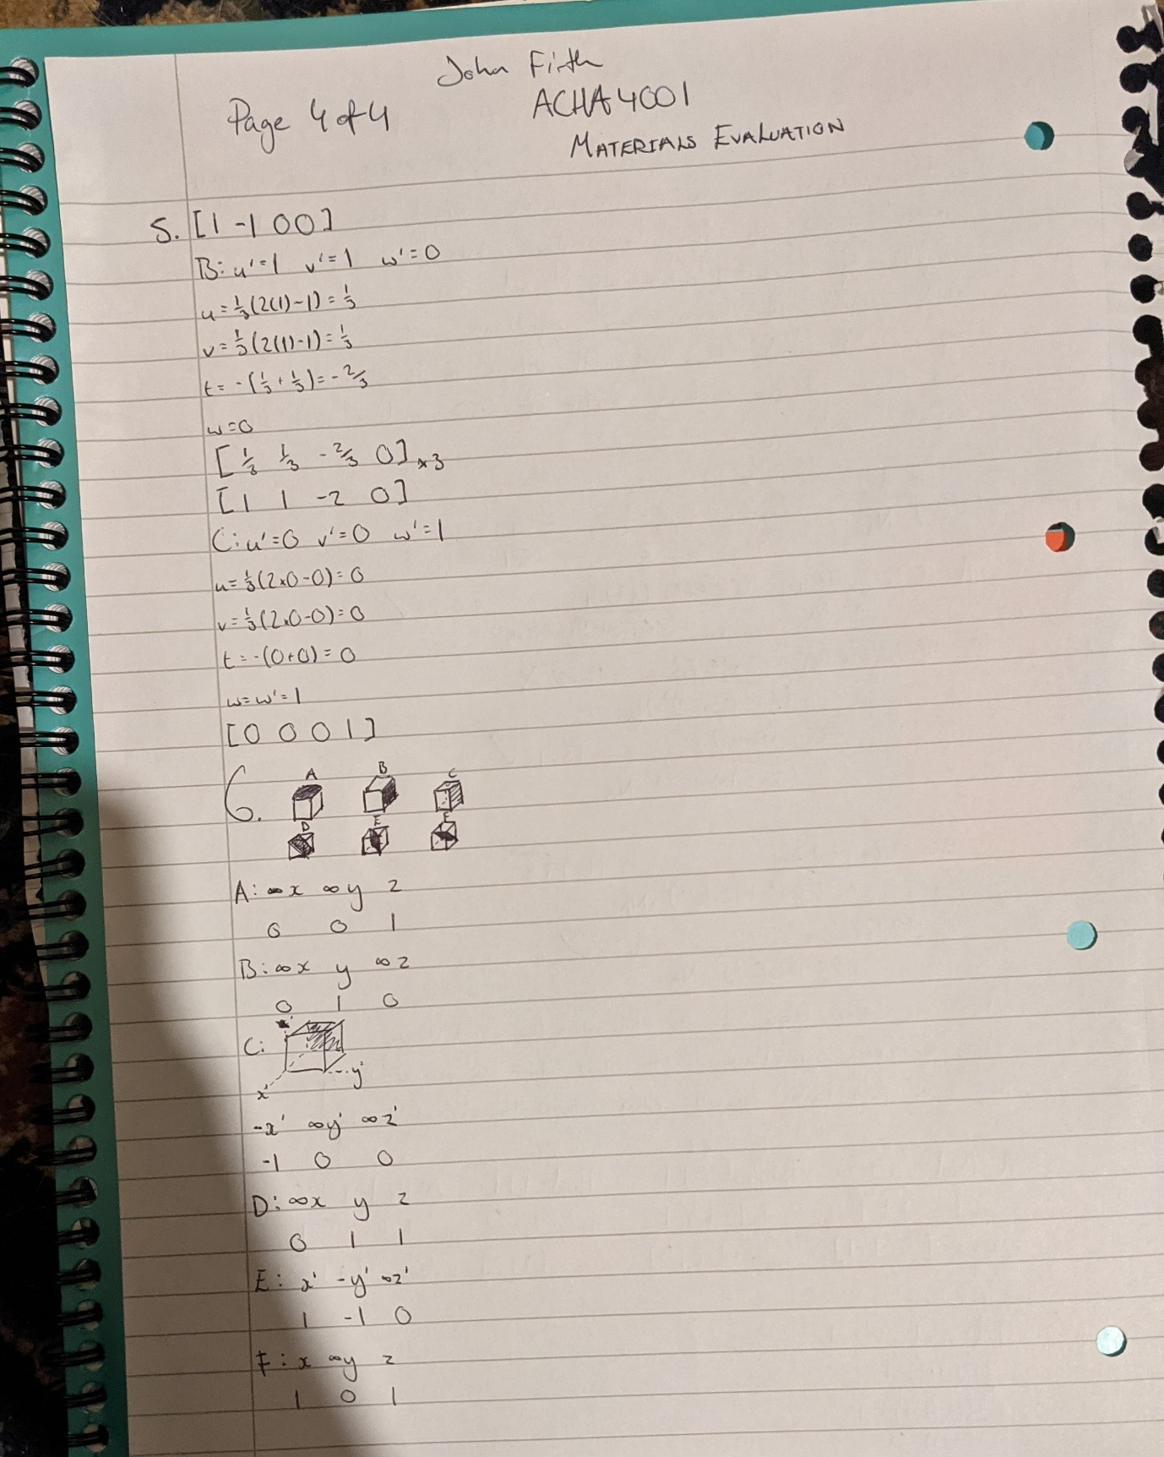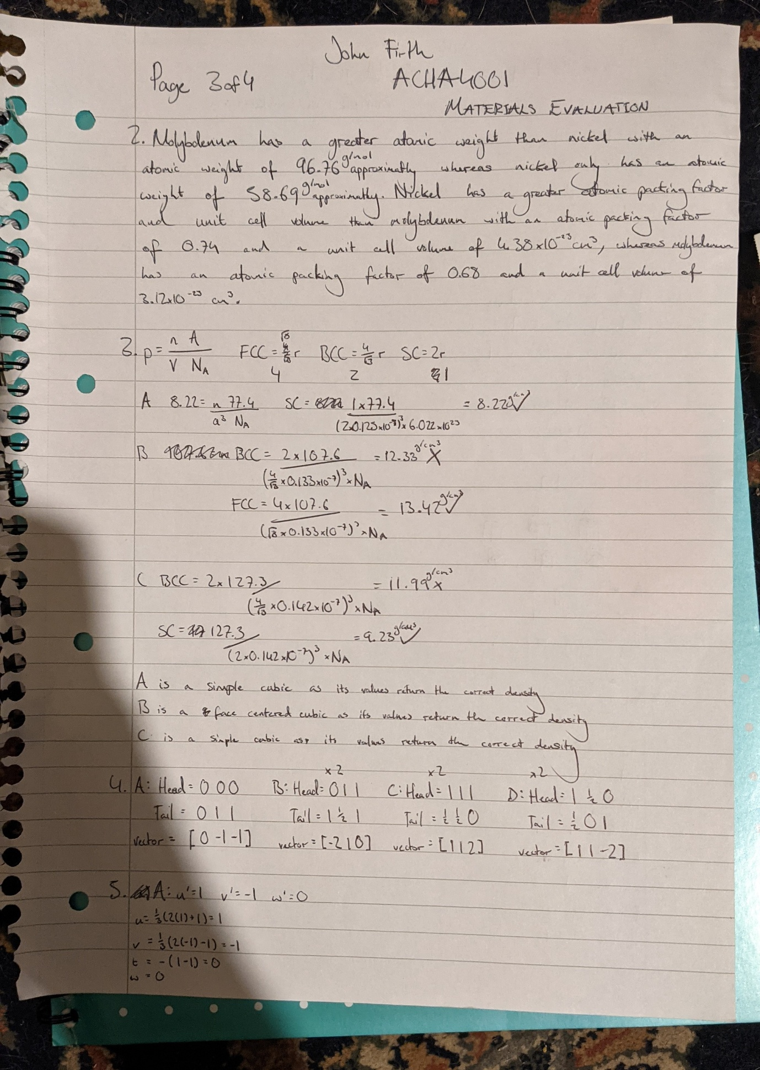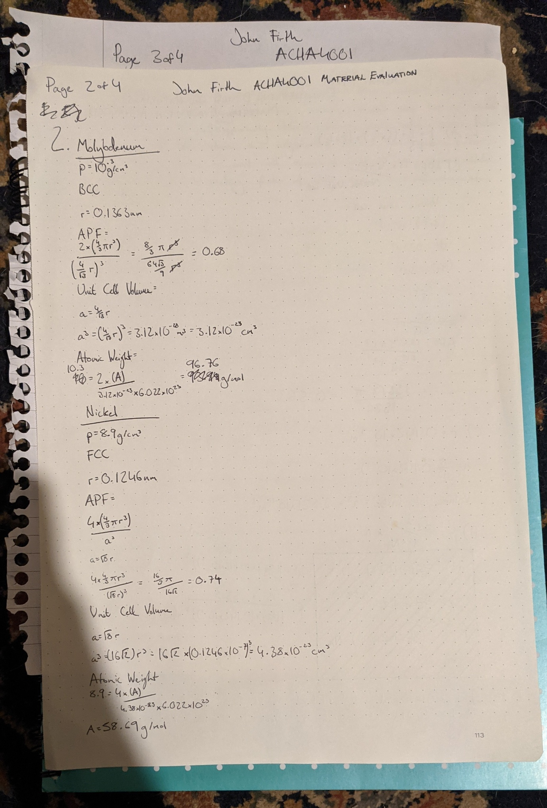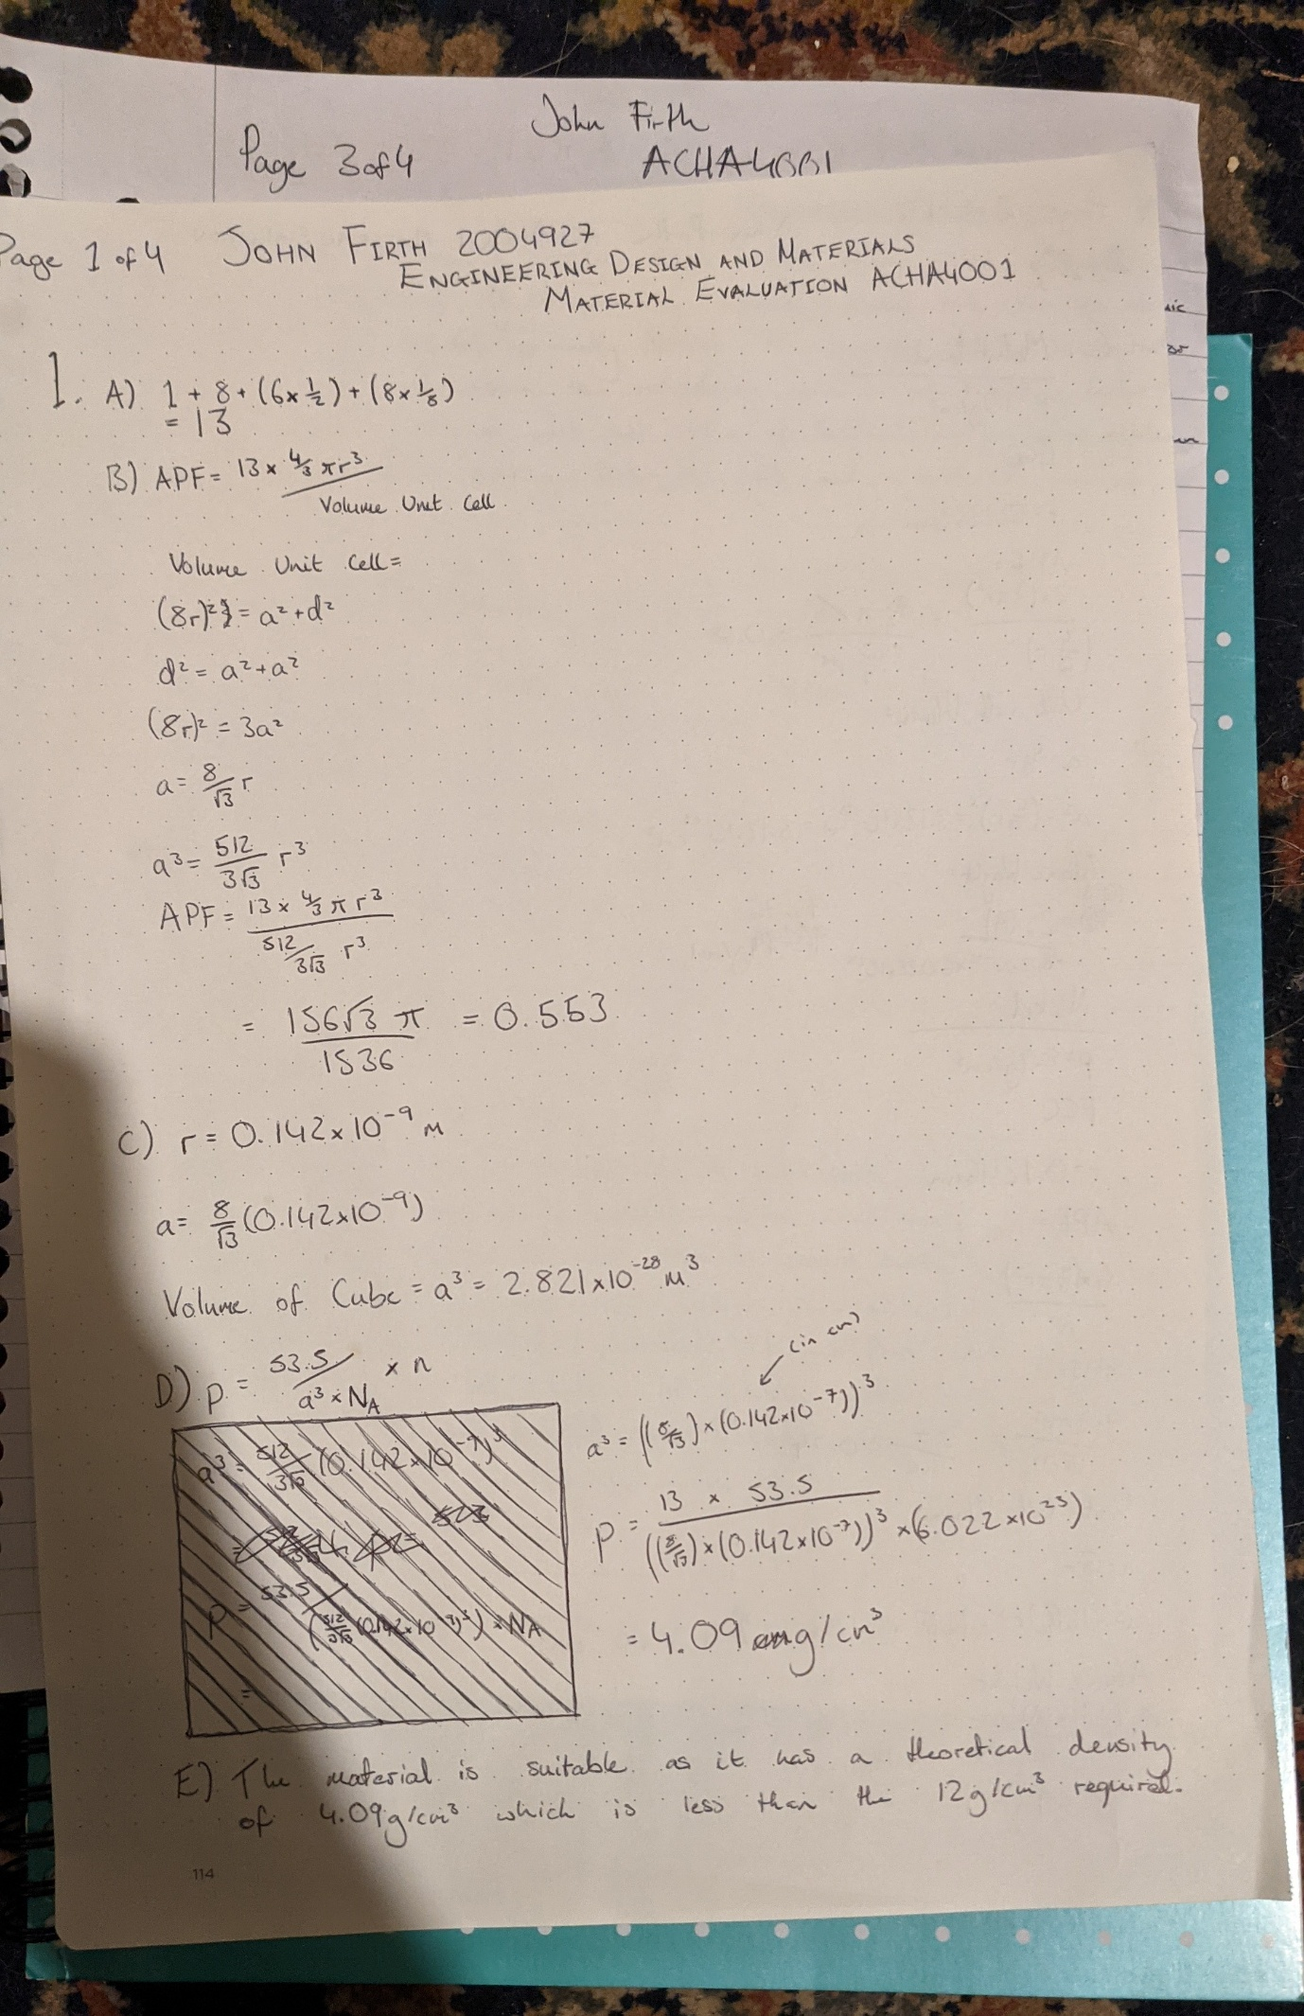
20 words 20 words 20 words 20 words 20 words 20 words 20 words 20 words 20 words 20 words 20 words 20 words 20 words 20 words 20 words 20 words 20 words 20 words 20 words 20 words 20 words 20 words 20 words 20 words

