Introduction
Developing and devising strategies is pivotal for the seamless operation of an organization. In layman's terms, strategic management is the process of analyzing and managing these strategies in an efficient and controlled environment. The concept also helps to set a direction for the organization, thereby aiding to achieve the goals and objectives promptly. The directional driving principles of strategic management can also help an organization to navigate through changes, both foreseen and unforeseen, and continuously adapt to them. This report will analyze the key strategic management principles of one of the largest multinational technology corporations in the world; Dell Technologies LTD.
The report will begin by providing a detailed background of Dell, its core competencies, as well as its operating principles. Then the report will discuss the micro and macro environment of the company and analyze them with the help of frameworks such as PESTLE and industry life cycle models. Post that, the report will concentrate on the internal factors affecting the organization with the help of VRIO and SWOT Analysis frameworks. The report will also elaborate on the strategic management concepts that could help the company gain a competitive advantage. Prior to the conclusion, the report will also discuss the growth, green strategies, and CSR initiatives of the company.

Dell Technologies Inc.
Dell Technologies is a multi-national technology company based in Round Rock, Texas, USA. The company was founded by Micheal Dell, a student at the University of Texas. Initially started as a business that sold computers and peripherals, Dell expanded rapidly during the 1990s and became one of the largest technology companies in the world. The company currently employs more than 165,000 employees and has operations in 185+ countries. Dell operates across numerous markets such as personal computers, servers, and networks (Li, 2022: Nayak, 2013). The company has a diverse portfolio of products and services and caters to both individual and corporate clientele.
The company is publicly traded and has a market value of 90 billion USD, as of 2022. Dell has also generated more than 96 billion USD in sales in 2021 (Financial Times, 2023). The company also invests heavily in research and development, which helps it to retain its position as one of the industry leaders. Lastly, the company is also renowned for its innovative strategies, such as the direct-to-consumer model, where customers can personalize the Dell products like laptops as per their requirements while ordering through the company website (Srinivasarao, 2018).

Mission and Objectives
The mission statement for Dell emphasizes driving human progress with the help of technology. This outlines the organization's commitment to applying technology to create a positive environment for its people, and for the world as a whole. In short, the company strives to use its knowledge of technology to connect and transform the lives of people. Similarly, the vision statement of Dell is to be the most innovative, efficient, and customer-focused technology company in the world (Dell, 2023; Ragulan, 2021). Dell tries to achieve this by delivering state-of-the-art products that could go above and beyond in satisfying the customer's needs and wants.
Dell also has several objectives that drive its business strategies. Some of them are as follows:
- Creating Exceptional Customer Value: Dell endeavors to provide superior service to its customers which helps them to achieve their business/personal goals more quickly.
- Improving Operational Excellence: The company continuously improvises its operations to increase its efficiency, reduce costs and increase customer satisfaction.
- Building a Perfect Workplace: The company is always in search of talented people and has effective strategies in place to retain them for the long run. This helps Dell to create a workplace that rewards innovation and collective thinking.
- Increasing Profitability: Dell aims to grow its business with a strong focus on profitability which in turn encourages financial sustainability.
As we had a detailed look into the background of Dell, we can now shift our attention towards the environmental analysis for Dell.

Environmental Analysis
Environmental Analysis is the process of evaluating the internal and external factors that affect the operations of an organization. It is used in the field of strategic management to analyze the existing business environment and make informed opinions from them for the future. The concept can be divided into two main categories; Macro Environmental Analysis and Micro Environmental Analysis (Assi & Jassem, 2021). The following diagram illustrates the factors associated with each one of them.
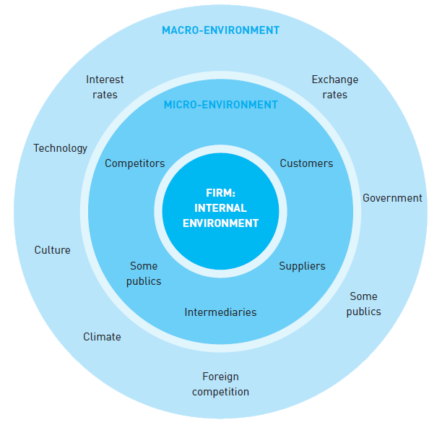
Figure 1: Micro-and macro-environmental forces (Source: (Blythe, 2005))

Macro-Environment Analysis
Macro Environmental Analysis evaluates the external factors (factors that are beyond the control of the organization) that affect the business such as politics, economics, and regulations. In other words, the analysis focuses on concepts that are beyond the control of the organization (CFI, 2023). This helps in identifying the threats and opportunities that might arise from them. For this report, we will use one of the most renowned macro models, the PESTLE.

PESTEL Analysis
The PESTLE analysis model examines the seven major external factors that affect a business namely, Politics, Economics, Social, Technology, Legal, and Environment (CIPD, 2021; University of Sydney, 2023). Analyzing these pivotal factors will help organizations to make informed decisions on several strategic business aspects such as the viability of a market and its business climate. The PESTLE analysis for Dell can be undertaken as follows:
- Political: These factors are caused by a change in the government or changes in government policies. Since Dell operates across the world, the company has to comply with the political factors of every operating country, which could have both negative and positive impacts. For instance, international trade agreements such as the United States-Mexico-Canada Agreement (USMCA) eliminate the trade tariffs between the 3 countries, which in turn reduces the burden of taxation on Dell (CBP, 2023). On the other hand, the Trump administration imposed additional tariffs on imported goods to the USA in 2018, which forced Dell to increase the prices of its products (Tankersley & Bradsher, 2018).
- Economical: These are caused by the changes in the economy of a country. The pandemic of Covid 19 has greatly benefitted the e-commerce industry. Dell recorded a 27% increase in sales during this period due to the increased demand for PCs and laptops, for remote work and education (Carlson, 2021). However, the company also faces certain challenges due to economical factors. For instance, Dell records low sales in developing countries like India due to the poorer population and competition from local brands.
- Social: These are the sociocultural trends that impact an organization. For instance, Dell is committed to diversity and inclusion, which led them to invest in programs that help under-represented people. The Dell Women's Entrepreneur Network and the Dell Scholars Program are examples of such initiatives (Dell, 2022; Michael & Susan Dell Foundation, 2023). On the other hand, the company has also faced criticism due to some social factors. In 2020, Dell was accused of being opaque about using forced labor in its supply chain. The company was criticized for using Chinese suppliers that used forced labor from Uighur Muslims (Kang & Wang, 2020).
- Technological: This factor discusses the impact of technology on the operations of a company. Dell has employed technologies such as Artificial Intelligence (AI) and machine learning to improve its products. For instance, Dell's Precision line of laptops uses AI to optimize performance, which helps its customers with high computing needs (Harper, 2020). On the other hand, the rise in technology has also caused some inconveniences to the company. In 2020, Dell faced a security breach, when hackers got information about sensitive user information such as contact information, of its customers (Page, 2020).
- Legal: These factors have legal implications on the operations of an organization. For instance, the company has updated its privacy policies to comply with data protection regulations like GDPR in Europe and HIPAA in the US (Li et al., 2019; Cohen & Mello, 2018). This will ensure the customer data is kept securely. However, Dell has also faced lawsuits for patent infringement and intellectual property rights (IPR) disputes, which negatively affect the business (Vardi, 2011).
- Environmental: These factors pertain to the impact of environmental issues on a company. For instance, Dell is hoping to power 100% of its global operations with renewable energy, by 2040 (Horwath, 2019). The company has also invested in solar and wind energy to reduce its global carbon footprint. Both these initiatives have helped Dell to build a positive image. However, Dell has also been facing criticism for the way it handles e-waste disposal. Although the company has started a recycling initiative, it is still far from being efficient (Villanueva, 2020).

Micro-Environment Analysis
Micro Environmental Analysis examines the internal factors, within the company, that affect the daily operations of an organization. As the factors are internal, they can be controlled by the organization (Singh et al., 2022). There are numerous frameworks to analyze internal factors. For the purpose of this report, we will be discussing two major such models; The Industry Life Cycle and Porter's Industry Five Forces.

Industry Life Cycle
The industry life model analyses the stages through which the industry progress over time. Typically, there are four different stages in the model; Introduction, growth, maturity, and decline (Sabol et al., 2013). The following graph illustrates these stages and the behavior of the market during each of them.
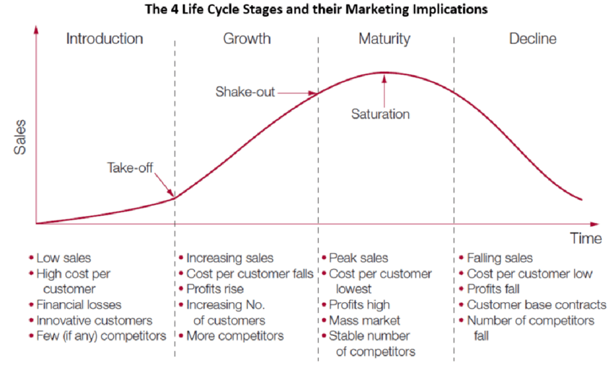
Figure 2: Industry Life Cycle ( Source: (Zhang, 2019))
The model can be applied to Dell as follows:
- Introduction: In this stage, an industry is in the emerging stage, with a low number of players and low sales. Here the core focus is on developing the brand image and creating products. The introductory stage for the computer hardware industry was around the 1980s when companies like Dell were just a startup.
- Growth: In this stage companies experience significant growth and an increase in demand for the products/services. This is the ideal stage to invest in marketing and branding, product expansion, and new market development. The 1990s were the growth period for the computer hardware industry. During this period Dell gained a competitive advantage by providing customizable PCs at affordable prices.
- Maturity: In this stage, the industry will reach maturity, where a large number of players, intense competition, and stable demand. Here the companies focus on cost reduction and new market development. The computer hardware industry reached maturity by the 2000s and Dell shifted its focus from PCs to laptops and other portable devices.
- Decline: In this stage, the industry will face a decline in demand and sales. At the moment, the computer hardware industry is in the decline stage as users are moving to substitutes such as smartphones and cloud computing. As a result companies like Dell are diverting their attention towards other profitable ventures such as data storage and cloud computing.
In short, Dell has successfully managed to navigate through the different stages of the computer hardware industry life cycle. By diversification and identifying new business prospectus, Dell has retained its position as one of the major players in the industry.

Porter’s Industry Five Forces Analysis
Porter's Industry Five Forces Analysis is a strategic management tool used to measure the attractiveness and profitability of an industry. It was developed by Michael E. Porter, a professor at Harvard Business School, and was first introduced in his book "Competitive Strategy", in 1980 (Porter, 1979; Goyal, 2020). The framework considers five major factors that could influence an organization's name, the threat of new entrants, the bargaining power of suppliers, the bargaining power of buyers, the threat of substitute products/services, and competitive rivalry. The following image shows the five forces and the main factors that influence them.

Figure 3: Porter’s Five Forces. (Source: (Bruin, 2020))
Let’s see how the forces affect Dell.
- The Threat of New Entrants: This force refers to the degree to which new companies can enter and compete in an industry. The computer hardware industry has high barriers to entry, such as the requirement of high initial capital, technical infrastructure, and a highly trained workforce. Hence, we can say that the threat of new entrants is low for Dell.
- Bargaining Power of Suppliers: This pertains to the degree to which suppliers can influence the cost of raw materials. Dell has numerous suppliers across the world, hence the power of a single supplier is low, for the company. The exceptions to this are the microprocessor suppliers of the company, like Intel and Samsung, who have a relatively higher power. This is because there are very few such manufacturers.
- Bargaining Power of Buyers: This force is about the degree of power exercised by the buyers in a company. The force is low for Dell as there are only a few established competitors in the computer hardware industry, which limits the number of alternatives for the customers.
- The Threat of Substitutes: This force refers to the number of substitutes that could meet the needs and wants of the customers. The computer industry has many substitute products, such as tablets, smartphones, and other mobile devices. They are increasingly becoming popular as they are as, if not more, powerful than a computer. Hence, we can say the threat of substitutes is high for Dell.
- Competitive Rivalry: This force is about the degree of competition between the existing companies in the market. The higher the competition, the less profitable the industry is. The computer hardware industry has a number of established players like HP, Lenovo, and Apple. Hence, we can say that the competitive rivalry is high for Dell.

Internal Analysis
The internal analysis is a framework in strategic management that examines the internal resources and capabilities of an organization, to identify its strengths and weaknesses. The key purpose of internal analysis is to identify the core competencies in an organization and leverage them to gain a competitive advantage (Hodges & Morris, 2019). The framework considers five major steps which are as follows:
- Assessing Resources: Here we asses all the resources of the organization such as capital, infrastructure, and the number of employees. Aspects such as intellectual property, brand equity, and brand image can also be assessed as resources. Dell has a significant amount of resources such as production facilities, warehouses, and offices. The company also has access to a large number of financial resources and employs a highly skilled workforce.
- Analyzing Capabilities: Here we analyze the operations of an organization across different fields of business, from production to customer service, to identify the strengths and weaknesses associated with them. Dell has a highly sophisticated supply chain which helps them to deliver the products quickly and safely (Kumar & Craig, 2007). The company also has a strong brand image which helps to retain its customer base.
- Evaluating Core Competencies: Here we look for unique skills and opportunities of the organization that could help to create a competitive advantage. The key core competency of Dell is its direct-to-customer sales method, which helps the company to sell its products cheaper, compared to its rivals (Srinivasarao, 2018).
- Value Chain Analysis: Here we analyze the processes/areas that create value for the customer, to improve them. Dell's value chain comprises areas like product design, manufacturing, marketing, customer service, and so forth. The direct-to-customer business model helps the company to recapture most of this created value.
- Identifying Strategic Issues: Here we identify the key threats and challenges faced by the organization. It will help us to analyze how well the organization addresses them. The most pressing issues faced by Dell in this aspect are the increase in competition in the computer hardware industry and the threat of substitutes like smartphones (Kothandaraman & Wilson, 2001).
As we have got a brief idea of the internal analysis, we can now proceed to look at certain important aspects of it such as resources and capabilities for Dell.

Dell’s Strategic Resources and Capabilities
The key strategic resources and capabilities of Dell are as follows:
- Direct-to-Customer Sales Method: With this method, Dell is able to sell the products directly to its end customers, eliminating the need for third-party distributors (Srinivasarao, 2018). This also helps to keep the prices lower than the competition.
- Supply Chain: Dell has a highly sophisticated supply chain and logistic system which helps them to deliver the products quickly and securely. The supply chain is based on the build-to-order model, where the company manufactures a product only when an order is placed (Gunasekaran & Ngai, 2005). This in turn reduces the need for warehouses and excess inventory.
- Brand Image: Dell also has a very good brand image, which is cultivated with the help of exceptional customer service and the delivery of quality products. This has helped the company to create brand-loyal customers, who will remain as customers for the foreseeable future (Nandan, 2005).
- Innovation: Dell invests heavily in research and development (Alsop, 2022). Additionally, the company encourages its employees to push the boundaries and be creative. This has helped the company to create innovative products.
- Talented Workforce: Dell employs a highly skilled and talented workforce. The employees are provided with state-of-the-art training and development programs as and when required.

Value Chain Analysis
Value chain analysis is the process of identifying and analyzing the activities that create value for an organization and its customers. Conducting a value chain analysis will help an organization check how much value is added/removed in each step of the business process (Hellin & Meijer, 2006; Taylor, 2005). High value-creating processes of the business can be used to create a competitive advantage. The competitive advantage can be either:
- Cost Reduction: If every business activity can be optimized to be more efficient, it will in turn make them less expensive.
- Product Differentiation: Here businesses invest time and money to research new innovative products that will stand out from the competition.
Porter's value chain model is a commonly used framework for value chain analysis. It divides the business processes into two separate groups; primary activities and support activities. Primary activities are directly responsible for the production of the product/service while support activities provide the infrastructure for the primary activities (Ensign, 2001).

The following figure shows Porter's value chain model for a typical organization and the different processes that come under primary and support activities.
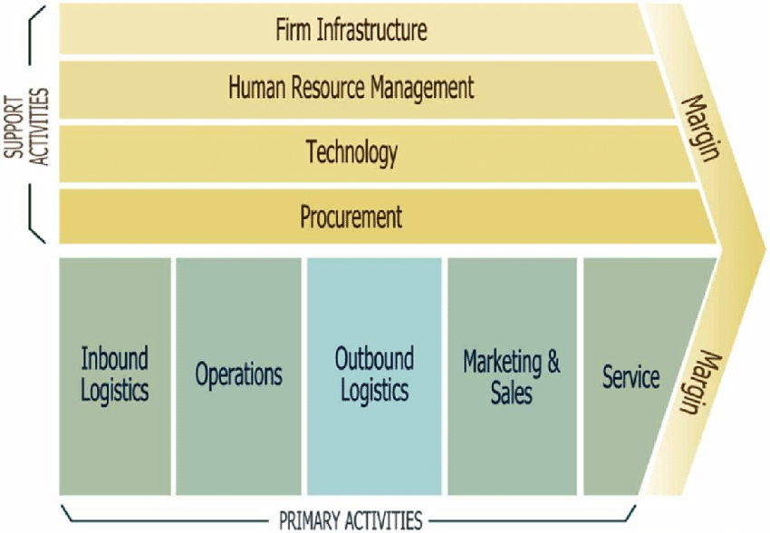
Figure 4: Porter's value chain model (Source: (Ali et al., 2017))

Primary Activities
The primary activities in the value chain for Dell are as follows:
- Inbound Logistics: This factor refers to the sourcing, storing, and distribution of inputs (raw materials) required to create a product or service. For Dell, this includes the procurement of computer parts from different suppliers, storing them in warehouses, and supplying them to production units. Dell uses a just-in-time (JIT) inventory system (Balkhi et al., 2022), where components are procured just before they are needed, to reduce inventory costs.
- Operations: This factor refers to the transformation of raw materials into finished goods. For Dell, this process is about assembling the computer parts to create a computer. Dell has manufacturing units across the world where it employs sophisticated techniques to manufacture high-quality computers quickly and efficiently.
- Outbound Logistics: This refers to the delivery of the finished products to the customers. For Dell, this is about the delivery of finished computers to its customers. The company uses its global supply chain to deliver, track and optimize shipping routes, which helps in the timely delivery of its products.
- Marketing & Sales: This factor refers to the marketing and promotional activities associated with the sale of the products/services. Dell advertises its products through different social media platforms as well as TV and print media. It also uses social media platforms like Twitter and Facebook to engage with customers and indirectly promote its products. The company sells its products through its official online and offline stores as well as third-party distributors like Amazon and Currys.
- Service: This factor refers to the service provided to the customers post a sale. Dell is world-renowned to provide exceptional after-sales service to its customers. The company achieves this by using its global support networks and repair facilities. Dell also uses advanced technologies like remote access and diagnostics for quick query redressal (Ghaffarzadegan et al., 2018).

Secondary Activities
The secondary activities in the value chain for Dell are as follows:
- Firm Infrastructure: This refers to the provision of facilities and equipment to support the primary business operations. For Dell, the infrastructure includes production units, warehouses, and stores (offline and online).
- Human Resource Management: This refers to the activities involved in the recruitment, training, development, and retention of the workforce. For Dell, HRM is about creating value with its workforce. Dell employs more than 165,000 people across the world and provides them with the best training and development initiatives (Li, 2002). The company also provides a competitive salary and other benefits to retain and encourage its workforce.
- Technology: This refers to the improvisation of manufacturing processes and finished products with the help of technology. For Dell, this pertains to the improvement of its production and computer technology. The company invests heavily in research and development to create new innovative products. Dell employs robotics and automation to fast-track the production line and data analytics and AI to improve its supply chain systems (McDowell, 2021).
- Procurement: This refers to the sourcing of raw materials. For Dell, procurement is about the acquisition of computer parts from its global suppliers. The company uses advanced procurement tools such as Supplier Relationship Management (SRM) software, Electronic Procurement (eProcurement) systems, Reverse Auction software, Spend Analysis tools, and Supplier Performance Management (SPM) software (Lee, 2007; Smart & Harrison, 2002). This helps Dell to negotiate better contracts, build strong relationships, and monitor the performance of its suppliers.
The following flowchart illustrates the value chain for Dell:
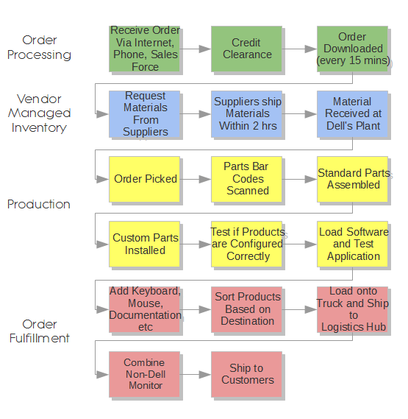
Figure 5: Dell’s value chain (Source: (Supply Chain Minded))

VRIO Analysis of Distinctive Resources and Capabilities
The VRIO Analysis is a strategic management tool created to analyze the internal competencies of an organization, in order to create and sustain a competitive advantage. The acronym VRIO stands for Value, Rarity, Imitability, and Organization (Cardeal, 2013; Knott, 2015).

The following flowchart illustrates the elements of the VRIO framework and how to gain a competitive advantage in each one of them.
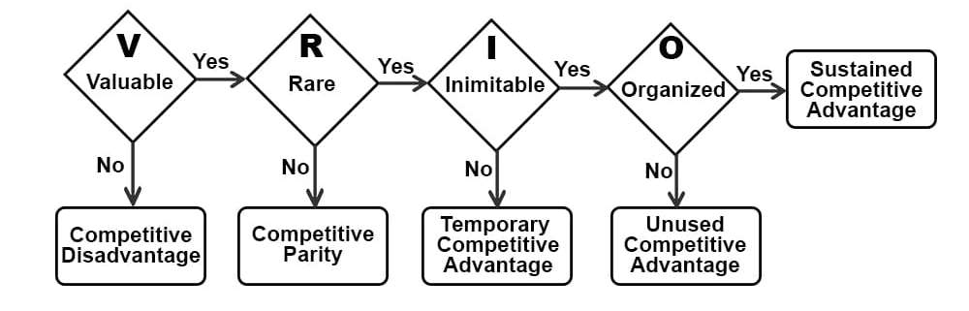
Figure 6: Elements of VRIO Framework (Source: (Usmani, 2022))
Value analyses whether the resources of an organization are valuable while rarity checks whether they are unique in comparison with the competitors. Similarly, imitability checks whether these resources and processes are easy to imitate/reproduce by the competitors whereas organization checks whether organizations are able to leverage these resources to the full extent. The following table discusses the different resources of Dell and how they perform with the VRIO matrices.
Resources | Value | Rare | Imitation | Organization | Competitive Advantage
Digital Strategy | Yes, digital strategy is vital for staying and competing in the market | No, post Covid 19, most of the competitors have either already moved to digital platforms or are planning to move, soon | Can be imitated by competitors | A major player in the industry | Although critical, a digital strategy cannot provide a sustainable competitive advantage
Brand Extensions | Yes, creating a niche market is possible | No, competitors to are targeting them | Yes | Will require specialized budgets to cover marketing and R&D | Temporary Competitive Advantage
Dell Corporate Strategy | Yes | No | Strategy varies with the organization | Yes, Dell has the organizational skills to implement the strategy. | Low Competitive Advantage
Competencies of Dell workforce | Yes | Yes | Cannot be imitated by competitors | Yes | Strong Competitive Advantage
Dell Customer Community | Yes, as Dell takes feedback from customers while developing new products | Yes, Dell has been able to build strong relationships with its customers. | Difficult to imitate | Yes | Strong Competitive Advantage
Cost reduction in logistics and supply chain | Yes, as it helps to lower costs | No | Can be imitated by competitors but requires economies of scale | Yes | Medium to Long Term Competitive Advantage
E-Commerce Opportunities | Yes, the e-commerce industry is growing | No, competitors are already in the industry | Applying AI and automation could make it difficult to imitate | Dell has just begun to explore the e-commerce landscape | Sustainable competitive advantage in the long run
Customer Loyalty | 84% of the revenue comes from 23% of the customers | Yes, Dell always invests in building customer loyalty | Competitors are yet to achieve the scale of loyalty that Dell holds | Dell is successful in leveraging the customer loyalty | Short-term competitive advantage
Brand Positioning | Yes | No | Can be imitated by others but requires huge marketing budgets | Yes, Dell employs consumer behavior principles to position itself in the market | Temporary Competitive Advantage
Addressing Regulatory and Legal Commitments | Yes | No | Can be imitated by competitors | Yes | No
Leveraging Sales Force and Channel sales | Yes | No | Can be imitated by competitors | Yes | Sustainable competitive advantage
Leadership | Yes | No | Can't be imitated by competitors | Yes | Strong Competitive Advantage
Intellectual Property Rights and Patents | Yes | Yes, products under IPR rights are extremely difficult to copy | Low risk of imitation | Dell is yet to apply its IPR rights to their full potential | Strong Competitive Advantage
Relationship with distributors | Yes, Dell has a strong relationship with its retailers and wholesalers | Yes, Dell has dedicated channel partners | Difficult to imitate | Yes, Dell has been successful in building relationships with its distributors | Sustainable Competitive Advantage

SWOT Analysis
The SWOT Analysis is a framework used to analyze the Strengths, Weaknesses, Opportunities, and Threats in an organizational process or in the organization as a whole. It helps to identify the internal and external factors that could affect organizational performance. The model analysis the internal strengths and weaknesses of an organization while simultaneously examining the opportunities and threats presented by the external environment. This will help organizations address their weaknesses, leverage their strengths, take advantage of opportunities, and reduce threats (Gurel, 2011; Watkins & Leighton, 2010). Let us now look at the SWOT factors of Dell.
Strengths
- Customization: Dell allows its customers to customize the products as per their requirements.
- Strong brand image: Dell is renowned for providing high-quality products at affordable prices to its customers. This has created a huge number of brand-loyal customers for the company.
- Global Presence: Dell operates in 180+ countries, which helps them to get access to new markets and expand its market share.
- Supply Chain: Dell has a highly efficient supply chain network. The direct-to-customer strategy of the company has helped the company to eliminate the middlemen and gain a competitive advantage over its rivals.
Weaknesses
- Limited Retail Presence: Dell has fewer retail stores in comparison to its competitors. For instance, the company closed all its stores in the US shopping malls in 2013.
- Dependence on the PC Market: The majority of Dell's revenue comes from the PC market. Dell Client Solutions, which includes PCs and laptops accounted for more than 73% of the total revenue in 2020.
- Competition: The company faces heavy competition from its rivals like HP and Lenovo. For instance, in the last quarter of 2020, HP had more than a 23% share of the PC market while Dell only had 15% (Infotech, 2021).
- Dependence on Outsourcing: The majority of Dell's manufacturing is outsourced to third-party manufacturers (Armbruster, 2010). In 2020 for instance, Foxconn accounted for more than 30% of the total production for Dell.
Opportunities
- New Market Development: Dell could expand its operations into new markets like developing countries, where technology is in demand. In 2015, Dell announced plans for investing 125 billion USD in China to expand its manufacturing in the country (Reuters, 2015).
- Enterprise Solutions: Dell could expand into the market of enterprise solutions, such as cloud computing and cybersecurity. For instance, Dell acquired EMC for 67 billion USD in 2019 to expand into the enterprise technology market (Roumeliotis & Finkle, 2015).
- Strategic Partnerships: The company could enter into strategic partnerships with other companies. In 2019, Dell decided to partner with Microsoft to provide Azure cloud services on Dell EMC VxRail and Dell EMC PowerEdge servers, helping the company to reach more corporate clients (Dell, 2019).
- Innovation: The company could also use innovation to retain its competitive edge. For instance, the company launched the Latitude series of laptops in 2020 which are AI-powered and adapt to user behavior (Microsoft, 2020).
Threats
- Recessions: Economic downturns could negatively affect the operations of the company. For instance, the revenue of the company declined by 3% in 2020 due to Covid 19 (Mathews, 2022).
- Trade Barriers: Geopolitical issues between two countries could affect the operations of the company. For instance, the current trade war between the US and China has caused disruptions in Dell's supply chain (Lovelace, 2018).
- The Decline in PC Sales: Although the company has diversified into cloud computing, a large portion of its revenue still comes from PC sales. However, the availability of substitutes such as smartphones and tablets has led the PC industry to decline (Mims, 2021).
- Environmental Concerns: Companies are facing increased pressure from governmental and non-governmental organizations to be more eco-friendly. Hence, Dell might have to rapidly reduce its carbon footprint and emissions (Dell, 2023).
As we had a detailed look at the SWOT factors affecting Dell, we can now move to discuss strategies that will help the company to gain a competitive advantage.

Strategies to Sustain Competitive Advantage
To gain a competitive advantage, companies have to devise strategies that are hard to imitate, unique, and valuable to the customers. There are several frameworks that will help us to analyze the competitive advantage of an organization. One such model is Porter's generic strategy framework. The model suggests that companies can gain a competitive advantage by adopting one of the following three strategies; cost leadership, differentiation, or focus (Akan et al., 2006; Tanwar, 2013). The following image shows the different strategies and examples of organizations that adopted them.
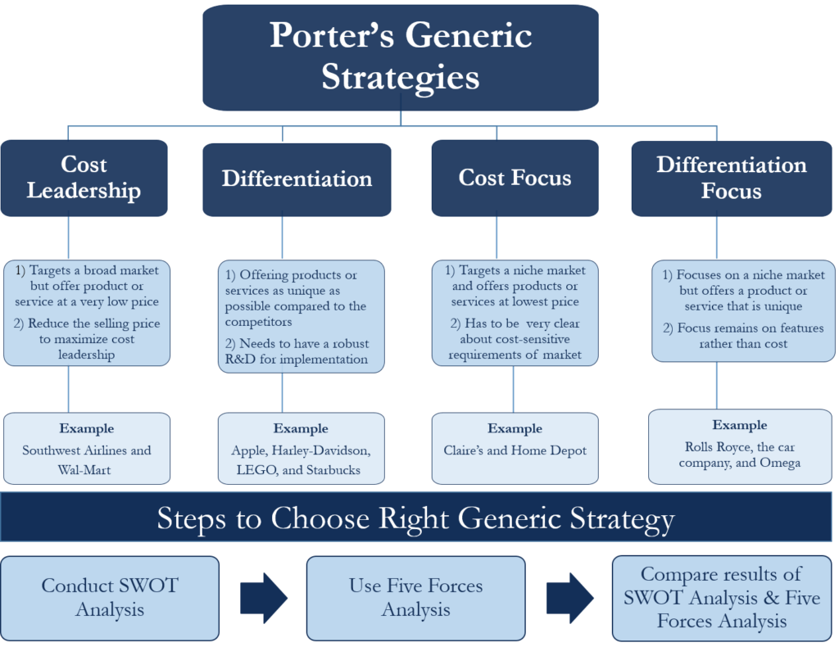
Figure 7: Porters Generic Strategy (Source: (Borad, 2022))
Dell has implemented these strategies, as follows:
- Cost Leadership: Dell has achieved cost leadership by gaining economies of scale and optimizing its supply chain. This helped the company to lower product prices and still be profitable. The company also promotes selling directly through its website which reduces the costs associated with selling through third-party retailers.
- Differentiation: Dell has pursued this strategy by providing unique and innovative products. For instance, the Alienware laptop range offered by the company is targeted exclusively toward high-performance PC gamers. This has helped the company to stand out from its competitors. The company also caters to the enterprise market by providing data management and cloud computing solutions, unlike some of its competitors (Mellor, 2021).
- Focus: Dell has also pursued the focus strategy by targeting niche customer segments. For instance, the company has launched the XPS series to provide affordable and high-performance laptops for its customers. The company has also expanded to emerging markets like India and China and provides services tailor-made for these markets.
In other words, creating a sustained competitive advantage requires continuous innovation, strong relationships with suppliers and distributors, and designing products that provide value to the customers.

Growth Strategies
Growth strategies are certain tools and frameworks used by organizations to increase their market share, expand operations and increase the return on investment (ROI) (Carman & Langeard, 1980). There are several frameworks that can be applied to promote organizational growth and the Ansoff Matrix is one of the most commonly used models. It was developed by the Russian mathematician Igor Ansoff, during the 1950s. The matrix explores four different methods to achieve growth; market penetration, market development, product development, and diversification (Meldrum & McDonald, 1995; Loredana, 2016).
The Ansoff matrix for Dell can be created as follows:
- Market Penetration: Dell can use this strategy to increase the sales of its existing products in the existing market. The company can increase its promotional activities and improve its customer service to achieve this. For instance, Dell can provide discounts to customers who refer its products to their friends.
- Market Development: Here the companies try to sell their existing products in a new market. The core purpose of this strategy is to expand the business. Dell can achieve this strategy by creating customized PCs and peripherals for schools. This will in turn create a new market for the company.
- Product Development: Here companies strive to create a new product for their existing markets. The new products will help companies to attract more customers. Dell can aim for this strategy by creating new laptops for gamers and businesses in the UK, an existing market of the company.
- Diversification: Diversification can be related or unrelated. In related diversification companies expand into a new business that is related to the existing one (Chatterjee & Wernerfelt, 2017). Dell moving into creating mp3 players and digital cameras is an example of related diversification. On the other hand, in unrelated diversification, companies expand into new ventures that are entirely different from their current operations. Dell acquiring EMC and moving into data management and storage is an example of this strategy.
The following figure provides a clearer idea of the matrix:
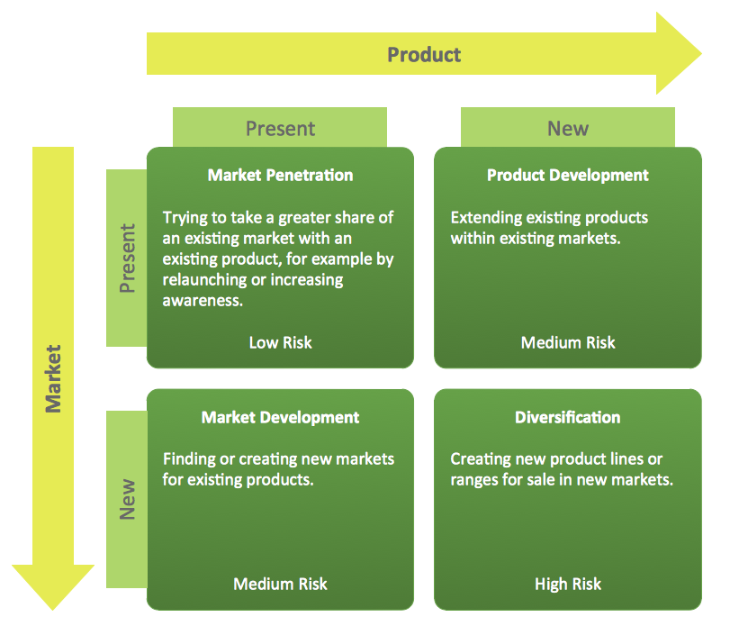
Figure 8: Ansoff Matrix (Source: (ConceptDraw Solutions))
Some of the strategies like product development and diversification have a higher risk compared to others. This is because these strategies require high initial investments in R&D and marketing.

Green Strategy and CSR
In the modern world, consumers and communities are becoming increasingly aware of the impact of business on the environment. Hence, Green strategy and CSR (Corporate Social Responsibility) initiatives are pivotal for any modern-day business. A renowned such strategy is the Green Marketing Mix, which will be explained in detail in Appendix 1. An image of the strategy is given below:
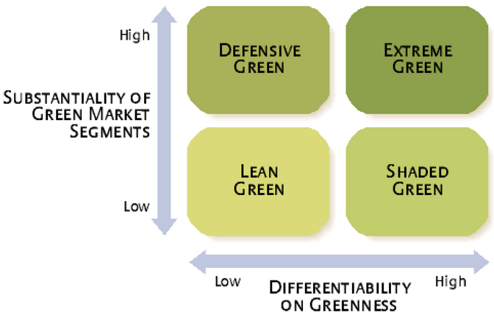
Figure 9: The Green Marketing Strategy Matrix (Ginsberg, J. M. and Bloom, P. N., 2004. Choosing the Right Green Marketing Strategy. Mit Sloan Management Review, p. 81)
Dell being an industry leader has implemented several such strategies in its operations. Some of them are as follows:
- Sustainable Operations: In order to become more environmentally sustainable, Dell is planning to become carbon neutral by 2030 (Motes, 2021). Dell has also implemented a closed-loop recycling process, which involves using recycled materials in new products and reducing waste.
- Sustainable Supply Chain: Dell has created a supplier code of conduct that is based on ethical supply chain practices like reducing environmental impact, respecting human resources, and promoting diversity (Dell, 2022). The company also collaborates with its suppliers and distributors to reduce the use of greenhouse gases and water resources in its supply chain.
- Dell Youth Learning Program: The company created this program to provide access to technology among the poorer sections of society (Businessline, 2018). Through this initiative, Dell has donated PCs and other resources to schools and community centers across the world.
- Concept Luna: In 2021, Dell announced its plans to create the Concept Luna series of laptops (Robson, 2021). The laptops will be designed to be fully repairable and will be made from recycled and sustainable parts.
- Driving Business Ethics: Dell has been listed as one of the most ethical companies by Ethisphere, for the tenth consecutive year (Rothberg, 2015). The company has also launched a mobile application called My Ethics App to help its employees to report misconduct and undergo training on ethics (McLaughlin, 2022).

Conclusion and Recommendations
Dell Technologies LTD is a company that aims to provide innovative solutions to its customers while maintaining its commitment to environmental sustainability. Through the applications of various frameworks like PESTLE and Porter's Industry Five Forces, we were able to analyze the external environment of the company and identify its strengths and weaknesses. The value chain analysis and VRIO analysis highlighted the company's distinctive resources and capabilities, which include a strong brand name, innovative product development, and efficient supply chain management.
Based on these analyses, we could recommend that the company should consider investing in R&D to maintain its innovative edge and pursue growth strategies such as diversification and product development, to expand its product portfolio and reach new markets. Similarly, Dell should continue to focus on sustainability and CSR initiatives, as it could enhance its reputation and improve relationships with customers, employees, and stakeholders.

