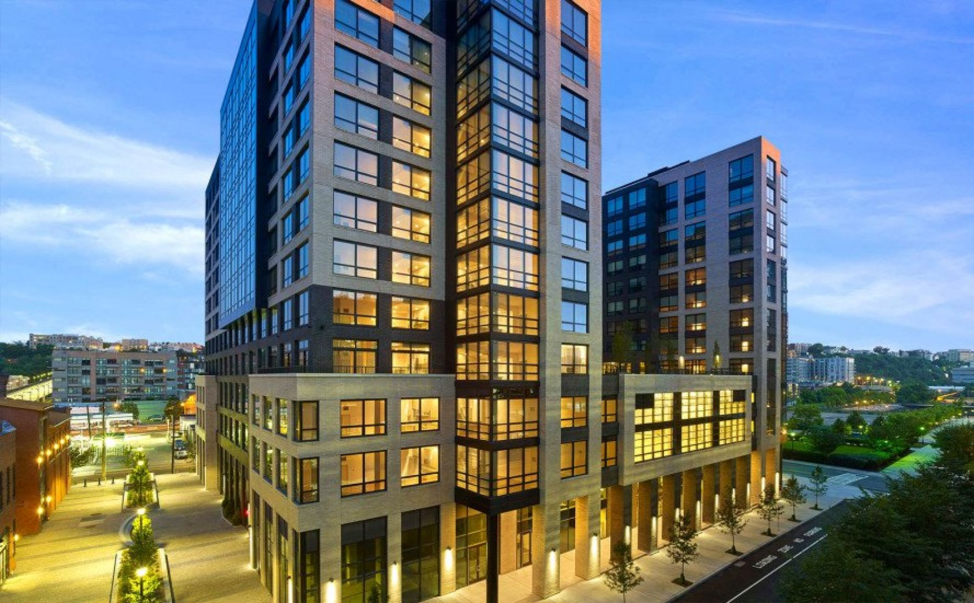
Construction Technology 2
Building Evaluation
Sean Bamber | 2320765 | Construction Management

Table of Contents
Introduction 1
Ground Types and Geological Considerations 1
Structural Frame and Foundation Design 2
Waterproofing Systems 3
Building Envelope, Materials, and Construction Methods 3
Regulations and Construction Considerations for the Proposed Development 4
Drainage and Flood Risk Management 4
Foundations and Waterproofing 4
Building Envelope and Materials 5
Construction Methods: Prefabrication vs. On-Site Construction 5
Sustainability Considerations 5
Energy-Efficient Materials and Systems 6
Renewable Energy Integration 6
Green Roofs and Landscaped Areas 6
Water Conservation and Efficiency 6
Conclusion 8
References 9

Introduction
The design and construction considerations for a medium-to high-rise student housing complex in Swansea's SA1 neighbourhood are covered in this paper. With housing apartments and other amenities like a student union, the facility is designed to accommodate the University's expanding student body. The design incorporates important elements including the building envelope's materials and construction techniques, foundation and structural frame systems that are suited to the site's ground conditions, and the viability of prefabrication as opposed to on-site construction. The SA1 site, which is close to the riverbank, has special challenges, such as high-water tables and potentially unstable soil conditions, which call for careful foundation design and water ingress prevention. The report also assesses options to ensure compliance with local building regulations and standards. Durability, sustainability, and cost-effectiveness are given priority.

Ground Types and Geological Considerations
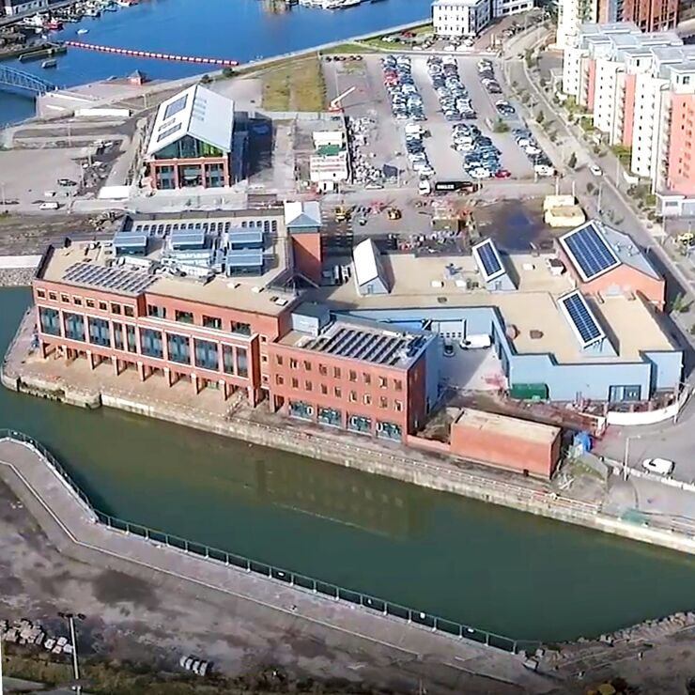
Alluvial deposits, including silt, clay, sand, and gravel, make up the SA1 area's geology. These deposits are prone to differential settlement and have a limited load-bearing capacity. The high-water table caused by the river's vicinity makes excavation more difficult and raises the hydraulic stresses on structures. Additionally, even though there isn't much seismic activity in the area, construction vibrations may have an impact on soft or saturated soils. To assess the groundwater conditions, bedrock depth, and soil profile, a thorough geotechnical survey is necessary. Accurate data collection for foundation design requires methods such as cone penetration testing (CPT), groundwater monitoring, and borehole drilling.
Compaction, grouting, or soil replacement are examples of stabilisation procedures that can be used to improve ground performance to address issues caused by weak soils. Drainage systems are also required to control the high-water table and lessen the structure's hydrostatic pressure. (Sundaram, Gupta and Gupa, n.d.)

Structural Frame and Foundation Design
Pile foundations are recommended in SA1 due to the expected ground conditions. Because bored piles may transfer heavy loads to deeper, more stable layers, they are especially well-suited for medium- to high-rise buildings. These piles are appropriate for urban settings because they produce less noise or vibration. Despite their ability to reach deeper stable levels, driven piles cause a lot of noise and vibration, which may disturb nearby properties. Strategies for vibration monitoring and mitigation will be needed if driven piles are needed.
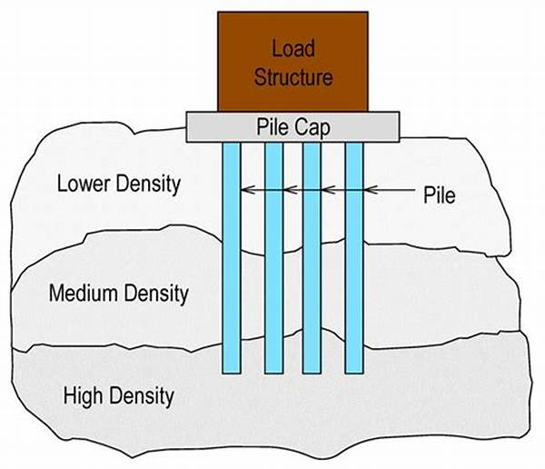
If the geotechnical investigation finds shallow bedrock and a consistent ground profile, raft foundations might be a viable solution. This foundation technique reduces differential settlement by distributing loads across a large region. But as SA1 is likely to have a high-water table, waterproofing measures are crucial to preventing water intrusion. Drainage layers and membranes will be required to protect the building from water-related problems.
The development's structural frame will be made of steel and reinforced concrete. The SA1 area is a good fit for reinforced concrete because of its resilience to water intrusion and longevity. It offers outstanding fire resistance and strong structural stability. Reinforced concrete successfully reduces the risks associated with the high-water table when used in conjunction with waterproofing solutions. Contrarily, steel is lightweight and enables quicker construction; but, in SA1's high moisture environment, corrosion prevention is essential. For long-term structural integrity, weathering steel, galvanisation, or advanced coatings are necessary.
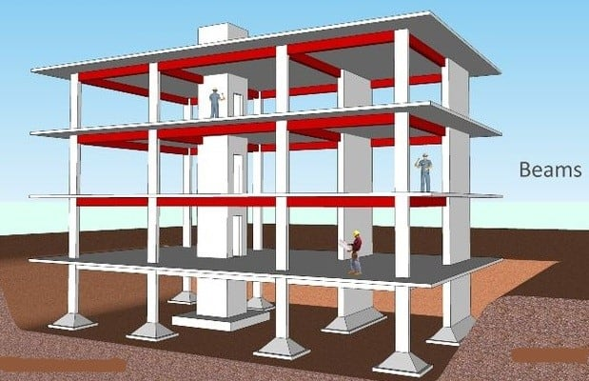
A reinforced concrete structural frame and bored pile foundations make up the ideal design. While the reinforced concrete frame gives durability, weather resistance, and load-bearing capacity, bored piles offer stability by shifting loads to stable substrata. Resilience against water intrusion is increased by waterproof additives in the concrete as well as cutting-edge waterproofing techniques like liquid-applied membranes or bentonite mats. (Woods, 2024)

Waterproofing Systems
Because of the high-water table and proximity to the river, which raise the risk of groundwater intrusion and flooding, waterproofing is essential for this development. To preserve the building's structural integrity and give its residents a safe environment, a multi-layered waterproofing method is necessary.
Type A systems prevent water from entering the building by using exterior or internal barriers. Because they adequately protect all exposed surfaces, flexible membranes—such as those that are sheet-based or liquid-applied—perform particularly well in circumstances where hydrostatic pressure is high.
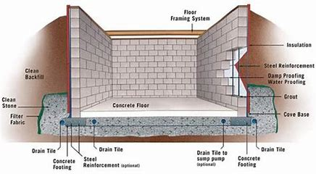
Waterproofing is integrated into the structure itself in Type B systems. This technology improves impermeability and self-sealing qualities by utilising water-resistant concrete with additions like crystalline waterproofing admixtures. Type B systems offer long-term, low-maintenance protection by serving as a supplementary barrier against water intrusion.
Water that seeps into underground locations, such as utility rooms and basements, is managed by type C systems. To establish a regulated drainage layer, these systems use hollow drain membranes on interior walls and floors. Drainage channels gather any water that escapes the outer barriers and send it to sump pumps for release. By using this technique, harm is avoided, and even residual water is efficiently managed.
The most complete protection for the SA1 development is provided by a mix of Type A, B, and C systems. The first line of defence is provided by Type A membranes, structural integrity is guaranteed by Type B systems, and any water that gets beyond the outer barriers is managed by Type C systems. When combined, these technologies efficiently handle site-specific circumstances and the high-water table. (membranes, 2019)

Building Envelope, Materials, and Construction Methods
Durability, energy efficiency, and aesthetic appeal are all dependent on the building envelope. The selection of materials at SA1 must take environmental factors into account, with an emphasis on architectural excellence, thermal performance, and weather resilience. For this project, precast concrete panels and composite cladding systems are the best option since they combine modern aesthetics, energy efficiency, and durability.
Energy efficiency and a contemporary look are provided by composite cladding systems, which blend materials like aluminium, insulated panels, and thermoplastic layers. These solutions guarantee adherence to energy rules because they are lightweight, simple to install, and offer superior thermal insulation. The development's modern appearance is enhanced by the aluminium exterior's toughness and smooth polish.
To satisfy thermal performance requirements, high-performance glass is required. Low-emissivity coatings or triple glazing maximise natural light penetration while minimising heat loss. Additionally, insulated panels in areas like the roof and external walls further enhance energy efficiency.
Prefabrication techniques have various benefits, especially for components like modular modules, floor systems, and wall panels. These components, which are manufactured off-site, guarantee accuracy and minimise labour and construction waste on-site. By increasing resource efficiency, this method speeds up building while lessening its negative effects on the environment. However, because of the site-specific difficulties brought on by the high-water table and fluctuating soil conditions, foundations and waterproofing systems must be built on-site. To achieve good waterproofing and proper integration with site circumstances, traditional procedures are required.
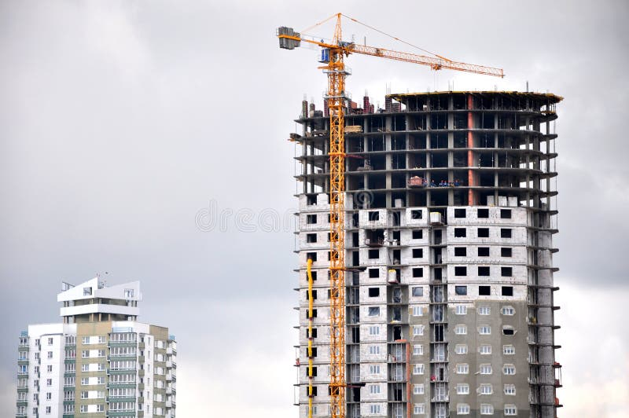
The best strategy for the SA1 development includes prefabricated building components for quicker, more affordable construction, composite cladding for energy efficiency and aesthetics, and precast concrete panels for durability. This hybrid approach promotes sustainability and high performance while addressing the site's particular architectural and environmental limitations. (Deshmukh & Yadav, 2025)

Regulations and Construction Considerations for the Proposed Development

A set of rules ensuring safety, sustainability, and resilience must be followed by the proposed development in Swansea's SA1 region. These rules address things like waterproofing, foundations, drainage, building materials, and construction techniques. Prefabrication and on-site construction techniques will be combined to achieve the necessary requirements and consider the site-specific conditions to maximise the development process.

Drainage and Flood Risk Management

Flood risk is a serious issue because of the SA1 site's proximity to the river. According to Technical Advice Note (TAN) 15: Development and Flood Risk and the National Planning Policy Framework (NPPF), a Flood Risk Assessment (FRA) is necessary. The FRA will evaluate the likelihood of groundwater and river-related flooding and suggest suitable mitigation measures. In addition, Schedule 3 of the Flood and Water Management Act of 2010 mandates the implementation of Sustainable Drainage Systems (SuDS). These features, which include retention basins, green roofs, and permeable pavement, will control surface water runoff, lower the risk of flooding, and improve the site's ecological value.

Foundations and Waterproofing

Strong foundation and waterproofing solutions are required due to the site's high-water table and possibility for flooding. For the construction to be able to endure the soft, alluvial soils, foundations must comply with Building Regulations Part A (construction). The type of foundation will be determined by a geotechnical survey; deep foundations or bored piles are the best options for moving loads to stable ground underneath the fragile layers.
To stop water intrusion, especially in subterranean spaces, waterproofing is crucial. BS 8102:2022, which addresses the waterproofing requirements for below-ground structures, will be followed throughout the development. Type B (structurally integral protection), Type C (drained protection), and Type A (barrier protection) systems will all be used in conjunction. Because of the high-water table and proximity to a river, these measures will guarantee the building's long-term stability by preventing moisture intrusion.

Building Envelope and Materials

The building envelope needs to be durable, moisture-resistant, and thermally efficient. The best materials for this are composite cladding systems and precast concrete panels. While composite cladding offers superior thermal performance and weather resistance, precast concrete delivers strength, accuracy, and building speed. Additionally, these materials enable the integration of energy-efficient insulation, satisfying the energy conservation requirements of Part L of the Building Regulations.
To improve thermal performance, lower energy consumption, and guarantee a comfortable indoor atmosphere, high-performance glass and insulated panels will be utilised. In addition to increasing energy efficiency, these actions will help achieve sustainability objectives. (OUP accepted manuscript, 2021)

Construction Methods: Prefabrication vs. On-Site Construction

Prefabrication and on-site building will be combined in a hybrid technique. Wall panels, modular units, and floor systems are examples of prefabricated components that will be produced in a controlled environment off-site. As a result, the construction timeframe is shortened, waste is reduced, and on-site labour is reduced. Additionally, prefabrication guarantees improved quality control and lessens the effect of unfavourable weather circumstances, like frost, which may otherwise cause on-site operations to be delayed.
On-site labour will be necessary for several construction-related tasks, such as waterproofing systems and foundations. Foundations must be planned and built on-site to account for local site circumstances, especially in regions with unstable soils and a high-water table. To guarantee that waterproofing systems are successful at preventing water intrusion into buildings, they must also be installed and tested precisely.

Sustainability Considerations

With a focus on minimising environmental effect, lowering carbon emissions, and designing an energy-efficient structure, sustainability is a major component of this development. To guarantee that the development satisfies legal criteria and serves as an example of responsible, environmentally friendly urban life, a few green technology and sustainable construction techniques will be used.

Energy-Efficient Materials and Systems

To improve energy efficiency, insulated panels will be widely employed throughout the building envelope. These panels reduce the demand for heating and cooling systems by keeping the building cool in the summer and minimising heat loss in the winter. High-performance glass will let in a lot of natural light while reducing heat loss in the winter and heat gain in the summer. Together, these materials significantly reduce energy use, improving operational efficiency and creating a comfortable living environment.
To reduce air leaks and improve energy efficiency, airtightness will also be given priority. While recovering heat from exhaust air, advanced ventilation systems like mechanical ventilation with heat recovery (MVHR) would guarantee constant fresh air circulation. This equilibrium saves energy and increases comfort.

Renewable Energy Integration

The integration of renewable energy solutions will lower the carbon footprint of the building. To reduce dependency on grid electricity and carbon emissions, solar panels will be erected on the roof to collect sunlight and transform it into sustainable energy. Common areas will be powered by the solar energy produced, further advancing the development's environmental objectives.
Using the earth's constant temperature, ground-source heat pumps will be taken into consideration for both heating and cooling. These systems are an excellent sustainable substitute for conventional HVAC systems because to their great energy efficiency and low carbon emissions.

Green Roofs and Landscaped Areas

To improve sustainability, the design will include landscaped spaces and green roofs. In the summer, green roofs help to keep interior temperatures lower by reducing heat absorption through natural insulation. Additionally, they absorb rainfall, which lowers surface runoff and lowers the risk of flooding.
With native plants serving as pollinator and wildlife habitats, landscaped spaces will be planned to promote local biodiversity. By absorbing CO2 and generating oxygen, these areas will also enhance the quality of the air, which will help the local ecosystem and its inhabitants. Natural drainage systems and permeable pavement will further effectively handle rainfall, avoiding waterlogging and improving sustainability.

Water Conservation and Efficiency

A major component of the development's sustainability plan will be water saving. To cut down on the amount of potable water used, low-flow faucets will be installed in restrooms, kitchens, and common areas. By collecting rainwater from the roof for non-potable applications like toilet flushing and irrigation, rainwater harvesting systems will lower the need for treated water.
Systems that treat washbasin, shower and bathtub water for use in non-potable applications—known as greywater recycling systems—will also be taken into consideration. These actions will improve the building's overall sustainability, lessen its negative effects on the environment, and assist conserve water. (Rocha et al., 2023)

Conclusion

At the SA1 site in Swansea, the medium-to-high-rise student housing design is a holistic solution that prioritises sustainability, energy efficiency, and durability while addressing the site's particular problems. The long-term stability of the construction will be ensured by addressing the geological and hydrological issues at the site using piling foundations and multi-layered waterproofing systems.
Precast concrete panels and composite cladding systems are among the long-lasting and energy-efficient components that have been carefully chosen to create the building envelope. The building's carbon footprint is decreased, and sustainability objectives are supported by the incorporation of renewable energy technology like solar panels and ground-source heat pumps.
Efficiency, economy, and flexibility are guaranteed by a hybrid construction method that combines prefabrication for essential building components with on-site construction for waterproofing and foundations. Green roofs, landscaped spaces, water conservation techniques, and the use of energy-efficient equipment all contribute to the development's increased sustainability.
Students will live in a secure, cosy, and environmentally friendly environment thanks to this building, which will benefit both the university and the neighbourhood. The project will set the norm for ecologically conscious student housing by following legal requirements and utilising cutting-edge technologies.

References
- (No date) Cengrs. Available at: https://www.cengrs.com/assets/technical-paper/1546410524-69-Paper-IGC-2018-Tall-Building-keynotelecture.pdf

- Woods, C. (2024) Solid ground and the various building foundations in modern construction, Buy and Sell Used Heavy Equipment - Boom & Bucket. Available at: https://www.boomandbucket.com/blog/building-foundation?srsltid=AfmBOoq3FAlMis-PKdi42jlx-N4yMfyEJ_Lcq87aGyJda7A5VrS9YSfz

- membranes, D. (2019) Structural waterproofing - types A, B & C, Delta Membranes. Available at: https://www.deltamembranes.com/structural-waterproofing-types-a-b-c/

- Deshmukh, M. and Yadav, M. (2025) Optimizing thermal efficiency of building envelopes with sustainable composite materials, MDPI. Available at: https://www.mdpi.com/2075-5309/15/2/230

- OUP accepted manuscript. (2021). International Journal of Low-Carbon Technologies. doi:https://doi.org/10.1093/ijlct/ctab016.

- Rocha, P.F., Ferreira, N.O., Pimenta, F. and Pereira, N.B. (2023). Impacts of Prefabrication in the Building Construction Industry. Encyclopedia, [online] 3(1), pp.28–45. doi:https://doi.org/10.3390/encyclopedia3010003.

